# C# Fundamental 1

# Introduction to programing

# Exercise10

## Provide a short list with information about the most popular programming languages.

## How do they differ from C#?

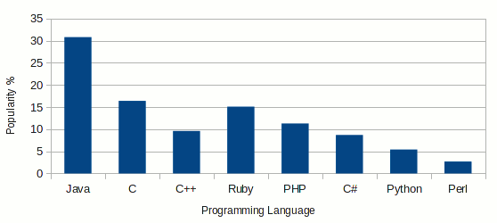

1. **Java**

Java is a high level, object oriented, compiled programming language. Java is used in developing complex dynamic web [applications](http://blog.sudobits.com/category/applications/), network programming and robotics.

* platform independent
* Object Oriented
* Speed(Java Based web apps are faster than conventional CGI based Apps)
* Static Typed
* Advanced Exception Handling Mechanism
* Advanced Exception Handling Mechanism

1. **C**

C language is a high level, procedure oriented and compiled programming language. it is very fast and efficient for system programming. C exactly comes between the Assembly language and object Oriented language such as Java.

* Fast
* static typed and compiled
* more control, due to low abstraction
* pointer

1. **Ruby**

Ruby is an object oriented and interpreted scripting language, mostly used in creating Web Applications. Ruby focuses on productivity. it is very human friendly. “Ruby on Rails” is one of the most popular framework for web apps development.

* dynamic typed
* interpreted
* optimized for productivity
* programmer/human friendly

1. **PHP**

PHP (Hypertext PreProcessor) or Personal Home Page is the most widely used scripting language over the web. it is an object oriented Interpreted language, mainly used in server side scripting , for creating dynamic web pages/apps.

* dynamic typed
* interpreted
* simplicity
* object oriented

1. **C++**

C++ as name implies, it adds some extra features(Object Oriented Features) to C language. So C++ is almost similar to C, with some added features. it is mostly used in system software development.

* Procedure Oriented and Object Oriented
* Generic
* static typed
* compiled

1. **C#**

C Sharp(or C#) is a generic, object oriented language developed by Microsoft , highly influenced by Java and C++. it is some sort of java, with improved reliability, productivity and security.

* static/dynamic typed
* object oriented
* optimized for Windows platform
* implementation with .NET framework

1. **Python**

Python is a general purpose, high level,interpreted [programming](http://blog.sudobits.com/category/programming/) language. it supports all platforms. It focus well on code readability. it’s syntax is very clear and easy to learn.

* Interpreted
* Dynamic/Duck Typed
* Object Oriented/Procedure Oriented
* Clear Syntax

1. **Perl**

Perl is another general purpose and open source scripting language. it is mainly used in web development and network programming. The perl focuses on the speed of coding and productivity.

* Dynamic Typed
* Object Oriented,Procedural
* Interpreted
* less coding, so quick development

Using information : blog.sudobits.com