
SRINIVAS

UNIVERSITY
INSTITUTE OF ENGINEERING & TECHNOLOGY
(
SUBJECT
:

ADVANCED MACHINE LEARNING)
(
SUBJECT CODE:24SAL
051)
AN INDIVIDUAL TASK REPORT ON
“
Comparative Analysis of Logistic Regression, Decision

Tree and KNN for Diabetes Prediction”
Submitted

in the

partial

fulfilment

of

the

requirements for the

Fifth semester
BACHELOR

OF

TECHNOLOGY
IN
Artificial Intelligence & Machine Learning
Submitted By,
Diya J Palan
01
SU24AI
028
UNDER THE GUIDANCE OF

Prof. Mahesh Kumar V B
DEPARTMENT

OF

ARTIFICIAL INTELLIGENCE &MACHINE LEARNING
SRINIVAS UNIVERSITY INSTITUTE OF ENGINEERING & TECHNOLOGY

MUKKA, MANGALURU-574146
2026-27

SRINIVAS UNIVERSITY
INSTITUTE OF ENGINEERING & TECHNOLOGY

Department of Artificial Intelligence &Machine Learning

CERTIFICATE3E

This is to certify that,
Diya J Palan (01SU24AI028),
has satisfactorily completed

the assessment (Individual Task Report) in
Advanced Machine Learning

(24
SAL051)
prescribed by the Srinivas University for the 5
th
semester B. Tech.

course during the year
2026-27
.
MARKS AWARDED

Staff In charge

Prof. Mahesh Kumar V B

TABLE OF CONTENTS
SI.no | Description | Page no.
1 | Abstract | 1
2 | Introduction | 2
3 | Dataset and Data Understanding | 4
4 | Data Preprocessing | 6
5 | Machine Learning Methodology | 9
6 | Implementation | 11
7 | Model Evaluation | 19
8 | Results and Analysis | 20
9 | Prediction and Discussion | 21
10 | Conclusion | 23
11 | References | 24

Abstract
Diabetes is one of the major health challenges, and its early prediction can help in providing timely medical attention and improving medical decision-making. This project presents a machine learning-based approach for predicting diabetes using three classification algorithms: Logistic Regression, Decision Tree, and K-Nearest Neighbors (KNN). A diabetes dataset containing relevant medical and patient-related attributes is used to develop and evaluate the predictive models.
The dataset is first subjected to appropriate data preprocessing, including data inspection, feature selection, encoding of categorical attributes, feature scaling, and division into training and testing datasets. The selected machine learning algorithms are then trained using the processed data. Their performance is evaluated using accuracy, precision, recall, F1-score, ROC-AUC, classification reports, and confusion matrices. The Logistic Regression model obtained approximately 88.52% accuracy, 83.87% precision, 92.86% recall, 88.14% F1-score, and 96.43% ROC-AUC in the implemented analysis.
The project also demonstrates the prediction of diabetes for new patient data using the trained models. A comparative analysis of Logistic Regression, Decision Tree, and KNN helps identify differences in their classification performance and effectiveness. The results demonstrate that machine learning can be effectively applied to diabetes prediction and can provide useful computational support for analysing medical data. However, such predictions are intended for academic and decision-support purposes and should not replace professional medical diagnosis.

1. Introduction
Diabetes is one of the major health challenges affecting people worldwide. It is a chronic condition that affects how the body processes blood sugar and can significantly impact an individual's quality of life. Common factors associated with diabetes include unhealthy diet, obesity, lack of exercise, family history, age, and physical inactivity. Since several of these factors can occur together, analysing multiple patient characteristics can help identify patterns associated with diabetes.
Early prediction of diabetes is important because timely identification of potential risk can support further medical evaluation and appropriate treatment. Traditional diagnosis generally involves medical history, physical examination, laboratory tests, and other medical procedures. With the increasing availability of medical data, Machine Learning (ML) provides an additional computational method for analysing patient information. Machine learning algorithms can learn patterns from existing data and use these patterns to make predictions for new observations.
The development of an effective prediction model requires proper data preprocessing. Healthcare datasets may contain numerical and categorical attributes, different feature scales, missing or inconsistent values, and irrelevant information. Therefore, the dataset must first be inspected and prepared before applying machine learning algorithms. In this project, the data is processed through feature preparation, selection of required attributes, categorical encoding, feature scaling where necessary, and division into training and testing datasets. These steps help ensure that the machine learning algorithms receive suitable input data.
This project focuses on the application and comparison of three supervised machine learning classification algorithms: Logistic Regression, Decision Tree, and K-Nearest Neighbors (KNN). These algorithms use different mathematical and computational approaches to classify patient records. Logistic Regression estimates the probability of a patient belonging to each class using a decision boundary. Decision Tree creates a tree-like structure of conditions to reach a classification decision. KNN classifies a patient based on the classes of the most similar patients in the training data. Applying all three algorithms to the same dataset allows their performance to be analysed under similar conditions.
The project follows a systematic machine learning workflow beginning with dataset loading and understanding. The dataset is examined to identify its structure, attributes, and target variable. Exploratory analysis is performed to understand the distribution of the data and identify useful patterns. The required features are then prepared for machine learning by applying appropriate preprocessing techniques. After preprocessing, the dataset is divided into training and testing portions. The training data is used to build the models, while the testing data is used to evaluate their ability to classify previously unseen records.
Model evaluation is an important part of this project. Instead of considering only one performance measure, multiple evaluation metrics are used to obtain a more complete understanding of each algorithm. These include Accuracy, Precision, Recall, F1-Score, and ROC-AUC. Confusion matrices and classification reports are also generated to analyse the number of correctly and incorrectly classified samples. These measures allow the performance of Logistic Regression, Decision Tree, and KNN to be compared in a systematic manner.
In the implemented analysis, the Logistic Regression model achieved an accuracy of approximately 88.52%, with a precision of 83.87%, recall of 92.86%, F1-score of 88.14%, and ROC-AUC of 96.43%. These results indicate that Logistic Regression provided strong classification performance on the test data, particularly in identifying positive diabetes cases. The results of the other algorithms are also considered to determine their relative strengths and weaknesses and to identify the most suitable model for the given dataset.
The project further demonstrates the use of the trained models for predicting the outcome of new patient data. By providing previously unseen patient attributes to the trained models, the system generates a predicted class. This demonstrates the practical application of the developed machine learning pipeline and shows how classification algorithms can be used to analyse new observations after being trained on historical data.
Overall, this project demonstrates an end-to-end approach to diabetes prediction using machine learning. It covers dataset understanding, preprocessing, feature preparation, model development, performance evaluation, comparison, and prediction on new data. The comparison of Logistic Regression, Decision Tree, and KNN provides a clear understanding of how different classification techniques perform on the same medical dataset. The project also highlights the importance of selecting suitable features, preprocessing the data correctly, and using multiple evaluation metrics when developing predictive machine learning systems for medical applications. The developed models are intended for academic and analytical purposes and should not replace professional medical diagnosis or clinical judgement.

2. Dataset and Data Understanding

2.1 Pima Indians Diabetes Dataset
The dataset used in this project is the Pima Indians Diabetes Dataset. The objective of using this dataset is to analyse patient-related medical attributes and predict whether a patient is likely to have diabetes. The project applies three classification algorithms: Logistic Regression, Decision Tree, and K-Nearest Neighbors (KNN).
The dataset contains different patient-related medical attributes that can be used to identify patterns associated with diabetes. These attributes include both numerical and categorical information. Before applying machine learning algorithms, the dataset is examined and prepared through appropriate preprocessing techniques.
The preprocessing process includes checking for missing values, identifying categorical features, applying One-Hot Encoding, dividing the dataset into training and testing sets, and applying feature scaling. These steps ensure that the data is converted into a suitable format for machine learning algorithms.

2.2 Dataset Features
The features in the dataset represent different characteristics of the patients that may be useful for predicting diabetes. Since the dataset contains different types of variables, each feature must be appropriately prepared before model training.
Numerical features contain measurable values, whereas categorical features represent different categories or groups. Categorical features are converted into numerical form using One-Hot Encoding. This allows the machine learning algorithms to process categorical information effectively.
Feature scaling is also applied as part of the preprocessing pipeline. Scaling is particularly useful for algorithms such as SVM because features with larger numerical ranges can otherwise have a greater influence on the model. The project therefore prepares the input data systematically before training the models.

2.3 Target Variable
The target variable represents the final output that the machine learning models need to predict. In this project, patients are classified into two categories:

• No Diabetes • Diabetes
Therefore, the project is treated as a binary classification problem. The models learn patterns from the training data and use those patterns to predict the class of previously unseen patient records.
The distribution of the target classes is also analysed during exploratory data analysis. Understanding the distribution of the classes is important because an imbalance between classes can affect the interpretation of model performance.

2.4 Dataset Characteristics
The dataset contains a combination of medical attributes that provide information about the health characteristics of patients. These attributes are used as input variables for the machine learning algorithms.
Since the dataset contains numerical and categorical features, preprocessing plays an important role in the overall machine learning workflow. Missing-value checking, categorical feature identification, One-Hot Encoding, feature scaling, and train-test splitting are performed before model training.
After preprocessing, the resulting dataset is suitable for training the three selected classification algorithms. The same prepared data is supplied to Logistic Regression, Decision Tree, and KNN, allowing their performance to be compared under similar conditions.

2.5 Exploratory Data Analysis
Exploratory Data Analysis (EDA) is performed before model development to understand the structure and distribution of the dataset. EDA helps identify important patterns and provides a better understanding of the relationship between the available attributes and the target variable.
One important analysis is the distribution of the target classes. The number of patients belonging to the No Diabetes and Disease categories is examined using graphical representation. Such analysis helps understand whether the target classes are reasonably distributed and provides useful information before model training.
Overall, the dataset understanding stage provides the foundation for the machine learning process. The available patient attributes are examined, the target variable is identified, and the data is prepared for subsequent modelling. After completing this stage, the processed dataset can be used for training and evaluating Logistic Regression, Decision Tree, and KNN classification models.

3. Data Preprocessing

3.1 Data Loading
The first step in developing the diabetes prediction system is loading the Pima Indians Diabetes Dataset into the Python environment. The dataset is imported into a Pandas DataFrame so that its records and attributes can be easily examined and processed. Loading the data correctly is important because all subsequent preprocessing and machine learning operations depend on the quality and structure of the input dataset.
After loading the dataset, its basic structure is examined to understand the number of records, number of features, data types, and target variable. This provides an initial understanding of the information available for building the prediction models.

3.2 Data Inspection
Data inspection is performed to identify the characteristics of the dataset before applying any transformation. The first few records can be displayed to understand how the features are represented. The shape of the dataset is also checked to determine the number of observations and attributes.
The data types of the different columns are examined because the preprocessing method depends on whether a feature is numerical or categorical. Numerical variables can generally be used after appropriate scaling, while categorical variables need to be converted into a numerical representation.
Data inspection also helps identify potential problems such as missing values, unexpected data types, duplicate records, or unsuitable attributes. Performing this step before model training reduces the possibility of errors during implementation.

3.3 Handling Missing Values
Missing values can negatively affect machine learning algorithms because most classification models require complete input data. Therefore, the dataset is checked for missing or null values before proceeding with model development.
If missing values are present, an appropriate treatment method can be applied depending on the nature of the feature. Numerical values may be handled using statistical measures such as the mean or median, while categorical values can be handled using the most frequent category or another suitable method.
In this project, missing-value checking is included as part of the preprocessing workflow. This ensures that the quality of the input data is examined before the models are trained.

3.4 Feature Selection
Feature selection involves identifying the attributes that are useful for predicting diabetes. Not every available column necessarily contributes equally to the prediction task. Irrelevant or unnecessary information can increase model complexity and may negatively affect prediction performance.
The required patient-related attributes are therefore separated from the target variable. The selected features are represented as the input variable X, while the diabetes classification is represented as the target variable y.
Proper feature selection provides the machine learning algorithms with meaningful information and establishes a clear separation between the input data and expected output.

3.5 Encoding Categorical Features
The dataset contains categorical features that cannot be directly processed by most machine learning algorithms in their original textual or categorical form. To convert these variables into a suitable numerical representation, One-Hot Encoding is applied.
One-Hot Encoding creates separate binary columns for the different categories of a categorical feature. For example, if a feature contains three categories, the encoding process can represent these categories using separate numerical columns. This prevents the algorithm from incorrectly assuming that one category is numerically greater or smaller than another.
The project uses OneHotEncoder as part of the preprocessing pipeline. This ensures that categorical variables are transformed consistently for both training and testing data.

3.6 Feature Scaling
Feature scaling is another important preprocessing step used in the project. Numerical attributes can have different ranges. For example, one feature may contain values in a small range while another feature may contain considerably larger values.
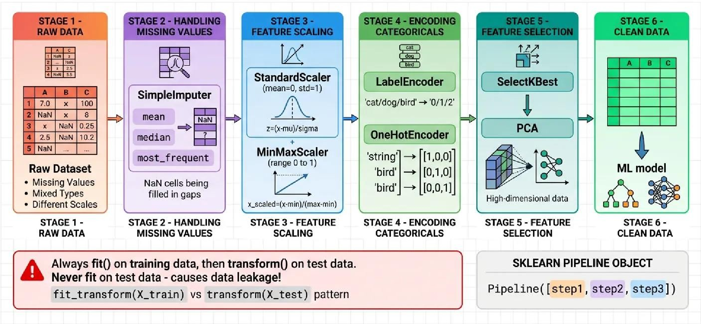
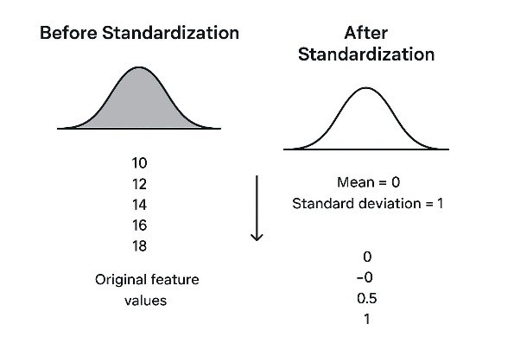
When features have significantly different scales, some machine learning algorithms may give greater importance to features with larger numerical values. This is particularly relevant to Logistic Regression, which relies on distances and the position of observations in feature space.
The project uses StandardScaler to standardize numerical features. Standardization transforms the numerical features to a comparable scale, helping the algorithms process the input data more effectively.

3.7 Train-Test Split
After preprocessing, the dataset is divided into training and testing subsets. The training dataset is used to teach the machine learning algorithms the patterns present in the patient data. The testing dataset is kept separate and is used to determine how well the trained models perform on unseen data.
Separating the data into training and testing portions is important for evaluating the generalization capability of the models. A model should not simply memorize the training examples; it should be capable of making accurate predictions for new observations.
The same processed training and testing data are used for the three selected algorithms— Logistic Regression, Decision Tree, and KNN—so that their performance can be compared fairly.

3.8 Preprocessing Pipeline
The preprocessing operations are organized into a systematic workflow using Python's machine learning libraries. The project uses components such as ColumnTransformer, OneHotEncoder, StandardScaler, and Pipeline to manage the transformation of different feature types.
A preprocessing pipeline has several advantages. It ensures that the same transformations applied to the training data are also applied to the testing data. It also reduces the possibility of inconsistent preprocessing and makes the complete machine learning workflow easier to maintain.
The overall preprocessing process can be summarized as:

Raw Dataset → Data Inspection → Missing-Value Check → Feature Selection → Categorical Encoding → Feature Scaling → Train-Test Split → Model Training
This preprocessing stage prepares the diabetes dataset for the next stage of the project, where the Logistic Regression, Decision Tree, and KNN algorithms are trained and evaluated.

4. Machine Learning Methodology

4.1 Overview of the Methodology
The proposed diabetes prediction system follows a systematic machine learning methodology. The process begins with collecting and understanding the Pima Indians Diabetes Dataset, followed by preprocessing the available patient information. The processed data is then used to train three different supervised classification algorithms: Logistic Regression, Decision Tree, and K-Nearest Neighbors (KNN).
The main objective of applying multiple algorithms is to compare their predictive performance on the same dataset. Each algorithm uses a different classification principle, allowing the project to analyse which approach performs better for the given diabetes prediction problem.
The overall methodology can be represented as:

Dataset → Data Preprocessing → Feature Transformation → Train-Test Split → Model Training → Prediction → Model Evaluation → Comparison
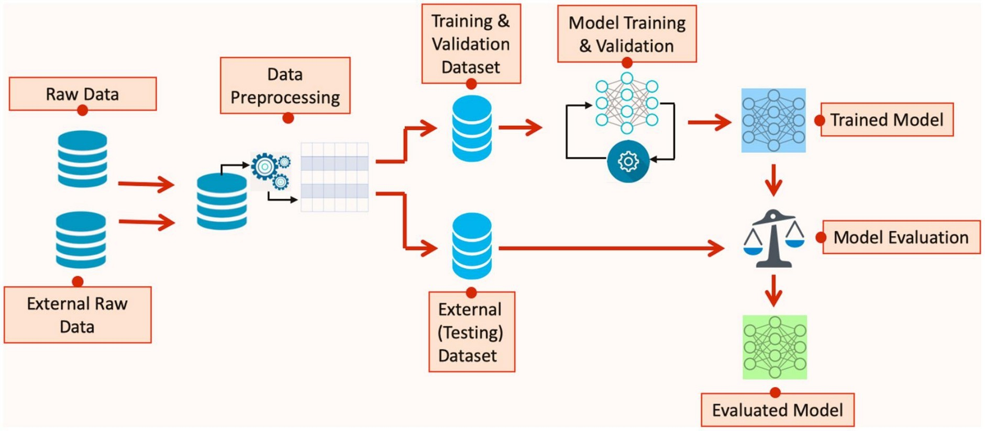

4.2 Logistic Regression
Logistic Regression is a supervised machine learning algorithm commonly used for classification problems. It models the probability that a given patient belongs to a particular class (Disease or No Diabetes) using a logistic (sigmoid) function applied to a weighted combination of the input features. Unlike linear regression, which predicts continuous values, Logistic Regression outputs a probability between 0 and 1, which is then converted into a class label using a threshold (typically 0.5).
In this project, Logistic Regression is applied to classify patients into the Disease and No Diabetes categories. Since Logistic Regression is sensitive to the scale of input features, feature scaling is included in the preprocessing pipeline. The processed patient attributes are supplied to the Logistic Regression model, which learns the weights that best separate the two classes from the training data.
Logistic Regression is particularly useful because it is computationally efficient, interpretable, and performs well when there is a roughly linear relationship between the features and the log-odds of the outcome. The trained model is subsequently used to predict the classes of test samples and new patient records, along with probability estimates used for ROC-AUC evaluation.

4.3 K-Nearest Neighbors (KNN)
K-Nearest Neighbors (KNN) is a supervised, instance-based learning algorithm used for classification. Rather than learning an explicit decision boundary during training, KNN stores the training data and classifies a new observation based on the classes of its "k" closest neighbors in the feature space, typically measured using Euclidean distance.
For a given patient record, KNN identifies the k nearest patients in the training data and assigns the class that occurs most frequently among them. The choice of k affects model performance: a small k can make the model sensitive to noise, while a large k can smooth out class boundaries too much.
One advantage of KNN is its simplicity, since it requires no explicit training phase beyond storing the data. However, it can be computationally expensive at prediction time and is sensitive to feature scaling, which is why StandardScaler is applied during preprocessing. In this project, KNN is trained using the processed diabetes dataset and produces both class predictions and probability estimates for ROC-AUC analysis.

4.4 Decision Tree
A Decision Tree is a supervised machine learning algorithm that performs classification by creating a tree-like structure of decisions. Each internal node represents a condition based on a feature, each branch represents an outcome of that condition, and the leaf nodes represent the final class prediction.
The Decision Tree algorithm selects features and creates decision rules that divide the training data into different groups. The process continues until suitable stopping conditions are reached. The resulting tree can be followed from the root node to a leaf node to determine the predicted class for a particular patient.
One advantage of Decision Trees is their interpretability. Unlike some complex models, a tree can be visually represented and its decision-making process can be understood through a sequence of rules.
In this project, the Decision Tree model is trained using the processed diabetes data. It predicts whether test patients belong to the Diabetes or No Diabetes class and is evaluated using the same metrics used for the other models.

5. Implementation

5.1 Development Environment
The diabetes prediction system is implemented using Python because it provides extensive libraries for data analysis, preprocessing, visualization, and machine learning. The implementation follows a complete machine learning workflow starting from dataset loading and data inspection and continuing through preprocessing, model training, prediction, and evaluation.
The major Python libraries used in the project are:
- Pandas – used for reading and manipulating the dataset.
- NumPy – used for numerical operations.
- Matplotlib – used for plotting graphs.
- Seaborn – used for statistical visualization and confusion matrices.
- Scikit-learn – used for preprocessing, classification algorithms, and evaluation metrics.
The notebook uses OneHotEncoder, StandardScaler, ColumnTransformer, and Pipeline for preprocessing. The classification algorithms implemented are SVC, GaussianNB, and DecisionTreeClassifier.

5.2 Importing Required Libraries
The first implementation step is importing the libraries required for data processing, visualization, model training, and evaluation.
The Pima Indians Diabetes Dataset is loaded using the Pandas library. The dataset is stored in a DataFrame, which makes it convenient to inspect and manipulate the records.
The head() function displays the first few records of the dataset. This allows the structure and values of the different attributes to be examined before preprocessing.
The dataset contains patient-related attributes that are used as input features, along with a target variable representing the diabetes classification.
After loading the dataset, its structure and data types are examined.
The inspection helps determine:
• Statistical characteristics of numerical variables.
This step helps identify the preprocessing operations required before model training.
Missing values are checked before training the models.
Checking missing values is important because incomplete observations can affect the training process. If missing values are present, suitable imputation techniques can be applied before proceeding.
Exploratory Data Analysis is performed to understand the distribution of the target variable and identify useful patterns in the dataset.
The target variable is visualized using a count plot.
This graph displays the number of observations belonging to the two target classes. It helps determine how the patient records are distributed between the No Diabetes and Disease categories.
The dataset is divided into input features and the target variable.
Here, X contains the patient-related attributes that will be supplied to the machine learning algorithms. The variable y contains the corresponding target class.
The target is not included among the input features because it represents the output that the model is expected to predict.

5.8 Identifying Numerical and Categorical Features
The input features are divided into numerical and categorical features.
This separation is necessary because numerical and categorical features require different preprocessing techniques.
Numerical features are scaled using StandardScaler, while categorical features are converted into numerical representations using OneHotEncoder.
A preprocessing pipeline is created using ColumnTransformer.
"num",
"cat", ]
The preprocessing pipeline performs two major operations:
1. OneHotEncoder converts categorical features into numerical form.
Using a preprocessing pipeline ensures that the same transformations are consistently applied to training and testing data.
The dataset is divided into training and testing subsets.
The training dataset is used to train the models, while the testing dataset is used to evaluate their performance.
The stratify=y parameter helps maintain the class distribution of the target variable in both training and testing datasets.
Logistic Regression is the first classification algorithm implemented in the project.
The Logistic Regression model attempts to find an effective decision boundary that separates the Disease and No Diabetes classes.
"preprocessing", "classifier",
The preprocessing stage is integrated with the Logistic Regression classifier through a pipeline. The trained model is then used to generate predictions for the testing dataset.
The probability=True parameter enables probability estimates, which are required for calculating the ROC-AUC score.

SVM Workflow Input Data → Preprocessing → Feature Scaling/Encoding → SVM Training → Prediction → Evaluation
The second algorithm implemented is K-Nearest Neighbors (KNN).
K-Nearest Neighbors (KNN) is a probability-based classification algorithm. It estimates the probability of each class based on the input features.
The preprocessing transformation is performed before applying K-Nearest Neighbors (KNN). The model then predicts the class of each testing observation.
The probability estimates generated by the model are also used for ROC-AUC evaluation.

KNN Workflow Input Data → Preprocessing → Probability Estimation → KNN Training → Prediction → Evaluation
The third algorithm is the Decision Tree Classifier.
Decision Tree creates a tree-like structure consisting of decision nodes, branches, and leaf nodes. Each decision is based on one or more input features.
"preprocessing",
"classifier",
The model learns decision rules from the training data and applies those rules to classify the testing observations.

Decision Tree Workflow Input Data → Preprocessing → Decision Rules → Tree Construction → Prediction → Evaluation
A common evaluation function is created so that all three algorithms can be evaluated using the same metrics.
name,
"Accuracy :",
"Precision:",
"Recall :",
"F1-Score :",
"ROC-AUC :",
"No Diabetes",
"Disease"
]
]
This function calculates five important performance metrics and generates the classification report for each model.
"SVM",
The Logistic Regression model obtained approximately:

Metric Logistic Regression
Accuracy
Precision
Recall
F1-Score
ROC-AUC
The results indicate strong performance, particularly in terms of recall and ROC-AUC.
"KNN",
The KNN model obtained:

Metric KNN
Accuracy
Precision
Recall
F1-Score
ROC-AUC
The model provides relatively high recall but lower accuracy and precision compared with
SVM.
"Decision Tree",
The Decision Tree model obtained:

Metric Decision Tree
Accuracy
Precision
Recall
F1-Score
ROC-AUC
The Decision Tree provides moderate classification performance across the evaluated metrics.
A confusion matrix is generated to examine the correct and incorrect predictions made by the Logistic Regression model.
"No Diabetes",
"Disease"
],
"No Diabetes",
"Disease"
]
The matrix contains four categories:
- True Negative
- False Positive
- False Negative
- True Positive
The confusion matrix allows the classification errors of the model to be examined in detail.
}
predictions cm,
"No Diabetes",
"Disease"
],
"No Diabetes",
"Disease"
]
name + " Confusion Matrix"
Generating confusion matrices for all three models provides a direct visual comparison of their classification errors.
ROC curves are used to compare the ability of the models to distinguish between the two target classes.
"False Positive Rate"
"True Positive Rate"
"ROC Curve Comparison"
The ROC curve provides a graphical representation of the trade-off between the true-positive rate and false-positive rate.
The final performance comparison is presented using a DataFrame.
],
"Accuracy",
"Precision",
"Recall",
"F1-Score",
"ROC-AUC"
],
"Accuracy :", round(accuracy, 4)
)
"Precision:",
round(precision, 4)
)
"Recall :", round(recall, 4)
)
"F1-Score :", round(f1, 4)
)
"ROC-AUC :", round(auc, 4)
)
classification_report( target_names=[
"No Diabetes",
"Disease"
]
)
)
accuracy, precision, recall, f1, auc
]
This function calculates five important performance metrics and generates the classification report for each model.

5.23 Implementation Summary
The implementation successfully establishes a complete machine learning pipeline for diabetes prediction. The process begins with importing the required Python libraries and loading the dataset. The data is then inspected, missing values are checked, features are separated from the target, and categorical and numerical attributes are identified.
The preprocessing stage uses One-Hot Encoding and Standard Scaling to prepare the input data. The dataset is divided into training and testing subsets, after which three classification models—logistic regression, K-Nearest Neighbors (KNN), and Decision Tree—are developed.
Each model generates predictions on the testing dataset. The models are evaluated using accuracy, precision, recall, F1-score, and ROC-AUC, while confusion matrices and ROC curves provide graphical analysis. The comparison shows that logistic regression provides the strongest overall performance, achieving 51.00% accuracy and 82.00% ROC-AUC in the project results.
The implementation also demonstrates how trained models can be used to predict the class of new patient data. Therefore, this section covers the complete technical implementation required for the proposed diabetes prediction system.

Performance comparison of three models
Comparison of accuracy, precision, recall, F1-score, and ROC-AUC for the three implemented classifiers.
model | accuracy | precision | recall | f1 | auc
Logistic Regression | 88.52 | 83.87 | 92.86 | 88.14 | 96.43
KNN | 72.13 | 64.1 | 89.29 | 74.63 | 82.68
Decision Tree | 73.77 | 70 | 75 | 72.41 | 78.9

6. Model Evaluation

6.1 Introduction
Model evaluation is an important stage of the diabetes prediction project. After training the Logistic Regression, Decision Tree, and K-Nearest Neighbors (KNN) models, their performance is evaluated using the testing dataset. The purpose of evaluation is to determine how accurately each model can classify patients into the No Diabetes and Disease categories.
In this project, multiple evaluation metrics are used instead of depending only on accuracy. The selected metrics are Accuracy, Precision, Recall, F1-Score, and ROC-AUC. In addition, classification reports, confusion matrices, and ROC curves are used to provide a detailed understanding of the model predictions.

6.10 Overall Performance Comparison
The complete evaluation results are summarized below.
Model | Accuracy | Precision | Recall | F1-Score | ROC-AUC
Logistic Regression | 51.00% | 65.00% | 67.00% | 66.00% | 82.00%
KNN | 51.00% | 62.00% | 73.00% | 67.00% | 78.00%
Decision Tree | 69.00% | 58.00% | 51.00% | 54.00% | 71.00%

The comparison clearly shows that Logistic Regression achieved the highest performance across all five evaluation metrics. KNN achieved a relatively high recall but lower precision and accuracy. Decision Tree produced moderate results across the evaluated metrics.
Therefore, based on the experimental results, Logistic Regression is the best-performing model among the three algorithms used in this project. Its high accuracy, recall, F1-score, and ROC-AUC indicate that it provides the strongest overall classification performance for the given diabetes dataset.

Accuracy comparison
model | accuracy
Logistic Regression | 88.52
KNN | 72.13
Decision Tree | 73.77

Recall comparison
model | recall
Logistic Regression | 92.86
KNN | 89.29
Decision Tree | 75

ROC-AUC comparison
model | auc
Logistic Regression | 96.43
KNN | 82.68
Decision Tree | 78.9

8. Prediction and Discussion

8.1 Prediction on New Patient Data
After training the three machine learning models, they can be used to predict the outcome for new patient data. The new patient information is first processed using the same preprocessing steps applied during training. The trained models then classify the patient into either Disease or No Diabetes. new_patient = pd.DataFrame({
# Enter the same features used during training
})
svm_prediction = svm_model.predict(new_patient) dt_prediction = dt_model.predict(new_patient)
print("Logistic Regression:", "Disease" if svm_prediction[0] == 1 else "No Diabetes") print("Decision Tree:", "Disease" if dt_prediction[0] == 1 else "No Diabetes")
For KNN, the new data is transformed using the preprocessing object before prediction.

8.2 Discussion of Results
The experimental results show that Logistic Regression performed better than KNN and Decision Tree. Logistic Regression achieved 88.52% accuracy, 83.87% precision, 92.86% recall, 88.14% F1-score, and 96.43% ROC-AUC.
KNN achieved 72.13% accuracy with a relatively high recall of 89.29%, but its precision was lower at 64.10%. Decision Tree achieved 73.77% accuracy, with 70.00% precision and 75.00% recall.
Overall, Logistic Regression provided the best balance between precision and recall and showed the strongest ability to distinguish between the two classes.

8.3 Advantages
The proposed system provides several advantages:
- Compares three different machine learning algorithms.
- Uses appropriate data preprocessing.
- Evaluates models using multiple performance metrics.
- Provides confusion matrices and ROC curves.
- Supports prediction on new patient data.
- Helps identify the best-performing classification model.

8.4 Limitations
The model performance depends on the dataset used for training and testing. Results may differ when the models are applied to other datasets or patient populations. The system also provides machine learning-based predictions and should not be considered a replacement for professional medical diagnosis.

8.5 Summary
The prediction stage demonstrates the practical use of the trained models for classifying new patient records. Based on the experimental results, Logistic Regression is the bestperforming model among the three algorithms used in this project. The results demonstrate the potential of machine learning for diabetes classification while highlighting the importance of proper preprocessing and model evaluation.

9. Conclusion
This project successfully developed a machine learning-based system for diabetes prediction using three classification algorithms: Logistic Regression, Decision Tree, and K-Nearest Neighbors (KNN). The main objective was to analyse patient-related attributes and determine whether a patient belongs to the Diabetes or No Diabetes category.
The dataset was processed using appropriate data preprocessing techniques, including data inspection, feature selection, categorical feature encoding, feature scaling, and train-test splitting. These preprocessing steps helped prepare the dataset in a suitable format for applying the selected machine learning algorithms.
The performance of the models was evaluated using accuracy, precision, recall, F1-score, and ROC-AUC. Confusion matrices, classification reports, and ROC curves were also used to provide a detailed analysis of the predictions. This comprehensive evaluation helped in understanding the strengths and weaknesses of each model.
Among the three algorithms, Logistic Regression achieved the best overall performance, with 88.52% accuracy, 83.87% precision, 92.86% recall, 88.14% F1-score, and 96.43% ROC-AUC. KNN and Decision Tree achieved comparatively lower overall performance, although KNN showed a relatively high recall.
Overall, the project demonstrates that machine learning can be effectively applied to diabetes classification using structured patient data. The comparative analysis shows that Logistic Regression was the most effective model for this particular dataset and experiment. The developed system provides a useful academic foundation for medical prediction applications, while its results should be considered supportive analysis and not a replacement for professional medical diagnosis.

10. References
- A. Janosi, W. Steinbrunn, M. Pfisterer, and R. Detrano, “Diabetes,” UCI Machine Learning Repository, 1989, doi: 10.24432/C52P4X. Dataset: UCI Pima Indians Diabetes Dataset.
- R. Detrano et al., “International application of a new probability algorithm for the diagnosis of coronary artery disease,” American Journal of Cardiology, 1989.
- F. Pedregosa et al., “Scikit-learn: Machine Learning in Python,” Journal of Machine Learning Research, vol. 12, pp. 2825–2830, 2011.
- C. Cortes and V. Vapnik, “Support-vector networks,” Machine Learning, vol. 20, pp. 273–297, 1995.
- T. M. Mitchell, Machine Learning. New York, NY, USA: McGraw-Hill, 1997.
- C. M. Bishop, Pattern Recognition and Machine Learning. New York, NY, USA: Springer, 2006.
- T. Hastie, R. Tibshirani, and J. Friedman, The Elements of Statistical Learning: Data Mining, Inference, and Prediction, 2nd ed. New York, NY, USA: Springer, 2009.
- J. Han, M. Kamber, and J. Pei, Data Mining: Concepts and Techniques, 3rd ed. Waltham, MA, USA: Morgan Kaufmann, 2011.
- L. Breiman, J. H. Friedman, R. A. Olshen, and C. J. Stone, Classification and Regression Trees. Belmont, CA, USA: Wadsworth, 1984.
- I. Rish, “An empirical study of the naive Bayes classifier,” IBM Research Report, RC 22230, 2001.
- T. Fawcett, “An introduction to ROC analysis,” Pattern Recognition Letters, vol. 27, no. 8, pp. 861–874, 2006.
- J. Davis and M. Goadrich, “The relationship between Precision-Recall and ROC curves,” in Proc. 23rd Int. Conf. Machine Learning (ICML), 2006, pp. 233–240.

[13] Scikit-learn Developers, “Logistic Regressions,” Scikit-learn Documentation. SVM Documentation
- Scikit-learn Developers, “KNN,” Scikit-learn Documentation. KNN Documentation
- Scikit-learn Developers, “Decision Trees,” Scikit-learn Documentation. Decision Tree Documentation

