Task 2: Manual Testing
Website : https://www.saucedemo.com
Activities
- Create:
■ 10 Test Cases
■ 5 Test Scenarios
- Execute testing and report:
■ At least 3 bugs (if no bugs found, report usability improvements)
- Prepare Bug Reports including:
■ Title
■ Steps to Reproduce
■ Expected Result
■ Actual Result
■ Severity
■ Priority
■ Screenshot
Deliverable:
- Test Case Sheet
- Bug Report Sheet

- Test Scenarios

Test Scenario Id | Test Scenario
TS01 | Login functionality
TS02 | Product detail functionality
TS03 | Add to cart functionality
TS04 | Remove from cart functionality
TS05 | Checkout functionality
TS06 | Logout functionality

- Test Cases

Test Case Id | Test Scenario | Test Case Description | Test Steps | Expected Result | Actual Result | Status
TC01 | Login Functionality | Check login with valid username and password | 1.Open website  2.Username=standard_user  Password=secret_sauce  3.Click Login button | User should be redirect to inventory.html page | Successfully open inventory page | Pass
TC02 | Login Functionality | Check login with invalid username or password | 1. Open website  2. Username=standard_usr  Password=secret_sauceee  3. Click Login button | Should be show the error message | Display the error message | Pass
TC03 | Login Functionality | Check login with empty field | 1 .Open website  2. Username=blank  Password=secret_sauce  3 .Click Login button | Should be show the validation message: “Username or password is required” | Display the validation message: “Username is required” | Pass
TC04 | Product Details functionality | Check the products are properly displayed after login | 1. Login successfully  2. Display the products | Products should be displayed properly | Products display properly | Pass
TC05 | Add to cart functionality | Check user can add the product to the cart | 1. Select product  2. click add to cart button | Product should be added to the cart | Product add to the cart | Pass
TC06 | Add to cart functionality | Check the cart count updates | 1. Add another item to the cart | Cart count should be updated | Cart count update successfully | Pass
TC07 | Remove from cart functionality | Check the product remove from the cart | 1. Click the remove button | Product should be removed from the cart | Product remove from the cart successfully | Pass
TC08 | Product detail functionality | Check the continue to shopping button work properly | 1. Click Continue to shopping button  2. go to the inventory page | Continue to shopping button should be worked properly | Continue to shopping button are working properly | Pass
TC09 | Checkout functionality | Verify the checkout process done successfully | 1. Click Checkout button  2. Enter user details (first name,last name, postal code)  3. Click continue and finish button | Order should be placed successfully | Order placed successfully | Pass
TC10 | Logout functionality | Check logout work properly | 1. Open menu  2. Click logout | User should be logged out successfully | User log out successfully | Pass

- Bug Report
Field | Details
Bug ID | BUG-001
Title | Password field does not provide Show/Hide Password option
Module | Login Page
Severity | Low
Priority | Medium
Steps to Reproduce | 1. Open SauceDemo website.  2. Click on Password field.  3. Enter password.
Expected Result | User should have an option to show or hide the entered password.
Actual Result | No show/hide password option is available.
Impact | Users may enter passwords incorrectly and cannot verify them.
Screenshot | 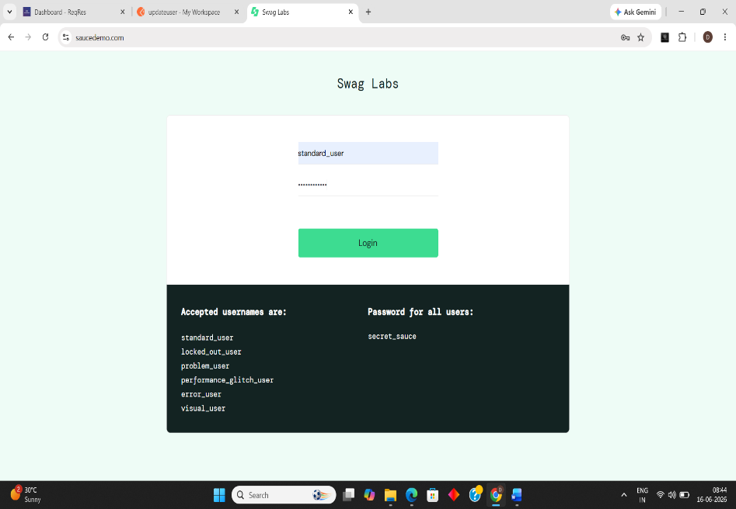

Field | Details
Bug ID | BUG-002
Title | No "Forgot Password" link available on Login Page
Module | Login
Severity | Low
Priority | Low
Steps to Reproduce | 1. Open SauceDemo login page.  2. Observe available login options.
Expected Result | A Forgot Password link should be available for password recovery.
Actual Result | No Forgot Password functionality is provided.
Impact | Users who forget credentials cannot recover their account.
Screenshot | 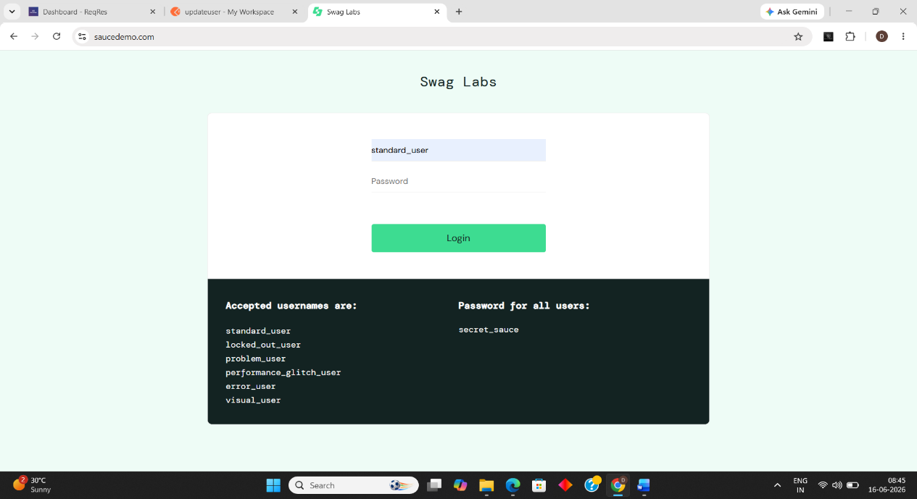

Field | Details
Bug ID | BUG-003
Title | Product sorting option is not highlighted after selection
Module | Product Listing
Severity | Low
Priority | Low
Steps to Reproduce | 1. Login with valid credentials.2. Select any sorting option from dropdown.
Expected Result | Selected sorting option should be visually highlighted for better visibility.
Actual Result | Selection visibility can be improved for better user experience.
Impact | Users may not easily identify the currently applied sorting option.
Screenshot | 