Task 4: Automation Testing
Tools: Selenium
Requirement
Automate the Login functionality of: https://www.saucedemo.com
Test Cases
- Valid Login
- Invalid Login
- Empty Username
- Empty Password
Deliverables
- Source Code
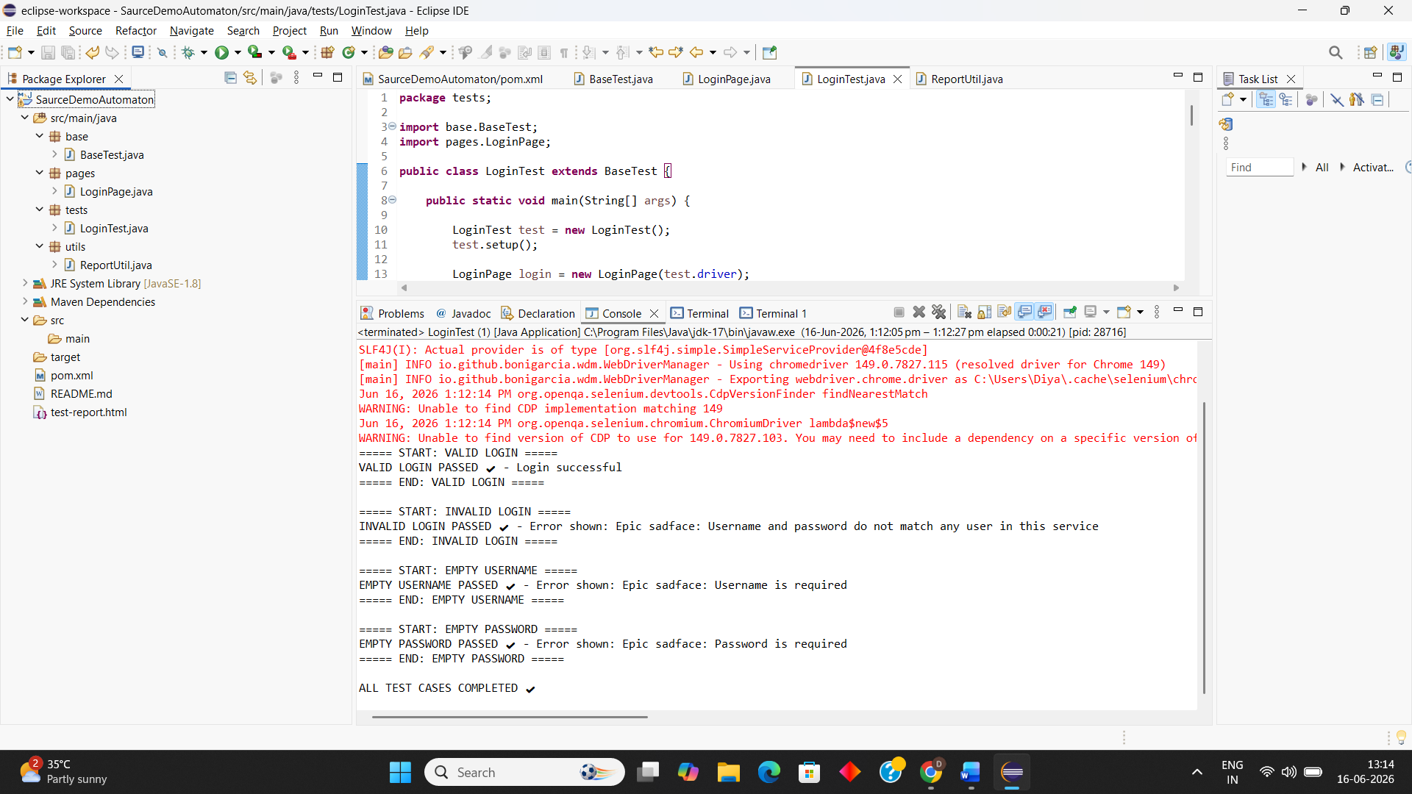
- Execution Screenshot

- README with setup steps

Bonus:
- Use Page Object Model (POM)
- Generate HTML Report

