Student Name: Diya Renny
Student Number: C17463706



BUSINESS COMPUTING
DT354/2

Module Name: Advanced Databases
Project Title: Hospital Management System

- Project Description

The Medmark Hospital is a small, community hospital recently found by two young Irish men, John and Luke in North Dublin. A new hospital administrator has recently been hired by the Board of Directors, and directed to right-size patient care and pharmacy services and improve profitability. The hospital also offers selected in-home care services. Many of the patients are repeat or regular patients who receive regular treatment for various conditions, and many utilize the hospital’s pharmacy services for prescription medications.
A doctor can order about 300 different medicines of various kinds. In order complete the order the doctor must go to the hospital’s website and enter the following details: doctor’s id, name, specialty and phone, as well as order time the estimated length of the purchase. The stock level for the medicines are also monitored by this way by the hospital’s monitoring system, when each purchase has been completed the system is able to track which doctor have made each purchase using doctor’s unique ID.
When each prescription has been issued at the pharmacy, each staff will be asked to enter the item’s (medicine’s) name, item number, quantity, colour and date of purchase. The new administrator wants to know which drugs are most prescribed, and also which are the most profitable.
The hospital has about 10 different types of rooms for the patients, the rooms are given according to the length of time for which they will be hospitalized. The booking can also be done online by visiting the hospital’s website www.medmark123.com. When a room is being booked by a patient, the patient’s personal details are asked such as name, id, age, sex and blood group.
The following is some general information about the organization and its current processes.
- The hospital operates three clinical facilities.
- The first name, last name, DOB, and Employee number is recorded for every employee.
- All employees have separate billing rate, which is determined by their job description. A form is given to fill out which determines the billing rate, details such as employee number, first name, last name, date of birth and home address are asked.
- Each medication dispensed by prescription is linked to both the item number and the item name, recording the quantity dispensed.
As a convenient and affordable means of providing hospice care, palliative care, and convalescent care to patients that need occasional/intermittent skilled nursing, but do not require hospitalization, the hospital offers limited in-home care. There is concern at this point that the cost of providing limited home healthcare is not providing adequate return on investment.
The project’s aim is to develop a software application to manage the activities of Medmark hospital.

- Entity Relationship Diagram

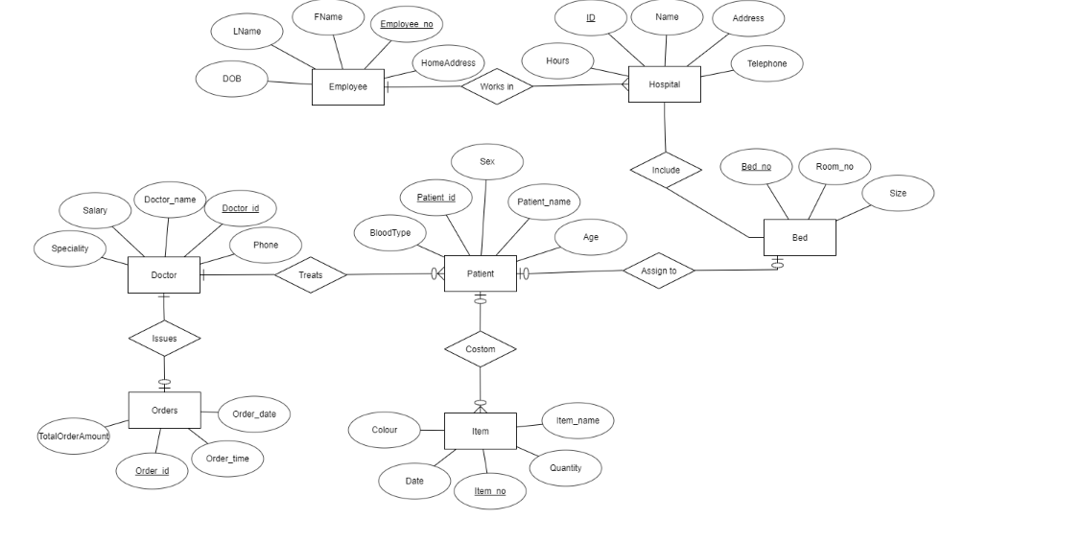

- Relational Model

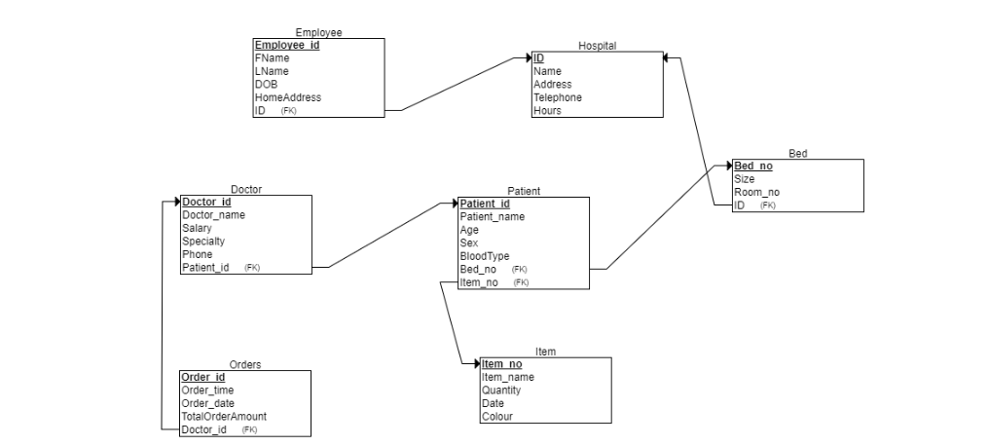

List of Constraints:

- Each entity has a unique number (PK constraint).
- Null value constraints on all columns.
- Blood Type must be either O-, O+, A-, A+, B-, B+, AB-, AB+.
- Patient’s sex must be female or male.
- The total order amount must be a positive number (constraints on domain of attribute).
- Bed size must be small, medium or large.

- SQL Scripts

- CREATE TABLE Employee(Employee_id Integer Primary Key, FName Text(50), LName Text(50), DOB DateTime, HomeAddress Text(100))

- CREATE TABLE Hospital(ID Integer Primary Key, Name Text(40), Address Text(60), Hours Number, Telephone Number))

- CREATE TABLE Bed(Bed_no Integer Primary Key, Size Text(10), Room_no Number))

- CREATE TABLE Patient(Patient_id Integer Primary Key, Patient_name Text(40), Age Number, Sex Text(10), BloodType Text(20))

- CREATE TABLE Item(Item_id Integer Primary Key, Item_name Text(40), Quantity Number, Colour Text(30), Date DateTime))

- CREATE TABLE Doctor(Doctor_id Integer Primary Key, Doctor_name Text(40), Salary Number, Specialty Text(30), Phone Number))

- CREATE TABLE Orders(Order_id Integer Primary Key, Order_time DateTime, Order_date DateTime, TotalOrderAmount Double))

