剑桥

<https://www.graduate.study.cam.ac.uk/courses>

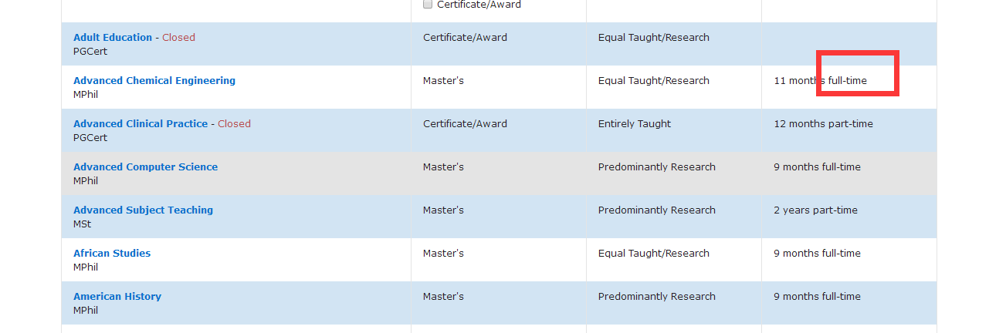只需要full time的专业名与对应的链接，part time的不需要

牛津

<https://www.ox.ac.uk/admissions/graduate/courses/courses-a-z-listing?wssl=1>

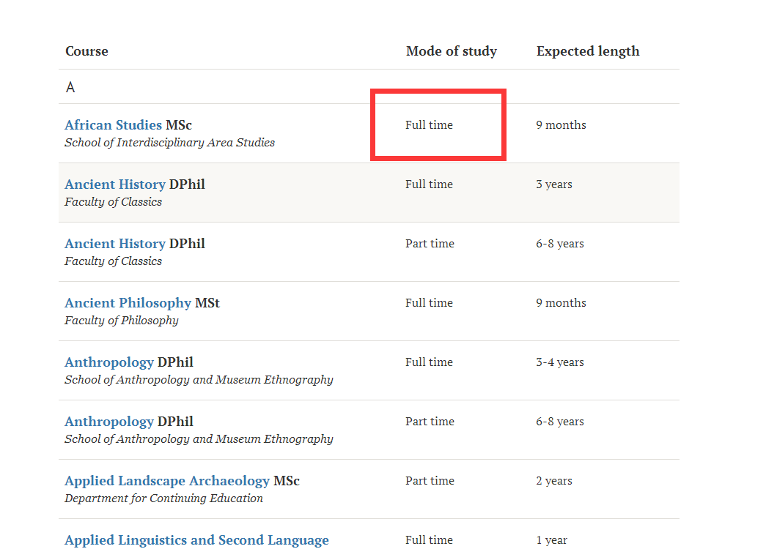

只需要full time的专业名与对应的链接，part time的不需要

帝国理工

http://www.imperial.ac.uk/study/pg/courses/

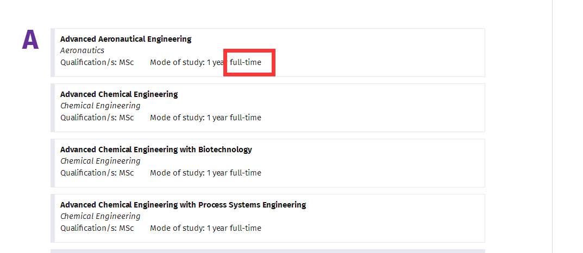

LSE

http://www.lse.ac.uk/study-at-lse/Graduate/Available-programmes

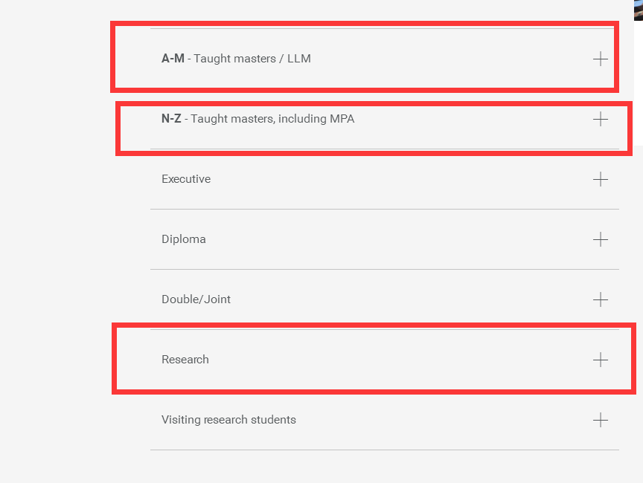

需要打开这三个，然后提取里面的专业和链接

UCL

<http://www.ucl.ac.uk/prospective-students/graduate/taught/degrees>

<http://www.ucl.ac.uk/prospective-students/graduate/research/degrees>

以上链接里的全部专业与链接

Edinburgh

<https://www.ed.ac.uk/studying/postgraduate/degrees/index.php?r=site%2Fsearch&pgSearch=&yt0=&moa=a>

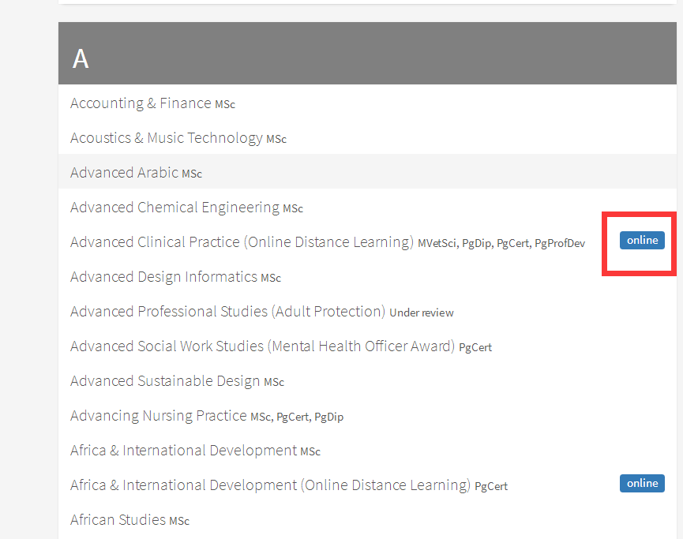有这个标志的专业不要，其它都要

KCL

<https://www.kcl.ac.uk/search/search.aspx#/courses?level=5089%2C5088&delivery=5084&studyMode=5078>

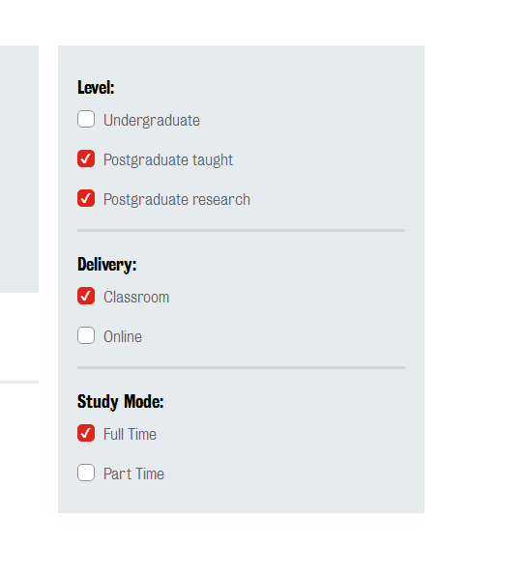这四个地方打钩

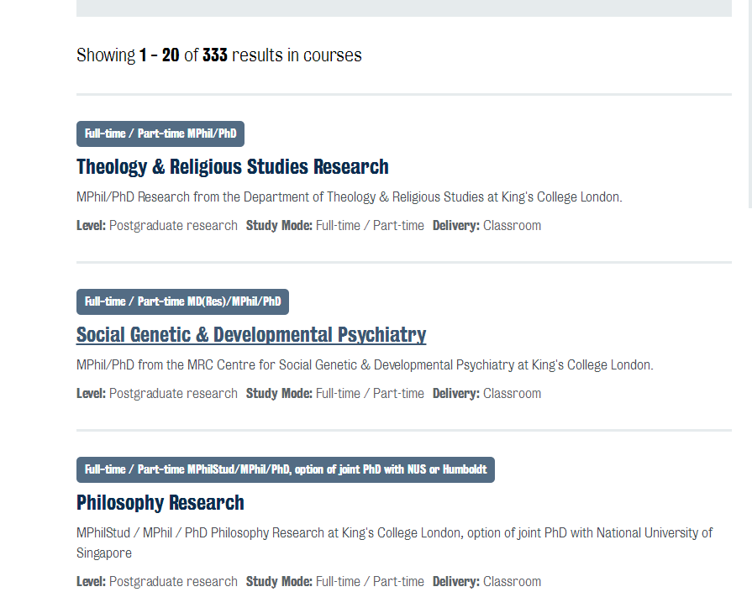需要所有333个专业和链接

Manchester

<http://www.manchester.ac.uk/study/masters/courses/list/>

<http://www.manchester.ac.uk/study/postgraduate-research/programmes/list/>

这两个链接的所有专业和链接

Bristol

<http://www.bris.ac.uk/study/postgraduate/search/>

链接里的所有专业和链接

Glasgow

<https://www.gla.ac.uk/postgraduate/taught/>

<https://www.gla.ac.uk/research/opportunities/>

这两个链接的所有专业和链接

Warwick

<https://warwick.ac.uk/study/postgraduate/courses-2018/>

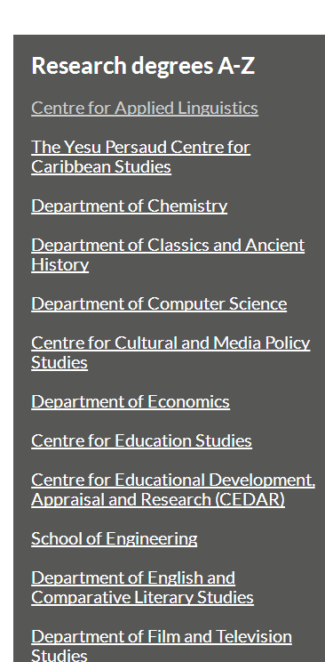这一部分的内容也要

链接里的所有专业和链接

Durham

<https://www.dur.ac.uk/courses/all/#indexA>

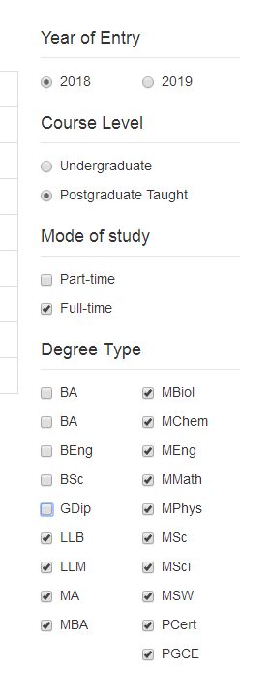选择这些选项

A-V所有专业与链接

<https://www.dur.ac.uk/study/pg/studyoptions/research/>

上面所有专业与链接

Sheffield

<https://www.sheffield.ac.uk/postgraduate/taught/courses/all>

上面所有专业与链接

<https://www.sheffield.ac.uk/postgraduate/research/areas/index>

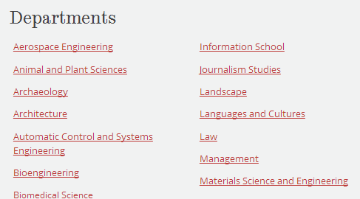

每一个department里面的postgraduate research和PHD专业与链接

Queenmary

http://search.qmul.ac.uk/s/search.html?collection=queenmary-coursefinder-pg&query=&f.Mode%7CM=full+time&sort=title

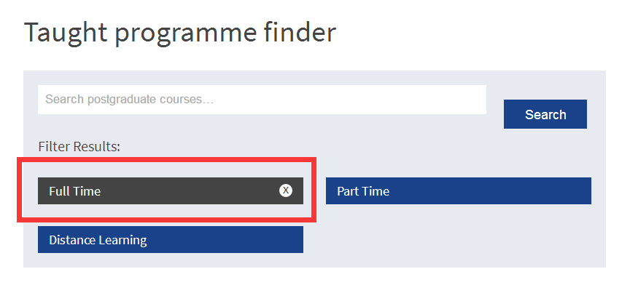

选fulltime后的所有专业和链接

<https://www.qmul.ac.uk/postgraduate/research/>

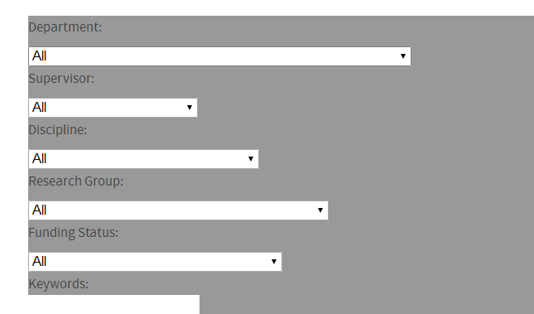

选all之后的所有专业和链接

Exeter

<https://www.exeter.ac.uk/postgraduate/all-courses/>

所有专业和链接

<https://www.exeter.ac.uk/pg-research/degrees/>

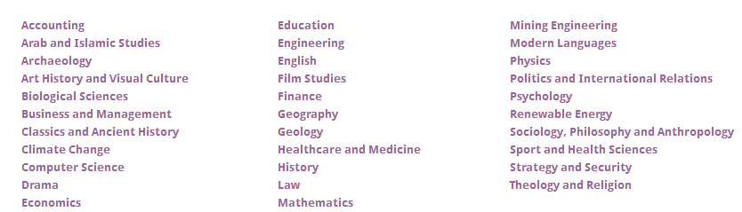

所有专业和链接

Southampton

<https://www.southampton.ac.uk/courses/taught-postgraduate.page>

所有专业和链接

<https://www.southampton.ac.uk/courses/research-postgraduate.page>

所有专业和链接

York

<https://www.york.ac.uk/study/postgraduate/courses/all?mode=taught>

所有专业和链接

<https://www.york.ac.uk/study/postgraduate/courses/all?mode=research>

所有专业和链接

Leeds

<https://courses.leeds.ac.uk/course-search?query=&type=PGT>

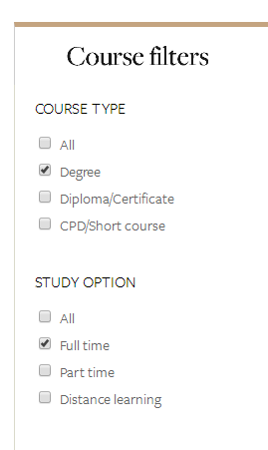选择后所有专业和链接

<https://courses.leeds.ac.uk/course-search?query=&type=PGR&term=201819>



选择后所有专业和链接

Birmingham

<https://www.birmingham.ac.uk/postgraduate/courses/search.aspx#CourseComplete_AtoZTab>

A-Z所有

<https://www.birmingham.ac.uk/postgraduate/courses/research/search.aspx?CurrentTab=AtoZ&CourseComplete_AtoZ_AtoZLetter=A>

A-Z所有

St Andrews

<https://www.st-andrews.ac.uk/subjects/>

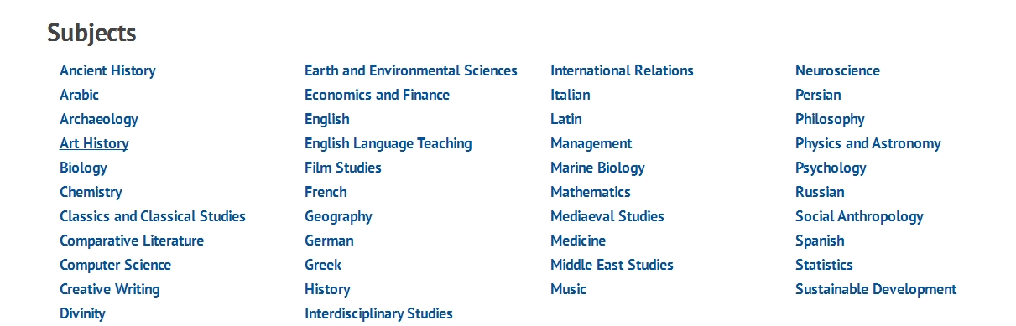

每一个subject摁进去

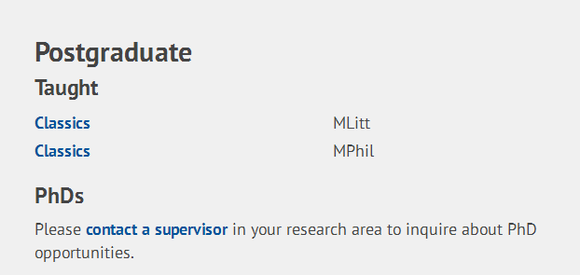

然后需要postgraduate的部分