ZRP (Zone Routing Protocol) [Hybrid]
- A hybrid routing protocol which effectively combines the best features of both proactive and reactive routing protocols.
- The key concept employed in ZRP is to use a proactive routing scheme within a limited zone in the γ-hop neighborhood of every node, and use a reactive routing scheme for nodes beyond this zone.
- Each node, individually creates its own neighborhood which it calls a routing zone.
- The zone is defined as a collection of nodes whose minimum distance (in hops) from the node in question is no greater than a value that is called the “zone radius” (denoted as ρ).
- Peripheral nodes are nodes whose minimum distance to the central node is exactly equal to the zone radius ρ. The nodes whose minimum distance is less than ρ are interior nodes.
- The routing in ZRP is divided into 2 parts:
  - Intrazone routing: First, the packet is sent within the routing zone of the source node to reach the peripheral nodes.
  - Interzone routing: Then the packet is sent from the peripheral nodes towards the destination node.
- ZRP refers to the locally proactive routing component as the IntrA-zone Routing Protocol (IARP) and to the globally reactive routing component as named IntEr-zone Routing Protocol (IERP).
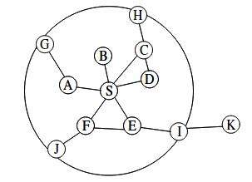

In the above figure, the routing zone of S includes the nodes A–I, but not K. The radius is marked as a circle around the node in question. It should however be noted that the zone is defined in hops, not as a physical distance. The nodes A–F are interior nodes, the nodes G–J are peripheral nodes and the node K is outside the routing zone.
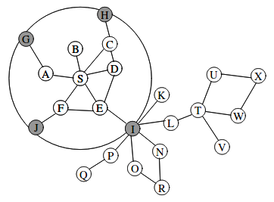

Figure 1: The routing zone of node S
- Consider the network in figure 1 . The node S has a packet to send to node X. The zone radius is ρ=2. The node uses the routing table provided by IARP to check whether the destination is within its zone. Since it is not found, a route request is issued using IERP. The request is bordercast to the peripheral nodes (gray in the picture). Each of these searches their routing table for the destination.
- Node I does not find the destination in its routing table. Consequently, it broadcasts the request to its peripheral nodes, shown in gray in Figure 2. Due to query control mechanisms, the request is not passed back to nodes D, F and S.
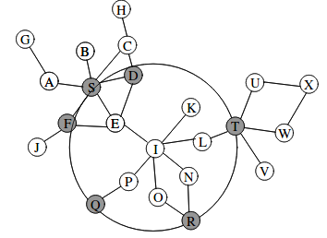

Figure 2: The routing zone of node I
- Finally, the route request is received by node T, which can find the destination in its routing zone, shown in Figure 3. Node T appends the path from itself to node X to the path in the route request. A route reply, containing the reversed path is generated and sent back to the source node. If multiple paths to the destination were available, the source would receive several replies.
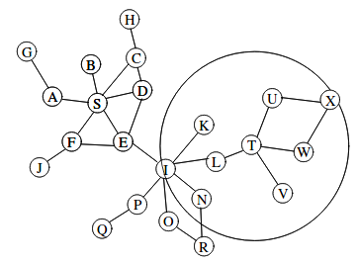

Figure 3: The routing zone of node T

OLSR (Optimized Link State Routing) Protocol [Table-Driven & Proactive]
The Optimized Link State Routing Protocol (OLSR)[1] is an IP routing protocol optimized for mobile ad hoc networks, which can also be used on other wireless ad hoc networks. OLSR is a proactive link-state routing protocol, which uses hello and topology control (TC) messages to discover and then disseminate link state information throughout the mobile ad hoc network.

N : number of nodes in the network
ni : set of 1-hop neighbors of node i
n2i : set of 2-hop neighbors of node i
mi : set of MPR(Multi-Point Relays) nodes chosen by node i

Example:
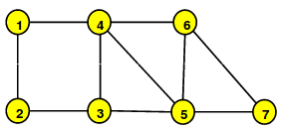
Consider the following network:

- Here is one possible MPR selection (there are many more)
  - In this selection each node tries to minimize the size of its MPR set:
  - MPR(1)={4}, MPR(2)={3}, MPR(3)={4,5}, MPR(4)={3,5}, MPR(5)={3,4}, MPR(6)={4}, MPR(7)={5}
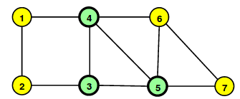

- Node 3 generates a TC message advertising nodes in MS(3) = {2, 4, 5}
- It sends it to the nodes in MS(3) and to its MPR (namely, node 4).
- Node 4 forwards Node 3’s TC message to all the nodes in MS(4), (namely, 1, 3 and 6) as well as to its MPR (3 and 5)
- Node 5 receives the first copy either from 3 (in which case it forwards to 4 and 7) or from 4 (in which case it forwards only to 7)
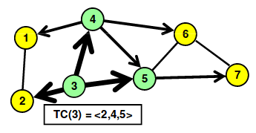

- Node 4 generates a TC message advertising nodes in MS(4) = {1, 3, 6}
- It sends it to 1, 3, 6 and 5
- Node 3 forwards to 2and 5
- Node 5 forwards to 7
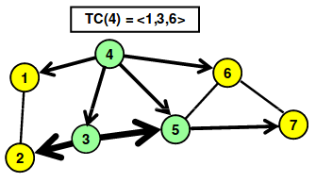

- Node 5 generates a TC message advertising nodes in MS(5) = {3,4,7}
- It sends it to 3, 4 and 7
- Node 4 sends it to 1, 6 and 3
- And node 3 to 2
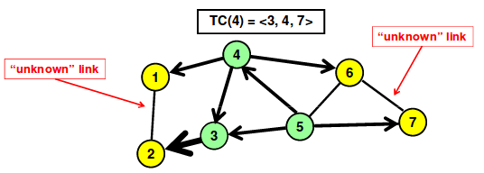
Note: the link 1 – 2 is known only to nodes 1 and 2. Similarly, the link 5 – 7 is known only to nodes 5 and 7.

TORA (Temporally Ordered Routing Algorithm) [On-Demand Driven & Reactive]
- The Temporally Ordered Routing Algorithm (TORA) is an algorithm for routing data across Wireless Mesh Networks or Mobile ad hoc networks.
- The main objective of TORA is to limit control message propagation in the highly dynamic mobile computing environment.
- Each node has to explicitly initiate a query when it needs to send data to a particular destination.
- TORA essentially performs three tasks:
  - Creation of a route from a source to a destination.
  - Maintenance of the route.
  - Erasure of the route when the route is no longer valid.
- TORA attempts to build what is known as a directed acyclic graph (DAG) which is rooted at the destination.
- TORA uses three kinds of messages:
  - The QRY message for creating a route.
  - The UPD message for both creating and maintaining routes.
  - The CLR message for erasing a route.
- TORA belongs to a class of algorithms called the link reversal algorithms

