Classifying and Comparing Free Trade Agreement Provisions at Scale
A Policy-Facing NLP and LLM Workflow for Regional Trade Analysis

Course: Machine Learning Foundation with Python
Institution: Carnegie Mellon University, Heinz College
Term: Spring 2026
Author: Diyouva Christa Novith
Project format: 5–10 page final report deliverable

Executive framing: this project tests whether low-cost LLM workflows can reduce the time needed for policy analysts to compare complex free trade agreements, while remaining honest about where the workflow is useful, where it fails, and what still requires human legal review.

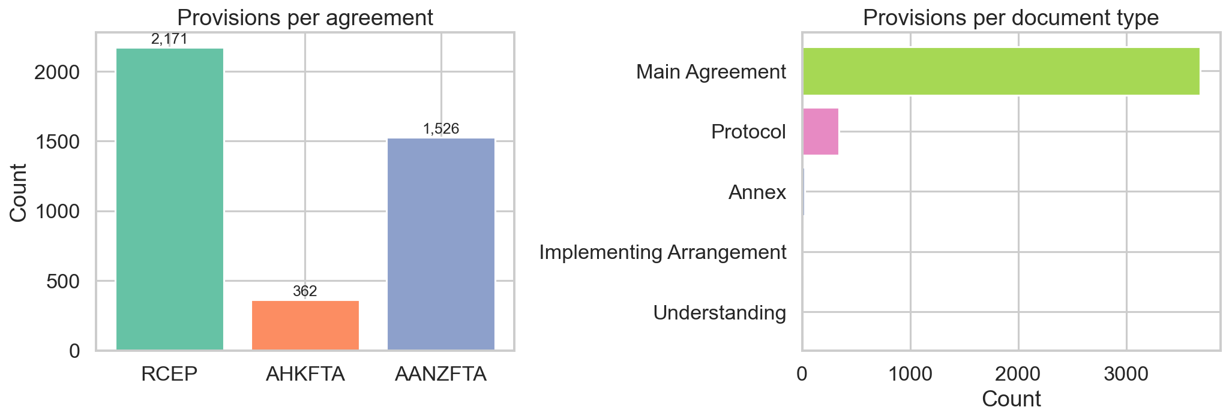
Figure 1. Corpus overview across the three Asia-Pacific FTAs.

1. Policy Problem and Decision Use Case
The policy problem behind this project is practical rather than academic: trade analysts, customs officials, and negotiators often need to answer cross-agreement questions quickly, but the source documents are sprawling, heterogeneous, and manually exhausting to compare. A single question such as "How does AHKFTA's rules-of-origin design differ from RCEP's, and what does that mean for exporters?" can require several days of article-by-article review across main chapters and annexes.
That workflow does not scale well in a region defined by overlapping agreements. The Asia-Pacific treaty landscape is a classic "spaghetti bowl": multiple FTAs cover related policy areas, but use different architectures, chapter structures, and legal drafting conventions. The core decision question for this project was whether a low-cost machine learning and LLM pipeline could reduce this search and comparison burden enough to be useful to a real policy audience.
- Primary stakeholder: trade policy analysts who need faster first-pass comparison across agreements.
- Secondary stakeholders: customs compliance teams and negotiators preparing briefings.
- Decision value: faster triage, faster retrieval of comparable provisions, and clearer visibility into where agreements converge or diverge.

2. Questions, Data, and Unit of Analysis
The project addressed three questions: whether LLMs can classify FTA provisions into a usable policy taxonomy, how the three agreements differ in issue emphasis and legal design, and whether some issue areas show regional convergence while others remain fragmented. The three agreements were RCEP, AHKFTA, and AANZFTA, chosen because together they span the main contemporary Asia-Pacific trade architecture.
Agreement | Rows / provisions | Share | Notes
RCEP | 2,171 | 53.5% | Main agreement dominates corpus size
AANZFTA | 1,526 | 37.6% | Includes protocol and implementing texts
AHKFTA | 362 | 8.9% | Goods-focused agreement; annex-heavy and partially scanned
Total | 4,059 | 100% | Final extracted provision corpus

The unit of analysis was the smallest meaningful legal provision that could be extracted cleanly from PDF source documents: article text, paragraph text, or a structured annex fragment. Each row stores an ID, agreement, document type, chapter, article, paragraph index, provision text, and character count. That level of granularity made it possible to classify, retrieve, and compare provisions without reducing the problem to whole-document summaries.

3. Planned Approach and Why It Changed
The pipeline combined several course-relevant techniques: NLP-style text extraction and segmentation, sentence embeddings for retrieval, large language models for classification and comparison, and hybrid structured extraction for numeric trade-rule features. The original second model was Gemini, but that plan broke under free-tier quota limits after roughly 200 calls. That forced a pivot to Qwen 3 32B, which preserved the educational goal of comparing distinct model families while remaining feasible on the available infrastructure.
- Extraction: pdfplumber, PyMuPDF, then Tesseract OCR fallback for scanned content.
- Retrieval: all-MiniLM-L6-v2 embeddings stored in ChromaDB for semantic similarity search.
- Classification: two models (LLaMA 3.3 70B and Qwen 3 32B) under zero-shot, few-shot, and CoT prompts.
- Attribute extraction: regex for deterministic numeric fields, LLM prompts for categorical trade-rule features.
This iterative shift matters because the assignment explicitly asked for more than a first-draft model choice. The project became stronger once it embraced this constraint instead of hiding it: quota limits, prompt failures, and misaligned validation cohorts all became part of the learning process.

4. Process: What We Tried, What Broke, and What We Fixed
The most important process lesson is that methodological plumbing changed the substantive story. Early versions of the pipeline used head-of-file sampling, comparison retrieval that was not filtered by classified category, and validation logic that could accidentally score non-matching cohorts. Those choices made some earlier results look stronger and more stable than they deserved to look.
- Sampling was repaired so main benchmark runs use reproducible random cohorts instead of the first N rows.
- A separate 300-row stratified cohort (100 per agreement) was created for fairer cross-agreement comparison.
- Validation now requires exact cohort matching and reads the checked Excel workbook when present.
- Classification runs now save incrementally so long API jobs can be resumed safely after interruption.
This was not cosmetic maintenance. It changed the interpretation of the project. Once the pipeline was repaired and rerun, the stronger claims in earlier drafts no longer held. That is a useful policy lesson by itself: in applied ML work, process errors can masquerade as substantive findings.

5. Model Comparison and Validation Findings
The project compared six model-strategy combinations on a shared 50-row hand-labelled gold set. This is exactly the kind of iterative model-selection evidence the assignment asked for. The headline result is not that one model "won" decisively, but that each strategy trades off overall hit rate and category balance differently.
Run | n | Accuracy | Macro-F1
LLaMA zero-shot | 50 | 0.480 | 0.431
Qwen CoT | 50 | 0.460 | 0.442
Qwen zero-shot | 50 | 0.380 | 0.424
Qwen few-shot | 50 | 0.380 | 0.373
LLaMA few-shot | 50 | 0.340 | 0.336
LLaMA CoT | 50 | 0.320 | 0.327

Two observations stand out. First, no configuration crossed 50% accuracy, which makes this a triage tool rather than a fully trusted classifier. Second, the most accurate run and the best macro-F1 run are not the same. LLaMA zero-shot gets the most labels correct overall, but Qwen CoT distributes performance more evenly across categories. That is a genuine trade-off a policy user would need to understand.
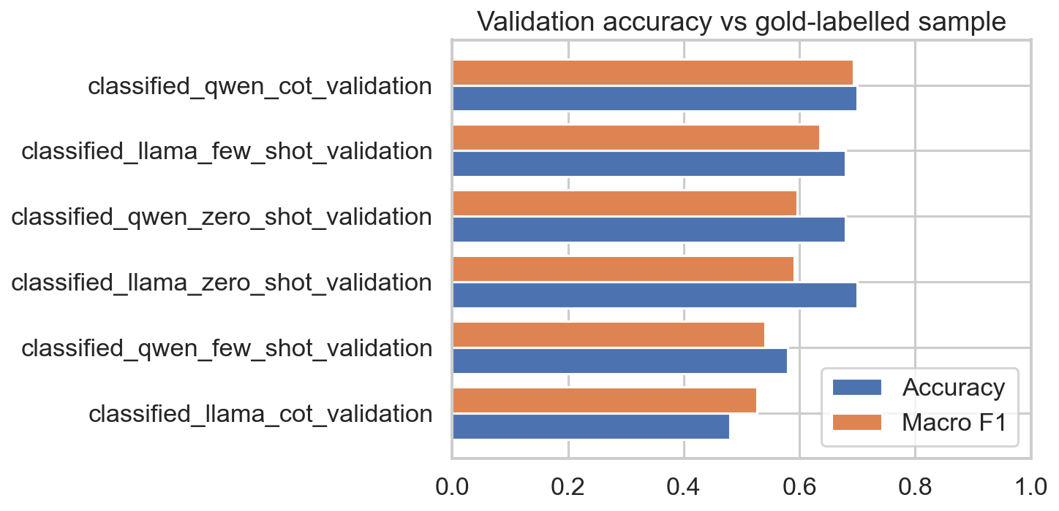
Figure 2. Validation performance across all six model-strategy combinations.
The repaired pairwise agreement analysis also matters. Once runs were compared only on exactly aligned cohorts, agreement became moderate to substantial rather than near-random. That means earlier instability claims were partly an evaluation-design problem. The current bottleneck is not chaos between models; it is low absolute validation quality against human labels.

6. Substantive Findings for a Policy Audience
Despite modest validation quality, the project still produced useful policy-facing findings at the aggregate level. That distinction matters: the system is more credible for pattern discovery across many provisions than for any single provision label.
- AHKFTA is visibly goods-focused, with zero sampled provisions in services, dispute settlement, or IP in the stratified cohort.
- AHKFTA devotes much more text to Rules of Origin than RCEP, indicating a more rule-intensive origin regime.
- RCEP and AHKFTA both use a 40% regional value content threshold, but differ in transformation strictness: RCEP uses CTH while AHKFTA uses CC.
- General Provisions and Dispute Settlement look more convergent across agreements than Tariff Commitments and Rules of Origin.
The most policy-actionable result is the CC-versus-CTH difference. Two agreements can appear similar at a headline level because both require 40% regional value content, but still impose meaningfully different compliance burdens through the structure of their tariff-classification tests. That is exactly the kind of subtle but consequential distinction that analysts often need surfaced quickly.
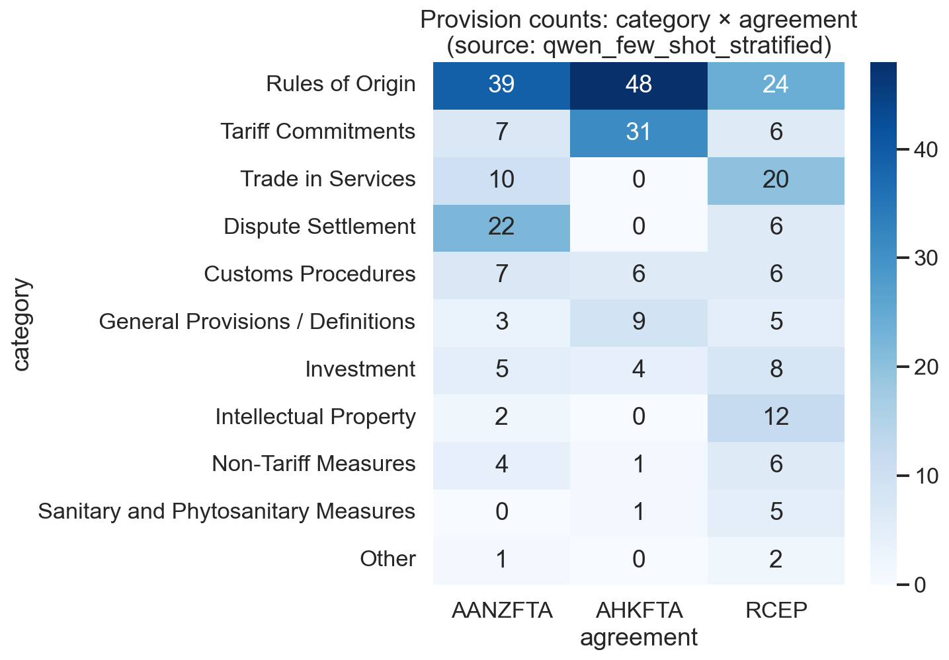
Figure 3. Category distribution by agreement on the 100-per-agreement stratified cohort.

7. Constraints, Risks, and Ethical Use
This project has several constraints that matter for responsible deployment. The gold set is only 50 rows and was labelled by a single annotator. Annex and schedule content is still harder to structure than main agreement prose. Free-tier API quotas limited the number of provisions that could be processed under longer prompts. These are not side notes: they bound what claims the report can honestly make.
- Do not use the classifier as a legal decision-maker or compliance oracle.
- Use provision labels as triage hints and use comparative outputs as briefing support, not final authority.
- Retain human review wherever policy or trade consequences are non-trivial.
- Future expansion should improve the taxonomy and enlarge the gold set before scaling to more agreements.
The ethical risk here is not personal-data harm but overconfidence. A polished LLM report can create a false sense of precision, especially in legal and quasi-legal settings. The correct governance response is not to ban the tool, but to constrain its role: summarisation, retrieval, first-pass comparison, and issue flagging are appropriate; final interpretation is still a human task.

8. Recommendations and Conclusion
The project succeeded on the assignment's most important educational goals. It asked a meaningful public policy question, used NLP and LLM methods covered in the second half of the course, tried multiple models and prompts, documented failed paths, and translated the technical work into a practical decision-use case. It also produced a realistic conclusion instead of an inflated one.
- Recommendation for current use: deploy as a policy analyst triage workflow, not as an autonomous legal classifier.
- Recommendation for next iteration: expand the labelled validation set and test a hierarchical taxonomy that separates definitional, procedural, and substantive trade provisions.
- Recommendation for technical refinement: extract annex tables more systematically so tariff schedules and rules-of-origin thresholds are captured more completely.
If I had to summarize the project in one sentence for a Heinz policy audience, it would be this: low-cost LLM workflows can materially speed up first-pass FTA analysis, but their value today lies in narrowing the search space and surfacing comparisons, not in replacing expert legal judgement.

9. What a Real Analyst Workflow Would Look Like
To make the project concrete, imagine a trade-policy desk preparing a briefing before bilateral talks. The analyst does not need a perfect classifier; the analyst needs a system that narrows a 4,000-row corpus into the handful of provisions most likely to matter. In that setting, the workflow demonstrated here is plausible even with modest validation scores.
- Step 1: ingest a new agreement PDF and extract provision-level rows in one reproducible pass.
- Step 2: classify provisions to get a rough issue map of the agreement.
- Step 3: retrieve comparable provisions from other FTAs in the same category.
- Step 4: generate a narrative contrast that highlights where obligations are stricter, narrower, or more flexible.
- Step 5: send only the shortlisted provisions to a human expert for legal verification.
The time savings are concentrated at the front end. Instead of reading everything linearly, the analyst reads a curated subset. That is why this should be understood as an augmentation pipeline rather than a replacement pipeline. The human analyst remains responsible for the final answer, but no longer has to search blindly.

10. Why the Project Is Still Compelling Despite Weak Validation
A weak validation result can make a project look disappointing if the only standard is raw accuracy. That would be the wrong reading here. This project remains compelling for three reasons. First, it operationalizes a real policy problem using techniques from the course rather than a toy dataset. Second, it demonstrates a full iteration cycle: model substitution, prompt comparison, cohort repair, and honest re-interpretation of results. Third, it produces substantive policy findings that remain useful even when provision-level labels are imperfect.
- It shows how methodological mistakes can inflate apparent model quality, then corrects them transparently.
- It translates ML outputs into a stakeholder workflow instead of stopping at benchmark metrics.
- It surfaces trade-law differences that matter in practice, especially around rules of origin and agreement scope.
That combination is valuable in a policy classroom. The report is not compelling because it claims an impossibly accurate system. It is compelling because it demonstrates judgement: knowing when the tool is good enough to support a decision process and when it is not.

11. Future Research and Deployment Roadmap
The clearest next step is not simply trying a bigger model. The stronger path is to improve the evaluation design and the structure of the task. Several concrete extensions would materially strengthen the project.
Priority | Improvement | Why it matters
High | Expand gold set beyond 50 rows and add a second human annotator | Separates model weakness from label noise
High | Use a hierarchical taxonomy | Reduces pressure on a flat 11-way classification task
Medium | Extract annex tables structurally | Captures tariff schedules and origin thresholds more fully
Medium | Test additional provider/model combinations | Checks whether current ceiling is prompt-specific or architecture-specific
Medium | Pilot with a real analyst user | Evaluates whether time savings survive real workflow use

A practical deployment roadmap would therefore move in phases: first, improve annotation and taxonomy; second, pilot the workflow with real users; third, only then consider broader automation. That sequencing follows the assignment's emphasis on realism and iterative evidence.

12. Reflection on Course Methods
This project drew most heavily on the NLP and LLM portions of the course, but it also illustrates a broader machine-learning lesson: model quality is only one part of the outcome. Data quality, cohort design, prompt selection, evaluation alignment, and user framing all matter at least as much. In that sense, the project is a better reflection of real applied ML work than a cleaner benchmark would have been.
The report also demonstrates why details and failed paths are educationally useful. The Gemini quota issue, the comparison-stage filtering problem, the validation-source confusion, and the resume-safe saving fix are not distractions from the project; they are the project. They show how applied ML systems evolve under practical constraints and why the final narrative must stay tethered to the actual artefacts.

Appendix: Pipeline Snapshot
Core modules used in the final pipeline: extraction, embeddings, classification, comparison, validation, analysis, and visualisation. Final saved artefacts include the 4,059-row provision corpus, six benchmark classification runs, one stratified comparison run, a 50-row gold set, and figure outputs used in this report.
Component | Purpose | Why it matters
Extraction | Convert PDFs to provision-level rows | Makes treaty text queryable and comparable
Embeddings | Retrieve semantically similar provisions | Enables cross-agreement comparison despite formatting differences
Classification | Assign one of 11 policy categories | Supports category-level distribution analysis
Comparison | Generate structured narrative contrasts | Turns retrieved evidence into analyst-friendly briefings
Validation | Score runs on a shared gold set | Prevents overclaiming model quality

Selected Sources
- RCEP legal text and annex materials used in the extracted corpus.
- ASEAN-Hong Kong, China Free Trade Agreement legal text and annexes.
- ASEAN-Australia-New Zealand FTA main text, protocol, and implementing documents.
- Project artefacts under data/raw, data/results, and the final validation workbook used for exact-cohort scoring.

