For the 1st week:
1.ping another computer
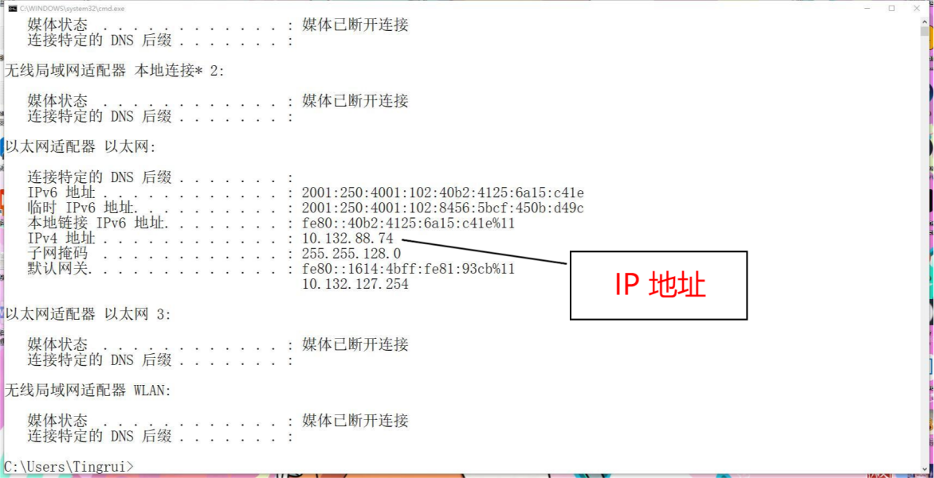
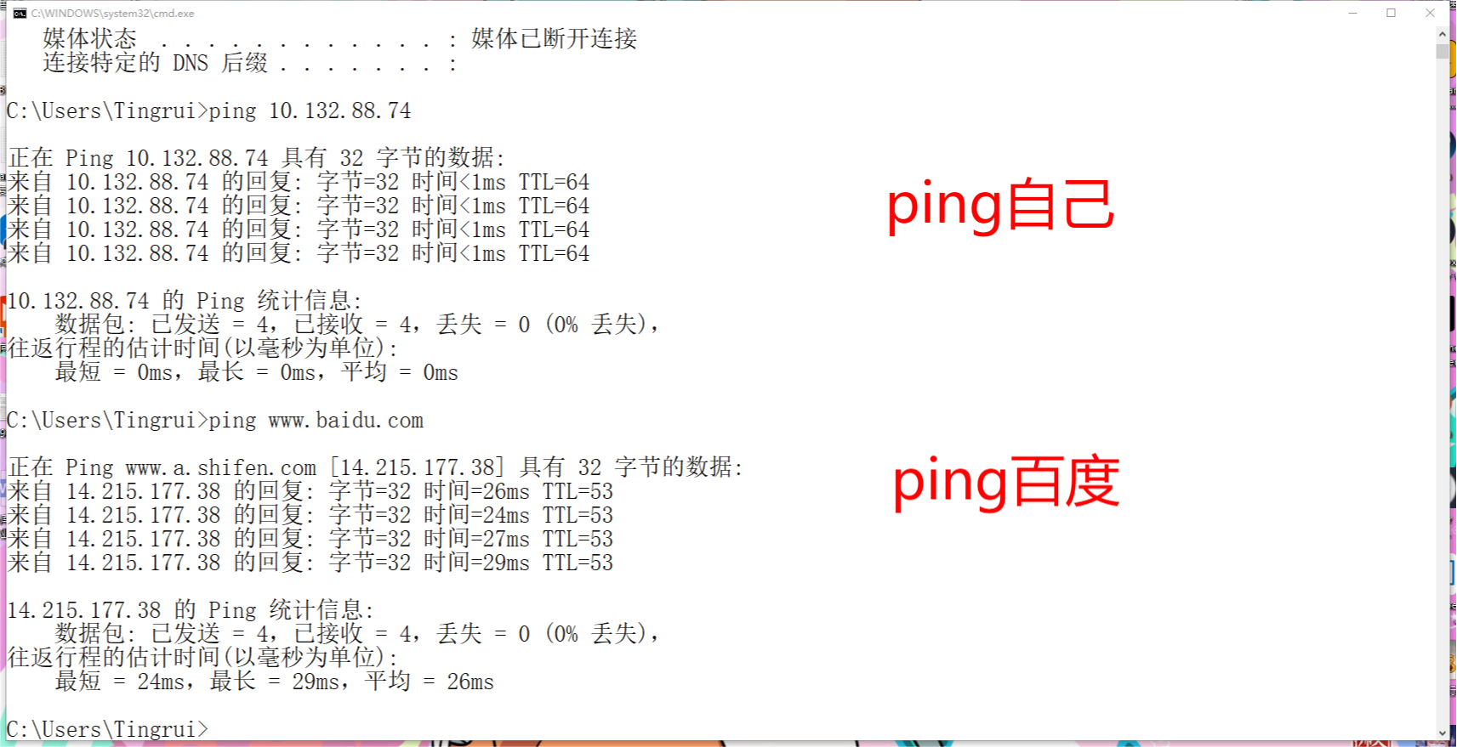
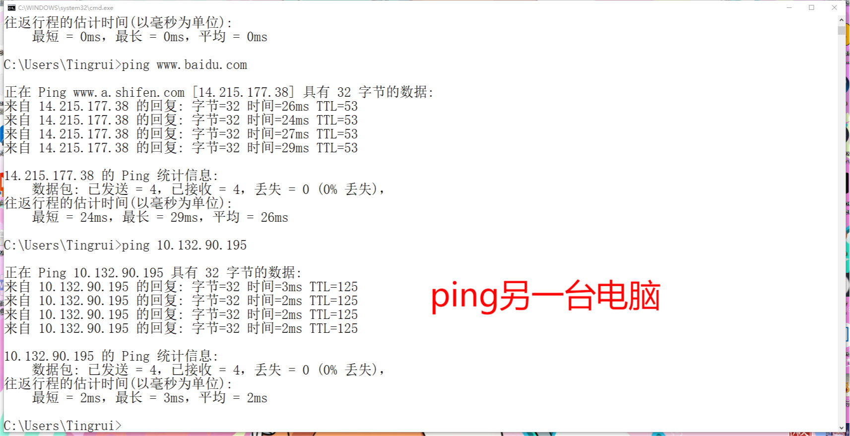
2.Tracert www.baidu.com
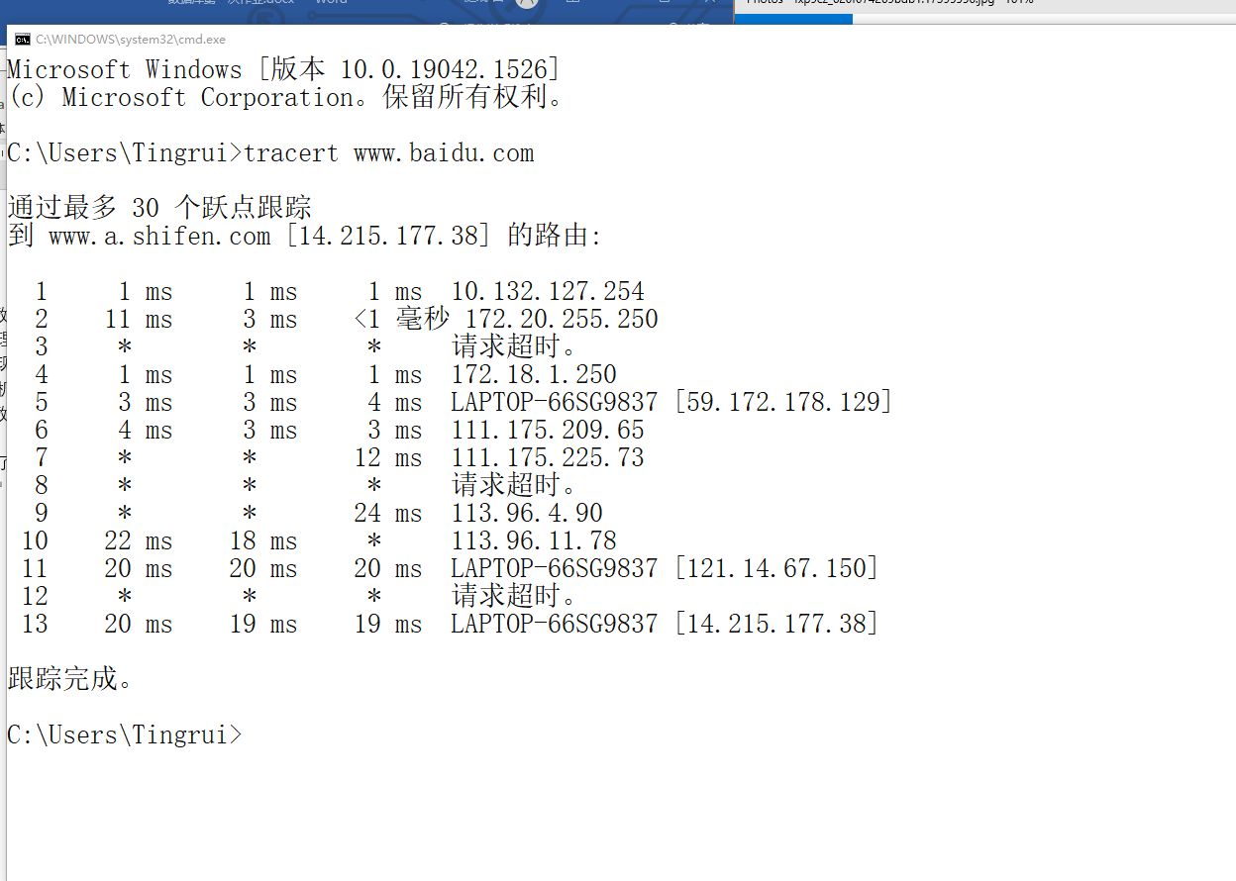
For the 2nd week:
I completed the exercise P6,P7,P12 of the 1st chapter
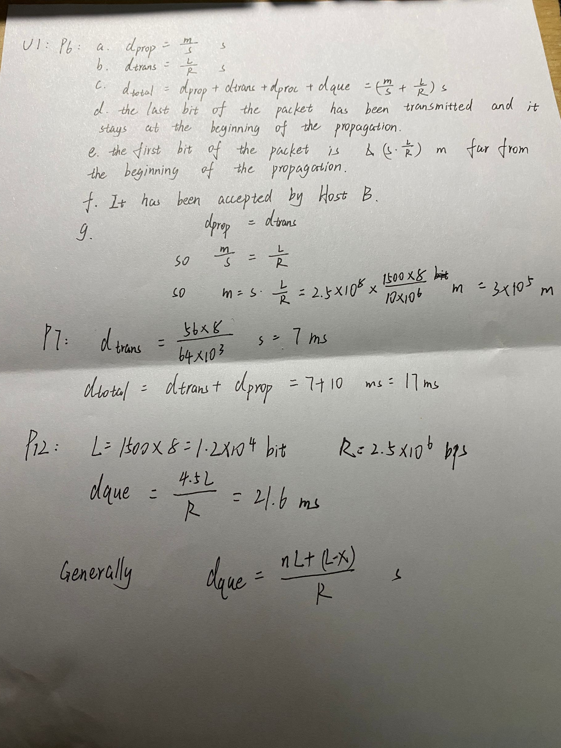
For the 3rd week:
- Telnet
Telnet mail.hust.edu.cn 80
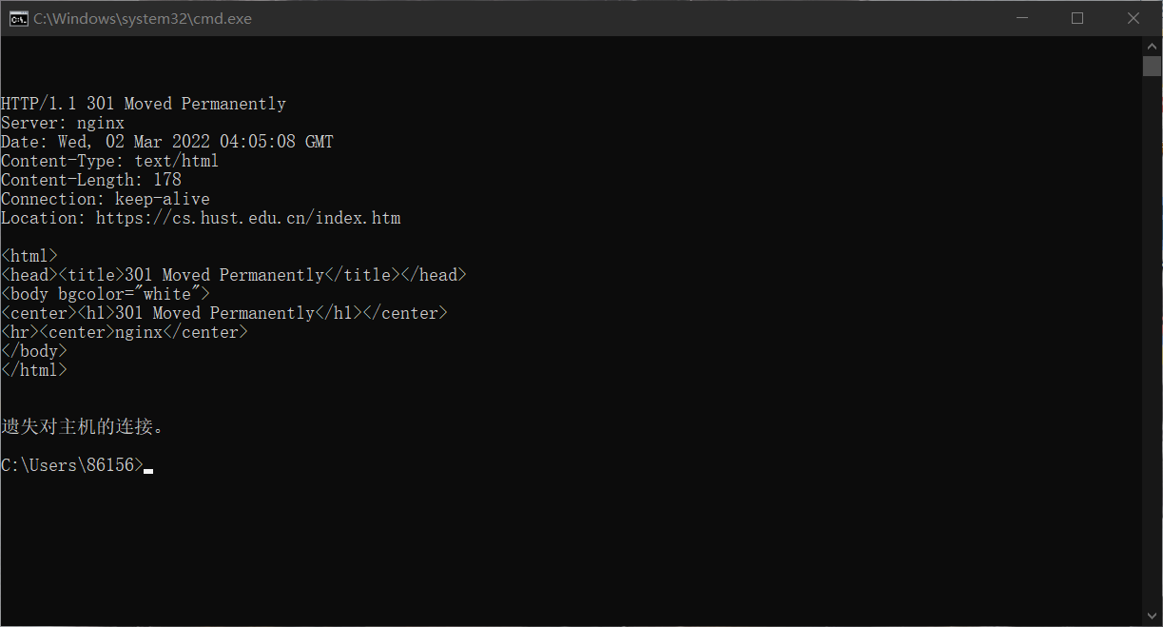
Telnet mail.whu.edu.cn 80
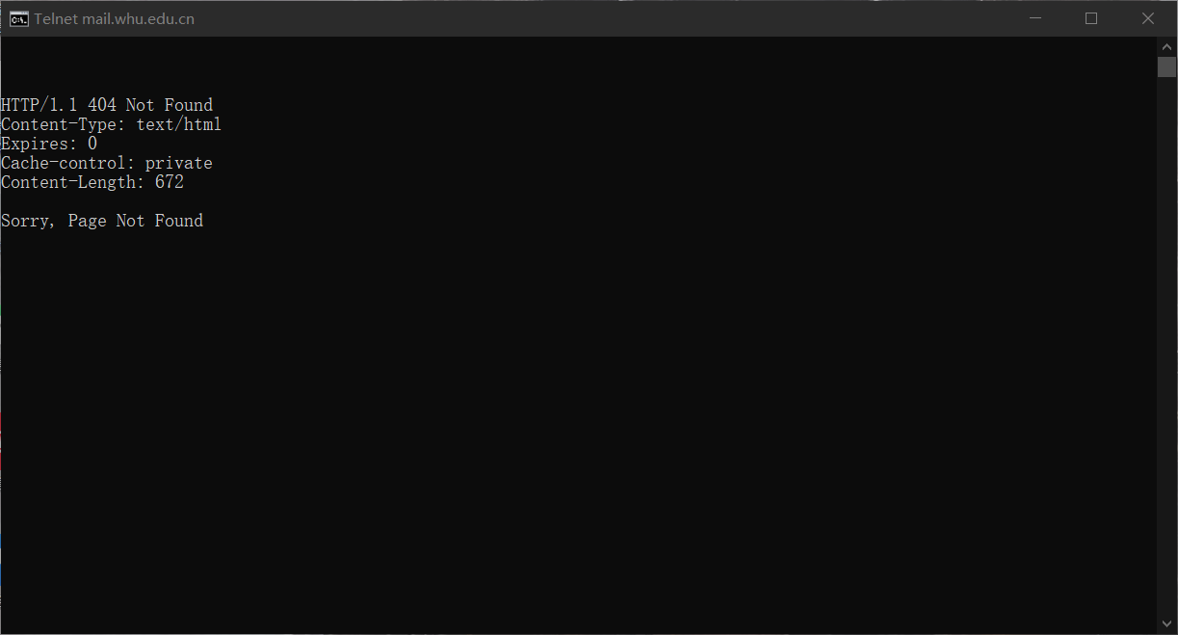
Telnet cs.whu.edu.cn 80
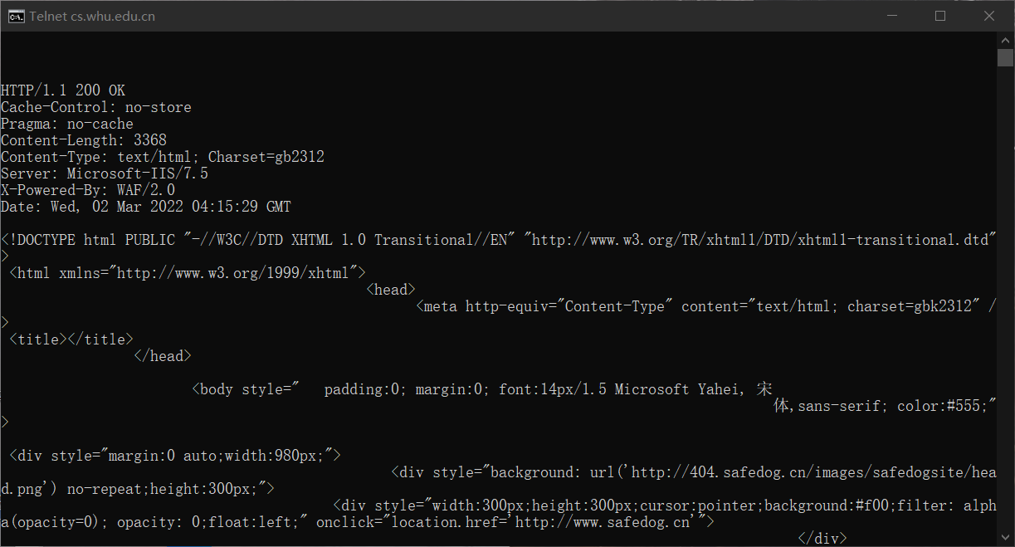
2.
I completed exercise P6,P12 of the 2nd chapter
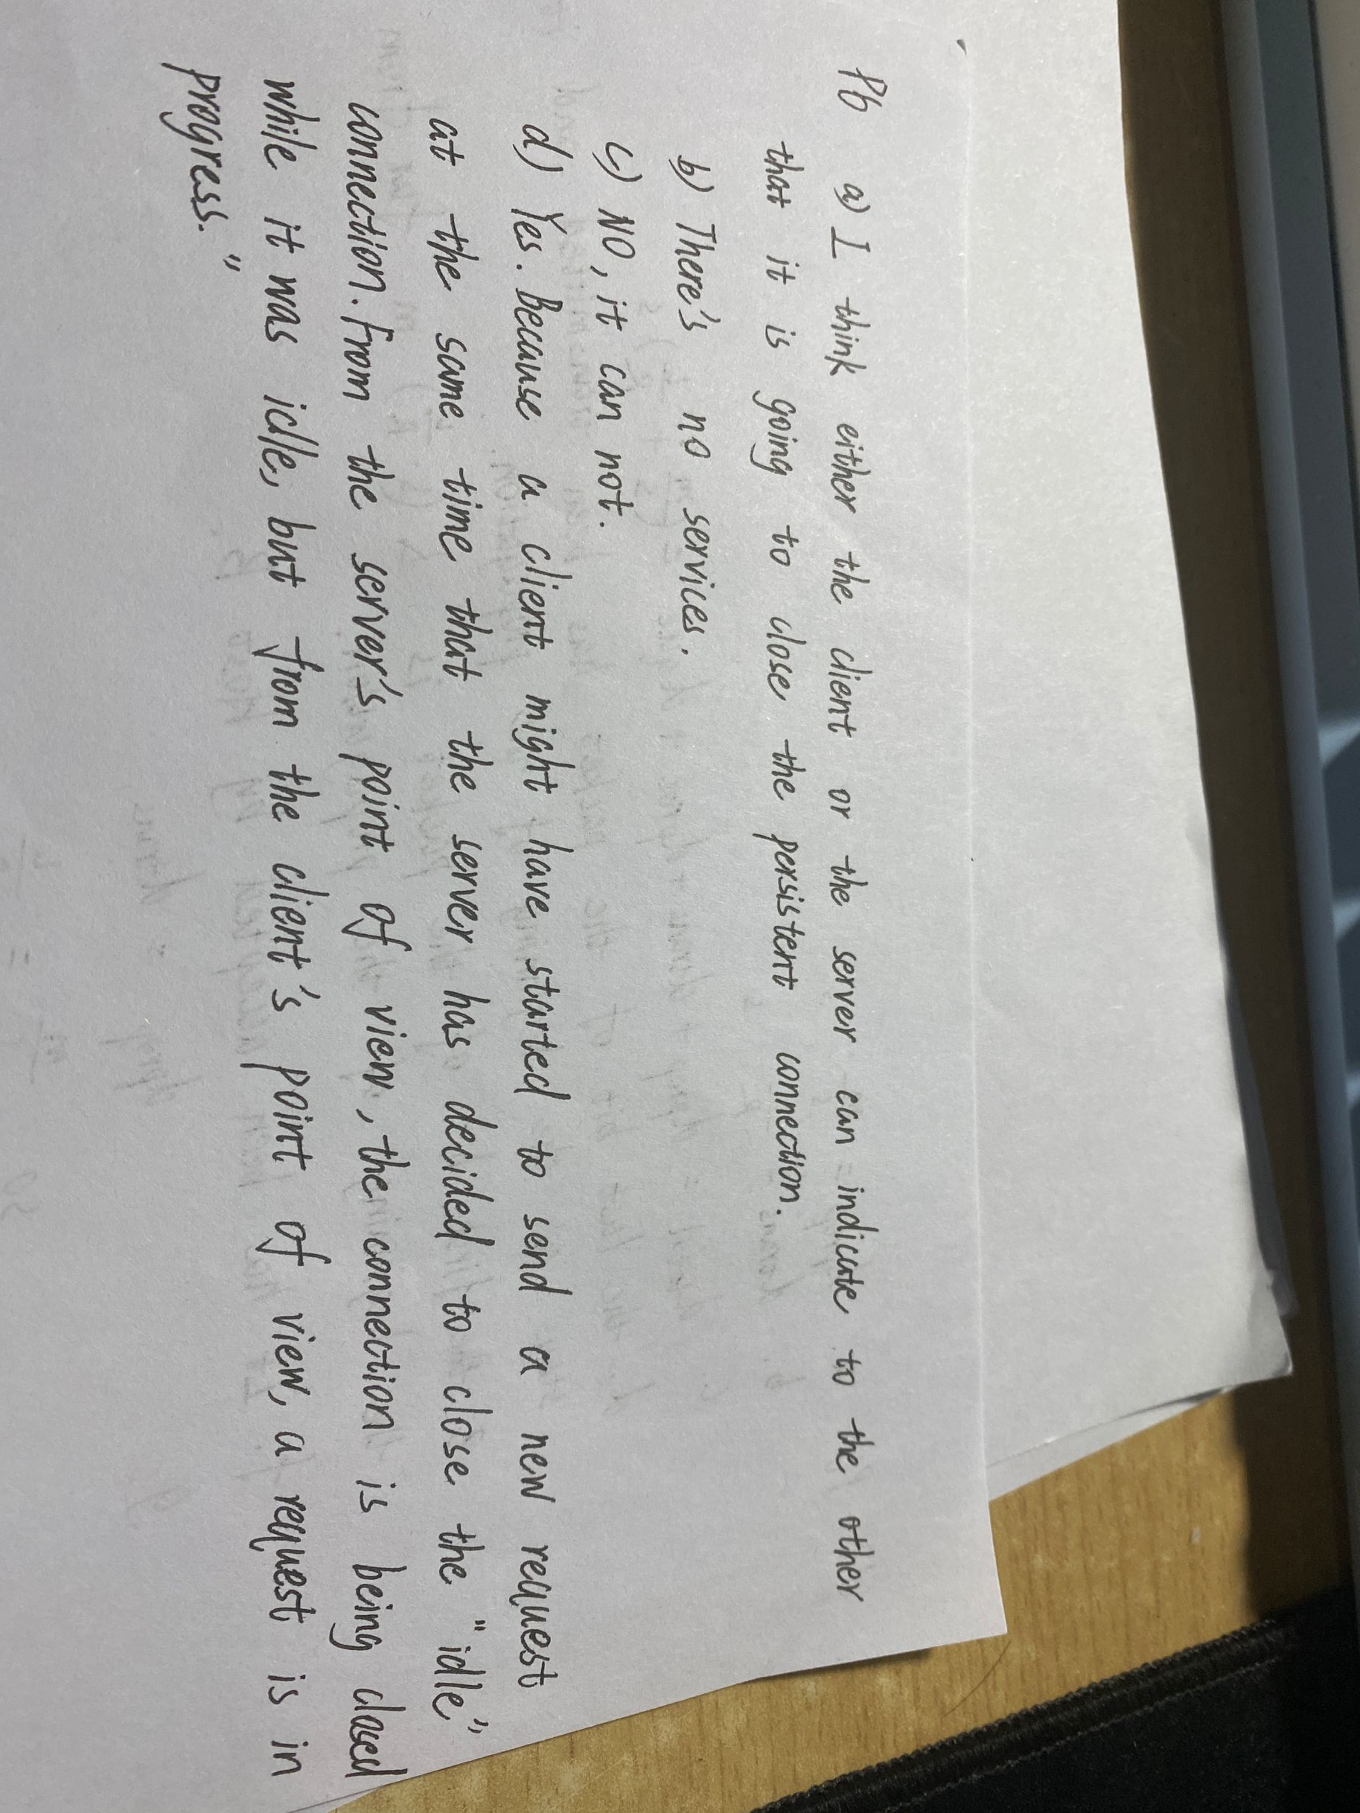
P12
