For the 1st week:
1.ping another computer
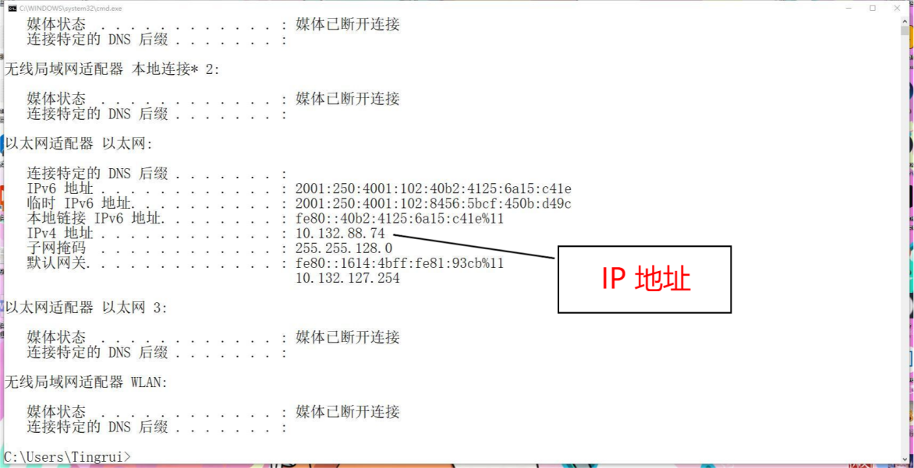
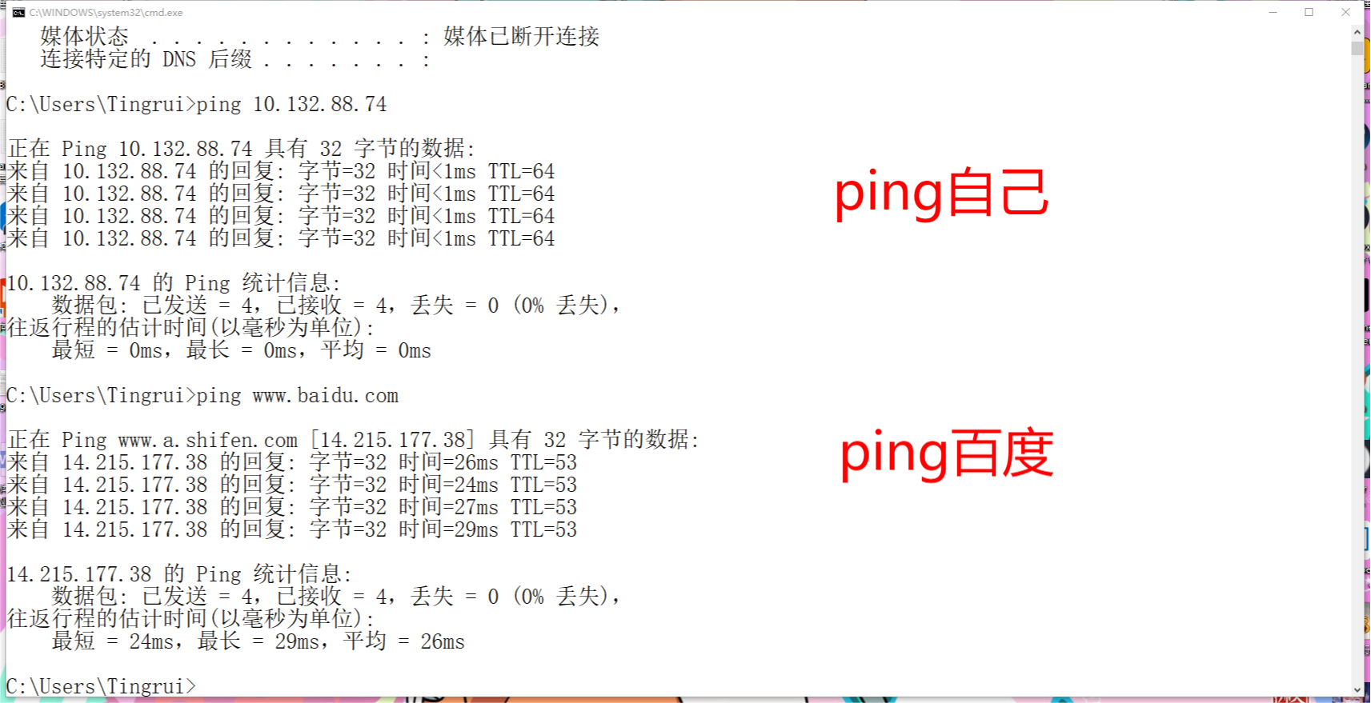
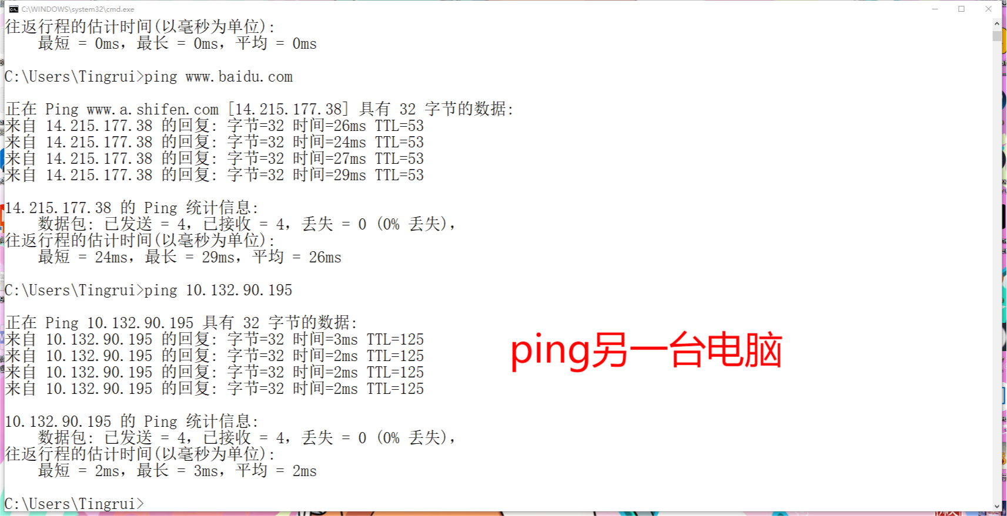
2.Tracert www.baidu.com
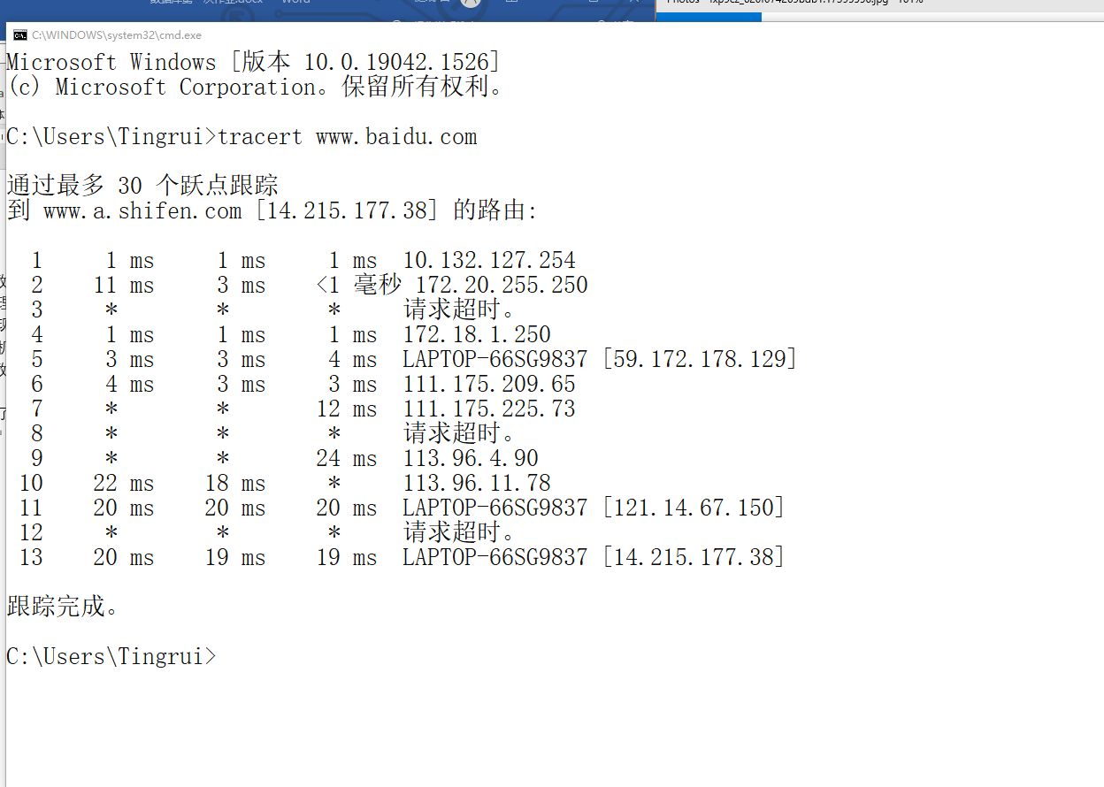

For the 2nd week:
I completed the exercise P6,P7,P12 of the 1st chapter
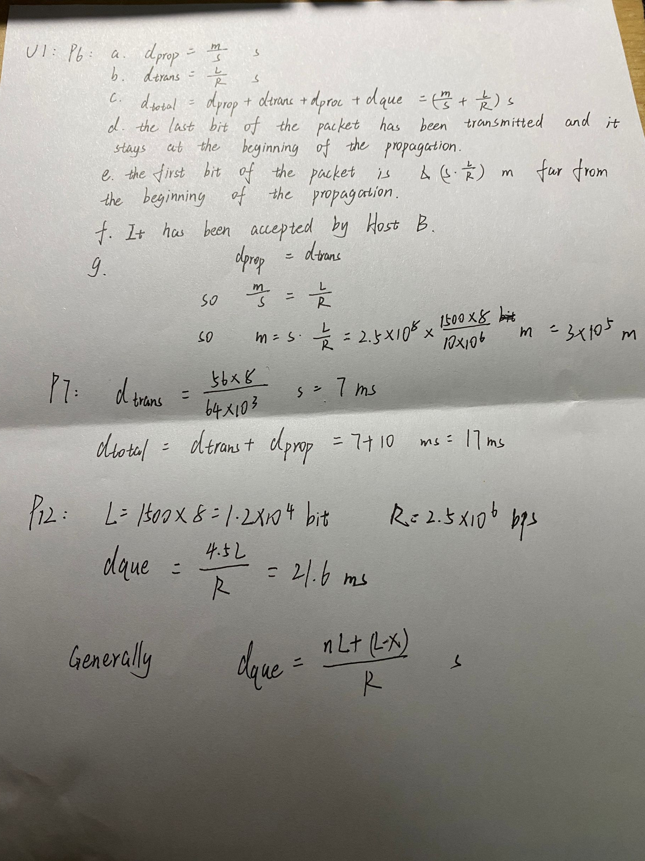

For the 3rd week:
- Telnet
Telnet mail.hust.edu.cn 80
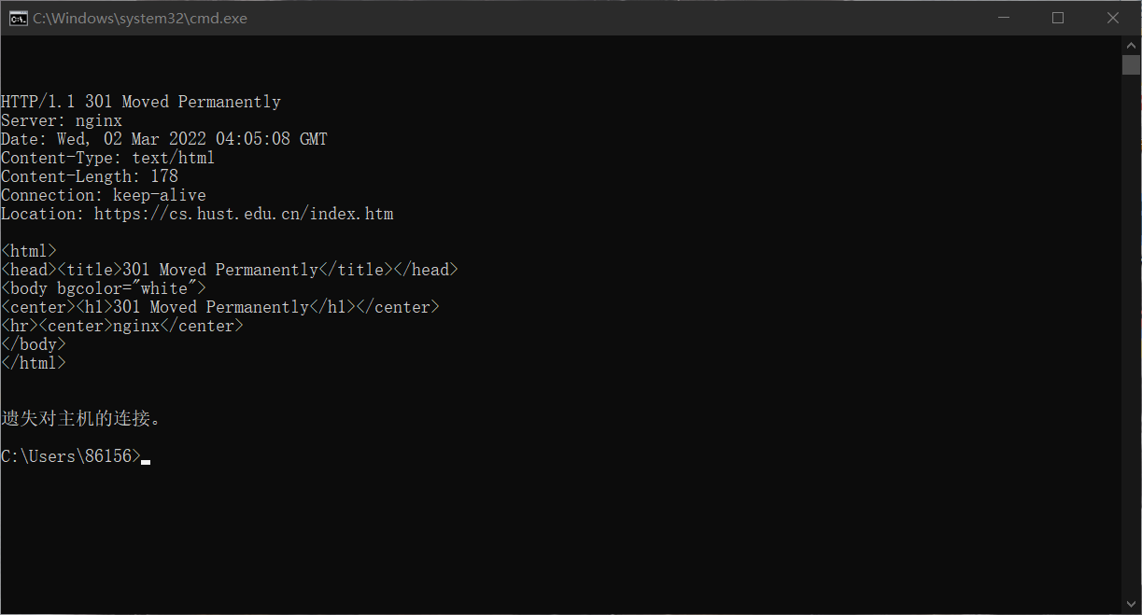
Telnet mail.whu.edu.cn 80
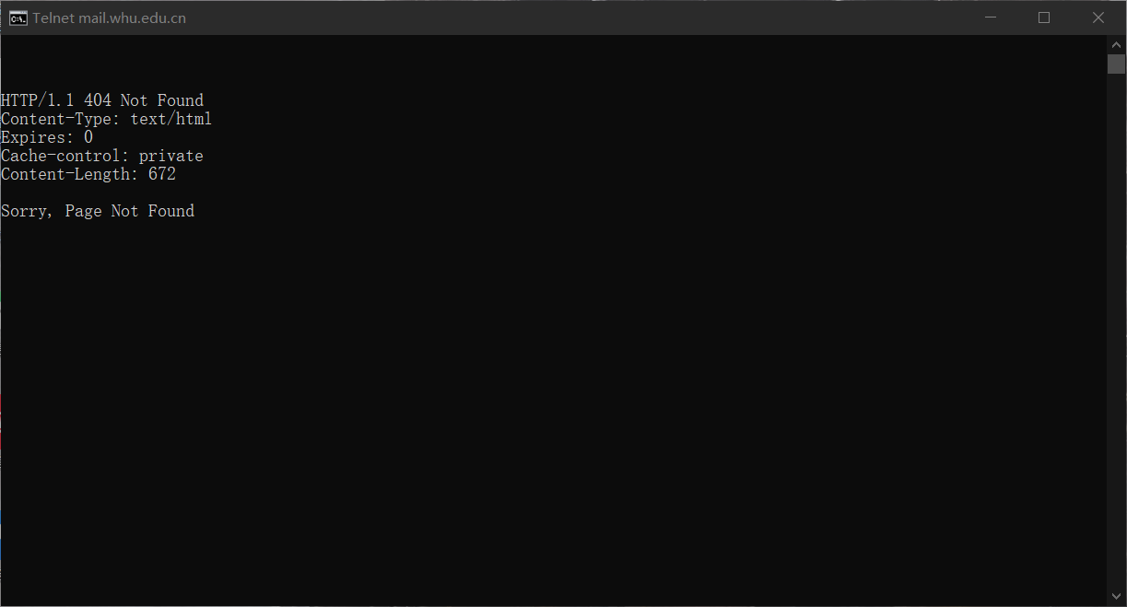
Telnet cs.whu.edu.cn 80
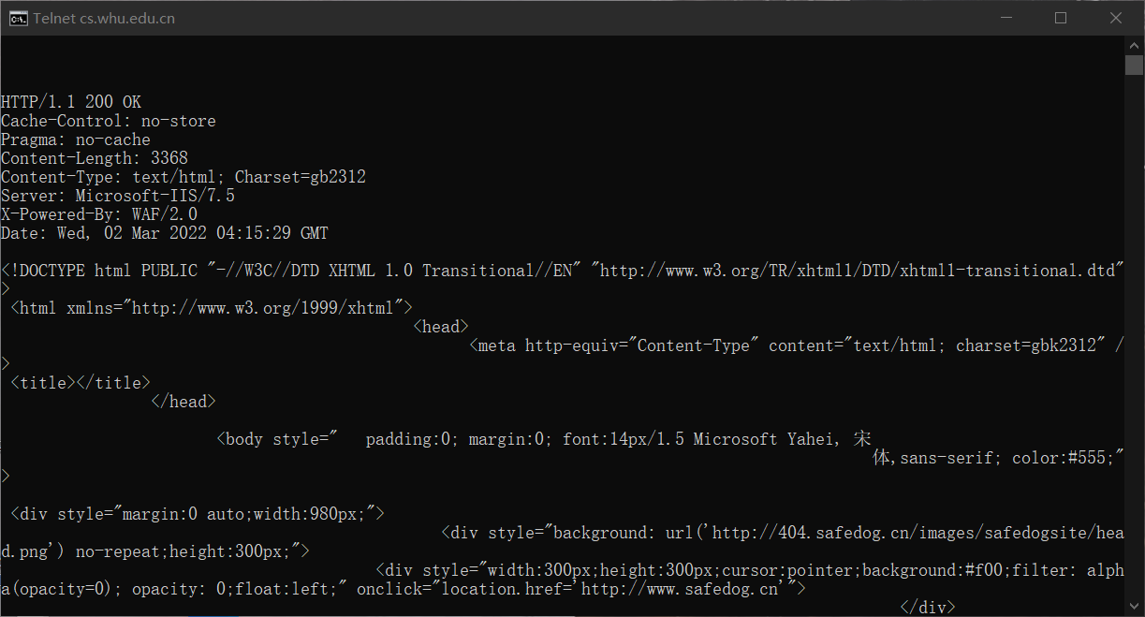
2.
I completed exercise P6,P12 of the 2nd chapter
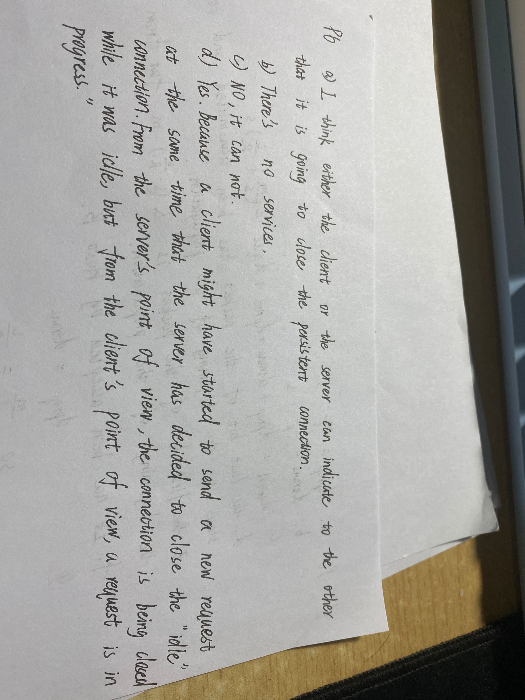
P12
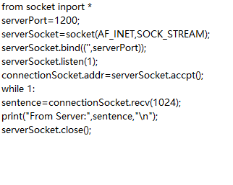

For the 4rd week:
I completed exercise P15,P20 of the 2nd chapter
P15:
MAIL FROM is an SMTP command.The From is not.In fact,the email can be sent without “From”.So MAIL FROM is more important.
P20:
You can periodically take a snapshot of the DNS cache on the local DNS server. The Web servers that the organization shows up most frequently in the DNS cache are the most popular. This is because if more users are interested in the Web server, DNS requests will be sent by the user more frequently. Therefore, the Web server will appear in the DNS cache more frequently.

