Lesson plan | 71 (old number 73)
Topic | The coordinate plane
Author | O. A. Korban
Date | 13.08-19.08.14
Lesson type | Reinforcement of the new material
Prerequisites | - What the students must know:  - the concepts of perpendicular and parallel lines;  - how to add mentally whole numbers with different signs and negative numbers ( numbers up to 50) ;  - how to mentally divide positive and negative numbers ( numbers up to 100);  - how to mentally multiply positive and negative numbers within the scope of the multiplication table for natural numbers as well as multiplying two-digit number by one-digit number, up to 100 without carrying over; two-digit numbers up to 30;  - names of components in operations of addition, subtraction, multiplication and division;  2) What the students may have forgotten (and needs to be reinforced):  - how to plot the points on the coordinate plane based on a given coordinate;  - how to find the coordinate of a point depicted on the coordinate line.
Lesson goals | Educational:  - Continue forming the skills of operating whole negative numbers (addition, subtraction, multiplication, division) within indicated number range.  - Reinforce the skill of recognizing perpendicular lines visually.  - Reinforce the skill of finding the coordinate of a point, expressed by a whole number on the coordinate line.  - Introduce the concept of the coordinate system, the coordinate plane, the coordinates of a point, an abscissa, an ordinate.  - Form the skill of plotting coordinate axes and mark on the coordinate plane a point with set coordinates.  - Form the skill of finding the coordinates of a point, expressed by whole numbers, depicted on the coordinate plane.  Developmental:  - Develop the skill of focusing  - Develop logical reasoning  Educational:  - Inculcate neatness
Lesson plan | - Mental math 3 min  - Actualization 5 min  - Explaining new material 9 min  - Reinforcing new material 17 min  - Review 4 min  - Lesson recap 1 min  - Assigning homework 1 min

Progress of the class

Stage 1: Mental math
Board | Teacher | Student | Notebook
 | Hello. In this lesson, we’ll learn a lot of new things.
a) -6+4 [ type 2]  4-12  -10-2  7-11  -5+8  -30-10  b)-12*2[ type 2]  -7*(-8)  10*(-3)  36:(-9)  -40:(-4)  -24:8 | But first we’ll do some mental math. [The teacher works frontally with the entire class.] | [Students raise hands, answering from their seats]
a) -6+4 | Let’s do the first problem. What shall we get? | -2
 | [In the event of an error, ask about calculations] What numbers are we adding? | -6 and 4
 | Are these summands with the same sigh or with different signs? | With different
-6+4 | Name the number with the greater absolute value. | -6
-6+4= - | In front of the result, we will have the sign of the number with the greater absolute value. So what sign will this expression have? | The minus sign
-6+4= - | Now we have to subtract the lesser absolute value from the greater one. How shall we calculate this? | We’ll subtract 4 from 6.
-6+4= -2 | What shall we get in the result? | -2
4-12 | Let’s do the next problem. What did we get? | -8
 | [In the event of an error, ask about calculations] What numbers are we adding? | 4 and -12
 | The summands are with the same sign or with different signs? | Two summands with different signs.
4-12 | Name the number with the greater absolute value. | -12
4-12= - | What sign shall we put in front of the result? | The minus sign
4-12= -8 | How did you calculate this? | From 12 we’ll subtract 4. We’ll get 8.
-10-2 | What is the result in this problem? | We’ll get -12
 | [In the event of an error, ask about calculations] What numbers are we adding? | -10 and -2
 | With the same sign or with different signs? | Two summands with the minus sign.
-10 -2= | How did you calculate this? | We’ll add 10 and 2, getting 12 and put the minus sign in front, i.e. the answer is -12
7 -11 | What do we get here? | -4
7 -11 | [In the event of an error, ask about calculations] What numbers are we adding? | 7 and -11
 | The summands are with the same sign or with different signs? | Two summands with different signs.
7 -11 | Name the number with the greater absolute value. | -11
7 -11 = - | What number do we put in front on the result? | The minus sign
7 -11 = -4 | How shall we calculate next? | From11 we’ll subtract 7. We’ll get - 4
-5+8 | What result will we get here? | 3
-5+8 | [In the event of an error, ask about calculations] What numbers are we adding? | -5 and 8
-5+8 | The summands – do they have the same sign or different ones? | Different
-5+8 | Name the number with the greater absolute value. | 8
 | What will be the sign of the result: positive or negative? | Positive
-5+8 =3 | How did you calculate this? | We’ll subtract 5 from 8, getting 3
-30 -10 | What shall we get? | -40
 | [In the event of an error, ask about calculations] What numbers are we adding? | -30 and -10
-30 -10 | Are the summands with the same sign or different signs? | Same
-30 -10 = - | What sign shall we put in front of the result? | The minus sign.
-30 -10 = -40 | How did you calculate this? | We’ll add 30 and 10, getting 40. And the minus. The answer is -40.
b) -12*2 | And another group of problems. Multiply. | [Students complete this task mentally]
-12*2= -24 | How much did we get? | - 24
 | [In the event of an error, ask a strong student about calculations] we multiplied numbers with the same signs or with different ones? | With different.
 | How did we multiply these two numbers? | We put the «-» in front and multiplied the absolute values of these numbers i.e. 12 multiplied by 2, getting 24. The answer is -24.
-7*(-8) | Correct. What shall we get in the next problem? | 56
 | [In the event of an error, ask a strong student about calculations] Are the numbers with the same sign or with different ones? | Same.
7*(-8)= -56 | I.e. two negative numbers. How to multiply these two numbers? | First you need to multiply the absolute values of these numbers. I. e. We multiply 7 by 8. We’ll get 56.
10*(-3) | The next problem. What is your answer? | -30
 | [In the event of an error, ask a strong student about calculations] Are the numbers with the same sign or with different ones? | With different signs.
10*(-3)=-30 | How do we multiply these numbers? | We put the «-» sign in front of the result and multiply the absolute values of these numbers, i.e. 10 multiplied by 3, we’ll get 30. In the answer we’ll get -30.
36:(-9) | The following are division problems. What shall we get? | -4
 | [In the event of an error, ask a strong student about calculations] Are the numbers with the same sign or with different ones? | With different signs.
36:(-9)=-4 | How do we divide the numbers with different signs? | Put the «-» sign in front of the result and divide the absolute values of these numbers, i. e. 36 divide by 9, we’ll get 4.  The answer is -4
- 40: (- 4) | Correct. What will be the answer in the next one? | 10
 | [In the event of an error, ask a strong student about calculations] are the numbers with the same sign or with different ones? | Same
 | What are these two numbers: positive or negative? | Two negative numbers
- 40: (- 4)=10 | How to divide two negative numbers? | We need to divide the absolute value of the dividend by the absolute value of the divisor i.e. 40 divide by 4. We’ll get 10.
 | Correct, and when we write the answer, we leave out the plus sign, so the answer is 10.
-24:8 | And the last problem. What did we get? | -3
 | [In the event of an error, ask a strong student about calculations] Are these numbers with the same sign or with different ones? | With different ones.
-24:8= -3 | How to divide two numbers with different signs? | Put the «-» sign in front of the result and divide the absolute values of these numbers, i.e. 24 divide by 8, getting 3.  We shall get -3 in the answer.
 | Good job, guys.

Stage 2: Actualization
Board | Teacher | Student | Notebook
 | In our today’s lesson we’ll learn new concepts, but first let us review what we already know.
No 1.  Find the coordinates of the points depicted on the drawing.  (Attachment 1) | Look at the board. You see the coordinate line on the drawing.  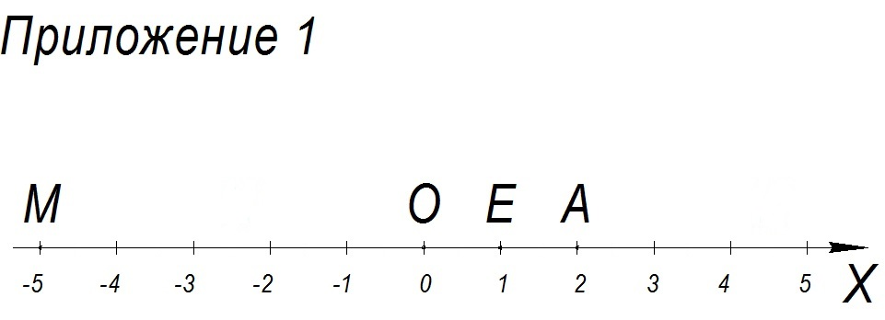 | [Students listen attentively to the teacher]
 | The line, on which the point of origin is marked, has the unit segment marked, and the positive direction is made, is called the coordinate line. | [Students listen attentively to the teacher]
 | In this assignment we will need to find the coordinates of points depicted on this line.
 | Look at the drawing, each point is removed from the point of origin by so many unit segments. | [Students listen attentively to the teacher]
 | I shall remind you that the coordinate of a point is the number designating the location of the point on the line.
 | Let us find the coordinates of the point О.
 | This point is the point of origin, it represents the number 0. | [Students listen attentively to the teacher]
 | It means that the coordinate of the point О will equal 0.
О(0) | This is written as follows: first we write the name of the point, i.e. the letter, and then, in the round brackets, the number, i.e. the coordinate. [The teacher makes a notation on the board]
О(0) | We read this notation as follows: point О with coordinate zero.
 | Now, let us find the coordinate of the point Е. By how many unit segments is it removed from the point of origin, i.e. the point О? | The point E is removed from the point of origin by 1 segment unit.
 | Since the point E is located to the right of the point О, its coordinate will have what sign? | С «+».
 | It means that what coordinate will the point Е have? | One
Е(1) | How can we write this? [In the event if a student fails to answer] I would like to hear your answer to this question. | Е(1) [One of the students writes on the board]
 | Read the notation. | Point Е with coordinate 1.[Possible answer: Е with coordinate 1]
А(2) | Please find the coordinate of the point А independently.  [The teacher gives the students the opportunity to find the coordinate of the point А]  Correct. | The point А has the coordinate 2.
 | [In the event of an error, the teacher uses scaffolding questions] By how many unit segments is this point removed from the point of origin, О? | The point А is removed by 2 unit segments.
 | It is located to the right or to the left from the point О? | To the right.
 | So, it means that what sign will the coordinate have? | The plus sign.
А(2) | Write the coordinates of the point А on the board. | А(2) [One of the students writes on the board]
А(2) | Read the notation. | Point А with coordinate 2.
 | Now find the coordinate of the point М. | The point М has the coordinate -5.
 | Why? | The point М is removed by 5 unit segments from the point of origin and is located to the left of the point О.
М (-5) | Write the coordinate of the M point on the board. | М (-5) [One of the students writes on the board]
М (-5) | Read the notation.  Correct. | Point М with coordinate minus five.
No 2. On these drawings you see lines. Find, visually, which of the intersecting lines are perpendicular. (Attachment 2) | In the next assignment, you will need to determine visually, which of the intersecting lines are perpendicular. [The teacher works frontally with the entire class. The assignment is being verbalized by the teacher.]  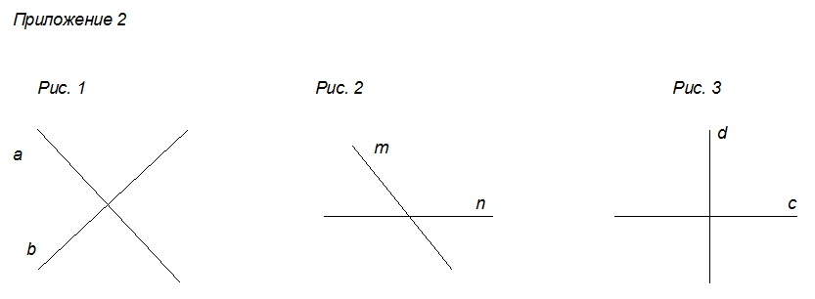
 |  | [Students answer from their seats] On drawings 1 and 3 the lines will be perpendicular.
 | And perpendicular lines intersect at what angle? | At the right angle.
 | Now I shall check whether the lines on drawings 1 and 3 are perpendicular, and I will use a square to do that.[The teacher applies a square to the lines on drawings 1 and 3, confirming that they are perpendicular] | [Student observe the teacher’s actions]
 | I would like to bring your attention to the drawing 3. [The teacher points to the lines depicted on the drawing 3]
 | One of the perpendicular lines on this drawing is located horizontally, and the other one, vertically.
 | Which line is located horizontally? | Line с.
 | And which one, vertically? | Line d.
 | Today in our class we shall work with this exact position of perpendicular lines.
No 3.  The following points are depicted on the drawing: O, M, K, P, N. Find, using the drawing, how many squares you have to go, moving first horizontally to the right, and then vertically, from the bottom up, to get from the point О to the points M, K, P, N?  (Attachment 3) | One more assignment. The following points are depicted on the drawing: O, M, K, P, N.  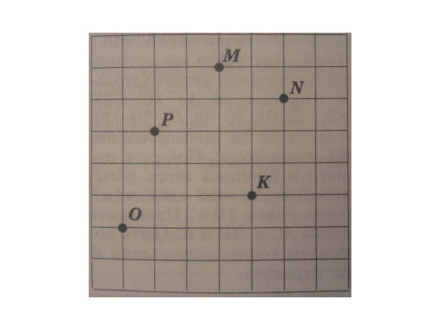  Find, using the drawing, how many squares you have to go, moving first horizontally to the right, and then vertically, from the bottom up, to get from the point О to the points M, K, P, N? [The teacher works frontally with the entire class. The assignment is verbalized by the teacher. The teacher asks questions, students answer from their seats.] | [Students working at their seats have a drawing with this assignment]
 | Let us find together, how many squares we will need to go from point O to point М. [The teacher enters the M point in the table] | [The students observe the teacher’s actions]
  From point O to point | From left to right | From bottom up
  М
 | First, we shall go horizontally from left to right. We need to go 3 squares to the right. Do you agree? [The teacher highlights by a different (contrasting) color the horizontal line 3 squares-long in the direction from left to right from the point О.] | Yes [The students observe the teacher’s actions]
  From point O to point | From left to right | From bottom up
  М
 | I shall record this in the table [The teacher records the number of squares in the table]
  From point O to point | From left to right | From bottom up
  М | 3
 | And now we shall be moving from the obtained point up to the point М. How many squares shall we cover going from the bottom up to the point М? [The teacher highlights by a different (contrasting) color the vertical line 5 squares-long, going in the direction from the bottom up.] | 5 squares
  From point O to point | From left to right | From bottom up
  М | 3
 | I shall record this in the table [The teacher records the number of squares in the table]
  From point O to point | From left to right | From bottom up
  М | 3 | 5
 | So, to get from point O to point M, first you need to go 3 squares to the right and then 5 squares from the bottom up.
  From point O to point | From left to right | From bottom up
  М | 3 | 5
 | Now, we will find how many squares you need to go from point О to point К. First, from left to right, how many squares shall we cover? [The teacher enters the name of point K in the table] | 4 squares
  From point O to point | From left to right | From bottom up
  К
 | [The teacher highlights by a different (contrasting) color the horizontal line 4 squares-long, going in the direction from left to right. Write the number of squares in the table. ]I agree. | [The students observe the teacher’s actions, answer questions]
  From point O to point | From left to right | From bottom up
  К | 4
 | And now, from this point, vertically from bottom up, how many squares do we have to cover? [The teacher highlights by a different (contrasting) color the vertical line 1 squares-long, going in the direction from bottom up.] | From bottom up 1 square.
  From point O to point | From left to right | From bottom up
  К | 4
 | I shall record this in the table [The teacher records in the table the number of squares] | [The students observe the teacher’s actions]
  From point O to point | From left to right | From bottom up
  К | 4 | 1
 | To get from point О to point К, we need to first go 4 squares from left to right and then 1 square from bottom up.
  From point O to point | From left to right | From bottom up
  К | 4 | 1
 | I can see that you understand how to act. Now let us find how many squares we have to cover from point О to point Р. [The teacher enters the name of point P in the table] | [The students observe the teacher’s actions, answer questions]
  From point O to point | From left to right | From bottom up
  Р
 | From left to right, how many squares do we have  to cover? [The teacher highlights on the drawing a horizontal line 1-square long from point O, going from left to right. Enters the number of squares in the table] | 1 square
  From point O to point | From left to right | From bottom up
  Р | 1
 | And now – upwards – how many? [The teacher highlights on the drawing a vertical line 3-squares long from point O, going from bottom up. Enters the number of squares in the table] | 3 squares [The students answer the teacher’s questions]
  From point O to point | From left to right | From bottom up
  Р | 1 | 3
 | So, how could we get from point О to point Р? | To get from point О to point Р, you need to go 1 square from left to right and then 3 squares from bottom up.
  From point O to point | From left to right | From bottom up
  Р | 1 | 3
 | Correct. We have one point left, N. How many squares shall we cover, going from left to right? | 5 squares [The students answer the teacher’s questions]
  From point O to point | From left to right | From bottom up
  N
 | Correct. [The teacher highlights with a different color a horizontal line, 5 squares-long, from point О going from left to right. Enters the number of squares in the table] | [The students observe the teacher’s actions]
  From point O to point | From left to right | From bottom up
  N | 5
 | And from bottom up – how many squares? [The teacher highlights with a different color a vertical line, 4 squares-long, from point О going from bottom up. Enters the number of squares in the table] | 4 squares.
  From point O to point | From left to right | From bottom up
  N | 5 | 4
 | So, how could we get from point О to point N? | To get from point O to point N, we need to go 5 squares from left to right, and then 4 squares from bottom up.
  From point O to point | From left to right | From bottom up
  N | 5 | 4
 | Good job guys, you did very well on this assignment.

Stage 3: Explanation of new material
Board | Teacher | Student | Notebook
The coordinate plane | So, we have come to the topic of today’s lesson, Open your notebooks and write today’s date and the topic: “The coordinate plane”. | [Students write the lesson’s topic and today’s date in their notebooks] | The coordinate plane
No 4.  John has a ticket for the performance: row 3, seat 8, and Margaret has a ticket for the same performance, for row 8, seat 3. Find their seats in the theater.  Attachment 4 | Look at the picture. [frontal work with the entire class]  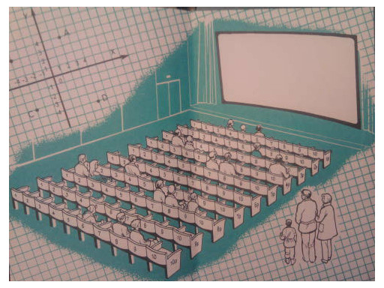  We need to find the seats that John and Margaret have in the theater.  John has a ticket for the performance: row 3, seat 8, and Margaret has a ticket for the same performance, for row 8, seat 3. | [On the seating plan, the students locate the seats of John and Margaret.]
 | Who is ready to point to John’s seat on the picture? | [One of the students volunteers to come up to the board and point to the location of John’s seat.]
 | How did you locate John’s seat? | First I found the row 3. And then, in that row I located seat 8. This will be John’s seat.
 | What about Margaret’s seat? | [One of the students volunteers to come up to the board and point to the location of Margaret’s seat.]
 | How did you locate that? | I found the row 8. And then, in that row I located seat 3. This will be Margaret’s seat.
 | Great. This is correct.
 | In similar cases, they say sometimes that these are the coordinates of someone’s location in the theater.
 | In a similar way, we can mark the location of a point on the plane. | [The students listen]
Attachment 5 | To do that, on the plane we shall have two perpendicular coordinate lines, х (horizontally) and у (vertically), which intersect at the point of origin. [The teacher shows on the board the depicted system of coordinates.]  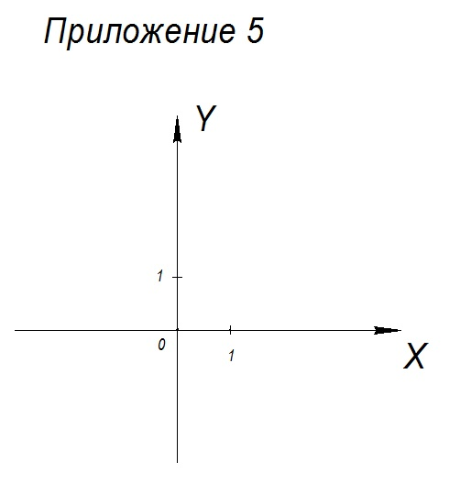
 | These lines are called the coordinate system on the plane, and the point О, the point of origin.
 | The plane, upon which the coordinate system is given, is called the coordinate plane.
 | On your desks you have a reference card containing the algorithm for constructing the coordinate plane.
To construct the coordinate plane, we need to:  - Plot two perpendicular lines, х (horizontally) and у (vertically);  - Mark the point of intersection of this lines as О;  - Mark with arrows the positive direction on the lines: on the х axis – to the right; on the у axis - up;  - Indicate segment units on the positive directions of both axes. | To construct the coordinate plane, we need to: [The teacher shows the coordinate system depicted on the board, highlighting each step of constructing the coordinate plane]  - Plot two perpendicular lines, х (horizontally) and у (vertically);  - Mark the point of intersection of this lines as О; this point О is called the point of origin;  - Mark with arrows the positive direction on the lines: on the х axis – to the right; on the у axis - up;  - Indicate segment units on the positive directions of both axes. | [The students listen to the teacher and read the card]
 | Using this algorithm, I shall draw the coordinate system on the board right now. And you will give me hints on the steps I need to take while constructing it. [Joint work of the teacher and students. The teacher constructs the coordinate system on the board, going through all construction stages]. | [The students read the algorithm and verbally indicate the steps to the teacher]
 | What do we start with? | [The students answer from their seats] we need to draw two perpendicular lines: х (horizontally) and у (vertically)
On the board, two perpendicular lines, х and у, appear. | To construct this, I shall use a square. [The teacher draws two perpendicular lines х and у using the square] | [The students observe the teacher’s actions]
Point О is marked | What else do we need to mark on the drawing? Look to see what would be the next step of our algorithm. [Marks the point О] | The point of intersection of the lines х and у, we’ll mark with the letter О.
 | What’s next? | We need to indicate with arrows the positive directions on the axes.
The positive direction is indicated with arrows | I am marking the positive directions on both axes: on the х axis- to the right, on the у axis – up. [Indicates the direction with arrows].
 | What else do we need to indicate? | On each axis, we need to mark a unit segment.
A unit segment is marked on each axis.  Attachment 5 (the coordinate plane divided into squares) | [Marks a unit segment on each axis].  To make it easier to use the coordinate system, you can also mark other whole numbers that would fit in the picture.
The picture of the coordinate plane from the document формулировки_7класс_ final к п.45 | Look at the picture you have in your Math Journal. | [Students are looking closely at the drawing]
The coordinate line х- abscissa axis | The coordinate line х is called the abscissa axis. Write this in your notebooks. [The teacher selects the x axis on the picture] |  | The coordinate line х- abscissa axis
The coordinate line у – ordinate axis | The coordinate line y is called the ordinate axis. Write this in your notebooks. [The teacher selects the y axis on the picture] |  | The coordinate line у - ordinate axis
The picture of the coordinate plane from the document формулировки_7класс_ final к п.45 | Points are depicted on the coordinate plane.  On this drawing, we see the point А.
The picture of the coordinate plane from the document формулировки_7класс_ final к п.45 | The location of points on the coordinate plane is defined by a pair of numbers which are called the coordinates of a point.
The picture of the coordinate plane from the document формулировки_7класс_ final к п.45 | This point A has the coordinates: 2 and -3.
The picture of the coordinate plane from the document формулировки_7класс_ final к п.45 | Conventionally, the notation is made as follows: after the name of the point, i.e. the letter, in the round brackets 2 numbers are written separated with either a colon or a semicolon.
А (2;-3):  1) point А with coordinates 2 and -3;  2) point А with abscissa 2 and ordinate -3;  3) coordinates of the point А: a pair of numbers, 2 and -3. | The notation А (2;-3) can be read in a number of ways:  - point А with coordinates 2 and -3;  - point А with abscissa 2 and ordinate -3;  - coordinates of the point А: a pair of numbers, 2 and -3.
 | Sometimes they say that the point A has the x coordinate which equals 2, and the y coordinate which equals -3.
Plot the point  М (6;-5)  Attachment 5 | Now I shall use the given coordinate plane for plotting the point M with the coordinates 6 and -5. Write this in your notebooks. |  | М (6;-5)
6 - abscissa | The first number in the pair, the first coordinate of the point М, which equals 6, the х coordinate is called the abscissa. |  | 6 - abscissa
-5 - ordinate | The second number in the pair, the second coordinate of the point M, which equals -5, the у coordinate is called the ordinate. |  | -5- ordinate
Attachment 6 а) | To plot the point M on the x axis, mark a point with the coordinate, corresponding to the first number in the coordinates of the point M, i.e. 6. | [Students observe the plotting that the teacher is completing]
Attachment 6 а) | This point will be located at the distance of 6 unit segments to the right from the point О. I will mark it as А. | [Students observe the plotting that the teacher is completing]
Attachment 6 b) | On the у axis, I shall mark a point with the coordinate, corresponding to the second number in the coordinates of the point M, i.e. -5. | [Students observe the plotting that the teacher is completing] | Attachment 6 b)
Attachment 6 b) | This point will be located at the distance of 5 unit segments down from the point О, because -5 is a negative number. I will mark is as В. | [Students observe the plotting that the teacher is completing] | Attachment 6 b)
Attachment 6 c) | Through the first obtained point А on the х axis, using a square, I shall plot a line, perpendicular to the х axis; and through the second point, B on the y axis, I shall plot a line, perpendicular to the y axis. | [Students observe the plotting that the teacher is completing] | Attachment 6 c)
Where these lines intersect, there we’ll find the location of the point M with coordinates 6 and -5.
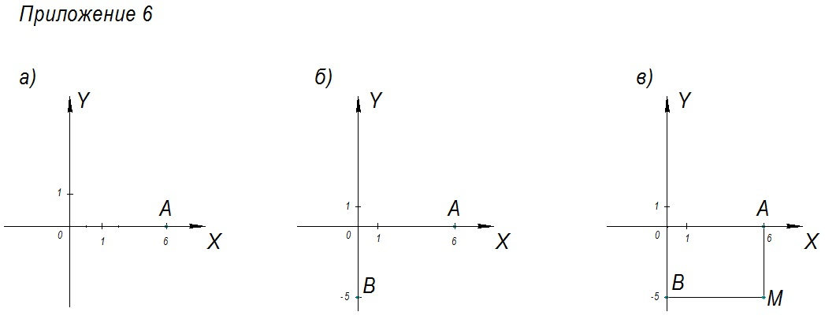
 | Look at your Math Journal: there you have the algorithm for plotting a point with given coordinates on the coordinate plane.
To plot a point with given coordinates on the coordinate plane, you need to:  - on х axis, find the number corresponding to the first coordinate;  - through this point plot a line, perpendicular to х axis;  - on у axis, find the number corresponding to the second coordinate;  - through this point plot a line, perpendicular to у axis;  - the point of intersection of the two lines is the point in question. | To plot a point with given coordinates on the coordinate plane, you need to: [The teacher points at the recently plotted on the board point M, selecting each step of the algorithm]  - on х axis, find the number corresponding to the first coordinate;  - through this point plot a line, perpendicular to х axis;  - on у axis, find the number corresponding to the second coordinate;  - through this point plot a line, perpendicular to у axis;  - the point of intersection of the two lines is the point in question. | [The students listen to the teacher and read the reference card]
 | To plot the point with the given coordinates it is convenient to use the given coordinate plane which has been preliminarily divided into squares.
No 5.  Plot the point  N (-5;6). | Let’s do the following assignment. Use the algorithm we have to plot the point N with coordinates -5 and 6. [Joint teacher-student activity; every step of the algorithm is practiced]
Attachment 5 (the coordinate plane divided into squares) | You have a given coordinate plane. | [The plotting is directed by the teacher.] | Attachment 5
Attachment 7а) | To plot a point N, we need to find the number on x axis which corresponds to which coordinate? | To the first one  [The plotting is directed by the teacher.]
 | What number is it? | -5
To mark this point, we need to separate off 5 unit segments on the x axis to the left, because -5 is a negative number.
And let us not mark this point with any letter.

 | Now, we have to plot a line through this point, perpendicular to the х axis.  See me do it. [The teacher applies one side of the right angle of the square to the х axis. At the same time, the corner of the square coincides with the number -5. Plots a line through the second side of the square’s right angle.] | [The students observe the teacher’s actions.]
 | Please note that the plotted line coincides with the vertical line along the grid (the top of squares).
 | It means that we can easily plot a desired perpendicular line simply plotting it along the grid. [The teacher shows how to do plotting using the squares (grid)] | [Students plot, guided by the teacher.]
Attachment 7b) | What number shall we look for on the у axis? | 6.  [Students plot, guided by the teacher.]
 | Correct, because it corresponds to the second coordinate.
 | To plot this point, you need to move along the у axis, 6 unit segments up, because 6 is a positive number.
 | Let us not mark this point with a letter, since this is not the ultimate plotting, but an intermediary step.
Attachment 7c) | Through this point, we shall plot a line perpendicular to the у axis. | [Students plot, guided by the teacher.]
 | You may use a square, of course. [The teacher applies one side of the right angle of the square to the y axis. At the same time, the corner of the square coincides with the number 6. Plots a line through the second side of the square’s right angle.]
 | See how the plotted line coincides with the horizontal line along the grid.
 | And it means that you can plot a perpendicular line simply along the grid. [The teacher shows how to plot on the grid] | [Students plot, guided by the teacher.]
 | Where will we find the point N? | At the intersection of these lines. [Students plot, guided by the teacher.]
Let us mark a point on the intersection of these lines and mark it as N.
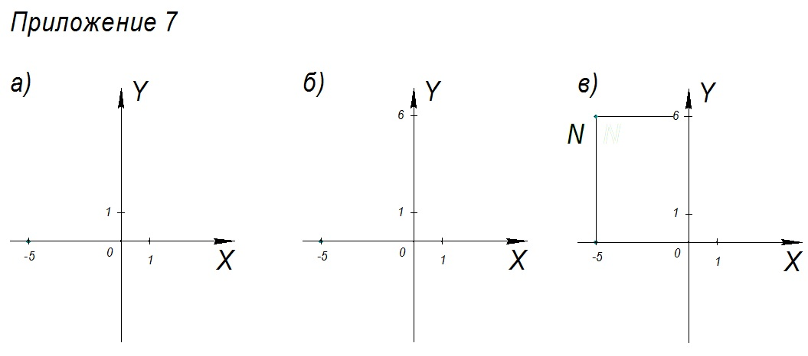

 | So, if we need to mark a positive number on the х axis, it will be located to the right of O, and the negative one, to the left of O; on the у axis, positive numbers will be above O, and negative ones, below O.

Stage 4: Reinforcing new material
Board | Teacher | Student | Notebook
No 6.  Mark on the coordinate plane points with the given coordinates:  а) М (1;4),  N (-2;5), К (-3;3),  Р (5;-2). | We have learned a lot of new material and reviewed what we already know; now it’s time to practice.  Mark points with the given coordinates on the coordinate plane.
Attachment 5 (the coordinate plane divided into squares) | Let us plot these points on a new coordinate plane. | [Each student has a new given coordinate plane divided into squares] | Attachment 5
М (1;4) | Let’s start with the point М. How do we read this notation? [The teacher asks scaffolding questions; students raise their hands, answer] | The point М with coordinates 1 and 4. [Other possible answers: point М with abscissa 1 and ordinate 4; or: coordinates of the point M – pair of numbers, 1 and 4.]
 | Use the algorithm.  Name the first coordinate (abscissa) of the point М. | 1
 | On what axis will you separate it off?  [The teacher completes the plotting on the board; students work at their seats]. | On the х axis
 | By how many unit segments and in which direction do we need to move on the х axis? | 1 unit segment to the right.
 | Why to the right? | Because 1 is a positive number.
 | Let’s not mark this point with a letter.
 | How shall we plot a line through this point? | Perpendicular to the х axis.
 | Correct, perpendicular to the х axis. On the grid, it would be sufficient to plot a vertical line along the grid. [The teacher plots at the board; student work from their seats]. |  | [Plot at their seats]
 | Name the second coordinate (ordinate) of the point М. | 4
 | On what axis shall we separate it off? | On the у axis.
 | In which direction and how many unit segments do we have to go along the y axis to mark this point? | 4 unit segments up.
 | Why up? | Because 4 is a positive number.
 | This point we will not mark with any letter, either.
 | What shall we plot next? | We will plot a line perpendicular to the у axis.
 | Correct, perpendicular to the у axis. And because we have a grid, we can just extend the horizontal line along the grid. [The teacher plots at the board; the students work at their seats]. |  | [Students plot at their seats]
 | Where will the M point be? | Where these lines cross, we’ll find the point М.
 | Let us mark a point at the intersection of these lines and call it M, this is our ultimate point.
 | Who wants to plot the next line at the board? | [The students raise their hands and volunteers plot at the board].
N (-2;5) | Read the notation. | Point N with coordinates -2 and 5.
 | Name the coordinate х of this point. | -2
 | On which axis will you mark the number -2? | On the х axis.
 | Where will you mark it? | To the left from the point О at the distance of 2 unit segments.
 | What’s next? | I will plot a vertical line through this point.
 | Correct, this line will be perpendicular to the х axis.
 | What will you separate off on the у axis? | On the y axis, I will mark the number 5.
 | Where will you mark it? | Up from the point О by 5 unit segments.
 | Now what do we do? | I will plot a line, perpendicular to the у axis. | [Students mark the point N; working from their seats]
 | This line will go horizontally along the grid.
 | Where will the N point be located? | The place where these lines intersect, will be the point N.
К (-3;3). | Let us mark the point К (-3; 3). | [One student at the board marks on the coordinate plane the point К, using the algorithm; the rest, independently, checking their actions with the actions of a student at the board and listening to his explanations] | [Mark the point К in notebooks ]
 | Name the coordinate x of the point К. | -3
 | On what axis shall you mark it? | On the х axis.
 | Correct, on abscissa axis. Where will the number -3 be located on the х axis? | To the left from О by 3 unit segments.
 | Now, what do we have to plot through this point? | A line, perpendicular to the х axis.
 | We can do this using the grid. The line will go vertically.
 | Name the coordinate of the point К. | 3
 | On what axis will you mark it? | On the у axis.
 | Correct, on the ordinate axis. Where will we find the number 3 on the у axis? | Up from the point О by 3 unit segments.
 | What do we have to plot now through this point? | A line, perpendicular to the у axis.
 | This can also be done using the grid. The line will go horizontally.
 | Where do we find the point К? | Where these lines intersect, we will find the point К.
Р (5;-2) | Mark the point Р (5;-2) independently. | [One student working at the board plots point P on the coordinate plane using the algorithm, the rest are working independently and later check their work against the board]. | [Plot point Р in notebooks ]
Attachment 8 | Compare it with the picture on the board.  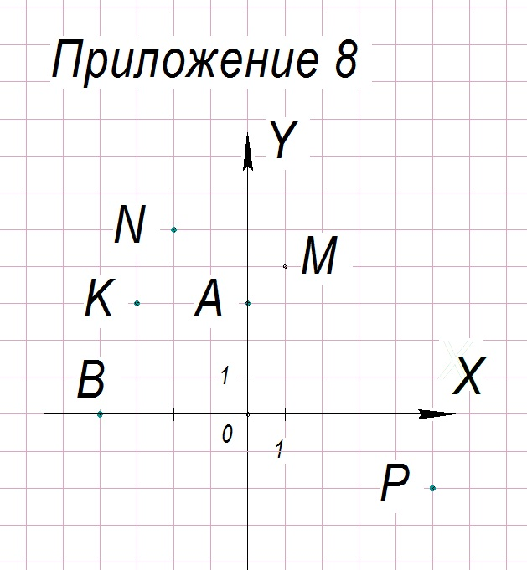  Does everyone has the same picture? Good job! | Yes. | Attachment 8
b) Mark point L on the coordinate plane, which has coordinate x equals 3, and coordinate y, 1 less. | [Assignment is done if spare time is available] And now we shall plot on the coordinate plane a point L, whose coordinate x equals 3, and coordinate 1 is one less.
 | What coordinate of the point L is unknown? | The у coordinate.
 | What do we know about it? | The у coordinate is 1 less.
 | Yes, the y coordinate is 1 less than the coordinate x, which equals 3.
 | Using what operation will we find the coordinate у? | Subtraction
3-1=2  у=2 | Let us write this. 3 minus 1equals 2. у=2 |  | 3-1=2  у=2
 | Coordinate y of the point L equals 2.
 | What coordinates does the L point have as the result? | The point L has the coordinates: 3 and 2. [Other possible answers: point L with abscissa 3 and ordinate 2 or, the coordinates of the point  L is a pair of numbers, 3 and 2. Or, point L has the first coordinate 3, and the second coordinate, 2.]
L (3;2) | Write the resulting coordinates. | [The students write in their notebooks] | L (3;2)
 | Name the coordinate x of this point. | 3
 | On what axis shall you mark the number 3? | On the х axis.
 | Where will you mark it? | To the right of the point О by 3 unit segments.
 | What will you do next? | I will plot a vertical line through this point.
 | Correct, this line will be perpendicular to х axis.
 | What will you separate off on у axis? | I will mark number 2 on у axis.
 | Where will you mark it? | Up from the point О by 2 unit segments.
 | Now what? | I will plot a line perpendicular to у axis. | [The students mark the point L, working at their seats]
 | This line will go horizontally along the grid.
 | Where will the point L be located? | Where the lines intersect, there the point L will be located.
No 7.  Based on the drawing, define and record in the notebook the coordinates of these points.  Attachment 9 | Based on the drawing, define and record in the notebook the coordinates of these points.  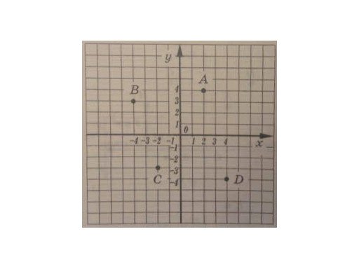 | [Each student has the drawing available at his or her desk]
To find the coordinates of the points depicted on the coordinate plane, we need to:  1) plot a line through the point, perpendicular to the х axis;  2) find the number on the х axis, which corresponds to the point of intersection of this line and the х axis, write it as the first coordinate;  3) through the point, plot a line, perpendicular to the у axis;  4) find the number on the у axis, which corresponds to the point of intersection of this line and the у axis, write it as the second coordinate. | Let us use the algorithm we have in our Math Journal. Try to answer all of the teacher’s questions. This will help you complete the assignment.
 | Let us find the coordinates of the point А. | [The students answer the teacher’s questions, using the algorithm from MJ]
 | What shall we start with? [The teacher plots on the board; the students do the same at their desks] | From the point А, we shall plot a line, perpendicular to the х axis.
 | This line will go vertically along the grid.
 | Which number on the х axis corresponds to the point of intersection of this line with the х axis? | 2
 | What first coordinate will the letter A have? | 2
А (2; | We must write it in the round brackets after the name of the point, in the first place. This is the x coordinate. [The teacher makes the notation on the board, students work at their desks] |  | А (2;
А (2; | We can also say that the abscissa of the point А equals 2. |  | А (2;
 | Now we shall plot from the point A, a line, perpendicular to the у axis.
 | How will this line go in relation to the grid? | Horizontally
 | What number on the y axis corresponds to the point of intersection of this line with the у axis? | 4
 | This will be the second coordinate of the point А or the coordinate у.
 | We can say that the ordinate of the point А equals 4.
А (2;4) | We need to write it in round brackets after the name of the point, on the second place. [The teacher completes the notation on the board, and the students work at their desks] |  | А (2;4)
 | Read the resulting notation. | The point А with coordinates 2 and 4 (Other possible answers: point А with abscissa 2 and ordinate 4; or, the coordinates of the point A – a pair of numbers 2 and 4).
 | Now, let’s find the coordinates of the point В. | [The students work with the given drawing]
 | What shall we plot? | From the point В, we shall plot a line, perpendicular to the х axis.
 | Which number did we get on the х axis at the intersection of this line with the х axis? | -4
 | What coordinate will you write on the first place? | -4
В (-4; | Make a notation |  | В (-4;
 | What shall we plot now? | Through the point В, we shall plot a line, perpendicular to the у axis.
В (-4;3) | What coordinate do we have to write in the round brackets after the name of the point, on the second place? | 3 | В (-4;3)
 | Correct. This number corresponds to the point of intersection of a perpendicular line with the у axis.
 | Name the coordinate х of the point В. | -4
 | What does the coordinate у of this point equal? | 3
 | Alternatively, we can say that the abscissa of the point B is -4, and the ordinate, 3.
 | Who would like to find the coordinates of the point С at the board? | [One of the students volunteers to work at the board; the rest are working independently at their desks]
 | What will you start with? | Through the point С, I will plot a line, perpendicular to the х axis. [Possible answer: We shall plot a vertical line through the point С]
 | What number did we get on the х axis at the intersection of this line with the х axis? | -2
С (-2; | What will be the first coordinate of the point С? | -2 | С (-2;
 | What else will you plot? | Through the point С, a line perpendicular to the у axis. [Possible answer: From the point С, I shall plot a horizontal line]
 | What number shall we get on the у axis at the point of intersection of this line with the у axis? | -3
С (-2;-3) | What is the second coordinate of the point С? | -3 | С (-2;-3)
С (-2;-3) | Read the resulting notation. | Point С with coordinates -2 and -3
 | Name the abscissa of the point С. [in the event if a student skips this question] Please answer this question. | -2
 | Name the ordinate of the point С. [in the event if a student skips this question] Please answer this question. | -3
 | All we have left to do is to find the coordinates of the point D. Please do this independently using the algorithm. | [Students work at their desks independently]
D (4;-4) | Let us check the resulting coordinates. | [Checking.] | D (4;-4)
 | Are there any other alternatives for coordinates?  Good. | No.
 | [In the event of incorrect coordinates of the point D, go through algorithm, step by step] How did you find the coordinates of the point D? | Through the point D we plot a line, perpendicular to the х axis.[Possible answer: We plotted a vertical line through the point D]
 | What number did we get on the х axis at the intersection of this line with the х axis? | 4
 | This is the first coordinate of the point D.
 | What else did we plot? | From the point D we plotted a line perpendicular to the у axis. [Possible answer: From the point D, we plotted a horizontal line]
 | What number did we get on the y axis at the intersection of this line with the у axis? | -4
 | This is the second coordinate of the point D.
D (4;-4) | Read the notation | The point D with coordinates 4 and -4.
 | Name the abscissa of the point D. | 4
 | Name the ordinate of the point D. | -4

Stage 5: Review
Board | Teacher | Student | Notebook
No 8  Complete the operations:  27+6 2/5*(7.3-7.9) | And now, we’ll evaluate an expression. [an alternative assignment is possible for a strong student]. Write the statement for No 8 in your notebooks. |  | No 8  27+6 2/5*(7.3-7.9)
 | What would be our order of operations? | The first operation, in parentheses, the second, multiplication, the third, addition.
 | Mark the order of operations. | [Students mark over the operation signs, the order of calculation operations in their notebooks] | 276 2/5(7.37.9)=
1) 7.3-7.9 | [The teacher calls students to the board one by one, to do one operation each]  What numbers are we adding? | [One student at the board is working on the first operation, the rest of students are working in their notebooks]  7.3 and – 7.9 | 1) 7.3-7.9
 | Are the summands with the same sign or with different signs? | With different ones.
 | To add numbers with different signs, how do we need to act? | We find a number, the absolute value of which is greater. Then, in front of the result we put the sign of the number with greater absolute value. From the greater absolute value we subtract the lesser absolute value.
7.3-7.9= -0.6  7.9  - 7.3  0.6 | What did we get? | -0.6 | 7.3-7.9= -0.6  7.9  - 7.3  0.6
- 6 2/5*(-0.6)= | The second operation at the board is completed by a different student. | [The second student the board is working on the second operation, the rest of the students, in their notebooks] | 2) 6 2/5*(-0.6)=
 | Please note: this operation involves a mixed number and a decimal number. What do we do in such cases? | We put the numbers in the same form. [If a student at the board does not respond to the question posed, other students can answer from their desks]
 | Let us turn to decimals, because farther down we have addition, which is more convenient to do if you operate decimals. Represent 6 2/5 as a decimal number. What will you do? [in the event if a student skips the question] Please answer this question. | We need to divide 2 by 5
  2 | 5
  20 | 0.4
  20
  0
  2 | 5
  20 | 0.4
  20
  0
6 2/5=6.4 | It means that the number 6 2/5 is the equivalent of what decimal number? | 6.4 | 6 2/5=6.4
6 2/5*(-0.6)= 6.4*(-0.6)= | Write down what numbers will you have to multiply now. Instead of 6 2/5, write 6.4. |  | 6 2/5*(-0.6)= 6.4*(-0.6)=
 | We multiply numbers with the same sign or with different signs? | With different signs.
= -3.84  6.4  *0.6  3.84 | How do we multiply these two numbers? | We put the «-» sign in front of the result and multiply the absolute values of these numbers. | = -3.84  6.4  *0.6  3.84
 | What did you get? | -3.84
 | And now, the last operation.  Who wants to do it? | [The third student volunteers to complete the operation at the board; the rest are working in their notebooks]
- 27+(-3.84)= | What numbers are we adding? | 27 and – 3.84 | 3) 27+(-3.84)=
 | How will you act? | We need to find the number, the absolute value of which is greater. It is 27. The number 27 is positive. It means that the result will be positive, but we will leave out the plus sign. From the greater absolute value we’ll subtract the lesser, i.e. from 27 we’ll subtract 3.84.
=23.16  27.00  - 3.84  23.16 | What shall we get? | 23.16 | =23.16  27.00  - 3.84  23.16
27+6.4*(7.3-7.9) = =23.16 | Don’t forget to write this in the answer of your source problem [end of section]. |  | 27+6.4*(7.3-7.9) = 23.16

Stage 6: Lesson recap
Board | Teacher | Student | Notebook
So, today you learned some new concepts.
The main one is the coordinate plane.

 | At what angle intersect the coordinate lines х and у, forming the coordinate system on the plane? | At a right angle
 | What do we call each of these lines? | The х axis – abscissa axis;  the у axis – ordinate axis.
 | What do we call the point of intersection of these lines? | The point О- the point of origin.
 | What do we call a pair of numbers defining the location of a point on the plane? | The coordinates of a point.
 | What is the first number called? | An abscissa.
 | What is the second number called? | An ordinate.
 | What new things have we done in this lesson? | We have been plotting points based on given coordinates.
 | What else? | We have been finding the coordinates of points, depicted on the coordinate plane.

Stage 7: Assigning homework
Board | Teacher | Student | Notebook
 | Homework assignment:  1. Plot on the coordinate plane (given coordinate plane) the following points: А (-6;2), В (-4;6), С (1;1), D (2;-5), Е (8;-1). Connect consecutively the points А and В, В and С, С and D, D and Е. On the same drawing, plot three more points: М (-5;-5), N (-1;7), К (8;4). Connect consecutively the points М and N, N and К. |  | Solution No1  Attachment: ДЗ 1  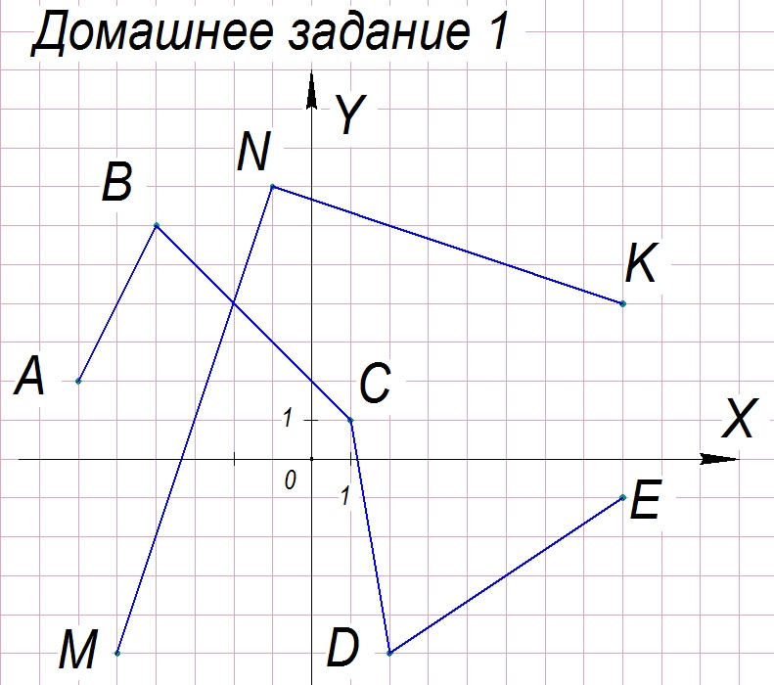
 | 2. Based on the drawing, find the coordinates of the points (Attachment: ДЗ 2). |  | Solution No 2  А (-2;-2), В (1;5), С (-7;4), Е (6;-2).  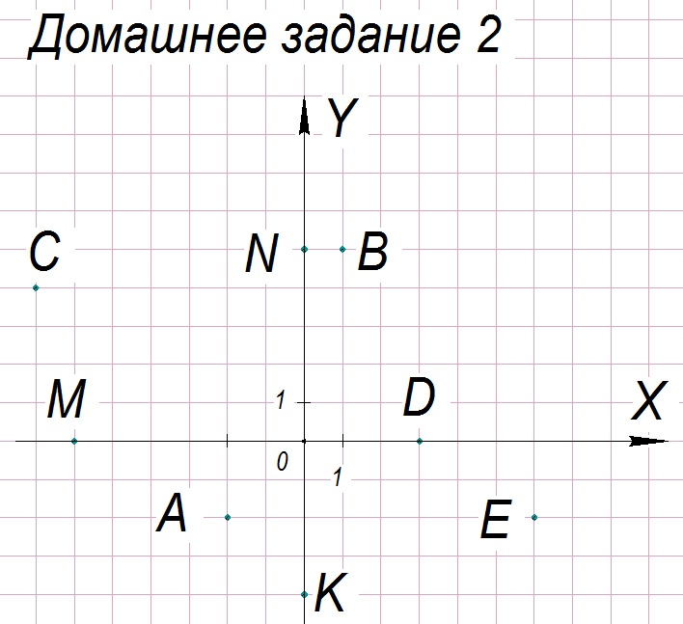
 | 3. Calculate:  а) -4.2:7+23*(5-1.1) ; |  | Solution No 3  а) -4.27 23(51.1)  =89.1  1)5.0  -1.1  3.9  - -4.2:7=-0.6;  4.2/ 7  42 0.6  -42  0  3)23  *3.9  207  +69  89.7  4)-0.6+89.7=89.1  89.7  -0.6  89.1
 | b) (-3.9*2.1+17.79):(-3.2)-2.1 |  | No 3 b) (-3.9 2.117.79) (-3.2)2.1 =-5.1  - -3.9*2.1=-8.19  3.9  *2.1  39  +78  8.19  - -8.19+17.79=9.6  17.79  - 8.19  9.60  3)9.6:(-3.2)=-3  9.6:3.2=96:32=3  4)-3-2.1=-5.1
Potential mistakes when solving No 1:
- incorrectly found abscissa (or the ordinate) of a point (on a wrong axis, in the wrong direction from the point of origin; wrong number of unit segments separated off );
- students fail to plot perpendicular lines (instead, they connect the points on axes)
Potential mistakes when solving No 2:
- incorrectly recorded coordinates ( in a wrong order, with wrong signs, wrong number of unit segments found);
- incorrectly written coordinates of points with one zero coordinate (0 is lost; coordinates written in the wrong order)
Potential mistakes when solving No 3:
- wrong order of operations,
- wrong sign when multiplying (dividing, adding, subtracting) numbers with different signs;
- calculation errors.

