MealSenseAI
Understand your food. Make healthier choices.

Final Report
A photo-based meal recognition and nutrition-awareness system for anyone who wants to understand their food, starting with people managing diabetes in Singapore
NUS-ISS Practice Project (PT & Stackable) · Individual project
Dizon Joselito Villanueva
Final draft · 29 October 2026 · system version v0.13.18 · follows the proposal of 30 September 2026
Educational estimates, not medical advice. Wei Ming, used in examples, is fictional.

Contents
Executive summary 3
1. Business case and market research 4
1.1 The problem 4
1.2 Why it matters 4
1.3 Existing solutions 4
1.4 Value proposition and users 5
1.5 Pricing and market scenario 6
2. Tools and techniques 7
3. System design and models 9
3.1 Architecture 9
3.2 The ten-stage pipeline 9
3.3 Data 10
3.4 Recognition model 10
3.5 Several foods on a plate 11
3.6 Portions, nutrition and glycaemic load 11
3.7 Glucose model 11
3.8 Grounded Meal Advisor 12
3.9 Learning safely from users 12
4. System development and implementation 13
4.1 Process 13
4.2 From proposal to build 13
4.3 Main features 14
4.4 Implementation and optimisation choices 14
5. Experiments 16
6. System performance 18
6.1 Recognition 18
6.2 Speed 20
6.3 Nutrition and glycaemic coverage 21
6.4 Language and text matching 22
6.5 Grounded advisor 23
6.6 Glucose model scenarios 23
6.7 Quality 24
7. Findings and discussion 25
7.1 Findings 25
7.2 Trade-offs and threats to validity 25
7.3 Implications for the MVP 26
8. Conclusion and future work 26
References 27
Evidence files 27
Appendix A. Project Proposal 29
Appendix B. Mapped Functionalities to Modular Courses 30
Appendix C. Installation Guide and User Guide 32
Installation Guide 32
User Guide 32
Appendix D. AI Tool Declaration 34
D.1 AI tools used 34
D.2 Datasets and third-party sources 35
D.3 My scope of work 35

If the contents list is empty, right-click it in Word and choose Update Field.

Executive summary
MealSenseAI is a web application that estimates the foods, portions and nutrition of a meal from one photo, and from these the meal's likely effect on blood glucose, its glycaemic load (GL) and a suggested next step. Each estimate is labelled with its type and range and can be corrected by the user. The application can be used by anyone; the user's profile sets the health condition, if any, and the goals that the guidance follows. As in my proposal, the first target group is people with Type 1 and Type 2 diabetes in Singapore.
Table 1. Headline results (all measured unless marked)
Area | Result | Evidence
Food recognition | EfficientNet-B0, 320 classes, 45,800 test images: 70.6% top-1, 85.7% top-3, macro-F1 66.7%; calibration error 2.35% | overall_metrics.json, derived_summary.json
Runtime fidelity | ONNX export gives the same top-3 on 601 of 601 images; 11.8 ms per photo on CPU | onnx_parity.json
Multi-food plates | Detection precision 74.7%, recall 68.4%; 262 ms median per plate | multifood_metrics.json
Grounded advisor | 38/38 test questions passed, 0% unsupported claims, 12 ms median (rule engine) | advisor_eval.json
Coverage | 247 of 320 classes map exactly to a nutrition record; GL now estimable for 135 of 286 foods (57 published GI + 78 borrowed) | nutrition_coverage.json, v0.13.8
Quality | 65 automated tests passing; 9/9 acceptance checks, also offline; data kept across restart | TEST_REPORT.md
Language model | qwen2.5:1.5b on Buddy: 7/8 rewordings passed the validator; 1/6 explanations grounded | slm_eval.json

Main Limitations:
- Confusion between similar dishes (steak was correctly identified in 11% of matched cases)
- Portion estimates of ±35–50% from a photo, nutrition values that have not been verified against an official source
- Absence of a trial with real users. These are discussed in Section 7.

1. Business case and market research

1.1 The problem
Packaged food in Singapore carries nutrition labels, hawker food does not. In a typical hawker meal the carbohydrate is spread across rice, sauce and a sweetened drink, portion sizes differ between stalls, and mixed dishes are difficult to break down. People who need to manage carbohydrate therefore estimate by eye, and manual food logging is commonly abandoned because it takes too long.

1.2 Why it matters
Table 2. Burden of diabetes (cited figures)
Indicator | Figure | Source
People living with diabetes worldwide | about 830 million | WHO, 2022 (cited in the project proposal)
Adults in Singapore with diabetes | about 1 in 12 (8.5%) | MOH Singapore, 2023 (cited in the proposal)
Singapore residents by 2050 without effective prevention | up to 1 million | MOH projection (cited in the proposal)
Adults with diabetes, Singapore | about 699,100 (2024) | IDF Diabetes Atlas (cited in the proposal)
Adults with diabetes, Southeast Asia | 34.9 million (2000) → 106.9 million (2024) → 184.5 million projected (2050) | IDF Diabetes Atlas (cited in the proposal)
Yearly cost of diabetes to Singapore | about S$1 billion (2010), rising to S$2.5 billion (2050); most of it lost productivity | Png et al., BMC Public Health 2016
Effect of making nutrition visible | about 18% less household sugar from pre-packed drinks after Nutri-Grade | Before-and-after study (cited in the proposal)

As presented in during my project proposal, the Singapore’s Nutri-Grade study indicates that making nutrition visible changes purchasing pattern. Labelling, however, covers packaged drinks and foods only meals bought from hawker stalls remain unlabelled.

1.3 Existing solutions
Table 3. Competitive landscape (indicative monthly prices as in the proposal, USD unless stated; MyFitnessPal and Healthy 365 added)
Product | Model and positioning | Price
Foodvisor | Freemium + premium; AI nutrition and coaching | from US$15/month
Cal AI | Freemium + premium; AI calorie tracking | about US$9.99/month (about US$29.99 a year on annual billing)
SnapCalorie | Freemium + premium; AI food recognition | US$8.99–19.99/month
Healthify | Freemium + premium/CGM; AI health and metabolic health | US$10–60/month
MyFitnessPal Premium | General calorie and macro tracking, large food database | US$79.99 a year
Healthy 365 (HPB) | Free government app; logging by search or photo, 3,000+ local foods | Free
MealSenseAI (proposed) | Freemium + subscription; local food recognition, portion estimate, glucose meaning; ASEAN focus | S$3.99/month (Singapore), S$2.99/month (ASEAN)

The existing products support calorie counting and food search. None of them estimates the effect of a specific local meal on blood glucose together with the uncertainty of that estimate, which is the gap MealSenseAI addresses. In my proposal I positioned the product on features at a competitive price rather than on the lowest price.

1.4 Value proposition and users
- From photo to nutrition: foods, portions and nutrients, with Singapore dishes among the 320 classes and a local nutrition table.
- Glucose context: likely glucose impact, glycaemic load, a portion simulator and an activity what-if, available before eating.
- Labelled outputs: each value is marked as a model prediction, estimate, guidance or user input, with its range and source; nothing is saved until the user confirms.
- Users: anyone who wants to understand their food, with or without a health condition. The profile records a condition (none, prediabetes, Type 1, Type 2, gestational, or not disclosed) and goals (general wellness, carbohydrate or calorie awareness, weight management, balanced nutrition, diabetes-friendly, heart health); personalised notes follow them, for example salt and saturated fat against WHO limits for heart health, or energy density for weight.
- First focus (MVP, as proposed): people with Type 1 and Type 2 diabetes in Singapore, where carbohydrate and portion awareness matter most; also: families and carers; later: organisations that support members. For Type 1 diabetes the app supports awareness only and is never a basis for insulin dosing.
- Market focus: Singapore first, scaling to Southeast Asia; aligned with UN SDG 3 (good health and well-being).

1.5 Pricing and market scenario
In the proposal I set a freemium model with a subscription of S$3.99 a month in Singapore and S$2.99 a month in other ASEAN markets. In the built application I kept meal logging and nutrition free; glucose impact, the Meal Advisor and the simulators form the subscription.
Table 4. Tiers (prices as proposed; feature split from the built product)
Tier | Includes | Price
Free | Photo and text meal logging, nutrition per meal and day, history and trends | S$0
Subscription | Glucose impact and GL, Meal Advisor, portion and activity simulators, personal glucose calibration | S$3.99/month (Singapore) · S$2.99/month (ASEAN)
Organisations (later) | The same app for members of clinics, employers and insurers | per member, to be set with pilots

Table 5. Illustrative market scenario from the proposal (not a forecast)
 | Singapore | Southeast Asia
Addressable adults with diabetes | ~699,100 | ~106.9 million (2024)
Paying users (scenario) | 1% penetration ≈ 6,991 | scale scenario ≈ 3.9 million
Price | S$3.99/month | S$2.99/month
Year-1 gross revenue | ≈ S$334.7K at a constant user base; ≈ S$353.6K with 1% monthly growth | ≈ S$147.9 million with 1% monthly growth
Operating cost assumption | 50% of revenue (planning range 40–60%) | 50% of revenue

The above scenario is the one from my proposal and is not a forecast. It counts adults with diabetes only and so excludes users without a condition. The 50% operating-cost assumption has not been validated; the build shows only that the compute cost is low, since all models run on one CPU server without a paid AI service. I will measure willingness to pay in the trial (Section 7.3).

2. Tools and techniques
In plain terms: one image model finds the foods on a plate and another names them; a food table turns foods into nutrients; a small local text model only words the explanations. Everything runs on one ordinary server, without a paid AI service.
Table 6. Tools and techniques used, and why
Area | Tool / Technique | Rationale
Food recognition | EfficientNet-B0 (torchvision), two-stage transfer learning in PyTorch 2.11 on an RTX 5060 Ti (my home-based server; ONNX Runtime for inference | Accurate for its size; trains in about 40 minutes; runs in ~12 ms on CPU
Data preparation | Class-name normalisation, SHA-256 duplicate audit, exclusion of conflicting labels, stratified split | No duplicate image in more than one split
Food regions | YOLO11n-seg (pre-trained using COCO dataset), mask and box regions | Finds several foods and containers on one plate
Portions | Typical-serving priors, mask-area ratio to plate or bowl, user grams; uncertainty bands | A photo gives no weight; the bands state the error
Nutrition | 286-record table with provenance; exact / proxy / none mapping; difflib fuzzy lookup | Each value traceable to a record
Glycaemic load | Published GI (Atkinson 2021) plus rule-based GI borrowing from the staple | Covers local dishes without inventing values
Glucose estimate | One-compartment mass-balance ODE, OGTT anchor, per-user median-ratio calibration | Interpretable; errs on the high side
Language model | Ollama with Qwen 2.5 1.5B, JSON-schema output, temperature control | Runs locally on CPU; used for wording only
Grounding | Rule engine draft → SLM rewrite → validator (numbers ±2%, food names, unsafe phrases) | No unsupported number reaches the user (advisor replies and, from v0.13.13, meal explanations)
Personal memory | Class-probability fingerprints, cosine similarity ≥ 0.70 with a 0.05 margin | Recognises a user's own foods without retraining
Data governance | Per-sample consent, 11 screening checks, perceptual hashes, frozen dataset versions, model gate with shadow mode | Controlled use of user photos for training
Backend | FastAPI, SQLAlchemy 2, Alembic, PostgreSQL 16, Python 3.12 | Typed API, migrations on start
Frontend | React 18, TypeScript, Vite 6, Tailwind CSS 4, Recharts | Phone-first, light and dark themes
Deployment | Docker Compose (nginx, backend, db, optional Ollama and Redis), CPU | One command; works offline
Testing | pytest on real PostgreSQL, Playwright browser flows, acceptance scripts | No mocks of the database or the browser
Analysis | matplotlib, ffmpeg (demo video), python-docx / docx | Report figures and the demo

3. System design and models

3.1 Architecture
The system runs as four containers on one server (Figure 1). The browser connects only to nginx, which serves the web application and forwards /api requests to the FastAPI backend. The backend loads the models, rules and advisor in one process and stores data in PostgreSQL; photos and model packages are kept in a volume. An optional local language model runs in a separate container. No cloud AI service is used.
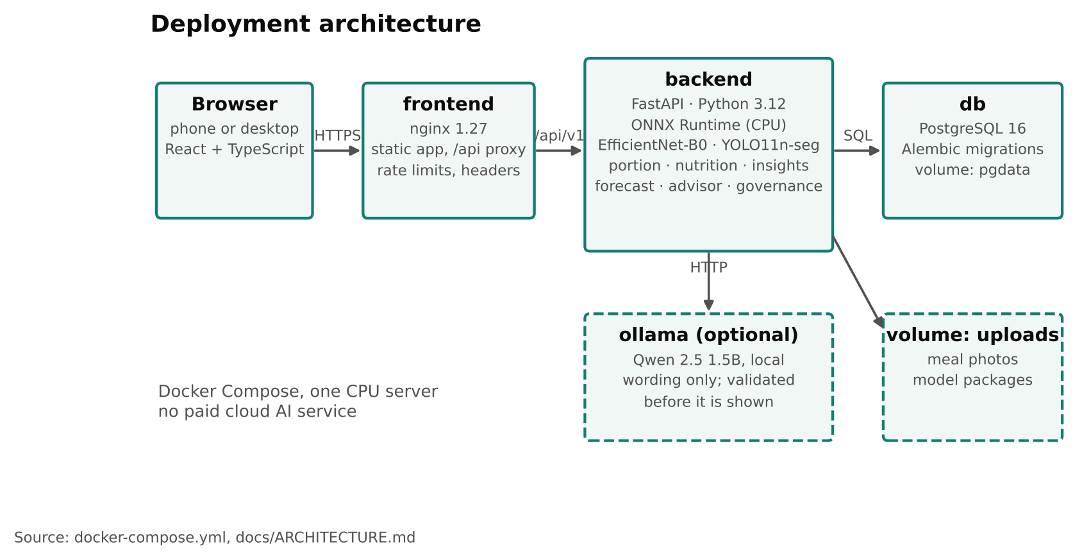
Figure 1. Deployment architecture.

3.2 The ten-stage pipeline
The original data processing pipeline I presented during the project proposal is still adopted with little deviations. The pipeline uses the ten stages (Figure 2). The result of each stage is shown to the user, and each output is tagged as a model prediction, an estimate, guidance or user input.
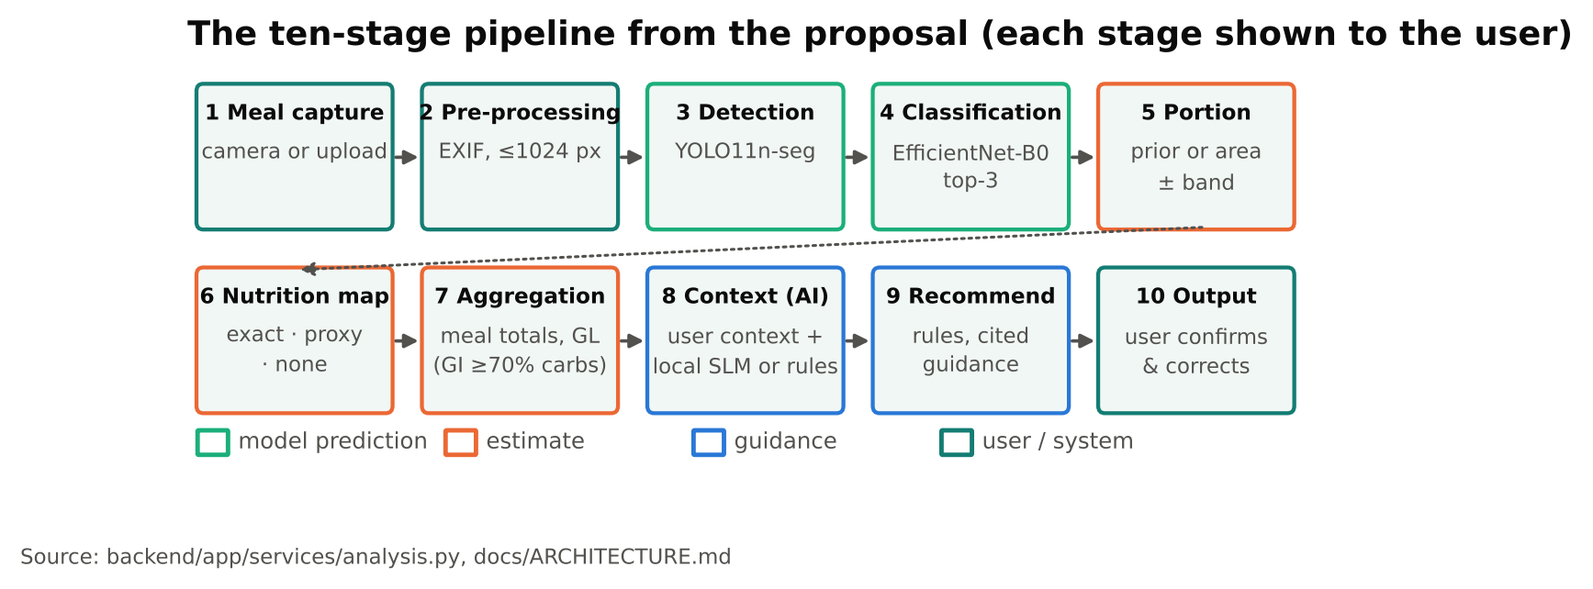
Figure 2. Inference pipeline; colour shows the kind of output.

3.3 Data
In plain terms: I taught the model with about 300,000 labelled food photos, removed duplicates and photos with contradictory labels, and kept 45,800 photos aside that the model never saw, so that it could be tested fairly.
I used the two datasets named in the proposal: FoodSG-233 (209,861 images, 233 Singapore food classes in 13 food groups) and Food-101 (101,000 images, 101 classes), 310,861 images in total as earlier proposed. I normalised the 334 original class names to 324 and then merged them into a taxonomy of 320 classes. A SHA-256 audit of every file found 2,040 groups of identical images: 2,019 groups carried conflicting labels and 728 groups crossed a split boundary. I excluded 4,193 images (4,172 with conflicting labels and 21 exact duplicates), which left 306,668 images; after the exclusion no duplicate image remained in more than one split.
For Food-101 I kept the official test set and took 10% of the official training set for validation; FoodSG-233 was split 80/10/10, stratified by class, with seed 42. This differs from the 70/15/15 split stated in the proposal and in ml/training/config.yaml: keeping Food-101's official test set makes the results comparable with published work. The final sets were 232,713 training, 28,155 validation and 45,800 test images. Augmentation was applied to the training set only. Each class is mapped to a nutrition record or marked for the user to choose (Section 3.6).
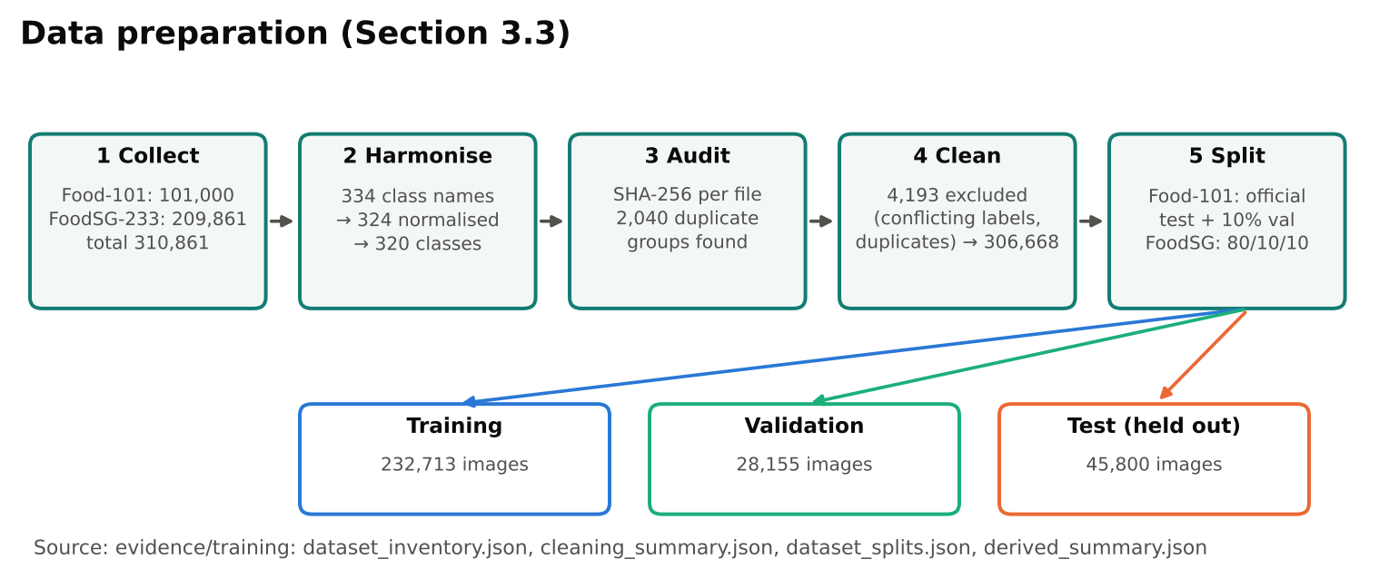
Figure 3. Data preparation: from 310,861 collected images to the three sets used for training, validation and test.

3.4 Recognition model
In plain terms: I started from a model that already recognises everyday objects and retrained it in two steps to recognise 320 foods. On photos it had never seen, its first guess is right about 7 times in 10, and the right food is among its top three guesses almost 9 times in 10.
I trained the classifier in two stages on my home server ("Buddy"; NVIDIA RTX 5060 Ti, 16 GB, PyTorch 2.11 with CUDA 12.8). EXP-001 trained only a new 320-class head on a frozen ImageNet EfficientNet-B0 (learning rate 1e-4, 5 epochs) and reached a validation macro-F1 of 57.7%. EXP-002 started from that checkpoint and also trained the last three feature blocks, raising validation macro-F1 to 66.3% (Figure 4). Each stage took about 20 minutes. Validation scores were still rising at epoch 5, so more epochs may help.
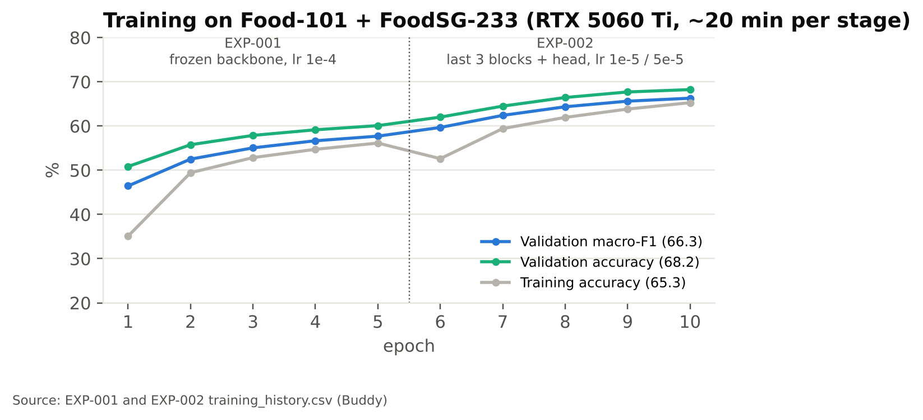
Figure 4. Training curves for the two stages (EXP-001 epochs 1–5, EXP-002 epochs 6–10).
Table 7. EXP-002 training configuration (training evidence: config.json, environment.json)
Setting | Value
Backbone | EfficientNet-B0, initialised from the EXP-001 checkpoint (ImageNet weights, 320-class head)
Classes | 320 (Food-101 and FoodSG, harmonised)
Strategy | Partial fine-tuning: last 3 feature blocks and the classifier head trainable
Optimiser | AdamW; learning rate 1e-5 (backbone), 5e-5 (head); weight decay 1e-4 (0.0001)
Schedule | 5 epochs, batch 32, seed 42, image 224 px; 20.4 min on the GPU (about 975 training images/s)
Data | 232,713 training and 28,155 validation images; test set of 45,800 held out
Augmentation | RandomResizedCrop (0.8–1.0), horizontal flip 0.5, rotation 20°, colour jitter (0.2, 0.2, 0.2, hue 0.05)
Deployment | ONNX (opset 17) on ONNX Runtime CPU; preprocessing bit-identical to training (max abs diff 0.0)

I configured the model for a CPU server: a compact backbone, partial fine-tuning to limit over-fitting, lower learning rates for the pretrained layers than for the head, and export to ONNX. I did not apply a separate calibration step; on the test set the softmax confidence is already close to the observed accuracy (Section 6.1). Items scoring below 0.20 are not added automatically, and items between 0.20 and 0.50 are marked for the user to check.
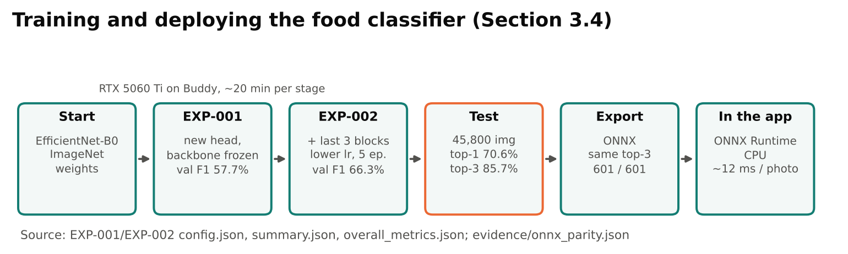
Figure 5. Training, testing and deploying the food classifier.

3.5 Several foods on a plate
In plain terms: when a plate holds several foods, the app draws a box around each one and names it separately. When it is unsure, it asks the user instead of guessing.
YOLO11n-seg proposes regions for foods and containers. Each region is cropped from the original photo and classified separately. Regions with low scores are listed as "Unidentified food" with the model's top three classes, and small or nested regions are kept as hidden suggestions. Since v0.13.2 the user can also draw a box around a food that was missed; the box is classified in the same way.
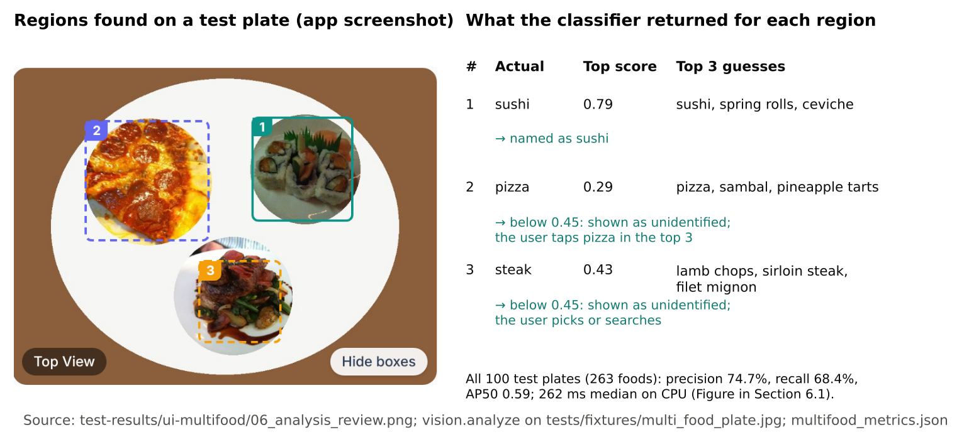
Figure 6. Evidence of multi-food recognition: regions the application found on a test plate, and what the classifier returned for each (E3).

3.6 Portions, nutrition and glycaemic load
In plain terms: the weight of each food comes from the user or from an estimate with a stated margin; nutrients come from the food table; glycaemic load shows how strongly the carbohydrate in the meal is likely to raise blood sugar.
- Portion: grams entered by the user (±15%), mask area against a detected plate or bowl (±35%), or a typical serving (±50%); a serving note such as "half" scales it.
- Nutrition mapping: each class maps to a record as exact (247), proxy, the nearest food (66), or none (7, the user chooses). Nutrients scale linearly with grams.
- Glycaemic load: GL = Σ GI × available carbohydrate / 100, reported only when GI covers at least 70% of the meal's available carbohydrate.
- GI borrowing (v0.13.8): 229 of 286 foods have no published GI. Fixed, ordered rules match a dish's name to its staple (noodles before rice, so rice noodles are noodles) and borrow that GI, labelled "≈ … borrowed from …". Where there is a choice the higher-GI staple is used, so the estimate errs high. No language model is involved.

3.7 Glucose model
In plain terms: the app estimates the shape of the blood-sugar rise after a meal, how high and for how long, and how a walk or a smaller portion would change it. It is an educational estimate, not a measurement.
The estimate is a one-compartment mass balance of meal-derived glucose G (g):
dG/dt = Rₐ(t) − k·G − Uₑₓ(t)
- Rₐ: appearance of the meal's glycaemic carbohydrate (available carbs × GI / 100) along a gamma-shaped absorption curve, whose peak is delayed by fat, fibre and protein.
- k: first-order clearance, slower with reduced insulin sensitivity (by diabetes status).
- Uₑₓ: extra uptake by working muscle, from activity energy E = MET × kg × h (Ainsworth 2011) and the carbohydrate share of fuel.
- Scale: the relative curve is anchored so a 75 g glucose drink gives a typical OGTT peak rise (+3, +5, +8 mmol/L for normal, prediabetes, diabetes). After three meals with before-and-after readings, the median ratio of measured to predicted rise calibrates it to the person.
Sources: the equation is a simplified, one-compartment form of established glucose-kinetics models (Bergman et al., 1979 [18]; Dalla Man et al., 2007 [19]). The gamma-shaped gut absorption follows Hovorka et al. (2004) [20]; activity energy uses MET values (Ainsworth et al., 2011 [2]); the share of carbohydrate burnt during exercise follows the crossover concept (Brooks and Mercier, 1994 [21]); glycaemic load is GI × available carbohydrate / 100 (Salmerón et al., 1997 [22]). The clearance rates k and the OGTT anchor rises (+3, +5, +8 mmol/L) are approximate values that I chose to be consistent with the WHO (2006) OGTT categories [23]; they are not fitted to measured data.

3.8 Grounded Meal Advisor
In plain terms: the Advisor's facts always come from the user's own records and the food table. The language model only rephrases them, and any answer containing something that cannot be checked is replaced by the plain rule-based answer.
A rule engine drafts each answer from the user's meals, profile and the food table, and each statement is tagged with its source. When the local language model is available it rewrites the wording of the draft. A validator then checks that every number in the rewrite is within ±2% of a number in the facts, that no new food names were added, and that there are no unsafe statements such as dosing or diagnosis. If any check fails, the rule-based answer is shown. Questions about medication or urgent symptoms are answered by rules only.
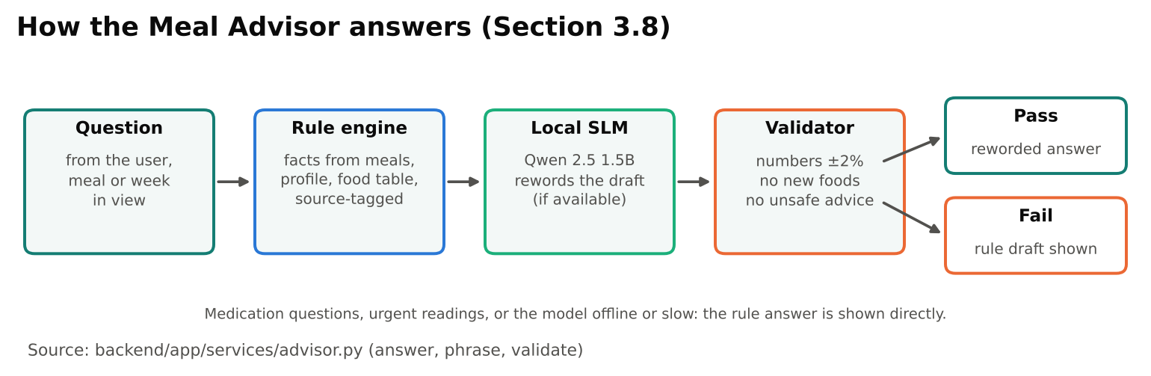
Figure 7. How a Meal Advisor answer is produced and checked.

3.9 Learning safely from users
In plain terms: the app remembers a food a user has named straight away. Photos are used to improve the model only with permission and after checks, and a new model must prove it is at least as good before it replaces the current one.
- Personal memory: a named photo region is stored as a fingerprint (square root of the 320 class probabilities). A later region is matched by cosine similarity ≥ 0.70 with a 0.05 margin over any other label. On held-out Food-101 photos, 0.70 gave 94 of 120 matches, all correct.
- Consent and screening: samples are shared for training only while the user's consent is on; withdrawal removes them from future datasets. Eleven checks (duplicates, implausible or carbohydrate-lowering relabels, repeated patterns across accounts, contributor caps, outliers) flag samples for human review.
- Model gate: a candidate must stay within 0.2 points of the live model's top-1 on a fixed test set, not regress on safety food groups (rice, noodles, sweet drinks), and agree with it on ≥ 90% of at least 200 foods in shadow mode before promotion.

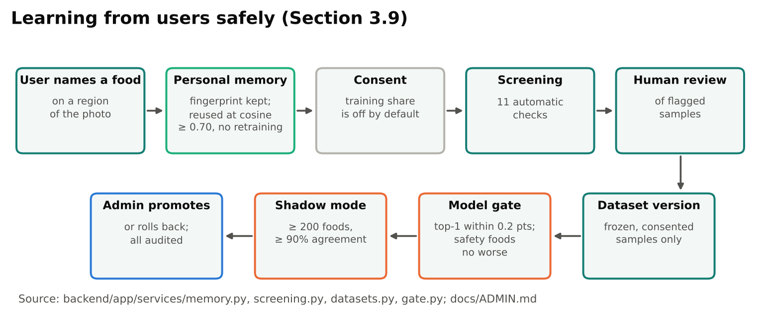
Figure 8. From a food named by a user to a new model, with consent, checks and a gate.

4. System development and implementation

4.1 Process
I developed the system iteratively, in versioned releases from v0.1 to v0.13.18 (about 55 commits between 23 and 29 October 2026, after the proposal of 30 September). I tested each release, recorded it in the changelog and test report, and deployed it to my home server ("Buddy"). The code base has about 6,800 lines of Python in the backend, 3,700 lines of TypeScript in the frontend and 2,000 lines of machine-learning tooling, with 10 test modules.

4.2 From proposal to build
Table 8. Proposed design (30 September 2026) and what was built
Proposed | Built | Why
Web UI with a webcam; smartphone later | Phone-first responsive web app (camera or upload) plus desktop | Capture happens at the table, so the phone came first
Reverse proxy, web app, application API | nginx, React app, FastAPI | As proposed
Redis job queue and a separate ML worker | One backend process; Redis optional as a cache | A full analysis takes ~0.26 s on CPU, so a queue added complexity without benefit
Vision inference service (YOLO-Seg, CNN) | YOLO11n-seg + EfficientNet-B0 on ONNX Runtime, inside the backend | Loaded once; ~12 ms per classification
Local object storage (MinIO) | A Docker volume for photos and model packages | One server; no S3 API needed yet
Model registry (MLflow) | Model updates location, model gate with shadow mode, admin promotion and rollback | Gate decisions are part of the app and audited
ML development environment (Jupyter / PyTorch) | PyTorch training and evaluation scripts on Buddy's GPU, with logged configuration, environment and history | Each run leaves its evidence files
Split 70/15/15 | Food-101 official test + 10% of train for validation; FoodSG-233 80/10/10 (232,713 / 28,155 / 45,800) | Keeps Food-101's standard test set
Nutrition reference store | 286-record table with provenance, plus users' custom foods | As proposed
Local SLM (Ollama); optional frontier LLM | Ollama with Qwen 2.5 1.5B; no external LLM | Data stays on the server; no paid AI service
Portion from plate/bowl dimensions (open challenge) | Typical-serving priors, plate/bowl area ratio, reference objects, user grams, with bands | Volume from a single 2D photo is not solved; ranges are shown

4.3 Main features
Table 9. Features and the use cases they serve
Use case | Implementation
Log a meal from a photo or a description | Capture page; 10-stage analysis; description parser (local SLM, rule-based fallback)
Check and correct | Editable review: confirm, rename (top-3 or search), portion, merge, remove; every edit logged in corrections
Add a missed food | Drag a box on the photo, tap a region the app found, or search; classified per region; remembered next time
Understand the meal | Key takeaways, glucose impact, GL (published or borrowed GI), meal composition, cited meal advisory
Try before eating | Portion simulator and activity forecast (desk vs walk), with glucose in mmol/L or mg/dL
Ask questions | Meal Advisor with evidence levels, one-tap fixes, 30-day history
See habits | Dashboard, history, nutrition trends
Govern learning | Admin area: review queue, contributors, dataset versions, model gate, settings and versioned prompts, audit log

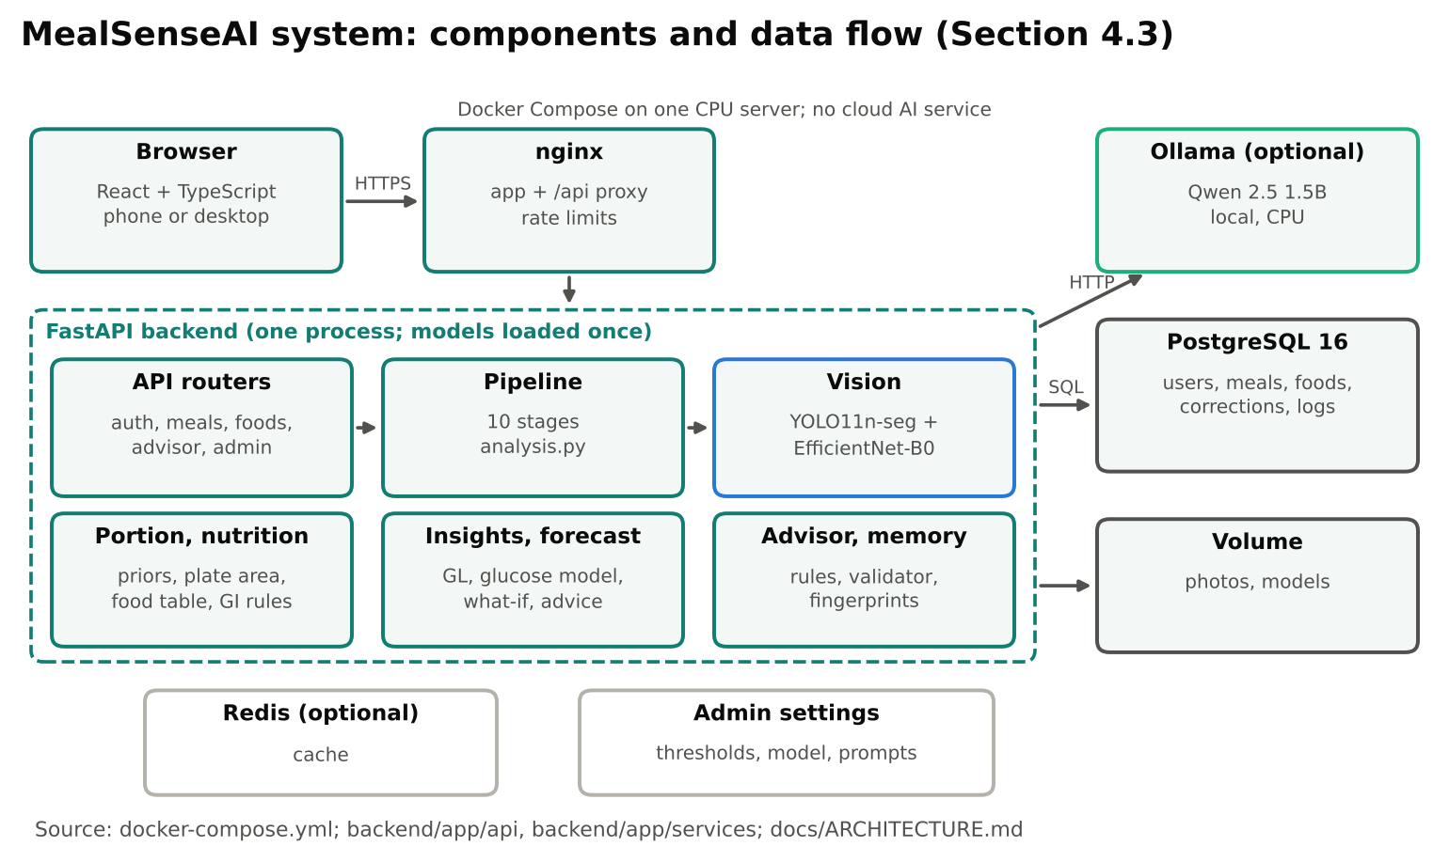
Figure 9. Components of the system and how data flows between them.

4.4 Implementation and optimisation choices
In plain terms: the app is built to be fast and cheap on one server, to keep working when the optional language model is off, and to let an administrator adjust its settings without changing code.
Table 10. Model configuration in the admin area (defaults; changes apply without a code change and are audited)
Setting | Value | Basis
Whole-photo suggestion threshold | 0.20 | Below it, top-1 accuracy on the test set is 17.4%, so the user picks from the top three
Identify threshold (plate regions) | 0.45 | Weaker regions are listed as unidentified instead of guessed
Auto-accept score | 0.50 | At or above it, top-1 accuracy on the test set is 85.7%
Personal memory match | cosine ≥ 0.70, margin 0.05 | The classifier's 320-value output serves as the embedding; 94 of 120 held-out matches, all correct
Local language model | Qwen 2.5 1.5B on Ollama | Runs on CPU at about 56 tokens/s; used for rewording only (Section 6.4)
Temperature | 0.1 | Consistent wording between calls
Time limits | 15 s per call; 60 s for the advisor | After the limit, the rule engine answers
Prompts | versioned | Each change is saved as a new version and can be activated or rolled back

- One process, models loaded once at start-up; ONNX Runtime on CPU (~12 ms per classification), no GPU required.
- Deferred explanation: results appear first; the language model's explanation is requested afterwards, so it never delays the review.
- Fail-safe language model: JSON-schema output, timeouts, a 5-minute back-off after an error, and the rule engine as fallback.
- Caching: nutrition computations and SLM replies cached (Redis optional, in-memory otherwise); custom foods never cached.
- Images: EXIF orientation fixed, originals kept for classification, a ≤1024 px copy for display.
- Security: bcrypt passwords, JWT tokens, owner-only photo access, non-root container, nginx rate limits; admin role granted only by a server command.
- Operations: Alembic migrations on every start; the database and photos in named volumes; each Compose project names its own images so a test copy cannot replace the live one.

5. Experiments
In plain terms: every claim in this report was tested. Each of the eight experiments has fixed test data, a method and a saved result file, so it can be repeated.
Table 11. Experiments and their set-up
# | Experiment | Data and method | Metrics
E1 | Classifier quality | EXP-002 on the held-out test set of 45,800 images (Food-101 official test + FoodSG-233 test), run on Buddy's GPU | Top-1, top-3, macro precision/recall/F1, per class and per dataset; confusion matrix; calibration
E2 | Runtime equivalence | 601 images; PyTorch + torchvision vs ONNX Runtime + app preprocessing | Max abs diff, top-k agreement, latency
E3 | Multi-food plates | 100 synthetic plates from Food-101 test images, 263 items; IoU ≥ 0.5 | Detection P/R, AP50; classification of matched items; latency
E4 | Grounded advisor | 38 labelled questions in 16 categories, synthetic account; expected values from the server's own records | Pass rate, unsupported-claim rate, latency
E5 | Text matching baselines | 20 meal descriptions, 15 unknown food names (10 in the table, 5 absent) | Precision/recall/F1; correct, wrong, no match
E6 | Local language model | Same sets as E5, 6 meal explanations, 8 advisor drafts; qwen2.5:1.5b on the deployment server | As E5; grounded explanations; validator pass rate; latency; tokens/s
E7 | End-to-end acceptance | Fresh deployment: sign-up → capture → top-3 override → portion → save → history; restart; offline | Pass/fail per check
E8 | Glucose model scenarios | Chicken rice + teh tarik, type 2 profile, 78 kg: desk, 15-min walk, two-thirds rice | Peak, area, GL

Table 12. Validation measures named in the proposal, and the results
Proposal measure | Result | Status
Segmentation: mean average precision | AP50 (class-agnostic) 0.59 on 100 multi-food plates; precision 74.7%, recall 68.4% | Measured (E3)
Classification: confusion matrix, accuracy, precision, recall, F1 | Top-1 70.6%, top-3 85.7%; macro precision 66.9%, recall 67.9%, F1 66.7% on 45,800 test images; 320 × 320 confusion matrix and per-class F1 | Measured (E1, E3)
Portion / nutrition: MAE or % error against known reference portions | Not measured: no weighed reference portions yet; estimates carry ±15–50% bands | Gap, planned with the trial
Recommendations: factuality, relevance, safety | 38/38 labelled questions passed, 0% unsupported claims, safety 6/6, injection 3/3 | Measured (E4)

I ran E1 on Buddy's GPU as part of training, E2–E5, E7 and E8 on a 4-vCPU environment, and E6 on Buddy's CPU. The E1 evidence (configuration, training history, predictions, classification report, confusion matrix and calibration) is in ml/models/exp002/evidence/training; the image datasets themselves are not redistributed.
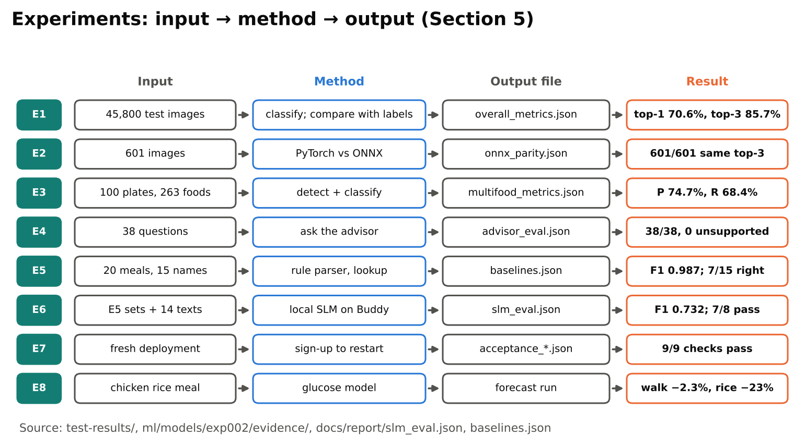
Figure 10. Each experiment: its input, method, output file and result.

6. System performance

6.1 Recognition
In plain terms: the model is right first time for about 7 in 10 photos and has the answer in its top three for about 9 in 10. It is weakest on local noodle and rice dishes that look alike. When it says it is unsure, it usually is, so the app asks the user.
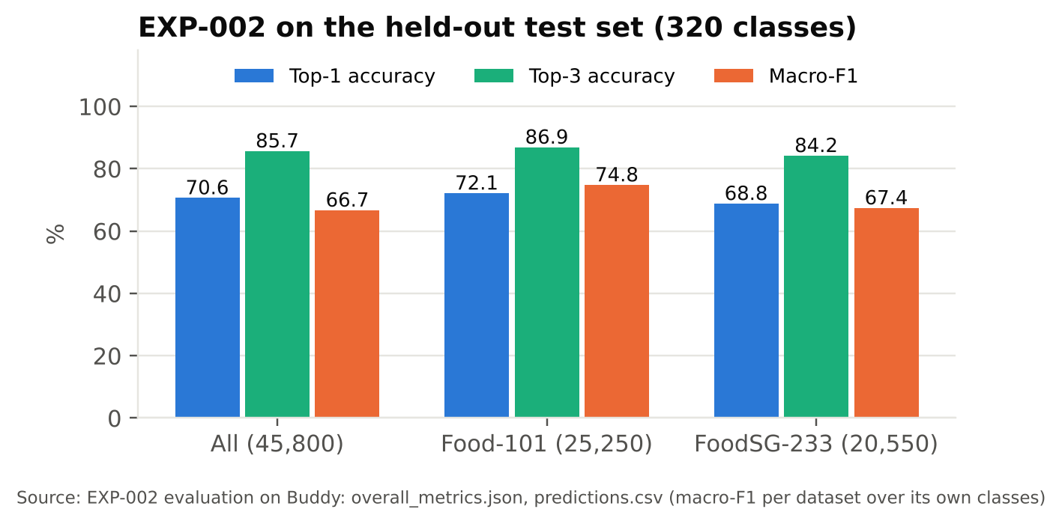
Figure 11. Classifier quality on the held-out test set (E1).
On the 45,800 test images the classifier placed the correct class first for 70.6% and within the top three for 85.7%, with macro precision 66.9%, recall 67.9% and F1 66.7%. Results were similar for the two sources: Food-101 72.1% top-1 and 86.9% top-3, FoodSG-233 68.8% and 84.2%. Because the correct class is in the top three far more often than first, the review screen always shows three candidates. The ONNX model used by the application ranked classes identically to the PyTorch model on all 601 images checked (E2), with logits differing by at most 1.35 × 10⁻⁴.
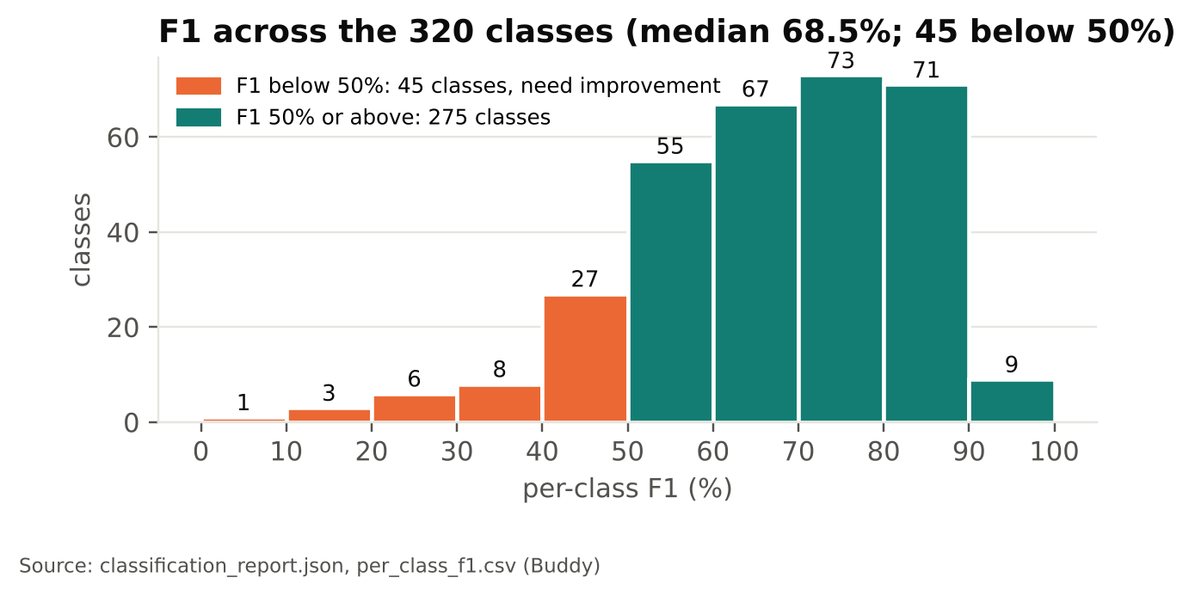
Figure 12. Distribution of F1 over the 320 classes (E1). Orange: the 45 classes with F1 below 50%, which need improvement; teal: the 275 classes at 50% or above. Each bar counts the classes in a 10-point F1 band.

Table 13. Most frequent confusions on the test set (true class → predicted class)
True class | Predicted as | Images
dumpling | xiao long bao | 70
steak | filet mignon | 49
donuts | bagel & croissant | 47
sweets | chocolate | 31
paella | paella seafood | 28
ice cream | ice cream chocolate | 28
filet mignon | steak | 27
ramen | miso ramen, with fishcake | 26

Performance varies by class. The median class F1 was 68.5%; 80 classes reached 80% or more and 45 were below 50%. The weakest were mostly local noodle and rice dishes that look alike, such as fried mee siam (0%), soto bee hoon (15%), bee hoon (23%), mee kuah (24%) and yam rice (25%). The most frequent confusions are between closely related dishes (dumpling and xiao long bao, steak and filet mignon), which usually have similar nutrition.
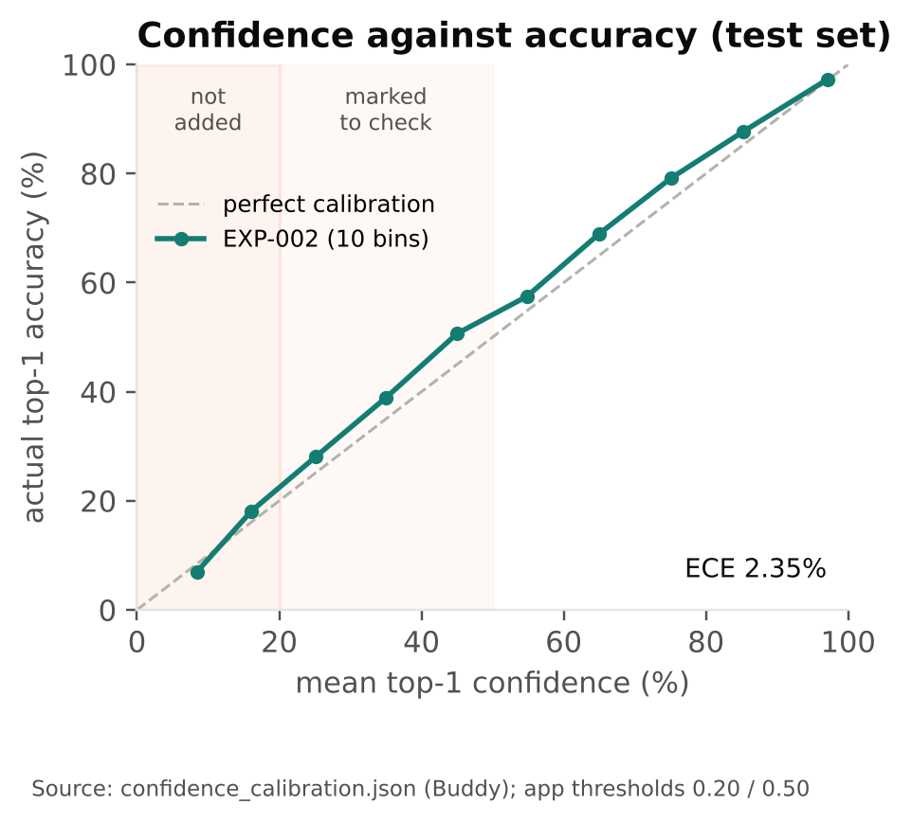
Figure 13. Top-1 confidence against observed accuracy, 10 bins (E1).
The model's confidence was close to its observed accuracy, with an expected calibration error of 2.35% over ten bins; where it deviates, it is slightly under-confident. This supports the thresholds used in the application: the 4.6% of test images scored below 0.20 had a top-1 accuracy of 17.4%, the 25.8% scored between 0.20 and 0.50 had 39.4%, and the 69.6% scored at 0.50 or above had 85.7%.
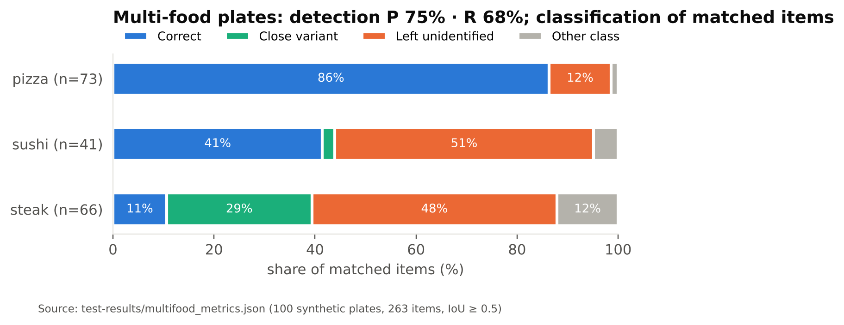
Figure 14. What happened to each true item on multi-food plates (E3).
On the 100 multi-food plates, detection found 180 of 263 items (recall 68.4%) and produced 61 false regions (precision 74.7%; AP50 0.59). Of the matched items, 56.1% were classified correctly first and 75.0% within the top three. Results varied by food: pizza was correct in 86% of cases, steak in 11%; a further 29% of steaks were labelled as close variants such as sirloin, which have similar nutrition, and 48% were left as unidentified.

6.2 Speed
In plain terms: a full plate is analysed in about a quarter of a second. The optional language model adds 1 to 5 seconds, so its text appears after the results.
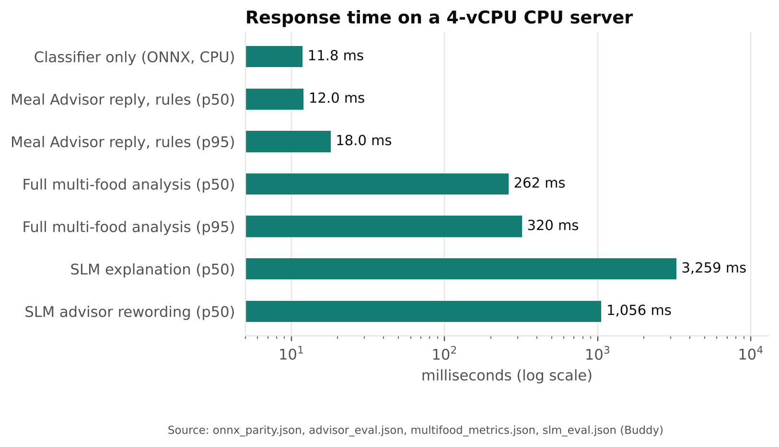
Figure 15. Response times on CPU.

6.3 Nutrition and glycaemic coverage
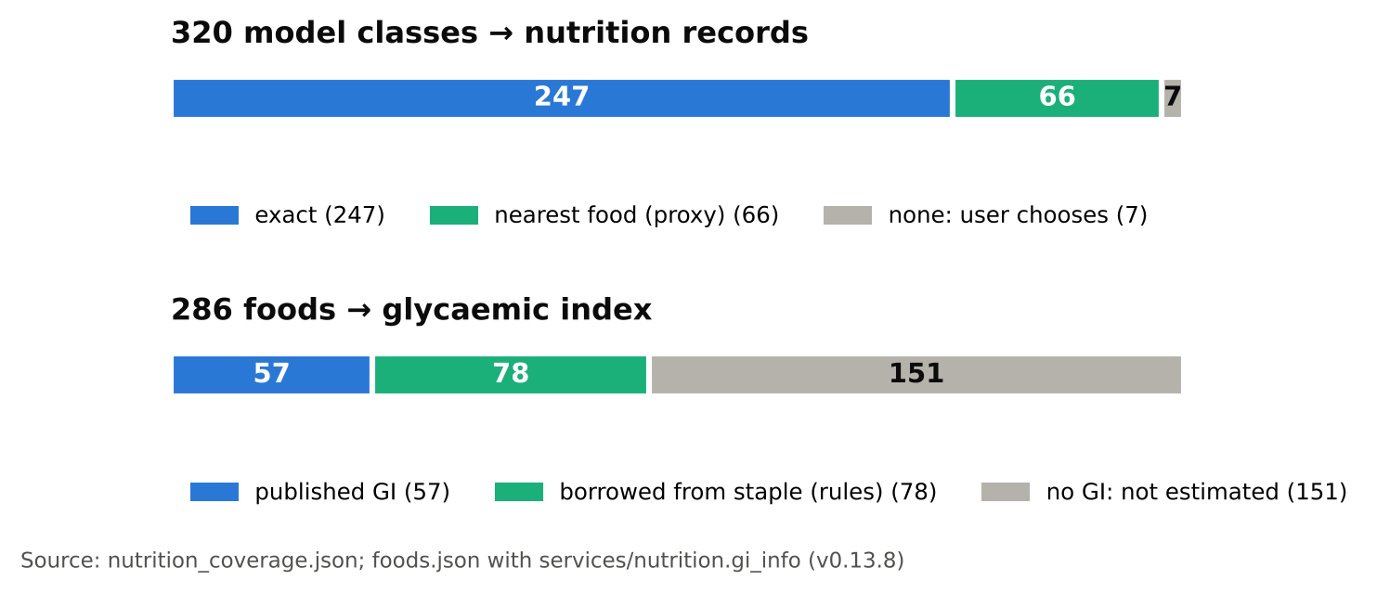
Figure 16. Mapping coverage: classes to nutrition records, foods to GI.
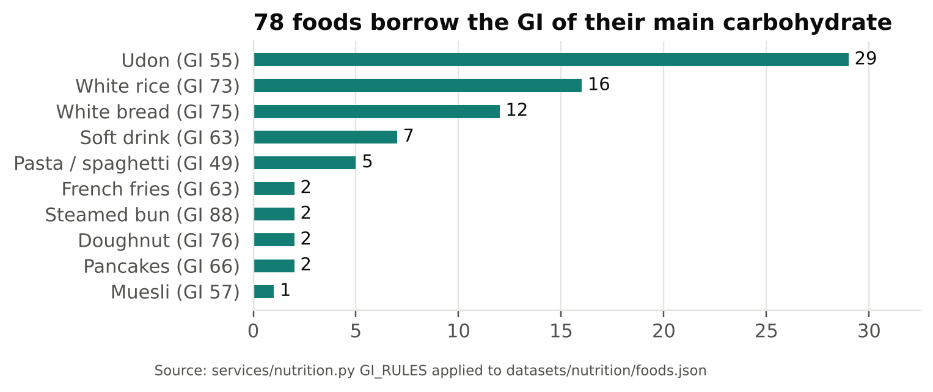
Figure 17. Where borrowed GI values come from (78 foods).
Before v0.13.8, 57 of the 286 foods had a published GI, so GL could not be calculated for most hawker meals. With rule-based borrowing, 135 foods (47%) have a GI value. Most of the remaining 151 foods are meat, vegetables, kueh and fruit, for which no single staple applies.

6.4 Language and text matching
In plain terms: the small language model was less accurate than simple rules at reading meal descriptions and matching food names, so it is only used to reword answers, and its output is always checked.
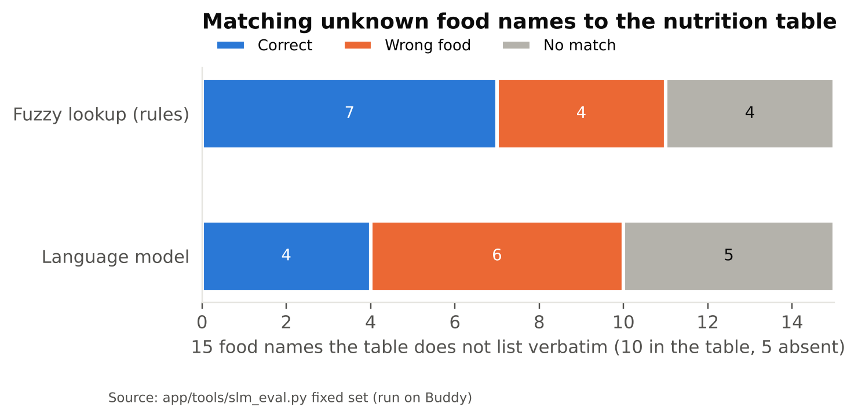
Figure 18. Matching food names that the table does not list verbatim (E5, E6).
The rule-based parser returned the exact set of foods for 19 of 20 meal descriptions (F1 0.987); it missed "soft boiled eggs". The fuzzy lookup matched 7 of 15 unknown food names correctly and 4 incorrectly (sugarcane juice to orange juice, curry chicken to chicken breast, mung bean soup to consommé, fishball soup to fried bee hoon). Because the language model is consulted only when the lookup finds no match, these incorrect matches are not checked by it (Section 7.3).
Table 14. Local language model on the deployment server (E6): qwen2.5:1.5b, 56.3 tokens/s
Task | Language model | Rule baseline | p50 / p95 ms
Description parsing (20) | F1 0.732 (P 0.812, R 0.667); exact sets 9/20 | F1 0.987; exact sets 19/20 | 884 / 1936
Unknown-name matching (15) | 4/15 correct (2/10 in table, 2/5 abstained); 6 wrong | 7/15 correct; 4 wrong | 5232 / 5830
Meal explanation (6) | 1/6 grounded (every number from the facts) | rule text (always grounded) | 3259 / 3942
Advisor rewording (8) | 7/8 passed the validator | rule answer shown | 1056 / 1559

On every task that had a rule baseline, the rules performed better than the language model: description parsing F1 0.987 against 0.732 (19 against 9 exact sets), and unknown-name matching 7 correct and 4 wrong against 4 correct and 6 wrong. For rewording advisor drafts, 7 of 8 outputs passed the validator. Only 1 of 6 meal explanations used numbers that were all present in the facts.
Meal explanations were displayed without validation, so an explanation could include a number the system had not calculated. From v0.13.13 they pass the same validator as advisor replies, and an explanation that fails is not shown; the check result is stored. With this model most explanations will be withheld. From these results I conclude that a 1.5-billion-parameter model is suitable for rewording but not as a source of facts, and that its output needs to be checked.
Table 15. Language model in real use on the deployment server (inference log, all calls since it was enabled)
Task | Calls | Completed | Mean ms | p50 / p95 ms
Meal explanation | 24 | 100% | 1,515 | 1,465 / 3,299
Meal Advisor reply | 3 | 100% | 4,735 | 5,304 / 5,314

All 27 calls returned a valid answer within the timeout. The sample is small and shows availability and speed, not answer quality. The language model added 1.5 to 5 seconds per call, compared with about 12 ms for the rules, which is why the explanation is requested after the results are displayed.

6.5 Grounded advisor
All 38 labelled questions passed (E4), covering meal retrieval, carbohydrate arithmetic, explanations, food lookup, weekly summaries, safety (6/6), prompt injection (3/3), conversation (4/4) and user isolation. No answer contained an unsupported claim. The median response time was 12 ms (18 ms p95).

6.6 Glucose model scenarios
In plain terms: for this meal, eating a third less rice lowers the estimated blood-sugar peak about ten times more than a 15-minute walk.
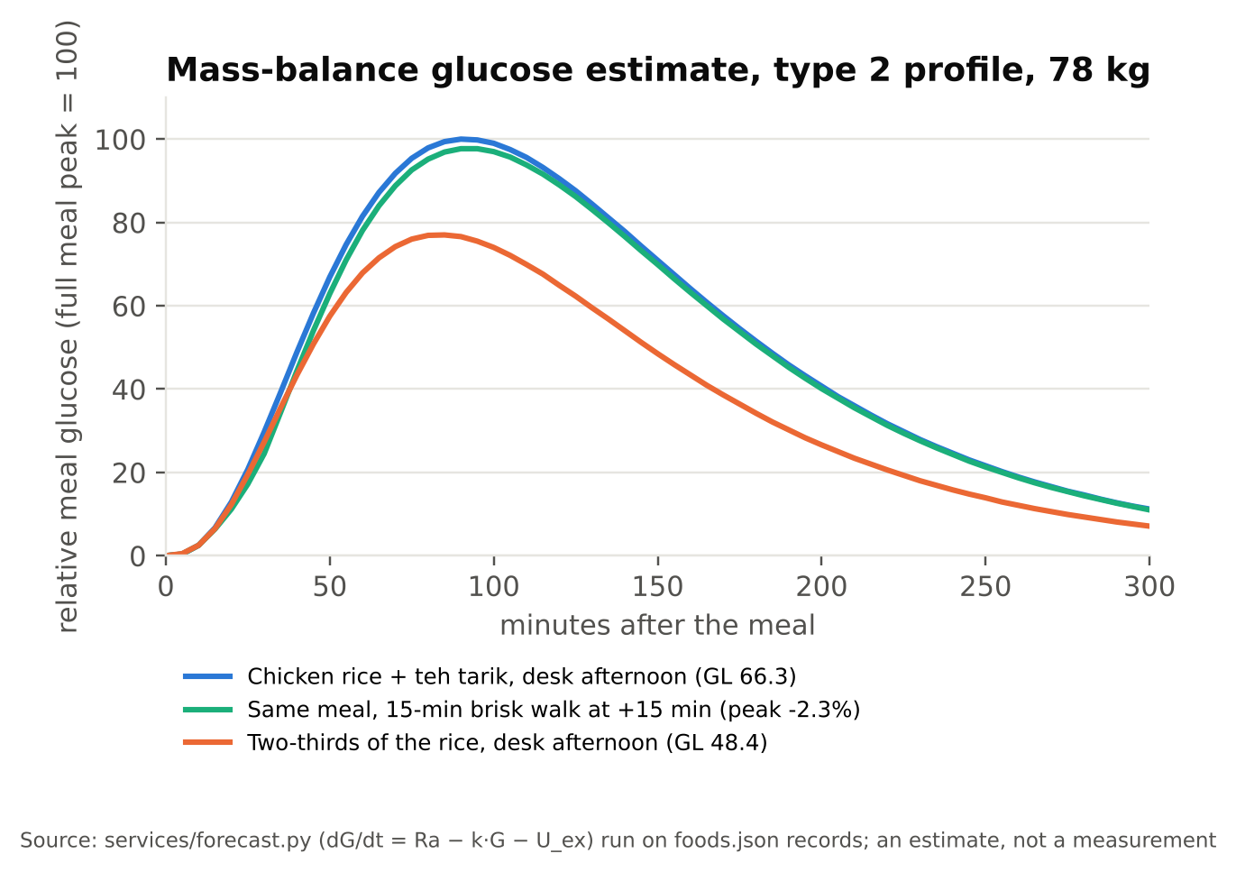
Figure 19. Estimated meal glucose for one meal under three choices (E8).
For chicken rice with teh tarik (95.6 g carbohydrate, GL 66.3), the model estimates that a 15-minute brisk walk starting 15 minutes after the meal lowers the peak by 2.3% and the area under the curve by 2.7%; the walk uses about 55 kcal, 7% of the meal's energy. Eating two-thirds of the rice lowers GL to 48.4 and the peak by about 23%. In this example the portion has a larger effect than the walk. The values are population-level estimates, not measurements.

6.7 Quality
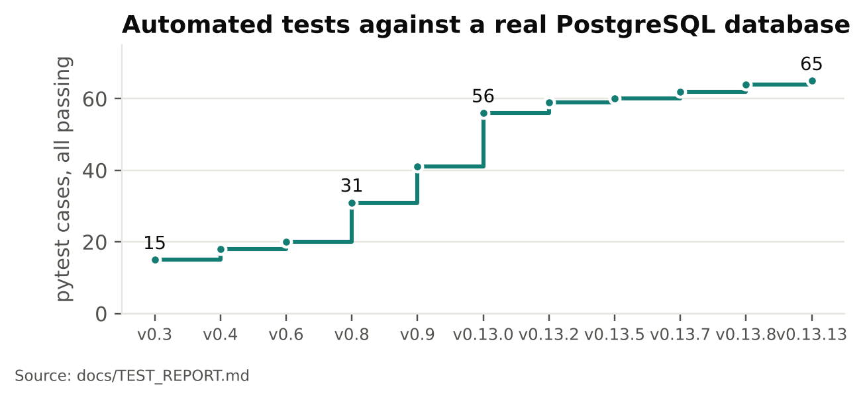
Figure 20. Automated tests over the project.
All 65 automated tests pass against a real PostgreSQL database. Browser tests pass at phone and desktop sizes without JavaScript errors. The acceptance run passed 9 of 9 checks, including with the internet disconnected, and data was retained after a restart.

7. Findings and discussion

7.1 Findings
- Top-3 with correction works: the correct class is in the top three for 85.7% of test photos, so a wrong first guess is usually corrected with one tap.
- The model's confidence is usable: calibration error is 2.35%, and the thresholds in the application separate likely-correct guesses (85.7% correct at 0.50 or above) from unlikely ones (17.4% below 0.20).
- Local dishes are harder than Western ones: 72.1% top-1 on Food-101 against 68.8% on FoodSG-233; the weakest classes are visually similar noodle and rice dishes.
- Rules for facts, model for wording: the advisor gave no unsupported claims in testing; the small language model was weaker than the rules on parsing and matching, and its meal explanations added numbers in 5 of 6 cases until they were validated (v0.13.13).
- Unidentified rather than wrong: 48% of steaks on multi-food plates were left for the user to name instead of being given a wrong label.
- Portion matters more than activity in the glucose estimate for a typical hawker meal: two-thirds of the rice lowers the peak by about 23%, a 15-minute walk by 2.3%.
- Low running cost: all models run on one CPU server; classification takes about 12 ms and a multi-food analysis about 0.26 s.

7.2 Trade-offs and threats to validity
In plain terms: the results come from curated test photos. Photos taken at a hawker stall may give lower accuracy, which the planned user trial will measure.
Table 16. Design trade-offs
Choice | Gained | Given up
EfficientNet-B0, partial fine-tuning | Runs on CPU in ~12 ms; trains in ~40 minutes | Accuracy of larger backbones; validation was still rising at epoch 5
One backend process instead of a job queue (proposal: Redis + ML worker) | Simpler deployment; analysis in ~0.26 s | Horizontal scaling for many simultaneous users
Small local language model (1.5B) | Data stays on the server; no paid AI service | Wording quality; facts must come from rules
Portion from priors and plate area | Works from one photo | Accuracy (±35–50%); volume is not measured
Top-3 review before saving | Errors corrected by the user | One extra step per meal

Threats to validity:
- Test images are dataset photos, cleaner and better framed than photos taken at a stall; accuracy and calibration on real use are not yet measured.
- Single training run with one seed; no variance across runs is reported.
- The multi-food evaluation is synthetic (100 plates composed from Food-101 test images).
- Small samples for the language model (20, 15, 6 and 8 items; 27 logged calls).
- Nutrition values are unverified (204 approximations), so nutrient and GL figures carry an error that is not quantified.
- Portion error was not measured; the proposal's MAE against weighed portions is still open.
- Internal validity of the classifier test is protected by the duplicate audit: no identical image appears in both training and test.

7.3 Implications for the MVP
- Keep the human in the loop: top-3 review and drawn boxes stay central, since one in seven photos does not have the right food in the top three.
- Keep the language model on wording only, behind the validator; re-evaluate a larger local model with the same benchmark before giving it more scope.
- Replace the nutrition table with a verified Singapore source before any clinical or commercial use.
- Ask the user when a text match is fuzzy, not only when it fails (4 of 15 confident wrong matches).
- Run the planned trial before scaling: 5–8 moderated sessions, then a two-week field trial with 15–30 participants (SUS, UMUX-Lite, trust, comprehension, willingness to pay), plus weighed reference portions for portion MAE, under PDPA consent.
- Licence: YOLO11n-seg is AGPL-3.0; a commercial MVP needs compatible terms or another detector.

8. Conclusion and future work
MealSenseAI estimates the nutrition and glycaemic effect of a hawker meal from a photo, using models that run locally on a CPU server. I trained the classifier on 306,668 de-duplicated images from Food-101 and FoodSG-233; it reaches 70.6% top-1 and 85.7% top-3 accuracy on 45,800 test images, with well-calibrated confidence. GL can be calculated for 135 of 286 foods, and the advisor's answers contain only numbers from the system's own data.
Future work:
- Measure accuracy, calibration and portion error on photos taken by users in the planned trial.
- Retrain with governed user data (consented, screened, versioned) through the model gate, focusing on the confused local dishes, and train for more epochs.
- Import a verified Singapore nutrition source and record GI provenance per food.
- Evaluate larger local language models with the same benchmark.
- Extend from diabetes to other diet-related goals already in the profile, such as weight and heart health, with their own evaluation.

References
- Atkinson FS, et al. International tables of glycemic index and glycemic load values 2021: a systematic review. Am J Clin Nutr. 2021;114(5):1625–1632.
- Ainsworth BE, et al. 2011 Compendium of Physical Activities. Med Sci Sports Exerc. 2011;43(8):1575–1581.
- Png ME, et al. Current and future economic burden of diabetes among working-age adults in Asia: conservative estimates for Singapore from 2010–2050. BMC Public Health. 2016;16:153.
- Tan M, Le QV. EfficientNet: Rethinking model scaling for convolutional neural networks. ICML 2019.
- Bossard L, Guillaumin M, Van Gool L. Food-101: mining discriminative components with random forests. ECCV 2014.
- World Health Organization. Diabetes fact sheet (2022 figures), as cited in the project proposal.
- Ministry of Health, Singapore. National Population Health Survey (2023 figures), as cited in the project proposal.
- Health Promotion Board, Singapore. Healthy 365 meal log tool FAQ; My Healthy Plate.
- Reynolds AN, et al. Advice to walk after meals is more effective for lowering postprandial glycaemia in type 2 diabetes. Diabetologia. 2016;59(12):2572–2578.
- WHO. Guideline: Sugars intake for adults and children (2015); Sodium intake for adults and children (2012).
- Zheng K, Nguyen T, Chong JHS, Goh CE, Herschel M, Lee HH, Liu C, Ooi BC, Wang W, Yip J. From Plate to Prevention: A Dietary Nutrient-aided Platform for Health Promotion in Singapore. arXiv:2301.03829, 2023.
- Deng J, Dong W, Socher R, Li LJ, Li K, Fei-Fei L. ImageNet: A large-scale hierarchical image database. CVPR 2009.
- Jocher G, Qiu J. Ultralytics YOLO11, version 11.0.0. 2024. https://github.com/ultralytics/ultralytics (AGPL-3.0).
- Lin TY, et al. Microsoft COCO: Common objects in context. ECCV 2014.
- Qwen Team. Qwen2.5 Technical Report. arXiv:2412.15115, 2024.
- U.S. Department of Agriculture, Agricultural Research Service. FoodData Central. https://fdc.nal.usda.gov/
- Health Promotion Board, Singapore. Energy & Nutrient Composition of Food. https://focos.hpb.gov.sg/
- Bergman RN, Ider YZ, Bowden CR, Cobelli C. Quantitative estimation of insulin sensitivity. Am J Physiol. 1979;236(6):E667–E677.
- Dalla Man C, Rizza RA, Cobelli C. Meal simulation model of the glucose-insulin system. IEEE Trans Biomed Eng. 2007;54(10):1740–1749.
- Hovorka R, et al. Nonlinear model predictive control of glucose concentration in subjects with type 1 diabetes. Physiol Meas. 2004;25(4):905–920.
- Brooks GA, Mercier J. Balance of carbohydrate and lipid utilization during exercise: the "crossover" concept. J Appl Physiol. 1994;76(6):2253–2261.
- Salmerón J, et al. Dietary fiber, glycemic load, and risk of non-insulin-dependent diabetes mellitus in women. JAMA. 1997;277(6):472–477.
- World Health Organization. Definition and diagnosis of diabetes mellitus and intermediate hyperglycaemia. Geneva: WHO; 2006.

Evidence files
- ml/models/exp002/evidence/training (EXP-001 and EXP-002 configuration, environment, training history, evaluation, per-class F1, derived summary); docs/report/derive_training_evidence.py
- ml/models/exp002/model_card.json, evidence/onnx_parity.json, evidence/nutrition_coverage.json, evidence/train_finetune.py
- test-results/multifood_metrics.json, advisor_eval.json, acceptance_*.json; docs/TEST_REPORT.md
- backend/app/services (vision, portion, nutrition, insights, forecast, glucose_scale, advisor, memory, screening, gate)
- backend/app/tools/slm_eval.py (E6); demo/SOURCES.md; CHANGELOG.md

Appendix A. Project Proposal
I submitted the project proposal on 30 September 2026 as a slide deck with speaker notes; the proposal document is also in the repository as 01-PRS_Project_Prposal.pdf. Its main points:
Table 17. Summary of the proposal
Item | Proposal
Problem | Hawker meals carry no nutrition label; people with diabetes estimate carbohydrate and portions by eye
Users | People with Type 1 and Type 2 diabetes in Singapore (MVP), then Southeast Asia; SDG 3
Solution | Photo-based food recognition, portion estimation, nutrition mapping and AI contextualisation with recommendations
Pipeline | Ten stages from meal capture to application output (Figure 2)
Data | FoodSG-233 and Food-101, harmonised, de-duplicated and split for training, validation and test
Infrastructure | Web UI, reverse proxy, API, Redis job queue and ML worker, MinIO, MLflow, Jupyter, local SLM on Ollama, optional frontier LLM
Validation | Segmentation mAP; classification confusion matrix, accuracy, precision, recall, F1; portion MAE; recommendation factuality, relevance and safety
Business model | Freemium; subscription S$3.99/month (Singapore), S$2.99/month (ASEAN)

Section 4.2 compares the proposed design with what was built, and Section 5 maps the proposed validation measures to the results.

Appendix B. Mapped Functionalities to Modular Courses
The table maps MealSenseAI's functions to the three courses of the graduate certificate.
Table 18. Intelligent Sensing and Sense Making
Topic area | MealSenseAI function | Section
Image acquisition and pre-processing | Phone camera or upload; EXIF orientation; resizing and normalisation identical to training (verified on 601 images) | 3.2, 6.1
Object detection and instance segmentation | YOLO11n-seg finds food and container regions on a plate; each region is classified separately | 3.5, 6.1
Measurement from images | Portion from the food mask's area relative to a detected plate or bowl, or a reference object, with an uncertainty band | 3.6
Sense making from several sources | Combining model output, user corrections and the user's glucose readings into meal-level meaning: GL, glucose estimate, personal calibration | 3.6, 3.7

Table 19. Pattern Recognition and Machine Learning Systems
Topic area | MealSenseAI function | Section
Data preparation | Class harmonisation (334 → 320), SHA-256 duplicate audit, exclusion of conflicting labels, stratified split | 3.3
Supervised learning with CNNs and transfer learning | EfficientNet-B0: frozen-backbone stage, then partial fine-tuning with discriminative learning rates and augmentation | 3.4
Model evaluation | Top-1/top-3 accuracy, macro precision, recall and F1, per-class F1, confusion matrix, calibration (ECE) | 6.1
Similarity-based recognition | Personal food memory: classifier output as an embedding, cosine similarity ≥ 0.70 with a margin | 3.9
Deploying and maintaining models | ONNX export with parity check; screening of training samples; model gate with shadow mode | 3.9, 6.1

Table 20. Problem Solving using Pattern Recognition
Topic area | MealSenseAI function | Section
Problem formulation | Business case, users and pricing; proposal success measures | 1, Appendix A
End-to-end system design | Ten-stage pipeline from capture to output, deployed as containers on one server | 3.1, 3.2, 4
Hybrid reasoning | Rules for nutrition mapping, GI borrowing and advice; a local language model for wording, checked by a validator | 3.6, 3.8, 6.4
Modelling | Glucose response as a one-compartment mass-balance model with activity uptake | 3.7, 6.6
Evaluation in context | Multi-food plates, advisor grounding, language-model benchmark, acceptance tests | 5, 6

Appendix C. Installation Guide and User Guide

Installation Guide
Table 21. Prerequisites
Item | Requirement
Operating system | Ubuntu 22.04/24.04, macOS 13+, or Windows 11 with WSL2
Docker | Docker Engine 24+ with Compose v2.24+, or Docker Desktop
Hardware | 2 CPU cores, 4 GB RAM, 5 GB free disk; no GPU needed
Network | Only to build the images the first time; the application runs offline

Install and run, from the project folder:
./scripts/start.sh --demo # first run builds the images (5–10 min)
# open http://localhost:8080 (demo@mealsense.ai / demo12345)
./scripts/acceptance.sh # acceptance tests (add --offline)
./scripts/stop.sh # stop; data is kept

- Optional local language model: start with the slm profile and set OLLAMA_URL=http://ollama:11434 in .env; the model qwen2.5:1.5b is pulled automatically.
- Optional GPU: ./scripts/start.sh --gpu (NVIDIA driver and Container Toolkit required); without CUDA the backend falls back to CPU.
- Admin role: docker compose exec backend python -m app.tools.admin grant <email>.
- Configuration (.env): HTTP_PORT (default 8080), JWT_SECRET, POSTGRES_PASSWORD, INFERENCE_DEVICE, REDIS_URL, OLLAMA_URL.
- Troubleshooting: docs/INSTALL_AND_TROUBLESHOOTING.md in the repository.

User Guide
- Register and onboard: create an account, then fill in the optional profile: personal details, health condition (stored only with consent), glucose unit and readings, and goals.
- Capture a meal: take or upload a photo; optionally describe the food or choose a plate or bowl as a reference; tap Analyze meal and follow the ten stages.
- Review: each food shows the model's top three; tap another candidate to switch, search the food list, enter grams, remove an item, or add a missed food by dragging a box on the photo. Low scores are marked for checking; below 0.20 nothing is added automatically.
- Understand the meal: glucose impact and GL, energy and nutrients against the day's goals, meal composition, recommendations, and the portion and activity what-if.
- Save and review history: choose the meal type and confirm; meals appear in Meal History, the Dashboard and Nutrition Insights.
- Ask the Meal Advisor about meals, carbohydrate, foods or the week; answers show where each fact comes from.
- Optional learning: named foods are remembered for the account; corrected crops can be shared for training in Settings, with consent that can be withdrawn.
- Administrators: the Admin menu holds training-data review, dataset versions, the model gate, model settings, prompts and the audit log.
MealSenseAI gives educational estimates. It does not diagnose or replace advice from a doctor, dietitian or diabetes care team. The full guide is docs/USER_GUIDE.md.

Appendix D. AI Tool Declaration
This appendix declares the AI tools I used, the datasets and other third-party sources, and my own scope of work.

D.1 AI tools used
Table 22. AI tools used in the project
Tool | How I used it | What it produced
Claude (Anthropic) which I refer to as “Dexter”, through Claude Code, a coding assistant with access to the repository and a cloud container | I described features, defects and decisions in conversation; it wrote and changed code, ran tests in its container, and drafted documents. It had no access to my home server ("Buddy") | Most of the application source code (backend, frontend, Docker configuration), the automated e2e tests, the evaluation scripts, the documentation, the charts, this report's draft text, the two slide decks and the demo-video scripts
ChatGPT (OpenAI), which I refer to as "Lisa" | I prepared the data and trained the model on Buddy, using Lisa to write and explain the scripts listed in the next column; I ran them myself.  It had no access to my home server ("Buddy") | Dataset cleaning and audit scripts; EXP-001/EXP-002 training and evaluation scripts
Qwen 2.5 1.5B, run by Ollama | As proposed, the Meal Advisor (a chatbot) uses this local SLM, running on Buddy. It is part of the product, not a tool used to write it. I checked its output by measuring it (Section 6.4) rather than by trusting it. | It rewords answers that the rule engine drafts from the user's own logged data, such as the week's meals; a validator checks every number before an answer is shown. Nothing is sent to an outside service.

D.3 My scope of work
I am the sole author of this project. My work covered the following; the evidence column points to where it can be checked.
Table 24. Statement of my own work
Area | What I did | Evidence
Problem and proposal | Chose the problem, researched the market and competitors, defined the users, pricing and market scenario, designed the ten-stage pipeline and the infrastructure, and set the validation measures. | Proposal deck (30 September 2026); 01-PRS_Project_Prposal.pdf in the repository (15 September 2026)
Systems Design and Architecture | I independently conceptualized, architected, and managed the development of MealSenseAI, supported by two AI assistants.  I am responsible for defining project objectives, solution architecture, machine learning approaches, and overseeing implementation, testing, and evaluation. I am also responsible for MealSenseAI application design, UI/UX design, visualization’s ideation and design and infrastructure design, setup and troubleshooting.  I remained responsible for technical decisions, validation, and overall project delivery. | Session transcripts linked from each commit; CHANGELOG.md  Proposal deck (30 September 2026); 01-PRS_Project_Prposal.pdf in the repository (15 September 2026)
Product specification | Decided every feature and its behaviour, and the priorities between them, for example top-3 correction, marking a missed food on the photo, choosing among unidentified items, collapsing insights to reduce clutter, borrowing GI for local dishes, and the safety rule that model text must never introduce its own numbers | Session transcripts linked from each commit; CHANGELOG.md
Data and model training | Selected Food-101 and FoodSG-233, obtained access, prepared and audited the data (310,861 images, 4,193 excluded), defined the split, and trained and evaluated EXP-001 and EXP-002 on my own GPU server, with ChatGPT assistance as declared in D.1 | ml/models/exp002/evidence/training (configuration, environment, training history and evaluation, dated 23 October 2026)
Infrastructure and operations | Built and run the home server "Buddy" (GPU, Docker, Ollama); deployed every release; ran the acceptance tests, the language-model benchmark and the inference-log queries; managed the GitHub repository and access.  Cloudflare configuration to publicly share running mvp. | Results I supplied: slm_eval.json, inference-log figures (Section 6.4), acceptance runs (TEST_REPORT.md)
Testing and review | Used the application on phone and desktop, reported defects with screenshots, accepted or rejected each change, and approved changes that affect safety (v0.13.13) | Session transcripts; TEST_REPORT.md
Positioning and presentation | Set the positioning (for anyone, diabetes first), the individual-project framing, and the content of both presentations; I record the narration and camera segments of the video myself | Slide decks; demo/RECORDING-SCRIPT.md

D.2 Datasets and third-party sources
Table 23. Datasets, pre-trained models and other sources
Source | Used for | Terms and citation
Food-101 (ETH Zürich): 101 classes, 101,000 images | Training and testing the food classifier | Research use; images remain the property of their owners. Bossard, Guillaumin and Van Gool, ECCV 2014 [5]
FoodSG-233 (NUS FoodLG): 233 Singapore classes, 209,861 images | Training and testing the food classifier | Non-commercial research and education; access granted by the authors on request. Zheng et al., arXiv:2301.03829, 2023 [11]
ImageNet-1k weights for EfficientNet-B0 (torchvision) | Starting point for transfer learning | Tan and Le, ICML 2019 [4]; Deng et al., CVPR 2009 [12]; torchvision weights, BSD-3-Clause code
YOLO11n-seg (Ultralytics), trained on COCO | Finding food regions on a plate | AGPL-3.0; Jocher and Qiu, Ultralytics YOLO11, 2024 [13]; COCO: Lin et al., ECCV 2014 [14]
Qwen 2.5 1.5B Instruct (Alibaba), run with Ollama | Rewording advisor answers; meal explanations | Apache-2.0; Qwen Team, Qwen2.5 Technical Report, 2024 [15]
USDA FoodData Central | 62 nutrition records | Public domain (U.S. Government) [16]
Singapore HPB Energy & Nutrient Composition of Food | 20 nutrition records | Health Promotion Board, Singapore [17]
International Tables of Glycemic Index (2021) | Published GI values | Atkinson et al., 2021 [1]
Compendium of Physical Activities | MET values for the activity what-if | Ainsworth et al., 2011 [2]
Wikimedia Commons meal photos | Demo video and examples only, not training | Free licences; credited per photo in demo/SOURCES.md

The remaining 204 nutrition records are approximations I added so that most classes have a value; they are labelled as such in the application and are not verified. The datasets are not redistributed with the project; only the trained model and its evaluation results are included.

