Born in Bradford RAG Assistant: Architecture and Methodology
Pilot technical note
Purpose. This document summarises the current retrieval-augmented generation (RAG) assistant built for the Born in Bradford data dictionary pilot. The system is intended as a first prototype to understand how an LLM-based research assistant can help researchers discover variables, understand questionnaires and measures, and locate relevant BiB papers and data variables.
Current deployment. The pilot is hosted on Google Cloud using a GPU Compute Engine VM (g2-standard-4 with one NVIDIA L4). The current hosted model is a local quantised GGUF version of the BiB fine-tuned Llama 3.1 8B model, served through llama.cpp / llama-cpp-python with full GPU offload.

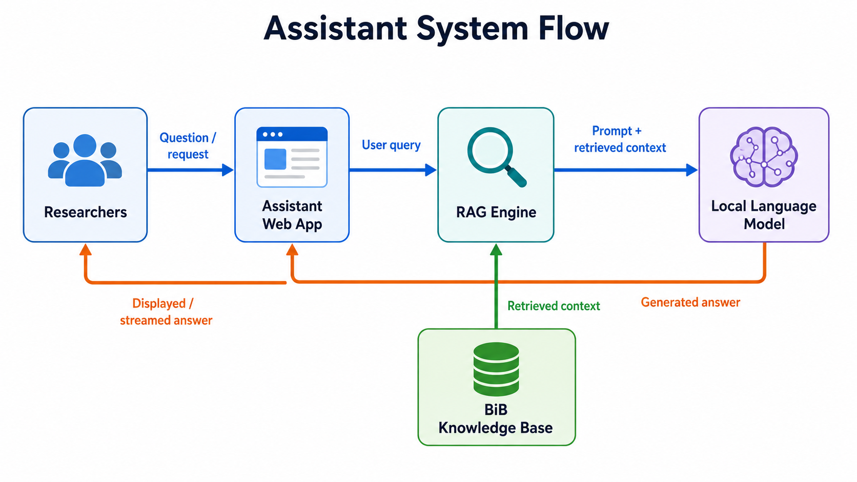

1. System Architecture
Layer | Main components | Role in the system
User interface | Data dictionary site, full assistant page, chat widget | Researchers ask natural-language questions while browsing the data dictionary or using the standalone assistant.
Application server | Flask app | Serves the UI, routes /api/chat requests, handles Basic Auth, variable-result rendering, and response streaming.
Retrieval engine | ChromaDB, MiniLM embeddings | Retrieves relevant paper/document chunks, questionnaire passages, table metadata, and variable records.
Deterministic registry | docs/csv/all_variables_meta.csv, all_tables.csv, parsed HTML data dictionary pages | Supports exact variable discovery, export baskets, table links, and complete variable lists.
Language model | Quantised GGUF BiB Llama 3.1 8B via llama.cpp | Synthesises retrieved context into grounded prose answers. Quantisation improves deployment feasibility but may reduce answer quality.
Hosting | GCP VM, NVIDIA L4, Caddy, systemd | Provides HTTPS pilot access for internal users and keeps the model loaded on GPU for faster responses.

2. Indexing and Retrieval Methodology
Knowledge sources. The assistant indexes multiple BiB knowledge sources: CSV variable metadata, table metadata, parsed HTML data-dictionary pages, local research paper PDFs, paper metadata/abstracts, questionnaires, survey instruments, and curated tool/reference documents such as RCADS-25. This gives the assistant access to both structured registry data and unstructured explanatory text.
Index construction. During indexing, text is chunked into retrievable passages and embedded locally using a sentence embedding model. The resulting vectors are stored in ChromaDB. Variable and table metadata are also normalised so that registry-style questions can be answered deterministically, with complete variable rows and links back to data dictionary tables.
Generation and grounding. The LLM is instructed to answer only from retrieved context or deterministic registry results, distinguish published papers from protocols/data summaries/questionnaires, avoid unnecessary tables for ordinary prose answers, and separate exact dates from age ranges or cohort labels. Variable discovery answers retain the existing structured UI so users can add variables to the export basket.

3. Current Quality and Safety Controls
- Exact variable discovery is backed by the data dictionary registry rather than the generative model, reducing hallucinated variable lists.
- Broad publication questions use a de-duplicated publication shortlist to avoid returning repeated chunks from the same paper.
- Follow-up questions inherit the previous topic where appropriate, reducing retrieval drift for short turns such as “what other ones have been used?”.
- Basic Auth and HTTPS protect the pilot endpoint, while the Flask app itself is bound to localhost behind Caddy.

4. Known Limitations
- The model is quantised for deployment, which improves memory use and speed but can reduce fluency, reasoning quality and faithfulness compared with larger hosted models.
- Retrieval quality remains the main determinant of answer quality. If relevant evidence is missing or noisy, the model may produce incomplete or overly generic answers.
- The current context window and context cap are intentionally conservative for latency; complex research questions may need broader retrieval or multi-step summarisation.
- The pilot uses shared Basic Auth rather than named user accounts, so it is suitable for a small internal trial but not for long-term access management.

5. Improvements Needed to Scale the System
Expanded research-paper coverage. The current PDF index is based on a relatively small subset of available research papers, approximately 100-200 documents. Expanding this to a much larger and more complete set of Born in Bradford publications would improve the assistant’s ability to answer literature, methods, measures, and evidence-summary questions. This would also require stronger metadata management to avoid mixing research papers with data summaries, protocols, questionnaires, or administrative documents.
Stronger language models. For better answer quality, especially on multi-step synthesis questions, the system should evaluate larger models such as 16B+ instruction-tuned models where GPU capacity and cost allow. Larger models are likely to improve reasoning, reduce repetition, and better follow evidence constraints, although they would increase serving cost and infrastructure complexity.
Improved embedding methods. The current system uses all-MiniLM-L6-v2, a lightweight local embedding model. This is fast and easy to deploy, but stronger embedding models could improve retrieval quality, especially for complex research questions, acronyms, measures, and semantically similar concepts. Larger or domain-tuned embedding models would require more compute and a rebuilt index, but may substantially improve recall and source relevance.
CI/CD Based monitoring and evaluation. Track retrieval recall, answer faithfulness, latency, and user-rated usefulness automatically after each system update as part of a CI/CD workflow.
User analytics and feedback. Add lightweight analytics and feedback collection to understand how users interact with the assistant, where they get stuck, which questions fail, and which UI features are most useful. This should include explicit feedback on answer quality, missing evidence, confusing outputs, and navigation problems, while being transparent about what is collected.
Better indexing and retrieval. The current system already uses separate collections for papers, variables, tables, questionnaires and tool references, with some metadata and keyword-style registry logic. The next improvement would be to make this more systematic: richer PDF parsing with reliable page and section metadata, stricter source type labels, fuller citation metadata, curated BiB measure/tool definitions, and a production hybrid retriever combining semantic search, keyword search, metadata filtering and reranking. This would reduce noisy context but requires more ingestion engineering, index rebuilds, evaluation, and potentially more compute.
Model serving. For broader use, consider a managed GPU endpoint, larger context windows, or a stronger model where cost permits. The current llama.cpp service is simple and portable but not optimised for many simultaneous users.
Further BiB-specific fine-tuning. Further fine-tuning research could help develop a stronger Born in Bradford-specific model. This could use curated question-answer pairs, retrieval-grounded examples, abstention examples, citation-following tasks, and examples of common BiB concepts such as cohorts, projects, variables, tables, questionnaires, measures, and data access constraints.
User access and governance. Replace shared Basic Auth with named accounts, SSO or identity-aware proxy. Add audit logs, rate limiting, clear privacy guidance, and a feedback button for incorrect or unsupported answers.
Operational robustness. Use infrastructure-as-code for reproducible deployment, automated backups of the Chroma index/model artefacts, health checks, alerting, budget alerts, and a documented disaster-recovery path. If guaranteed GPU uptime is needed, evaluate GPU reservations or a managed inference provider.
Product workflow. Add answer citations/source previews, clearer confidence and “retrieved evidence” panels, improved export workflows, and an admin workflow for adding new papers, questionnaires and curated tool references without rebuilding the whole application manually.

