# **CVI620/DPS920- Lab 5**

# **Histograms and Filtering**

| Total Mark: | 10 marks (2.5% of the total course grade)   * 7 out of 10: Blackboard submission * 3 out of 10: Lab demo |
| --- | --- |
| Submission file(s): | * Lab05_1.cpp * Lab05_2.cpp * Lab05_20W.docx |

Please work in **groups** to complete this lab. This lab is worth 2.5% of the total course grade and will be evaluated through your written submission ***(include all results)***, as well as the lab demo. During the lab demo, group members are *randomly* selected to explain the submitted solution. Group members not present during the lab demo will lose the demo mark. Only one person must submit for the group.

## **Part I: Histograms**

1. Create a program (save as Lab04_1.cpp). Include code to:
   1. Open a color image and display.
   2. Convert the image to gray scale using cv::cvtColor (see OpenCV documentation) and display.
   3. Apply histogram equalization to the gray image and display the results.

*(INSERT ‘BEFORE’ AND ‘AFTER’ IMAGES HERE)*

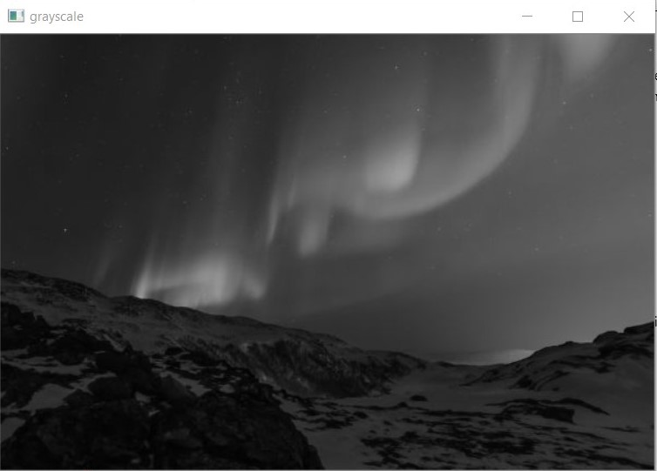

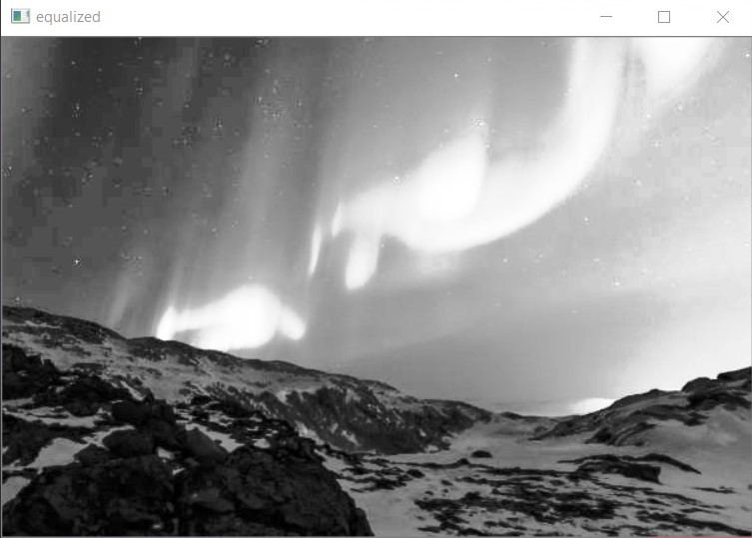

## **Part II: Filtering**

1. Create a program (save as Lab04_2.cpp). Include code to:
   1. Open a color image and display.
   2. Ask for a probability value between 0 and 1, and implement the salt and pepper noise with the given probability. Create a noisy image with p=0.1. Display the noisy image.
   3. Smooth the above noisy image using a 3 x 3 box kernel. Display the blurred image.
   4. Choose a pixel and output the pixel’s blue value, as well as its neighbors’. Calculate what you expect for the blurred pixel value. Then check the value for the blurred image. Are they the same?
   5. Filter the above noisy image using a 3 x 3 bilinear filter and display the result.
   6. De-noise the noisy image using a median filter and display the resulting image.
   7. Compare the results of the above filters. Which filter works better for de-noising?

*(INSERT THE DISPLAYED IMAGES HERE)*

Original:

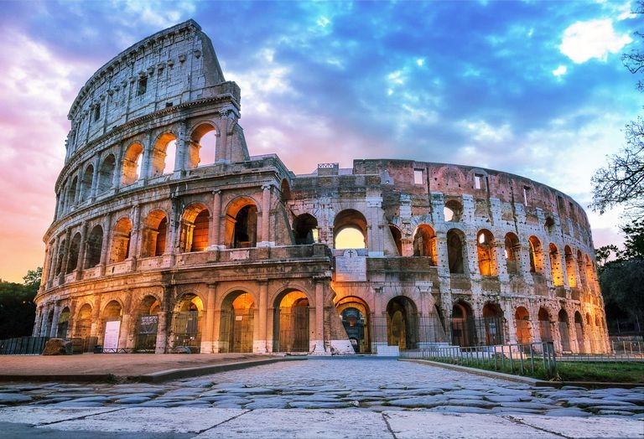

Noise:

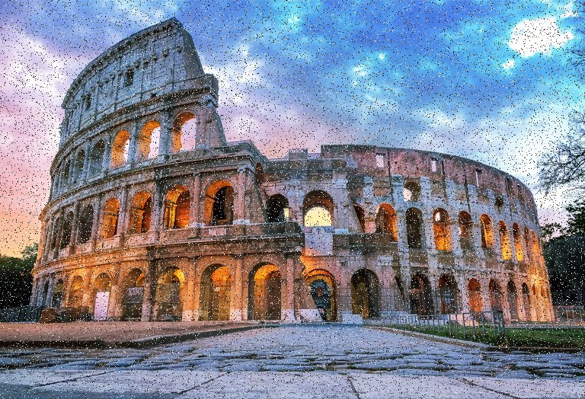

Blurred:

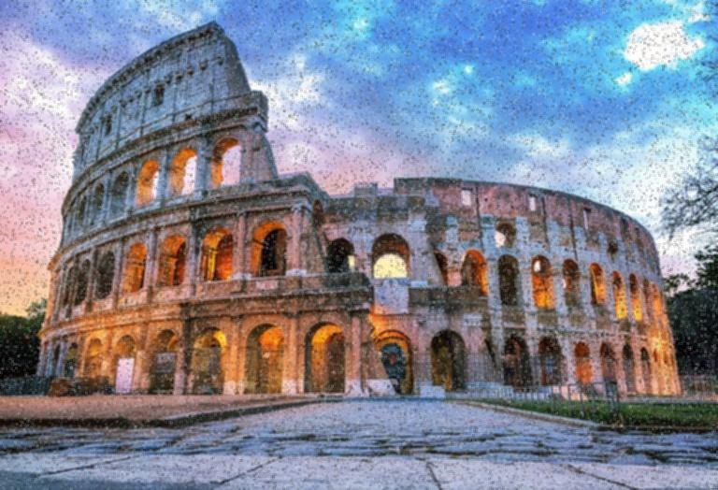

Bilinear:

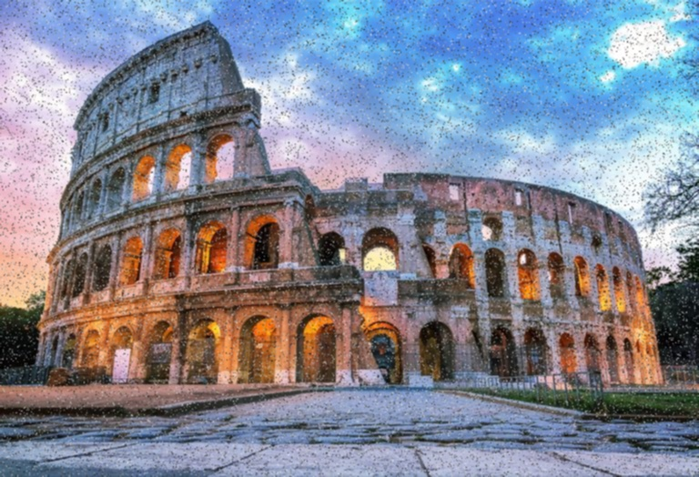

Median:

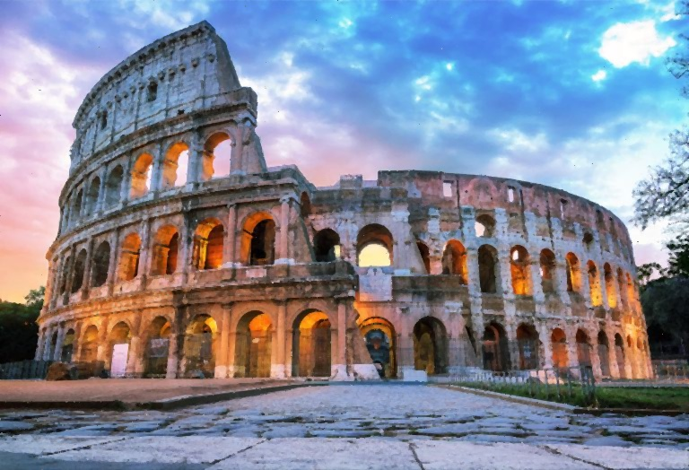

1. Add this declaration to your file:

We, Jason, Matteo, and Muqing declare that the attached assignment is our own work in accordance with the Seneca Academic Policy. We have not copied any part of this assignment, manually or electronically, from any other source including web sites, unless specified as references. We have not distributed our work to other students.

1. Specify what each member has done towards the completion of this work:

|  | Name | Task(s) |
| --- | --- | --- |
| 1 | Jason | Code |
| 2 | Matteo | Code |
| 3 | Muqing | Code |