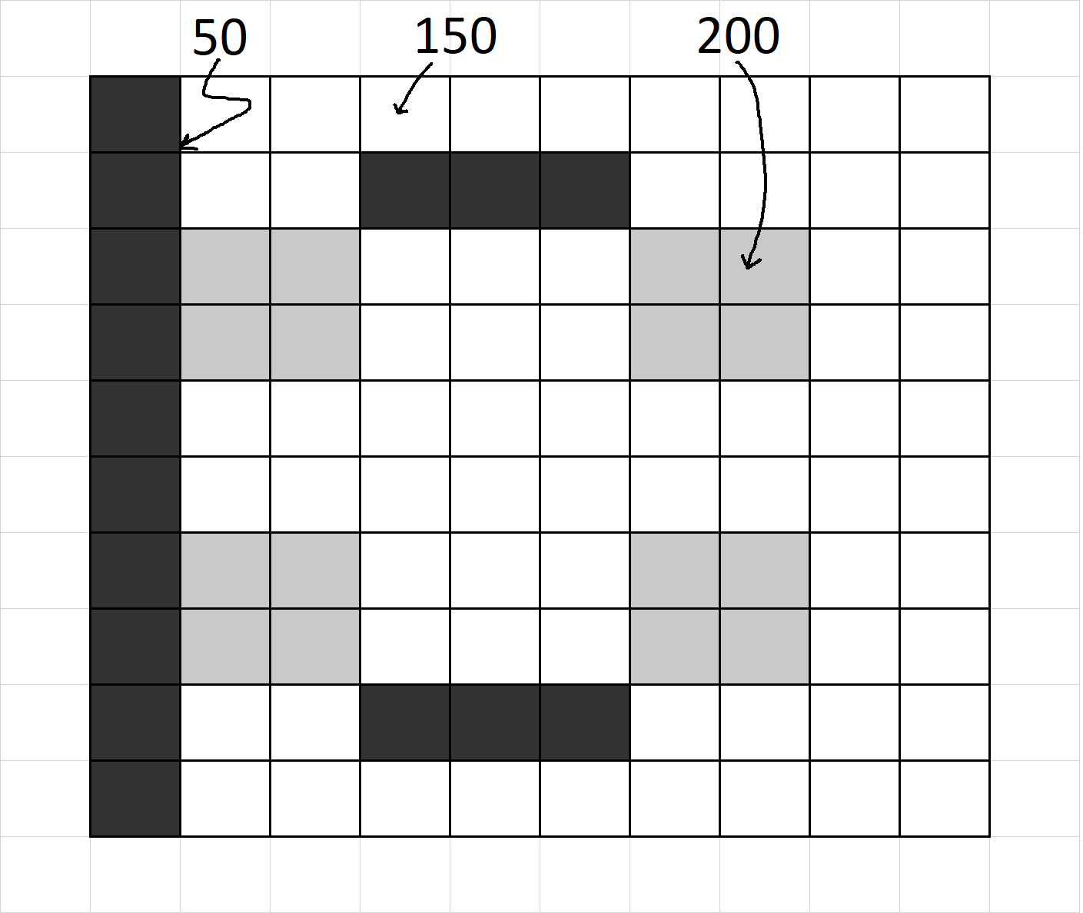**CVI620/ DPS920 Worksheet 3- Histograms**

Given the following grayscale image, plot the histograms

1. Assuming 256 bins
2. Assuming four bins

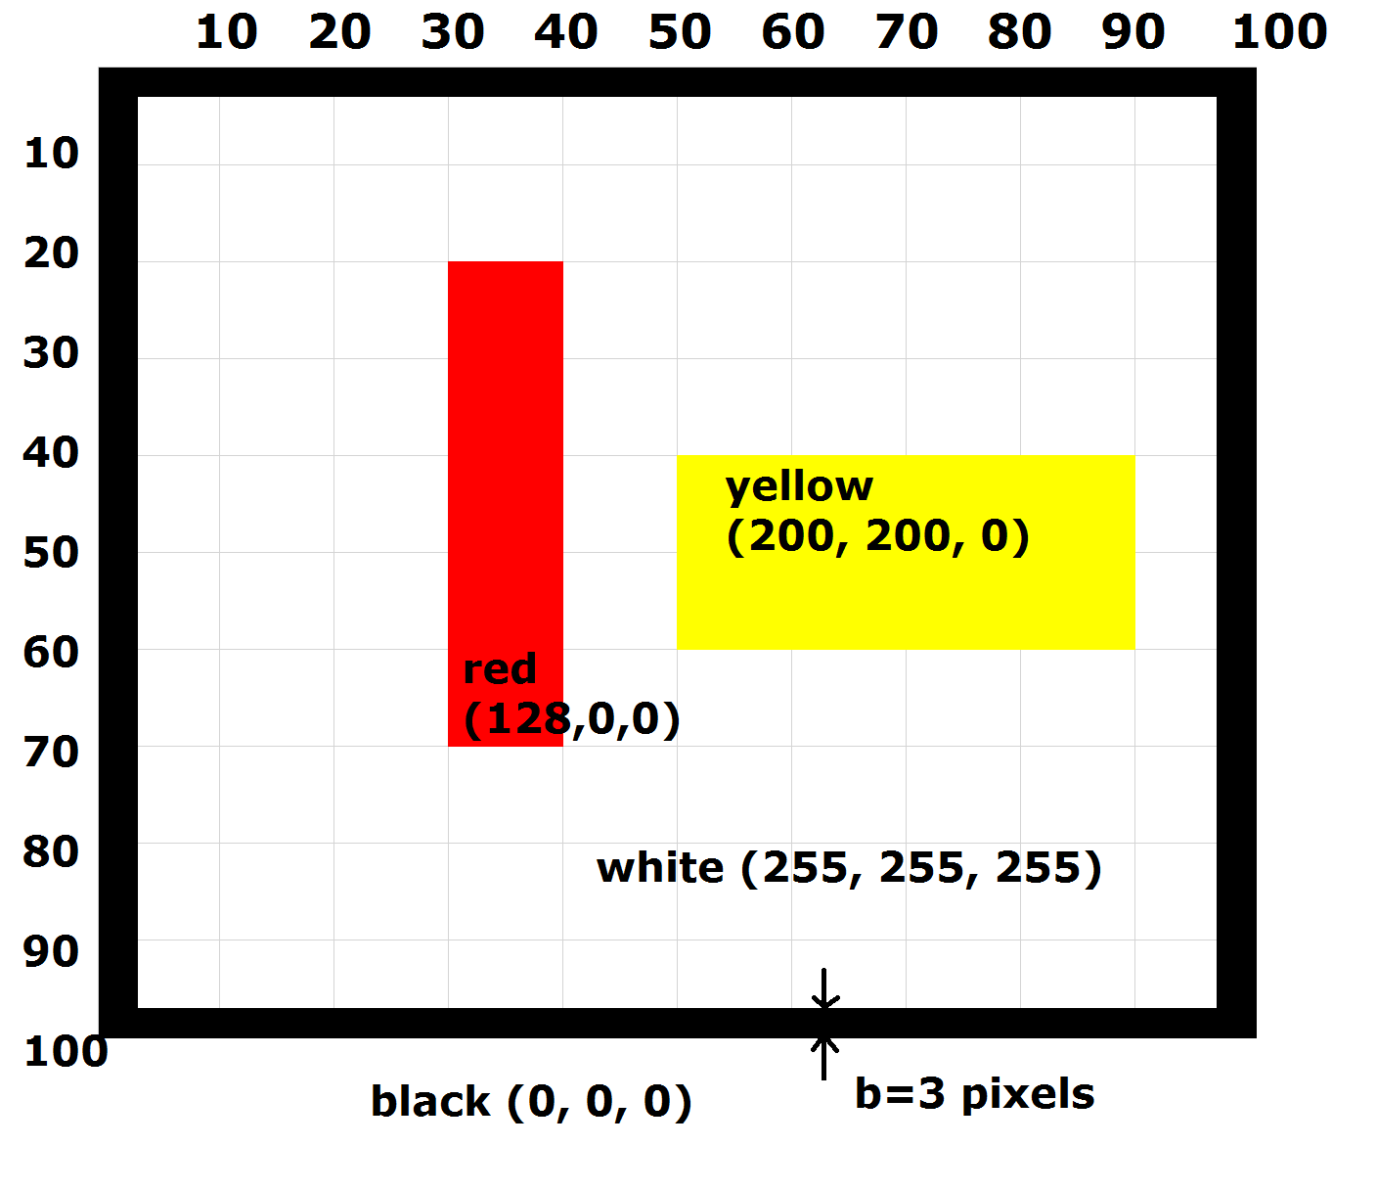

Given the following image, plot the color histograms

1. Assuming 256 bins per color
2. Assuming two bins per color