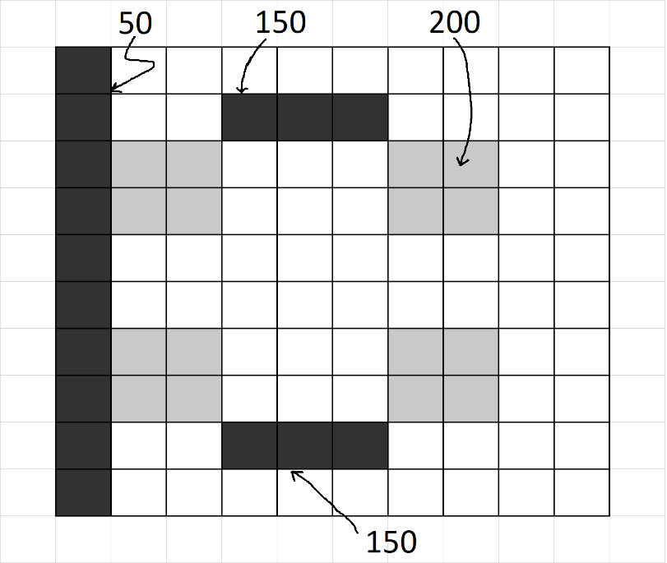**CVI620/ DPS920 Worksheet 3- Histograms**

1. Given the following grayscale image, plot the histograms
2. Assuming 256 bins
3. Assuming four bins

Answer.

|  |  |  |  |
| --- | --- | --- | --- |
| Gray | Grayscale Value | Number of pixels | Explanation |
| Darkest | 50 | = 10 | One column (10 pixels) |
| Darker | 150 | = 2 * 3 = 6 | Two segments, 3 pixels each |
| Lighter | 200 | = 4 * 2 * 2 = 16 | 4 squares, each 2 * 2 = 4 pixels |
| White | 255 | = 10 * 10 – (10 + 6 + 16) = 68 | The whole image minus the above gray parts |

1. 256 bins, i.e. one bin for each gray level

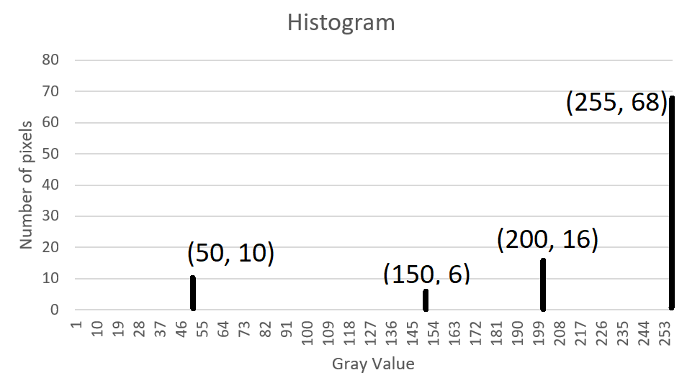

1. 4 bins

Dividing 256 values into 4 bins:

Bin width = 256/ 4 = 64

|  |  |  |
| --- | --- | --- |
| Bin | Color Values | Number of pixels |
| 0 | 0 – 63 | = 10 |
| 1 | 64-127 | = 0 |
| 2 | 128-191 | = 6 |
| 3 | 192-255 | = 16 + 68 = 84 |

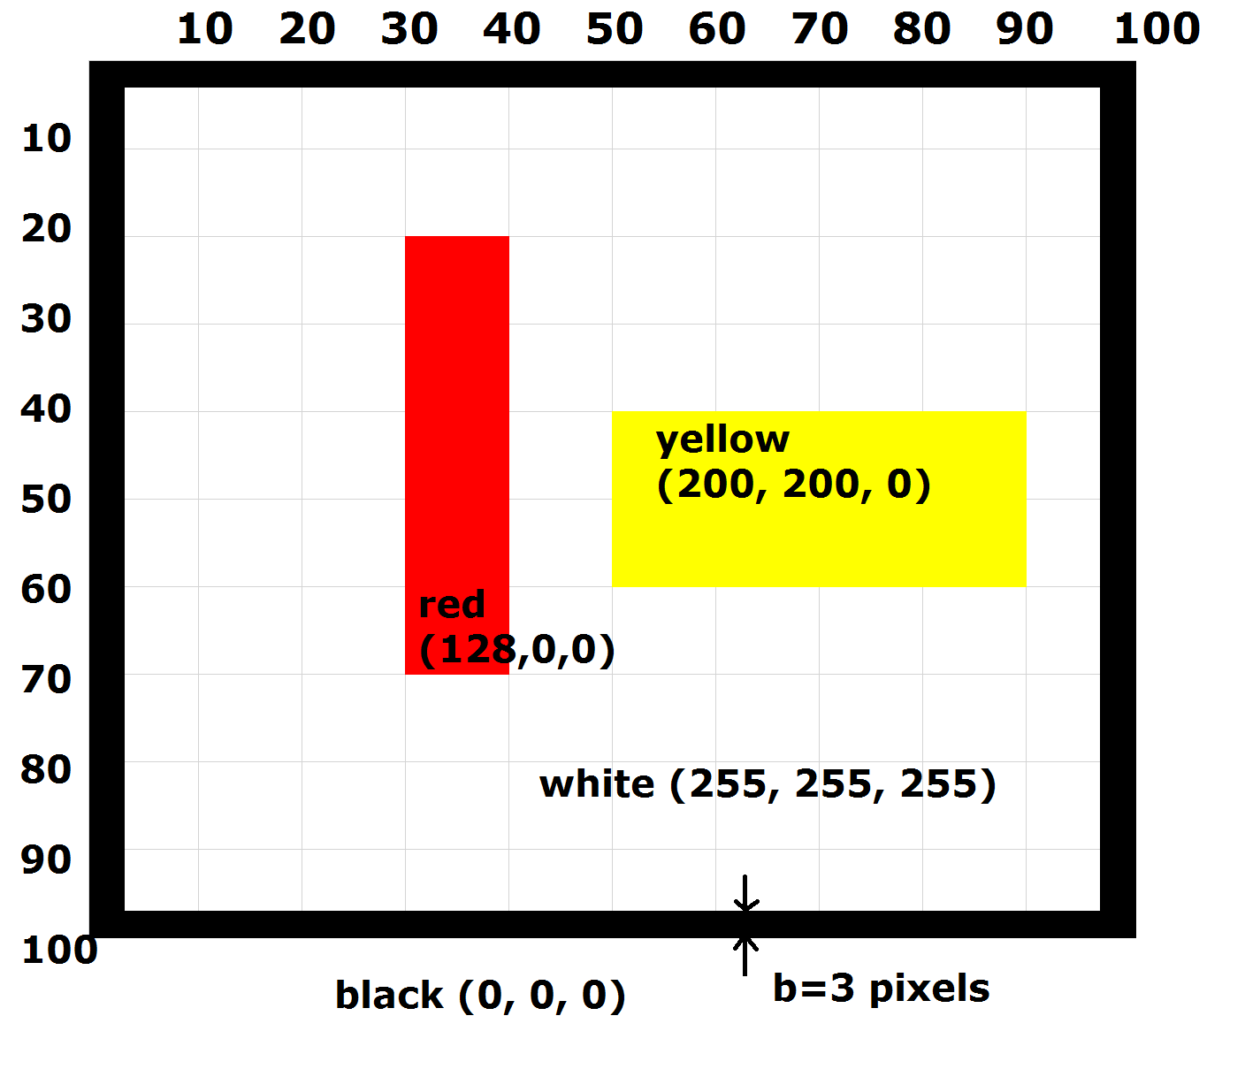

1. Given the following image, plot the color histograms
2. Assuming 256 bins per color
3. Assuming two bins per color

Answer.

|  |  |  |  |
| --- | --- | --- | --- |
| Color | Color Values | Number of pixels | Explanation |
| Red | (128, 0, 0) | = 50 * 10 = 500 | Area of a rectangle |
| Yellow | (200, 200, 0) | = 20 * 40 = 800 | Area of a rectangle |
| Black | (0, 0, 0) | = 2 * 100 *3 + 2 * (100 – 2 * 3 ) * 3 = 1164 | 4 rectangles around the borders: two rectangles with length = 100, and two rectangles with length = 94 |
| White | (255, 255, 255) | = 100 * 100 – (500 + 800 + 1164) = 7536 | The whole image minus the above colored parts |

(a)

(b) 2 bins

Dividing 256 values into 2 bins:

Bin width = 256/ 2 = 128

|  |  |
| --- | --- |
| Bin | Color Values |
| 0 | 0 - 127 |
| 1 | 128 - 255 |