**CVI620/ DPS920 Worksheet 4- Noise and Filtering**

1. Use the following formula to calculate the intensity values resulting from a salt and pepper noise applied on a small 2x2 window of an image (Iin) shown in the following figure. Assume p = 0.15 and the random numbers given for x and y at each pixel location.

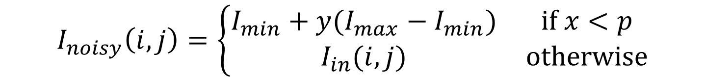



Pixel (0, 0):

$$x<p,\text{ therefore: }$$

$$I_{noisy}\left(0, 0\right)=0+0.8 \left(255-0\right)=204$$

Pixel (0, 1):

$$x>p,\text{ therefore: }$$

$$I_{noisy}\left(0, 1\right)=I_{in}\left(0,1\right)=200$$

Pixel (1, 0):

$$x>p,\text{ therefore: }$$

$$I_{noisy}\left(1, 0\right)=I_{in}\left(1,0\right)=200$$

Pixel (1, 1):

$$x<p,\text{ therefore: }$$

$$I_{noisy}\left(1, 1\right)=0+0.4 \left(255-0\right)=102$$

1. Apply a 3 x 3 averaging filter to the noisy image, assuming zero padding. Show padded image.

Assuming the 2x2 noisy image and zero padding for a 3x3 filter, we have one row or column of zeros added on each side around the image.



**0 0 0 0**

**0 204 200 0 78**

**0 200 102 0**

**0 0 0 0**

Pixel (0, 0):

The averaging kernel will be positioned as shown

Therefore:



$$I_{filtered}\left(0, 0\right)=\frac{0*5+ 204+200*2+102}{9}≈78$$

**0 0 0 0**

**0 204 200 0 78**

**0 200 102 0**

**0 0 0 0**

Pixel (0, 1):

$$I_{filtered}\left(0, 1\right)=\frac{0*5+ 204+200*2+102}{9}≈78$$

And similarly for the next two pixels.



**0 0 0 0**

**0 204 200 0 78 78**

**0 200 102 0 78 78**

**0 0 0 0**

1. Apply a 3 x 3 averaging filter to the noisy image, assuming replicate (or clamp) padding. Show padded image.



**204 204 200 200**

**204 204 200 200 191**

**200 200 102 102**

**200 200 102 102**

Assuming the 2x2 noisy image and clamp padding for a 3x3 filter, we have the replicated values added on each side around the image.

Pixel (0, 0):

The averaging kernel will be positioned as shown

Therefore:

$$I_{filtered}\left(0, 0\right)=\frac{ 204*4+200*4+102}{9}≈191$$

And similarly for the other pixels.



**204 204 200 200**

**204 204 200 200 191 179**

**200 200 102 102 179 157**

**200 200 102 102**

1. 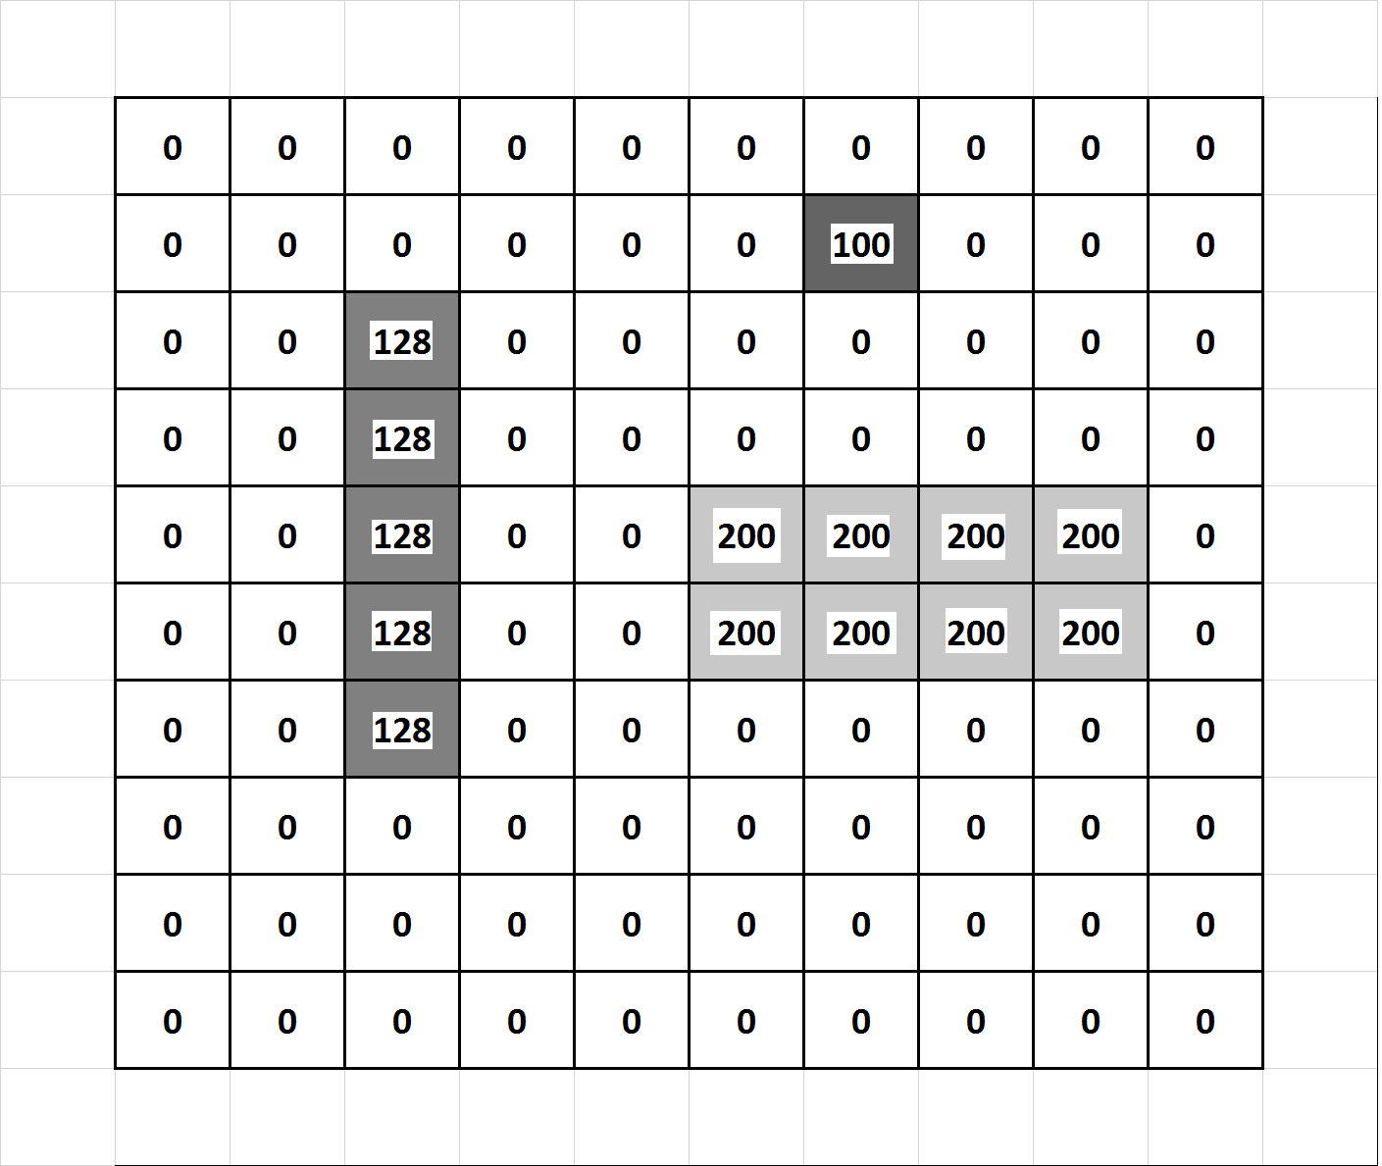Given the following 10 x 10 image

Apply a 3 x3 averaging filter, assuming zero padding to find values at marked pixels.

Filtered image:



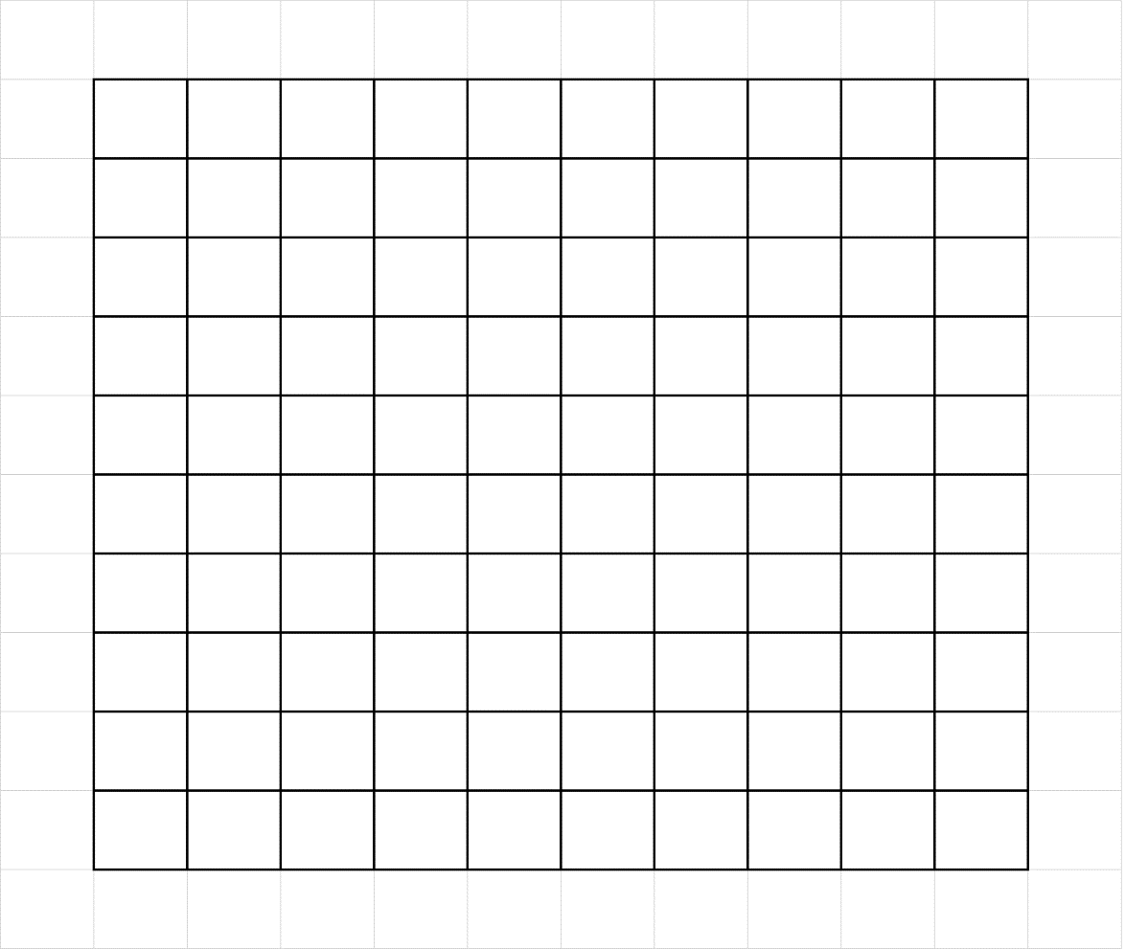This is the complete filtered image:

|  |  |  |  |  |  |  |  |  |  |
| --- | --- | --- | --- | --- | --- | --- | --- | --- | --- |
| 0 | 0 | 0 | 0 | 0 | 11 | 11 | 11 | 0 | 0 |
| 0 | 14 | 14 | 14 | 0 | 11 | 11 | 11 | 0 | 0 |
| 0 | 28 | 28 | 28 | 0 | 11 | 11 | 11 | 0 | 0 |
| 0 | 43 | 43 | 43 | 22 | 44 | 67 | 67 | 44 | 22 |
| 0 | 43 | 43 | 43 | 44 | 89 | 133 | 133 | 89 | 44 |
| 0 | 43 | 43 | 43 | 44 | 89 | 133 | 133 | 89 | 44 |
| 0 | 28 | 28 | 28 | 22 | 44 | 67 | 67 | 44 | 22 |
| 0 | 14 | 14 | 14 | 0 | 0 | 0 | 0 | 0 | 0 |
| 0 | 0 | 0 | 0 | 0 | 0 | 0 | 0 | 0 | 0 |
| 0 | 0 | 0 | 0 | 0 | 0 | 0 | 0 | 0 | 0 |