**Game Engine Foundations**

**Labs Seven & Eight**

**This lab has 4% grade weight**

In this lab, we are going to create small vehicles travelling in the game scene. To create the vehicle, you are requested to combine five boxes with different scales. One used for the main body and other four smaller ones to serve as for wheels. The illustration of the vehicle is below.

**NOTE: The wheels are supposed to spin as the vehicle moves.**

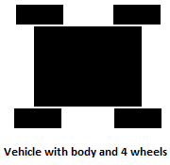

You are requested to take care of collision between the player and these vehicles. Once the player collides with any of these vehicles, the player is dead. To represent the death:

1. Set the height of camera very close to the ground level and rotate it about the forward vector.
2. Disable the input: mouse and keyboard. **How?**