Resource Letter CC-1: Controlling Chaos
Daniel J. Gauthier
Department of Physics and Center for Nonlinear and Complex Systems, Duke University, Durham, North Carolina 27708
Abstract
This Resource Letter provides a guide to the literature on controlling chaos. Journal articles, books, and web pages are provided for the following: controlling chaos, controlling chaos with weak periodic perturbations, controlling chaos in electronic circuits, controlling spatiotemporal chaos, targeting trajectories of nonlinear dynamical systems, synchronizing chaos, communicating with chaos, applications of chaos control in physical systems, and applications of chaos control in biological systems.

I. Introduction
Nonlinear systems are fascinating because seemingly simple “textbook” devices, such as a strongly-driven damped pendulum, can show exceedingly erratic, noise-like behavior that is a manifestation of deterministic chaos. Deterministic refers to the idea that the future behavior of the system can be predicted using a mathematical model that does not include random or stochastic influences. Chaos refers to idea that the system displays extreme sensitivity to initial conditions so that arbitrary small errors in measuring the initial state of the system grow large exponentially and hence practical, long-term predictability of the future state of the system is lost (often called the “butterfly effect”).
Early nonlinear dynamics research in the 1980s focused on identifying systems that display chaos, developing mathematical models to describe them, developing new nonlinear statistical methods for characterizing chaos, and identifying the way in which a nonlinear system goes from simple to chaotic behavior as a parameter is varied (the so-called “route to chaos”). One outcome of this research was the understanding that the behavior of nonlinear systems falls into just a few universal categories. For example, the route to chaos for a pendulum, a nonlinear electronic circuit, and a piece of paced heart tissue are all identical under appropriate conditions as revealed once the data has been normalized properly. This observation is very exciting since experiments conducted with an optical device can be used to understand some aspects of the behavior of a fibrillating heart, for example. Such universality has fueled a large increase in research on nonlinear systems that transcends disciplinary boundaries and often involves interdisciplinary or multi-disciplinary research teams.
A dramatic shift in the focus of research occurred around 1990 when scientists went beyond just characterizing chaos: They suggested that it may be possible to overcome the butterfly effect and control chaotic systems. The idea is to apply appropriately designed minute perturbations to an accessible system parameter (a “knob” that affects the state of the system) that forces it to follow a desired behavior rather than the erratic, noise-like behavior indicative of chaos. The general concept of controlling chaos has captured the imagination of researchers from a wide variety of disciplines, resulting in well over a thousand papers published on the topic in peer-reviewed journals.
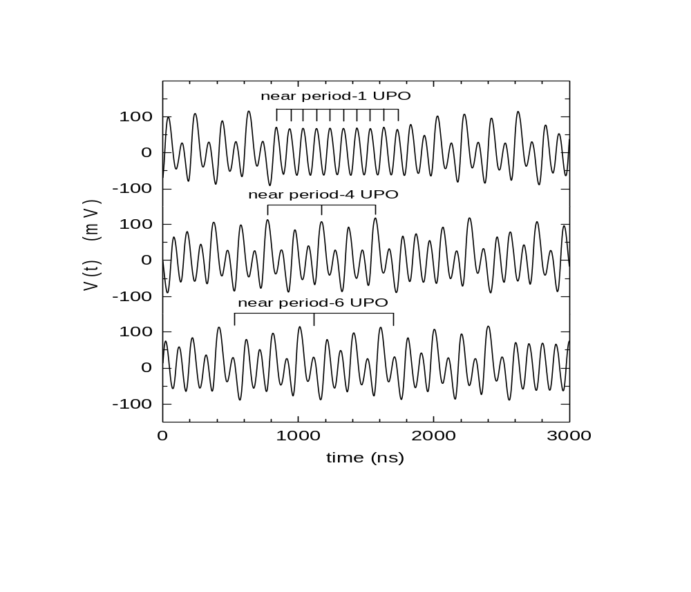
In greater detail, the key idea underlying most controlling-chaos schemes is to take advantage of the unstable steady states (USSs) and unstable periodic orbits (UPOs) of the system (infinite in number) that are embedded in the chaotic attractor characterizing the dynamics in phase space. Figure 1 shows an example of chaotic oscillations in which the presence of UPOs is clearly evident with the appearance of nearly periodic oscillations during short intervals. (This figure illustrates the dynamical evolution of current flowing through an electronic diode resonator circuit described in ref. 78.) Many of the control protocols attempt to stabilize one such UPO by making small adjustments to an accessible parameter when the system is in a neighborhood of the state.
Figure 1. Chaotic behavior observed in a nonlinear electronic circuit, from ref. 78. The system naturally visits the unstable periodic orbits embedded in the strange attractor, three of which are indicated.

Techniques for stabilizing unstable states in nonlinear dynamical systems using small perturbations fall into three general categories: feedback, non-feedback schemes, and a combination of feedback and non-feedback. In non-feedback (open-loop) schemes (see Sec. V.B below), an orbit similar to the desired unstable state is entrained by adjusting an accessible system parameter about its nominal value by a weak periodic signal, usually in the form of a continuous sinusoidal modulation. This is somewhat simpler than feedback schemes because it does not require real-time measurement of the state of the system and processing of a feedback signal. Unfortunately, periodic modulation fails in many cases to entrain the UPO (its success or failure is highly dependent on the specific form of the dynamical system).
The possibility that chaos and instabilities can be controlled efficiently using feedback (closed-loop) schemes to stabilize UPOs was described by Ott, Grebogi, and Yorke (OGY) in 1990 (ref. 52). The basic building blocks of a generic feedback scheme consist of the chaotic system that is to be controlled, a device to sense the dynamical state of the system, a processor to generate the feedback signal, and an actuator that adjusts the accessible system parameter, as shown schematically in fig. 2.

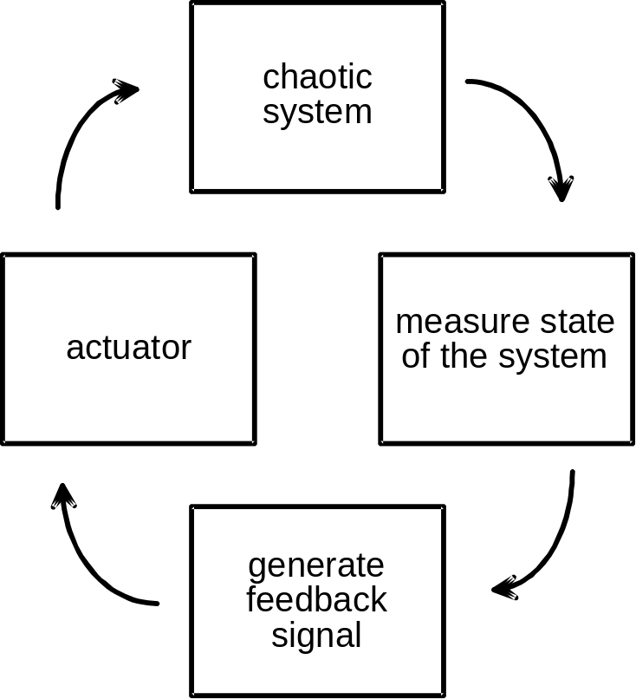

Figure 2. Closed-loop feedback scheme for controlling a chaotic system. From ref. 78.

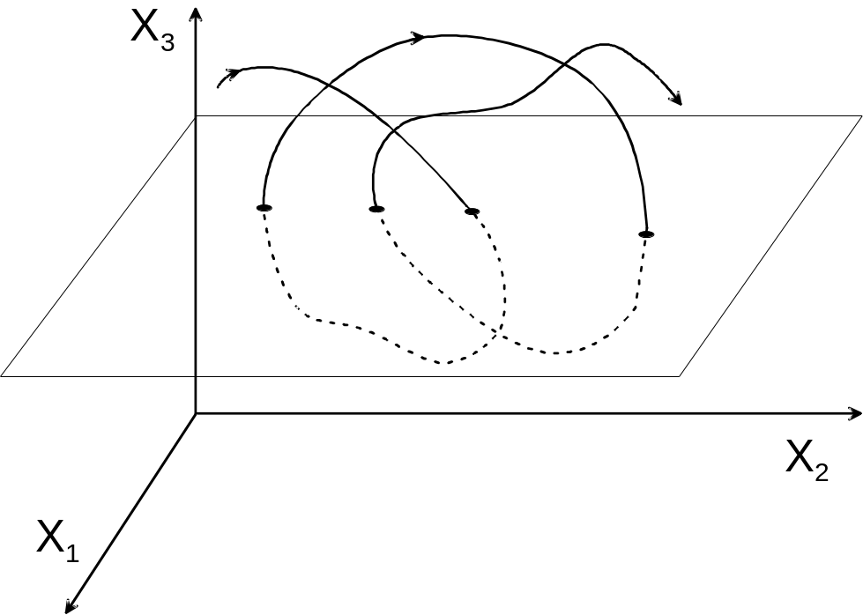
In their original conceptualization of the control scheme, OGY suggested the use of discrete proportional feedback because of its simplicity and because the control parameters can be determined straightforwardly from experimental observations. In this particular form of feedback control, the state of the system is sensed and adjustments are made to the accessible system parameter as the system passes through a surface of section. Figure 3 illustrates a portion of a trajectory in a three-dimensional phase space and one possible surface of section that is oriented so that all trajectories pass through it. The dots on the plane indicate the locations where the trajectory pierces the surface.

Figure 3. A segment of a trajectory in a three-dimensional phase space and a possible surface of section through which the trajectory passes. Some control algorithms only require knowledge of the coordinates where the trajectory pierces the surface, indicated by the dots.

In the OGY control algorithm, the size of the adjustments is proportional to the difference between the current and desired states of the system. Specifically, consider a system whose dynamics on a surface of section is governed by the m-dimensional map z_{i+1} = F(z_{i}, p_{i}), where z_{i} is its location on the i^{th} piercing of the surface and p_{i} is the value of an externally accessible control parameter that can be adjusted about a nominal value p_{o}. The map F is a nonlinear vector function that transforms a point on the plane with position vector z_{i} to a new point with position vector z_{i+1}. Feedback control of the desired UPO (characterized by the location z( p_{o}) of its piercing through the section) is achieved by adjusting the accessible parameter by an amount δp_{i} = p_{i} - p_{o} = - γn[z_{i} - z( p_{o})] on each piercing of the section when z_{i} is in a small neighborhood of z( p_{o}), where γ is the feedback gain and n is a m-dimensional unit vector that is directed along the measurement direction. The location of the unstable fixed-point z( p_{o}) must be determined before control is initiated; fortunately, it can be determined from experimental observations of z_{i} in the absence of control (a learning phase). The feedback gain γ and the measurement direction n necessary to obtain control is determined from the local linear dynamics of the system about z( p_{o}) using the standard techniques of modern control engineering (see refs. 34 and 55), and it is chosen so that the adjustments δp_{i} force the system onto the local stable manifold of the fixed point on the next piercing of the section. Successive iterations of the map in the presence of control direct the system to z( p_{o}). It is important to note that δ p_{i} vanishes when the system is stabilized; the control only has to counteract the destabilizing effects of noise.
As a simple example, consider control of the one-dimensional logistic map defined as
x_{n+1} = f(x_{n}, r) = r x_{n} (1 - x_{n}). (1)
This map can display chaotic behavior when the “bifurcation parameter” r is greater than ~3.57. Figure 4 shows x_{n} (solid circles) as a function of the iterate number n for r =3.9. The non-trivial period-1 fixed point of the map, denoted by x*, satisfies the condition x_{n+1} = x_{n} = x* and hence can be determined through the relation
x* = f(x*, r). (2)
Using the function given in eq. 1, it can be shown that
x* = 1 - 1/r . (3)
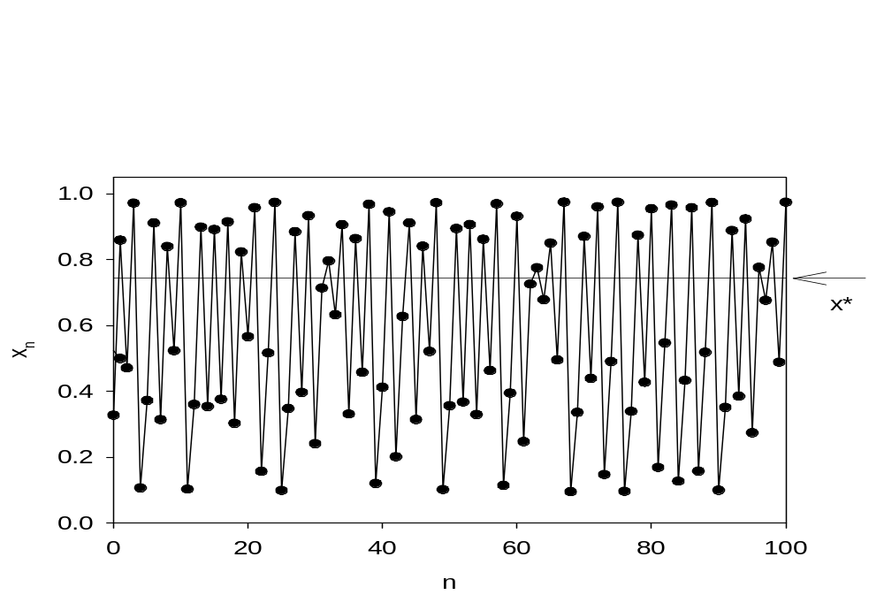
A linear stability analysis reveals that the fixed point is unstable when r > 3. For r = 3.9, x* = 0.744, which is indicated by the thin horizontal line in figure 4. It is seen that the trajectory naturally visits a neighborhood of this point when n ~ 32, n ~ 64, and again when n ~ 98 as it explores phase space in a chaotic fashion.

Figure 4. Chaotic evolution of the logistic map for r = 3.9. The circles denote the value of x_{n} on each iterate of the map. The solid line connecting the circles is a guide to the eye. The horizontal line indicates the location of the period-1 fixed point.

Surprisingly, it is possible to stabilize this unstable fixed point by making only slight adjustments to the bifurcation parameter of the form
r_{n} = r_{o} + δr_{n}, (4)
where
δr_{n} = - γ (x_{n} - x*). (5)
When the system is in a neighborhood of the fixed point (i.e., when x_{n} is close to x*), the dynamics can be approximated by a locally linear map given by
x_{n+1} = x* + α (x_{n} - x*) + β δr_{n}. (6)
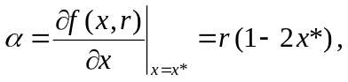The Floquet multiplier of the uncontrolled map is given by

(7)
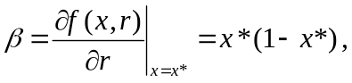and the perturbation sensitivity by

(8)
where I have used the result that δr_{n} = 0 when x = x*. For future reference, α = -1.9 and β = 0.191 when r = 3.9 (the value used to generate fig. 4). Defining the deviation from the fixed point as
y_{n} = x_{n} - x*, (9)
the behavior of the controlled system in a neighborhood of the fixed point is governed by
y_{n+1} = (α +βγ )y_{n}, (10)
where the size of the perturbations is given by
δr_{n} =βγy_{n}. (11)
In the absence of control (γ = 0), y_{n+1} = α y_{n} so that a perturbation to the system will grow (i.e., the fixed point is unstable) when |α | ≥ 1.
With control, it is seen from eq. (10) that an initial perturbation will shrink when
|α + βγ | < 0 (12)
and hence control stabilizes successfully the fixed point when condition (12) is satisfied. Any value of γ satisfying condition (12) will control chaos, but the time to achieve control and the sensitivity of the system to noise will be affected by the specific choice. For the proportional feedback scheme (5) considered in this simple example, the optimum choice for the control gain is when γ = -α/β. In this situation, a single control perturbation is sufficient to direct the trajectory to the fixed point and no other control perturbations are required if control is applied when the trajectory is close to the fixed point and there is no noise in the system. If control is applied when the y_{n} is not small, nonlinear effects become important and additional control perturbations are required to stabilize the fixed point.
Figure 5 shows the behavior of the controlled logistic map for r = 3.9 and the same initial condition used to generate fig. 4. Control is turned on suddenly as soon as the trajectory is somewhat close to the fixed point near n ~ 32 with the control gain is set to γ = -α/β = 9.965. It is seen that only a few control perturbations are required to drive the system to the fixed point. Also, the size of the perturbations vanish as n becomes large since they are proportional to y_{n} [see eq. (11)]. When random noise is added to the map on each iterate, the control perturbations remain finite to counteract the effects of noise, as shown in fig. 6.
This simple example illustrates the basic features of control of an unstable fixed point in a nonlinear dynamical system using small perturbations. Over the past decade since the early work on controlling chaos, researchers have devised many techniques for controlling chaos that go beyond the closed-loop proportional method described above. For example, it is now possible to control long period orbits that exist in higher dimensional phase spaces. In addition, researchers have found that it is possible to control spatiotemporal chaos, targeting trajectories of nonlinear dynamical systems, synchronizing chaos, communicating with chaos, and using controlling-chaos methods for a wide range of applications in the physical sciences and engineering as well as in biological systems. In this Resource Letter, I highlight some of this work, noting those that are of a more pedagogical nature or involve experiments that could be conducted by undergraduate physics majors. That said, most of the cited literature assumes a reasonable background in nonlinear dynamical systems (and the associated jargon); see ref. 33 for resources on the general topic of nonlinear dynamics.
I gratefully acknowledge discussion of this work with Joshua Socolar and David Sukow, and the long-term financial support of the National Science Foundation and the U.S. Army Research Office, especially the current grant DAAD19-02-1-0223.

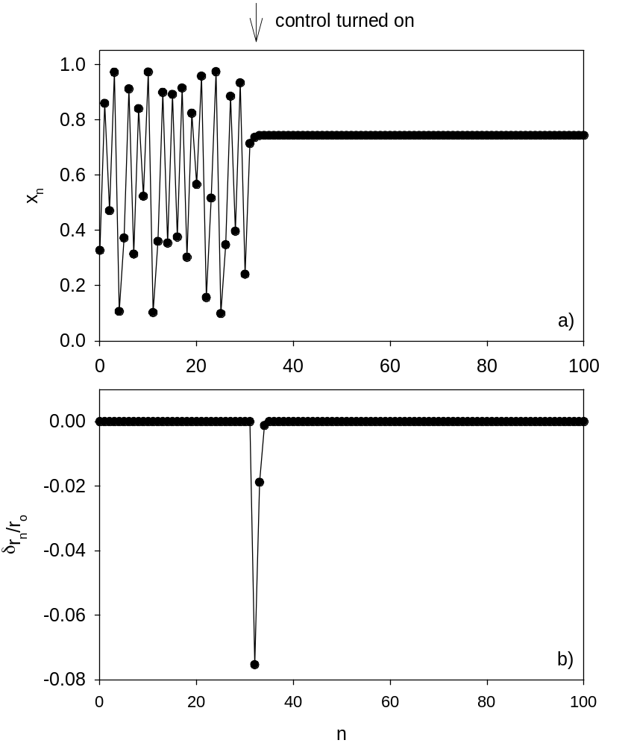
Figure 5. Controlling chaos in the logistic map. Proportional control is turned on when the trajectory approaches the fixed point. The perturbations δr_{n} vanish once the system is controlled in this example where there is no noise in the system.

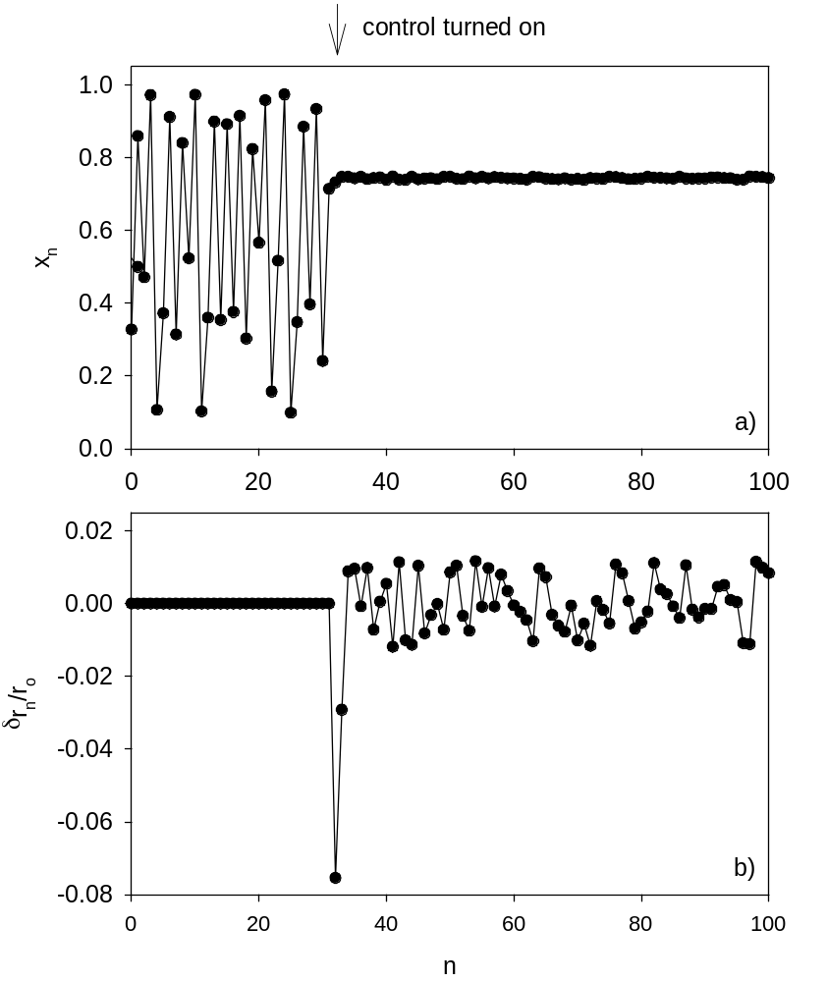
Figure 6. Controlling chaos in the logistic map with noise. Uniformly distributed random numbers between +/- 0.1 are added to the logistic map on each interate. The perturbations δr_{n} remain finite to counteract the effects of the noise.

II. Journals
As mentioned above, research on controlling chaos is highly interdisciplinary and multi-disciplinary so that it is possible to find papers published in a wide variety of journals. I give only a partial list of journals in which papers that are written by physicists on the topic of controlling chaos or where other seminal results can be found.
American Journal of Physics
Chaos
Chaos, Solitons and Fractals
IEEE Transactions on Circuits and Systems. Part I, Fundamental Theory and Applications
(prior to 1992, IEEE Transactions on Circuits and Systems)
International Journal of Bifurcation and Chaos in Applied Sciences and Engineering
Nature
Nonlinear Dynamics
Physica D
Physical Review Letters
Physical Review E
(prior to 1993, Physical Review A)
Physics Letters A
Science

Conferences
There are several conferences on nonlinear dynamics held regularly that often feature sessions on controlling chaos.
- The American Physical Society March Meeting
- Dynamics Days
- Dynamics Days Europe
- Gordon Conference on Nonlinear Science (every other year).
- SIAM Conference on Applications of Dynamics Systems (every other year).

Conferences Proceedings
The following proceedings give an excellent snapshot of the state of research at the time of the associated conference.
- Proceedings of the 1st Experimental Chaos Conference, Arlington, Virgina, October 1-3, 1991, edited by S. Vohra, M. Spano, M. Shlesinger, L. Pecora, and W. Ditto (World Scientific, Singapore, 1992). (A) No longer in print.
- Proceedings of the 2nd Conference on Experimental Chaos, Arlington, Virginia, 6 - 8 October 1993, edited by W. Ditto, L. Pecora, S. Vohra, M. Shlesinger, M. Spano (World Scientific, Singapore, 1995). (A)
- Experimental Chaos, Proceedings of the 3rd Conference, Edinburgh, Scotland, UK, 21 - 23 August 1995, edited by R.G. Harrison, W.-P. Lu, W. Ditto, L. Pecora, M. Spano, and S. Vohra (World Scientific, Singapore, 1996). (A)
- Proceedings of the 4th Experimental Chaos Conference, Boca Raton, Florida, USA, 6 - 8 August 1997, edited by M. Ding, W. Ditto, L. Pecora, S. Vohra, and M. Spano (World Scientific, Singapore, 1998). (A)
- The 5th Experimental Chaos Conference, Orlando, Florida, 28 June - 1 July 1999, edited by M. Ding, W.L. Ditto, L.M. Pecora, M.L. Spano (World Scientific, Singapore, 2001). (A)
- Experimental Chaos: 6th Experimental Chaos Conference, Potsdam, Germany, 22-26 July 2001 (AIP Conference Proceedings, 622), edited by S. Boccaletti, B.J. Gluckman, J. Kurths, L.M. Pecora and M.L. Spano (American Institute of Physics, New York, 2002). (A)
- Space-Time Chaos: Characterization, Control and Synchronization, Pamplona, Spain, 19-23 June 2000, edited by S. Boccaletti, J. Burguete, W. Gonzalez-Vinas, H.L. Mancini and D.L. Valladares (World Scientific, Singapore, 2001). (A)
Some conferences have elected to have papers appear as a special issue in a journal rather than in an independent book. See, for example, the following thematic issues.
- "Selected Articles Presented at the Third EuroConference on Nonlinear Dynamics in Physics and Related Sciences Focused on Control of Chaos: New Perspectives in Experimental and Theoretical Nonlinear Science," Int. J. Bifurcation Chaos Appl. Sci. Eng. 8 (8) and (9), 1641-1849 (1998). (A)
- "Selected Articles Presented at the International Workshop on Synchronization, Pattern Formation, and Spatio-Temporal Chaos in Coupled Chaotic Oscillators, Galicia, Spain, 7-10 June, 1998," Int. J. Bifurcation Chaos Appl. Sci. Eng. 9 (11) and (12), 2127-2363 (2002). (A)
- "Selected Articles Presented at the First Asia-Pacific Workshop on Chaos Control and Synchronization, Shanghai, June 28-29, 2001," Int. J. Bifurcation Chaos Appl. Sci. Eng. 12 (5), 883-1219 (2002). (A)
V. Textbooks and Expositions
There are several texts on control and synchronization of chaos, but most are monographs or collections of articles around a basic theme. The intended audience is researchers or advanced graduate students for most of these books.
- Chaos and Complexity in Nonlinear Electronic Circuits, M.J. Ogorzalek, (World Scientific, Singapore, 1997). (A) Chapter 11 describes work on controlling chaos. Quite mathematical and not a lot of details given concerning building the electronic circuits.
- Chaos in Circuits and Systems, edited by G. Chen and T. Ueta (World Scientific, Singapore, 2002). (A)
- Chaos in Communications, Proceedings of the SPIE, Volume: 2038, edited by L.M. Pecora (SPIE- The International Society for Optical Engineering, Bellingham, Washington, 1993). (A)
- Chaos in Dynamical Systems, 2nd Edition, E. Ott, (Cambridge University Press, Cambridge, 2002). (A) Contains a brief discussion of controlling chaos.
- Chaos in Electronics, M.A. van Wyk and W.-H. Steeb (Kluwer Academic Publishers, Dordrecht, 1997). (A) Chapter 7 describes research on controlling chaos. Fairly mathematical and limited discussion of actually building the electronic circuits. Extensive bibliography.
- Chaos in Nonlinear Oscillators: Controlling and Synchronization, M. Lakshmanan and K. Murali (World Scientific, Singapore, 1996). (A)
- Chaotic Dynamics, An Introduction, 2nd Ed., G.L. Baker and J.P. Gollub (Cambridge University Press, New York, 1996). (E) A good, truly introductory text to nonlinear dynamics and chaos. A brief discussion of modifying chaotic dynamics.
- Chaotic Synchronization: Applications to Living Systems, E. Mosekilde, Y. Maistrenko, and D. Postnov (World Scientific, Singapore, 2002). (A) Quite mathematical; interesting coverage of synchronization in pancreatic cells, population dynamics, and nephrons.
- Controlling Chaos and Bifurcations in Engineering Systems, edited by G. Chen (CRC Press, Boca Raton, Florida, 2000). (A) Extensive, quite mathematical.
- Controlling Chaos: Theoretical and Practical Methods in Non-Linear Dynamics, T. Kapitaniak (Academic Press, London, 1996). (A) Contains a brief introduction and a collection of reprints.
- Coping with Chaos: Analysis of Chaotic Data and the Exploitation of Chaotic Systems, edited by E. Ott, T. Sauer and J.A. Yorke (John Wiley & Sons, New York, 1994). (A) Contains some sections on controlling and synchronizing chaos and a collection of reprints.
- From Chaos to Order: Methodologies, Perspectives and Applications, G. Chen and X. Dong (World Scientific, Singapore, 1998). (A)
- Handbook of Chaos Control: Foundations and Applications, edited by H.G. Schuster (Wiley-VCH, Weinheim, 1999). (A) Gives a comprehensive review of chaos control with applications to a wide range of dynamical systems, including electronic circuits, lasers, and biological systems. You may have sticker shock.
- Introduction to Control of Oscillations and Chaos, A.L. Fradkov, A. L and Yu. P. Pogromsky (World Scientific, Singapore, 1998). (A) Nice introduction, quite mathematical.
- Nonlinear Dynamics and Chaos: With Applications in Physics, Biology, Chemistry, and Engineering, S.H. Strogatz (Perseus Publishing, Cambridge, Massachusetts, 1994). (I) Contains only a brief discussion of synchronization of chaos. Discussion of nonlinear dynamics appropriate for an upper-level undergraduate or lower-level graduate course.
- Nonlinear Dynamics in Circuits, edited by T. Carroll and L. Pecora (World Scientific, Singapore, 1995). (I) I recommend this book highly if you are interested in constructing chaotic electronic circuits to study control and synchronization processes.
- Self-Organized Biological Dynamics and Nonlinear Control, edited by J. Walleczek (Cambridge University Press, Cambridge, 2000). (A)
- Synchronization in Coupled Chaotic Circuits and Systems, C.W. Wu (World Scientific, Singapore, 2002). (A) Quite mathematical.
There are numerous texts that treat the topic of modern control engineering at an undergraduate level. Reference 55 suggests using the following text to learn more about the pole-placement technique.
- Modern Control Engineering, 2nd Ed., K. Ogata (Prentice–Hall, Englewood Cliffs, NJ, 1990), Chap. 9.
A good place to begin to learn about nonlinear dynamics is given in a previous Resource Letter, which has been expanded in the following reprint collection.
- Chaos and Nonlinear Dynamics, edited by R.C. Hilborn and N.B. Tufillaro (American Association of Physics Teachers, College Park, Maryland, 1999). (I)
VI. Internet Resources
- Many nonlinear dynamics papers, including those on controlling chaos, are often posted on the Nonlinear Science preprint archive. (http://arxiv.org/archive/nlin). (A)
- Nonlinear FAQ maintained by J.D. Meiss, with a section on controlling chaos. (http://amath.colorado.edu/faculty/jdm/faq-%5B3%5D.html#Heading27). (E)
- "Control and synchronization of chaotic systems (bibliography),'' maintained by G. Chen. (http://www.ee.cityu.edu.hk/~gchen/chaos-bio.html). (A) Contains citations up to 1997.

VII. Current Research Topics
For a very nice and extensive review of controlling chaos that starts at a fairly elementary level, see the following article, which also includes a discussion of experiments.
- "The control of chaos: theory and applications," S. Boccaletti, C. Grebogi, Y.-C. Lai, H. Mancini, D. Maza, Phys. Rep. 329, 103-197 (2000). (E)
There have been many special issues in journals devoted to controlling chaos and its offshoots. They give a glimpse of the field without spending the day in the library searching out individual articles. A few of these collections are given below.
- "Focus Issue: Synchronization and Patterns in Complex Systems," Chaos 6 (3), 259- 503 (1996). (A)
- "Focus Issue: Control and Synchronization of Chaos," Chaos 7 (4), 509-826 (1997). (A)
- "Special Issue on Controlling Chaos," Chaos Solitons Fractals 8 (9), 1413-1586 (1997). (A)
- "Focus Issue: Mapping and Control of Complex Cardiac Arrhythmias," Chaos 12 (3), 732- 981 (2002). (A)
The following special issues all have at least one tutorial or review article.

- "Special Issue on Chaos Synchronization, Control and Applications," IEEE Trans. Circuits Syst. I: Fundamental Th. Appl. 44 (10), 853-988 (1997). (I)
- "Special Issue Control and Synchronization of Chaos," Int. J. Bifurcation Chaos Appl. Sci. Eng. 10 (3) and (4), 511-891 (2000). (I)
- "Special Issue on Phase Synchronization," Int. J. Bifurcation Chaos Appl. Sci. Eng. 10 (10) and (11), 2289-2649 (2000). (I)
- "Special Issue on Applications of Chaos in Modern Communication Systems," IEEE Trans. Circuits Syst. I, Fundamental Th. Appl. 48 (12), 1385-1523 (2001). (I)

A. Controlling Chaos
- "Application of Stochastic Control Techniques to Chaotic Nonlinear Systems," T.B. Fowler, IEEE Trans. Autom. Control 34, 201-205 (1989.) (A)
- "Adaptive Control of Chaotic Systems," A.W. Hubler, Helv. Phys. Acta 62, 343-346 (1989). (A)
- "The Entrainment and Migration Controls of Multiple-Attractor Systems," E.A. Jackson, Phys. Lett. A 151, 478-484 (1990). (A) Nonlinear control methods to direct a trajectory to a desired location in phase space. Usually requires a mathematical model of the system and may require the application of large perturbations to the system.
- "Adaptive Control in Nonlinear Dynamics," S. Sinha, R. Ramaswamy, and J.S. Rao, Physica D 43, 1188-128 (1990). (A)
- "Controlling Chaos," E. Ott, C. Grebogi, and J.A. Yorke, Phys. Rev. Lett. 64, 1196-1199 (1990). (A) One of the early papers to suggest that chaos can be controlled using closed-loop feedback methods. The method does not require a mathematical model of the system and stabilizes the dynamics about one of an infinite number of unstable periodic orbits that are embedded in the chaotic attractor. It was very accessible to researchers in the field and triggered many future studies. While not fully appreciated by the authors at the time, the control method was very similar to elementary control techniques known from the control engineering community. See ref. 50 where the authors make a connection to and distinguish their work from previous control engineering methods.
- "Experimental Control of Chaos," W.L. Ditto, S.N. Rauseo, and M.L. Spano, Phys. Rev. Lett. 65, 3211-3215 (1990). (A) First experimental demonstration of feedback control of chaos. The experimental system was a buckling megnetoelastic ribbon.
- "Controlling Chaos Using Time Delay Coordinates,'' U. Dressler and G. Nitsche, Phys. Rev. Lett. 68, 1-4 (1992). (A) Time-delay coordinates are often used to reconstruct an attractor in experiments so it is important to appreciate how the use of such coordinates affects the feedback signal.
- "Controlling Chaotic Dynamical Systems," F.J. Romeiras, C. Grebogi, E. Ott, and W.P. Dayawansa, Physica D 58, 165-192 (1992). (I) A detailed exposition of one method for closed-loop control of chaos using a proportional error signal. Extends the work in ref. 52. Uses techniques developed in the controlling engineering field and makes a nice connection between the research of the two communities. As suggested by the authors, it is important to read one of the many introductions to modern control engineering used in many undergraduate electrical engineering programs; following their suggestion, see ref. 34. Read and work your way through this paper if you want to have a solid foundation for understanding the principles of chaos control. Useful for both theorists and experimentalists.
- "Using Small Perturbations to Control Chaos," T. Shinbrot, C. Grebogi, E. Ott, and J.A. Yorke, Nature 363, 411-417 (1993). (I) An early review of research on controlling chaos.
- "Mastering Chaos," W.L. Ditto, and L.M. Pecora, Sci. Am. 78-84, August (1993). (E)
- "Controlling Chaos in the Belousov-Zhabotinsky Reaction," V. Petrov, V. Gaspar, J. Masere, and K. Showalter, Nature 361, 240-243 (1993). (A) Demonstration that chaos control methods can be applied to chemical reactions.
- "Continuous Control of Chaos by Self-Controlled Feedback," K. Pyragas, Phys. Lett. A 170, 421-428 (1992). (A) Describes a technique for controlling chaos that does not require a priori knowledge of the desired unstable periodic orbit and uses an error signal that compares the current state of the system to its state one period in the past.
- "From Chaos to Order -- Perspectives and Methodologies in Controlling Chaotic Nonlinear Dynamical Systems," G. Chen, and X. Dong, ," Int. J. Bifurcation Chaos Appl. Sci. Eng. 3, 1363-1409 (1993). (A) An extensive review and bibliography.
- "Chaos: Unpredictable yet Controllable?" T. Shinbrot, Nonlin. Sci. Today, 3 (2) 1-8 (1993). (I)
- "Experimental Characterization of Unstable Periodic Orbits by Controlling Chaos,'' S. Bielawski D. Derozier, and P. Glorieux, Phys. Rev. A 47, 2492-2495 (1993). (A)
- "Experimental Control of Chaos by Delayed Self-Controlling Feedback,'' K. Pyragas, and A. Tamasevicius, Phys. Lett. A 180, 99-102 (1993). (A)
- "Taming Chaos: Part II - Control," M.J. Ogorzalek, IEEE Trans. Circuits Syst. I, Fundam. Theory Appl. 40, 700-706 (1993). (I)
- "Using Neural Networks for Controlling Chaos,'' P.M. Alsing, A. Gavrielides, and V. Kovanis, Phys. Rev. E 49, 1225-1231 (1994). (A)
- "Practical Considerations in the Control of Chaos,'' P.V. Bayly, and L.N. Virgin, Phys. Rev. E 50, 604-607 (1994). (A) A nice discussion of what to watch out for.
- "Pre-Recorded History of a System as an Experimental Tool to Control Chaos,'' A. Kittel, K. Pyragas, and R. Richter, Phys. Rev. E 50, 262-268 (1994). (A) A combination of synchronization and control.
- "A Unified Framework for Synchronization and Control of Dynamical Systems,'' C.W. Wu, and L.O. Chua, Int. J. Bifurcation Chaos Appl. Sci. Eng. 4, 979-998 (1994). (A)
- "Controlling chaos experimentally in systems exhibiting large effective Lyapunov exponents," B. Hübinger, R. Doerner, W. Martienssen, M. Herdering, R. Pitka, and U. Dressler, Phys. Rev. E 50, 932–948 (1994). (A)
- "Controlling Chaos," E. Ott and M. Spano, Phys. Today, 48 (5), 34-40 (1995). (E) A review for the physics community.
- "Control of the Chaotic Driven Pendulum," G.L. Baker, Am. J. Phys. 63, 832-838 (1995). (E) Describes how to use the methods described in ref. 73 for controlling the dynamics of a chaotic pendulum that could be found in an undergraduate laboratory. Gives more details about the method than usually found in most journal articles on controlling chaos.
- "Experimental Maintenance of Chaos,'' V. In, S.E. Mahan, W.L. Ditto and M. Spano, Phys. Rev. Lett. 74, 4420-4423 (1995). (A) Sometimes chaos is good.
- J. Starret and R. Tagg, "Control of a Chaotic Parametrically Driven Pendulum,'' Phy. Rev. Lett. 74, 1974-1977 (1995). (A) One possible experiment that could be undertaken with a modified undergraduate laboratory pendulum.
- "Speed Gradient Control of Chaotic Continuous-Time Systems,'' A. L. Fradkov and A. Yu. Pogromsky, IEEE Trans. Circuits Syst. I, Fundam. Theory Appl. 43, 907-913 (1996). (A)
- "Automated Adaptive Recursive Control of Unstable Orbits in High-Dimensional Chaotic Systems,'' M.A. Rhode, J. Thomas, R.W. Rollins and A.J. Markworth, Phys. Rev. E 54, 4880-4887 (1996). (A)
- "Controlling Chaos in High Dimensions: Theory and Experiment,'' M. Ding, W. Yang, V. In, W. L. Ditto, M. L. Spano and B. Gluckman, Phys. Rev. E 53, 4334-4344 (1996). (A)
- "Controlling Chaos Using Nonlinear Feedback with Delay,'' M. de S. Vieira and A.J. Lichtenberg, Phy. Rev. E 54, 1200-1207 (1996). (A)
- "Controlling Chaos in Fast Dynamical Systems: Experimental Results and Theoretical Analysis," D.W. Sukow, M.E. Bleich, D.J. Gauthier, and J.E.S. Socolar, Chaos 7, 560-576 (1997). (I) Gives a reasonably accessible introduction to controlling chaos and an overview of current research.
- "Mechanism of Time-Delayed Feedback Control," W. Just, T. Bernard, M. Ostheimer, E. Reibold, and H. Benner, Phys. Rev. Lett. 78, 203-206 (1997). (A)
- "A Simple Method for Controlling Chaos," C. Flynn and N. Wilson, Am. J. Phys. 66, 730-735 (1998). (E)
- "New Method for the Control of Fast Chaotic Oscillations," K. Myneni, T.A. Barr, N.J. Corron, and S.D. Pethel, Phys. Rev. Lett. 83, 2175-2178 (1999). (A)
- "Influence of Control Loop Latency on Time-Delayed Feedback Control," W. Just, D. Reckwerth, E. Reibold, and H. Benner, Phys. Rev. E 59, 2826 (1999). (A)
- "Optimal Multi-Dimensional OGY Controller," B.I. Epureanu, and E.H. Dowell, Physica D 139, 87-96 (2000). (A)
- "Controlling Chaos with Simple Limiters," N.J. Corron, S.D. Pethel, and B.A. Hopper, Phys. Rev. Lett. 84, 3835-3838 (2000). (A)

B. Controlling Chaos Using Weak Periodic Perturbations
- "Periodic Entrainment of Chaotic Logistic Map Dynamics,'' E.A. Jackson, and A. Hubler, Physica D 44, 407-420 (1990). (A)
- "Suppression of Chaos by Resonant Parametric Perturbations," R. Lima ,and M. Pettini, Phys. Rev. A 41, 726-733 (1990). (A)
- "Taming Chaotic Dynamics with Weak Periodic Perturbations," Y. Braiman, and I. Goldhirsch, Phys. Rev. Lett. 66, 2545-2548 (1991). (A)
- "Experimental Evidence of Suppression of Chaos by Resonant Parametric Perturbations,'' L. Fronzoni, and M. Giocondo, Phys. Rev. A 43, 6483-6487 (1991). (A)
- "Experimental Control of Chaos by Means of Weak Parametric Perturbations," R. Meucci, W. Gadomski, M. Ciofini, and F.T. Arecchi, Phys. Rev. E 49, R2528-R2531 (1994). (A)
- "Parametric Entrainment Control of Chaotic Systems,'' R. Mettin, A. Hubler, A. Scheeline, and W. Lauterborn, Phys. Rev. E 51, 4065-4075 (1995). (A)
- "Tracking Unstable Steady States by Large Periodic Modulation of a Control Parameter in a Nonlinear System," R. Vilaseca, A. Kul'minskii, and R. Corbalán, Phys. Rev. E 54, 82-85 (1996). (A)
- "Conditions to Control Chaotic Dynamics by Weak Periodic Perturbation," Rue-Ron Hsu, H.-T. Su, J.-L. Chern, and C.-C. Chen, Phys. Rev. Lett. 78, 2936-2939 (1997). (A)
- "Experimentally Tracking Unstable Steady States by Large Periodic Modulation," R. Dykstra, A. Rayner, D.Y. Tang, and N.R. Heckenberg, Phys. Rev. E 57, 397-401 (1998). (A)
- "Mechanism for Taming Chaos by Weak Harmonic Perturbations," T. Tamura, N. Inaba, and J. Miyamichi, Phys. Rev. Lett. 83, 3824-3827 (1999). (A)
- "Entraining Power-Dropout Events in an External Cavity Semiconductor Laser Using Weak Modulation of the Injection Current," D.W. Sukow, and D.J. Gauthier, IEEE J. Quantum Electron. 36, 175-183 (2000). (A)

C. Controlling chaos in electronic circuits
- "Stabilizing High-Period Orbits in a Chaotic System," E.R. Hunt, Phys. Rev. Lett. 67, 1953-1955 (1991). (A)
- "Synchronizing Chaotic Circuits," T.L. Carroll, and L.M. Pecora, IEEE Trans. Circuits Syst. 38, 453-456 (1991). (A)
- "A Simple Circuit for Demonstrating Regular and Synchronized Chaos," T.L. Carroll, Am. J. Phys. 63, 377-379 (1995). (E) A nice setup for demonstrating synchronized chaos that is appropriate for an undergraduate laboratory.
- "Images of Synchronized Chaos: Experiments with Circuits," N.F. Rulkov, Chaos 6, 262-279 (1996). (E) A nice discussion of synchronization and a good description of how to construct the electronic circuit.
- "Electronic Chaos Controller," Z. Galias, C.A. Murphy, M.P. Kennedy, and M.J. Ogorzalek, Chaos Solitons Fractals 8, 1471-1484 (1997). (I)
- "Stabilizing Unstable Steady States Using Extended Time-Delay Autosynchronization," A. Chang, J.C. Bienfang, G.M. Hall, J.R. Gardner, and D.J. Gauthier, Chaos 8, 782-790 (1998). (I) Experiments undertaken by undergraduates (Chang and Bienfang) using chaotic electronic circuits.

D. Controlling Spatiotemporal Chaos
- "Controlling Extended Systems of Chaotic Elements," D. Auerbach, Phys. Rev. Lett. 72, 1184-1187 (1994). (A)
- "Controlling Spatiotemporal Chaos," I. Aranson, H. Levine, and L. Tsimring, Phys. Rev. Lett. 72, 2561-2564 (1994). (A)
- "Synchronization of Spatiotemporal Chaotic Systems by Feedback Control," Y.-C. Lai, and C. Grebogi, Phys. Rev. E 50, 1894-1899 (1994). (A)
- "Controlling Spatiotemporal Patterns on a Catalytic Wafer,'' F. Qin, E. E. Wolf, and H.-C. Chang, Phys. Rev. Lett. 72, 1459-1462 (1994). (A)
- "Controlling Spatio-Temporal Dynamics of Flame Fronts," V. Petrov, M.F. Crowley, and K. Showalter, J. Chem. Phys. 101, 6606-6614 (1994). (A)
- "Controlling Spatiotemporal Chaos in Coupled Map Lattice Systems,'' G. Hu, and Z. Qu, Phys. Rev. Lett. 72, 68-71 (1994). (A)
- "Taming Spatiotemporal Chaos with Disorder,'' Y. Braiman, J. F. Lindner, and W. L. Ditto, Nature 378, 465-467 (1995). (I)
- "Stabilized Spatiotemporal Waves in Convectively Unstable Open Flow Systems: Coupled Diode Resonators," G.A. Johnson, M. Locher, and E.R. Hunt, Phys. Rev. E 51, R1625-1628 (1995). (A)
- "Controlling Turbulence in the Complex Ginzburg-Landau Equation,'' D. Battogtokh, and A. Mikhailov, Physica D 90, 84-95 (1996). (A)
- "Stabilization, Selection, and Tracking of Unstable Patterns by Fourier Space Techniques,'' R. Martin, A. J. Scroggie, G. -L. Oppo, and W. J. Firth, Phys. Rev. Lett. 77, 4007-4010 (1996). (A)
- "Nonlinear Control of Remote Unstable States in a Liquid Bridge Convection Experiment," V. Petrov, M.F. Schatz, K.A. Muehlner, S.J. VanHook, W.D. McCormick, J.B. Swift, and H.L. Swinney, Phys. Rev. Lett. 77, 3779–3782 (1996). (A)
- "Synchronization of Spatiotemporal Chaos and its Application to Multichannel Spread-Spectrum Communication," J.H. Xiao, G.Hu, and Z.Qu, Phys. Rev. Lett. 77, 4162-4165 (1996). (A)
- "Taming Chaos with Disorder in a Pendulum Array," W.L. Shew, H.A. Coy, and J.F. Lindner, Am. J. Phys. 67, 703-708 (1999). (E) Experimental suppression of spatiotemporal chaos in a system appropriate for an advanced undergraduate laboratory.
- "Controlling Spatiotemporal Chaos in a Chain of the Coupled Logistic Maps,'' V.V. Astakhov, V.S. Anishchenko, and A.V. Shabunin, IEEE Trans. Circuits Syst. I, Fundam. Theory Appl. 42, 352-357 (1995). (A)
- "Controlling Spatiotemporal Dynamics with Time-Delay Feedback,'' M.E. Bleich, and J.E.S. Socolar, Phys. Rev. E 54, R17-R20 (1996). (A)
- "Synchronizing Spatiotemporal Chaos in Coupled Nonlinear Oscillators,'' Lj. Kocarev, and U. Parlitz, Phys. Rev. Lett. 77, 2206-2210 (1996). (A)
- "Pinning Control of Spatiotemporal Chaos," R. O. Grigoriev, M. C. Cross, and H. G. Schuster, Phys. Rev. Lett. 79, 2795-2798 (1997). (A)
- "Failure of linear control in noisy coupled map lattices," D.A. Egolf, and J.E.S. Socolar, Phys. Rev. E 57, 5271–5275 (1998). (A)
- "Controlling Chaos and the Inverse Frobenius-Perron Problem: Global Stabilization of Arbitrary Invariant Measures," E.M. Bollt, Int. J. Bifurcation Chaos Appl. Sci. Eng. 10, 1033-1050 (2000). (A)
- "Controlling Chemical Turbulence by Global Delayed Feedback: Pattern Formation in Catalytic CO Oxidation on Pt(110)," M. Kim, M. Bertram, M. Pollmann, A. von Oertzen, A.S. Mikhailov, H.H. Rotermund, and G. Ertl, Science 292, 1357-1360 (2001). (I)
- "Feedback Stabilization of Unstable Waves," E. Mihaliuk, T. Sakurai, F. Chirila, and K. Showalter, Phys. Rev. E 65, 065602(R)-1 - 065602(R)-4 (2002). (A)
- "Comparison of Time-Delayed Feedback Schemes for Spatiotemporal Control of Chaos in a Reaction-Diffusion System with Global Coupling," O. Beck, A. Amann, E. Schöll, J. E.S. Socolar, and W. Just, Phys. Rev. E 66, 016213-1 - 016213-6 (2002). (A)
- "Design and Control Patterns of Wave Propogation Patterns in Excitable Media," T. Sakurai, E. Mihaliuk, F. Chirila, and K. Showalter, Science 296, 2009-2012 (2002). (I)

E. Targeting Trajectories of Nonlinear Dynamical Systems
- "Using Chaos to Direct Trajectories to Targets," T. Shinbrot, E. Ott, C. Grebogi, and J.A. Yorke, Phys. Rev. Lett. 65, 3215-3218 (1990). (A)
- "Using the Sensitive Dependence of Chaos (the "Butterfly Effect") to Direct Trajectories in an Experimental Chaotic System, T. Shinbrot, W. Ditto, C. Grebogi, E. Ott, M. Spano, and J.A. Yorke, Phys. Rev. Lett. 68, 2863-2866 (1992). (A) Demonstrates how to target desired dynamical states of a chaotic buckling magnetoelastic ribbon using the sensitivity of chaotic systems.
- "Higher Dimensional Targeting," E.J. Kostelich, C. Grebogi, E. Ott, and J.A. Yorke, Phys. Rev. E 47, 305-310 (1993). (A)
- "Targeting Unstable Periodic Orbits," V.N. Chezhevsky, and P. Glorieux, Phys. Rev. E 51, 2701-2704 (1995). (A)
- "Directing Orbits of Chaotic Dynamical Systems,'' M. Paskota, A.I. Mees and K.L. Teo, Int. J. Bifurcation Chaos Appl. Sci. Eng. 5, 573-583 (1995). (A)
- "Targeting in Nonlinear Dynamics of Laser Diodes," L.N. Langley, S.I. Turovets, and K.A. Shore, IEE Proc.-Optoelectron. 142, 157-161 (1995). (A)
- "Efficient Switching Between Controlled Unstable Periodic Orbits in Higher Dimensional Chaotic Systems," E. Barreto, E.J. Kostelich, C. Grebogi, E. Ott, and J.A. Yorke, Phys. Rev. E 51, 4169-4172 (1995). (A)
- "Directing Nonlinear Dynamic Systems to Any Desired Orbit," L. Zonghua, and C. Shigang, Phys. Rev. E 55, 199-204 (1997). (A)
- "Optimal targeting of chaos," E.M. Bollt, and E.J. Kostelich, Phys. Lett. A 245, 399-406 (1998). (A)
- "Targeting unknown and unstable periodic orbits," B. Doyon, and L.J. Dubé, Phys. Rev. 65, 037202-1 - 037202-4 (2002). (A)

F. Synchronizing Chaos
- "Stability Theory of Synchronized Motion in Coupled Oscillator Systems," H. Fujisaka, and T. Yamada, Prog. Theor. Phys. 69, 32-47 (1983). (A)
- "On the Interaction of Strange Attractors," A.S. Pikovsky, Z. Phys. B - Condensed Matter 55, 149-154 (1984). (A)
- "Stochastic Synchronization of Oscillators of Dissipative Systems," V.S. Afraimovich, N.N. Verichev, and M.I. Rabinovich, Radiophys. Quantum Electon. 29, 795-803 (1986). (A) An important early paper on synchronous chaotic motion. Several ideas are introduced that appear in later papers.
- "Experimental Study of Bifurcations at the Threshold for Stochastic Locking," A.R. Volkovskii and N.F. Rul'kov, Sov. Tech. Phys. Lett. 15, 249-251 (1989). (A)
- "Synchronization in Chaotic Systems," L.M. Pecora, and T.L. Carroll, Phys. Rev. Lett. 64, 821-824 (1990). (A) One of the early papers on synchronizing chaotic systems that was very popular and triggered significant interest in the problem.
- "Mutual Synchronization of Chaotic Self-Oscillators with Dissipative Coupling," N.F. Rul'kov, A.R. Volkovskii, A. Rodríguez-Lozano, E. Del Río, and M.G. Velarde, Int. J. Bifurcation Chaos Appl. Sci. Eng. 2, 669-676 (1992). (A)
- "Taming Chaos - Part I: Synchronization," M.J. Ogorzalek, IEEE Trans. Circuits Syst. I, Fundam. Theory Appl. 40, 693-699 (1993). (I)
- "Experimental and Numerical Evidence for Riddled Basins in Coupled Chaotic Oscillators," J.F. Heagy, T.L. Carroll, and L.M. Pecora, Phys. Rev. Lett. 73, 3528-3531 (1994). (A)
- "Synchronization of Chaos Using Proportional Feedback," T.C. Newell, P.M. Alsing, A. Gavrielides, and V. Kovanis, Phys. Rev. E 49, 313-318 (1994). (A)
- "Experimental Synchronization of Chaotic Lasers," R. Roy, and K.S. Thornburg, Phys. Rev. Lett. 72, 2009-2012 (1994). (A)
- "Synchronizing Chaotic Systems Using Filtered Signals,'' T.L. Carroll, Phys. Rev. Lett. 50, 2580-2587 (1994). (A) Takes into account some of the effects that might happen in a transmission channel.
- "Short Wavelength Bifurcation and Size Instabilities in Coupled Oscillator Systems,'' J.F. Heagy, L.M. Pecora, and T.L. Carroll, Phys. Rev. Lett. 74, 4185-4188 (1995). (A) Synchronization becomes more complicated when there are many oscillators hooked together.
- "Synchronizing Hyperchaos with a Scalar Transmitted Signal," J.H. Peng, E.J. Ding, M. Ding, and W. Yang, Phys. Rev. Lett. 76, 904-907 (1996). (A)
- "Generalized Synchronization, Predictability, and Equivalence of Unidirectionally Coupled Dynamical Systems,'' Lj. Kocarev and U. Parlitz, Phys. Rev. Lett. 76, 1816-1819 (1996). (A) Generalized synchronization refers to the situation where the slave variables are not identical to the master oscillator, but are functionally related.
- "Intermittent Loss of Synchronization in Coupled Chaotic Oscillators: Toward a New Criterion for High-Quality Synchronization," D.J. Gauthier, and J.C. Bienfang, Phys. Rev. Lett. 77, 1751-1754 (1996). (A)
- "Phase Synchronization of Chaotic Oscillators,'' M.G. Rosenblum, A.S. Pikovsky and J. Kurths, Phys. Rev. Lett. 76, 1804-1808 (1996). (A) Phase synchronization refers to the case where the relative phase of the two oscillators is locked but the amplitudes are not. Most instances of naturally occurring synchronization (e.g., in biological systems) are probably of this form.
- "Fundamentals of Synchronization in Chaotic Systems, Concepts, and Applications," L.M. Pecora, T.L. Carroll, G.A. Johnson, and D.J. Mar, and J.F. Heagy, Chaos 7, 520-543 (1997). (I) A nice overview of the research on synchronizing chaos.
- "From Phase to Lag Synchronization in Coupled Chaotic Oscillators," M.G. Rosenblum, A.S. Pikovsky, and J. Kurths, Phys. Rev. Lett. 78, 4193-4196 (1997). (A)
- "Designing a Coupling That Guarantees Synchronization between Identical Chaotic Systems," R. Brown, and N.F. Rulkov, Phys. Rev. Lett. 78, 4189-4192 (1997). (A)
- "Robustness and Stability of Synchronized Chaos: An Illustrative Model," M.M. Sushchik, Jr., N.F. Rulkov, and H.D.I. Abarbanel, IEEE Trans. Circuits Syst. I, Fundam. Theory Appl. 44, 867-873 (1997). (A)
- "Master Stability Functions for Synchronized Coupled System," L.M. Pecora and T.L. Carroll, Phys. Rev. Lett. 80, 2109-2112 (1998). (A) Presents a general scheme for determine whether chaotic oscillators will synchronize for a large class of problems.
- "Experimental Investigation of High-Quality Synchronization of Coupled Oscillators," J.N. Blakely, D.J. Gauthier, G. Johnson, T.L. Carroll, and L.M. Pecora, Chaos 10, 738-744 (2000). (A)
- "Phase Synchronization in Regular and Chaotic Systems," A. Pikovsky, M. Rosenblum, and J. Kurths, , Int. J. Bifurcation Chaos Appl. Sci. Eng. 10, 2291-2305 (2000). (I) Tutorial article.
- "Anticipating chaotic synchronization," H.U. Voss, Phys. Rev. E 61, 5115-5119 (2000). (A)
- "Anticipation in the Synchronization of Chaotic Semiconductor Lasers with Optical Feedback," C. Masoller, Phys. Rev. Lett. 86, 2782-2785 (2001). (A)
- "Loss of Synchronization in Coupled Oscillators with Ubiquitous Local Stability," N.J. Corron, Phys. Rev. E 63, 055203-1 - 055203-4 (2001). (A)

G. Communicating with Chaos
- "Experimental demonstration of secure communications via chaotic synchronization,'' Lj. Kocarev, K.S. Halle, K.S. Eckert, and L.O. Chua, Int. J. Bifurcation Chaos Appl. Sci. Eng. 2, 709-713 (1992). (A) Uses synchronization to decode a message encoded on a chaotic waveform.
- "Transmission of Digital Signals by Chaotic Synchronization," U. Parlitz, L.O. Chua, Lj. Kocarev, K.S. Halle, and A. Shang, Int. J. Bifurcation Chaos Appl. Sci. Eng. 2, 973-977 (1992). (A)
- "Circuit Implementation of Synchronized Chaos with Application to Communications," K.M. Cuomo, and A.V. Oppenheim, Phys. Rev. Lett. 71, 65-68 (1993). (A)
- "Transmission of Signals by Synchronization in a Chaotic Van der Pol - Duffing Oscillator," K. Murali, and R.E. Lakshmanan, Phys. Rev. E 48, 1624-1626 (1993). (A)
- "Communicating with Chaos," S. Hayes, C. Grebogi, and E. Ott, Phys. Rev. Lett. 70, 3031-3034 (1993). (A) The technique described in this paper does not use synchronization for decoding the message. Rather, it encodes and decodes the information by targeting a specific symbolic sequence.
- "Chaotic Digital Encoding: An Approach to Secure Communication,'' D.R. Frey, IEEE Trans. Circuits Syst. II, Analog Digit. Signal Process. 40, 660-666 (1993). (A)
- "Secure Communications and Unstable Periodic Orbits of Strange Attractors,'' H.D.I Abarbanel, and P.S. Linsay, IEEE Trans. on Circ. Sys. II, Analog Digit. Signal Process. 40 643-645 (1993). (A)
- "Robust Communication Based on Chaotic Spreading Sequences," U. Parlitz, and S. Ergezinger, Phys. Lett. A 188, 146-150 (1994). (A)
- "Communications Using Chaotic Frequency Modulation," P. A. Bernhardt, Int. J. Bifurcation Chaos Appl. Sci. Eng. 4, 427-440 (1994). (A)
- "Experimental Control of Chaos for Communication," S. Hayes, C. Grebogi, E. Ott. and A. Mark, Phys. Rev. Lett. 73, 1781-1784 (1994). (A)
- "Digital Communication with Synchronized Chaotic Lasers," P. Colet, and R. Roy, Opt. Lett. 19, 2056-2058 (1994). (A)
- "Extracting Messages Masked by Chaos,'' G. Perez, and H. A. Cerdeira, Phys. Rev. Lett. 74, 1970-1973 (1995). (A)
- "Multichanel Communication Using Autosynchronization,'' U. Parlitz, and Lj. Kocarev, Int. J. Bifurcation Chaos Appl. Sci. Eng. 6, 581-588 (1996). (A)
- "Unmasking a Modulated Chaotic Communications Scheme,'' K.M. Short, Int. J. Bifurcation Chaos Appl. Sci. Eng. 6, 367-375 (1996). (A)
- "Multiplexing Chaotic Signals Using Synchronization,'' L.S. Tsimring, and M.M. Sushchik, Phys. Lett. A 213, 155-166 (1996). (A)
- "Noise Filtering in Communication with Chaos," E. Rosa, Jr., S. Hayes, and C. Grebogi, Phys. Rev. Lett. 78, 1247-1250 (1997). (A)
- "Applications of Symbolic Dynamics in Chaos Synchronization," IEEE Trans. Circuits Syst. I, Fundam. Theory Appl. 44, 1014-1018 (1997). (A)
- "Communication with Chaotic Lasers," G.D. VanWiggeren, and R. Roy, Science 279, 1198-1200 (1998). (I)
- "Applications of Chaotic Digital Code-Division Multiple Access (CDMA) to Cable Communication Systems," T. Yang, and L.O. Chua, Int. J. Bifurcation Chaos Appl. Sci. Eng. 8, 1657-1669 (1998). (I) Tutorial article.
- "Communication with chaos over band-limited channels", N.F. Rulkov, and L. Tsimring, Int. J. Circuit Theory Appl. 27, 555 -567 (1999). (A)
- "Chaotic modulation for robust digital communications over multipath channels," M. P. Kennedy, G. Kolumban, and G. Kis, Int. J. Bifurcations Chaos Appl. Sci. Eng. 10, 695-718 (2000). (A)
- "Chaotic Pulse Position Modulation: A Robust Method of Communicating with Chaos," M.M. Sushchik, N.F. Rulkov, L. Larson, L. Tsimring, H.D.I. Abarbanel, K. Yao, and A.R. Volkovskii, IEEE Commun. Lett. 4, 128-130 (2000). (A) A robust approach that has reached the state of a device.
- "Communicating with Optical Hyperchaos: Information Encryption and Decryption in Delayed Nonlinear Feedback Systems," V.S. Udaltsov, J.-P. Goedgebuer, L. Larger, and W.T. Rhodes, Phys. Rev. Lett. 86, 1892-1895 (2001). (A)
- "Synchronization and Communication Using Semiconductor Lasers with Optoelectronic Feedback," H.D.I. Abarbanel, M.B. Kennel, L. Illing, S. Tang, H.F. Chen, and J.M. Liu, IEEE J. Quantum Electron. 37, 1301-1311 (2001). (A)
- "Parallel Communication with Optical Spatiotemporal Chaos," J. Garcia-Ojalvo, and R. Roy, IEEE Trans. Circuits Syst. I, Fundam. Theory Appl. 48, 1491 - 1497 (2001). (A)
- "Chaotic Wavelength-Hopping Device for Multiwavelength Optical Communications," P. Davis, Y. Liu, and T. Aida, IEEE Trans. Circuits Syst. I, Fundam. Theory Appl. 48, 1523 - 1527 (2001). (A)
- "Optical Communication with Synchronized Hyperchaos Generated Electrooptically," J.-P. Goedgebuer, P. Levy, L. Larger, C.-C. Chen, and W.T. Rhodes, IEEE J. Quantum Electron. 38, 1178-83 (2002). (A)
- "Communication with Dynamically Fluctuating States of Light Polarization," G.D. VanWiggeren, and R. Roy, Phys. Rev. Lett. 88, 097903-1 - 097903-4 (2002). (A)

H. Applications of Chaos Control
- "Controlling a Chaotic System," J. Singer, Y.-Z. Wang, and H.H. Bau, Phys. Rev. Lett. 66, 1123-1125 (1991). (A) Demonstrates that a chaotic fluid flow can be laminarized using closed-loop feedback.
- "Tracking Unstable Steady States: Extending the Stability Regime of a Multimode Laser System," Z. Gills, C. Iwata, R. Roy, I.B. Schwartz, and I. Triandaf, Phys. Rev. Lett. 69, 240-243 (1992). (A) Demonstrates that the so-called "green problem" in intracavity frequency-doubled solid-state lasers can be suppressed using chaos control methods, resulting in a substantial increase in the useful output power from the laser.
- "Tunable Semiconductor Oscillator Based on Self-Control of Chaos in the Dynamic Hall Effect,'' E. Schöll, and K. Pyragas, Europhys. Lett. 24, 159-164 (1993). (A)
- "Crisis Control: Preventing Chaos-Induced Capsizing of a Ship," M. Ding, E. Ott, and C. Grebogi, Phys. Rev. E 50, 4228-4230 (1994). (A) Ship capsizing and chaos in shipboard cranes in rough seas are problems that might be amenable to chaos control methods.
- "Controlling the Unstable Steady State in a Multimode Laser,'' T.W. Carr, and I.B. Schwartz, Phys. Rev. E 51, 5109-5111 (1995). (A)
- "Controlling Chaos in a Model of thermal pulse combustion,'' M.A. Rhode, R.W. Rollins, A.J. Markworth, K.D. Edwards, K. Nguyen, C.S. Daw, and J.F.Thomas, J. Appl. Phys. 78, 2224-2232 (1995). (A) Engines might run more efficiently using chaos-control methods.
- "Using Chaos to Broaden the Capture Range of a Phase-Locked Loop: Experimental Verification,'' E. Bradley, and D. Straub, IEEE Trans. Circuits Syst. I, Fundam. Theory Appl. 43, 914-921 (1996). (A)
- "Controlling Chaotic Frictional Forces," M.G. Rozman, M. Urbakh, and J. Klafter, Phys. Rev. E 57, 7340-7343 (1998). (A)

I. Applications of Chaos Control in Biological Systems
- "Controlling Cardiac Chaos," Science 257, 1230-1235 (1992). (A) First demonstration that closed-loop feedback methods can be used to stabilize a chaotic cardiac rhythm.
- S. H. Strogatz and I. Stewart, "Coupled Oscillators and Biological Synchronization,'' Sci. Am. 68-75, December (1993). (E)
- "Bifurcation, Chaos and Suppression of Chaos in FitzHugh-Nagumo Nerve Conduction Model Equation,'' S. Rajasekar, and M. Lakshmanan, J. Theor. Biol. 166, 275-288 (1994). (A)
- "Controlling chaos in the brain,'' S.J. Schiff, K. Jerger, D.H. Duong, T. Chang, M.L. Spano, and W.L. Ditto, Nature 370, 615-620 (1994). (I) Somewhat controversial result. They concluded that there was chaos in the brain since the controlling-chaos method appeared to stabilize the dynamics. Other researchers have found that the controlling-chaos methods work just fine in non-chaotic systems (see refs. 202 and 204, for example).
- "Controlling Chaos by Pinning Neurons in a Neural Network,'' J.E. Moreira, F.W.S. Lima, and J.S. Andrade, Jr., Phys. Rev. E 52, 2129-2132 (1995). (A)
- "Controlling Nonchaotic Neuronal Noise Using Chaos Control Techniques," D.J. Christini, and J.J. Collins, Phys. Rev. Lett. 75, 2782-2785 (1995). (A)
- "Preserving Chaos: Control Strategies to Preserve Complex Dynamics with Potential Relevance to Biological Disorders,'' W. Yang, M. Ding, A. Mandell, and E. Ott, Phys. Rev. E 51, 102-110 (1995). (A)
- "Using Chaos Control and Tracking to Suppress a Pathological Nonchaotic Rhythm in a Cardiac Model,'' D.J. Christini, and J.J. Collins, Phys. Rev. E 53, 49-52 (1996). (A)
- "Applications of Chaos in Biology and Medicine,'' W.L. Ditto, in Chaos and the Changing Nature of Science and Medicine: An Introduction, edited by D.E. Herbert (American Institute of Physics, New York, 1996), pp.175-201. (E)
- "Electric Field Suppression of Epileptiform Activity in Hippocampal Slices," B.J. Gluckman, E.J. Neel, T.I. Netoff, W.L. Ditto, M.L. Spano, and S.J. Schiff, J. Neurophysio. 76, 4202-4205 (1996). (A)
- "Entrainment and Termination of Reentrant Wave Propagation in a Periodically Stimulated Ring of Excitable Media," T. Nomura, and L. Glass, Phys. Rev. E 53, 6353-6360 (1996). (A)
- "Dynamic Control of Cardiac Alternans," K. Hall, D.J. Christini, M. Tremblay, J.J. Collins, L. Glass, and J. Billette, Phys. Rev. Lett. 78, 4518-4521 (1997). (A)
- "Synchrony in an Array of Integrate-and-Fire Neurons with Dendritic Structure," P.C. Bressloff, and S. Coombes, Phys. Rev. Lett. 78, 4665-4668 (1997). (A)
- "Controlling Spiral Waves in Confined Geometries by Global Feedback," V.X. Zykov, A.S. Mikhailov, and S.C. Müller, Phys. Rev. Lett. 78, 3398-3401 (1997). (A)
- "Spatiotemporal Control of Wave Instabilities in Cardiac Tissue," W.-J. Rappel, F. Fenton, and A. Karma, Phys. Rev. Lett. 83, 456-459 (1999). (A)
- "Control of Human Atrial Fibrillation," W.L Ditto, M.L. Spano, V. In, J. Neff, B. Meadows, J.J. Langberg, A. Bolmann, and K. McTeague, Int. J. Bifurcation Chaos Appl. Sci. Eng. 10, 593-601 (2000). (A) The results described in this paper have led to other follow-up studies, such as that described in ref. 219.
- "Controlling Cardiac Arrhythmias: The Relevance of Nonlinear Dynamics," D.J. Christini, K. Hall, J.J. Collins, and L. Glass, in Handbook of Biological Physics, Volume 4. Neuro-informatics, Neural Modelling, edited by F. Moss, S. Gielen (Elsevier, Amsterdam, 2001), pp. 205 - 228. (I)
- "Controlling Cardiac Arrhythmias: The Relevance of Nonlinear Dynamics," D.J. Christini, K. Hall, J.J. Collins, and L. Glass, in Handbook of Biological Physics, Volume 4. Neuro-informatics, Neural Modelling, edited by F. Moss, S. Gielen (Elsevier, Amsterdam, 2001), pp. 205 - 228. (I)
- "Controlling the Dynamics of Cardiac Muscle Using Small Electrical Stimuli," D.J. Gauthier, S. Bahar, and G.M. Hall, in Handbook of Biological Physics, Volume 4. Neuro-informatics, Neural Modelling, edited by F. Moss, S. Gielen (Elsevier, Amsterdam, 2001), pp. 229 - 256. (I)
- "Nonlinear-dynamical arrhythmia control in humans," D.J. Christini, K.M. Stein, S.M. Markowitz, S. Mittal, D.J. Slotwiner, M.A. Scheiner, S. Iwai, and B.B. Lerman, Proc. Natl. Acad. Sci. U.S.A. 98, 5827-5832 (2001). (A)
- "Defibrillation via the Elimination of Spiral Turbulence in a Model for Ventricular Fibrillation," S. Sinha, A. Pande, and R. Pandit, Phys. Rev. Lett. 86, 3678- 3681 (2001). (A)
- "Experimental Control of Cardiac Muscle Alternans," G.M. Hall, and D.J. Gauthier, Phys. Rev. Lett. 88, 198102-1 - 198102-4 (2002). (A)
- "Progress toward controlling in vivo fibrillating sheep atria using a nonlinear-dynamics-based closed-loop feedback method," D.J. Gauthier, G.M. Hall, R.A. Oliver, E.G. Dixon-Tulloch, P.D. Wolf, and S. Bahar, Chaos 12, 952-961 (2002). (A)
- "Predicting the Entrainment of Reentrant Cardiac Waves Using Phase Resetting Curves," L. Glass, Y. Nagai, K. Hall, M. Talajic, and S. Nattel, Phys. Rev. E 65, 021908-1 - 021908-10 (2002). (A)
- "Suppressing Arrhythmias in Cardiac Models Using Overdrive Pacing and Calcium Channel Blockers," A.T. Stamp, G.V. Osipov, J.J. Collins, Chaos 12, 931-940 (2002). (A)

Throughout this Resource Letter, I assume that the reader is familiar with the general concept of chaos and the general behavior of nonlinear dynamical systems. For those unfamiliar with these topics, ref. 35 provides a good entry to this fascinating field.

