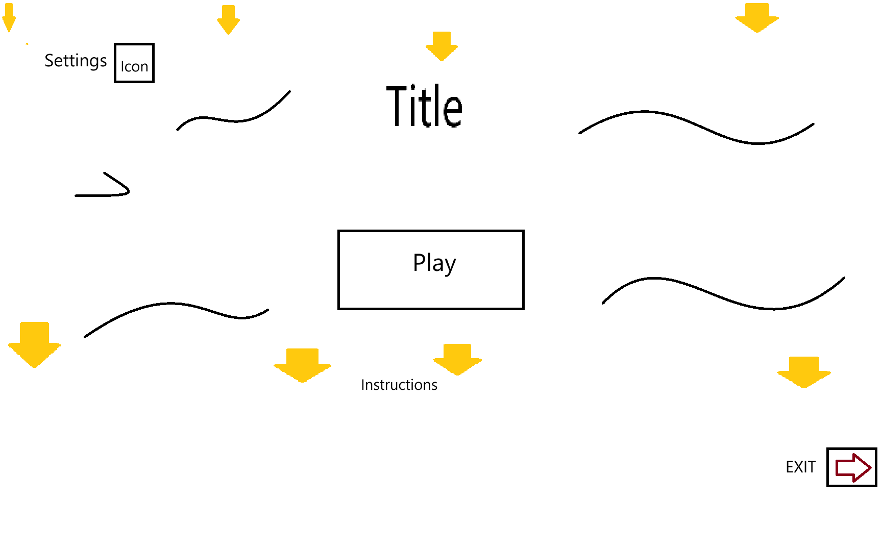

Title: “Toy Dive” Large

Play Button: “Play” Large Moves left and right slightly. Starts the game when clicked.

Instructions Button: “Help” Will Display Instructions.

Settings: Change the Settings of Sound and the Speed and timer of the game. A cog Icon will represent it

Background: will have water moving and waves moving from left to right

Toys: represented by a yellow down arrow. Will be moving downwards from the top to the bottom. Like the game. They will be different colours.

Sound will have some beach music.

The exit button will close out of the program.

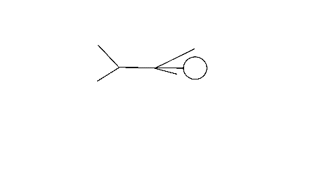

The Swimmer will be animated with a sprite sheet.

It will be controlled with WASD or the Arrow Keys.

The Space Bar will collect toys when collided.

They Must always be inside the game and visible.

Sounds will be made when the player starts swimming.

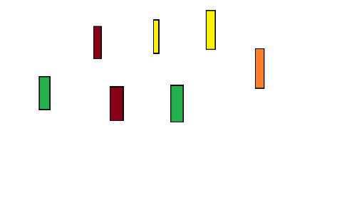

Toys will start falling from the top of the pool and sinking to the bottom of the pool.

When the Toys collide with the opponent pressing space. The toys are collected, and the score is incremented.

They will appear in different colours. All bright in contrast to the pools light blue

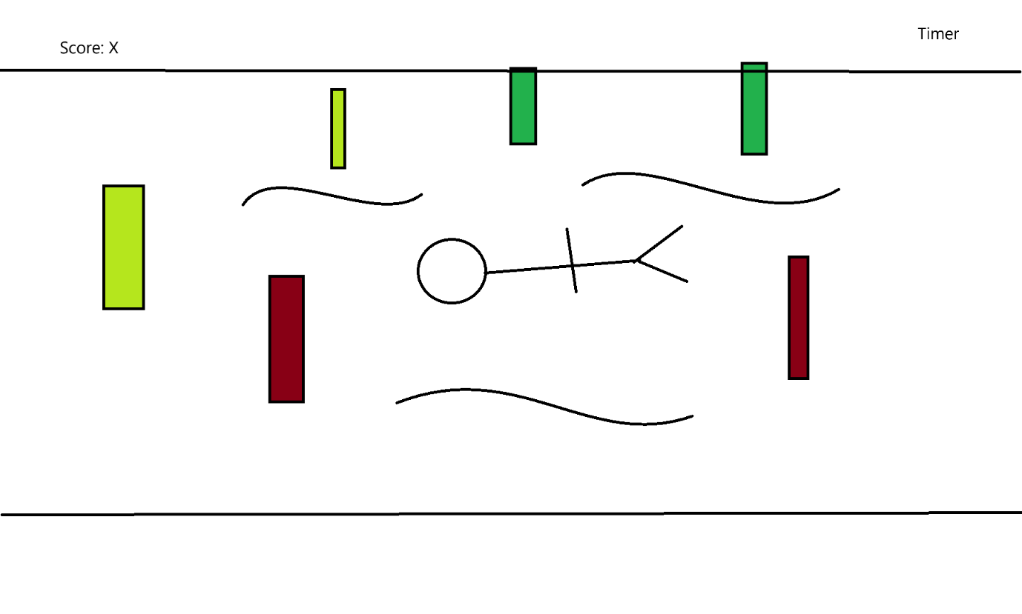

The Score is X which is the number of toys collected

The timer is set to a minute but can be changed in the settings.

The swimmer will be swimming to collect all the toys.

For each toy that is collected a congratulatory sound will be played. While for each miss a disappointed sound will appear. A splash sound will appear as a toy enters the pool to alert the player.

After the timer hits 0 the game is over, and the score is counted.

Background is water with air at the top and the pool floor at the bottom. A black border will show the boundaries.

Wave effects.

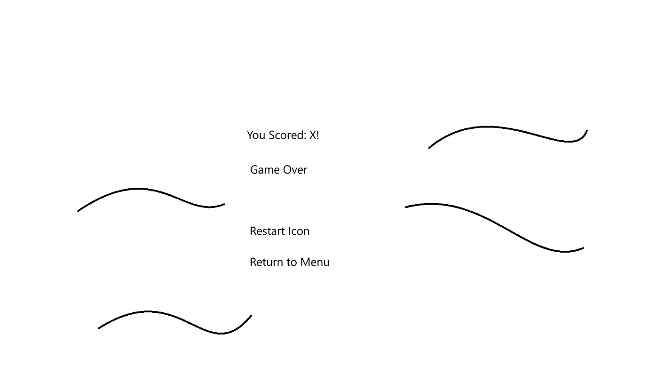

In the end the scored is displayed as X

Game over label is presented to alert the user the game has ended

A restart Icon will be shown to restart the game without returning to menu.

The Return to Menu will go back to the start.

It will play background music.

Waves will play in the background.