**Functional and Technical Document for**

**Rich Content Database**

**Introduction**

In this document, we will briefly describe the main purpose of the application Rich Content Database, the functional and technical specifications among with the corresponding schema of the database, UML class diagram and use cases.

**1 Functional Document**

* 1. **Business Goal/Scope definition:** With this application we plan to solve the problem regarding the organization of an inventory of rich content files using Microsoft Technologies. The main purpose is that Windows Service will regularly read the content of the rich content files that are mainly located on a ‘shared location’, take each file and put it accordingly to its extension in the corresponding folder. (Eg: file pdf will be put in the pdf folder, jpg file will be put in jpg folder and so on.)

* 1. **Target audience:** The Rich Content Database application is for all types of users without an advanced background of technical skills and knowledge.
  2. **Environment specifications:** The application is useful when you want to easily find a document (a functionality of the app is to search depending of something like: type, resolution, size) and to organize documents.
  3. **General requirements:** Rich Content Database offers the possibility for users to upload files, organize them, add custom metadata, delete them or search for a specific one.
  4. **Specific requirements:** The specific requirements are:
  5. **Use case scenarios:** In this app, we have the following scenarios to present and implement:
* the user has an account and has the possibility to upload, delete, add custom metadata for a specific file or search for a specific one (Owner -> Individual person and Owner-> Organisation/Company )
* the user does not have an account and he only has the possibility to view the files and search for them (Anonymous person -> we do not have his registration in the database, he will be like a visitor with limited actions)
  1. **Non-functional requirements:** The non-functional requirements are:
* Security
* Response Time
* Low/Medium Usability (the app cannot be used within all the situations in which the user needs. Its purpose is to organize rich content files)
  1. **Deliverables:** This didactical application: Rich Content Database is intended to be delivered/finish at the end of June 2016.

**2 Technical document**

**2.1 General architecture description:** The general architecture of the application will be available in

**2.2 Environment requirements: -**

**2.3 General technical details: -**

**2.4 Database model:**

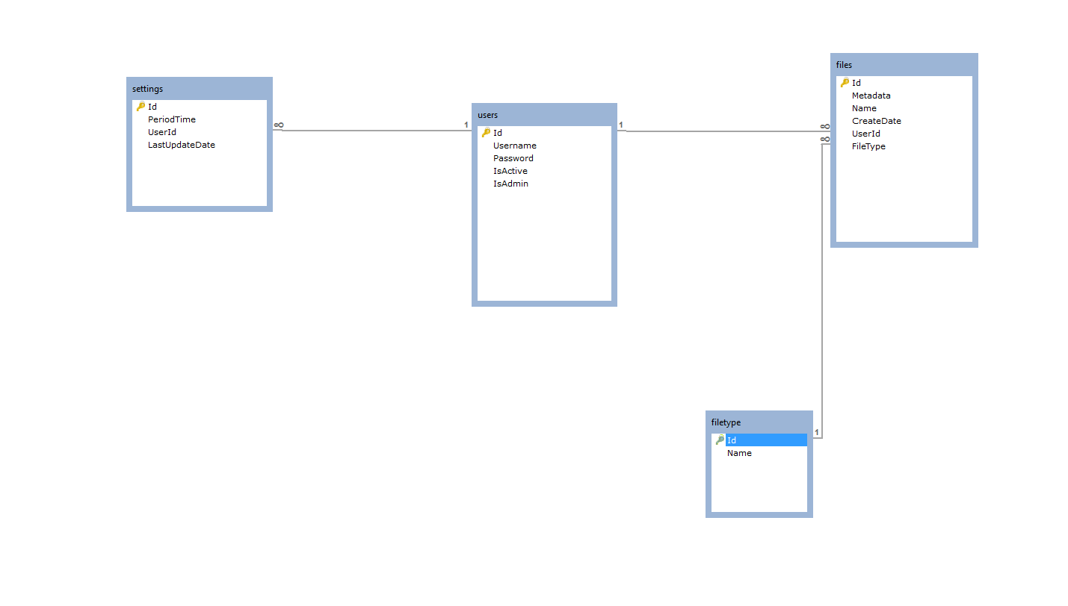

**2.5 Technical solution:** This part will be further completed when we will have the UML class diagram and we have sketched the entire business logic of the application.

**2.6 Development effort:** Due to the fact that for the implementation of the didactical application Rich Content Database, we do not have any background knowledge of the technologies and the programming language itself, we will need extra time in order to invest in understand all the patterns required among with the all the necessary info for the implementation. (technologies, code convention for .Net and so on).

**2.7 Test plan:** We will try to test our application in all cases as we implement in order to obtain a stable version of the application.

**2.8 Conclusions:** The conclusions will be reached after the project has been delivered/finished.