- Creating and Renaming Files/Directories
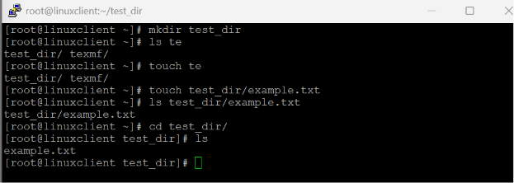

- Viewing File Contents
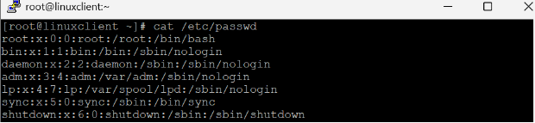
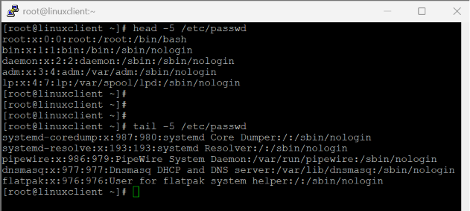

- Searching for Patterns
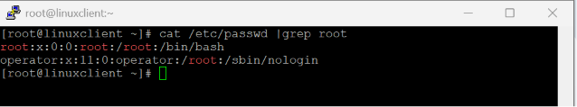

- Zipping and Unzipping
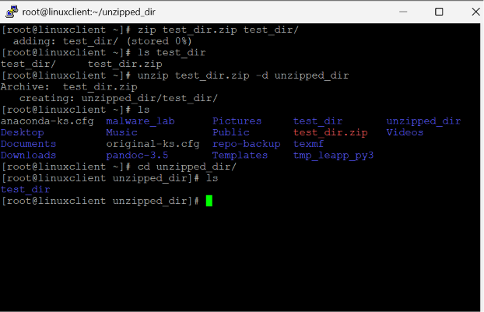

- Downloading Files
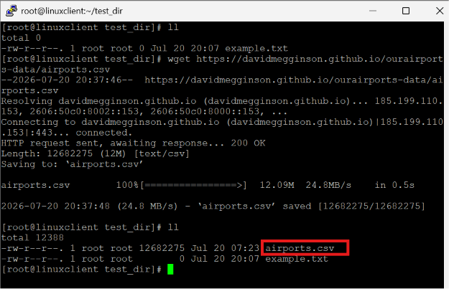

- Changing Permissions
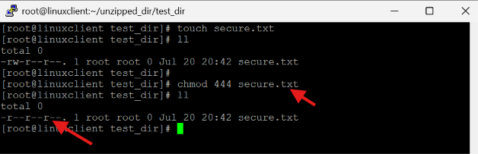

- Working with Environment Variables
