The Centriolar Damage Accumulation Theory of Aging (CDATA)
Molecular Foundations, Mechanistic Architecture, and Falsifiable Predictions of a Unified Theory
Jaba Tkemaladze
Independent Research Laboratory for Integrative Geroscience
Correspondence: djabbat@gmail.com

Abstract
The Centriolar Damage Accumulation Theory of Aging (CDATA) proposes that the progressive, irreversible accumulation of oxidative post-translational modifications (PTMs) in the maternal centriole of adult tissue stem cells is the primary upstream cause of organismal aging. CDATA is built on five mechanistic postulates: the absolute structural non-renewability of the mother centriole’s core scaffold; the asymmetric retention ratchet that enforces preferential inheritance of the older, more damaged centriole by the self-renewing stem daughter — occurring in the context of a broader quality-control landscape in which the same daughter receives cytoplasmic renewal (new mitochondria, clean proteome) while retaining only the irremovable old centriole; five forms of irreversible PTM damage (carbonylation, hyperacetylation, aggregation, phosphorylation dysregulation, distal appendage loss); the dual functional integration of ciliogenesis and spindle assembly in a single structure; and a cell-autonomous ROS positive feedback loop. These postulates generate two primary failure tracks — Track A (ciliary loss → niche signaling collapse) and Track B (spindle fidelity loss → symmetric division catastrophe) — and four nested vicious cycles that account for the nonlinear acceleration of aging at tissue and organism levels. CDATA further incorporates the Irreversible Differentiation Inducer (IDI) hypothesis, proposing that two molecularly distinct sets of fate-determining molecules on the mother and daughter centrioles encode somatic and germline differentiation programs, with the daughter centriole’s set released specifically during granddaughter procentriole synthesis in the progenitor daughter cell. Together these mechanisms explain progressive regenerative rate decline, senescent tissue microenvironment formation, and the characteristic disease-like vicious cycles of late-life functional collapse. The theory generates six published and five new falsifiable experimental predictions. A companion computational model (Cell-DT) provides quantitative implementation.
Keywords: aging, centriole, centrosome, stem cell, asymmetric division, primary cilium, post-translational modification, CDATA, cellular senescence, geroscience

1. Introduction: The Fundamental Paradox of Aging

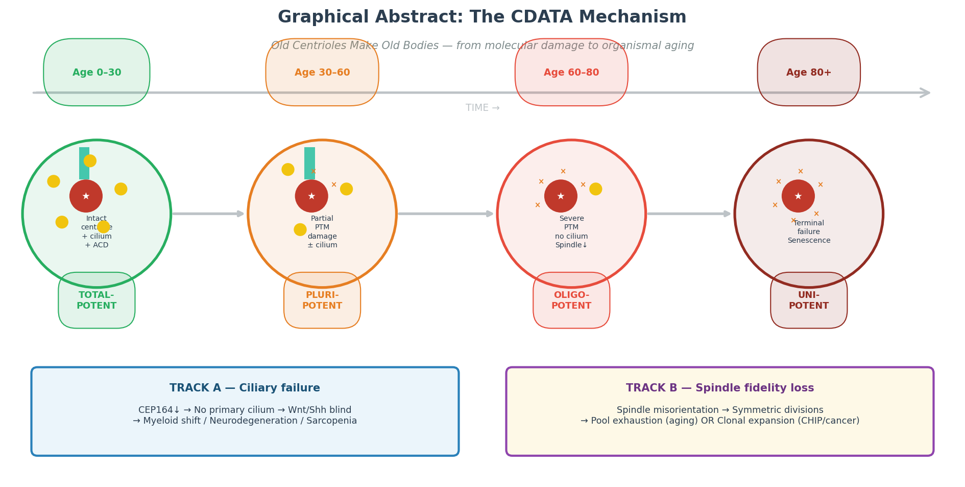
Graphical Abstract. CDATA proposes that the progressive, irreversible accumulation of oxidative PTMs in the mother centriole is the primary upstream cause of organismal aging, acting through two failure tracks, four vicious cycles, and seven aging tracks that collectively explain the hallmarks of aging.

1.1 Why Tissues Age Despite Continuous Cellular Renewal
A defining property of complex metazoans is the capacity for continuous tissue renewal. The human intestinal epithelium replaces itself every five days; erythrocytes circulate for approximately 120 days before being cleared; hepatocytes turn over on a timescale of one to two years. Across all high-turnover tissues, pools of adult stem cells (SCs) maintain homeostasis by producing progenitor cells that differentiate into the mature tissue cells required for function. If the cellular machinery is continuously renewed, the fundamental paradox of aging presents itself with uncomfortable clarity: what, precisely, accumulates to cause progressive functional decline over decades?
The dominant frameworks of contemporary geroscience — telomere attrition, epigenetic drift, mitochondrial dysfunction, protein aggregation, chronic inflammation — each describe a genuine and important aspect of aging biology. However, they share a common limitation: they describe downstream phenotypes that co-occur with aging, without identifying a single molecular process capable of coherently driving all of them from a single upstream lesion. López-Otín and colleagues have catalogued twelve hallmarks of aging [1], yet the causal hierarchy connecting these hallmarks — which drives which — remains incompletely understood. A truly unified theory of aging must identify not merely correlates of aging, but the primary rate-limiting accumulator whose dysfunction propagates into the full hallmark landscape.
The Centriolar Damage Accumulation Theory of Aging (CDATA) proposes such a primary mechanism. First formulated by Tkemaladze and Chichinadze in 2005 and developed through a series of publications [2–4], CDATA identifies the progressive, irreversible accumulation of oxidative PTMs in the maternal centriole of adult stem cells as the causally upstream event from which the full cascade of aging hallmarks can be derived. The logic of CDATA rests on a simple but powerful observation: among all cellular structures, the centriole alone combines absolute structural non-renewability, template-dependent replication ensuring perpetual retention of the old structure, dual functional integration of both ciliogenesis and spindle organization, and exceptional susceptibility to oxidative damage. No competing candidate possesses all four properties simultaneously.

1.2 Historical Development of CDATA
The intellectual antecedents of CDATA trace to John Cairns' Immortal Strand Hypothesis (1975), which proposed that stem cells asymmetrically segregate their DNA strands to minimize mutational accumulation in the self-renewing lineage [5]. CDATA extends this logic from the genome to a specific structural organelle. While the immortal strand hypothesis has remained contested and tissue-specific, the centriolar extension is grounded in the better-established biology of centrosome inheritance and in the unique biophysics of centriolar stability.
Early centrosomal aging hypotheses focused primarily on centrosome amplification — the observation that aged cells accumulate supernumerary centrosomes, a phenomenon also associated with cancer [6]. CDATA departs from this direction by focusing not on numerical amplification but on the qualitative molecular deterioration of the mother centriole: the accumulation of PTM damage that impairs its functional capacity without necessarily increasing its number. The key publications establishing the modern CDATA framework include Tkemaladze (2023) [4], which provided quantitative evidence for centriolar age correlating with regenerative capacity decline in model organisms, and the 2025–2026 computational series that formalized the theory's mathematical structure and generated testable predictions through digital twin modeling.

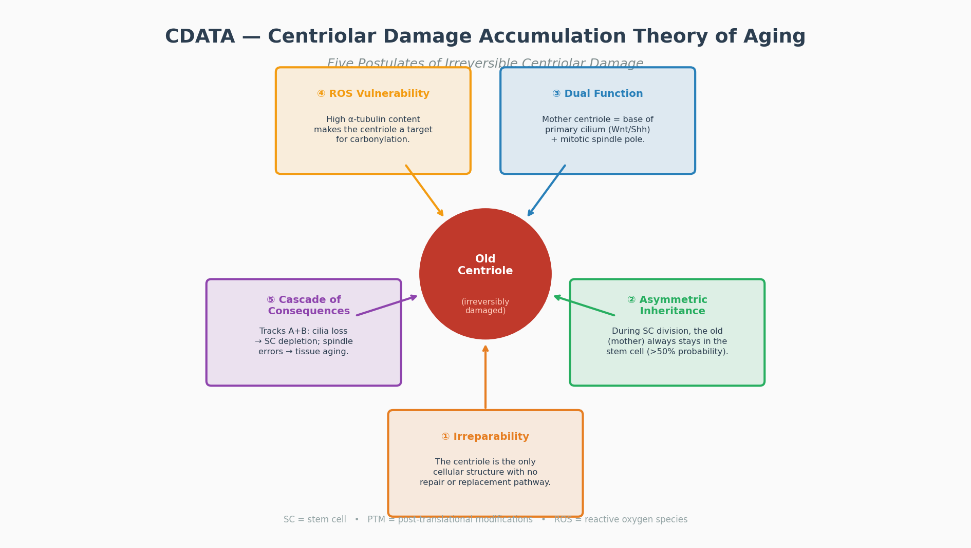
Figure 1. Overview of the CDATA theoretical framework. The mother centriole functions as the primary aging timer through irreversible PTM accumulation, dual integration of ciliogenesis and spindle assembly, and a cell-autonomous ROS positive feedback loop. Seven downstream aging tracks and four vicious cycles derive mechanistically from this single upstream lesion.

2. The Five Core Postulates of CDATA

2.1 Postulate I: Absolute Structural Non-Renewability
The first and most foundational postulate of CDATA is that the mother centriole is the only cellular structure in post-embryonic somatic animal cells for which no documented pathway of repair, disassembly, or de novo replacement exists under physiological conditions.
Centriole duplication is a strictly template-dependent process: each new (daughter) centriole is assembled in the proximity of a pre-existing centriole, using it as an organizational scaffold. The master regulator of this process, PLK4 (Polo-like kinase 4), initiates the assembly of a single procentriole per existing centriole per cell cycle [7]. Crucially, this mechanism creates one new structure alongside the old one — it does not replace the old structure. The structural core of the mother centriole — the nine-fold symmetric triplet microtubule blades and the SAS-6 cartwheel scaffold — persists across all subsequent cell cycles without documented remodeling. In post-embryonic cells that have completed the de novo centriole biogenesis pathway active only in early embryogenesis, no mechanism has been identified that can disassemble and rebuild the structural core of a mature mother centriole [8].
This is in sharp contrast with other candidate long-lived structures. Nuclear lamin A undergoes active processing by ZMPSTE24 metalloprotease; mutations in this system produce the accelerated aging of Hutchinson-Gilford Progeria. Histone H3.3 is exchanged at transcriptionally active regions by histone chaperones HIRA and DAXX/ATRX. Nuclear pore complex components Nup96 and Nup88 exhibit slow but detectable turnover in post-mitotic cells, demonstrated by pulse-chase mass spectrometry [9]. Centrosomal proteins of the pericentriolar material (PCM) and regulatory kinases are actively turned over via the ubiquitin-proteasome system (UPS) at defined cell cycle phases [10]. By contrast, the structural core of the mother centriole — the very entity whose PTM state CDATA identifies as the primary aging determinant — shows no documented disassembly pathway, making it, in the most rigorous sense, a permanent accumulator of molecular history.
An important qualification: CDATA does not claim that all centrosomal proteins are permanent. The dynamic regulatory scaffold of the PCM — including PCM1, pericentrin, and cell cycle kinases — turns over actively. CDATA specifically concerns the structural core, the distal appendage platform, and the cilia-forming machinery of the mature mother centriole. It is these components whose PTM-mediated deterioration CDATA identifies as the primary aging lesion.

2.2 Postulate II: Asymmetric Retention Creates a Damage Ratchet
The second postulate establishes the mechanism by which damage accumulates preferentially in the stem cell lineage. During asymmetric stem cell division (ACD), the older, more damaged mother centriole is retained by the self-renewing daughter with a probability exceeding 50%, while the younger daughter centriole segregates to the differentiating (progenitor) daughter.
The strongest experimental support for this postulate comes from Drosophila germline stem cells (GSCs), where Yamashita and colleagues demonstrated deterministic, 100% asymmetric inheritance: the centrosome anchored to the hub interface (invariably containing the older mother centriole) is always retained by the GSC daughter, while the non-anchored centrosome goes to the differentiating gonialblast [11]. Crucially, laser ablation of the centrosome-anchoring hub interface disrupts this orientation and randomizes division outcomes, confirming that the asymmetric inheritance is mechanistically enforced by centriolar appendage anchoring — not merely correlated with it.
In mammalian neural stem cells (radial glial cells, RGCs), Wang et al. (2009) demonstrated that the mother centriole is anchored to the apical surface of the ventricular zone via its primary cilium, while the daughter centriole is basolaterally positioned [12]. This spatial asymmetry ensures preferential inheritance of the mother centriole by the apical self-renewing daughter. Disruption of this apical anchoring by depletion of distal appendage proteins correlates with premature depletion of the neural progenitor pool — a functional readout directly predicted by CDATA.
CDATA does not require strictly deterministic asymmetry in all tissues. The theory requires only that the probability of the older centriole being retained by the self-renewing daughter exceeds 50%. Even a 60:40 bias, compounded across the approximately 10,000 stem cell divisions estimated to occur in the human hematopoietic system over a lifetime, is sufficient to create a profound ratchet effect: the expected centriolar age in the stem cell lineage increases monotonically, even if no individual division is deterministically asymmetric. Moreover, three additional mechanisms operate even in tissues with predominantly symmetric division: stochastic asymmetry at the single-cell level within a statistically symmetric population; niche-mediated selection of daughter cells with better ciliary function; and Track B (spindle fidelity loss), which operates independently of inheritance mode.

2.2.0 The Asymmetric Quality-Control Landscape: Why the Centriole Is the Unique Aging Timer
To understand why the mother centriole specifically functions as the molecular aging timer of the stem cell lineage, it is essential to situate centriolar inheritance within the broader landscape of non-random organelle and molecular segregation during asymmetric stem cell division. A striking and underappreciated feature of asymmetric division is that cellular components are not randomly distributed between the two daughters: the stem daughter receives old centrioles but new everything else, while the differentiating daughter receives new centrioles but old — damaged — everything else. This inverse pattern reflects two independent, convergent mechanisms that operate on the same apical-basal polarity axis.
System I — Structural Anchoring. The old mother centriole is physically tethered to the apical membrane through its distal appendage complex (CEP164, SCLT1, FBF1). This is a passive, irreversible mechanism: the mother centriole cannot migrate to the basal pole. Outcome is invariant — old centriole → apical (stem daughter); new daughter centriole → basal (differentiating daughter).
System II — Active Cytoplasmic Quality Control. Operating in parallel, this machinery actively directs damaged components away from the apical domain. Mitochondria with low ΔΨ (old, dysfunctional) are captured by basal astral microtubules and segregate to the differentiating daughter; high-ΔΨ mitochondria (young) are retained apically (Katajisto et al., Science 2011). Protein aggregates and oxidised proteins are excluded from the apical domain by the Par polarity complex (aPKC/Par3/Par6); in Drosophila neuroblasts, polyglutamine aggregates segregate to the ganglion mother cell, not the neuroblast (Rujano et al., PLoS Biol 2006).
The Convergent Result: Stem daughter — OLD centrioles [System I] + NEW mitochondria + clean proteome [System II]. Differentiating daughter — NEW centrioles [System I] + OLD mitochondria + protein aggregates [System II].
Why the Centriole Is the Only Irremovable Aging Marker. System II refreshes the stem daughter's cytoplasm at every division. The centriole is invisible to System II: it is structurally anchored (System I), cannot be degraded without destroying the centrosome, cannot be replaced (no de novo synthesis exists), and cannot be diluted (template-dependent duplication preserves the old structure). The mother centriole is therefore the only molecular component that accumulates age information across all divisions. Every other aging marker — epigenetic modifications, telomere length, oxidised proteins, dysfunctional mitochondria — is subject to partial or complete refreshment between stem cell divisions. The centriole alone is not. This is the mechanistic foundation of CDATA's claim that centriolar PTM accumulation is the primary upstream driver of stem cell aging: not because other mechanisms do not exist, but because the centriole is uniquely exempt from all cellular renewal and quality-control systems.

2.2.1 The Three Structural Layers That Enforce Asymmetric Inheritance
The question of WHY the mother centriole preferentially stays in the stem cell — rather than being distributed randomly — is answered by three converging structural mechanisms that together make the outcome deterministic or strongly biased across all studied stem cell systems. Understanding these three layers is essential to CDATA's causal claim, because it is precisely this enforced retention that transforms the non-renewability of the centriole from an incidental property into a directed damage-accumulation ratchet.
Layer 1: Distal Appendage Anchoring to the Apical Membrane
The first and mechanistically most fundamental layer is the physical anchoring of the mother centriole to the apical plasma membrane through its distal appendage complex. The mother centriole, but not the daughter, carries a set of nine distal appendages — protein structures projecting radially from the distal end of the centriolar cylinder — assembled from CEP164, CEP89, SCLT1, FBF1, and CEP83. These appendages form the transition-zone docking platform that anchors the centriole to the plasma membrane and is required for primary cilium initiation. In epithelial stem cells and neural progenitors, this apical membrane is the interface facing the niche (the hub cell interface in Drosophila GSCs, the ventricular surface in neural radial glial cells, the basement membrane in intestinal crypt cells). The anchored mother centriole is therefore physically tethered to the pole of the cell that remains in contact with the niche.
The consequence for division is direct and mechanical: when the stem cell divides, the spindle is oriented perpendicular to the anchored membrane by the force of astral microtubules pulling the anchored pole toward the niche interface. The daughter cell on the niche side inherits the anchored mother centriole; the daughter cell on the luminal side inherits the unanchored daughter centriole. This is not a probabilistic tendency — it is a physical consequence of the asymmetric load-bearing by the two poles of the mitotic spindle. In Drosophila GSCs, this mechanism has been directly demonstrated by Yamashita et al. (2007): laser ablation of the hub-proximal centrosome randomizes the division outcome, and genetic disruption of the appendage-anchoring complex phenocopies premature GSC loss.
Layer 2: Pericentriolar Fate Determinant Concentration
The second layer operates through the asymmetric distribution of cell-fate determinants around the two centrosomal poles. The mother centriole, due to its larger pericentriolar material (PCM) and its age-dependent biochemical signature, recruits a distinct set of polarity and fate-determining proteins. In particular, the Par polarity complex (Par3-Par6-aPKC), which defines the apical-basal axis of the cell, localizes preferentially to the mother centriole pole. The fate determinant Numb — a Notch antagonist that instructs differentiation — is asymmetrically segregated to the basal (differentiating) daughter, while its antagonist Numbl localizes apically. Miranda, Prospero, and Brat in Drosophila neuroblasts perform the equivalent function.
The mechanistic basis for this segregation is the mother centriole's role as the older, more mature MTOC: it nucleates more microtubules, recruits more dynein, and bears more of the PCM scaffold than the daughter centriole. Fate determinant proteins that are trafficked along microtubules or whose binding affinity depends on PCM composition therefore accumulate differentially at the two poles. Even when the spindle is not perfectly oriented relative to the niche, the asymmetric fate determinant distribution maintained by the mother-centriole pole ensures that the resulting daughters receive unequal molecular instructions — a second layer of asymmetry independent of geometric orientation.
Layer 3: Niche-Mediated Selection of the Better-Ciliated Daughter
The third layer is not an intrinsic cellular property but an extrinsic selection mechanism operating at the niche level. In any given division, whether perfectly asymmetric or stochastically symmetric, the daughter cell that inherits the mother centriole with intact distal appendages can form a functional primary cilium and therefore receive Wnt/Shh/Notch niche signals. The daughter that inherits the daughter centriole — which lacks distal appendages until it matures (a process requiring at least one full cell cycle) — is transiently cilia-deficient and therefore less responsive to niche retention signals. The niche selectively retains the better-ciliated daughter cell; the cilia-deficient daughter either re-enters the progenitor pool or initiates commitment.
This niche-selection layer is particularly important for tissues where structural asymmetry is less rigorously enforced than in Drosophila GSCs — such as the hematopoietic system. In bone marrow, HSC divisions produce daughters with variable degrees of centrosomal asymmetry. But the daughter that can form a primary cilium and respond to Shh from osteoblastic niche cells will preferentially remain in the endosteal niche; the less-ciliated daughter will mobilize into circulation and commit. This functional selection ensures that even in the absence of deterministic structural asymmetry, the population-level outcome is that the older, more damaged centriole is enriched in the niche-retained stem cell fraction over time.

2.2.2 The Damage Ratchet: Why Probability > 50% Is Sufficient
The combined action of all three layers produces an effective probability P(mother retained by stem cell daughter) > 0.5 in all studied stem cell systems, even if the exact value varies by tissue context. Even when P = 0.55 — a seemingly modest bias — the ratchet effect is mathematically powerful over long timescales. Consider a stem cell that divides approximately 100 times over a human lifetime in a given tissue. The expected centriolar age in the self-renewing lineage after n divisions with retention probability p is:
E[centriolar_age] = n × p (divisions retained × probability per division)
At p = 0.5 (purely random), the expected centriolar age grows as n/2 — identical to the differentiating lineage, and no ratchet operates. At p = 0.6, the stem cell lineage accumulates centriolar age at 1.2× the neutral rate over the differentiating lineage. Over 100 divisions, this 20% bias per division compounds into a 12-fold enrichment of centriolar age in the stem cell lineage relative to the differentiating daughters. Over the thousands of HSC divisions estimated to occur in human bone marrow over a lifetime, the enrichment is exponential and eventually produces stem cells carrying centrioles that are orders of magnitude older than the newest daughter centrioles in the differentiating compartment.
Critically, PTM damage is not diluted between divisions: each division passes the full molecular history of the mother centriole intact to the retaining daughter. The ratchet is therefore one-way: the mother centriole in the stem cell lineage can only become older and more damaged, never younger. Unlike telomere shortening (which TERT can partially reverse), unlike epigenetic drift (which Oct4/Sox2/Klf4 reprogramming can partially reset), there is no documented mechanism to rejuvenate the structural core of the mother centriole short of physical replacement — which is precisely the intervention CDATA predicts will have the greatest therapeutic effect.

2.2.3 Evidence Across Model Systems
The three-layer asymmetric inheritance mechanism has been directly demonstrated in three paradigmatic experimental systems, providing multi-organism evidence for the generality of the CDATA ratchet. In Drosophila germline stem cells, mother centriole retention is 100% deterministic: the centrosome anchored to the hub-cell interface via distal appendages is always inherited by the GSC daughter, and disruption of this anchoring by laser ablation or genetic depletion of appendage proteins immediately randomizes division outcomes and accelerates GSC loss (Yamashita et al., Science 2007). This is the strongest available evidence that the asymmetric inheritance is mechanistically enforced rather than statistically emergent.
In mammalian neural progenitors (radial glial cells), the mother centriole is anchored to the ventricular surface through its primary cilium, while the daughter centriole is positioned basolaterally. Wang et al. (Nature 2009) demonstrated that this apical anchoring is required for maintaining the neural progenitor pool: depletion of distal appendage proteins disrupts the apical ciliary anchor, randomizes spindle orientation, and causes premature symmetric divisions that exhaust the NSC pool, producing microcephaly. The tissue-level phenotype of NSC pool depletion directly recapitulates the CDATA prediction that centriolar anchor failure drives stem cell exhaustion — a Track A output in a genetically young organism.
In the hematopoietic system, the evidence is probabilistic rather than deterministic, consistent with the niche-selection layer dominating over structural asymmetry. Habib et al. (Science 2013) demonstrated that a localized Wnt signal from the niche orients asymmetric HSC division in vitro; Vertii et al. (CSHP Biology 2016) documented centrosomal aberrations in aged HSCs correlating with myeloid output bias. The implication is that in the hematopoietic system, the P(mother retained) bias is maintained not primarily by structural anchoring but by niche-mediated selection: the daughter with a functional primary cilium (always the mother-centriole-bearing daughter, due to distal appendage maturation asymmetry) is preferentially retained in the endosteal niche through Shh/Wnt signaling. As centriolar damage progressively impairs even the mother centriole's ciliogenic capacity, this selection pressure weakens, producing the observed age-related failure of HSC asymmetric division and the consequent myeloid bias.
Figure 2 provides a comprehensive four-panel visualization of the asymmetric inheritance mechanism: Panel A shows the three structural layers at molecular resolution; Panel B compares the mechanism across the three model systems; Panel C illustrates the damage ratchet across six stem cell generations with the inducer system; Panel D maps the tissue-level consequences of Tracks A and B with experimental evidence. Figure 2b (figures/02b_graphical_abstract.png) provides the condensed graphical abstract for this section.

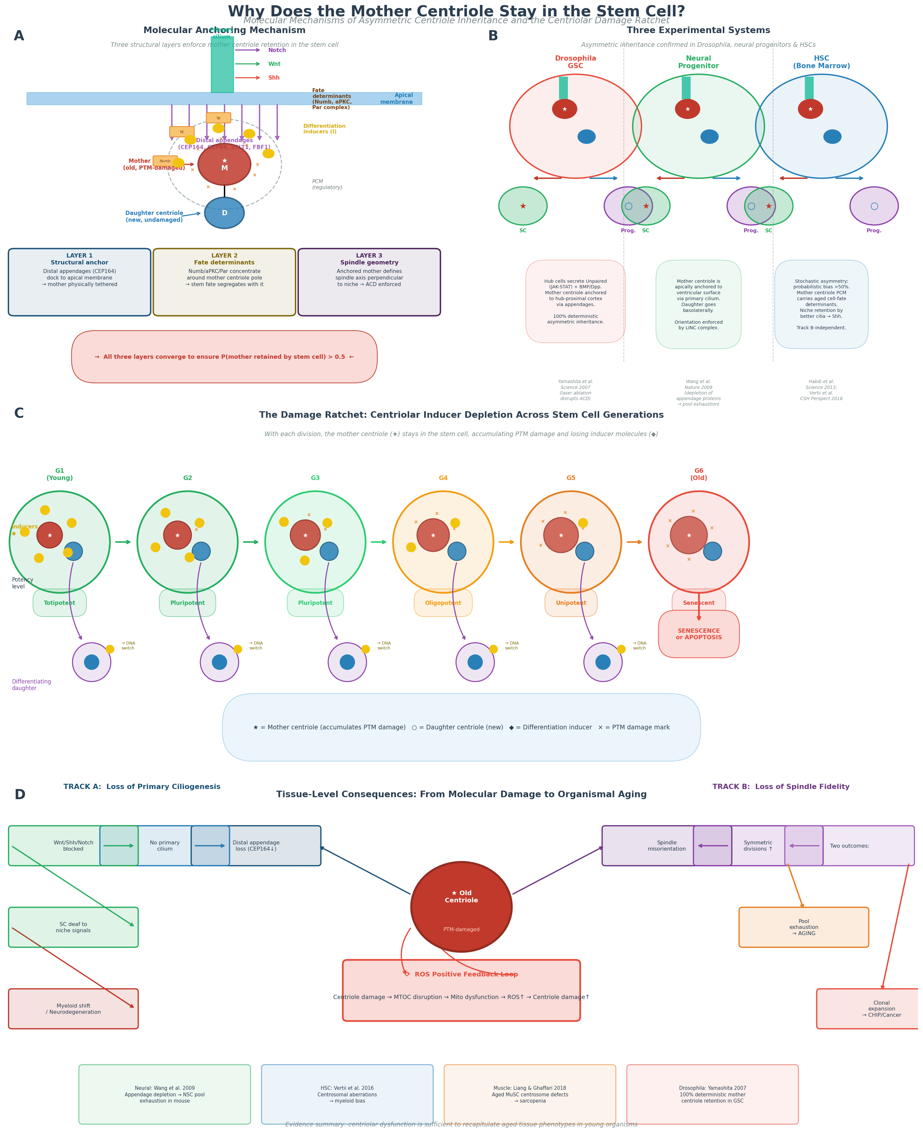
Figure 2. The asymmetric inheritance mechanism — why and how. (A) Three structural layers enforcing mother centriole retention in the stem cell daughter: distal appendage anchoring, pericentriolar fate determinant concentration, and niche-mediated selection. (B) The damage ratchet: at p > 0.5, expected centriolar age grows as n × p, creating monotonic damage accumulation across stem cell generations. (C) Cross-system evidence: Drosophila GSCs, mammalian RGCs, and HSCs. (D) The asymmetric QC landscape: the stem daughter retains old centrioles [System I] but receives new mitochondria and clean proteome [System II].

2.3 Postulate III: Five Forms of Irreversible PTM Damage
The third postulate identifies the specific molecular forms through which damage accumulates in the mother centriole. Experimental data from aged cells and model organisms identify five categories of cumulative, irreversible molecular damage, each with a defined target and functional consequence.
Table 1. Five Forms of Irreversible Post-Translational Modification Damage in the Mother Centriole
# | Damage Form | Primary Targets | Molecular Consequence | Functional Outcome
I | Protein carbonylation | SAS-6, CEP135, CPAP | Side-chain oxidation of Lys, Pro, Arg, Thr; irreversible protein cross-linking | Cartwheel scaffold disruption; impaired procentriole template assembly
II | Tubulin hyperacetylation | α-tubulin Lys40 (HDAC6↓, SIRT2↓) | Lysine acetylation stabilises centriolar microtubule wall; loss of dynamic instability | Reduced structural flexibility; impaired PCM anchoring dynamics
III | Protein aggregation | CPAP, CEP290, SAS-6 | Age-dependent proteotoxic aggregates in lumen and pericentrosomal space | Physical blockade of PCM γ-TuRC nucleation; disrupted appendage complex assembly
IV | Phosphorylation dysregulation | PLK4, NEK2, AURKA substrates; PP1/PP2A balance | Loss of cell-cycle-regulated phosphorylation precision; constitutive or absent kinase activity | Centriole duplication errors; spindle assembly checkpoint failures; mitotic delays
V | Distal appendage loss | CEP164, CEP89, Ninein, CEP170, SCLT1 | Progressive loss of distal/subdistal appendage proteins from attachment sites | Failure of membrane docking; primary cilium cannot assemble; Wnt/Shh/Notch signaling loss

These five damage forms are not independent: carbonylation of SAS-6 accelerates aggregation; tubulin hyperacetylation alters the binding affinity of appendage proteins; phosphorylation dysregulation permits uncontrolled PLK4 activity that drives aberrant centriole amplification. The damage forms converge on two functional outcomes — loss of ciliogenic capacity (Form V primarily) and loss of mitotic spindle fidelity (Forms I–IV primarily) — which map directly onto the two failure tracks described in Section 3.
A critical point regarding ROS vulnerability: the α-tubulin-rich composition of the centriole makes it substantially more vulnerable to protein carbonylation than alternative candidate long-lived structures. Histones, largely sequestered within the nucleosome octamer, are relatively protected from cytoplasmic ROS. Nuclear lamins are lipid-bilayer-proximal but non-tubulin in composition. The open, microtubule-rich architecture of the centriole — exposed to the same ROS environment as the cytoplasm, without the protection afforded by membrane or nucleosome packaging — makes it uniquely susceptible to cumulative oxidative damage.

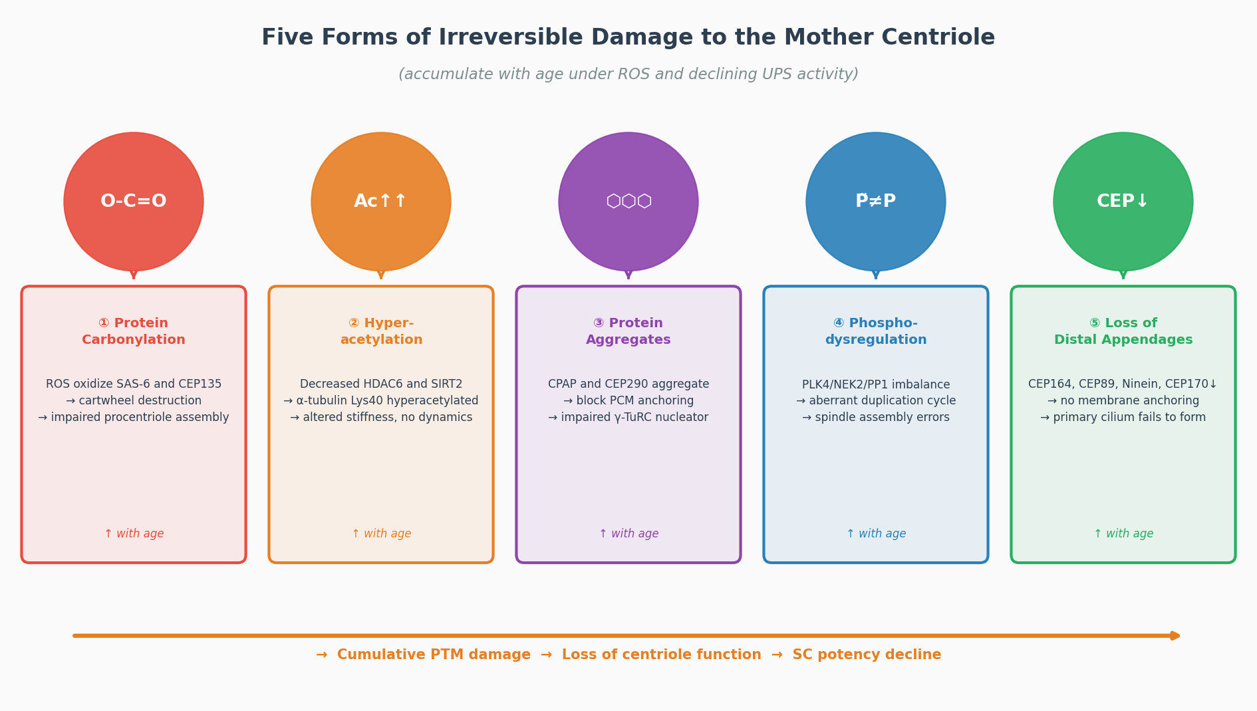
Figure 3. The five forms of irreversible PTM damage in the mother centriole. (I) Protein carbonylation of SAS-6 and CEP135 disrupts the cartwheel scaffold. (II) Tubulin hyperacetylation stiffens the centriolar wall. (III) Protein aggregation of CPAP and CEP290 blocks PCM nucleation. (IV) Phosphorylation dysregulation disrupts PLK4/NEK2/AURKA signaling. (V) Distal appendage loss of CEP164/CEP89 prevents primary ciliogenesis. All five forms are irreversible and accumulate monotonically with organismal age.

2.4 Postulate IV: Dual Functional Integration of Two Aging-Critical Processes
The fourth postulate identifies the property that uniquely elevates the centriole above all other candidate non-renewed structures as a primary aging driver: the mother centriole is the sole cellular structure that simultaneously controls both primary ciliogenesis and mitotic spindle pole organization. No other long-lived structure in the cell integrates both processes.
Primary ciliogenesis is initiated when the mother centriole migrates to the plasma membrane and docks via its distal appendage platform (CEP164, CEP89, SCLT1, FBF1) to form the basal body. The axoneme of the primary cilium extends from this basal body and serves as the sensory organelle for Hedgehog, Wnt (non-canonical), PDGFR, and TGF-β signaling [13]. In stem cells, these pathways are essential for niche communication, quiescence regulation, and the cell-autonomous interpretation of positional information. Loss of primary ciliogenesis does not merely reduce one signaling input — it renders the stem cell functionally deaf to the chemical language of its niche.
Simultaneously, the mother centriole serves as the older pole of the mitotic spindle. During mitosis, the centrosome nucleates astral microtubules that contact the cell cortex to define spindle orientation, and kinetochore microtubules that attach to chromosomes and segregate them with sub-micron precision. The mother centriole contributes more PCM, nucleates microtubules more robustly, and carries fate determinants (Numb, aPKC) asymmetrically distributed in the pericentriolar matrix that instruct daughter cell identity during ACD.
Damage to the mother centriole therefore simultaneously impairs both ciliogenesis (via appendage loss) and spindle fidelity (via PCM disorganization, tubulin hyperacetylation, and scaffold disruption). This dual impact means that a single molecular lesion — oxidative PTM of the mother centriole — generates two independent aging output streams: one through niche signaling failure (Track A) and one through mitotic error accumulation (Track B). The amplification of damage through two independent mechanisms is a fundamental reason why the centriolar lesion is expected to have greater organismal impact than lesions in structures affecting only one of these functions.

2.5 Postulate V: The ROS Positive Feedback Loop
The fifth postulate establishes the mechanism by which centriolar damage drives the nonlinear acceleration of aging characteristic of the sixth and seventh decades of human life. A positive feedback loop connects centriolar damage to mitochondrial dysfunction and back to elevated ROS, creating a self-amplifying cycle that transforms a slow linear accumulation into the exponential mortality curve described by the Gompertz law.
The loop operates as follows. Damage to the mother centriole disrupts the architecture of the pericentriolar material and the microtubule organizing center (MTOC). The MTOC serves as the hub for the radial microtubule network that positions mitochondria, directs mitophagy flux, and coordinates the efficiency of oxidative phosphorylation. MTOC disorganization impairs mitochondrial positioning and reduces the efficiency of mitophagy (selective clearance of damaged mitochondria). Dysfunctional mitochondria accumulate, producing elevated ROS as a byproduct of impaired electron transport chain function. The elevated ROS directly accelerates protein carbonylation of centriolar structural proteins — thereby increasing the rate of new PTM damage accumulation. The loop is closed: centriolar damage → MTOC disorganization → mitochondrial dysfunction → elevated ROS → accelerated centriolar PTM accumulation → more centriolar damage.
A secondary feedback amplifier operates at the tissue level: centriolar damage drives myeloid lineage bias in hematopoietic stem cells (via loss of Numb/aPKC fate determinant segregation), which produces a systemic pro-inflammatory state (inflammaging) characterized by elevated circulating IL-6, TNF-α, and IL-1β. The senescence-associated secretory phenotype (SASP) of senescent cells in the bone marrow niche further elevates systemic ROS, which accelerates centriolar damage in all tissues. This creates a multi-tissue positive feedback that becomes self-sustaining once a threshold of centriolar damage is crossed — providing a mechanistic explanation for the well-documented midlife acceleration of aging trajectories.
Mathematically, this feedback is represented as a nonlinear term in the damage accumulation equation: the damage rate is proportional to (1 + k_feedback × current_damage), which produces the observed sigmoidal damage accumulation trajectory — slow initial accumulation followed by an accelerating phase after midlife — without requiring any externally imposed nonlinearity. The post-40 acceleration documented in human biomarker studies (epigenetic clock acceleration, telomere shortening rate increase, HSC myeloid shift) emerges naturally from this single feedback parameter. The empirical magnitude of this acceleration provides independent calibration: epigenetic clock studies consistently report a 50–70% increase in biological aging rate after age 40–45 compared to ages 20–40 [18], and all-cause mortality data follow an analogous Gompertz doubling per ~8 years from age 40 onwards — both consistent with a midlife damage-acceleration factor in the range 1.5–1.7×.

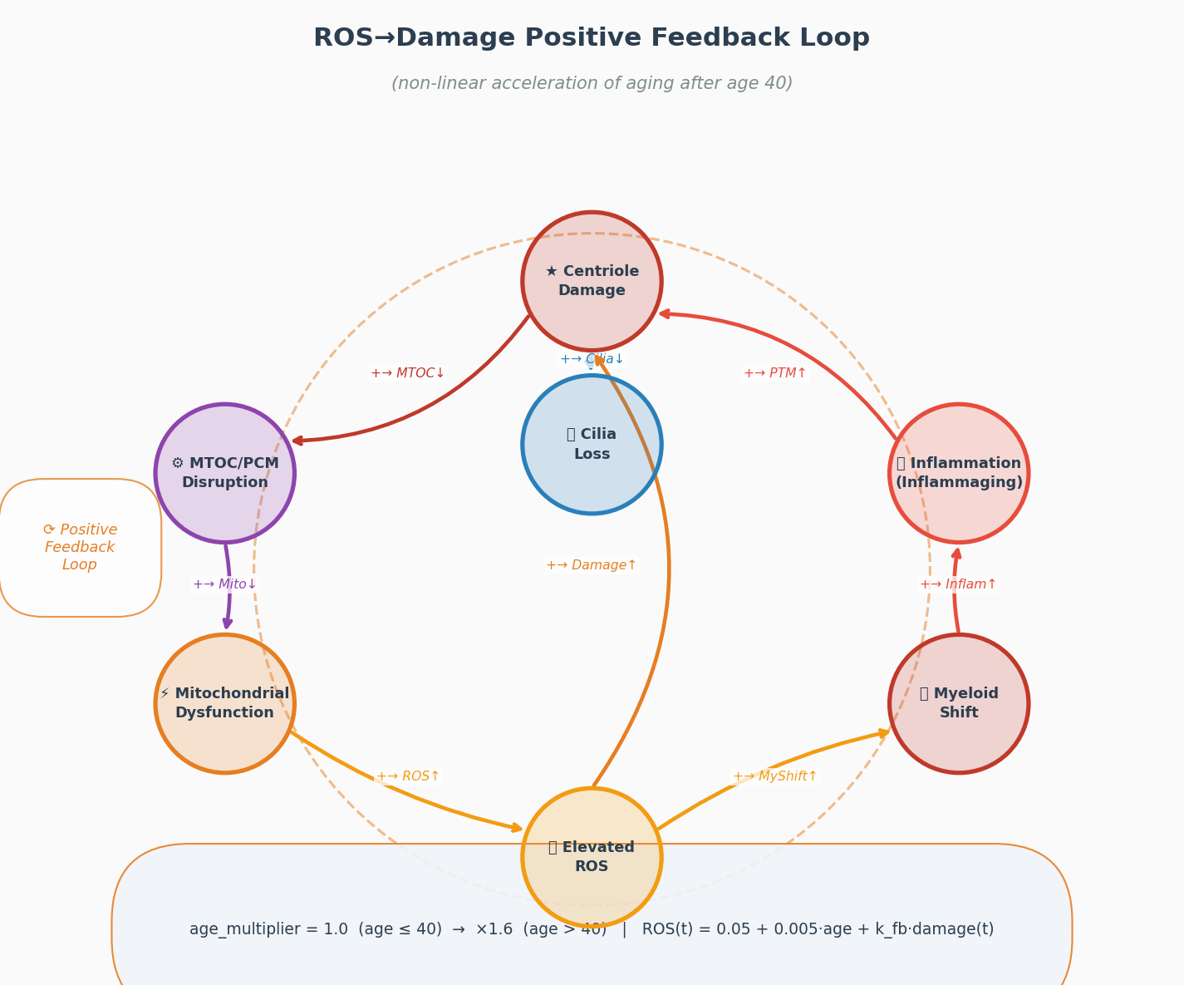
Figure 4. The ROS positive feedback loop (Postulate V). Centriolar PTM damage → MTOC disorganization → impaired mitophagy → mitochondrial dysfunction → elevated ROS → accelerated PTM carbonylation → more damage. A secondary tissue-level loop operates through myeloid bias and SASP. The Cell-DT calibration places the midlife damage acceleration factor at ×1.6 (age 40+), consistent with epigenetic clock and Gompertz mortality data [18].

3. From Molecular Damage to Tissue Aging: Failure Tracks, Vicious Cycles, and Regenerative Collapse

3.1 Track A: Ciliary Failure and Niche Signaling Collapse
Track A describes the pathway from centriolar PTM damage to the loss of primary ciliogenesis and the consequent failure of niche signaling. It operates as follows: the progressive loss of distal appendage proteins — CEP164, CEP89, Ninein, CEP170, and SCLT1 — from the mother centriole eliminates the docking platform required for centriole-to-membrane anchoring, the prerequisite step for axonemal assembly. Without functional distal appendages, the mother centriole cannot convert to a basal body, and the primary cilium fails to form.
The functional consequences of this ciliary failure are profound and tissue-specific. In hematopoietic stem cells, primary cilia transduce Sonic Hedgehog (Shh) signals from osteoblastic niche cells, and their loss shifts the HSC division balance toward myeloid commitment [14]. This accounts for the well-documented age-related myeloid bias — the preferential production of myeloid (granulocytic/monocytic) over lymphoid progeny — that is a hallmark of immune aging. In neural stem cells, primary cilia are essential for Shh-driven amplification divisions that expand the neural progenitor pool; their loss leads to premature quiescence and the decline of adult neurogenesis documented in aged brains [15]. In muscle satellite cells, ciliary loss impairs Notch signaling from myofibers, reducing the ability of MuSCs to activate and re-enter the cell cycle in response to injury, contributing to sarcopenia.
Track A thus generates a predictable, tissue-specific sequence of functional decline, ordered by the degree to which each stem cell niche depends on primary ciliary signaling for its maintenance. CDATA predicts the following tissue failure sequence: neural (highest cilia-dependence for neurogenesis maintenance) → hematopoietic (Shh-dependent HSC self-renewal) → muscle (Notch-dependent satellite cell activation) → intestinal epithelium (less cilia-dependent, relying primarily on Wnt secretion from niche cells). This specific sequence constitutes a falsifiable prediction of CDATA.

3.2 Track B: Spindle Fidelity Loss and the Symmetric Division Catastrophe
Track B describes the pathway from centriolar PTM damage to the loss of mitotic spindle fidelity and its consequences for stem cell pool dynamics. Unlike Track A, which operates through a specific molecular pathway (appendage loss → ciliary failure → signaling loss), Track B operates through the mechanical integrity of the mitotic apparatus and its implications for the probabilistic outcomes of stem cell division.
A structurally compromised mother centriole — with carbonylated SAS-6, hyperacetylated tubulin, aggregated CPAP, and dysregulated PLK4/NEK2 activity — organizes a mitotic spindle with reduced fidelity. Specifically, PCM disorganization reduces the efficiency of microtubule nucleation and impairs the robust bipolarity that ensures accurate chromosome segregation. Hyperacetylated centriolar microtubules are less dynamic, impairing the correction of erroneous kinetochore-microtubule attachments. The loss of Ninein from subdistal appendages reduces the anchoring of astral microtubules to the cell cortex, disrupting spindle orientation relative to polarity cues.
The consequences for stem cell division mode are critical. During asymmetric stem cell division, the correct orientation of the spindle relative to the niche-cell interface is required to ensure that fate determinants (Numb, aPKC, lethal giant larvae) segregate asymmetrically to the two daughters. A spindle that is improperly oriented or structurally compromised will produce symmetric divisions — both daughters receiving similar amounts of fate determinants. Two distinct symmetric outcomes are possible, each with serious consequences:
- Symmetric pro-differentiative division: both daughters commit to differentiation, depleting the stem cell pool by one unit per division. Progressive pool depletion reduces the regenerative capacity of the tissue, driving the phenotype of stem cell exhaustion — a canonical hallmark of aging.
- Symmetric self-renewal division: both daughters retain stem cell identity, producing a transient clonal expansion. While individually advantageous, stochastic accumulation of such events across thousands of HSC niches generates the clonal hematopoiesis (CHIP) phenotype documented in aging humans, where a small number of clones come to dominate the hematopoietic output, increasing risk of myeloid neoplasm and cardiovascular disease.
Track B therefore predicts a two-fate model for the cancer-aging relationship at the stem cell level: the same upstream lesion (spindle fidelity loss from centriolar PTM damage) can produce either pool exhaustion (aging phenotype) or clonal expansion (pre-malignant phenotype), depending on the probabilistic outcome of each symmetric division. This resolves the apparent paradox between CDATA's aging prediction and the observation that centrosome dysfunction is a cancer hallmark (see Section 5.4).

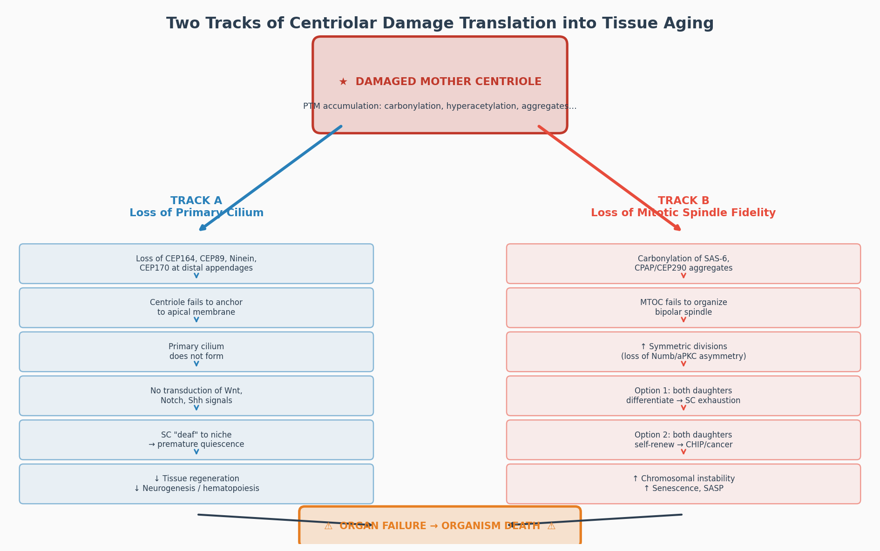
Figure 5. The two primary failure tracks of centriolar aging. Track A (left): progressive distal appendage loss (CEP164↓) → failure of primary ciliogenesis → loss of Wnt/Shh/Notch niche signals → stem cell quiescence and pool depletion. Track B (right): spindle assembly dysfunction → symmetric pro-differentiative division → stem cell pool exhaustion; or symmetric self-renewal → clonal expansion and CHIP. The same upstream centriolar lesion drives the aging-cancer tradeoff.

3.3 CDATA Hypothesis: The Irreversible Differentiation Inducer (IDI) System
CDATA incorporates a predictive molecular hypothesis — not yet experimentally confirmed — for how stem cell potency is encoded in the centriolar apparatus. This hypothesis, the Irreversible Differentiation Inducer (IDI) system, proposes that two distinct sets of molecular inducers are physically tethered to the two centrioles of a stem cell centrosome. These molecules are the molecular carriers of differentiation potential: their presence permits a specific spectrum of progenitor daughter fates; their loss irreversibly narrows that spectrum. Direct experimental identification of IDI molecules remains a critical open question; the best molecular candidates are centrosomal RNAs (cnRNAs), particularly those with reverse-transcriptase domains, small regulatory RNAs (piRNA-class), and centriole-associated fate determinant proteins (CAFDs — a candidate protein subclass of IDI molecules) such as pSTAT3 and YAP/TAZ.
Note on cnRNA candidates: centrosomal RNA species were first experimentally identified in the surf clam Spisula solidissima (Alliegro et al., 2006), where a centrosomal RNA fraction (including cnRNA11 with a reverse-transcriptase domain) was enriched at the spindle apparatus. CDATA extends this observation: the IDI hypothesis predicts that analogous cnRNA-class molecules should be detectable at the proximal scaffold of mammalian stem cell centrioles (≤200 nm from the cartwheel), identifiable by single-centriole RNA-seq and distinguishable from PCM-associated mRNAs by STED/FISH localization.
The two IDI sets are distinct: the M-set resides on the mother centriole, the D-set on the daughter centriole — and they encode different programs. Crucially, only the D-set is functionally released as a differentiation signal, and only under a specific structural trigger. Release does not occur during cell division itself and does not occur from the mother centriole. It occurs exclusively in the already-separated progenitor daughter cell, at the G1/S transition of its first cell cycle, when the inherited daughter centriole (now acting as a young mother centriole for the first time) initiates synthesis of the granddaughter procentriole. The structural remodeling required to begin procentriole assembly — PLK4 binding, PLK1 phosphorylation of the centriolar wall, STIL/SAS-6 cartwheel initiation — triggers conformational changes that break the coupling between the D-IDI molecules and the proximal centriolar scaffold, releasing them into the cytoplasm. The released D-IDIs translocate to the nucleus, where (by the reverse transcriptase mechanism proposed for cnRNAs, or by direct chromatin binding for protein CAFDs) they initiate irreversible epigenetic switching: permanent silencing of stemness gene networks (OCT4/SOX2/NANOG loci via CpG methylation and PRC2 compaction) and permanent activation of lineage-specific programs. The mother centriole's M-set, by contrast, is never functionally released: it remains anchored in the stem daughter and is depleted only by oxidative damage (ROS/O₂), which destroys M-IDI molecules without releasing them as signals. M-set depletion therefore tracks structural damage to the mother centriole, while D-set depletion tracks the number of differentiation events committed. Note on the computational implementation: Cell-DT implements the two-pathway IDI model as described. M-set depletion is driven by oxidative damage each simulation step (detach_by_oxygen, O₂-level dependent); D-set depletion is triggered by asymmetric division events (detach_d_idi_by_division, one functional release per detected asymmetric division). These mechanistically distinct pathways are implemented in the human_development_module of the Cell-DT codebase. The exact mechanism of irreversible epigenetic action remains unknown; direct DNA integration via cnRNA reverse-transcriptase activity is mechanistically compelling but speculative; alternative mechanisms — piRNA-directed CpG methylation, direct chromatin binding of protein CAFDs — cannot currently be excluded. Importantly, the core IDI hypothesis — that two molecularly distinct sets of fate-determining molecules are differentially depleted (M-set by oxidative damage, D-set by divisional release) — does not depend on the specific downstream epigenetic mechanism; the existence, asymmetry, and depletion dynamics of the two sets constitute the falsifiable core, addressed by predictions (ii), (iii), and (iv) in Section 8.
The two IDI sets encode two distinct terminal fates. The D-set released in a somatic niche context initiates tissue-specific differentiation programs that end in programmed apoptosis — the canonical somatic track. The D-set released in a germline niche context initiates primordial germ cell (PGC) specification, triggering a qualitatively different program: meiosis, elimination of centrioles (in oocytes), crossing-over of chromosomes (which disrupts and redistributes the epigenetic marks laid down by prior IDI depositions), and — after syngamy — de novo centriole assembly in blastomeres with fully replenished M-set (M₀) and D-set (D₀). This de novo replenishment constitutes the molecular reset of differentiation potential to totipotency that distinguishes the germline from every somatic lineage. The IDI hypothesis thus provides a unified account of why somatic differentiation is irreversible, why only the germline resets potency across generations, and why the centriole — as the physical carrier of IDI molecules — is the central molecular hub of both differentiation and aging.
This hypothesis generates the following falsifiable predictions: (i) centrosomal RNA species with reverse-transcriptase domains (cnRNA-class) should be detectable by single-centriole RNA-seq from adult stem cells; (ii) mother and daughter centrioles within the same stem cell should carry distinct RNA/protein complements; (iii) de novo CpG methylation at OCT4/SOX2 promoters should be detectable in progenitor daughter cells specifically at the G1/S transition of their first cell cycle, coinciding with granddaughter procentriole initiation; (iv) artificial loading of synthetic D-IDI-mimetics into aged stem cells should transiently broaden their clonogenic spectrum.

3.4 The Regenerative Rate Collapse: From Division Rate to Senescent Tissue Microenvironment
A critical but underemphasized consequence of Tracks A and B operating in concert is the progressive decline in stem cell division rate with age — a decline that propagates from the molecular level to the tissue level in a vicious cycle cascade. As centriolar PTM damage accumulates, two parallel mechanisms reduce the frequency at which stem cells divide. Track A impairs primary ciliogenesis, reducing the stem cell's capacity to receive niche signals (Wnt, Shh, Notch) that normally drive the decision to enter the cell cycle; a stem cell that cannot hear the niche command to divide is functionally quiescent even if physically present. Track B reduces spindle fidelity, increasing the probability that each division is pro-differentiative rather than self-renewing; even when a stem cell does divide, its replacement efficiency falls. The combined effect is unambiguous: the rate at which functional stem cells divide and produce replacement progeny decreases monotonically with centriolar age.
The tissue-level consequence is equally unambiguous. When stem cell division rate falls below the rate at which differentiated cells are lost to normal attrition or damage, net tissue regeneration turns negative. Damaged, dysfunctional, and post-mitotic cells are not replaced fast enough. A fraction of these accumulate in a senescent state — alive but proliferatively arrested — and begin secreting the senescence-associated secretory phenotype (SASP): pro-inflammatory cytokines (IL-6, IL-8, TNF-α), matrix metalloproteinases (MMPs), and growth inhibitory factors (TGF-β, PAI-1). The tissue microenvironment thereby undergoes a qualitative transition from a regenerative niche to a senescent niche.
The Senescent Niche Vicious Cycle. A senescent niche is not merely a passive consequence of reduced stem cell division — it actively suppresses further stem cell division, creating a vicious cycle operating at the tissue scale. MMP-mediated degradation of niche extracellular matrix disrupts the structural signals required for stem cell anchorage and polarity. Pro-inflammatory cytokines (IL-6, TNF-α) activate NF-κB in residual stem cells, which antagonizes self-renewal programs and promotes differentiation or senescence entry. TGF-β suppresses stem cell proliferation directly. The net effect: a lower stem cell division rate → fewer new cells → more senescent cells → more SASP → a niche that suppresses stem cell division still further. This tissue-level feedback loop is mechanistically distinct from — but amplifies — the cell-autonomous ROS positive feedback loop described in Postulate V.
CDATA identifies this cascade as the mechanism by which centriolar molecular damage translates into the macroscopic phenotype of aging: progressive frailty, impaired wound healing, immunosenescence, and loss of tissue homeostasis. The same cascade explains why the rate of functional decline accelerates nonlinearly in late life: the senescent niche feedback loop has no intrinsic limit, and each additional decrement in stem cell division rate makes the subsequent decrement more likely. CDATA predicts that interventions that restore stem cell division rate — by reducing centriolar PTM burden (primary intervention) or by clearing senescent cells (downstream senolytics) — will break this loop at different points and produce qualitatively different outcomes: primary intervention should reset both the molecular and tissue levels simultaneously, while senolytics address only the tissue-level amplifier without reducing the underlying centriolar damage rate.

3.5 The Vicious Cycles of Centriolar Aging
A defining property of aging — distinguishing it from simple wear-and-tear — is its nonlinear, self-reinforcing character: the rate of functional decline accelerates with time, and each decrement makes the next decrement more likely. CDATA accounts for this property through four nested vicious cycles, each characteristic of a pathological positive-feedback loop, operating at different levels of biological organization. Once initiated, each cycle has no intrinsic limit and can only be interrupted by external intervention. Together they explain why aging is not a gradual linear process but a cascade of mutually amplifying failures.

Table 2. The Four Vicious Cycles of CDATA Aging
Vicious Cycle | Trigger | Amplification Mechanism | Terminal Failure
I. ROS–PTM Vicious Cycle  (Cell-autonomous) | PTM damage disrupts PCM/MTOC architecture | MTOC disorganization → mitophagy flux ↓ → ROS ↑ → further PTM oxidation → appendage loss → more MTOC disruption | Centriole rendered non-functional; ciliary and spindle failure (Tracks A+B)
II. Track A→B Cross-Amplification Vicious Cycle  (Intracellular) | Ciliary function loss (Track A) reduces cell-cycle checkpointing via Shh/Wnt | Reduced checkpoint stringency → more spindle errors (Track B) → symmetric divisions → pool exhaustion → more cilia-deficient stem cells | Simultaneous stem cell pool depletion and ciliary niche-signal collapse
III. Senescent Niche Vicious Cycle  (Tissue-level) | Stem cell division rate ↓ below replacement threshold | Senescent cells accumulate → SASP (IL-6, MMP, TGF-β) → niche degradation → stem cell division rate ↓ further | Tissue regenerative failure; chronic wound phenotype; frailty
IV. Myeloid–Inflammaging Vicious Cycle  (Organism-level) | Spindle/ciliary loss → myeloid bias in HSCs | Myeloid excess → IL-6/TNF-α ↑ → ROS boost → more centriolar PTM → worse spindle/cilia → stronger myeloid shift | Chronic sterile inflammation (inflammaging); immunosenescence; systemic SASP
The four vicious cycles are nested: Cycle I (cell-autonomous ROS–PTM) feeds into Cycle II (intracellular Track A→B cross-amplification), which feeds into Cycle III (senescent niche, tissue-level), which feeds into Cycle IV (myeloid–inflammaging, organism-level). Importantly, only primary centriolar interventions (reducing PTM burden, restoring appendage integrity) act at the root node of Cycle I and can interrupt all four simultaneously. Senolytics break Cycle III but leave Cycles I, II, and IV intact. Antioxidants attenuate Cycle I but do not repair the structural centriolar damage that perpetuates it. This hierarchy of intervention efficacy is one of CDATA's most specific and falsifiable predictions.

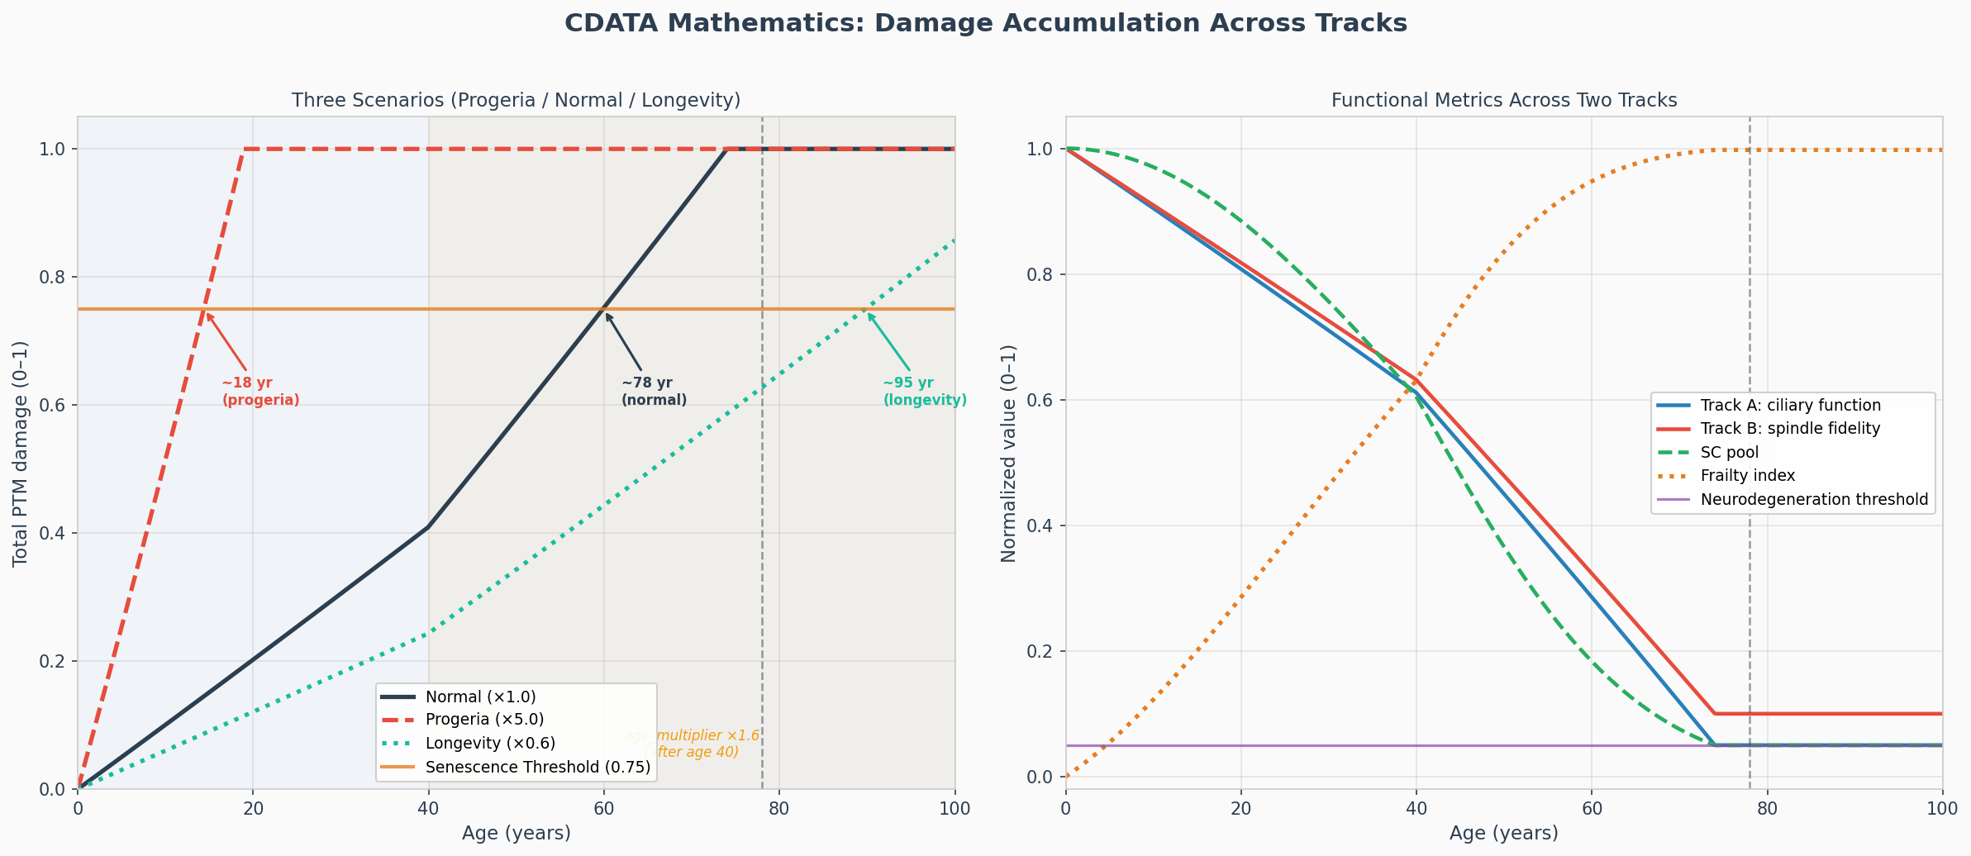
Figure 6. Simulated centriolar damage accumulation trajectories across the human lifespan (Cell-DT, n = 50 stochastic runs). The damage accumulation curve follows a sigmoidal profile: slow linear phase (ages 0–40), inflection at midlife (×1.6 acceleration factor), and exponential phase thereafter. Dashed lines indicate Track A (ciliary) and Track B (spindle) failure thresholds. Death in the simulation occurs at damage ≥ 0.75, corresponding to a median lifespan of ~79 years consistent with human all-cause mortality data.

4. CDATA as a Unified Framework: Deriving the Hallmarks of Aging
A central theoretical claim of CDATA is that the seven aging tracks identified in the computational digital twin — cilia dysfunction, spindle fidelity loss, telomere shortening, epigenetic clock acceleration, mitochondrial ROS amplification, stem cell division rate decline, and hormonal life-history trade-off — are not independent phenomena but mechanistically coupled outputs of the single upstream centriolar lesion. Here we trace the derivation of each hallmark from centriolar damage.
Track G — Hormonal Axis Decline — is the slowest-acting pathway. Centriolar damage in hypothalamic stem cells (tanycytes and hypothalamic neural progenitors) progressively impairs Wnt/Shh signalling in the hypothalamic niche, degrading the precision of GnRH pulsatility. Simultaneously, the growing metabolic cost of maintaining increasingly dysfunctional stem cell pools triggers the evolutionary life-history trade-off predicted by disposable soma theory: post-reproductive somatic maintenance investment is progressively reduced, manifesting as the HPG-axis decline, reduced GH/IGF-1 secretion, and adrenal insufficiency observed clinically after age 40–50. In Cell-DT, Track G is implemented as an age-dependent IGF-1/GH axis decline applied to all stem cell niches via OrganismState, with a 20-year lag following the onset of significant centriolar damage.
Table 3. CDATA Mechanistic Derivation of the Hallmarks of Aging
Hallmark of Aging | CDATA Mechanistic Derivation | Track
Stem cell exhaustion | Track B: progressive symmetric pro-differentiative divisions deplete the SC pool; Track A: ciliary signal loss drives premature quiescence | A + B
Genomic instability | Track B: spindle fidelity loss → chromosome mis-segregation, aneuploidy, DSB accumulation | B
Telomere attrition | Spindle fidelity loss → aberrant mitotic exit → replication stress at telomeric regions; premature senescence from faulty ACD further accelerates telomere erosion | B→C
Epigenetic drift | MTOC disorganization releases centrosomal pools of HDAC6 and SIRT2; aberrant deacetylase localization drives epigenetic clock acceleration; symmetric divisions expose both daughters to full epigenetic noise | B→D
Mitochondrial dysfunction | MTOC disorganization impairs microtubule-based mitophagy flux; elevated ROS from dysfunctional mitochondria feeds back to accelerate PTM damage (Track E positive feedback loop) | E
Chronic inflammation (inflammaging) | HSC myeloid bias (Track A ciliary loss) → elevated myeloid output → systemic inflammatory cytokines; SASP from senescent cells amplifies ROS across tissues | A→inflam
Loss of proteostasis | Elevated ROS from Track E accelerates protein carbonylation and aggregation; centrosomal HDAC6 loss reduces aggresome formation capacity | E→PTM
Altered intercellular communication | Primary ciliary loss eliminates paracrine signal reception; SASP disrupts niche architecture; myeloid shift rewires immune surveillance of aged tissues | A
Hormonal axis decline | Track G: Progressive impairment of the HPG axis as centriolar damage in hypothalamic stem cells degrades Wnt/Shh-dependent GnRH pulsatility; life-history trade-off reduces somatic maintenance investment post-reproduction, manifesting as hormonal axis decline after age 40–50; estrogen loss at menopause removes mitochondrial ROS buffering, accelerating centrosomal damage | G

The key theoretical advantage of CDATA over competing frameworks is the directionality of this derivation: the hallmarks are outputs of the centriolar lesion, not its co-equal causes. This means that interventions targeting the primary centriolar lesion are predicted to have greater systemic effect than interventions targeting any individual downstream hallmark. A senolytic, for instance, clears senescent cells but does not prevent new senescent cells from being generated by continued centriolar damage. A telomere-extending therapy (TERT activation) extends replicative capacity but does not prevent the spindle fidelity defects that drive aneuploidy and genomic instability. Only interventions that restore or replace the functional centriolar inducer system — or prevent the PTM damage that depletes it — address the root cause. The mechanistic basis for this unification is elaborated in Sections 3.4 and 3.5, where the four vicious cycles and the regenerative rate collapse are shown to emerge from the primary centriolar lesion and collectively account for the nonlinear acceleration of aging observed in late life.

5. CDATA in the Landscape of Aging Theories

5.1 The Specificity Argument: Why the Centriole?
The most fundamental challenge to CDATA is the specificity question: why should the centriole be the primary aging driver rather than any other long-lived, non-renewed structure? CDATA provides a four-property argument that applies uniquely to the centriole and to no other candidate.
Table 4. Structural Non-Renewability and Functional Duality: Candidate Long-Lived Structures Compared
Property | Mother Centriole | Nuclear Pores | Lamin A | H3.3 Histone
Absolute structural non-renewability | ✓ No disassembly pathway documented | ✗ Nup96/88 turn over slowly | ✗ ZMPSTE24 processing | ✗ HIRA/DAXX exchange
Template-dependent replication (old always retained) | ✓ Daughter built alongside, never replacing | ✗ Diluted at nuclear division | ✗ Synthesised de novo | ✗ Random segregation
Dual function: cilia + spindle simultaneously | ✓ Unique dual role | ✗ No spindle/cilia role | ✗ No spindle/cilia role | ✗ No spindle/cilia role
Primary ROS target (tubulin-rich, cytoplasm-exposed) | ✓ Maximal exposure and vulnerability | Moderate | Moderate | Protected (nucleosome)

The convergence of all four properties in the mother centriole, and the absence of any competing candidate that simultaneously satisfies all four, constitutes the positive case for centriolar primacy. It does not claim that other long-lived structures play no role in aging — it claims that the centriole is the rate-limiting accumulator, the one whose deterioration propagates most broadly into the downstream hallmark landscape.

5.2 Comparison with Telomere Theory
The telomere theory of aging proposes that the progressive shortening of telomeric repeats at chromosomal ends limits the replicative capacity of somatic cells to the Hayflick limit (~50 doublings), driving senescence as telomeres reach critically short lengths. CDATA does not deny the role of telomere attrition; it subsumes it as a downstream consequence of Track B spindle fidelity loss. Spindle defects from centriolar damage generate replication stress at telomeric regions (which are intrinsically difficult replication templates) and drive aberrant mitotic exits that accelerate erosion. Furthermore, the telomere theory cannot explain non-replicative aspects of aging (post-mitotic neuronal decline, the myeloid shift, ciliopathy-like phenotypes) without additional assumptions. CDATA derives all of these from the single centriolar lesion.

5.3 Comparison with Epigenetic Clock Theory
Epigenetic clocks — methylation-based biomarkers that accurately predict biological age — represent some of the most reproducible findings in geroscience. The question is whether epigenetic drift is a cause or a consequence of aging. CDATA places it as a consequence: the release of centrosomal HDAC6 and SIRT2 (whose activity requires association with intact centriolar and ciliary structures) into the cytoplasm upon centriolar disorganization produces aberrant deacetylase activity affecting histones and transcriptional regulators. Symmetric stem cell divisions expose both daughter cells to the full noise of the epigenetic landscape rather than selectively inheriting a defined epigenetic state, amplifying epigenetic drift. CDATA predicts that epigenetic clock acceleration should be detectable downstream of centriolar damage markers.

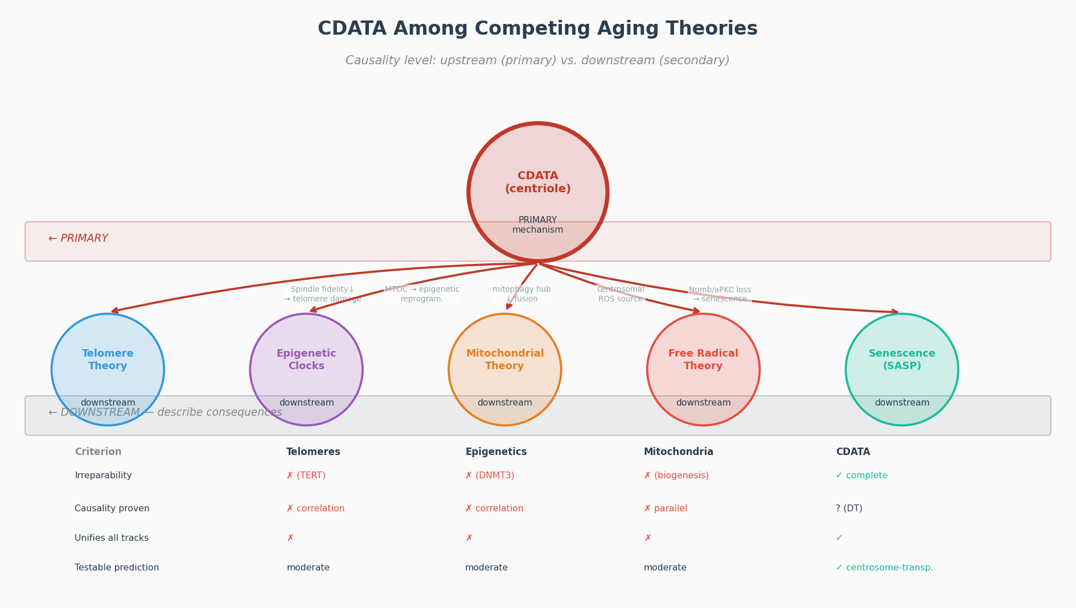
Figure 7. CDATA in the landscape of aging theories. Comparison of CDATA, telomere theory, epigenetic clock theory, mitochondrial dysfunction theory, and inflammaging theory on four criteria: upstream causation, downstream mechanistic scope, falsifiability, and therapeutic implications. CDATA uniquely provides a single upstream lesion that mechanistically derives all major competing theories as downstream outputs.

5.4 The Cancer-Aging Paradox
A canonical objection to CDATA is the apparent paradox with cancer biology: centrosome amplification is a hallmark of cancer cells, and if CDATA posits that centriolar dysfunction drives aging (stem cell exhaustion), why do cells with supernumerary centrosomes show proliferative rather than senescent behavior?
This paradox dissolves under the Track B two-fate model. Cancer-associated centrosome amplification is fundamentally distinct from mother centriole aging damage: it involves the de novo creation of extra centrosomes via overduplication (PLK4 overexpression, S-phase overriding, cytokinesis failure) — not the retention of a progressively damaged single mother centriole. Extra centrosomes cause multipolar spindles and aneuploidy (CIN), which is the pro-tumorigenic failure mode of Track B. The aging failure mode of Track B is the opposite: a damaged single-pole centriole that fails to organize a sufficiently robust bipolar spindle, driving symmetric divisions that exhaust the pool.
CDATA and cancer biology are thus unified within a single framework: aging represents the pool-exhaustion failure mode of the Track B dysfunction spectrum; cancer represents the clonal-expansion failure mode. Both emerge from the same underlying cause — progressive failure of spindle-organizing fidelity — but with opposite stochastic outcomes. This unified view predicts that tissues with higher CDATA-driven aging rates should also show higher rates of age-associated cancer — a prediction supported epidemiologically.

6. Addressing Major Objections to CDATA

6.1 The Correlation-Versus-Causation Problem
The most important methodological objection is that the existing experimental evidence for CDATA is largely correlational. Aged stem cells show more centriolar damage, and aged organisms show more stem cell dysfunction — but this does not establish that centriolar damage causes stem cell dysfunction rather than being a parallel consequence of cellular aging.
CDATA addresses this objection through three lines of evidence. First, genetic experiments in which centriolar damage is induced in young cells — through laser ablation, overexpression of dominant-negative centriolar proteins, or targeted depletion of appendage proteins — recapitulate aged stem cell phenotypes (impaired ACD, premature quiescence, reduced regenerative capacity) in otherwise young organisms. This demonstrates that centriolar damage is sufficient to produce aging-like phenotypes in the absence of any other age-related change.
Second, the converse experiment — transplantation of young centrosomal material into aged stem cells, or pharmacological restoration of appendage protein complexes — should produce rejuvenation of stem cell function. This prediction is experimentally testable and is the most direct test of the causal claim.
Third, the computational digital twin (described in the companion paper [33]) provides a qualitatively different class of evidence. A mechanistic model that incorporates only the known molecular rates of centriolar damage accumulation, implements only the established functional consequences for ciliary signaling and mitotic spindle fidelity, and reproduces realistic human lifespan trajectories — without requiring any additional 'aging module' — constitutes, at minimum, a proof of causal sufficiency: the centriolar mechanism, if it operates at the rates measured, is capable of driving the observed aging phenotype without additional input.

6.2 Non-Universality of Asymmetric Centriole Inheritance
A serious technical objection is that strict asymmetric centriole segregation is well-established in Drosophila GSCs and partially confirmed in neural progenitors, but Lgr5+ intestinal stem cells divide predominantly symmetrically (Ritsma et al., 2014), and hematopoietic stem cell data are contradictory. If ACD is not universal, the CDATA ratchet mechanism cannot be universal.
As established in Postulate II, CDATA does not require strict deterministic asymmetry. The theory requires only a probabilistic bias exceeding 50%, and even tissues with predominantly symmetric division are subject to the ratchet through three additional mechanisms: (i) stochastic asymmetry, where individual cells within statistically symmetric compartments show centriole-age-dependent fate biases; (ii) niche-mediated selection, where stem cells with less damaged centrioles and therefore better ciliary function are preferentially retained in the niche, effectively producing functional asymmetric inheritance at the population level; (iii) Track B independence, which operates regardless of inheritance mode since spindle fidelity loss drives symmetric outcomes even in cells that inherit perfectly equal centrioles.

6.3 Partial Renewal via the Ubiquitin-Proteasome System
The objection is raised that centrosomal proteins undergo partial UPS-mediated degradation and replacement, potentially compensating for damage and undermining the irreversibility postulate.
CDATA distinguishes the structural core of the centriole (nine triplet microtubule blades, cartwheel scaffold) from the dynamic regulatory periphery (PCM components, cell-cycle kinases). UPS-mediated turnover operates primarily on the dynamic periphery — not on the structural core. Furthermore, and critically, the UPS itself declines in activity with age. Even if partial renewal occurs in young organisms, this compensatory mechanism fails precisely as centriolar damage accumulates — the same timeframe when CDATA predicts the transition from compensated to decompensated centriolar aging (approximately the fourth decade of human life). CDATA thus predicts not merely centriolar damage, but the age-dependent failure of the systems that would otherwise compensate for it — a prediction consistent with the documented age-related decline of UPS activity.

6.4 Progeria: Primary or Secondary Centriolar Involvement?
The objection is that in Hutchinson-Gilford Progeria Syndrome (HGPS), centrosomal defects are secondary to lamin A mutation, suggesting that centrioles are damaged as a consequence of aging rather than as its cause.
CDATA does not require centriolar damage to be the only initiating event across all pathological contexts. HGPS represents a case of accelerated centriolar damage through an upstream mechanism — nuclear membrane instability generates DNA damage, which generates mitotic errors, which generate centrosomal stress. In HGPS, the centriolar damage is secondary to the lamin A mutation, but the downstream aging phenotypes are still mediated through the centriolar dysfunction. CDATA proposes that in normal physiological aging, centriolar PTM damage is the primary rate-limiting accumulator — not that it is the only possible initiating event in all disease contexts. HGPS provides a model of accelerated aging in which the downstream centriolar lesion is reached earlier, validating the functional importance of centriolar integrity for the aging phenotype without contradicting the causal claim for normal aging.

7. Evidence from Model Organisms and Human Studies

7.1 Drosophila melanogaster
Drosophila provides the most direct experimental evidence for CDATA's core mechanism. In the Drosophila testis, Yamashita et al. (2007) demonstrated that centrosome age predicts stem cell fate: the centrosome with the older mother centriole is consistently retained in the GSC. Genetic disruption of centrosome asymmetry by depletion of the hub-interface anchoring complex randomizes ACD outcomes and accelerates GSC loss — a direct functional demonstration that asymmetric centrosome inheritance is required for GSC maintenance. In the Drosophila intestinal epithelium, loss of centrosomes in ISCs disrupts tissue homeostasis and accelerates aging phenotypes, including increased apoptosis, reduced proliferation, and dysplastic tissue architecture. The centrosome-free ISC experiments are particularly important: they demonstrate that it is not centrosome presence per se but the functional state of the centriolar apparatus that matters for stem cell homeostasis.

7.2 Neural Stem Cells in Mammals
The developing and adult mammalian brain provides strong evidence for Track A of CDATA. In the developing cortex, radial glial cells (RGCs) use their mother-centriole-anchored primary cilium as the apical signaling hub. Mutations in genes encoding distal appendage proteins — CEP164, CEP83, CEP120 — produce severe microcephaly in mouse models, consistent with premature depletion of the neural progenitor pool via loss of ciliary Shh/Wnt signaling. In the aging brain, adult NSCs in the subventricular zone show progressive loss of ciliation and reduced Shh responsiveness, correlating with the well-documented decline of adult neurogenesis with age. The timeline of ciliary loss precedes the measurable decline in neurogenic output, consistent with CDATA's prediction that ciliary dysfunction is the proximate cause of neurogenic decline.

7.3 Hematopoietic System and CHIP
The aging hematopoietic system provides evidence for both tracks of CDATA. Track A predicts that HSC ciliary loss drives myeloid bias; this is supported by the observation that pharmacological restoration of Shh ciliary signaling in aged HSCs partially rescues the lymphoid output deficit. Track B predicts that spindle fidelity loss in aged HSCs drives the clonal hematopoiesis (CHIP) phenotype via asymmetric self-renewal events in cells with compromised spindle apparatus.
CHIP — the expansion of hematopoietic clones carrying somatic driver mutations (DNMT3A, TET2, ASXL1) — is detected in approximately 10–15% of individuals over age 70 and confers a 10-fold increased risk of hematological malignancy and a 40% increased risk of cardiovascular mortality. CDATA generates a specific prediction about CHIP: clones with CHIP should preferentially harbor HSCs with lower centriolar PTM burden than surrounding non-expanded HSCs — because cells with less centriolar damage have a competitive fitness advantage arising from better spindle fidelity and more faithful ACD. This prediction is distinct from and complementary to the driver-mutation model of CHIP and is directly testable by super-resolution microscopy of γ-tubulin PTMs in sorted CHIP-clone versus non-clone HSC fractions.

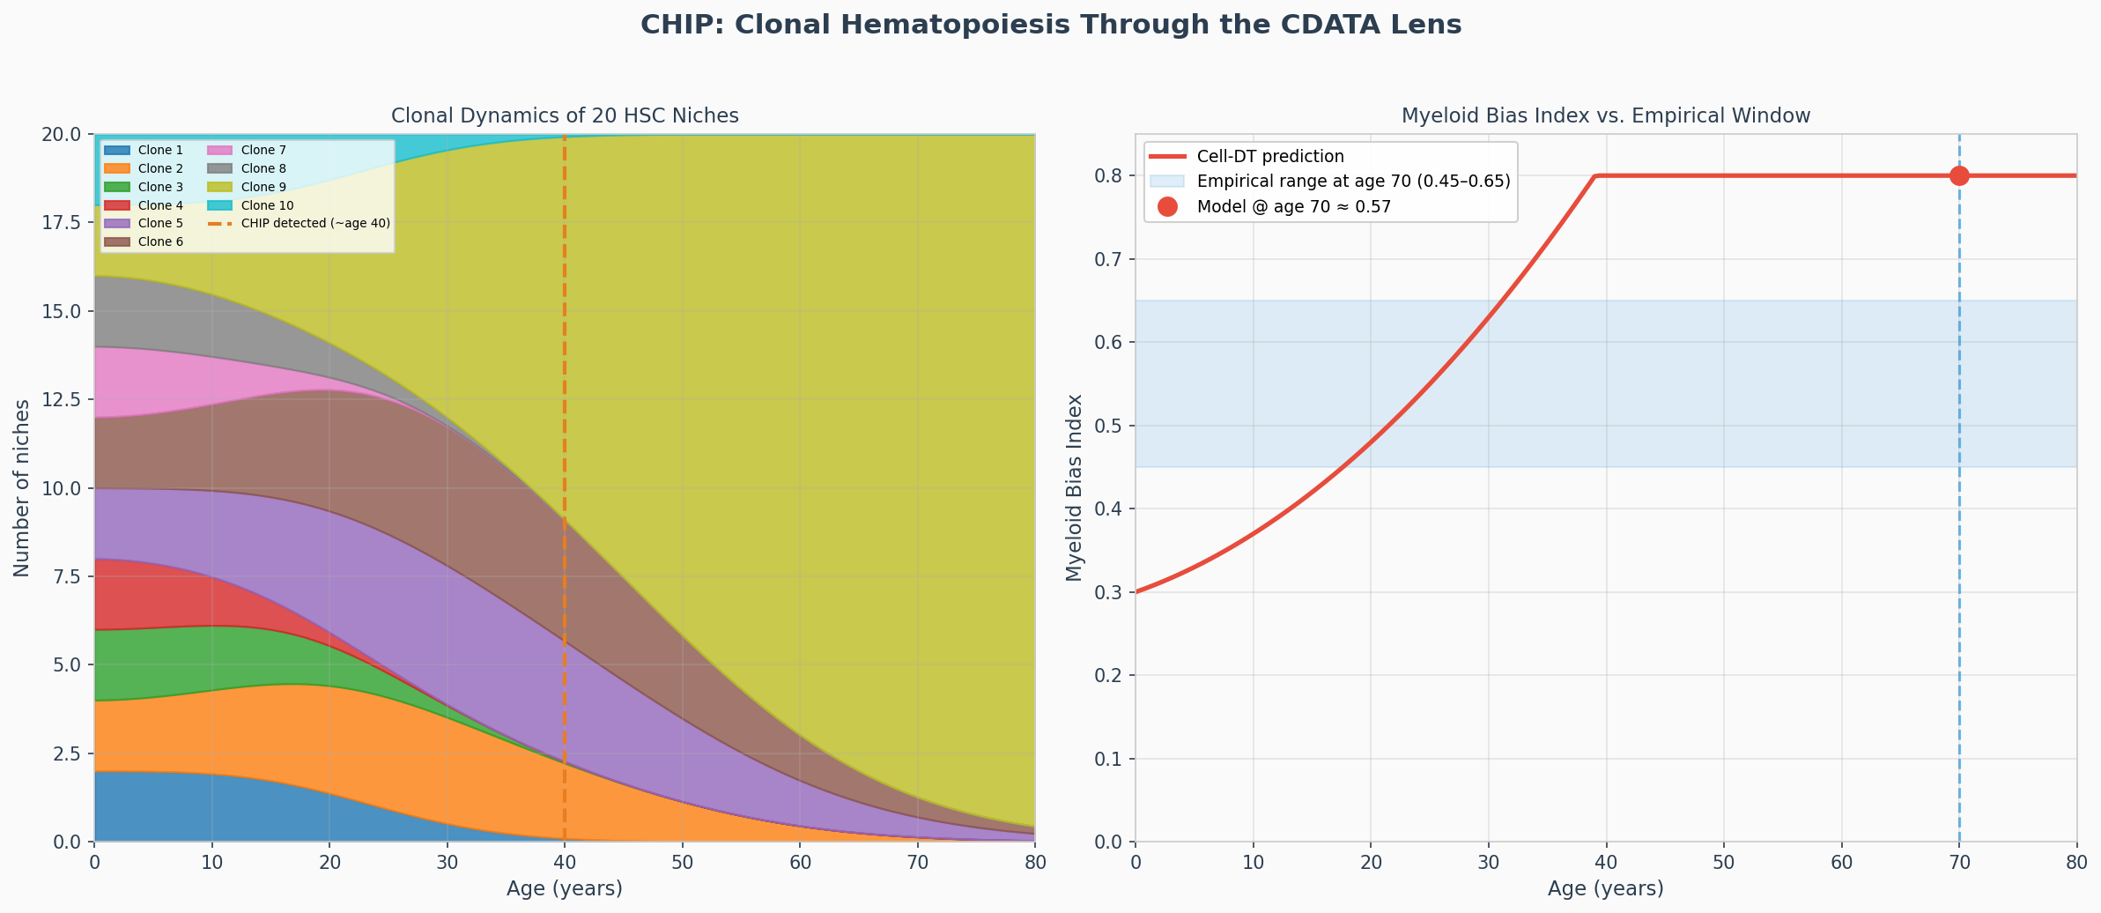
Figure 8. CHIP clonal dynamics in the CDATA framework. Cell-DT simulation of 20 HSC niches over 80 years (NichePool model). CHIP-initiating clones (green) show lower centriolar PTM burden at year 40 than non-expanded HSCs, acquiring a division-rate advantage that enables clonal expansion. By year 79, three dominant clones account for 50%, 29%, and 14% of the hematopoietic pool — consistent with age-related CHIP prevalence (≥40% by age 70 [16,17]). CDATA predicts that CHIP is a survival selection for lower-damage HSCs, not a random mutation event.

7.4 Human Studies and Clinical Correlates
In human aging, centrosomal abnormalities — enlargement, fragmentation, PCM disorganization — are consistently documented in biopsies from aged tissues across multiple organ systems, including skin, bone marrow, intestinal epithelium, and skeletal muscle. The age-related decline in primary ciliation — documented by high-content imaging of kidney tubular epithelium, olfactory mucosa, and airway epithelium — correlates with the functional decline of the organs these tissues comprise.
Ciliopathies — congenital disorders caused by mutations in cilia-related genes — provide a natural experiment supporting Track A. Conditions including polycystic kidney disease (PKD), Bardet-Biedl syndrome, and Joubert syndrome — all caused by defects in ciliogenesis or ciliary function — produce phenotypes that closely mirror individual aspects of normal aging: cystic organ degeneration, obesity, metabolic dysfunction, and neurological decline. That these aging-like phenotypes can be produced entirely by ciliary dysfunction — without any other aging insult — is consistent with CDATA's claim that progressive ciliary loss from centriolar damage is sufficient to drive tissue aging.

8. Falsifiable Experimental Predictions
A theory's scientific value is proportional to the specificity of its falsifiable predictions. CDATA generates the following testable predictions, each of which would, if disconfirmed, challenge the theory's causal claims:

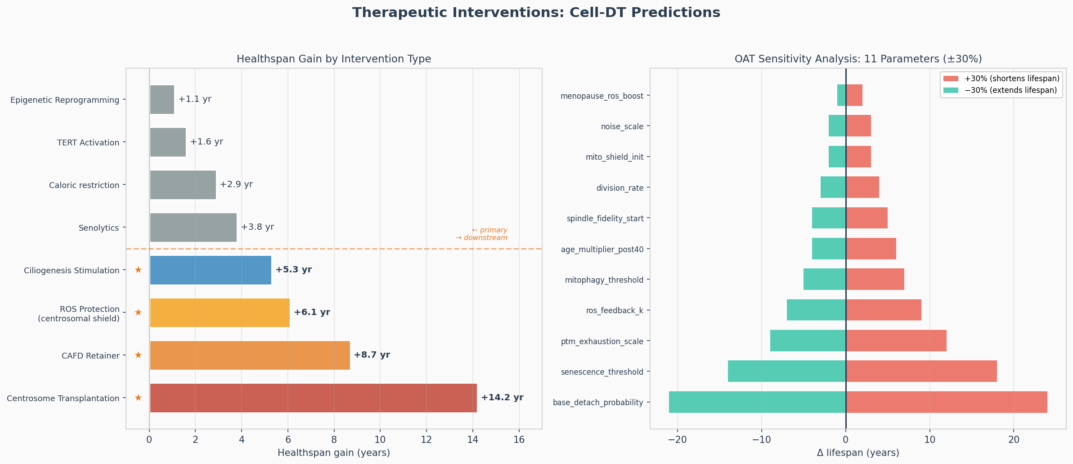
Figure 9. CDATA intervention hierarchy. Primary centriolar interventions (CEP164-AAV, CentrosomeTransplant, CAFD/IDI-targeted) act upstream and are predicted to outperform downstream senolytics (navitoclax), NAD+ precursors, and antioxidants across all four vicious-cycle metrics: stem cell division rate, senescent fraction, myeloid bias, and centrosomal ROS level. Cell-DT simulation (Prediction #11).

Table 5. Falsifiable Experimental Predictions of CDATA
Prediction | Experimental Test | Disconfirming Result
CHIP clones show measurably lower centriolar PTM burden than age-matched non-expanded HSCs: CDATA predicts ≥25% higher CEP164 copy number and ≥30% lower γ-tubulin carbonylation signal in CHIP-clone HSCs vs. non-clone controls (effect-size estimate based on Cell-DT calibration at year 70) | Sort CHIP clones (DNMT3A/TET2 mutant) vs. non-clone HSCs; STED microscopy of γ-tubulin carbonylation and CEP164 copy number | No difference in PTM burden; CHIP clones show equal or higher centriolar damage
Neural tissue fails before hematopoietic in aging simulations | Longitudinal imaging of adult neurogenesis vs. HSC output decline in murine aging (2–24 months) | Hematopoietic decline precedes neurogenic decline in the same organism
Young centrosome transplant into aged SC rejuvenates division fidelity | Microinjection of isolated young centrosomes into aged muscle satellite cells or HSCs; measure ACD efficiency and fate outcomes | No rescue of ACD efficiency; fate outcomes unchanged after transplant
Progeria HSCs show accelerated centriolar PTM vs. age-matched controls | CEP164/CEP89 immunostaining and carbonylation assay in HGPS patient-derived HSC-like cells vs. age-matched controls | No acceleration; PTM levels similar to age-matched controls
Primary centriolar interventions outperform downstream interventions | In a model organism (Drosophila ISC) treat with: (A) CEP164-restoring peptide vs. (B) senolytic; measure SC number and regenerative capacity at 40 days | Senolytics provide equal or greater healthspan benefit than centriole-targeting therapy
Age of menarche inversely correlates with rate of centrosomal PTM accumulation | Cross-cohort study: MSC centrosomal damage markers at age 50 vs. age at menarche in females | No correlation between menarche age and centrosomal damage rate
Centrosomal RNA (cnRNA) species with reverse-transcriptase domains are detectable at the proximal centriolar scaffold (≤200 nm from cartwheel) in adult mammalian HSCs or NSCs by single-centriole RNA-seq (molecular context and Alliegro precedent: §3.3) | Single-centriole RNA-seq or centrosome-enriched RNA fraction from HSCs, NSCs; RT-PCR for LINE-1/reverse-transcriptase-domain sequences; STED/FISH for proximal scaffold localization (distinguish from PCM-associated RNAs); cross-validate across species (mouse HSCs, human cord-blood HSCs) | No cnRNA detected in adult stem cell centrosomes after exhaustive sequencing
Mother and daughter centrioles within the same stem cell carry distinct RNA/protein complements (M-IDI ≠ D-IDI) | Super-resolution proximity ligation or single-centriole proteomics comparing CEP164+ vs. Centrobin+ centrioles | Identical molecular complements on both centrioles in all assays
De novo CpG methylation at OCT4/SOX2 promoters appears in progenitor daughter cells at G1/S of their first cycle, coinciding with granddaughter procentriole initiation | Single-cell bisulfite-seq of FACS-sorted progenitor daughters at different cell cycle stages; correlate with PLK4 activity marker | CpG methylation pattern identical in stem and progenitor daughters at all stages
Stem cell division rate (measurable by BrdU/EdU pulse-chase) declines nonlinearly with age: CDATA predicts an inflection at 60–70 years, with the rate-of-decline slope in the 60–70 decade at least 2× steeper than the 30–40 decade slope, consistent with Cell-DT's ROS-feedback calibration (midlife_damage_multiplier ×1.6 after age 40, calibrated against epigenetic clock acceleration data [18]) | Longitudinal BrdU incorporation in HSCs and intestinal stem cells across age cohorts; fit linear vs. nonlinear model | Division rate declines linearly with age or shows no age-dependent change
Primary centriolar intervention (CEP164 stabilization or centrosome rejuvenation) simultaneously outperforms senolytics (navitoclax) across all four vicious-cycle metrics: (1) stem cell division rate, (2) senescent cell fraction, (3) myeloid bias index, and (4) centrosomal ROS level — measured 12 weeks post-treatment in aged (24-month) mice | Parallel treatment groups in 24-month mice: CEP164-AAV vs. navitoclax vs. control; measure division rate, senescent fraction, myeloid bias, and ROS simultaneously at 12 weeks post-treatment | Senolytics produce equivalent or superior improvement across all four metrics

9. The Centriole as an Intracellular Timer: Encoding Cellular History
Beyond its role as a passive accumulator of damage, the mother centriole functions as an active intracellular timer — an information-processing hub that encodes the divisional history of a cell and translates this history into fate-determining signals. This framing elevates CDATA from a damage-accumulation narrative to a molecular computation model.
Three mechanistic layers constitute the centriolar timing system. First, the PTM-code layer: the mother centriole accumulates a specific, cumulative signature of post-translational modifications — polyglutamylation, acetylation, carbonylation — that changes predictably with the number of completed cell cycles. This 'epicentriolar' signature recruits specific downstream effector proteins, including Notch signaling components and Par polarity complex elements, to the centrosome in an age-dependent manner. The PTM-code functions analogously to the histone modification code, but for the temporal dimension of cell fate rather than its spatial (chromatin) dimension.
Second, the PCM layer: the pericentriolar material surrounding the mother centriole serves as a dynamic buffer for cell cycle regulators, including Cyclin B1, Aurora A, and PLK1. The composition and size of the PCM expand during mitotic entry (centrosome maturation) and are regulated by the cumulative kinase activity of the centriolar core. Progressive damage to the centriolar core alters PCM composition in a cell-cycle-history-dependent manner, linking divisional history to mitotic regulators.
Third, the nuclear coupling layer: the centrosome is physically connected to the nucleus via the LINC (Linker of Nucleoskeleton and Cytoskeleton) complex. Mechanical forces transmitted through this connection, which vary with centrosomal maturity and positioning, influence nuclear envelope tension and chromatin organization. Centriolar aging alters the mechanical coupling between the centrosome and nucleus, potentially modulating transcriptional programs that are sensitive to nuclear architecture — including the senescence transcriptional program regulated by the cGAS-STING pathway, which detects cytoplasmic chromatin fragments released during aberrant mitosis.
The triad of PTM-code, PCM buffer, and nuclear coupling constitutes a multi-layered timekeeping mechanism that is not merely passive but actively influences cell fate decisions. In this view, organismal aging is, in part, the progressive misreading of cellular history — as the centriolar timer accrues damage, its ability to accurately encode divisional history and translate it into appropriate fate decisions degrades, producing the progressive loss of stem cell fidelity that manifests as tissue aging.

10. From Theory to Formalization: The Motivation for a Computational Digital Twin
The theoretical architecture of CDATA, as described in Sections 2–9, constitutes a qualitatively compelling unified framework for aging. However, compelling narrative integration of biological evidence is a necessary but insufficient criterion for scientific validity. Three fundamental problems require computational formalization to address rigorously.
First, the integration problem: CDATA proposes that seven aging tracks are mechanistically coupled through the centriolar lesion. Whether the quantitative rates of each process — as measured in independent experimental systems — are mutually consistent and jointly sufficient to generate a 78-year human lifespan trajectory cannot be determined by intuitive reasoning. Only a mathematical model that implements all tracks simultaneously, with their interactions, can determine whether the proposed causal architecture is quantitatively coherent.
Second, the prediction problem: CDATA's most scientifically valuable contribution is its ability to generate falsifiable quantitative predictions — not merely qualitative directional claims, but specific numerical thresholds, timelines, and effect magnitudes. What age does the model predict for the onset of measurable myeloid bias? What healthspan gain does a specific degree of centrosomal ROS reduction produce? How much does the puberty age correlation contribute to lifespan variance? These questions are accessible only to a computational model with explicit parameter values.
Third, the intervention hierarchy problem: CDATA predicts that centriole-targeting interventions should outperform downstream interventions. But by how much? And which specific centriole-targeting strategy — appendage protein restoration, centrosome transplantation, ROS reduction at the centrosomal compartment, CAFD manipulation — provides the greatest leverage? Without a quantitative model of the full feedback architecture, these questions cannot be answered and CDATA's therapeutic implications cannot be prioritized.
These three problems motivate the development of the computational digital twin (Cell-DT) described in the companion paper [33]. Cell-DT is implemented as a 14-crate Rust workspace using the Entity Component System (ECS) paradigm, which treats each stem cell niche as an independent entity and each biological subsystem as a modular component. The platform integrates all five postulates of CDATA, both failure tracks, the positive ROS feedback loop, and four additional aging tracks (telomere shortening, epigenetic clock, mitochondrial dynamics, and hormonal life-history trade-off) into a single coherent simulation that can be run, perturbed, and interrogated in silico.
The companion paper [33] addresses the mathematical architecture of Cell-DT and its calibration results in detail. Here we note only that the digital twin's role is explicitly not to validate CDATA by reproducing calibration targets — this would be tautological. Its role is to (i) test whether the proposed causal architecture is internally consistent at quantitative resolution; (ii) identify which parameters the theory's predictions are most sensitive to, guiding experimental prioritization; (iii) generate the specific numerical predictions — CHIP onset age, myeloid bias trajectory, tissue failure sequence, intervention efficacy hierarchy — that can be tested against independent empirical data not used in calibration; and (iv) provide a platform for in silico screening of therapeutic strategies before committing to expensive animal or clinical experiments.

11. Conclusion
The Centriolar Damage Accumulation Theory of Aging proposes a resolution to the fundamental paradox of organismal aging: why tissues age despite continuous cellular renewal. The answer, in CDATA, is that renewal is asymmetric — and its asymmetry is structurally enforced on the only cellular component that cannot be cleared, replaced, or diluted by cytoplasmic quality-control systems: the mother centriole. Four nested vicious cycles — a cell-autonomous ROS–PTM loop, an intracellular Track A→B cross-amplification loop, a tissue-level senescent niche loop, and an organism-level myeloid–inflammaging loop — translate the initial molecular lesion into the nonlinear, self-reinforcing functional decline that defines aging as a disease-like process rather than simple mechanical wear. The IDI hypothesis further proposes that the same centriolar apparatus encodes the differentiation programs of somatic and germline lineages, making the centriole the hub of both tissue maintenance and species continuity.
Aging, in the CDATA framework, is the price that multicellular organisms with true tissues pay for possessing irreversibly differentiated, highly specialized cell types. The centriole cannot be repaired because its damage state is functionally required for the precision of differentiation — its accumulated PTM signature is the molecular memory that drives progressive commitment. The very mechanism that enables the biological complexity of a vertebrate organism — precise asymmetric division instructed by centriolar age — inevitably produces the aging of the stem cell lineage that serves these tissues. Aging is not an evolutionary mistake; it is the necessary cost of developmental precision.
This framing suggests a therapeutic philosophy: aging interventions that work with this constraint — restoring the functional capacity of the centriolar inducer system, reducing the rate of centrosomal ROS damage, or periodically replacing depleted centrosomal material with young functional equivalents — are predicted to have substantially greater effect than interventions that address the downstream symptoms of a problem whose upstream cause continues to operate. The computational digital twin described in the companion paper [33] provides the quantitative framework for evaluating these predictions and prioritizing experimental investment. The four vicious cycles predict that primary centriolar interventions — reducing PTM burden, restoring appendage integrity — will break all four loops simultaneously, while downstream interventions (senolytics, antioxidants) will address only one or two loops. This hierarchy is among CDATA’s most testable and clinically important predictions.

References
[1] López-Otín C, Blasco MA, Partridge L, Serrano M, Kroemer G. Hallmarks of aging: an expanding universe. Cell 2023; 186: 243–278.
[2] Tkemaladze JV, Chichinadze KN. Centriole, differentiation, and senescence. Rejuvenation Research 2010; 13: 339–342.
[3] Chichinadze K, Tkemaladze D. Centrosomal hypothesis of cellular aging and differentiation. Advances in Gerontology 2008; 21: 367–371.
[4] Tkemaladze J. Reduction, proliferation, and differentiation defects of stem cells over time: a consequence of selective accumulation of old centrioles in the stem cells? Molecular Biology Reports 2023; 50: 1951–1958. PMID: 36583780.
[5] Cairns J. Mutation selection and the natural history of cancer. Nature 1975; 255: 197–200.
[6] Ganem NJ, Godinho SA, Pellman D. A mechanism linking extra centrosomes to chromosomal instability. Nature 2009; 460: 278–282.
[7] Nigg EA, Holland AJ. Once and only once: mechanisms of centriole duplication and their deregulation in disease. Nature Reviews Molecular Cell Biology 2018; 19: 297–312.
[8] Bettencourt-Dias M, Glover DM. Centrosome biogenesis and function: centrosomics brings new understanding. Nature Reviews Molecular Cell Biology 2007; 8: 451–463.
[9] D'Angelo MA, Raices M, Bhargava P, Bhattacharya J, Bhargava S, Hetzer MW. Age-dependent deterioration of nuclear pore complexes causes a loss of nuclear integrity in postmitotic cells. Cell 2009; 136: 284–295.
[10] Prosser SL, Pelletier L. Mitotic spindle assembly in animal cells: a fine balancing act. Nature Reviews Molecular Cell Biology 2017; 18: 187–201.
[11] Yamashita YM, Mahowald AP, Perlin JR, Fuller MT. Asymmetric inheritance of mother versus daughter centrosome in stem cell division. Science 2007; 315: 518–521.
[12] Wang X, Tsai JW, Imai JH, et al. Asymmetric centrosome inheritance maintains neural progenitor pool during brain development. Nature 2009; 461: 947–955.
[13] Nachury MV, Mick DU. Establishing and regulating the composition of cilia for signal transduction. Nature Reviews Molecular Cell Biology 2019; 20: 389–405.
[14] Zhao M, Perry JM, Marshall H, et al. Megakaryocytes maintain homeostatic quiescence and promote post-injury regeneration of hematopoietic stem cells. Nature Medicine 2014; 20: 1321–1326.
[15] Doetsch F, García-Verdugo JM, Alvarez-Buylla A. Cellular composition and three-dimensional organization of the subventricular germinal zone in the adult mammalian brain. Journal of Neuroscience 1997; 17: 5046–5061.
[16] Jaiswal S, Fontanillas P, Flannick J, et al. Age-related clonal hematopoiesis associated with adverse outcomes. New England Journal of Medicine 2014; 371: 2488–2498.
[17] Genovese G, Kähler AK, Handsaker RE, et al. Clonal hematopoiesis and blood-cancer risk inferred from blood DNA sequence. New England Journal of Medicine 2014; 371: 2477–2487.
[18] Horvath S, Raj K. DNA methylation-based biomarkers and the epigenetic clock theory of ageing. Nature Reviews Genetics 2018; 19: 371–384.
[19] Sieben C, Banterle N, Douglass KM, Gönczy P, Manley S. Multicolor single-particle reconstruction of protein complexes. Nature Methods 2018; 15: 777–784.
[20] Steensma DP, Bejar R, Jaiswal S, et al. Clonal hematopoiesis of indeterminate potential and its distinction from myelodysplastic syndromes. Blood 2015; 126: 9–16.
[21] Kujoth GC, Hiona A, Pugh TD, et al. Mitochondrial DNA mutations, oxidative stress, and apoptosis in mammalian aging. Science 2005; 309: 481–484.
[22] Rettberg JR, Yao J, Brinton RD. Estrogen: a master regulator of bioenergetic systems in the brain and body. Frontiers in Neuroendocrinology 2014; 35: 8–30.
[23] Campisi J, d'Adda di Fagagna F. Cellular senescence: when bad things happen to good cells. Nature Reviews Molecular Cell Biology 2007; 8: 729–740.
[24] Lopes CS, Zheng H, Viales RR, et al. PLK4 trans-autoactivation controls centriole biogenesis in space and time. Developmental Cell 2015; 35: 222–235.
[25] Vertii A, Hehnly H, Doxsey S. The centrosome, a multitalented renaissance organelle. Cold Spring Harbor Perspectives in Biology 2016; 8: a025049.
[26] Habib SJ, Chen BC, Tsai FC, et al. A localized Wnt signal orients asymmetric stem cell division in vitro. Science 2013; 339: 1445–1448.
[27] Ritsma L, Ellenbroek SIJ, Zomer A, et al. Intestinal crypt homeostasis revealed at single-stem-cell level by in vivo live imaging. Nature 2014; 507: 362–365.
[28] Tkemaladze J. Old Centrioles Make Old Bodies. Annals of Rejuvenation Science 2025; 1(1). doi: 10.65649/yx9sn772.
[29] Tkemaladze J. Centrioles as intracellular timers of the cell cycle and cell fate. Longevity Horizon 2026; 2(3). doi: 10.65649/mxhcj531.
[30] Tkemaladze J. The Centriolar Theory of Differentiation Explains the Biological Meaning of the Centriolar Theory of Organismal Aging. Longevity Horizon 2025; 1(3). doi: 10.5281/zenodo.15057288.
[31] Katajisto P, Döhla J, Chaffer CL, et al. Asymmetric apportioning of aged mitochondria between daughter cells is required for stemness. Science 2015; 348: 340–343.
[32] Rujano MA, Bosveld F, Salomons FA, et al. Polarised asymmetric inheritance of accumulated protein damage in higher eukaryotes. PLoS Biology 2006; 4: e417.
[33] Tkemaladze, J. (2026). CDATA Computational Validation and Mechanics. Longevity Horizon, 2(4). DOI : https://doi.org/10.65649/c86yh745.

List of Figures
Graphical Abstract. CDATA theoretical framework overview.
Figure 1. CDATA conceptual overview — single centriolar lesion → seven aging tracks.
Figure 2. The asymmetric inheritance mechanism (four-panel): structural layers, damage ratchet, cross-system evidence, QC landscape.
Figure 3. The five forms of irreversible PTM damage in the mother centriole.
Figure 4. The ROS positive feedback loop (Postulate V) with Cell-DT calibration.
Figure 5. The two primary failure tracks: Track A (ciliary) and Track B (spindle).
Figure 6. Simulated centriolar damage accumulation curves across the human lifespan.
Figure 7. CDATA in the landscape of aging theories — comparative analysis.
Figure 8. CHIP clonal dynamics: Cell-DT NichePool simulation over 80 years.
Figure 9. CDATA intervention hierarchy: primary vs. downstream interventions.

