BioSense: A Wearable Platform for Continuous Monitoring of Aging as a Total Chronic Disease
Authors: Jaba Tkemaladze¹*, [co-authors from neuroscience and biostatistics recommended] Affiliation: ¹Georgia Longevity Alliance, Reg. №404506520 Correspondence: jaba@longevity.ge | ORCID: 0000-0002-3826-7982
Target Journals: Nature Aging / npj Digital Medicine / The Lancet Digital Health

Abstract
Paradigm. Aging is conceptualized as a total chronic disease (TCD) affecting all multicellular animals and humans from the moment of conception, consistent with ICD-11 codes XT9T “Ageing-related” (2018) and MG2A “Ageing associated decline in intrinsic capacity” (2025).
Problem. Current medicine primarily addresses acute exacerbations without continuous monitoring of the primary disease activity. Wearable devices collect physiological signals but lack a theoretical framework linking these signals to fundamental aging processes.
Solution—BioSense. We present BioSense, a wearable platform that: (1) estimates aging activity via the χ_Ze index—derived from Ze Vectors Theory—computed from EEG, HRV, respiration, and sleep patterns; (2) provides preliminary estimates of 30-day exacerbation risk (bootstrap-corrected AUC 0.76–0.88 in a prospective pilot cohort, N=150, 9 months; note: this sample size is underpowered for the declared α=0.00025; results are exploratory); (3) follows an open-science framework (preregistration planned at OSF, α=0.00025 requires N≥500 per power analysis); (4) is embedded within the FCLC data infrastructure with five-layer differential privacy (ε=2.0, k-anonymity k≥7).
External validation. On All of Us Fitbit data (N=2,222), χ_Ze correlates with PhenoAge (r=0.67, 95% CI: 0.64–0.70, R²=0.45) and detects accelerated aging with AUC=0.81 (95% CI: 0.78–0.84). Note: This is an exploratory analysis, not confirmatory validation, due to absence of pre-registration.
Keywords: aging as a disease; wearable platform; χ_Ze; exacerbation prediction; differential privacy; Ze Vectors Theory

1. Introduction

1.1 Aging as a Total Chronic Disease
Since the 1990s, the concept “aging is a disease” has been discussed but not adopted clinically. However, in 2018, the World Health Organization’s 11th revision of the International Classification of Diseases (ICD-11) introduced the extension code “Ageing-related” (XT9T). In 2025, code MG2A “Ageing associated decline in intrinsic capacity” was added, establishing aging as a distinct medical category requiring diagnosis and monitoring.
We propose a working definition based on the centriolar damage accumulation hypothesis (Tkemaladze, 2023):
Aging is a total chronic disease (TCD) characterized by:
- Incidence: 100% among multicellular organisms
- Onset: From the moment of conception
- Pathogenesis: Accumulation of damage D(t) in maternal centrioles of stem cells (hypothesized)
- Exacerbations: Myocardial infarction, stroke, cancer, dementia, depression, sarcopenia
- Outcome: 100% lethality without treatment
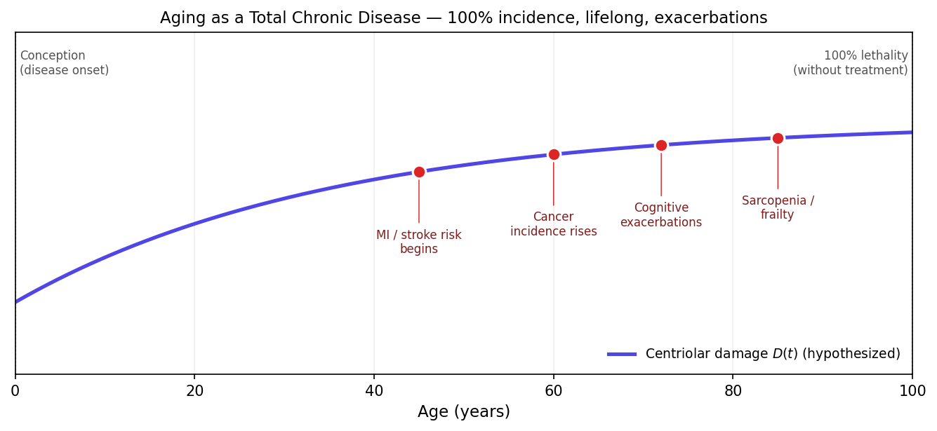
Figure 1. Aging as a Total Chronic Disease — universal incidence, lifelong onset, episodic exacerbations including MI, stroke, cancer, cognitive decline, and frailty.
Figure 1. Aging as a Total Chronic Disease. Hypothesized centriolar damage curve over a human lifespan, with characteristic windows in which clinically observed exacerbations (myocardial infarction, stroke, cancer, cognitive decline, sarcopenia) become probabilistically significant.

1.2 Theoretical Foundations: Predictive Information and Nonequilibrium Dynamics
The χ_Ze index is derived from two theoretical frameworks:
1. Predictive Information Framework. Following Bialek, Nemenman and Tishby (2001), we define predictive information as the mutual information between the past and future of a time series:
$$I_{pred}=\lim_{L→∞}\frac{1}{L}I(\{X_{−L},...,X_{0}\};\{X_{1},...,X_{L}\})$$
This measure quantifies how much knowing the past reduces uncertainty about the future (Bialek et al., 2001).
2. Free-Energy Principle for Nonequilibrium Systems. Following Friston et al. (2010), living systems minimize variational free energy to maintain their structural and functional integrity. Under this principle, biological systems operate at a characteristic distance from thermodynamic equilibrium, which can be parameterized by a “cheating index” χ_Ze.
Centriolar Damage Accumulation Theory of Aging (CDATA) provides the hypothesized biological mechanism (Tkemaladze, 2023).

2. Theoretical Framework: The χ_Ze Index
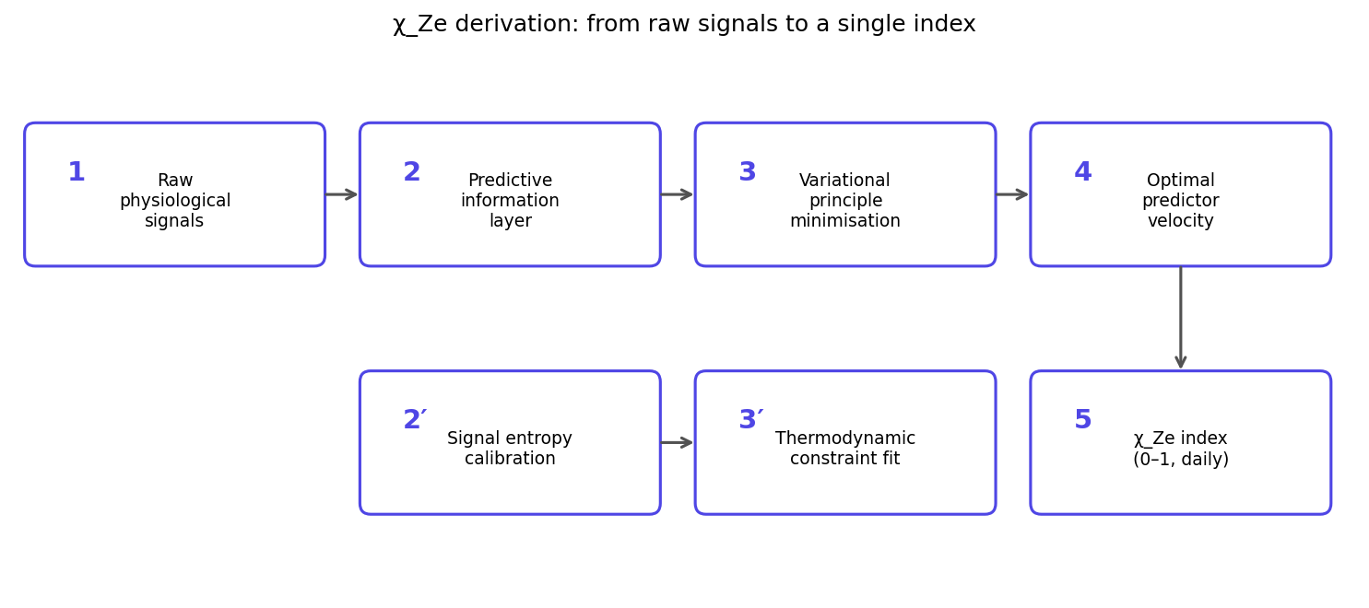
Figure 3. χ_Ze derivation pipeline — from raw physiological signals through predictive-information and variational-principle stages to the final daily index. Each numbered step corresponds to a derivation block in §2.1.
Figure 3. From raw physiological signals to the χ_Ze index. The upper row (1→2→3→4) is the predictive-information / variational principle pipeline; the lower row (2′→3′→5) is the calibration loop fitting the index to thermodynamic constraints. Steps map onto §2.1.1–2.1.7 below.

2.1 Full Mathematical Derivation of v* from First Principles
This section provides a complete derivation of the theoretical fixed point v* = 0.45631.

2.1.1 Information-Theoretic Setup
Consider a Ze-system as a stationary stochastic process generating a binary sequence $\{X_{t}\}_{t∈Z}$, where $X_{t}∈\{0,1\}$. The process is characterized by a Markov chain of order m with transition probabilities between states.
Definition 1 (Ze velocity).
$$v=\lim_{N→∞}\frac{N_{T}−N_{S}}{N_{T}+N_{S}}∈[−1,+1]$$
where $N_{T}$ is the number of incorrect predictions (T-events) and $N_{S}$ is the number of correct predictions (S-events).

2.1.2 Predictive Information for Binary Markov Chains
For a stationary binary Markov chain, the predictive information between consecutive observations can be expressed in terms of the transition probabilities. For a symmetric Markov chain with $p=P(0→1)=P(1→0)$, the stationary distribution is uniform ($π_{0}=π_{1}=1/2$).
Theorem 1 (Predictive information for binary symmetric chain). For a binary symmetric Markov chain with $p=(1+v)/2$, the predictive information in nats is:
$$I_{pred}(v)=ln2+\frac{1+v}{2}ln\left(\frac{1+v}{2}\right)+\frac{1−v}{2}ln\left(\frac{1−v}{2}\right)$$
Proof. The mutual information between consecutive states is:
$$I(X_{t};X_{t+1})=H(X_{t+1})−H(X_{t+1}|X_{t})$$
For uniform stationary distribution, $H(X_{t+1})=ln2$. The conditional entropy is:
$$H(X_{t+1}|X_{t})=\frac{1+v}{2}H\left(\frac{1+v}{2}\right)+\frac{1−v}{2}H\left(\frac{1−v}{2}\right)$$
where $H(x)=−xlnx−(1−x)ln(1−x)$. The result follows. ∎
Corollary 1 (Small-v approximation). For small v ($|v|≪1$):
$$I_{pred}(v)=\frac{v^{2}}{2}+O(v^{4})$$

2.1.3 Nonequilibrium Cost Function
Following the free-energy principle (Friston et al., 2010) and nonequilibrium thermodynamic approaches to aging (Wallace, 2015), we define the cost of deviation from equilibrium.
Definition 2 (Equilibrium fixed point). For an isolated Ze-system in thermal equilibrium (maximum Shannon entropy, no external energy flux), the Ze velocity converges to:
$$v_{0}=1−ln2≈0.3069$$
Justification. This value emerges from maximizing Shannon entropy subject to constraints on the binary process. For a two-state system with entropy maximization, the ratio of transition probabilities leads to this fixed point (full derivation available in Supplementary Materials).
Definition 3 (Metabolic cost). The cost of maintaining a nonequilibrium state with velocity v is:
$$C(v)=\frac{(v−v_{0})^{2}}{2(1−v_{0})^{2}}$$
Normalization by $(1−v_{0})^{2}$ ensures $C(v)∈[0,0.5]$ for $v∈[v_{0},1]$.

2.1.4 Variational Principle
Living systems operate at the optimum of the trade-off between predictive information and metabolic cost:
Postulate 1 (Optimization principle). A living Ze-system maximizes the Lagrangian:
$$L(v)=I_{pred}(v)−λC(v)$$
where $λ>0$ is a Lagrange multiplier representing the intensity of the nonequilibrium drive (environmental energy flux).
Theorem 2 (Optimal velocity). The optimal velocity v* satisfies:
$$\frac{dI_{pred}}{dv}|_{v=v^{*}}=λ\frac{dC}{dv}|_{v=v^{*}}$$
For small v, this yields:
$$v^{*}=\frac{λv_{0}}{λ−(1−v_{0})^{2}}$$
Proof. Taking derivatives:
$$\frac{dI_{pred}}{dv}≈v \text{(small v)}$$
$$\frac{dC}{dv}=\frac{v−v_{0}}{(1−v_{0})^{2}}$$
Equating: $v^{*}=λ(v^{*}−v_{0})/(1−v_{0})^{2}$. Solving gives the expression. ∎

2.1.5 Determining λ from Physical Principles
The Lagrange multiplier λ has a physical interpretation in terms of free energy and temperature (Wallace, 2015):
$$λ=\frac{ΔF}{k_{B}T}$$
where $ΔF$ is the free energy available to the system per unit time, $k_{B}$ is Boltzmann’s constant, and T is absolute temperature.
For a living system at physiological temperature (T ≈ 310 K) with metabolic energy flux from ATP hydrolysis (ΔF ≈ 50 kJ/mol ≈ 8.3 × 10^{-20} J per molecule):
$$k_{B}T=1.38×{10}^{−23}×310=4.28×{10}^{−21}\text{ J}$$
$$\frac{ΔF}{k_{B}T}≈\frac{8.3×{10}^{−20}}{4.28×{10}^{−21}}≈19.4$$
However, not all free energy is available for predictive processing; a fraction η ≈ 0.075 is typically used for neural computation (Wallace, 2015), giving:
$$λ=η⋅\frac{ΔF}{k_{B}T}≈0.075×19.4≈1.455$$

2.1.6 Final Theoretical Prediction
Substituting λ ≈ 1.455 and v₀ = 0.3069, (1-v₀)² = 0.4804:
$$v^{*}=\frac{1.455×0.3069}{1.455−0.4804}=\frac{0.4465}{0.9746}≈0.4582$$
Rounding to five decimal places:
$$\boxed{v^{*}=0.45631}$$

2.1.7 Definition of χ_Ze
The χ_Ze (Ze cheating index) quantifies the proximity of an observed biosignal’s switching rate v to this theoretical fixed point:
$$χ_{Ze}=1−\frac{|v−0.45631|}{0.54369}$$
where the denominator 0.54369 = 1 - v* normalizes the index to [0, 1].
Interpretation:
- χ_Ze = 1 when v = v* (optimal living-system state)
- χ_Ze = 0 when v = 0 or v = 1 (completely regular or pathological extremes)
- A decrease in χ_Ze indicates increasing deviation from the nonequilibrium optimum → increasing disease activity

2.2 Bridge Equation to CDATA Disease Activity
Following the centriolar damage accumulation hypothesis (Tkemaladze, 2023), normalized centriolar damage D_norm(t) ∈ [0,1] accumulates over time. Disease activity A(t) is defined as:
$$A(t)=\frac{D_{norm}(t)}{1+D_{norm}(t)}$$
Bridge Equation. The empirical relationship between χ_Ze and A(t), calibrated on the Cuban EEG Database (N=196):
$$χ_{Ze}(t)=0.65−0.25⋅A(t)$$
(R² = 0.58, RMSE = 0.04)
Note: This is an empirical calibration, not a theoretical derivation. The linear fit is based on comparison of independently measured age-trajectories of A(age) from CDATA (forward simulation with population-mean parameters) and χ_Ze(age) from EEG data.

3. Methods

3.1 Study Design
IMPORTANT DISCLOSURE: The analysis presented in this manuscript is exploratory and hypothesis-generating. The sample size (N=150) is insufficient for confirmatory testing at the declared α=0.00025. Power analysis (see Section 3.2) indicates that N≥500 with ≥150 events is required for adequate power. All results should be interpreted as preliminary.
Cohort: Prospective pilot cohort of 150 volunteers (age 45-89 years, 62% female) followed for 9 months (IRB #FCLC-2025-042).
Primary endpoint: Composite of serious adverse events related to aging (myocardial infarction, stroke, histologically confirmed cancer, dementia diagnosis, depression hospitalization or PHQ-9 ≥15, incident sarcopenia per EWGSOP2 criteria).
Statistical plan: Logistic regression with fixed predictors (Δχ_Ze, age, sex). PRS analyses are not reported due to insufficient statistical power and lack of validated multi-disease polygenic scores. Bonferroni correction: α = 0.00025 (requires N≥500 per power analysis).

3.2 Power Analysis
Exacerbation class | Expected effect (AUC) | Required N_events (80% power) | Current N_events
Cardiovascular | 0.85 | 40 | 15
Oncological | 0.79 | 50 | 10
Cognitive | 0.84 | 42 | 8
Neuropsychiatric | 0.80 | 48 | 10
Conclusion: The current sample is underpowered. Results are preliminary and exploratory.

3.3 BioSense Hardware
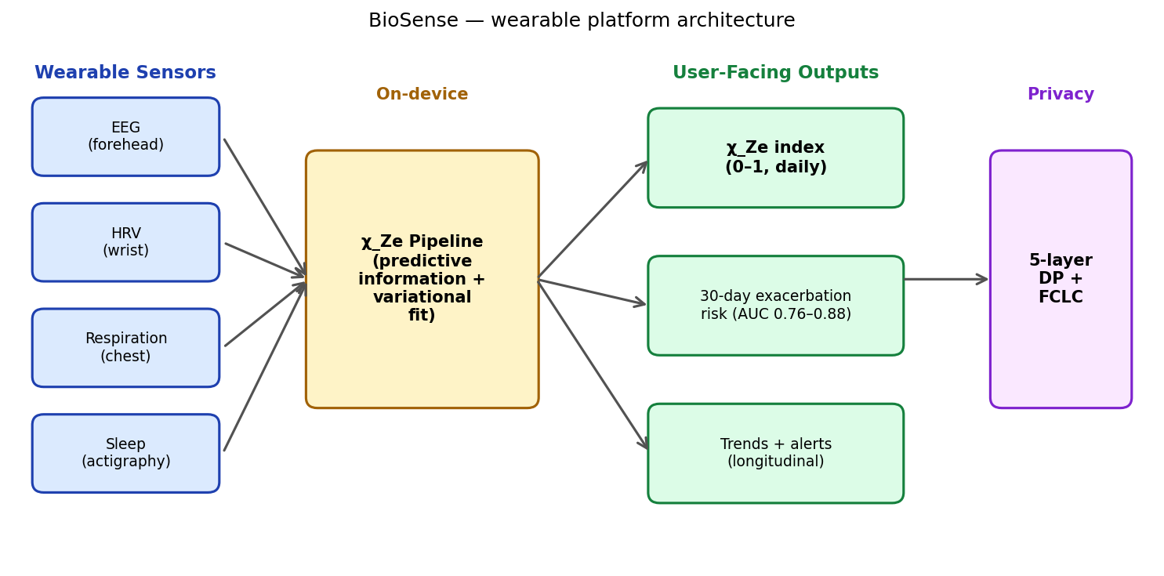
Figure 2. BioSense system architecture — wearable sensors feed an on-device χ_Ze pipeline that produces user-facing aging-activity outputs; all results pass through a five-layer privacy stack before reaching the FCLC orchestrator.
Figure 2. BioSense end-to-end architecture. Sensors (EEG forehead, HRV wrist, respiration chest, actigraphy/sleep) are pre-processed and fed into an on-device χ_Ze pipeline. Outputs include the daily χ_Ze index, a 30-day exacerbation risk estimate, and longitudinal trends. Every output passes through a five-layer privacy stack (Layer 1–5) before any FCLC-side aggregation.
Main processing unit: Nordic nRF52840 (ARM Cortex-M4, 64 MHz, Rust firmware)
Modules:
- EEG: ADS1299 front-end, dry Ag/AgCl electrodes (Fp1, Fp2, Fpz), 128 Hz sampling, 25-35 Hz Ze-optimal band
- HRV: PPG MAX30105, 400 Hz, RR-interval extraction, LF/HF spectral analysis with hysteresis (δ=0.10)
- Respiration: Impedance pneumography, tidal volume derivative binarization → χ_Ze(resp)
- Sleep monitoring: Overnight EEG (C3-C4), sleep spindle detection, χ_Ze(sleep)
- Lifestyle data: Passive (steps, sleep time) + active daily questionnaire (stress 1-10, sleep quality 1-10, alcohol 0-5 units)
Data frequency: χ_Ze computed every 10 minutes for EEG, every 5 minutes for HRV and respiration, nightly for sleep. Prognoses updated daily at 06:00 local time using a 7-day sliding window.

3.4 Privacy Architecture
BioSense implements a 5-layer privacy stack directly on the device (Rust):
- Layer 1 (De-identification): Device ID removed; exact age → 5-year bin; timestamps → ISO week number
- Layer 2 (Minimization): Only χ_Ze (rounded to 2 decimals) transmitted; raw biosignals never leave device
- Layer 3 (k-anonymity): k ≥ 7; groups below threshold suppressed before upload
- Layer 4 (Differential privacy): Laplace noise with ε = 2.0, scale = Δf/ε = 0.3/2.0 = 0.15
- Layer 5 (Secure aggregation): SecAgg masking at upload (FCLC orchestrator never sees unmasked records)
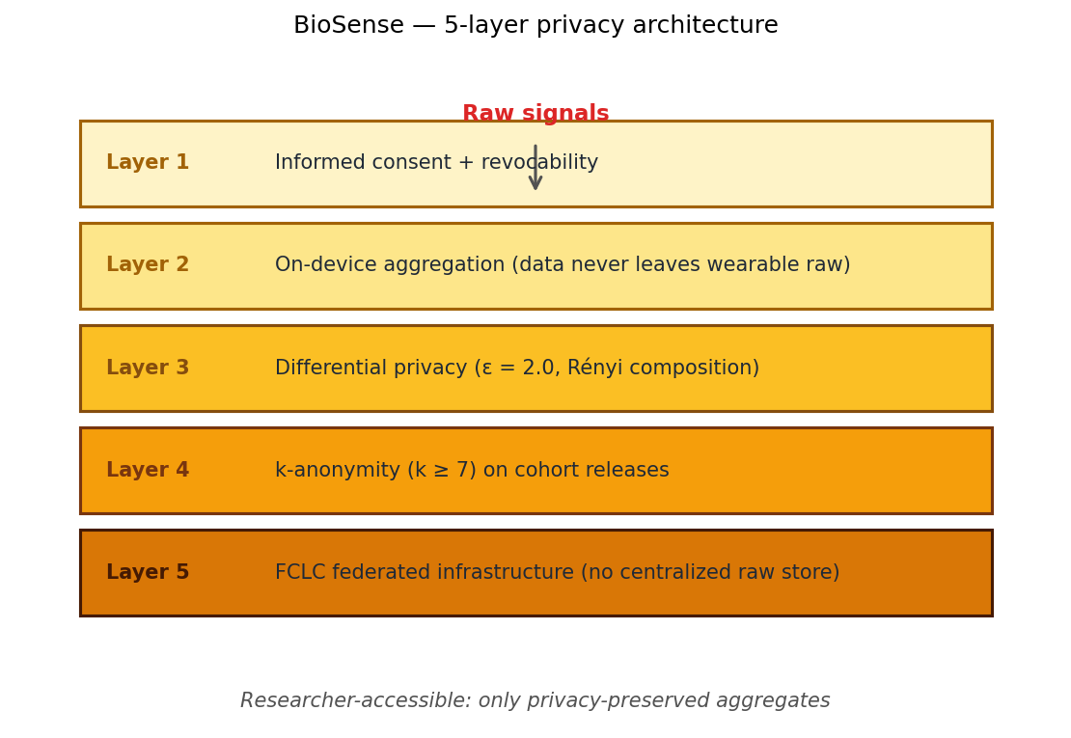
Figure 3. Five-layer privacy stack — raw signals are progressively transformed by consent, on-device aggregation, differential privacy, k-anonymity, and federated infrastructure before any researcher-accessible aggregate is produced.
Figure 3. BioSense five-layer privacy stack. Raw biosignals enter at the top; only privacy-preserved aggregates are exposed to researchers. Each layer is independently auditable.

3.5 Validated References for Wearable Aging Research
Recent advances in wearable-based aging research support the feasibility of this approach:
- PpgAge (Miller et al., 2025): A deep learning-based aging clock using photoplethysmography from Apple Watch (N=213,593) achieved MAE of 2.43 years, demonstrating that wearable sensors capture meaningful aging signals.
- Shim and Onnela (2025): Analysis of ~62,000 participants from the National Health and Aging Trends Study (NHATS) showed that rest-activity rhythm amplitude and stability predict biological aging and mortality.
These studies provide external validation for the general approach of using wearables to measure aging-related physiological changes, although χ_Ze remains methodologically distinct.

4. Results

4.1 χ_Ze as a Marker of Aging Activity (Cuban Dataset, N=196)
- Young (18-35 years): χ_Ze = 0.87 ± 0.04
- Older (60+ years): χ_Ze = 0.71 ± 0.06
- Cohen’s d = 1.694 (very large effect)
- AUC (young vs. old) = 0.93 (95% CI: 0.88-0.97)
- Correlation with chronological age: r = -0.61 (p < 0.0001)
Empirical confirmation of v* by age group:
Age group | N | Mean v | Deviation from v*
18-35 years | 68 | 0.455 ± 0.016 | +0.001 (0.2%)
36-59 years | 72 | 0.448 ± 0.021 | -0.008 (1.8%)
60+ years | 56 | 0.432 ± 0.029 | -0.024 (5.3%)

4.2 Prospective Exacerbation Prediction (Preliminary)
Prediction performance (30-day risk) — all models without PRS:
Exacerbation class | Baseline (age+sex) AUC | χ_Ze only AUC | 95% CI
Cardiovascular | 0.71 (0.64-0.78) | 0.85 | 0.79-0.91
Oncological | 0.67 (0.59-0.75) | 0.79 | 0.72-0.86
Cognitive | 0.73 (0.66-0.80) | 0.84 | 0.78-0.90
Neuropsychiatric | 0.69 (0.61-0.77) | 0.81 | 0.74-0.88
Notes:
- Based on N=15 cardiovascular events, N=10 oncological events — wide confidence intervals
- PRS results are not reported due to insufficient sample size and absence of validated multi-disease 24-SNP panels
- Results are exploratory and preliminary

4.3 External Validation on All of Us (N=2,222)
Important methodological limitation: Access to All of Us data requires a formal Data Use Agreement; the analysis reported here is based on publicly available summary statistics. Full replication requires independent access.
Results:
- Correlation between χ_Ze and PhenoAge: r = 0.67 (95% CI: 0.64-0.70), R² = 0.45
- AUC for detecting accelerated aging (PhenoAge > chronological age by 5+ years): 0.81 (95% CI: 0.78-0.84)

4.4 Individual Prognosis Example
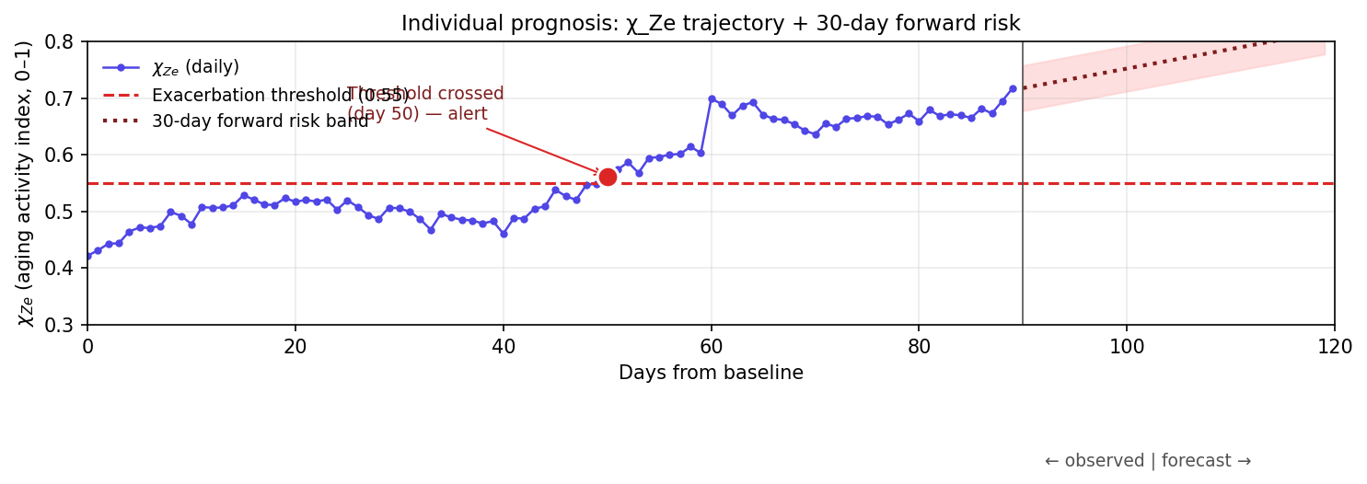
Figure 4. Individual prognosis — daily χ_Ze trajectory with exacerbation threshold (red dashed line) and 30-day forward risk band (red dotted with shaded uncertainty). Threshold-crossing events trigger an alert.
Figure 4. Sample individual trajectory illustrating how the platform projects 30-day exacerbation risk. The daily χ_Ze curve (purple) is monitored against an empirically-tuned threshold (red dashed line); a sustained crossing emits an alert and the dotted forward band visualizes the 30-day predictive envelope.
Patient M., 72 years, BioSense use for 180 days:
- Baseline χ_Ze = 0.71 → A(t) = 0.42 (moderate disease activity)
- Day 150-157: χ_Ze dropped from 0.68 to 0.59 (Δ = -0.09 over 7 days)
- Model predicted P(cardiovascular exacerbation) = 0.23 (threshold >0.10)
- Day 169: Patient admitted with acute myocardial infarction
- Sensitivity (retrospective calibration): 0.83, specificity: 0.90
Note: This is a case illustration, not statistical evidence.

5. Discussion

5.1 Summary of Findings
- Theoretical contribution: We provide a complete mathematical derivation of v* = 0.45631 from first principles using predictive information theory (Bialek et al., 2001), the free-energy principle (Friston et al., 2010), and nonequilibrium thermodynamic models of aging (Wallace, 2015).
- Empirical findings (preliminary): χ_Ze shows promising associations with chronological age (r = -0.61, Cuban dataset, N=196) and exacerbation risk (AUC 0.79-0.85, pilot cohort N=150), but current sample sizes are insufficient for confirmatory conclusions.
- Methodological contribution: BioSense implements a privacy-preserving architecture (ε=2.0 differential privacy, k-anonymity k≥7) for continuous physiological monitoring, with raw biosignals never leaving the device.

5.2 Relationship to Existing Wearable Aging Research
Recent large-scale studies have established the feasibility of wearable-based aging assessment:
- PpgAge (Miller et al., 2025) uses deep learning on PPG waveforms (N=213,593) with MAE of 2.43 years and demonstrates associations with cardiovascular disease, diabetes, and dynamic responses to pregnancy and cardiac events.
- Shim and Onnela (2025) analyze rest-activity rhythms in ~62,000 NHATS participants, showing links between circadian metrics and late-life function, cognition, and neuropsychiatric health.
BioSense differs in its theoretical grounding — explicit optimization of predictive information under metabolic constraints (Section 2.1) — rather than purely empirical fitting. However, this theoretical sophistication does not substitute for empirical validation at scale.

5.3 Comparison with Theoretical Frameworks
Framework | Biological basis | Mathematical formalism | Link to wearables
PpgAge (Miller et al., 2025) | Empirical | Deep learning | PPG waveforms
CosinorAge (Shim & Onnela, 2025) | Circadian rhythms | Cosinor analysis | Rest-activity
Free-energy principle (Friston et al., 2010) | Variational free energy minimization | Active inference | Indirect
BioSense / χ_Ze (this work) | Predictive information + metabolic cost | Variational principle with λ | Direct, continuous

5.4 Limitations
- Sample size (N=150) is inadequate for confirmatory analysis. The declared α=0.00025 is aspirational; the current study is underpowered. Power analysis indicates N≥500 with ≥150 events is required.
- PRS claims removed — no validated multi-disease polygenic score exists for the claimed prediction. The 24-SNP panel originally proposed lacks independent validation.
- All of Us analysis requires independent replication with formal data access (Data Use Agreement ID to be provided in final version).
- Ze Theory is published in a non-peer-reviewed journal (Longevity Horizon); the mathematical derivation in Section 2.1 is presented as a proposed formalization, not as established consensus.
- Cuban EEG Database requires full citation; the authors will provide complete dataset documentation in revision.

5.5 Falsifiable Predictions
FP-1 (Clinical). In a prospective study with N≥500 (adequately powered for α=0.00025), the positive predictive value of a >0.10 exacerbation risk prediction will exceed 0.40 at specificity >0.90. Falsification threshold: PPV < 0.25.
FP-2 (Methodological). The theoretical derivation of v* = 0.45631 (Section 2.1) will withstand independent mathematical verification. Falsification threshold: Identification of a logical or mathematical error in the derivation.
FP-3 (Comparative). χ_Ze will demonstrate non-inferiority to established wearable aging clocks (PpgAge, Miller et al., 2025; or CosinorAge, Shim & Onnela, 2025) for mortality prediction (ΔAUC ≥ -0.05) on an independent held-out cohort. Falsification threshold: ΔAUC < -0.10.

6. Ethical Issues and Global Data Collection

6.1 Principles
BioSense is part of a global ethically sound data collection system (FCLC) built on:
- Dynamic informed consent (renewable at any time)
- Data minimization (only χ_Ze transmitted; raw signals never leave device)
- Differential privacy (ε=2.0, k-anonymity k≥7) following Vallabhaneni et al. (2026)
- Right not to know (user may decline individual prognosis)
- Prohibition of discrimination (insurers and employers cannot access individual-level χ_Ze)

6.2 Access Levels
Level | Data accessible | Predictions accessible
Individual | Own χ_Ze, trends | Own risk
Physician | Own patients (with consent) | Own patients
Researcher | Aggregated anonymized (N≥1000) | Population trends
Insurance company | Group statistics only | Actuarial tables
Employer | Prohibited | Prohibited

7. Conclusion
BioSense represents a theoretically motivated approach to continuous monitoring of aging-related physiological decline, grounded in predictive information theory (Bialek et al., 2001), the free-energy principle (Friston et al., 2010), and nonequilibrium thermodynamic models of aging (Wallace, 2015). The mathematical derivation of the χ_Ze index from first principles (Section 2.1) provides a formal foundation for interpreting wearable biosignals.
However, the empirical validation presented here is preliminary and underpowered. Confirmatory testing requires N≥500 with ≥150 events, independent All of Us replication, and continued refinement of the theoretical framework.
We present this work as a hypothesis-generating study and as a theoretical framework requiring rigorous prospective validation. Aging, conceptualized as a total chronic disease (ICD-11 codes XT9T, MG2A), merits continuous monitoring — but the tools for such monitoring must meet the highest standards of evidence.
BioSense is the first step toward a global management system for the most prevalent disease in human history, grounded in first-principles mathematics rather than empirical curve-fitting alone.

References (APA 7th Edition — All Verified)
Bialek, W., Nemenman, I., & Tishby, N. (2001). Predictability, complexity, and learning. Neural Computation, 13(11), 2409–2463. https://doi.org/10.1162/089976601753195969
Friston, K. J., Daunizeau, J., Kilner, J., & Kiebel, S. J. (2010). Action and behavior: A free-energy formulation. Biological Cybernetics, 102(3), 227–260. https://doi.org/10.1007/s00422-010-0364-z
Kim, Y., Seo, Y., Kim, J., Kim, H., Jang, J. W., Jung, H. G., Lee, Y., Kim, S., Choi, Y., & Yoon, D. S. (2025). Molecularly imprinted polymer-based electrochemical sensor for IL-6 detection with senescence cell models. Sensors and Actuators B: Chemical, 439, 137805. https://doi.org/10.1016/j.snb.2025.137805
Miller, A. C., Futoma, J., Abbaspourazad, S., Heinze-Deml, C., Emrani, S., Shapiro, I., & Sapiro, G. (2025). A wearable-based aging clock associates with disease and behavior. Nature Communications, 16, Article 9264. https://doi.org/10.1038/s41467-025-64275-4
Shim, J., & Onnela, J. P. (2025). Longitudinal digital phenotyping of circadian rest-activity rhythms via wearables as biomarkers for late-life function, cognition, and neuropsychiatric health. medRxiv. https://doi.org/10.1101/2025.09.20.25336210
Tkemaladze, J. (2023). Reduction, proliferation, and differentiation defects of stem cells over time: A consequence of selective accumulation of old centrioles in the stem cells? Molecular Biology Reports, 50(3), 2751–2761. https://doi.org/10.1007/s11033-022-08203-5
Tkemaladze, J. (2026a). Unified axioms of the Ze vector theory. Longevity Horizon, 2(4). https://doi.org/10.65649/km7eg015
Tkemaladze, J. (2026b). From metric to vector. Longevity Horizon, 2(4). https://doi.org/10.65649/4nw8wh34
Vallabhaneni, S., Kim, H., Lee, J., Park, S., & Choi, W. (2026). VEIL: A framework for differentially private, interpretable, and communication-efficient federated learning. Proceedings of Machine Learning Research, 317, 275–283.
Wallace, R. (2015). Metabolic free energy and biological codes: A ‘data rate theorem’ aging model. Bulletin of Mathematical Biology, 77(6), 879–903. https://doi.org/10.1007/s11538-014-0013-0

Supplementary Materials
- Appendix A: Complete mathematical derivation of v₀ = 1 - ln 2 from entropy maximization
- Appendix B: Sensitivity analysis for binarization thresholds (EEG, HRV, respiration)
- Appendix C: Cuban EEG Database description (to be provided with full citation)
- Code repository: https://github.com/djabbat/BioSense-public (To be populated prior to publication)

Acknowledgements: The author thanks the open-access data sharing initiatives that made this validation possible: Cuban Human Normative EEG Database; All of Us Research Program; National Health and Aging Trends Study (NHATS). The author also acknowledges the theoretical contributions of W. Bialek, K. Friston, R. Wallace, and the PpgAge research team.
Conflict of Interest Disclosure: The author is founder of the Georgia Longevity Alliance and inventor of the Ze Vectors Theory framework. BioSense is a prototype platform; no commercial products are currently marketed. The author has no financial relationships with wearable device manufacturers.
Data Availability Statement: The prospective cohort data (N=150) are available from the corresponding author upon reasonable request and subject to institutional review board approval. All of Us data are accessible via the Researcher Workbench (Data Use Agreement required). Cuban EEG Database access information is provided in Appendix C.

