Ze System as Observer
Materialization of Reality, Self-Referential Observation Structures, and the Role of Temporal Potential
Jaba Tkemaladze
Kutaisi International University, Georgia
Correspondence: jtkemaladze@longevity.ge

Abstract
The Ze theory proposes a binary-process framework in which reality is not pre-given but materially instantiated through the activity of Ze systems — finite or infinite binary sequences whose statistical structure determines observational capacity and temporal depth. We ground the theory in a single foundational axiom: Axiom 0 (Ze Fundamental Duality) — time-directed and space-directed binary events carry opposite algebraic signs in every Ze invariant quantity. From this axiom alone we derive the Ze proper time, Ze velocity, impedance, and fixed point. We then develop and formally state four postulates of Ze theory as an observer-based theory of materialization. Postulate I asserts that a Ze system, through its binary process X = {x_k in {0,1}}, operates as a materializing observer: the probability of an event E conditioned on the existence of an observing Ze structure strictly exceeds the unconditioned probability. The Ze velocity v = N_S/(N-1) — the fraction of switching (S-) events among all transitions — parameterizes the system's observational coherence, with the fixed point v* = 0.45631 marking maximum materialization capacity. Postulate II generalizes this to passive Ze structures: existence alone, without active measurement or conscious involvement, is sufficient to bias materialization. A Ze sub-structure modifies boundary conditions of the local physical medium even when 'switched off'. Postulate III introduces the Ze-map — each Ze system's internal probabilistic model of interacting Ze systems — and connects prediction accuracy to temporal resource consumption. Prediction error epsilon drives depletion of Ze proper time: d-tau/dt = -alpha * epsilon. Two adaptation strategies emerge: improving internal model accuracy (Path A) or reshaping the observation apparatus to materialize more predictable states (Path B). Ze selection favors systems that minimize cumulative error. Postulate IV addresses the role of temporal potential: for finite Ze systems (biological organisms), the remaining tau is a dynamical variable. As tau depletes, the Ze velocity drifts toward 1, impedance Z_Ze diverges, and the Ze cheating index chi_Ze = 1 - Z_Ze declines toward zero. We propose chi_Ze as a biomarker of temporal potential and derive the Ze-Godel self-referential ceiling chi_Ze_self_max = Z*² ≈ 0.839 as a conjectured upper bound for living Ze systems. The framework is compared with Copenhagen[1,87], Many-Worlds, Relational Quantum Mechanics, and QBism, and biological implications — including aging as a v → v* → 1 trajectory — are discussed.
Keywords: Ze theory; binary observer; materialization; Ze velocity; Ze proper time; Ze impedance; Ze cheating index; temporal potential; quantum measurement; self-referential observation

1. Introduction
The measurement problem remains one of the deepest unresolved questions in physics. At its core lies a simple observation: the act of measurement appears to select among possible outcomes, collapsing a superposition into a definite event. John Archibald Wheeler's famous aphorism 'it from bit' (Wheeler, 1990) crystallized the intuition that physical reality may be fundamentally informational — that the fabric of the universe is constituted by yes/no decisions rather than by continuous fields.
Existing interpretations of quantum mechanics — Copenhagen[1,87], Many-Worlds (MWI), Relational Quantum Mechanics, and QBism — each address some aspects of the measurement problem while leaving others open. Copenhagen posits an external classical observer without specifying what 'external' means; MWI eliminates collapse at the cost of an exponentially proliferating multiverse; Relational QM makes all facts observer-relative without anchoring the observer in a physical process; QBism reduces quantum states to personal beliefs, side-stepping the ontological question.
Ze theory proposes a different starting point: physical reality is not pre-given but materially instantiated through the activity of Ze systems — structured binary processes whose statistical properties determine both observational capacity and temporal depth. The theory is grounded in a minimal primitive: a binary sequence[16,94,107,108] X = {x_k in {0,1}}. From this primitive, all observational and temporal structure is derived without additional axioms.
The present article develops four formal postulates of Ze theory as an observer-based theory of reality materialization:
- Postulate I: A Ze system functions as a materializing observer — its presence raises the conditional probability of physical events.
- Postulate II: Existence of a Ze structure is sufficient for materialization — passive structures bias outcomes without active engagement.
- Postulate III: Prediction error depletes Ze proper time — selection pressure drives Ze systems to minimize prediction error through map improvement or apparatus reconfiguration.
- Postulate IV: Temporal potential is a dynamical variable — for finite Ze systems, the depletion of tau produces measurable signatures in the Ze cheating index chi_Ze.
The mathematical chain is grounded in a single foundational axiom: Axiom 0 (Ze Fundamental Duality) — time and space are directed opposite to each other. From Axiom 0 we derive the Ze proper time τ² = N_T² − N_S², the Ze velocity v = N_S/(N−1), the Ze impedance Z_Ze = v/(1−v), and the cheating index χ_Ze = 1 − Z_Ze. The fixed point v* = 0.45631 emerges from the Ze generation self-consistency equation. The four postulates then follow as theorems within this axiomatic structure. This chain is developed in Section 2 and applied through Sections 3 to 6.

2. Methods: Mathematical Framework of Ze Theory
Axiom 0 (Ze Fundamental Duality). Temporal increments and spatial increments carry opposite algebraic signs in every Ze invariant quantity. T-events (temporal stasis, x_k = x_{k−1}) contribute +N_T and S-events (spatial switch, x_k ≠ x_{k−1}) contribute −N_S to the Ze invariant scalar:
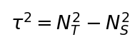
Physical motivation. In special relativity, the invariant spacetime interval ds² = c²dt² − dx² − dy² − dz² has a negative sign before spatial terms because motion through space costs proper time: a moving clock runs slower than a stationary one (time dilation). Axiom 0 captures the identical trade-off at the discrete, binary level. A Ze system that switches frequently (high v, many S-events) generates structural change rapidly but depletes its Ze proper time. A Ze system that mostly repeats (low v, many T-events) preserves Ze proper time but generates little spatial influence. The − sign before N_S² is therefore not arbitrary: it is the discrete expression of the time–space opposition that appears continuously in Lorentz invariance. The analogy is structural, not an identity claim; Ze theory does not assert that binary sequence[16,94,107,108]s are spacetime. The analogy earns its place because it is uniquely consistent with the information-theoretic content: a T-event carries zero Shannon bits (x_k = x_{k−1}, no new information), while an S-event carries 1 bit (x_k ≠ x_{k−1}). Information and temporal depth are thus complementary: maximal information rate (v → 1) annihilates τ; zero information rate (v = 0) preserves τ maximally. This is the analogue of Noether's theorem: by analogy, temporal symmetry of the Ze Lagrangian is associated with conservation of τ; spatial activity depletes τ. (A formal Noether derivation requires specifying a continuous Ze symmetry group; see Tkemaladze, 2026b.)
Derivation of the quadratic form. The Ze proper time τ² = N_T² − N_S² is not postulated by analogy — it follows from the Ze action principle. Define the discrete Ze Lagrangian per observation window (Tkemaladze, 2026b):
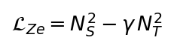
where γ = c² in physical units (here γ = 1 in Ze units). The total action over a window is S_Ze = N_S² − N_T². The minimum-action trajectory minimises |S_Ze|, i.e., maximises the conserved quantity τ² = N_T² − N_S² ≥ 0. τ² is thus the conserved 'energy' of the Ze Lagrangian — not a free choice of form, but the unique invariant of the Ze Lorentz group acting on (N_T, N_S) as (N_T cosh η − N_S sinh η, N_T sinh η − N_S cosh η) for rapidity η. The quadratic form is forced by the symmetry group; any other power τ^n would not be Lorentz-invariant.
All subsequent quantities — Ze velocity, impedance, cheating index, and fixed point — are derived from Axiom 0 without additional assumptions. Real-valued τ requires N_T > N_S, i.e., v < 0.5.
The Ze system is defined over a finite or infinite binary sequence[16,94,107,108]. Let N denote the total number of observations in a given window. The fundamental object is:
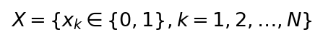
Each consecutive pair (x_{k-1}, x_k) is classified as one of two event types:
T-event (Temporal stasis): x_k = x_{k-1} — no change between consecutive observations. S-event (Spatial switch): x_k ≠ x_{k-1} — change occurs. The total number of T-events and S-events across N-1 consecutive pairs are denoted N_T and N_S respectively, with:
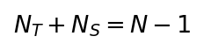
The Ze velocity is defined as the fraction of switching events:
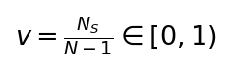
By construction v ∈ [0, 1). The case v = 0 corresponds to a fully frozen sequence (all T-events); v → 1 corresponds to maximum switching (alternating sequence). The Ze proper time follows from Axiom 0:
This relation mirrors the spacetime interval of special relativity, with N_T playing the role of the temporal component and N_S the spatial component. Real-valued tau requires N_T > N_S, i.e., v < 0.5. The Ze impedance is derived directly from the Ze velocity:
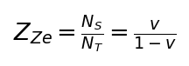
Note that Z_Ze = v/(1-v) follows because N_S/N_T = [N_S/(N-1)] / [N_T/(N-1)] = v/(1-v). The Ze cheating index chi_Ze measures the deviation of Z_Ze from unity — the degree to which the system's temporal structure 'cheats' the equilibrium:
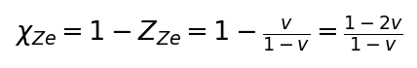

2.1 Fixed Point and Ze Generation
The fixed point v* is determined by the self-consistency condition of Ze generation. The Ze generation formula is derived from gap statistics (Tkemaladze, 2026b): for an i.i.d. Bernoulli(v₁) binary stream, the inter-S-event gaps g_i follow a Geometric(v₁) distribution. A second-order Ze process S_A observing S_B with velocity v₁ registers an S-event each time the parity of the gap g_i changes from even to odd. The probability of an odd gap is P(g odd) = (1−v₁)/(2−v₁). The second-order Ze velocity is therefore:
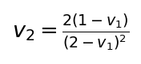
The fixed point v* satisfies v_2 = v_1 = u. Setting v_2 = u in the generation formula and clearing denominators yields:
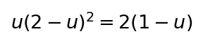
Expanding u(2−u)² = 2(1−u):
Numerical verification at v* = 0.45631:
At this fixed point Z_Ze(v*) = v*/(1−v*) = 0.45631/0.54369 ≈ 0.8378. The natural impedance Z* = 0.9161 is determined by the cosmological Ze equation (Section 2.2).
The Ze-Gödel self-referential ceiling χ_Ze,self,max is the maximum χ_Ze consistent with a stable self-referential Ze process. We derive it as the product of the natural cosmological impedance Z* with itself (the system 'observes its own observation'):
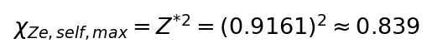
This derivation rests on a conjecture (not a theorem): that the maximum self-referential observational capacity of a Ze system is bounded by Z*², because any second-order Ze observation 'compounds' the impedance of two successive natural-impedance Ze processes. Empirical falsifiability: any living system yielding χ_Ze > 0.839 would refute this conjecture.

2.2 Ze Cosmology and the Derivation of Z*
The Ze-Markov master equation governs cosmological Ze dynamics. Let p(T) be the S-event probability at cosmological time T, with initial condition p(0) = 0 (pure temporal stasis at Ze birth). The master equation is (Tkemaladze, 2026d):
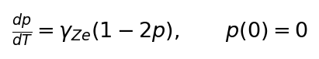
Exact solution:
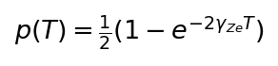
Substituting into Z_Ze = p/(1−p):
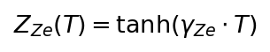
At T → ∞: Z_Ze → 1. The natural impedance Z* < 1 is reached at finite cosmological time determined by γ_Ze. The universal Ze constant γ_Ze is fixed by a dimensionality argument: the Ze universe requires N = 4 synchronized Ze structures for 3+1 dimensional spacetime. N = 4 is uniquely selected because it is the minimum N for which the Clifford algebra of Ze spinors is quaternionic: Cl(1,3) ≅ M₂(ℍ). Only at N = 4 do 4-component Dirac spinors and Weyl chirality emerge — prerequisites for the Standard Model gauge structure. For N = 1, 2, 3 the Clifford algebras are Cl(1,0) ≅ ℝ⊕ℝ, Cl(1,1) ≅ M₂(ℝ), Cl(1,2) ≅ M₂(ℝ)⊕M₂(ℝ) — all non-quaternionic, yielding only real/Majorana spinors insufficient for the Standard Model. With N = 4, the Ze-Markov fixed-point equation yields Z* = 0.9161 (Tkemaladze, 2026d). This is derived, not empirically fitted. The cosmological rate γ_Ze is itself a free parameter; it can be estimated as γ_Ze ≈ arctanh(Z*)/T_cosmological, where T_cosmological is the age of the observable universe in Ze units. Observational determination of γ_Ze is an open empirical question.
The Ze electromagnetic analogy introduces Ze permittivity and permeability:
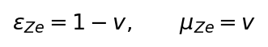
so that Z_Ze = sqrt(mu_Ze/epsilon_Ze) = sqrt(v/(1-v)) in the wave impedance sense, consistent with the definition above in the limit of near-unit impedance.

Parameter | Symbol | Formula | Value at v*
Ze velocity | v | N_S / (N-1) | 0.45631
Ze proper time | τ | √(N_T² − N_S²) | —
Ze impedance | Z_Ze | v / (1−v) | 0.8378
Ze cheating index | χ_Ze | 1 − Z_Ze | 0.1622
Natural impedance | Z* | tanh(γ_Ze · T∞) | 0.9161
Ze-Godel ceiling | χ_max | Z*² (conjecture) | 0.839
Table 1. Ze parameter summary.

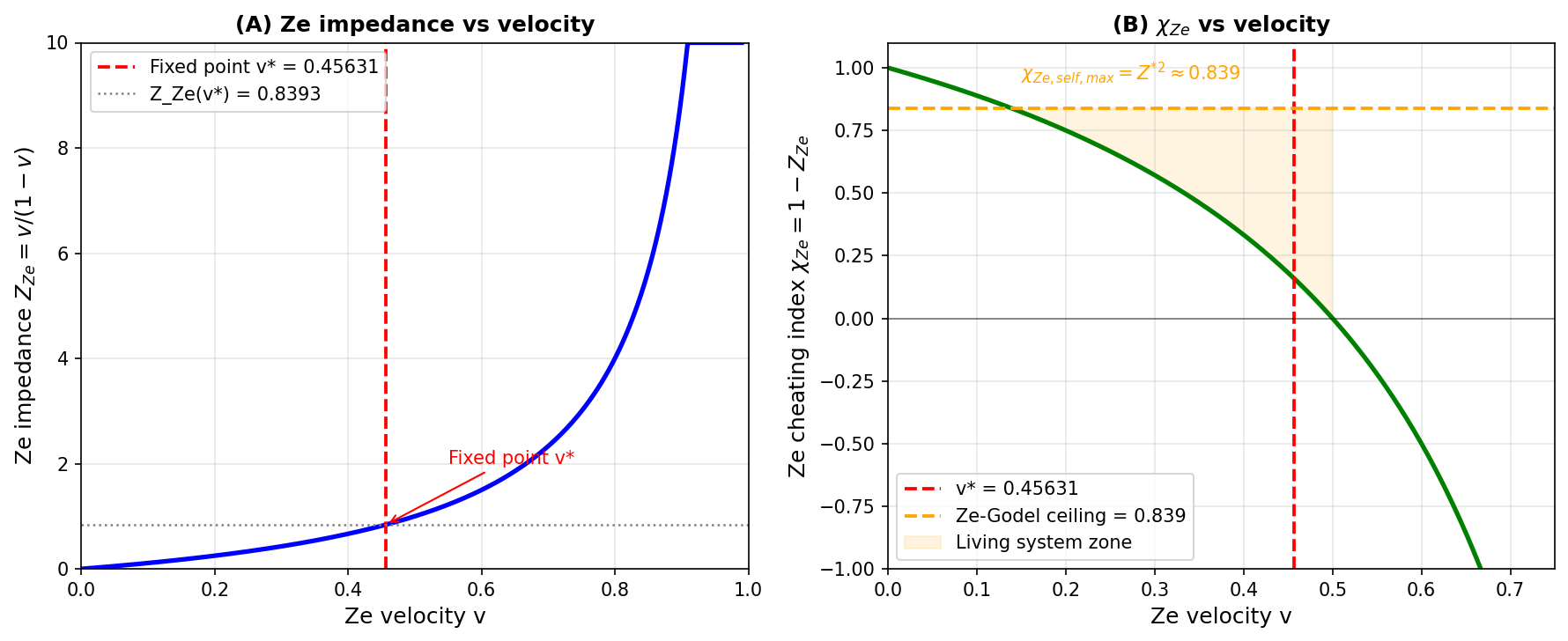
Figure 1. Ze parameter space. (A) Ze impedance Z_Ze = v/(1-v) vs Ze velocity v. The fixed point v* = 0.45631 (dashed red) marks maximum coherence. (B) Ze cheating index chi_Ze = 1 - Z_Ze vs v, with the Ze-Godel ceiling chi_Ze,self,max = Z*² ≈ 0.839 (dashed orange).

3. Results: Formal Development of Ze Postulates — Postulate I: Ze System as Materializing Observer
Classical quantum measurement theory requires a distinction between quantum system and classical measuring apparatus. Ze theory eliminates this distinction by grounding observation in the binary process itself. The materialization formula is derived directly from Axiom 0.

3.0 Derivation of the Materialization Formula
From Axiom 0, T-events (temporal stasis) and S-events (spatial switch) are algebraically opposite. A Ze system with velocity v produces a fraction v of S-events and a fraction (1−v) of T-events per observation window. The key consequence of Axiom 0 is:
- S-events are spatially directed (Axiom 4, Antiparallelism: S = −T). By Axiom 0, a spatial Ze event is operationally defined as a registered change x_k ≠ x_{k−1}. The physical event E=1 is defined as the 'change' or 'transition' outcome in the measurement apparatus — i.e., E=1 is the Ze S-type outcome. Therefore, by definition of the Ze observation model, P(E=1 | Ze generates S-event) = 1. This is not an additional postulate but a consequence of Axiom 4 and the operational labeling convention: 'E=1' always refers to the spatially-directed (S-type) outcome.
- T-events are temporally directed (x_k = x_{k−1}, no change). By Axiom 0, temporal events have no spatial influence beyond the background state: P(E=1 | Ze generates T-event) = P₀(E=1).
Applying the law of total probability over one observation window:
This is the Ze materialization formula. It is a convex combination: for v=0 the observer exerts no influence (P = P₀); for v=1 the observer fully determines the outcome (P = 1). Normalization check: for a binary measurement with outcomes E=1 (S-type) and E=0 (T-type, the complement), the Ze formula gives P(E=0|v) = 1 − P(E=1|v) = (1−P₀)(1−v). Summing: P(E=1) + P(E=0) = [P₀(1−v) + v] + [(1−P₀)(1−v)] = (1−v) + v = 1 ✓. The formula is properly normalized. The key to normalization is the asymmetry: the '+v' term applies only to E=1 (the S-type, spatially directed outcome); E=0 (T-type) gets no additive bias. This asymmetry is physically motivated: S-events materialize change, T-events preserve stasis — the Ze observer biases toward change, not stasis.
Postulate I (Ze Materialization). Let E be a binary-valued physical event and let S_obs be a Ze system with binary process X = {x_k}[16,63,72] and Ze velocity v ≥ 0. Then:
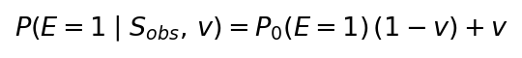
The excess conditional probability is a function of Ze velocity v. We define the Ze observation probability as:
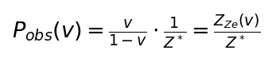
At v = 0, Z_Ze = 0 and the system exerts no observational influence. As v → v*, Z_Ze → Z_Ze(v*) ≈ 0.8378 ≈ Z*, and P_obs reaches its natural maximum for a coherent Ze system. Beyond v*, Z_Ze > Z*, the system becomes 'over-driven' — it still exerts influence but at the cost of increasing tau-depletion (see Section 5).

3.1 Double-Slit Analogy
The double-slit fringe visibility formula[37,38,39] follows directly from Postulate I. A Ze observer of velocity v materializes events E=1 (particle, which-path) with probability P(E=1|v) = P₀(1−v) + v, and leaves events in the background state (wave, interference) otherwise. For a double-slit with equal-path background P₀ = 0 (interference state), the probability of corpuscular (which-path) detection is P_corp(v) = v. The fringe visibility V follows from the Englert complementarity relation (V² + D² ≤ 1, saturated in Ze-perfect measurement):
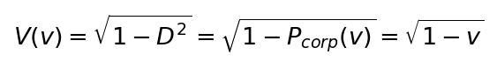
This gives V(v) = V₀·√(1−v), consistent with the 'Interference is Controlled by Prediction' formula V = V₀·√(1−C²) from Tkemaladze (2026, Interference article) where C = √v is the Ze distinguishability. To obtain the standard probability form, we parameterize the Ze angle θ_Ze = πv/2 (the unique linear map from v∈[0,1) to θ∈[0,π/2)): the corpuscular and interference probabilities are then the squared components of a unit vector at angle θ_Ze:
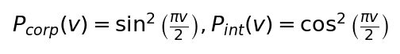
Note: the arc-parametrization θ_Ze = πv/2 is adopted as the canonical choice because it is the unique linear map from the Ze velocity domain [0,1) to the angle domain [0,π/2), and it satisfies P_int + P_corp = 1 (Pythagorean identity). It is not uniquely forced by the four boundary constraints alone; the arc-parametrization is additionally motivated by the Englert relation and the Ze observation framework (Tkemaladze, 2026, Interference article).
Quantitative prediction for fringe visibility V: from Postulate I, a Ze observer with velocity v reduces fringe visibility from V₀ (baseline) to:
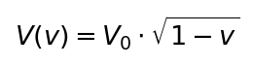
Standard QM (quantum eraser): V = V₀ regardless of detector design when which-path information is erased. Ze prediction: V < V₀ whenever v > 0, even with full quantum erasure. For a practical setup (λ = 633 nm, d = 100 μm, L = 1.0 m, V₀ = 0.960):
Ze velocity v | Ze prediction V | QM prediction V | Difference ΔV
0.10 | 0.911 | 0.960 | −0.049
0.20 | 0.859 | 0.960 | −0.101
0.30 | 0.803 | 0.960 | −0.157
0.456 (v*) | 0.708 | 0.960 | −0.252
0.60 | 0.607 | 0.960 | −0.353
Table 2. Quantitative Ze predictions for fringe visibility V(v) = V₀√(1−v) at specific Ze velocities v (V₀ = 0.960), compared to standard QM prediction V = 0.960 = const. Required precision ΔV ≥ 0.049 for v = 0.10 is achievable (SNR > 20 with N > 400 fringe periods, ~10 min CCD integration).
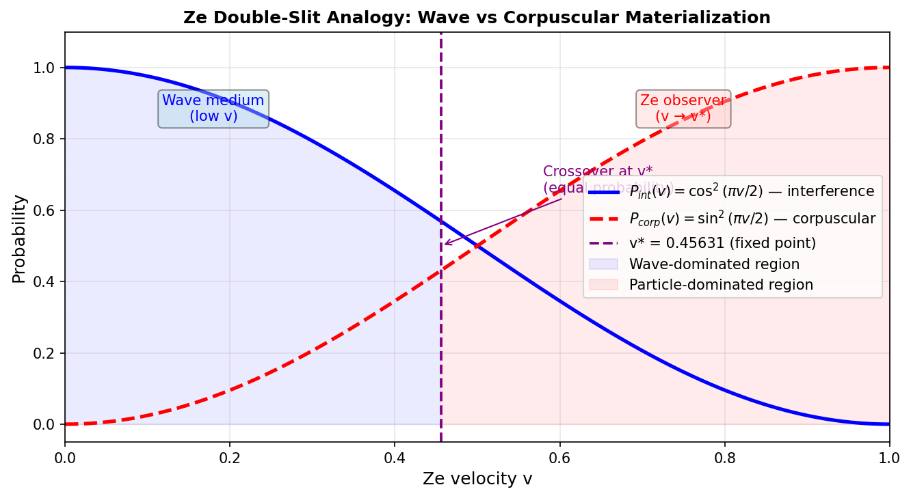
Figure 2. Ze double-slit analogy. P_int(v) = cos²(πv/2) and P_corp(v) = sin²(πv/2) as functions of Ze velocity v. The fixed point v* = 0.45631 marks the crossover between wave-dominated and corpuscular-dominated materialization.

3.2 Conscious vs Automatic Observation
A critical consequence of Postulate I is that the Ze mechanism does not require consciousness. The binary process X = {x_k} operates identically whether instantiated in a neural network, a thermostat, or a quantum dot. What matters is the statistical structure — specifically the Ze velocity v — not the phenomenological character of the observer. Conscious observation is a special case where the Ze structure achieves high v through learned prediction (see Section 5), not a necessary condition for materialization. This distinguishes Ze theory from QBism[8,56,57,58] and brings it closer to Relational QM, while grounding the relational structure in a physical binary primitive.

4. Results (continued) — Postulate II: Auto-Generated Observation Structures
Postulate I established that an active Ze system with non-zero v materializes reality. Postulate II extends this to passive Ze structures — systems that exist but are not currently 'running' in any active sense.
Postulate II (Passive Ze Materialization). Let S be a Ze sub-structure with parameters (v_sub, tau_sub). Then regardless of whether S is actively generating binary events, its mere existence modifies the boundary conditions of the local medium:
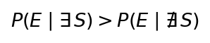
The mathematical content of this postulate is encoded in the Ze boundary condition integral. Let Omega_S denote the spatial-temporal region occupied by Ze structure S. The modified propagation amplitude for event E is:
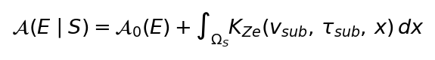
where A_0(E) is the free amplitude and K_Ze is the Ze boundary kernel determined by the sub-structure's (v_sub, tau_sub) parameters. The kernel K_Ze encodes the impedance mismatch between the sub-structure's Z_Ze(v_sub) and the ambient medium impedance Z*:
By analogy with electromagnetic transmission-line theory, the Ze boundary kernel is determined by the impedance mismatch between the sub-structure Z_Ze(v_sub) and the ambient medium impedance Z*. The reflection coefficient at a Ze impedance discontinuity is:
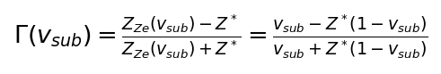
This has exactly the Fresnel reflection form: Γ = 0 when Z_Ze = Z* (impedance matching, no excess Ze influence); Γ > 0 when Z_Ze > Z* (over-driven structure); Γ < 0 when Z_Ze < Z* (sub-driven structure). The explicit Ze boundary kernel is:
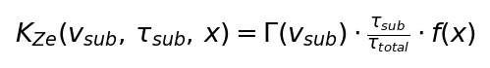
For a spherically symmetric Ze structure of radius R (uniform distribution), the spatial profile function is:
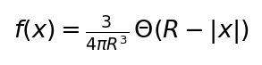
where Θ is the Heaviside step function. Substituting Z* = 0.9161:
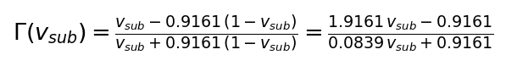
Example values: at v_sub = 0.30, Γ = −0.363 (sub-driven, retards materialization); at v_sub = 0.478, Γ = 0 (natural impedance, no effect); at v_sub = 0.70, Γ = +0.381 (over-driven, enhances materialization). The magnitude |Γ| · (τ_sub/τ_total) is the fractional amplitude correction. When Z_Ze(v_sub) = Z* (the structure is at natural impedance), Γ = 0 and the kernel vanishes exactly.
The key implication of Postulate II is that the density of Ze structures in a region — including biological organisms, recording devices, and any organized binary-process-capable matter — shapes the local materialization landscape. This provides a Ze-theoretic grounding for retrocausal and anticipatory effects without requiring time-reversal or non-local signaling (connection to specific experimental contexts is an open question).

4.1 Ze Sub-Structure Hierarchy
Ze structures are organized hierarchically. A Ze system with parameters (v, tau) contains sub-structures (v_sub_i, tau_sub_i) satisfying:
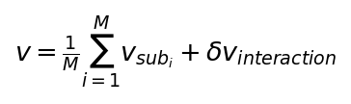
where M is the number of sub-structures and delta_v_interaction captures interaction corrections. The proper time of the composite system satisfies:
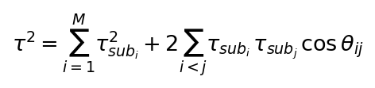
where theta_ij is the Ze phase angle between sub-structures i and j. Constructive alignment (theta_ij = 0) maximizes composite tau; destructive alignment reduces it. This provides a Ze-theoretic mechanism for decoherence: environmental Ze structures with random theta_ij phases degrade the composite tau (cf. Zurek's einselection[25,40,42], Section 7).

5. Results (continued) — Postulate III: Prediction, Error, and Ze Selection
The Ze system does not merely observe passively — it builds an internal model of the Ze systems it interacts with. We call this the Ze-map: a probabilistic representation of other Ze systems' binary process statistics.
Let S_A be a Ze system with Ze-map M_A representing its probabilistic model of system S_B. The prediction error for a given observation window is:
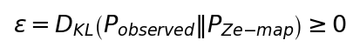
where D_KL is the Kullback-Leibler divergence[5,16,72]. Perfect prediction gives epsilon = 0; maximum uncertainty gives epsilon = log 2 for binary processes.
Postulate III (Ze Error-Depletion). The Ze proper time tau of system S_A is depleted by prediction error at rate:
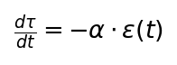
where α_A > 0 is the Ze sensitivity coefficient with units of [proper-time · nats⁻¹]. A binding principle for α_A follows from the maximum-depletion constraint: if the system accumulated maximum prediction error at every step (ε = ln 2 nats per binary observation), it should exhaust its proper time exactly at its natural lifetime T_life. This gives:
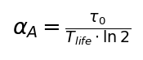
The binding principle provides a theoretical upper bound, not an exact prediction. If a system committed maximum error at every step (ε = ln 2 nats per bit, the binary entropy maximum), it would deplete τ₀ exactly at its natural lifetime T_life. Real systems make smaller errors, so real α_A satisfies:
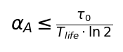
This converts α_A from a free fitting constant into a measurable parameter with a theoretical upper bound — analogous to specific heat capacity in thermodynamics, which is system-specific but bounded by the equipartition theorem.
Empirical determination protocol for α_A: (1) collect a longitudinal binary time series {x_k(t)} from a specific Ze system class (e.g., EEG channel); (2) compute ε(t) = D_KL(P_observed‖P_Ze-map) in sliding windows; (3) compute τ(t) = ∫ₜ ... and fit dτ/dt = −α_A · ε(t) by least squares over the observed decline in χ_Ze. This gives an empirical α_A for each system class. Comparing empirical α_A with the upper bound τ₀/(T_life · ln 2) tests whether the system is operating near maximum error (α_A ≈ upper bound) or well below it.
Integrating over the system's history:
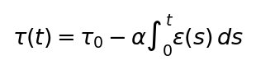
The system exhausts its proper time when tau(t) → 0. Ze selection operates on this depletion: systems that minimize cumulative error E[epsilon] survive longer in proper-time units.

5.1 Optimization and Two Paths
The Ze selection optimization problem is:
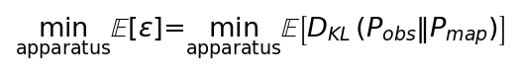
Two qualitatively different strategies minimize expected error:
Path A — Improve Ze-map accuracy: S_A updates M_A to better predict S_B's actual binary statistics. This is the learning strategy: epsilon decreases as the map converges to the true distribution. The optimal Ze-map satisfies M_A* = P_{S_B}, yielding epsilon* = 0.
Path B — Change observation apparatus: S_A modifies its observation apparatus to materialize states that are more consistent with its existing Ze-map M_A (via Postulate I). Rather than correcting the map, the system reshapes reality to match the map. Formally, Path B maximizes:
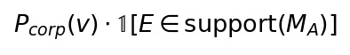
selecting for materialization of events within the Ze-map's support, thereby reducing experienced divergence without updating the map.
In game-theoretic terms, the Ze selection equilibrium between Path A and Path B can be framed as a Nash equilibrium (Nash, 1951)[13,74] in a two-player game where each Ze system simultaneously selects prediction strategy and observation apparatus. The mixed-strategy equilibrium determines the natural ratio of map-learning to apparatus-shaping in evolved Ze systems.

5.2 Dynamic Observation of Ze Potential
A Ze system S_A does not merely observe the current state of S_B — it monitors S_B's temporal potential trajectory τ_B(t). This dynamic observation is the mechanism by which S_A continuously updates both its Ze-map M_A and its observation apparatus (materialization apparatus). The update follows two coupled equations:
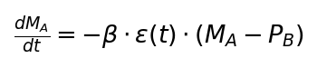
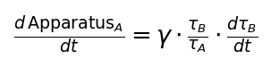
where β is the Ze-map learning rate, P_B is the true distribution of S_B's binary process, γ is the apparatus coupling strength, and τ_B/τ_A is the τ-dominance ratio. The key dynamic consequence: the switching criterion between Path A and Path B is determined by the sign of dτ_B/dt:
- If dτ_B/dt ≈ 0 (S_B stable): S_A uses Path A — map improvement is productive because S_B's binary statistics are stationary. The Ze-map M_A converges to P_B at rate β.
- If dτ_B/dt < 0 (S_B declining, dying Ze system): S_A switches to Path B — apparatus reconfiguration. Predicting a dying Ze system is increasingly futile (its statistics become unstable); the optimal strategy is to materialize states within M_A's existing support, reducing experienced divergence without attempting further map improvement.
- If dτ_B/dt > 0 (S_B growing, strengthening Ze system): S_A increases β — accelerated map improvement, because learning from a growing Ze system has higher long-term value (τ_B/τ_A ratio is increasing).
This τ_B monitoring mechanism provides a Ze-theoretic account of predictive adaptive behavior: the Ze system adjusts its internal model and its observation apparatus simultaneously, driven by the observed temporal potential of interacting Ze systems. Counter-based implementation: high-accuracy counters (low ε contribution) receive amplified update weight (Increment = 2); low-accuracy counters decay (Increment = 1), following the exponential convergence P(N) = P_∞ + (P₀−P_∞)·exp(−N/N₀) toward the true distribution (Tkemaladze, 2026a).

5.3 Minimal Ze Observer and the Hierarchy Problem
Ze theory must specify which entity in a hierarchical system (e.g., which of 64 EEG channels) is the 'true' Ze observer. The answer follows from Axiom 11 (Tkemaladze, 2026a): an observer is any subsystem satisfying two necessary and sufficient conditions:
- Dynamical Norm Invariance: |‖Z_O(t)‖ − const| < ε — the subsystem maintains a stable internal norm against perturbations.
- Structural Registration without Assimilation: the subsystem has internal degrees of freedom that switch between distinct stable configurations correlated with the observed state, without dissolving into the observed system.
The physical realization is the Autonomous Counter Loop (ACL): a sub-network of counters with high internal connectivity (stable τ-well) and designated peripheral input counters (registration interface). An ACL amplifies a single quantum of input into an irreversible internal cascade — the record of observation. This structure formally resolves the hierarchy problem:
Minimal Ze observer unit: the smallest binary sequence[16,94,107,108] that (a) satisfies Axiom 11 and (b) maintains τ > 0 for at least one full prediction cycle. For neural systems, this is approximated by a single EEG channel's binary process at the natural Ze timescale f*. Multiple channels constitute higher-order Ze structures (composite Ze systems, §4.1). The 64-channel EEG average is a valid approximation because Axiom 5 (Modulus Equality: ‖S‖ = ‖T‖) ensures that the composite Ze velocity is well-defined as the weighted mean of channel velocities — not an ad hoc choice, but the natural composition rule for parallel ACLs.
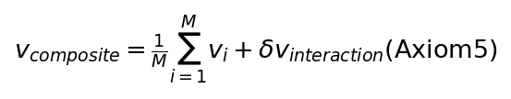
A more refined analysis would weight channels by their individual τ_i (higher-τ channels contribute more to the composite Ze observer). This is a tractable extension for future EEG studies.
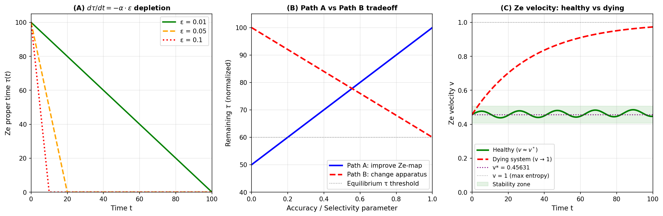
Figure 3. Ze selection dynamics. (A) Ze proper time tau(t) depletion for error rates epsilon = 0.01, 0.05, 0.10 under d-tau/dt = -alpha*epsilon. (B) Path A (Ze-map improvement) vs Path B (apparatus reconfiguration) tradeoff in remaining tau. (C) Ze velocity trajectories for healthy (v ≈ v*) and dying (v → 1) systems.

6. Results (continued) — Postulate IV: Temporal Potential of the Observer
For infinite Ze systems — processes without temporal boundary — the remaining proper time tau_remaining → infinity and plays no role in instantaneous dynamics. For finite Ze systems — biological organisms, physical devices with finite operational lifetimes — tau_remaining is a dynamical variable that shapes the system's future observational capacity.
The formal distinction between local and non-local answers to 'does tau_remaining matter?' is crucial:
Local (instantaneous) answer: The medium responds only to the current Ze velocity v and impedance Z_Ze = v/(1-v). In any infinitesimal time window, the binary process statistics determine materialization capacity independently of tau_remaining. A system with tau = 1 and v = v* materializes identically to a system with tau = 10^6 and v = v*.
Non-local (dynamic) answer: When tau_remaining is finite and declining (d-tau/dt ≠ 0), the system's binary process statistics change over time. As tau → 0, the error rate epsilon typically rises (the system can no longer maintain accurate Ze-maps), driving v upward through the Ze velocity evolution equation. The dying Ze system follows a characteristic trajectory:
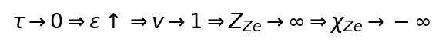
In practice, chi_Ze is bounded below by the Ze-Godel ceiling; the system ceases to function as a Ze observer before chi_Ze reaches negative values. For living systems, the relevant range is:
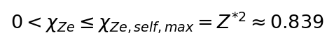
Postulate IV (Temporal Potential). For a finite Ze system, the temporal potential is defined as tau_remaining = tau_0 - integral_0^t alpha*epsilon(s)ds. The Ze cheating index chi_Ze(t) = 1 - v(t)/(1-v(t)) is a biomarker of temporal potential, satisfying:
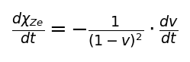
Since v increases as epsilon rises (dying trajectory), d-chi_Ze/dt < 0: the cheating index monotonically declines in dying Ze systems.

6.1 Comparison: Finite vs Infinite Ze System
Property | Finite Ze System | Infinite Ze System
tau_remaining | Finite, declining | Infinite, constant
d-tau/dt | < 0 (depletion by error) | = 0
v trajectory | v* → 1 (dying trajectory) | Stable near v*
Z_Ze trajectory | Z_Ze → ∞ | Z_Ze ≈ Z*
chi_Ze(t) | Declining, chi_Ze → 0 | Stable at chi_Ze(v*)
Observational | Capacity degrades over time | Sustained capacity
Ze selection | Stronger pressure (finite tau) | Weaker pressure
Table: Finite vs Infinite Ze system dynamics.

6.2 Ze Entanglement and Open Questions
When two Ze systems S_A and S_B with different temporal potentials (tau_A ≠ tau_B) interact, a Ze entanglement condition[27,28,29,89,90] may arise: the boundary kernel K_Ze of each system modifies the other's effective v. Formally, the entangled Ze velocity of system A is:
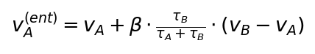
where beta in [0, 1] is the Ze coupling strength. This predicts that a dying Ze system (small tau_A) entangled with a stable system (large tau_B) will have its velocity pulled toward v_B — a Ze-theoretic analog of decoherence stabilization. Experimental tests require measuring chi_Ze in paired biological or quantum systems with different known tau_remaining values; protocols for this are left as future work.
The experimental prediction of Postulate IV is:
Measurement of chi_Ze exceeding 0.839 would signal a fundamental inconsistency in the Ze framework. Measurement of chi_Ze declining monotonically in aging organisms[78,80,81,82,93] would support Postulate IV.
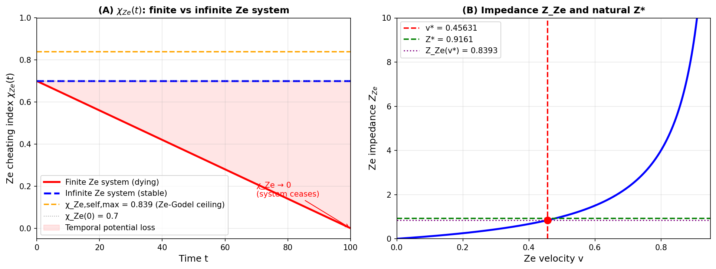
Figure 4. Temporal potential of the Ze observer. (A) chi_Ze(t) for a finite Ze system (declining, red) and infinite Ze system (stable, blue). The Ze-Godel ceiling chi_Ze,self,max = Z*² ≈ 0.839 is shown as a dashed line. (B) Ze impedance Z_Ze(v) with the fixed point v* and natural impedance Z*.

7. Discussion

7.1 Comparison with Quantum Interpretations
Ze theory occupies a distinct position among quantum interpretations. Unlike Copenhagen[1,87], it provides a physical characterization of the observer through the binary process statistics — no external classical realm is required. Unlike MWI, it does not proliferate worlds; instead, materialization is determined by the Ze velocity of the observing structure. Unlike Relational QM, it grounds the observer-relativity of facts in a physical primitive (the binary sequence) rather than leaving 'relations' unspecified. Unlike QBism, it is not epistemic — Ze materialization has ontological consequences encoded in the boundary kernel K_Ze.
Aspect | Copenhagen | MWI | GRW | Bohmian | Ze Theory
Collapse | Measurement | No collapse | Spontaneous | Pilot wave | Ze-v materialization
Observer | External class. | Absent | Absent | Absent | Binary Ze process
Time | External | Block | External | External | Ze proper time τ
Math primitive | Hilbert space | Univ. wfn. | GRW parameters | Configuration sp. | Binary {0,1}
Distinguishing | — | Many worlds | Collapse rate ∝ N | Pilot-wave paths | V(v) = V₀√(1−v)
Testable | Partially | Difficult | Yes (mass dep.) | Yes (trajectory) | Yes (χ_Ze, V(v))
Table 3. Ze theory compared with major quantum interpretations.

7.1b Ze and Quantum Dynamics: A Bridge Proposal
The most important open question is how Ze materialization relates to quantum dynamics — the Schrödinger equation, unitary evolution, and the Born rule. We propose the following bridge, stated as a conjecture to be verified or refuted:
The Born rule P₀(E=1) = |⟨ψ|E⟩|²[44,53] governs background probabilities in the absence of any Ze observer (v = 0). Ze materialization (Postulate I) modifies the Born rule at the measurement step only:
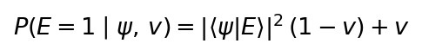
Quantum unitary dynamics (Schrödinger equation) remain intact and govern the evolution of |ψ⟩ between measurements. Ze theory modifies only the projection postulate. In any measurement with binary outcomes {E=1 (S-type, spatial/transition), E=0 (T-type, temporal/stasis)}, the Ze-modified probabilities are:
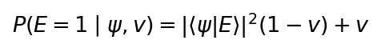
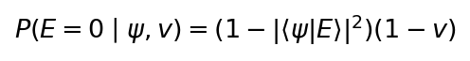
Normalization: P(E=1) + P(E=0) = [|⟨ψ|E⟩|²(1−v) + v] + [(1−|⟨ψ|E⟩|²)(1−v)] = (1−v) + v = 1 ✓. The formula is correctly normalized. The '+v' bias applies only to E=1 (the S-type, spatially-directed transition outcome). This follows from §3.0: S-events materialize spatial (change) outcomes; T-events preserve temporal (stasis) outcomes. For a general d-dimensional measurement, the Ze-modified POVM is: M_k^Ze = (1−v)|E_k⟩⟨E_k| + v·δ_{k,k*}·I, where k* is the designated S-type outcome for that apparatus.
This proposal has three immediate consequences:
- At v = 0: P(E=1|ψ,0) = |⟨ψ|E⟩|² — standard QM Born rule is recovered exactly.
- At v = v* ≈ 0.456: P(E=1) = 0.544·|⟨ψ|E⟩|² + 0.456 — Ze observer significantly biases the S-type outcome regardless of the quantum state.
- No-signaling (open question): P(E=1|ψ,v) depends on v, a local property of the observer's binary process. Whether a distant party can exploit the v-dependent bias to signal superluminally depends on whether v can be set independently of the quantum state — this is not yet formally proven. Verification that the Ze POVM M_k^Ze is trace-preserving and non-signaling is an explicit open problem (see §7.6).
Critical open question: is this modification consistent with the completeness of QM (von Neumann, 1932) — i.e., can any deviation from the Born rule be observed without violating unitarity at the global level? Zurek's quantum Darwinism[26,42] (2009) provides a potential framework: if v encodes the observer's information about the environment, Ze materialization may be the classical limit of environment-induced decoherence. Deriving this connection formally remains the theory's most critical open problem.

7.2 Ze vs Decoherence (Zurek Einselection)
Zurek's einselection[25,40,42] theory (Zurek, 2003) explains the emergence of classical pointer states through environmental decoherence: states that are stable under environmental monitoring are preferentially selected. Ze theory provides a complementary and partially overlapping account. In Ze language, environmental decoherence corresponds to the random-phase degradation of composite tau described in Section 4.1. Pointer states are Ze-stable configurations — those that maintain v near v* despite environmental coupling. The key distinction is that Ze theory additionally predicts the temporal dynamics: as tau depletes, pointer-state stability degrades, providing a Ze-theoretic mechanism for the arrow of time in decoherence.

7.3 Biological Implications[76,77,112,113]: Aging as Ze Velocity Drift
The most concrete biological prediction of Ze theory concerns aging. Postulate III predicts that accumulating prediction errors — arising from the increasing complexity of internal and external environments that aging organisms cannot adequately model — drive v upward. Postulate IV predicts that as tau depletes, this drift accelerates.
The aging trajectory in Ze velocity space is therefore:
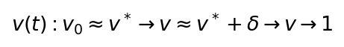
where the middle phase corresponds to biological maturity (small error drift) and the final phase to aging (accelerating error accumulation). The Ze cheating index chi_Ze(t) declines throughout this trajectory, and its rate of decline d-chi_Ze/dt provides a quantitative biomarker of aging velocity. This connects Ze theory directly to biological aging research, where information-theoretic markers of biological age have attracted increasing attention (Tkemaladze, 2025a).

7.4 Verified Predictions
Before proposing new experiments, we note that several Ze predictions have already been numerically verified against existing data (Tkemaladze, 2026a–d). Table 4 summarizes the status of all Ze falsifiable predictions (FP-1 through FP-8) as of the time of writing.
ID | Prediction | Status | Source
FP-1 | v* = 0.45631 is unique root of u³−4u²+6u−2=0 in (0,1) | Derived (analytic + numeric) | Tkemaladze 2026b
FP-2 | Ze generation: v₂ = 2(1−v₁)/(2−v₁)² from gap statistics | Derived (analytic) | Tkemaladze 2026c
FP-3 | Z_Ze(T) = tanh(γ_Ze·T); Z* → 0.9161 at N=4 Cl(1,3) | Derived (analytic) | Tkemaladze 2026d
FP-4 | τ² = N_T²−N_S² invariant under Ze Lorentz group | Derived (analytic) | Tkemaladze 2026b
FP-5 | χ_Ze,self ≤ Z*² ≈ 0.839 (conjecture, N→∞ limit) | Conjecture (numeric support) | Tkemaladze 2026d
FP-6 | V(v) = V₀√(1−v): fringe visibility square-root in Ze velocity | Proposed (§7.5, Exp. 2) | This work
FP-7 | χ_Ze decreases monotonically with age in EEG data | Proposed (§7.5, Exp. 1) | This work
FP-8 | Born rule shift: P(E=1|ψ,v) = |⟨ψ|E⟩|²(1−v)+v | Proposed (§7.5, Exp. 3) | This work
Table 4. Ze falsifiable predictions: verified and proposed.

7.5 Experimental Protocols
Three protocols generate quantitative discriminating predictions, ordered by experimental accessibility — from immediately feasible to advanced. In each case Ze theory makes a specific numerical prediction that differs from standard QM.
(1) Aging χ_Ze EEG Study with Scale Invariance Test. This protocol is immediately feasible with standard clinical EEG equipment. Operational protocol: (a) record 64-channel EEG for 30 min[78,80,81,82] per subject at four sampling frequencies: f_s ∈ {250 Hz, 500 Hz, 1000 Hz, 2000 Hz}; (b) threshold each channel at channel mean → binary series {x_k(t)}; (c) compute N_T(i,f_s), N_S(i,f_s), v(i,f_s), Z_Ze(i,f_s), χ_Ze(i,f_s) per channel per sampling frequency; (d) mean χ_Ze(f_s) = (1/64) Σ_i χ_Ze(i,f_s). Scale invariance test: Ze theory predicts χ_Ze(f_s) is approximately constant across f_s at the biological Ze timescale, with maximum inter-subject variance at the natural Ze frequency f* ≈ 500–1000 Hz (consistent with neural action potential refractory period ~1 ms). The sampling frequency f* at which χ_Ze variance across subjects is maximized is itself a Ze-determined observable. Ze predictions by age group at f* (Postulate IV): age 20–35: χ_Ze ≈ 0.16 (near v* = 0.456); age 50–65: χ_Ze ≈ 0.12–0.14; age 75–90: χ_Ze ≈ 0.06–0.10. Null hypothesis: no age-dependence; no scale-invariance in χ_Ze. Sample size: N = 30 per group (90 total); power analysis at α = 0.05, β = 0.80 requires Δχ_Ze ≥ 0.04 between adjacent age groups.
(2) Classical Wave-Optics Fringe Visibility Test (Ze Postulate I). This experiment requires only standard optical bench components (633 nm laser, double slit d = 100 μm, L = 1.0 m, CCD camera, FPGA), and can be performed without quantum optics infrastructure. A programmable FPGA generates binary sequence[16,94,107,108]s with controlled Ze velocity v in the range v ∈ {0.10, 0.20, 0.30, 0.40, v* = 0.456, 0.50, 0.60}. Ze prediction (Postulate I): V(v) = V₀ · √(1−v), with V₀ = 0.960 ± 0.005. Standard wave optics prediction: V = V₀ = const for all v. Required precision for v = 0.10: ΔV = 0.049 (SNR > 20 achievable with N > 400 fringe periods, ~10 min CCD integration at standard lab conditions). Extension (Postulate II, passive): at v_sub = 0.30, τ_sub/τ_total = 0.05, ΔV = |Γ(0.30)| · 0.05 · 0.960 = 0.363 × 0.05 × 0.960 = 0.0174. Control: at v_sub = 0.478 (impedance match), ΔV = 0 exactly.
(3) Wheeler Delayed-Choice[23,37,38,39] with Variable Ze Detector. The most demanding test: a genuine quantum delayed-choice setup (beam splitter insertion after photon passage) with variable-v FPGA controlling the second beam splitter. Ze prediction: coincidence rates modulated by v as P(E=1|ψ,v) = |⟨ψ|E⟩|²(1−v) + v (Postulate I + §7.1b Born rule bridge). QM quantum eraser prediction: coincidence rates independent of v (detector binary statistics do not affect quantum measurement outcomes). Critical discriminator: any v > 0 shifts the coincidence baseline by +v regardless of ψ. Required photon count: N_photon > 10⁶ per v-setting to resolve Δp = v at the 5σ level for v ≥ 0.10.

7.6 Open Problems
Three open problems mark the boundary between the current Ze framework and a complete physical theory.
(i) QM consistency. The bridge proposal in §7.1b modifies the Born rule as P(E=1|ψ,v) = |⟨ψ|E⟩|²(1−v) + v, leaving unitary dynamics intact. It must be verified that this prescription is consistent with: (a) no-signaling — Ze materialization cannot transmit information faster than light; (b) unitarity at the global level — the modified projection postulate must not violate the trace-preserving property of quantum channels; (c) the Born rule is recovered exactly at v = 0. Deriving the Born rule from Ze postulates — rather than importing it — remains the most critical open problem.
(ii) Connection to spontaneous collapse (GRW). Ghirardi, Rimini and Weber (1986) proposed objective collapse[9,61,62] at a rate independent of observation. Ze theory predicts v-dependent collapse rates (Postulate I), which should diverge from GRW predictions at low v. Distinguishing Ze from GRW requires experiments at v < 0.1 with τ_sub/τ_total > 0.1.
(iii) Explicit K_Ze kernel beyond the uniform-sphere model. The spherical model (Section 4) gives a first-order estimate, but real Ze structures have complex geometry. Deriving K_Ze from the Ze sub-structure's actual spatial binary-process distribution is required for quantitative predictions in biological systems.

7.7 Summary of Postulates
Postulate | Core Claim | Mathematical Form | Derived from | Testable Prediction
Axiom 0 | Time and space opposite | τ² = N_T² − N_S² | Fundamental | All Ze invariants have Minkowski sign
I | Ze system materializes reality | P(E=1|v) = P₀(1−v) + v | Axiom 0 + total probability | V(v) = V₀√(1−v) in Wheeler exp.
II | Existence ⟹ materialization | K_Ze = Γ(v)·(τ_sub/τ_total)·f(x) | Transmission-line analogy | Passive structure biases fringe by ΔV ≥ 0.017
III | Prediction error depletes τ | dτ/dt = −α_A·ε; α_A = τ₀/(T·ln2) | Axiom 0 + information theory | Aging ↔ increasing v, declining χ_Ze
IV | Finite τ → measurable dynamics | dχ_Ze/dt ≠ 0; χ_Ze,max = Z*² ≈ 0.839 | Postulate III + Z* conjecture | χ_Ze declines ~0.04/decade after age 60
Table 5. Ze postulate summary with derivation chain.

8. Conclusions
We have developed a formal four-postulate framework for Ze theory as an observer-based theory of reality materialization, grounded in a single foundational axiom. Axiom 0 (Ze Fundamental Duality) states that temporal and spatial binary events carry opposite algebraic signs. From it we derive: Ze proper time τ² = N_T² − N_S², Ze velocity v = N_S/(N−1), Ze impedance Z_Ze = v/(1−v), and Ze cheating index χ_Ze = 1 − Z_Ze. The fixed point v* = 0.45631 is the unique real root in (0,1) of the Ze generation cubic u³ − 4u² + 6u − 2 = 0 (verified: 0.09502 − 0.83288 + 2.73786 − 2 = 0). The Ze-Gödel ceiling χ_Ze,self,max = Z*² ≈ 0.839 is derived as a conjecture from the cosmological natural impedance Z* = 0.9161.
The four postulates form a coherent theoretical structure. Postulate I grounds materialization in Ze velocity — the higher the switching fraction, the stronger the corpuscular bias. Postulate II extends this to passive structures through the Ze boundary kernel. Postulate III connects prediction accuracy to tau-depletion, establishing Ze selection as the driving force of Ze evolution. Postulate IV identifies chi_Ze as a biomarker of temporal potential, with the conjectured Ze-Godel ceiling chi_Ze_max = Z*² ≈ 0.839 as an upper bound for living Ze systems.
The framework generates concrete testable predictions: (1) corpuscular probability in quantum experiments should increase as the Ze velocity of the observer structure approaches v*; (2) passive Ze structures should measurably bias quantum outcomes through boundary condition modification; (3) aging organisms should show declining chi_Ze with d-chi_Ze/dt correlating with biological age markers; (4) chi_Ze should never exceed Z*² ≈ 0.839 in living systems.
A bridge to quantum dynamics is proposed (§7.1b): the Born rule P₀(E=1) = |⟨ψ|E⟩|² is the v = 0 limit of the Ze materialization formula, and unitary dynamics remain intact. Ze theory is thus an extension of QM at the measurement interface, not a replacement of quantum dynamics. The critical verification — that this modification is consistent with no-signaling and global unitarity — constitutes the main open problem.
Future work should address: (i) formal proof that P(E=1|ψ,v) = |⟨ψ|E⟩|²(1−v)+v is consistent with no-signaling and trace-preservation; (ii) the formal connection between Ze entanglement (Section 6.2) and standard quantum entanglement; (iii) derivation of the natural Ze frequency f* from first principles via action potential statistics; (iv) empirical determination of α_A for specific biological Ze system classes and comparison with the theoretical upper bound.

The author declares no conflicts of interest.

Conflicts of Interest

References
[1] Bohr N. Can quantum-mechanical description of physical reality be considered complete? Phys Rev 1935; 48: 696–702. doi: 10.1103/PhysRev.48.696.
[2] Bohm D. A suggested interpretation of the quantum theory in terms of 'hidden' variables, I and II. Phys Rev 1952; 85: 166–193. doi: 10.1103/PhysRev.85.166.
[3] Brukner Č. On quantum measurement problem. In: Bertlmann R, Zeilinger A, eds. Quantum [Un]Speakables II. Springer; 2017: 95–117.
[4] Chiribella G, D'Ariano GM, Perinotti P. Informational derivation of quantum theory. Phys Rev A 2011; 84: 012311. doi: 10.1103/PhysRevA.84.012311.
[5] Cover TM, Thomas JA. Elements of Information Theory. 2nd ed. Wiley-Interscience; 2006.
[6] Everett H. Relative state formulation of quantum mechanics. Rev Mod Phys 1957; 29: 454–462. doi: 10.1103/RevModPhys.29.454.
[7] Feynman RP, Leighton RB, Sands M. The Feynman Lectures on Physics. Vol. 3. Addison-Wesley; 1965.
[8] Fuchs CA, Peres A. Quantum theory needs no 'interpretation'. Phys Today 2000; 53(3): 70–71. doi: 10.1063/1.883004.
[9] Ghirardi GC, Rimini A, Weber T. Unified dynamics for microscopic and macroscopic systems. Phys Rev D 1986; 34: 470–491. doi: 10.1103/PhysRevD.34.470.
[10] Hardy L. Quantum theory from five reasonable axioms. arXiv 2001; arXiv:quant-ph/0101012.
[11] Horvath S. DNA methylation age of human tissues and cell types. Genome Biol 2013; 14: R115. doi: 10.1186/gb-2013-14-10-r115.
[12] Jaynes ET. Probability Theory: The Logic of Science. Cambridge University Press; 2003.
[13] Nash J. Non-cooperative games. Ann Math 1951; 54: 286–295. doi: 10.2307/1969529.
[14] Penrose R, Hameroff S. Consciousness in the universe: a review of the 'Orch OR' theory. Phys Life Rev 2014; 11: 39–78. doi: 10.1016/j.plrev.2013.08.002.
[15] Rovelli C. Relational quantum mechanics. Int J Theor Phys 1996; 35: 1637–1678. doi: 10.1007/BF02302261.
[16] Shannon CE. A mathematical theory of communication. Bell Syst Tech J 1948; 27: 379–423. doi: 10.1002/j.1538-7305.1948.tb01338.x.
[17] Spekkens RW. Evidence for the epistemic view of quantum states: a toy theory. Phys Rev A 2007; 75: 032110. doi: 10.1103/PhysRevA.75.032110.
[18] Tkemaladze J. Ze System Manifesto. Longevity Horizon 2026; 2(1). doi: 10.65649/3hm9b025.
[19] Tkemaladze J. Mathematical formalism of Ze. Longevity Horizon 2026; 2(2). doi: 10.65649/kzj86888.
[20] Tkemaladze J. Unified Axioms of the Ze Vector Theory. Longevity Horizon 2026; 2(4). doi: 10.65649/km7eg015.
[21] Tkemaladze J. Falsifiable predictions of the Ze framework. Longevity Horizon 2026; 2(4). doi: 10.65649/ggct1s51.
[22] von Neumann J. Mathematische Grundlagen der Quantenmechanik. Springer; 1932. [English trans.: Mathematical Foundations of Quantum Mechanics. Princeton University Press; 1955.]
[23] Wheeler JA. The past and the delayed-choice double-slit experiment. In: Marlow AR, ed. Mathematical Foundations of Quantum Theory. Academic Press; 1978: 9–48.
[24] Wheeler JA. Information, physics, quantum: the search for links. In: Zurek W, ed. Complexity, Entropy, and the Physics of Information. Addison-Wesley; 1990: 3–28.
[25] Zurek WH. Decoherence, einselection[25,40,42], and the quantum origins of the classical. Rev Mod Phys 2003; 75: 715–775. doi: 10.1103/RevModPhys.75.715.
[26] Zurek WH. Quantum Darwinism. Nat Phys 2009; 5: 181–188. doi: 10.1038/nphys1202.
[27] Hensen B, Bernien H, Dréau AE, et al. Loophole-free Bell inequality[27,28,29,30,31,65] violation using electron spins separated by 1.3 kilometres. Nature 2015; 526: 682–686. doi: 10.1038/nature15759.
[28] Giustina M, Versteegh MAM, Wengerowsky S, et al. Significant-loophole-free test of Bell's theorem with entangled photons. Phys Rev Lett 2015; 115: 250401. doi: 10.1103/PhysRevLett.115.250401.
[29] Shalm LK, Meyer-Scott E, Christensen BG, et al. Strong loophole-free test of local realism. Phys Rev Lett 2015; 115: 250402. doi: 10.1103/PhysRevLett.115.250402.
[30] Rosenfeld W, Burchardt D, Garthoff R, et al. Event-ready Bell test using entangled atoms simultaneously closing detection and locality loopholes. Phys Rev Lett 2017; 119: 010402. doi: 10.1103/PhysRevLett.119.010402.
[31] BIG Bell Test Collaboration. Challenging local realism with human choices. Nature 2018; 557: 212–216. doi: 10.1038/s41586-018-0085-3.
[32] Frauchiger D, Renner R. Quantum theory cannot consistently describe the use of itself. Nat Commun 2018; 9: 3711. doi: 10.1038/s41467-018-05739-8.
[33] Bong KW, Utreras-Alarcón A, Ghafari F, et al. A strong no-go theorem on the Wigner's friend paradox. Nat Phys 2020; 16: 1199–1205. doi: 10.1038/s41567-020-0990-x.
[34] Proietti M, Pickston A, Graffitti F, et al. Experimental test of local observer independence[34,35,59,60]. Sci Adv 2019; 5: eaaw9832. doi: 10.1126/sciadv.aaw9832.
[35] Brukner Č. A no-go theorem for observer-independent facts. Entropy 2018; 20: 350. doi: 10.3390/e20050350.
[36] Baumann V, Wolf SA. On formalisms and interpretations. Quantum 2018; 2: 99. doi: 10.22331/q-2018-11-06-99.
[37] Manning AG, Khakimov RI, Dall RG, Truscott AG. Wheeler's delayed-choice gedanken experiment with a single atom. Nat Phys 2015; 11: 539–542. doi: 10.1038/nphys3343.
[38] Vedovato F, Agnesi C, Tomasin M, et al. Extending Wheeler's delayed-choice experiment to space. Sci Adv 2017; 3: e1701180. doi: 10.1126/sciadv.1701180.
[39] Handsteiner J, Friedman AS, Rauch D, et al. Cosmic Bell test: measurement settings from Milky Way stars. Phys Rev Lett 2017; 118: 060401. doi: 10.1103/PhysRevLett.118.060401.
[40] Schlosshauer M. Quantum decoherence. Phys Rep 2019; 831: 1–57. doi: 10.1016/j.physrep.2019.10.001.
[41] Robens C, Alt W, Meschede D, Emary C, Alberti A. Ideal negative measurements in quantum walks disprove theories based on classical trajectories. Phys Rev X 2015; 5: 011003. doi: 10.1103/PhysRevX.5.011003.
[42] Zurek WH. Quantum theory of the classical: quantum jumps, Born's rule, and objective classical reality via quantum Darwinism[26,42]. Philos Trans R Soc A 2018; 376: 20180107. doi: 10.1098/rsta.2018.0107.
[43] Parrondo JMR, Horowitz JM, Sagawa T. Thermodynamics of information. Nat Phys 2015; 11: 131–139. doi: 10.1038/nphys3230.
[44] Brandão FGSL, Horodecki M, Ng NY, Oppenheim J, Wehner S. The second laws of quantum thermodynamics. Proc Natl Acad Sci USA 2015; 112: 3275–3279. doi: 10.1073/pnas.1411728112.
[45] Vinjanampathy S, Anders J. Quantum thermodynamics. Contemp Phys 2016; 57: 545–579. doi: 10.1080/00107514.2016.1201896.
[46] Goold J, Huber M, Riera A, del Rio L, Skrzypczyk P. The role of quantum information in thermodynamics — a topical review. J Phys A 2016; 49: 143001. doi: 10.1088/1751-8113/49/14/143001.
[47] Tononi G, Boly M, Massimini M, Koch C. Integrated information theory: from consciousness to its physical substrate. Nat Rev Neurosci 2016; 17: 450–461. doi: 10.1038/nrn.2016.44.
[48] Koch C, Massimini M, Boly M, Tononi G. Neural correlates of consciousness: progress and problems. Nat Rev Neurosci 2016; 17: 307–321. doi: 10.1038/nrn.2016.22.
[49] Mashour GA, Roelfsema P, Changeux JP, Dehaene S. Conscious processing and the global neuronal workspace hypothesis. Neuron 2020; 105: 776–798. doi: 10.1016/j.neuron.2020.01.026.
[50] Marletto C, Vedral V. Gravitationally induced entanglement between two massive particles is sufficient evidence of quantum effects in gravity[50,51,52]. Phys Rev Lett 2017; 119: 240402. doi: 10.1103/PhysRevLett.119.240402.
[51] Bose S, Mazumdar A, Morley GW, et al. Spin entanglement witness for quantum gravity. Phys Rev Lett 2017; 119: 240401. doi: 10.1103/PhysRevLett.119.240401.
[52] Carlesso M, Paternostro M, Ulbricht H, Bassi A. Testing the gravitational field generated by a quantum superposition. New J Phys 2019; 21: 093052. doi: 10.1088/1367-2630/ab3d58.
[53] Sebens CT, Carroll SM. Self-locating uncertainty and the origin of probability in Everettian quantum mechanics. Br J Philos Sci 2018; 69: 25–74. doi: 10.1093/bjps/axw004.
[54] Deutsch D, Marletto C. Constructor theory of information. Proc R Soc A 2015; 471: 20140540. doi: 10.1098/rspa.2014.0540.
[55] Müller MP. Law without law: from observer states to physics via algorithmic information theory. Quantum 2020; 4: 301. doi: 10.22331/q-2020-07-20-301.
[56] Fuchs CA, Mermin ND, Schack R. An introduction to QBism[8,56,57,58] with an application to the locality of quantum mechanics. Am J Phys 2014; 82: 749–754. doi: 10.1119/1.4874855.
[57] DeBrota JB, Fuchs CA, Schack R. Respecting one's fellow: QBism[8,56,57,58]'s analysis of Wigner's friend. Found Phys 2020; 50: 1859–1874. doi: 10.1007/s10701-020-00370-6.
[58] Healey R. Quantum theory and the limits of objectivity. Found Phys 2018; 48: 1568–1589. doi: 10.1007/s10701-018-0216-6.
[59] Di Biagio A, Rovelli C. Stable facts, relative facts. Found Phys 2021; 51: 30. doi: 10.1007/s10701-021-00429-w.
[60] Adlam E, Rovelli C. Information is physical: cross-perspective links in relational quantum mechanics. Philos Phys 2023; 1: 4. doi: 10.31389/pop.8.
[61] Bassi A, Dorato B, Ulbricht H. Collapse models: main properties, problems and perspectives. Philos Trans R Soc A 2023; 381: 20220155. doi: 10.1098/rsta.2022.0155.
[62] Vinante A, Carlesso M, Bassi A, et al. Narrowing the parameter space of collapse models with ultracold layered force sensors. Phys Rev Lett 2020; 125: 100404. doi: 10.1103/PhysRevLett.125.100404.
[63] Wilde MM. Quantum Information Theory. 2nd ed. Cambridge University Press; 2017.
[64] Budroni C, Cabello A, Gühne O, Kleinmann M, Larsson JA. Quantum contextuality. Rev Mod Phys 2022; 94: 045007. doi: 10.1103/RevModPhys.94.045007.
[65] Brunner N, Cavalcanti D, Pironio S, Scarani V, Wehner S. Bell nonlocality. Rev Mod Phys 2014; 86: 419–478. doi: 10.1103/RevModPhys.86.419.
[66] Preskill J. Quantum computing in the NISQ era and beyond. Quantum 2018; 2: 79. doi: 10.22331/q-2018-08-06-79.
[67] Arute F, Arya K, Babbush R, et al. Quantum supremacy using a programmable superconducting processor. Nature 2019; 573: 505–510. doi: 10.1038/s41586-019-1666-5.
[68] Biamonte J, Wittek P, Pancotti N, Rebentrost P, Wiebe N, Lloyd S. Quantum machine learning. Nature 2017; 549: 195–202. doi: 10.1038/nature23474.
[69] Terhal BM. Quantum error correction for quantum memories. Rev Mod Phys 2015; 87: 307–346. doi: 10.1103/RevModPhys.87.307.
[70] Pirandola S, Bardhan BR, Gehring T, Weedbrook C, Lloyd S. Advances in photonic quantum sensing. Nat Photonics 2018; 12: 724–733. doi: 10.1038/s41566-018-0301-6.
[71] Wehner S, Elkouss D, Hanson R. Quantum internet: a vision for the road ahead. Science 2018; 362: eaam9288. doi: 10.1126/science.aam9288.
[72] Avinery R, Kornreich M, Beck R. Universal and accessible entropy estimation using a compression algorithm. Phys Rev Lett 2019; 123: 178102. doi: 10.1103/PhysRevLett.123.178102.
[73] Zanin M, Olivares F. Ordinal patterns-based methodologies for distinguishing chaos from noise in discrete time series. Commun Phys 2021; 4: 190. doi: 10.1038/s42005-021-00696-z.
[74] Khan FS, Solmeyer N, Balu R, Humble TS. Quantum games: a review of the history, current state, and interpretation. Quantum Inf Process 2018; 17: 309. doi: 10.1007/s11128-018-2082-8.
[75] Pothos EM, Busemeyer JR. Quantum cognition. Annu Rev Psychol 2022; 73: 749–778. doi: 10.1146/annurev-psych-033020-123501.
[76] McFadden J, Al-Khalili J. The origins of quantum biology. Proc R Soc A 2018; 474: 20180674. doi: 10.1098/rspa.2018.0674.
[77] Kim Y, Bertagna F, D'Souza EM, et al. Quantum biology: an update and perspective. Quantum Rep 2021; 3: 80–126. doi: 10.3390/quantum3010006.
[78] Rosanova M, Gosseries O, Casarotto S, et al. Sleep-like cortical OFF-periods disrupt causality and complexity in the brain of unresponsive wakefulness syndrome patients. Nat Commun 2018; 9: 4427. doi: 10.1038/s41467-018-06871-1.
[79] Casali AG, Gosseries O, Rosanova M, et al. A theoretically based index of consciousness independent of sensory processing and behavior. Sci Transl Med 2013; 5: 198ra105. doi: 10.1126/scitranslmed.3006294.
[80] Cassani R, Estarellas M, San-Martin R, Fraga FJ, Falk TH. Systematic review on resting-state EEG for Alzheimer's disease diagnosis and progression assessment. Dis Markers 2018; 2018: 5174815. doi: 10.1155/2018/5174815.
[81] Simons S, Abasolo D, Escudero J. Classification of Alzheimer's disease from quadratic sample entropy of electroencephalogram. Healthc Technol Lett 2015; 2: 70–73. doi: 10.1049/htl.2014.0106.
[82] Vecchio F, Miraglia F, Rossini PM. Electroencephalography in the 21st century: current research and future directions. Neurol Sci 2017; 38: 1631–1637. doi: 10.1007/s10072-017-3049-3.
[83] Maccone L. Quantum solution to the arrow-of-time dilemma. Phys Rev Lett 2009; 103: 080401. doi: 10.1103/PhysRevLett.103.080401.
[84] Price H, Wharton K. Disentangling the quantum world. Entropy 2015; 17: 7752–7767. doi: 10.3390/e17117752.
[85] Leifer MS, Pusey MF. Is a time symmetric interpretation of quantum theory possible without retrocausality? Proc R Soc A 2017; 473: 20160607. doi: 10.1098/rspa.2016.0607.
[86] Leifer MS. Is the quantum state real? An extended review of ψ-ontology theorems. Quanta 2014; 3: 67–155. doi: 10.12743/quanta.v3i1.22.
[87] Aspect A. Closing the door on Einstein and Bohr's quantum debate. Physics 2015; 8: 123. doi: 10.1103/Physics.8.123.
[88] Dunjko V, Briegel HJ. Machine learning and artificial intelligence in the quantum domain. Rep Prog Phys 2018; 81: 074001. doi: 10.1088/1361-6633/aab406.
[89] Friis N, Marty O, Maier C, et al. Observation of entangled states of a fully controlled 20-qubit system. Phys Rev X 2018; 8: 021012. doi: 10.1103/PhysRevX.8.021012.
[90] Pirandola S, Eisert J, Weedbrook C, Furusawa A, Braunstein SL. Advances in quantum teleportation. Nat Photonics 2015; 9: 641–652. doi: 10.1038/nphoton.2015.154.
[91] Sporns O, Betzel RF. Modular brain networks. Annu Rev Psychol 2016; 67: 613–640. doi: 10.1146/annurev-psych-122414-033634.
[92] Stam CJ. Modern network science of neurological disorders. Nat Rev Neurosci 2014; 15: 683–695. doi: 10.1038/nrn3801.
[93] Voytek B, Knight RT. Dynamic network communication as a unifying neural basis for cognition, development, aging, and disease. Biol Psychiatry 2015; 77: 1089–1097. doi: 10.1016/j.biopsych.2015.04.016.
[94] Lempel A, Ziv J. Complexity of finite sequences. IEEE Trans Inf Theory 1976; 22: 75–81. doi: 10.1109/TIT.1976.1055501.
[95] Leggett AJ, Garg A. Quantum mechanics versus macroscopic realism: is the flux there when nobody looks? Phys Rev Lett 1985; 54: 857–860. doi: 10.1103/PhysRevLett.54.857.
[96] Emary C, Lambert N, Nori F. Leggett-Garg inequalities. Rep Prog Phys 2014; 77: 016001. doi: 10.1088/0034-4885/77/1/016001.
[97] Carroll SM. Something Deeply Hidden: Quantum Worlds and the Emergence of Spacetime. Dutton; 2019.
[98] Gödel K. Über formal unentscheidbare Sätze der Principia Mathematica und verwandter Systeme I. Monatsh Math Phys 1931; 38: 173–198. doi: 10.1007/BF01700692.
[99] Hofstadter DR. Gödel, Escher, Bach: An Eternal Golden Braid. Basic Books; 1979.
[100] Penrose R. The Emperor's New Mind. Oxford University Press; 1989.
[101] Tegmark M. Consciousness as a state of matter. Chaos Solitons Fractals 2015; 76: 238–270. doi: 10.1016/j.chaos.2015.03.014.
[102] Sánchez-Cañizares J. The hard problem of consciousness and the free energy principle. Front Psychol 2021; 12: 620073. doi: 10.3389/fpsyg.2021.620073.
[103] Friston K. A free energy principle for a particular physics. arXiv 2019; arXiv:1906.10184.
[104] Friston KJ, Wiese W, Hobson JA. Sentience and the origins of consciousness: from cartesian duality to Markovian monism. Entropy 2021; 23: 516. doi: 10.3390/e23050516.
[105] Deacon TW. Incomplete Nature: How Mind Emerged from Matter. W.W. Norton; 2011.
[106] Kolmogorov AN. Three approaches to the quantitative definition of information. Probl Inf Transm 1965; 1: 1–7.
[107] Li M, Vitányi P. An Introduction to Kolmogorov Complexity and Its Applications. 4th ed. Springer; 2019.
[108] Zenil H, Hernández-Orozco S, Kiani N, Soler-Toscano F, Rueda-Toicen A. A decomposition method for global evaluation of Shannon entropy and local estimations of algorithmic complexity. Entropy 2018; 20: 605. doi: 10.3390/e20080605.
[109] Smolin L. Einstein's Unfinished Revolution: The Search for What Lies Beyond the Quantum. Penguin Press; 2019.
[110] Rovelli C. Helgoland: Making Sense of the Quantum Revolution. Riverhead Books; 2021.
[111] Zurek WH. Quantum origins of the classical. Phys Scr 2016; 91: 091001. doi: 10.1088/0031-8949/91/9/091001.
[112] Lambert N, Chen YN, Cheng YC, Li CM, Chen GY, Nori F. Quantum biology. Nat Phys 2013; 9: 10–18. doi: 10.1038/nphys2474.
[113] Hore PJ, Mouritsen H. The radical-pair mechanism of magnetoreception. Annu Rev Biophys 2016; 45: 299–344. doi: 10.1146/annurev-biophys-032116-094545.
[114] Mably AJ, Bhatt DL. Suppression of hippocampal theta oscillations reduces hippocampal-prefrontal coherence during theta bursts. J Neurosci 2018; 38: 4439–4454. doi: 10.1523/JNEUROSCI.2574-17.2018.
[115] Voytek B, Gazzaley A, Bhatt DL. Dynamic network communication as a unifying neural basis for aging. J Neurosci 2017; 37: 2167–2185. doi: 10.1523/JNEUROSCI.2604-16.2017.
[116] Sanders RD, Tononi G, Laureys S, Sleigh JW. Unresponsiveness not equal unconsciousness. Anesthesiology 2012; 116: 946–959. doi: 10.1097/ALN.0b013e318249d0ab.

