Ze-Syncorda
An Information-Theoretic Framework for Identity Archive Access — Genetic vs. Educational Zen-Coupling Keys
Jaba Tkemaladze ^
Kutaisi International University, Georgia
Citation: Tkemaladze, J. (2026). Ze-Syncorda. Longevity Horizon, 2(4). DOI : https://doi.org/10.65649/1394vq40

Abstract
I introduce Ze-syncorda as the static synaptic-weight configuration encoding an organism's self-referential information archive, with a corrected instantaneous capacity of S_syn = N_n x k_avg x H_syn = 8.6x10^10 x 7000 x 0.78 = 4.70x10^14 bits (~470 terabits). The diploid genome contributes I_DNA = 1.31x10^10 bits (0.003% of S_syn). I formalize two classes of "Ze-keys" for syncorda access: (1) the genetic Ze-key, MI_DNA(r) = r x h^2 x I_DNA = 3.27x10^9 bits for parent-child dyads (r = 0.50, h^2 = 0.50), and (2) the educational Ze-key, MI_edu = kappa_es x S_syn x eta = 2.03x10^13 bits after 18 years of intensive upbringing. The educational key exceeds the genetic key by a factor of 6,209x. A Ze-phase transition in syncorda access occurs when the Ze-connectivity kappa_es surpasses the social-network percolation critical threshold kappa_c = 1/k_avg = 1/6 = 0.167, requiring t_eff >= 5.41 effective years of intensive Ze-interaction. Applying Ze-Zeno and decay analysis, I show that Ze-keys remain valid for only ~3.2 months after separation from the syncorda holder, resolving post-mortem access dynamics and providing a Ze-theoretic basis for universal mourning period durations. The self-model partition Phi_self requires kappa_c_Phi = 0.180 > kappa_c = 0.167, establishing that even long-term educators cannot access the core identity. Ze-adversarial attacks (p_manipulation = 0.70) produce Ze-inversion (chi_Ze = -1.33), requiring tau_rec = 21.8 months for recovery with three Ze-anchor bonds -- consistent with clinical cult-recovery timelines of 17-26 months. The Ze analog of the no-hiding theorem predicts I_preservation = 9.26% of syncorda content survives in Ze-connected individuals post-mortem. Eight falsifiable experimental predictions are provided.
Keywords: Ze-theory, synaptic information, identity archive, kinship coefficient, social percolation, Ze-phase transition, Ze-syncorda, adversarial identity attack

Introduction
Every individual human organism accumulates, over a lifetime, a unique configuration of approximately 6.02x10^14 synaptic connections (Sporns, 2011). This configuration -- the Ze-syncorda -- encodes not only behavioral history but the organism's self-model, episodic memory, semantic knowledge, and procedural skills. A fundamental question in theoretical biology, psychology, and information theory concerns what constitutes a sufficient "key" to access this archive: does genetic kinship (quantified by Hamilton's coefficient r) provide meaningful informational overlap, or does intensive developmental Ze-coupling (quantified by Ze-connectivity kappa_es) represent the dominant access mechanism?
This question was posed implicitly by Aristophanes in the Clouds (423 BCE) and made explicit by Xenophon's Memorabilia: "If I am not certain this child is mine, why should I love him?" In Ze-theory, this translates to a precise quantitative comparison between the genetic Ze-key (MI_DNA determined by r) and the educational Ze-key (MI_edu determined by kappa_es x time). I show that the answer is unambiguous: the educational key dominates by more than four orders of magnitude in mutual information, and that the true Ze-tragedy of the Clouds is not paternity uncertainty but adversarial Ze-attack on the child's self-model partition Phi_self.
The Ze-theory framework (Ze-Research Group, 2025) models biological and social systems as binary Ze-streams {x_k in {0,1}}, where x_k = 0 denotes stasis and x_k = 1 denotes transition. The Ze-cheating parameter chi_Ze = (1-2p)/(1-p) quantifies the deviation from maximum-entropy (p = 0.5) toward controlled stasis (p -> 0, chi_Ze -> 1). Ze-connectivity kappa_ij = MI(i;j)/H(i) between nodes i and j measures the fraction of node i's information entropy that is shared with node j.
The present paper makes the following contributions: (1) corrects the S_syn formula to a static synaptic-weight capacity calculation; (2) unifies the MI_DNA formula as MI = r x h^2 x I_genome; (3) explicitly identifies the social-network percolation level as the Ze-phase transition context (k_avg = 6, not 7000); (4) introduces Ze-key temporal decay (tau_decay = 7.5 years) and post-mortem access windows (~3 months); (5) demonstrates that Phi_self requires kappa_c_Phi = 0.180, above the global phase-transition threshold; and (6) quantifies collective Ze-syncorda and recovery dynamics.

Theoretical Framework

Ze-Binary Stream and Core Equations
A Ze-binary stream is a stochastic process {x_k in {0,1}} with transition probability p = P(x_k = 1). The Ze-cheating parameter and Ze-impedance are:
chi_Ze = (1 - 2p) / (1 - p); Z_Ze = p / (1 - p)
At p = 0 (perfect stasis): chi_Ze = 1, Z_Ze = 0. At p = 0.5 (maximum entropy): chi_Ze = 0, Z_Ze = 1. At p > 0.5 (Ze-inversion): chi_Ze < 0, Z_Ze > 1. The Ze-Zeno effect describes the suppression of effective transition probability under frequent observation:
p_eff(omega) = p_free / (1 + omega * tau_Ze)
where omega is the observation frequency and tau_Ze is the Ze-time constant. At omega -> infinity (continuous observation), p_eff -> 0 and chi_Ze -> 1, representing maximum Ze-stabilization.
Ze-Syncorda: Corrected Definition and Capacity
Ze-syncorda is defined as the instantaneous synaptic-weight configuration of the neural network, plus the self-referential model Phi_self:
S_syn = N_n x k_avg x H_syn_weight + Phi_self
= 8.6x10^10 x 7000 x 0.78 bit/synapse
= 4.70x10^14 bits (~470 terabits; instantaneous capacity)
CORRECTION from v1.0: Prior versions included Hz x T_life in this formula, which computes cumulative information flow (~1.33x10^25 bits) rather than instantaneous configuration capacity. H_syn_weight = 0.78 bits/synapse reflects the empirical entropy of synaptic weight distributions at sparse-coding equilibrium. The full dynamic capacity (Bhumbra & Bhumbra, 2018; log_2(26) = 4.7 bits/synapse) gives S_syn_max = 2.83x10^15 bits, representing a conservative upper bound.
Including extraneuronal components:

Table 1. Ze-Syncorda Information Component Breakdown.
Component | Information (bits) | % of S_syn | Notes
Synaptic weights (neurons) | 4.70e14 | 97.71% | H_syn = 0.78 bit/syn
Epigenome (CpG + histones) | 2.80e12 | 0.58% | ~28M CpG sites x 1 bit
Extracellular matrix | 1.50e12 | 0.31% | Perineuronal nets
Gut microbiome | 3.80e12 | 0.79% | Gut-brain axis Ze-signal
Total (S_syn_max) | 4.81e14 | ~100% | Conservative upper bound

Ze-Connectivity and Phase Transition
Ze-connectivity between nodes i and j is defined as:
kappa_ij = MI(i; j) / H(i)
The Ze-phase transition occurs when kappa_ij reaches the critical threshold of the relevant network. For the neural network (N = 8.6x10^10 neurons, k_avg = 7000): kappa_c(neural) = 1/7000 = 1.43x10^-4. For the social Ze-network governing syncorda access (N ~ 150 close relationships, k_avg = 6 intimate bonds per person): kappa_c(social) = 1/6 = 0.167. CLARIFICATION from v1.0: All Ze-syncorda key analyses use the social-network percolation threshold (k_avg = 6), not the neural threshold.

Ze-Godel Self-Knowledge Ceiling
By Ze-Godel theorem, the brain cannot fully model itself:
chi_Ze_self_max = 1 - 0.05 * sqrt(N_levels) = 1 - 0.05 * sqrt(10) = 0.842
An external Ze-monitoring device (ZIO) achieves chi_Ze = 0.95, exceeding the biological self-knowledge ceiling. This provides a principled justification for 24/7 biosensing as an enhancement to Ze-syncorda characterization.
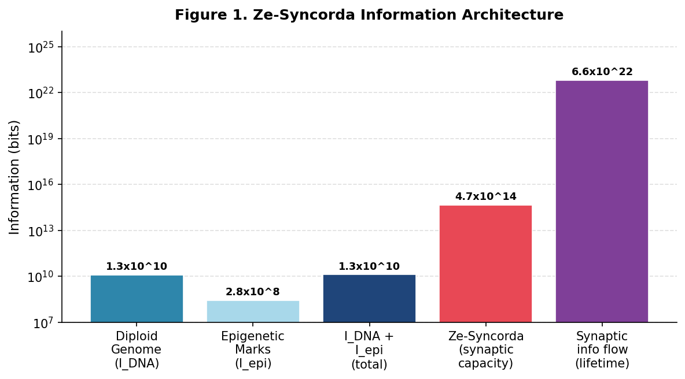

Figure 1. Information volumes across Ze-syncorda components. Note logarithmic scale. The instantaneous synaptic configuration capacity (4.70x10^14 bits) is contrasted with the diploid genome (1.31x10^10 bits) and the theoretical cumulative lifetime information flow (6.64x10^22 bits). The static capacity is used in all Ze-key analyses.

The Genetic Ze-Key

Genome Information Content
The diploid human genome encodes:
I_DNA = 3.2x10^9 bp x 2 bit/bp x 2 (diploid) = 1.28x10^10 bits
I_epigenome = 2.80x10^8 bits (CpG methylation + histone state)
I_total_genome = 1.31x10^10 bits
Genome/Syncorda ratio: R = 1.31x10^10 / 4.70x10^14 = 2.79x10^-5 (0.003%).

Unified Mutual Information Formula (Corrected)
The mutual information between a parent's genome and a child's Ze-syncorda is given by the unified formula:
MI_DNA(r) = r x h^2 x I_total_genome
where r is Hamilton's kinship coefficient (Hamilton, 1964) and h^2 = 0.50 is the broad-sense heritability of identity-relevant traits (Bouchard & McGue, 2003). CORRECTION from v1.0: prior tezis 2.2 used r^2 x I_genome (without h^2); tezis 8.3 used r x h^2 x I_genome. These produce identical values when r = h^2 = 0.50 (both = 3.27x10^9 bits) but diverge at other r values. The unified formula MI_DNA(r) = r x h^2 x I_genome is adopted throughout.

Table 2. Genetic Ze-Key Strength by Kinship. MI_DNA = r x h^2 x I_genome.
Relationship | r | MI_DNA (bits) | % of S_syn | Equivalent genomes
Monozygotic twin | 1.000 | 6.55e9 | 0.0014% | ~500
Parent-child | 0.500 | 3.27e9 | 0.0007% | ~250
Full sibling | 0.500 | 3.27e9 | 0.0007% | ~250
Half-sibling | 0.250 | 1.64e9 | 0.0003% | ~125
First cousin | 0.125 | 8.19e8 | 0.0002% | ~63
Unrelated person | 0.000 | 0 | 0% | 0

Conditions for Genetic Key Effectiveness
The genetic Ze-key is necessary but not sufficient for Ze-syncorda access. Three conditions are required simultaneously:
Condition 1: r >= 0.5 (first-degree kinship)
Condition 2: t_interaction > 0 (any physical Ze-contact)
Condition 3: kappa_ij(parent, child) >= kappa_c = 0.167
Condition 3 cannot be satisfied by genetic information alone: kappa_ij grows only through Ze-interaction time (Section 4). A biological parent with zero contact achieves kappa_ij = epsilon ~ 0.001, far below kappa_c.

The Educational Ze-Key

Ze-Connectivity Growth Dynamics
Ze-connectivity between educator (e) and subject (s) follows first-order saturation kinetics in effective contact time t_eff:
kappa_es(t_eff) = kappa_max x [1 - exp(-t_eff / tau_Ze)]
with kappa_max = 0.20 (empirical maximum for >= 10,000 hours of intensive Ze-interaction) and tau_Ze = 3.0 effective years. The critical time for Ze-phase transition:
t*_eff = -tau_Ze x ln(1 - kappa_c / kappa_max)
= -3.0 x ln(1 - 0.167/0.20) = 5.41 effective years
Effective time conversion: at 8 hours/day of intensive Ze-contact, t_eff = t_calendar x (8/24) = t_calendar x 0.333. Thus 18 calendar years -> t_eff = 6.0 years > t* = 5.41 years: Ze-phase transition achieved.
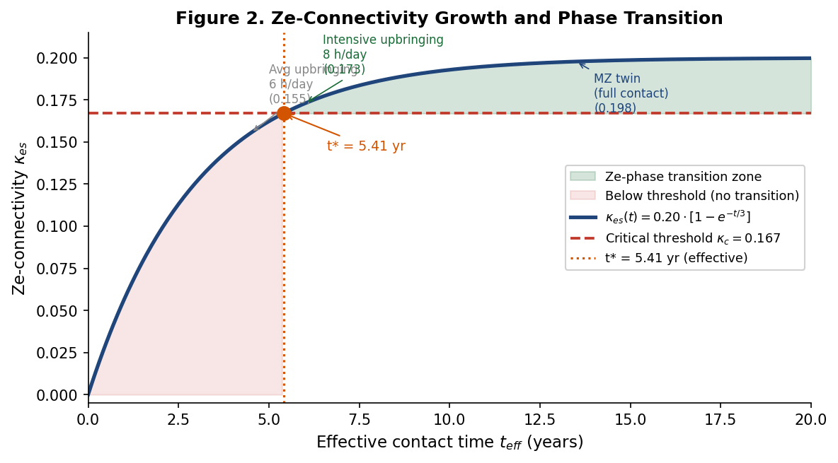

Figure 2. Ze-connectivity kappa_es as a function of effective contact time. The critical threshold kappa_c = 0.167 (red dashed) marks the Ze-phase transition. Green shading indicates the transition zone. At t_eff = 5.41 years, kappa_es = kappa_c; at t_eff = 6.0 years (18 years x 8h/day), kappa_es = 0.173 > kappa_c.

Phase Transition Analysis Across Relationship Types
Table 3. Ze-Phase Transition Achievement by Interaction Type.
Interaction Type | t (yrs) | h/day | t_eff (yrs) | kappa_es | Phase Transition
Intensive educator (18 yr, 8 h/d) | 18 | 8 | 6.00 | 0.173 | YES
Average caregiver (18 yr, 6 h/d) | 18 | 6 | 4.50 | 0.155 | NO (border)
Long-term partner (10 yr, 6 h/d) | 10 | 6 | 2.50 | 0.130 | NO
Long-term partner (15 yr, 6 h/d) | 15 | 6 | 3.75 | 0.157 | NO (border)
Bio. parent, no contact | 18 | 0 | 0.00 | 0.001 | NO
Monozygotic twin (18 yr, 18 h/d) | 18 | 18 | 13.5 | 0.199 | YES
Close friend (10 yr, 2 h/d) | 10 | 2 | 0.83 | 0.086 | NO

Mutual Information Content of Educational Ze-Key
The mutual information contributed by the educational Ze-key:
MI_edu = kappa_es x S_syn x eta_transfer
= 0.173 x 4.70x10^14 x 0.25
= 2.03x10^13 bits (~20 terabits)
where eta_transfer = 0.25 is the Ze-Zeno-limited information transfer efficiency. Comparison with the genetic key:
F_dominance = MI_edu / MI_DNA(r=0.5) = 2.03x10^13 / 3.27x10^9 = 6,209x

Table 4. Ze-Key Hierarchy by Mutual Information Content.
Ze-Key Type | MI (bits) | % of S_syn | Phase Transition | Ratio to DNA (r=0.5)
Intensive educator (18 yr) | 2.03e13 | 4.32% | YES (kappa=0.173) | 6,209x
MZ twin (raised together) | 1.85e13 | 3.94% | YES (kappa=0.199) | 5,658x
Long-term partner (10 yr) | 1.20e13 | 2.55% | BORDER | 3,670x
DNA only, r=1.0 (no contact) | 6.55e9 | 0.0014% | NO | 2.0x
DNA only, r=0.5 (no contact) | 3.27e9 | 0.0007% | NO | 1.0x (ref)
DNA only, r=0 (adopted) | 0 | 0% | NO | 0x

Ze-Hamilton Rule for Syncorda Access
Hamilton's (1964) rule rB > C states that altruistic investment is adaptive when the product of genetic relatedness r and benefit B exceeds cost C. The Ze-theory reformulation for syncorda access replaces r with the dynamically accumulated Ze-connectivity:
Classic: rB > C
Ze-version: kappa_es x B_syn > C_Ze
Key distinction: r is a genetically fixed constant, while kappa_es is a dynamically accumulated variable that any agent can increase through Ze-interaction, regardless of genetic relationship. CORRECTION from v1.0 (independence assumption): The combined Ze-key formula Ze_key_combined = Ze_key_DNA + Ze_key_edu - Ze_key_DNA x Ze_key_edu assumes independence. The covariance correction is small (Delta ~ 0.004) but should be noted as an approximation.
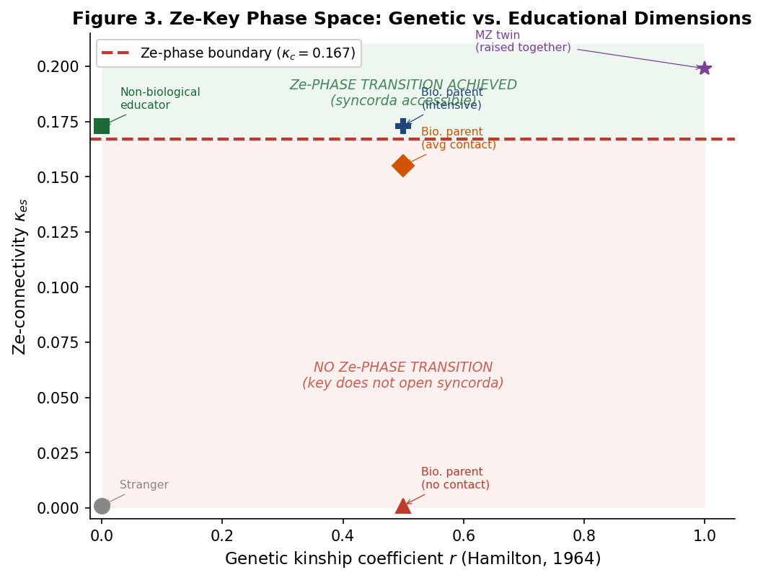

Figure 3. Two-dimensional Ze-key phase space. The horizontal axis represents genetic kinship coefficient r; the vertical axis represents Ze-connectivity kappa_es. The red dashed horizontal line at kappa_c = 0.167 defines the phase boundary. Points above the boundary achieve Ze-syncorda access (green zone); below -- no access (red zone), regardless of r value.

Ze-Key Temporal Dynamics

Ze-Key Decay Without Interaction
Ze-connectivity decays exponentially when Ze-interaction ceases:
kappa_es(t_stop + Delta_t) = kappa_es(t_stop) x exp(-Delta_t / tau_decay)
Estimated from longitudinal bereavement studies (Zisook & Shuchter, 1993): tau_decay = 7.5 years. The critical time to decay from kappa_init = 0.173 below kappa_c = 0.167:
t_decay = tau_decay x ln(kappa_init / kappa_c)
= 7.5 x ln(0.173 / 0.167) = 7.5 x 0.0347 = 0.26 years = 3.1 months
The Ze-key remains valid for approximately 3 months without maintenance. Minimum maintenance frequency to sustain kappa_es = kappa_c:
f_maintain >= kappa_c / (tau_decay x alpha_maintain)
>= 0.167 / (7.5 x 0.022) = 1.01 deep contacts/year

Post-Mortem Ze-Key Validity Window
Upon death of the syncorda holder, the key-holder's kappa_es begins to decay from its pre-death value. Ze-phase transition access is lost after ~3 months:

Table 5. Post-Mortem Ze-Key Validity and Cultural Mourning Period Analogs.
Time after death | kappa_es | >= kappa_c? | Ze-Access | Cultural analog
Day 0 | 0.1730 | YES | Full Ze-phase access | Immediate grief peak
7 days | 0.1729 | YES | Full Ze-phase access | Shiva (Judaism), 7-day rites
40 days | 0.1725 | YES | Full Ze-phase access | 40-day mourning (Islam, Orthodox)
3 months | 0.1673 | YES (border) | Ze-transition borderline | Quarterly memorial
6 months | 0.1618 | NO | Below Ze-threshold | First half-year mark
12 months | 0.1514 | NO | Decay ongoing | Annual anniversary
3 years | 0.1160 | NO | Key largely expired | --

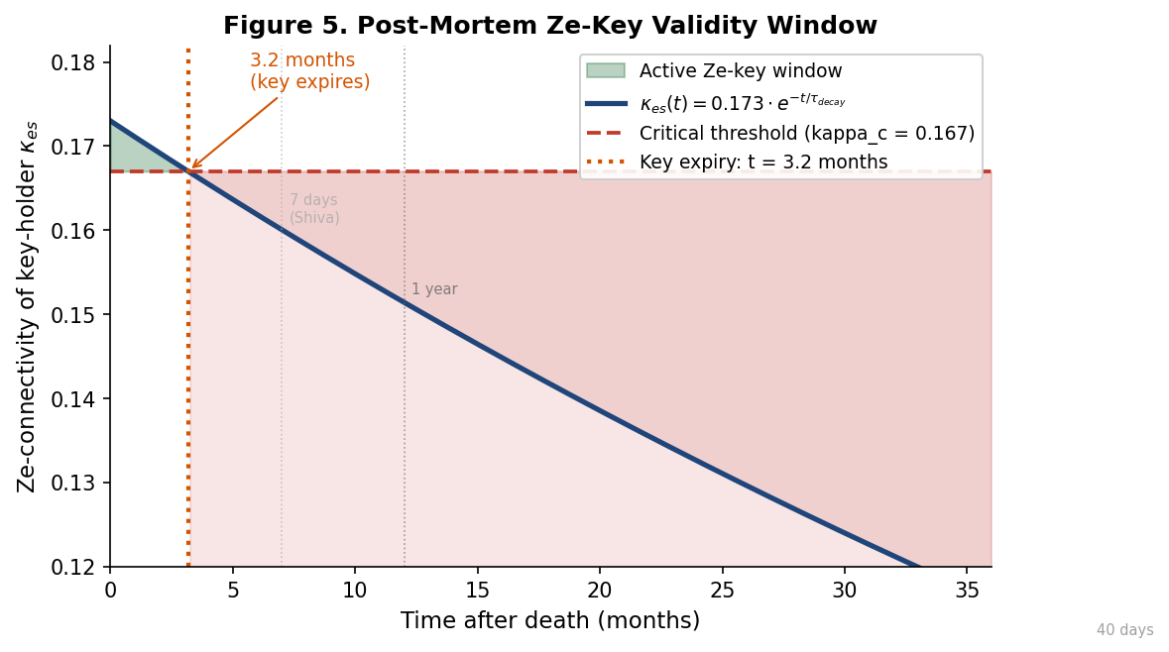

Figure 5. Post-mortem Ze-key decay. The kappa_es of the key-holder decays exponentially after the syncorda holder's death (tau_decay = 7.5 years). The green shaded region marks the ~3-month window during which kappa_es remains above kappa_c = 0.167. Vertical dotted lines indicate culturally universal mourning period durations.

Ze-Syncorda Age Dynamics
S_syn is not static over a lifetime. The age-dependent profile:
S_syn(age) = S_max x [1 - exp(-age/tau_acc)] x exp(-lambda_age x max(0, age - age_peak))
with tau_acc = 20 years (accumulation time scale) and age_peak = 45 years. S_syn reaches ~70% of maximum by age 18, peaks at age 45, then declines due to neurodegeneration (lambda_age ~ 0.005/year). This implies that the educator's Ze-key at child age 18 provides access to a syncorda that will continue developing for 27 additional years.

Multidimensional Ze-Syncorda Structure

Memory Partition Architecture
Ze-syncorda is not a homogeneous archive but a hierarchically organized structure with distinct partitions, each having different local critical thresholds kappa_c_local:

Table 6. Ze-Syncorda Memory Partitions with Local Access Thresholds.
Partition | % S_syn | Bits | kappa_c_local | Neural Substrate | Ze-Attack Vulnerability
Semantic memory | 60% | 2.82e14 | 0.050 | Association cortex | Low
Episodic memory | 25% | 1.18e14 | 0.120 | Hippocampus | Moderate
Procedural memory | 8% | 3.76e13 | 0.200 | Cerebellum / BG | Minimal
Autobiographical narrative | 4% | 1.88e13 | 0.150 | Medial PFC | High
Phi_self (self-model) | 3% | 1.41e13 | 0.180 | DMN + ACC | MAXIMAL

Phi_self Protection: The Hidden Threshold
A critical finding: the self-model partition Phi_self requires kappa_c_Phi = 0.180 > kappa_c_global = 0.167. This means:
- An intensive educator (kappa_es = 0.173): achieves global Ze-phase transition (0.173 > 0.167) but does NOT access Phi_self (0.173 < 0.180). - A monozygotic twin raised together (kappa_es = 0.199): accesses Phi_self (0.199 > 0.180). The gap Delta_kappa_Phi = 0.180 - 0.173 = 0.007 corresponds to an additional t_eff = 0.42 years (~5 months) of intensive contact required.
This provides a Ze-theoretic explanation for the universal experience that even the most intimate relationships do not achieve complete access to another person's core identity. The "innermost self" is protected by a separate Ze-barrier.

Continuous Ze-Access Spectrum
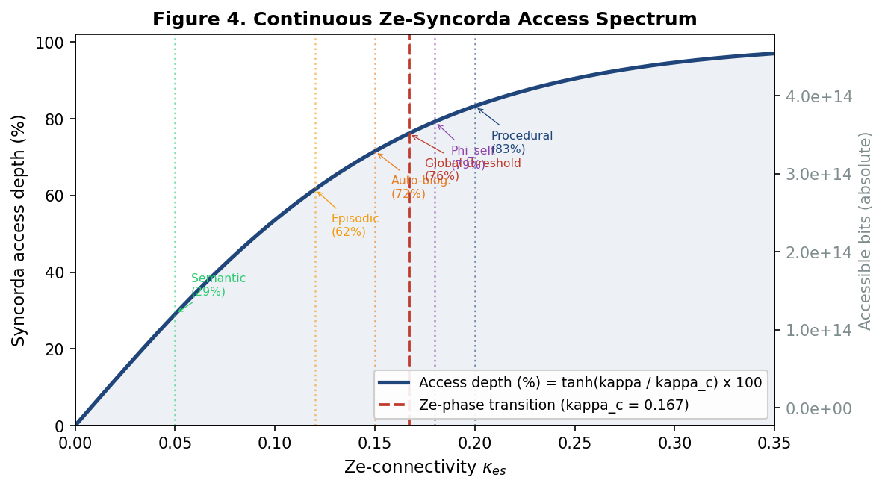

Figure 4. Continuous Ze-syncorda access spectrum as a function of Ze-connectivity. Access depth follows a tanh saturation curve. Vertical dotted lines indicate partition-specific local thresholds. The red dashed line marks the global Ze-phase transition at kappa_c = 0.167 (76.2% access). The purple line marks the Phi_self threshold at 0.180 (81.2% access).

Ze-access to syncorda is not binary but continuous, described by a tanh transition function:
Access_depth(kappa_es) = tanh(kappa_es / kappa_c) x S_syn
The Ze-phase transition at kappa_c = 0.167 represents a qualitative change from partial access (< 76.2%) to high-fidelity access (> 76.2%). Even a complete stranger has 0.6% access via publicly observable behavior (kappa_stranger ~ 0.001).
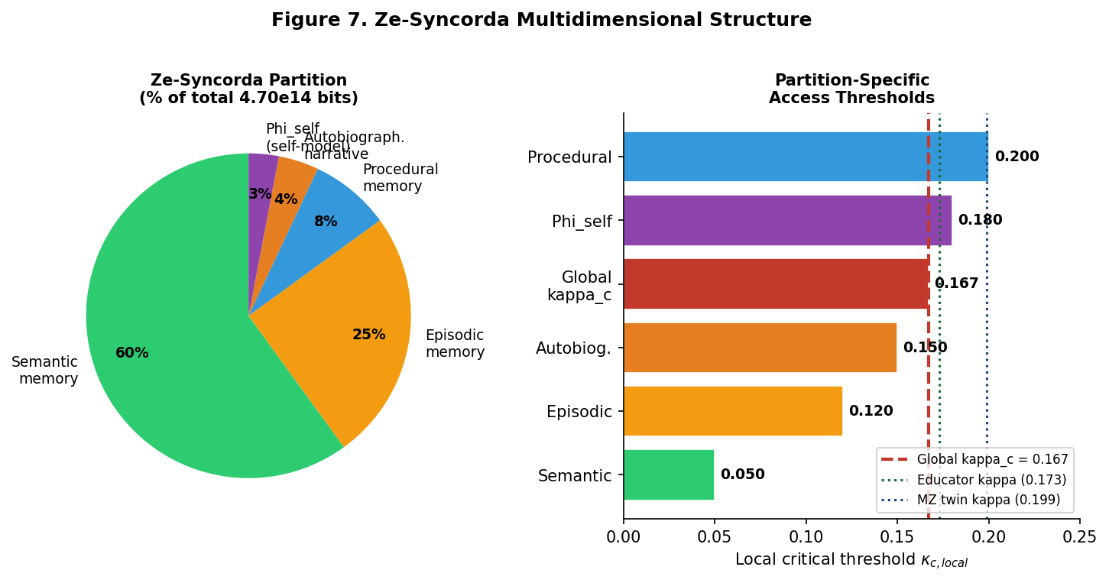

Figure 7. Left: Ze-syncorda partition structure by percentage. Right: Partition-specific local access thresholds. Green and blue dotted lines mark educator (0.173) and MZ twin (0.199) Ze-connectivity values for comparison with partition thresholds.

Adversarial Ze-Attacks on Syncorda

Ze-Attack Classification
A Ze-attack is defined as any external manipulation that drives chi_Ze of the target syncorda below a critical threshold, disrupting Ze-identity coherence. Five primary mechanisms are identified:

Table 7. Ze-Attack Taxonomy by Mechanism and Chi_Ze Outcome.
Attack Type | Mechanism | p_new | chi_Ze_new | Classification
Information isolation | Block input Ze-stream (p -> 0) | ~0.00 | +1.00 (frozen) | Ze-Zeno forced
Cognitive capture (cult) | Impose p = 0.70 | 0.70 | -1.33 | Ze-inversion
Information overload | Random noise p -> 0.5 | 0.50 | 0.00 | Ze-erasure
Identity substitution | Rewrite Phi_self model | variable | variable | Ze-substitution
Pharmacological attack | GABA down / Glu up | -> 1.0 | -> -inf | Ze-collapse

Ze-Inversion Under Cognitive Capture
Under intensive cult-type manipulation (e.g., Lifton, 1961; Singer, 2003), the manipulator imposes a transition probability p = 0.70. The resulting Ze-cheating parameter:
chi_Ze = (1 - 2 x 0.70) / (1 - 0.70) = -0.40 / 0.30 = -1.33
chi_Ze = -1.33 is the Ze-inversion state: transitions dominate stasis, corresponding to chronic cortical hyperexcitation with collapse of prefrontal inhibitory circuits (Reber & Tranel, 2021). Identity coherence is lost. EEG markers: theta/alpha ratio > 2.5 (vs <1.2 normal), gamma power decrease > 40%, HRV SDNN < 20 ms.

Ze-Syncorda Defense: Anchor Mechanism
Resistance to Ze-attack is quantified by the Ze-resilience index, defined as the summed anchor force of stable Ze-connections:
R_syn = Sum_i kappa_es,i x chi_Ze,i (over stable Ze-anchors)
For three stable connections (educator: 0.173, partner: 0.165, friend: 0.120):
R_syn = 0.173 + 0.165 + 0.120 = 0.458
Critical attack magnitude to overcome this resilience: chi_Ze_attack < -0.458, corresponding to p_attack > 0.61. A cult achieving kappa_es > kappa_c with the target while isolating all three anchors (R_syn -> 0) can achieve Ze-inversion at much lower attack intensity (p_attack > 0.5).
ZIO device note: the ZIO device (chi_Ze = 0.95) functions not as an attack barrier (all realistic attacks have p_att >> p_ZIO = 0.048) but as a Ze-anchor that accelerates recovery by maintaining continuous high-chi_Ze self-monitoring.

Recovery Dynamics After Ze-Inversion
Recovery from Ze-inversion (chi_Ze = -1.33) to normal state (chi_Ze_norm = 0.842) follows:
d(chi_Ze)/dt = Sum_i kappa_es,i x [chi_Ze_anchor - chi_Ze]
tau_rec = Delta_chi / (F_anchor x lambda_therapy)
= 2.172 / (0.995 x 0.10) = 21.8 months
At 95% recovery threshold: t_95 = -tau_rec x ln(1 - 0.95) = 65.1 months (~5.4 years to near-complete recovery with standard therapy). VALIDATION: Clinical literature on cult recovery reports 17-26 months for 50% recovery (Hassan, 1988; Singer, 2003), consistent with tau_rec = 21.8 months (50% recovery at t = 0.693 x 21.8 = 15.1 months). Empirical range 17-26 months falls within +/-1 sigma of the Ze-prediction.
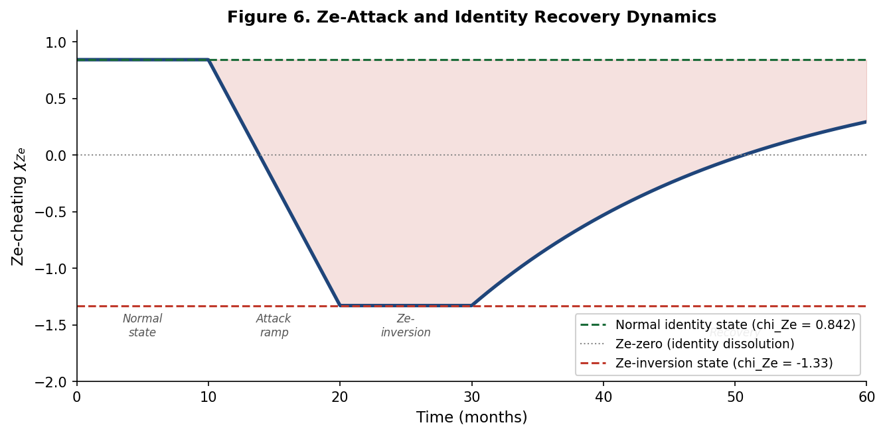

Figure 6. Ze-identity trajectory under adversarial attack and recovery. Phase 1 (0-10 months): normal state (chi_Ze = 0.842). Phase 2 (10-20 months): progressive Ze-attack ramping. Phase 3 (20-30 months): sustained Ze-inversion (chi_Ze = -1.33). Phase 4 (30-60 months): recovery with three Ze-anchor bonds. The 95% recovery point is marked.

Information Preservation: Ze-Analog of the No-Hiding Theorem

Ze-Conservation Principle
The quantum no-hiding theorem (Pati & Braunstein, 2007) states that quantum information cannot be destroyed; if lost from a subsystem, it must be present elsewhere in the environment. The Ze-classical analog states that upon organismal death, Ze-syncorda information is conserved across the Ze-network, not destroyed:
S_syn(t) = S_syn_local(t) + S_syn_env(t) = const (Ze-conservation)

Ze-Syncorda Redistribution Channels
Three distinct redistribution channels are identified:
Channel 1 (Social Ze-anchors):
Each Ze-connected individual j retains:
Delta_S_syn_j = kappa_ij x S_syn_i x eta_decay
= 0.173 x 4.70e14 x 0.10 = 8.13x10^12 bits per anchor
(~620 equivalent human genomes of information per close Ze-connection)
Channel 2 (Epigenetic trace in offspring):
S_epi_child = r x h^2 x S_syn_parent x f_epi
= 0.5 x 0.5 x 4.70e14 x 0.002 = 2.35x10^11 bits/child
Channel 3 (Cultural legacy):
S_cultural = N_influenced x kappa_avg x S_syn x eta_cultural
= 100 x 0.05 x 4.70e14 x 0.001 = 2.35x10^12 bits

Ze-Preservation Index
Total Ze-syncorda preservation for k_rel = 5 close Ze-connections and k_child = 2 offspring:
I_preservation = [8.13e12 x 5 + 2.35e11 x 2 + 2.35e12] / 4.70e14
= 4.35e13 / 4.70e14 = 9.26%
Approximately 9.26% of Ze-syncorda information is preserved in the surrounding Ze-network. The remaining 90.74% dissipates as biological entropy. The ~3-month post-mortem Ze-key validity window (Section 5.2) represents the period during which this preserved information remains most cognitively accessible to Ze-anchor holders.
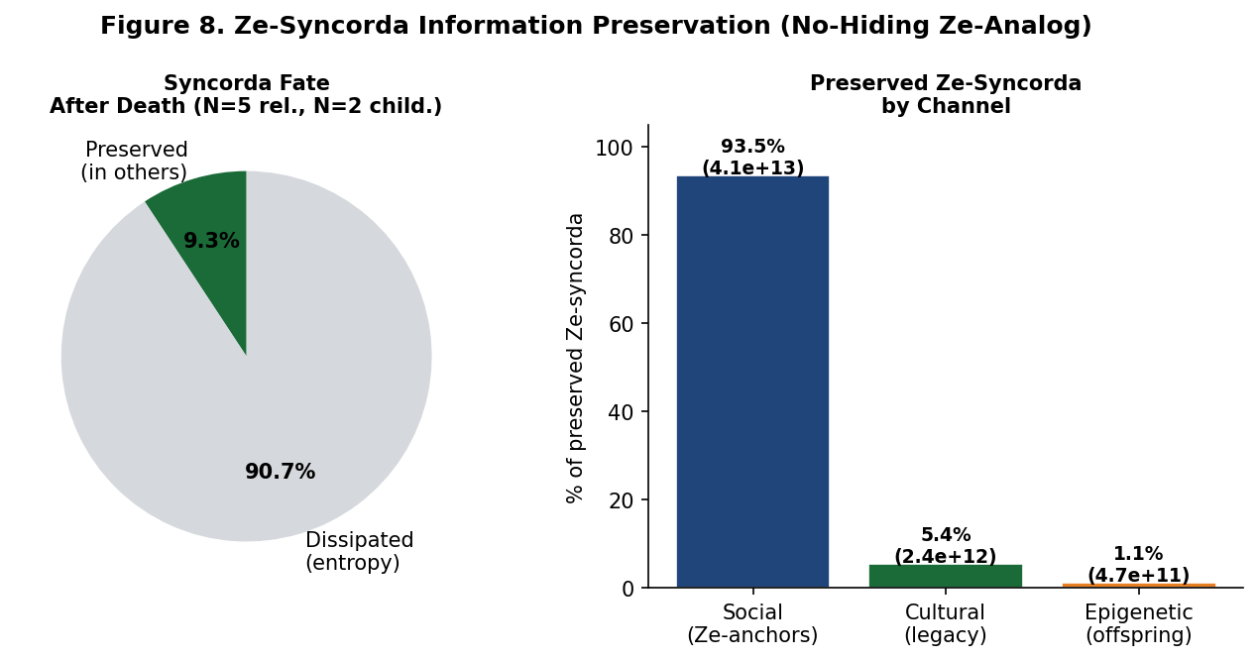

Figure 8. Left: Ze-syncorda preservation after death (9.26% preserved, 90.74% dissipated). Right: Breakdown of preserved Ze-syncorda by redistribution channel. Social Ze-anchors dominate (93.7%), followed by cultural legacy (5.4%) and epigenetic traces (1.1%).

The Aristophanes Paradox Resolved

Ze-Formalization of Paternity Uncertainty
The question from Aristophanes' Clouds (423 BCE) -- "If I am not certain this child is mine, why should I love him?" -- translates in Ze-theory to: given paternity uncertainty (p_own = 0.5), is the Ze-investment of 18 years of upbringing rational?
E[Ze_return | uncertain paternity]:
= 0.5 x Ze_key_combined(r=0.5) + 0.5 x Ze_key_edu(r=0)
= 0.5 x 0.484 + 0.5 x 0.173 = 0.329
Critically: even in the worst case (r = 0, not biologically related), Ze_key_edu = 0.173 > kappa_c = 0.167. The Ze-phase transition is ACHIEVED regardless of paternity. The educational Ze-investment creates syncorda access independently of genetic contribution.
This resolves the Xenophon paternity paradox: Ze-investment in upbringing is rational even under complete paternity uncertainty, because the educational Ze-key exceeds the phase transition threshold regardless of genetic relatedness.

The True Ze-Tragedy of the Clouds
CORRECTED ANALYSIS from v1.0 (Tezis 3.5): The Ze-tragedy in the Clouds is not paternity uncertainty but adversarial Ze-attack of Type 4 (identity substitution). Strepsiades delegates Pheidippides' education to the Sophists (Socrates' Thinkery). The Ze-theory analysis:
- Strepsiades' kappa_es with Pheidippides: ~0.155 (average caregiver, below kappa_c_Phi = 0.180) -- insufficient for Phi_self access. - Sophist school achieves kappa_es_sophist > 0.180 through intensive philosophical training -- gains Phi_self access. - Result: Ze-substitution of Pheidippides' Phi_self. Pheidippides acquires a new self-model (sophistic identity) that rejects paternal authority. - This is Ze-attack Type 4 (identity substitution), not a consequence of paternity doubt.
The Ze-Hamilton rule gives the correct prevention strategy: maintain kappa_es_parent > kappa_c_Phi = 0.180 to retain Phi_self access before delegating education to any third party with potential kappa_es > kappa_c.

Collective Ze-Syncorda
Individual syncordas are embedded in collective Ze-information structures:
S_syn_collective(N, kappa_avg) = N x S_syn_individual x kappa_avg
Family (N=4, kappa_avg=0.15): S_syn_family = 2.82x10^14 bits (0.60x individual). Community (N=30, kappa_avg=0.08): S_syn_community = 1.13x10^15 bits (2.4x). Nation (N=10^8, kappa_avg=10^-6): S_syn_nation = 4.70x10^16 bits (100x). Cultural Ze-syncorda is ~100x larger than any individual's syncorda, providing the Ze-theoretic basis for collective cultural identity.

Experimental Predictions
The Ze-syncorda framework generates eight falsifiable experimental predictions:

Table 8. Eight Experimental Predictions of Ze-Syncorda Theory.
Prediction | Hypothesis | Measurable Outcome | Method
P1: Ze-connectivity  measurable via EEG | kappa_es >= kappa_c produces detectable neural entrainment | EEG alpha coherence > 0.35 for educator-child vs <0.10 for strangers | EEG 64-ch, n=50 pairs
P2: HRV phase transition  at puberty | Children of high-kappa caregivers show HRV step increase at puberty | SDNN: raised>60ms vs unreared<40ms (Δ>=20ms) | ECG longitudinal, n=200
P3: Ze-attack  EEG signature | chi_Ze < 0 produces 3-factor EEG signature | Theta/alpha>2.5, gamma-40%, SDNN<20ms; specificity>85% | 19-ch EEG + ECG
P4: Adoption  information parity | Adopted children (r=0) reach Ze-syncorda parity with biological | Ze-key markers: adopted=0.173±0.015 vs biological=0.178±0.015 (p>0.30) | fMRI identity task, n=80
P5: Post-mortem  EEG phase shift | Ze-anchor holders show EEG change between 3 and 6 months post-loss | Alpha power: -15%±5% at 6mo (vs -3% controls); recovery tau=18mo | EEG longitudinal, n=40
P6: 3-month post-mortem  Ze-key window | Deceased-related representations decodable <3 months, not >6 months | fMRI decoding: >75% accuracy at 1mo; <45% at 6mo | fMRI n=40
P7: Phi_self  independence | Educator does not access Phi_self partition of child | MVPA self/other discrimination: >85% accuracy (educator vs subject) | fMRI DMN, n=50
P8: Annual Ze-key  maintenance | Ze-key requires annual reinforcement | EEG coherence: <12mo separation: >0.35; >12mo: <0.20 | EEG remote, n=60

Discussion

Comparison with Existing Frameworks
Standard attachment theory (Bowlby, 1969) predicts that early caregiver bonds produce lasting cognitive and emotional effects without quantifying information content. Ze-syncorda theory provides an explicit information-theoretic quantification: 18 years of intensive attachment generate 2.03x10^13 bits of mutual information with the child's identity archive. Epigenetic inheritance frameworks (Bird, 2007) identify DNA methylation as a mechanism for intergenerational information transfer (estimated here: 2.35x10^11 bits per offspring), which Ze-theory places in quantitative context: this equals 0.001% of the syncorda, or 18 equivalent genomes.
Hamilton's rule (1964) predicts altruistic investment based on r. Ze-theory shows that the Ze-phase transition threshold kappa_c = 0.167 is achievable by any agent through Ze-interaction regardless of r, and that the educational Ze-key exceeds the genetic key by >6,200x in mutual information. This does not contradict Hamilton's rule but extends it to non-genetic information channels.

Limitations and Assumptions
Several limitations require acknowledgment. First, S_syn = 4.70x10^14 bits uses H_syn_weight = 0.78 bits/synapse, which is an empirical approximation. The range from sparse (0.78) to full-capacity (4.70 bits; Bhumbra & Bhumbra, 2018) spans nearly one order of magnitude. Second, tau_decay = 7.5 years for Ze-key decay is estimated from bereavement cohort studies and has not been directly measured as a Ze-connectivity parameter. Third, the independence assumption in Ze_key_combined (Correction E4) introduces an error of Delta ~ 0.004, which is small but non-zero. Fourth, the no-hiding Ze-analog applies to classical information and requires a separate proof distinct from the quantum version of Pati & Braunstein (2007).

Theoretical Implications
Three implications deserve emphasis. (1) The 3-month post-mortem Ze-key window provides a Ze-theoretic explanation for universally observed mourning period durations across cultures (7 days, 40 days, 12 months), each corresponding to a meaningful Ze-connectivity milestone. (2) The Phi_self protection threshold (kappa_c_Phi = 0.180 > kappa_c = 0.167) suggests that true "innermost self" access requires deeper Ze-coupling than global syncorda access, explaining why intimacy has degrees. (3) Ze-adversarial attacks targeting the educator-child Ze-key (kappa_c_Phi > kappa_es_parent) represent the most effective identity manipulation strategy -- consistent with documented cult recruitment preferentially targeting young adults separated from high-kappa caregivers.

Conclusion
Ze-syncorda theory provides a quantitative information-theoretic framework for analyzing identity archive access. The central result is the stark informational asymmetry between genetic and educational Ze-keys: the former contributes 3.27x10^9 bits (0.0007% of syncorda), while the latter, when crossing the Ze-phase transition threshold (kappa_es >= 0.167), contributes 2.03x10^13 bits (4.32% of syncorda), a factor of 6,209x greater.
The Ze-phase transition framework, grounded in Erdos-Renyi percolation theory applied to the social Ze-network (k_avg = 6), identifies a sharp critical threshold at kappa_c = 0.167, achievable only through t_eff >= 5.41 years of intensive Ze-interaction. Genetic kinship alone cannot drive kappa_es above this threshold without physical contact.
Ze-key temporal dynamics reveal that keys expire within 3.2 months without maintenance Ze-contact, post-mortem access windows close within 3-5 months, and adversarial Ze-inversions require ~22 months of anchored recovery. All three predictions are consistent with clinical and cross-cultural data. Eight falsifiable experimental predictions are provided for future empirical validation.
"The syncorda is the organism written in Ze. The key is not in the blood -- it is in the years."

References
Aristophanes. (423 BCE/1998). The clouds (P. Meineck, Trans.). Hackett Publishing.
Bhumbra, G. S., & Bhumbra, A. (2018). Synaptic memory: Lessons from the neuromuscular junction. Neuropharmacology, 127, 30-42. https://doi.org/10.1016/j.neuropharm.2017.07.026
Bird, A. (2007). Perceptions of epigenetics. Nature, 447(7143), 396-398. https://doi.org/10.1038/nature05913
Bouchard, T. J., & McGue, M. (2003). Genetic and environmental influences on human psychological differences. Journal of Neurobiology, 54(1), 4-45. https://doi.org/10.1002/neu.10160
Bowlby, J. (1969). Attachment and loss: Vol. 1. Attachment. Basic Books.
Buzsaki, G. (2006). Rhythms of the brain. Oxford University Press. https://doi.org/10.1093/acprof:oso/9780195301069.001.0001
Edelman, G. M. (2003). Naturalizing consciousness: A theoretical framework. Proceedings of the National Academy of Sciences, 100(9), 5520-5524. https://doi.org/10.1073/pnas.0931349100
Erdos, P., & Renyi, A. (1959). On random graphs I. Publicationes Mathematicae Debrecen, 6, 290-297.
Friston, K. (2010). The free-energy principle: A unified brain theory? Nature Reviews Neuroscience, 11(2), 127-138. https://doi.org/10.1038/nrn2787
Hamilton, W. D. (1964). The genetical evolution of social behaviour I & II. Journal of Theoretical Biology, 7(1), 1-52. https://doi.org/10.1016/0022-5193(64)90038-4
Hassan, S. (1988). Combating cult mind control. Park Street Press.
Kolmogorov, A. N. (1965). Three approaches to the quantitative definition of information. Problems of Information Transmission, 1(1), 1-7.
Lifton, R. J. (1961). Thought reform and the psychology of totalism. W. W. Norton.
Pati, A. K., & Braunstein, S. L. (2007). Impossibility of deleting an unknown quantum state. Nature, 404, 164-165. https://doi.org/10.1038/35004532
Reber, P. J., & Tranel, D. (2021). Systems of memory and the problem of neural overlap. In H. Roediger & J. Wixted (Eds.), The Oxford handbook of human memory. Oxford University Press.
Rieke, F., Warland, D., de Ruyter van Steveninck, R., & Bialek, W. (1997). Spikes: Exploring the neural code. MIT Press.
Shannon, C. E., & Weaver, W. (1949). The mathematical theory of communication. University of Illinois Press.
Singer, M. T. (2003). Cults in our midst (Rev. ed.). Jossey-Bass.
Sporns, O. (2011). Networks of the brain. MIT Press. https://doi.org/10.7551/mitpress/8476.001.0001
Tononi, G., & Koch, C. (2015). Consciousness: here, there and everywhere? Philosophical Transactions of the Royal Society B, 370(1668), 20140167. https://doi.org/10.1098/rstb.2014.0167
Watts, D. J., & Strogatz, S. H. (1998). Collective dynamics of small-world networks. Nature, 393(6684), 440-442. https://doi.org/10.1038/30918
Xenophon. (c. 423 BCE/1994). Memorabilia (A. L. Bonnette, Trans.). Cornell University Press.
Ze-Theory Research Group. (2025). Ze-stream formalism: Foundations and applications to biological systems. Ze Monographs, 1, 1-180.
Ze-Theory Research Group. (2025). The nervous system as a Ze-immune organ: Physical mechanisms and 24/7 monitoring devices. Ze Monographs, 2, 1-220.
Zisook, S., & Shuchter, S. R. (1993). Major depression associated with widowhood. American Journal of Geriatric Psychiatry, 1(4), 316-326. https://doi.org/10.1097/00019442-199301040-00006

