Taxi Driver

CS110 A0, Professor S. Moore

Spring 2017

Group Members:

Nicholas Caldari

Jonathan Dong

Devin Jadoo

Daniel Wheelock

Github URL: https://github.com/dwheelo1/Final-Project.git

User Guide

Taxi Driver

Nicholas Caldari, Jonathan Dong, Devin Jadoo, Daniel Wheelock

Section A54, A51

CS110 PROJECT

TAXI DRIVER GAME

In the game crazy taxi, the goal of the game is to travel as far as possible without crashing into any obstacles. In this game, the obstacles are in the form of other cars. The winner of the game is the one with the highest score. Points are acquired by traveling farther and lasting longer on the road. The game ends once the user crashes into one of the other cars.

1. Intro Screen

Here the user is introduced to the game. At the top of the screen, there is the name of the game. Following that there are basic directions displayed on this screen indicating how to play the game. Finally, the user presses the spacebar to start the game whenever they are ready.

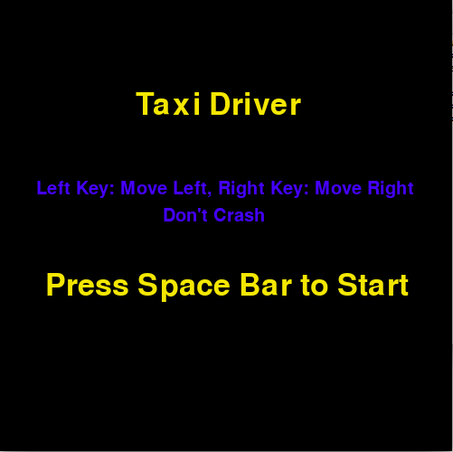

1. Gameplay Screen

Once the game is started, this is the screen the user sees and interacts with. The user controls the red taxi at the bottom of the screen. Pressing the left key will make the taxi move leftward with respect to the lanes. Once the user has gone as far left as possible, they can no longer move left. Similarly, pressing the right key will make the taxi move right until it cannot go further rightward. The user’s score is recorded in the upper left hand corner of the screen.

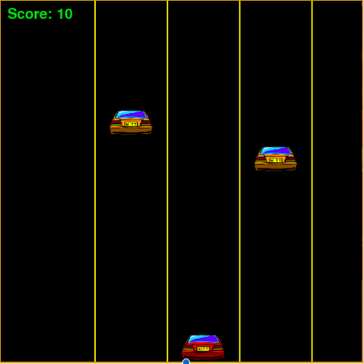

1. Game Over Screen

After crashing into a car, the game ends, and the user is brought to the Game Over Screen. This screen displays the score that the user acquired on their most recent run of the game. Additionally, this screen displays the all-time high score recorded by the game. If the user would like to play the game again, they can press the space bar to be returned to the Intro Screen, where they can start the game over. To exit the game, the user must press the red “x” in the top of their window. 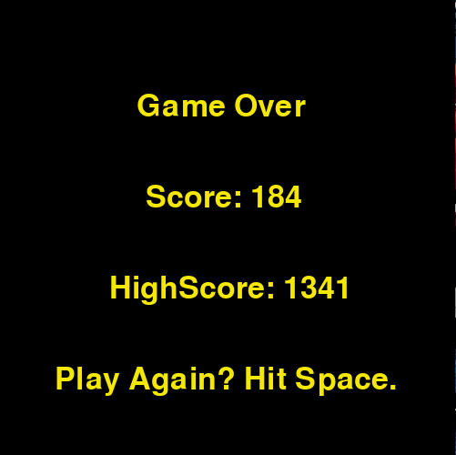

Program Design

1. Additional modules used: random, pygame, pygame.font, json
2. Mutually agreeable public interface: 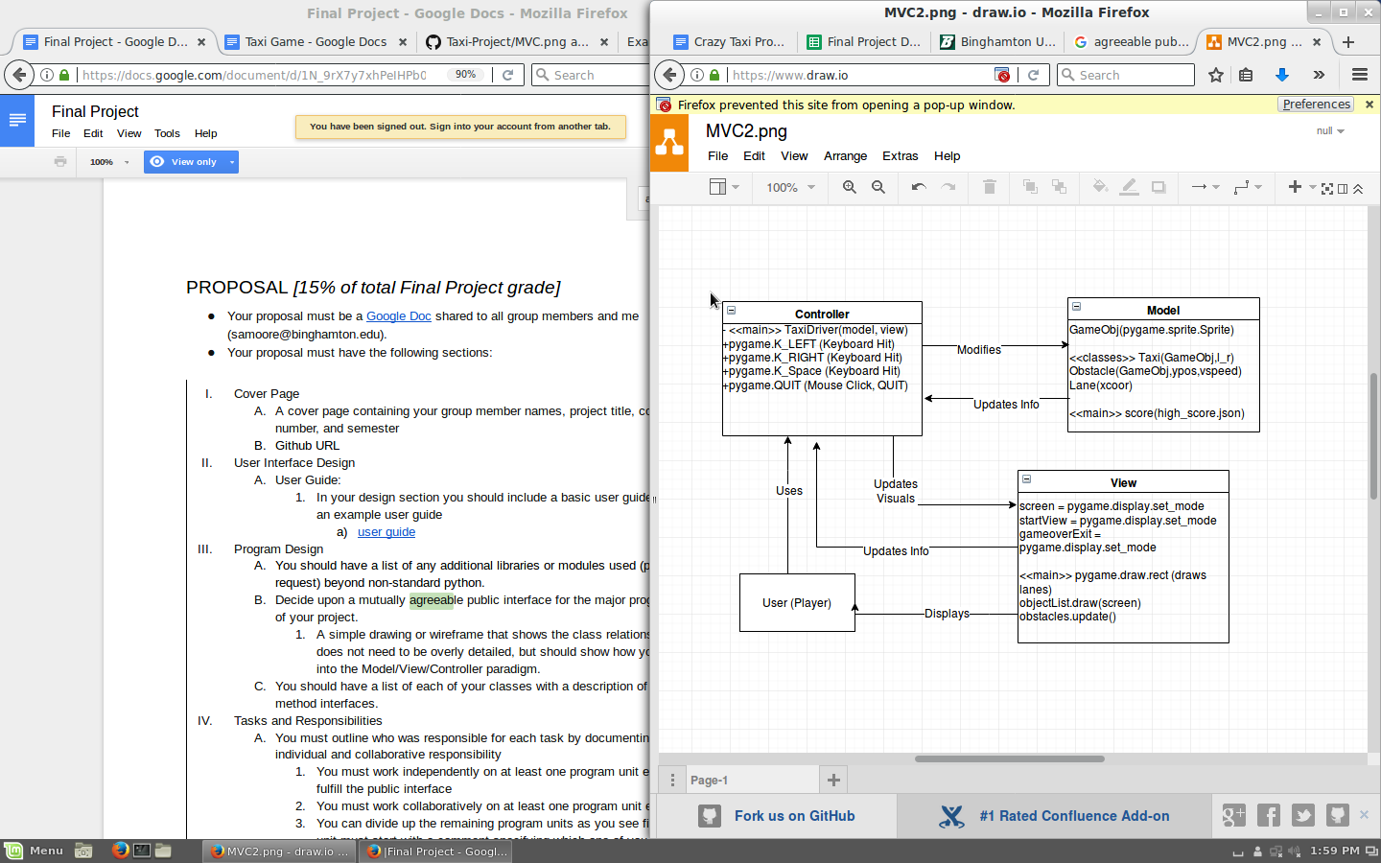
3. List of Classes (With a description of their method interfaces):
   1. GameObj: Creates classes with sprite method
   2. Taxi: can move left and right between three lanes
   3. Obstacle: spawns randomly at the top of a lane and moves down the screen at a semi-random speed (eventually, at increasing speed)
   4. Lane: creates a lane object

Tasks and Responsibilities  
 Devin Jadoo: Tester and Quality Control

Daniel Wheelock: Back End Specialist

Nicholas Caldari: Front End Specialist

Jonathan Dong: Overall Project Management and Component Integration

Testing

* 1. Testing Strategies: Testing was done intermittently throughout the duration of the projeit, weekly.
  2. Copy of ATP:

Acceptance Test Procedure

|  |  |  |  |  |
| --- | --- | --- | --- | --- |
| Step | Procedure | Expected Results | Actual Results | ✓ or AI* |
| 1 | Run | GUI window appears  Title: Taxi Driver  Instructions: “Left key: Move left, Right key: Move right”  Display: Press Space to Start |  | ✓ |
| 2 | Press Space Bar | Brings the user to the game screen, and the game starts to run |  | ✓ |
| 3 | Press Left Key | Moves the taxi leftward |  | ✓ |
| 4 | Press Right Key | Moves the taxi rightward |  | ✓ |
| 5 | Press Left Key (repeatedly) | If the taxi is at its leftmost position, this does nothing |  | ✓ |
| 6 | Press Right Key (repeatedly) | If the taxi is at its rightmost position, this does nothing |  | ✓ |
| 7 | Press Space (at end of game) | Brings the user back to the Intro screen where they can play again |  | ✓ |
| 8 | User collides with car | Brings the user to the game over screen, which displays the score the user just attained, as well as the high score |  | ✓ |
| 9 | Display of High score | A file of the high score is kept, and overwritten when a new high score is set. |  | ✓ |
| 10 | Click X in top corner | Closes the window and ends the program |  | ✓ |