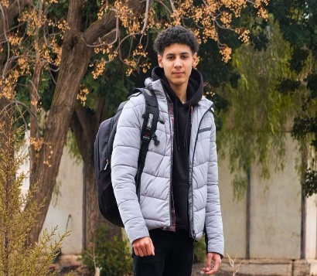DJAIR MOUAD

# FULL-STACK DEVELOPER

* Algeria/Sidi Bel Abbes

 +213658025414

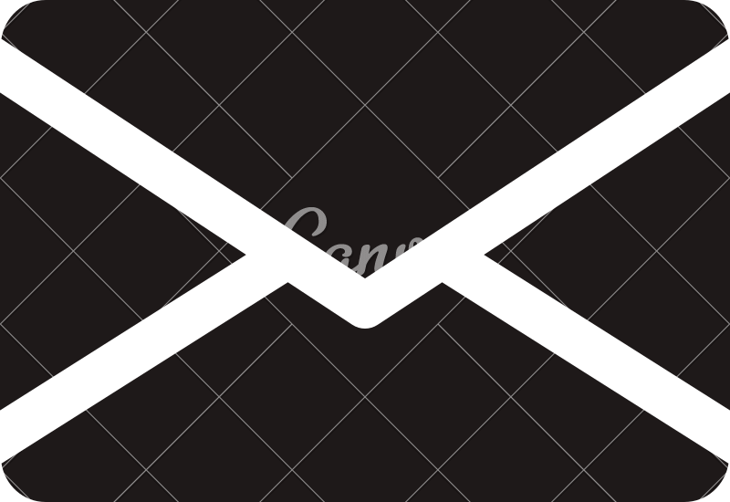 djairmouad@gmail.com

# PROFESSIONAL SUMMARY

I thrive in high-pressure environments, proving adept project implementation skills. My patience complements my ability to work with timeliness. I am committed to continuous learning, consistently seeking opportunities to enhance both my practical and intellectual ability.

## EDUCATION

**2021-2024**

Université Djillali Liabes, Sidi Bel Abbès

## EXPERIENCE

portfolio [see demo](https://incredible-mermaid-97e8df.netlify.app/)

## SKILLS & TECHNOLOGIES

## SOFT SKILLS

Problem solving Time management Creativity Organization Teamwork Communication Typing quickly

## LANGUAGES

English

Arabic Native

HTML

CSS [Tailwind ]

JavaScript [ Typescript - React.js]

Framer Motion

Data Structure

Object-oriented programming Node.js

MongoDB Express

Php

MySql

Git/GitHub

Nginx

Design pattern

## CAREER OBJECTIVE

Proven ability to collaborate in agile environments. Dedication to writing clean, modular, and well-documented code.

Passion for creating visually appealing, user-friendly interfaces. Strong communication skills and proactive problem-solving.

Contribute to cutting-edge web apps using React.js. Collaborate with teams to deliver user-centric solutions. Enhance coding skills and stay informed on emerging technologies.

Active participation in the software development lifecycle.