**Seizure Detection and Brain Machine Interface Decoding with Neural Networks**

Dan Jaklic, University of Michigan April 1, 2021

**Introduction[1]**

Seizure Detection: Epilepsy is a debilitating neural condition, marked by recurrent seizures, that currently affects about 50 million people worldwide. 25% of these patients cannot be treated with current medications or medical technology, with mortality very high in uncontrolled patients. Biomedical technologies such as electrical stimulation can abort seizures and have proven to be safe and effective. However, the ability to abort seizures is not so helpful if seizures can’t be predicted or detected. Seizure detection attempts have been made by placing intracranial electrode matrices (ECoG) on the surface of the brain and processing neural data with signal processing algorithms that decode signal features[2]. In this study, we attempt to detect seizures from patient ECoG data using three approaches. First, we combine common features such as “signal amplitude”, “zero crossings” and “line length.” Next, we attempt seizure detection using Linear Discriminant Analysis (LDA). Finally, we attempt seizure detection using common features extracted from 100-500 Hz “high-frequency oscillations” (HFO).

Neural Networks: An artificial neural network (ANN) is a machine learning (ML) technique that has captured the imagination of computational scientists since Farley and Clark used computers to simulate a Hebbian network in 1954 [1]. ANN’s were not very useful for any applications until algorithmic advances such as backpropagation [2] and technology advances such as Graphical Processing Units (GPU) appeared in the 1980’s and 1990’s. Still, neural decoding largely depended on support vector machines (SVM), or more recently, linear regression and Kalman filtering. The performance of ANN’s have improved such that in the last ten years, they became viable neural signal decoders. Previously, we used continuous decoding methods such as linear regression, ridge regression, LASSO, and Kalman filtering to predict hand positions and velocities from firing rates of 95 recorded neurons in monkeys [10]. In this study, we implement a simple, feed-forward neural network to decode the same data set and compare results to [10].

**Methods**

1. **Data Acquisition and Assumptions**

Seizure Detection: From two patients (Patient A, Patient B), three channels of ECoG data sampled at 3 kHz (1800 seconds total) were recorded and saved to MAT files (MATLAB, Natick MA). ECoG arrays are assumed to be 360 (60x60) channels and spaced at 1 cm2. ECoG arrays across patients are assumed to be placed on corresponding anatomical brain regions (individual differences cannot be completely avoided). In this study, all seizure detection algorithms were trained on patient A and tested on patient B. All detection algorithms were written manually in MATLAB.

Neural Networks: Neural firing rates from 95 monkey neurons, 8 reach directions, with 182 samples for each neuron-direction combination were recorded and saved so a MAT file [4]. We assumed that the distribution of spike rates followed a Poisson distribution. The data set was split evenly into training data and test data. All algorithms were implemented in Python with the use of PyTorch.

1. **Seizure Detection Using Common Features**

To attempt seizure detection, three features prominently seen in EEG or ECoG recordings were used: signal amplitude (SA), zero crossings (ZC) and line length (LL). For all algorithms, EcoG signals were smoothed and analyzed over 10 second, non-overlapping windows.

* 1. **Signal Amplitude Detection**

An increase in ECoG signal amplitude is a common marker of seizure activity. For each channel, the root mean square (RMS) was taken over the whole sample time course to establish a patient and channel specific baseline. Loosely speaking, this gives an average power of the signal. Then, the RMS was taken for each window. Values were normalized using the average power value described, giving each window (180 windows over the sample) a normalized power value[3]. A threshold was determined[4] to classify ‘seizure’ or ‘no seizure.’ Then, testing was carried out on patient B[5].

**2.2 Zero Crossing Detection**

For each channel, the total number of ZCs (crossing the x-axis at voltage = zero) over the whole sample time course was determined using MATLAB’s Zero Crossing Detector from the Digital Signal Processing library. The number of zero crossings can be an indicator of signal frequency, a higher frequency indicating potential seizure activity. Using this, an average number of ZCs per window was calculated. Next, the actual number of ZCs for each window was calculated with the same method. Normalization, threshold tuning, and testing followed.

* 1. **Line Length Detection**

Calculating ECoG signal line lengths can be useful because a longer line length within a time window tends to correspond with higher frequencies and larger amplitudes, markers of seizure. For each channel, the total LL was calculated in MATLAB [sum(abs(diff(signal)))]. Then, average LL per window was calculated. Next, the actual LL for each window was calculated with the same method. Normalization, threshold tuning, and testing followed.

All features were combined into a single seizure detection algorithm. Binary results (seizure or no seizure) from each corresponding time window were compared using ‘AND’ logic – Seizure detected only if indicated by all three features, otherwise no seizure detected.

1. **Seizure Detection Using Linear Discriminant Analysis**

LDA is a well known and broadly used classifier, ideal for two class differentiation (seizure or no seizure), and previously used for BMI classification [10]. We implemented LDA using ‘classify()’ in MATLAB. Again, patient A was used for training and patient B used for testing.

1. **Seizure Detection Using High Frequency Oscillation Detection**

HFOs are a commonly used frequency band used in filtering neural signals to identify seizure activity [5]. These frequency bands are defined broadly as 100 - 600 Hz, although this range is often manipulated (a few hundred Hz in either direction). In this study, we identify HFOs in the 100 – 500 Hz range using a simple bandpass filter in MATLAB. An example of an HFO seen in a seizure can be seen in Figure 6. Then, we run the same SA, ZC, and LL algorithms used for common feature detection. New thresholds were obtained from training on patient A. Again, testing was done on patient B.

1. **Brain Machine Interface Decoding with an Artificial Neural Network**

An ANN was constructed using the open source machine learning library PyTorch in Python. The ANN consisted of three linear layers: an input layer (size = 285 nodes), one hidden layer (size = 256 nodes), and an output layer (size = 4 nodes). Batch normalization [6] was done on the input, hidden, and output layers to provide stable traversal of data through layers. Dropout regularization [7] was done on the input and hidden layers to reduce overfitting during ANN training. The ANN was initialized using a normal Kaiming distribution with a rectified linear unit (RELU) nonlinearity (ANN Normal). For comparison, the ANN was run a second time using uniform Kaiming initialization (ANN Uniform) with all other parameters remaining the same.

A standard loss function, to predict ANN error, was defined using PyTorch’s ‘MSELoss()’ function. To reduce these losses, an optimizer was implemented with PyTorch’s ‘’Adam Optimizer,’ weight decay of 0.01, and learning rate of 1E-5. We chose ‘Adam’ because of its reputation as a fast and effective optimizer. The network was trained over 100 epochs and evaluated with MSE and correlation coefficients (CC).

**Results**

1. **Seizure Detection Using Common Features**

For SA detection, the normalized power threshold was manually determined to be 1.35 (> 1.35 = seizure, < 1.35 = no seiz.). For ZC detection, the normalized ZC thresholds were manually determined to be: low = 0.4, high = 0.7. Anything outside of this range was marked ‘seizure.’ For LL detection, the normalized LL threshold was manually determined to be 1.1 (> 1.1 = seizure, < 1.1 = no seiz.).

Seizure detection was 97.95% accurate (Table 1) after ‘AND’ logic combination of SA, ZC, LL. False positive rate[6] was 0% and true negative[7] rate was 2.05% (Table 1). However, a seizure was indicated for at least one window during the seizure period for all channels (Figure 1). This single detection can still be valuable to a patient and health care providers, pointing providers to an applicable timepoint when searching for seizure activity in patient data. Qualitatively, LL and SA seemed to give the best indication of seizure activity (Figure 2). ZC was much less selective and we would consider heavy modifications or removal of this feature in future implementations.

1. **Seizure Detection Using Linear Discriminant Analysis**

LDA seizure detection was 95.16% accurate (Table 1). False positive rate was 2.23% and true negative rate was 2.61% (Table 1). LDA detection turned out to be much less selective than that of common feature detection. Qualitatively, detection bracketed the time points of seizure activity (Figure 3). LDA particularly had a hard time with channel 3 of patient B as it interestingly showed prediction-like behavior (coincidence) many seconds before actual seizure activity. Because we used built-in LDA functionality of MATLAB, the causes of this behavior are abstracted and unknown to us.

1. **Seizure Detection Using High Frequency Oscillation Detection**

Threshold values obtained from training on patient A were as follows: SA = 1.35, ZC low = 0.76, ZC high = 0.84, LL = 1.1. HFO seizure detection was 97.02% accurate (Table 1). False positive rate was 0.19% and true negative rate was 2.79% (Table 1). Interestingly, extracting HFOs did not improve seizure detection performance over common feature detection. The highly supervised methods we employ (manual tuning of thresholds) are likely one reason for this subpar performance. We attribute lack of performance to feature extraction and identification rather than to HFO extraction itself. Use of HFOs has proven to be a reliable seizure detection method ([8], [9]) and our algorithms need to be improved. Temporal detection patterns and individual feature detection is shown in Figures 4,5.

1. **Brain Machine Interface Decoding with an Artificial Neural Network**

The quantitative results of ANN Normal and ANN Uniform are shown in Table 2. The overall CCs of 0.7944 and 0.8077 did not eclipse those of previous methods. Positional decoding was notably poor, with CCs of ~0.66 for both ANN’s and X-Y positions. The worst positional CC of previous methods was y-position decoding using the Kalman filter (0.8175), a known poor performer in offline decoding. This suggests that ANNs are not quite ready for implementation in BMIs. Figure 8 shows real vs. predicted X-Y positions of ANN Normal, indicating credible temporal predictions of movement. But the same figure shows the lack of positional accuracy[8].

**Discussion**

Seizure detection using common features, LDA, and HFOs proved to be challenging as described in [3], [5], [8], [9], among many other sources. Our methods resulted in detections that could point health care providers toward a time of interest among hours of ECoG data, but not one that can reliably predict ‘seizure on’ and seizure ‘off’ at high resolution windows. Manual tuning of threshold values may not be the best way to approach this problem. We found it to be unreliable and tedious. Future work will revolve around solutions to this problem. To start, threshold values independent to each ECoG channel may be useful. But this would still require some consistency between ECoG placement between patients if we are to use one patient for training. Individual anatomical differences are of concern here. More positively, our work on seizure detection gives us a starting point to employ a hybrid method of seizure features, machine learning techniques, and general signal processing techniques for high resolution and reliable seizure detection.

In our study, ANNs for continuous decoding did not prove as effective as previous methods [10]. “Uniform’ and ‘Normal’ starting distribution conditions produced nearly identical results. It is possible that tuning starting distributions, layer sizes, number of layers, learning rates, decay rates, and epochs could improve decoder performance. It is likely that increasing epochs (from 100) will improve decoder performance. Nonetheless, we have produced a good ANN template for building future ANN decoders.

**References**

[1] Farley B., Clark W. Simulation of self-organizing systems by digital computer.Transactions of the IRE Professional Group on Information Theory, vol. 4, no. 4, pp. 76-84, (1954). doi:10.1109/TIT.1954.1057468.

[2] Rumelhart D., Hinton G., Williams R. Learning representations by back-propagating errors. Nature 323, 533–536 (1986). <https://doi.org/10.1038/323533a0>

[3] Chestek C., Stacey W. Lab 10 handout: Seizure Detection. BIOMEDE 517. 2021

[4] Chestek, C. Lab 11 handout: Artificial Neural Networks. BIOMEDE 517. 2021

[5] Bragin A, Wilson CL, Staba RJ, Reddick M, Fried I, Engel J Jr. Interictal high-frequency oscillations (80-500 Hz) in the human epileptic brain: entorhinal cortex. Ann Neurol. 2002;52(4):407-415. doi:10.1002/ana.10291

[6] Ioffe S., Szegedy C. Proceedings of the 32nd International Conference on Machine Learning, PMLR 37:448-456, 2015.

[7] Hinton G., et al. Improving neural networks by preventing co-adaptation of feature detectors. arXiv. 2012. [https://www.connectedpapers.com](https://www.connectedpapers.com/main/1366de5bb112746a555e9c0cd00de3ad8628aea8/Improving-neural-networks-by-preventing-coadaptation-of-feature-detectors/graph)

[8] Worrell GA, Gardner AB, Stead SM, et al. High-frequency oscillations in human temporal lobe: simultaneous microwire and clinical macroelectrode recordings. *Brain*. 2008;131(Pt 4):928-937. doi:10.1093/brain/awn006

[9] Gliske SV, Irwin ZT, Davis KA, Sahaya K, Chestek C, Stacey WC. Universal automated high frequency oscillation detector for real-time, long term EEG. *Clin Neurophysiol*. 2016;127(2):1057-1066. doi:10.1016/j.clinph.2015.07.016

[10] Jaklic, D. Neural Data Processing using Supervised Classifiers and Continuous Decoders. BIOMEDE 517. 2021

**Appendix A – Figures**

Figure : Common Feature seizure detection results. Any non-zero detection value indicates seizure detection. Channel 1-3 (top to bottom) of patient B ECog.

Figure : Common Feature seizure detection feature breakdown. Any non-zero value indicates intermediate seizure detection for that time bin. Ultimate seizure detection depends on seizure indication of all three features. Channel 1-3 (top to bottom) of patient B.

Figure : LDA seizure detection results. Any non-zero detection value indicates seizure detection. Channel 1-3 (top to bottom) of patient B ECog. (editor’s note – Had a lot of trouble with this figure in MATLAB for unknown reasons. It practice, the format should be the same as the others)

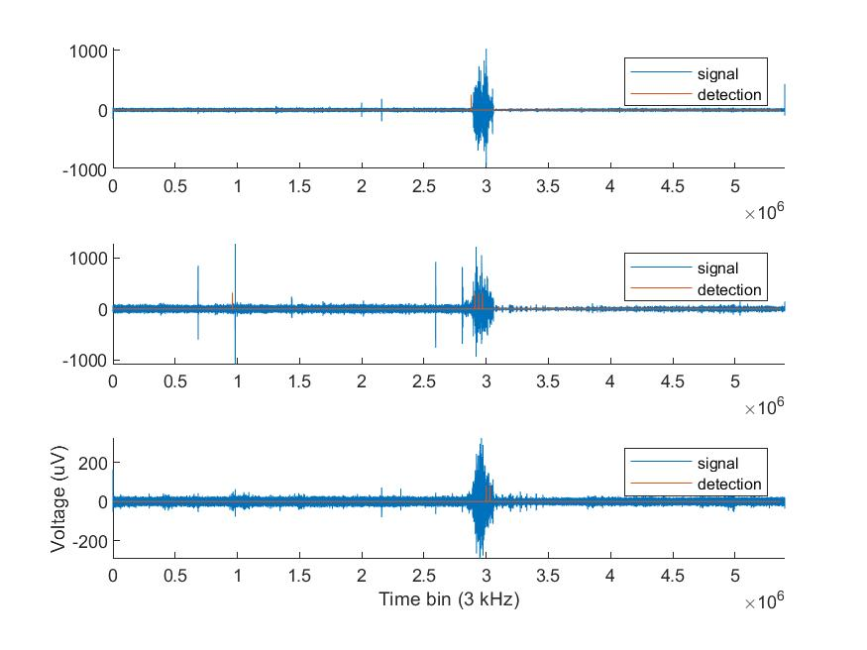

Figure : HFO seizure detection results. Any non-zero detection value indicates seizure detection. Channel 1-3 (top to bottom) of patient B ECog.

Figure : HFO seizure detection feature breakdown. Any non-zero value indicates intermediate seizure detection for that time bin. Ultimate seizure detection depends on seizure indication of all three features. Channel 1-3 (top to bottom) of patient B.

Figure : Example of an HFO from Patient A, channel 3.

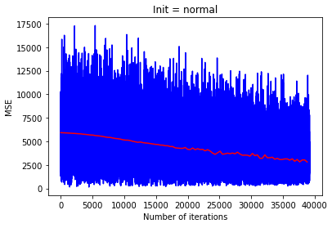

**---** Training Loss

**---** MSE

Figure : Training loss and MSE vs. number of iterations for ANN Normal. ANN uniform is not shown, performance is close enough to where this additional trace shows no useful or new information.

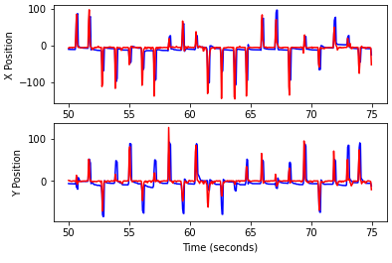

**---** Actual position

**---** Predicted position

Figure : Actual vs. predicted positions of ANN Normal. ANN uniform is not shown, performance is close enough to where this additional trace shows no useful or new information.

**Appendix B – Tables**

|  |  |  |  |
| --- | --- | --- | --- |
|  | Common  Features | Linear Discriminant Analysis | High Frequency Oscillation |
| **Overall Accuracy** | **97.95%** | **95.16%** | **97.02%** |
| False Positive | 0% | 2.23% | 0.19% |
| True Negative | 2.05% | 2.61% | 2.79% |

Table : Accuracy of seizure detection for 3 different algorithms: Common features (LL, ZC, and SA combined), linear discriminant analysis (LDA), and High frequency oscillations (HFO).

|  |  |  |  |  |  |  |
| --- | --- | --- | --- | --- | --- | --- |
|  | **Linear Regression** | **Ridge Regression** | **LASSO** | **Kalman** | **ANN**  **‘Normal’** | **ANN**  **‘Uniform’** |
| X position | 0.9141 | 0.9144 | 0.9151 | 0.8623 | 0.6699 | 0.6932 |
| Y position | 0.8859 | 0.8860 | 0.8869 | 0.8175 | 0.6680 | 0.6684 |
| X velocity | 0.8696 | 0.8700 | 0.8701 | 0.8262 | 0.9385 | 0.9473 |
| Y velocity | 0.8388 | 0.8391 | 0.8393 | 0.7899 | 0.9012 | 0.9217 |
| **Total** | **0.8593** | **0.8596** | **0.8493** | **0.8117** | **0.7944** | **0.8077** |

Table : Accuracy (correlation) of ANN Normal and ANN Uniform X-Y positions and speeds (orange). Correlations of previous decoding methods are shown for comparison (white and grey).

**Appendix C – Code**

<https://github.com/djaklic/bme517_lab10-11>

1. This paper covers two studies: Seizure detection and linear decoding with artificial neural networks.
2. Features such as spectral power, spikes, zero crossings, Teager Kaiser Energy, among others.
3. This and all following ‘window’ values were normalized by average signal values
4. This and all following ‘seizure’ or ‘no seizure’ thresholds determined from patient A
5. This and all following testing done on patient B
6. Detector indicates seizure when truth data indicates no seizure
7. Detector indicates no seizure when truth data indicates seizure
8. It would be interesting to see how an ANN preforms online, although there is no reason to believe that a Kalman-like behavior would be observed, since Kalman filtering makes physics estimates and ANN does not. MSE and training loss decrease over iterations, as expected (Figure 7). Due to computational constraints, no more than 100 epochs could be tested. The MSE plot indicates more room for improvement, so its possible CCs could improve with more training epochs. The high X-Y velocity correlations are interesting and is subject to further investigation.