1. **Example : “Example_1_Flying_Fitness_Data”**

First, partition the data into Training and Test Sets Take, 60% for Training and 40% for Testing purpose randomly

**Input Requirement:**

1.Use Dependent variable: TestRes/Var1

2. Independent vars: Var2-Var6

3. ‘Success class” : use the default of 1 indicating that a value of 1 will be specified as a success.

4. Specify initial cutoff probability for success: 0.5

5. Prior class probabilities: 1. Relative occurrence in training data

2. Equal probability

3. user specified

First select option 1 and repeat the analysis for other two

**Expected Output:**

1. Confusion matrix: your output should have confusion matrix and other model performance metrics

Training data

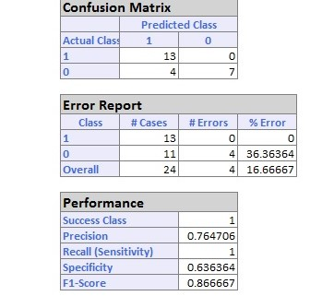

Test data

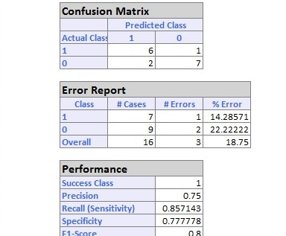

1. Save this to a file: (logpdf is not required) Data and respective predicted class , predicted prob etc should eb saved

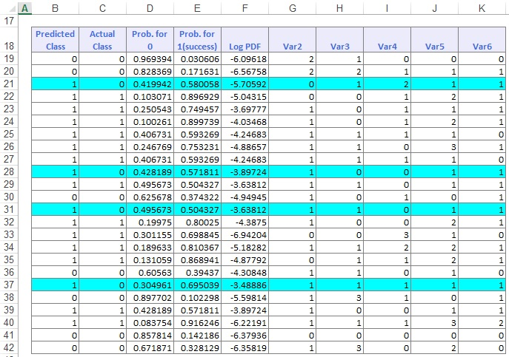

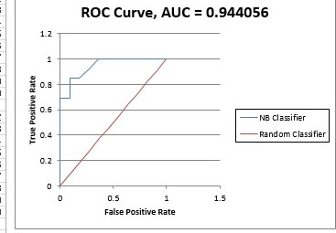

Lastly, when a new data is specified , your algo should predict the class