*David Jamieson*

*8/29/20*

*IT FDN 110 A Su 20: Foundations Of Programming: Python*

*Assignment 08*

*GitHub Repository:* <https://github.com/djamies1/IntroToProg-Python-Mod08>

**Assignment 08 – Documentation**

**Summary:**

The purpose of this assignment was to create a basic application that reads data from a text file, places it into a list in python, and then allows that user to add to that list and eventually save their changes back to the text file once complete. An addition to this assignment was that we were to use classes for data, processing, and presentation. Inside these classes there were variables placed or functions created and then these functions and variables were called upon in the main portion of the script to perform the actual applications interaction with the user.

**Scripting:**

The scripting piece of this assignment was split into 3 classes, Data, FileProcessing, and Presentation (input / output).

Fig1 – the data section is very simple. It identified a few of the data variables to be used within the file, and then created the Product class which stored the product name and price. 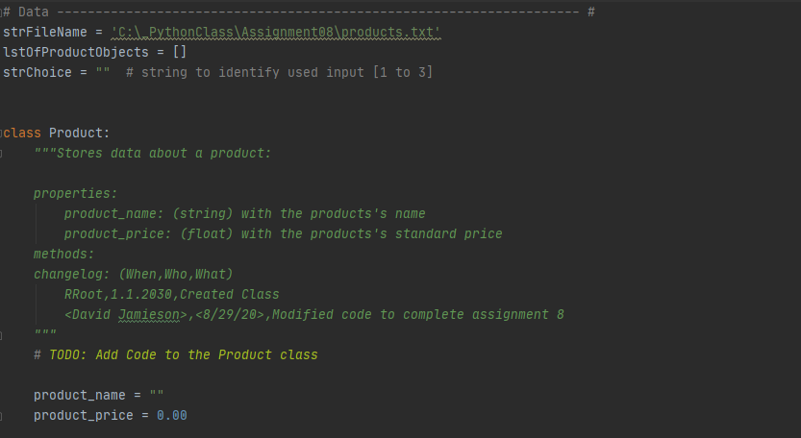

Fig2 – the processing section of this script was stored in the class FileProcessor. This included two functions which are outlined below:

Read_data_from_file – this function opens the product .txt file and for each line in the file appends it to the empty list object defined in the data section

Save_data_to_file – this function takes the current list object in the python file, which may or may not have been added to by the user, and saves it to the text file.

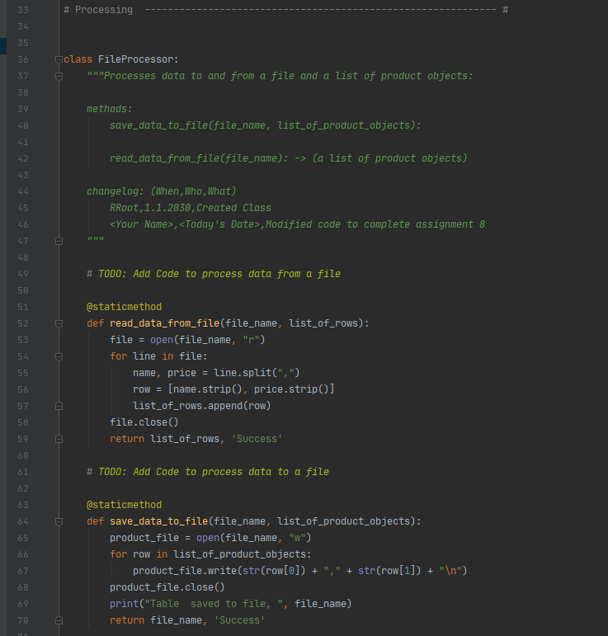

Fig3 – the last class used for this assignment was for the presentation piece. Class IO stores the functions outlined below to interact with and present data to the user:

Print_menu_tasks – this function simply prints the list of options the user can select from. This is needed after each process of their selection is complete.

Input_menu_choice – this prompts and stores the menu input from the user for which option they want to select.

Show_current_file_data – this option prints out the current list object to the user.

Input_new_product – this function prompts the user for input on the new product name and price, which is then added to the list object in the FileProcessor class.

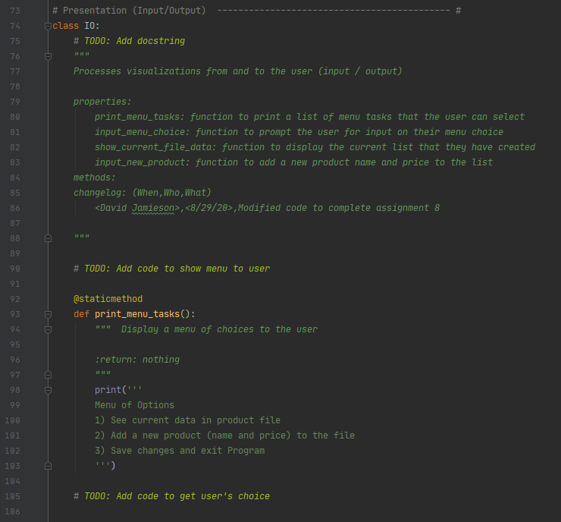

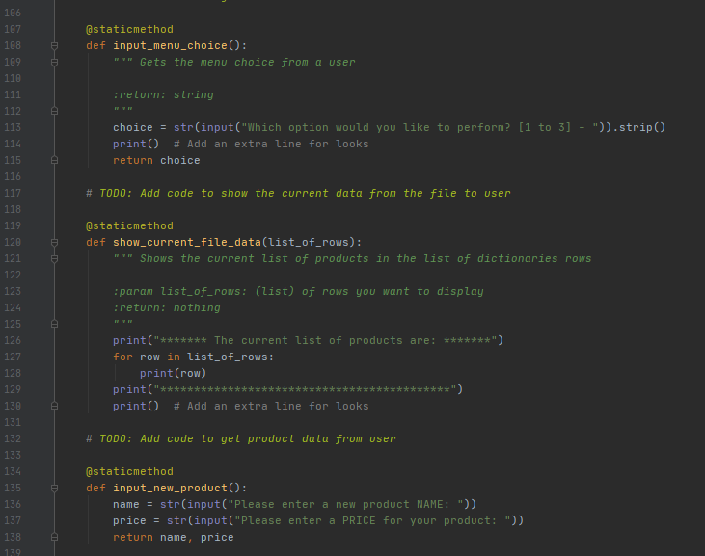

Fig4 – shows the main body of the script, and all the functions and work stored in the classes above being put to use. This section reads data from the file and processes it into the python list. Then it creates a loop which prints menu tasks and prompts the user for the input of their selection. Depending on what option they choose (1 to 3) it will loop through and process data based on their input. The comments in the script blow show what each section is accomplishing and you’ll notice that the class is also referenced before each of the function or variable names (e.g. Class.Function is the syntax used).

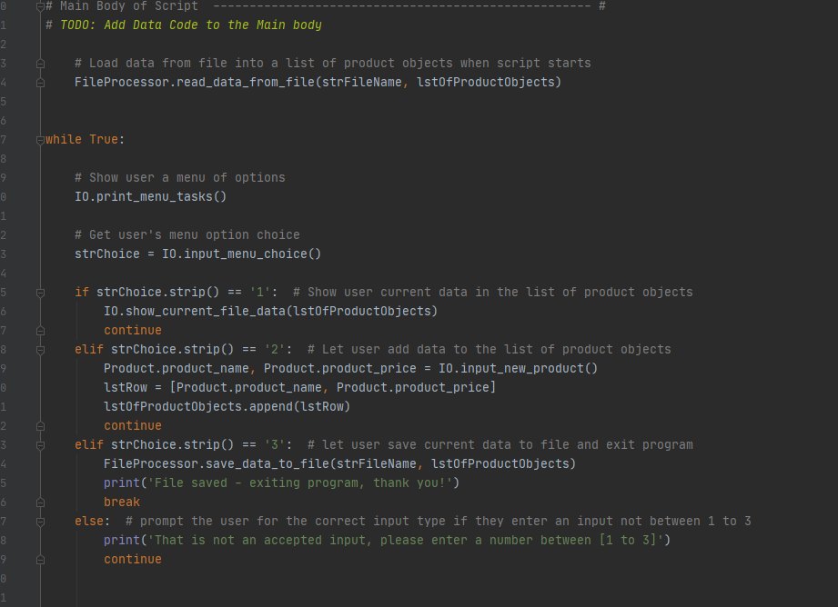

**Conclusion:**

Using classes is a great way to group and store functions or variables in logical formats. It is clear that when working on larger applications with many more functions and many more variables that the use of classes will be essential. Being able to input the class and see a list of all the functions or variables stored within that class is extremely useful, and also makes the actual code much easier to read and troubleshoot to identify where issues may be occurring.