*David Jamieson*

*8/8/20*

*IT FDN 110 A Su 20: Foundations Of Programming: Python*

*Assignment 05*

**Assignment 05 – Documentation**

**Summary:**

The purpose of this assignment was to create a basic script that provided a menu of options and allowed the user to read data from a text file, write new data to the text file, remove data from the text file, or save their modifications to the text file. This is a good basic tool to show how an application can be made to interact with a user and allow them to modify subsets of data.

**Scripting:**

This assignment was completed by essentially having one large if, else if statement that looped through 5 different options for w hat the user wanted to accomplish. First the data was pulled from the existing text file and parsed into dictionary rows, which were then saved into a table (list variable).

1. The user could read data from the file, which was accomplished in Fig1 by printing all the data currently stored in the lstTable variable.

Fig1:

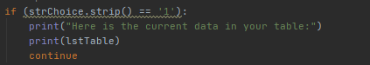

1. The user can add new data to the list / table (two variables for them to add). This data is appended to the existing lstTable variable, but it is not saved down to the text file.

Fig2:

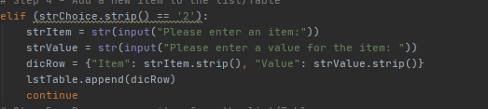

1. The user can remove an existing row of data from the table, if it matches their item of choice. The below code loops through each row and either removes the row or indicates that the row did not match their item. For a larger subset of data this would need to be cleaned up.

Fig3:

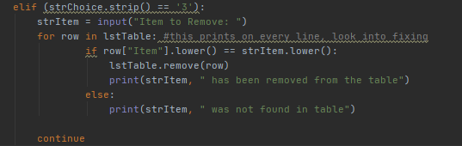

1. The user can save all their changes made while accessing the application to the .txt file, it writes all the data stored in the lstTable variable to the .txt file.

Fig4:

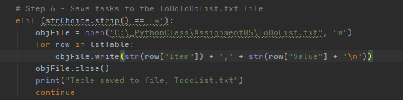

**Conclusion:**

This was a more complicated scripting process then our previous assignments and provided a combination of concepts. Looping through options and reiterating ifs and elifs allows for this program to basically become a very simple application and gives some good insight on how python can be used to build applications on a grander scale.