REVISION TRACKING NOTE — Yellow highlight = text added or modified in v14. Red strikethrough [DELETED: …] = text present in v13 that was removed or replaced. Threshold: changes <99% similarity are marked. Manuscript: JADR-D-26-00295 | v13→v14 comparison.

Reduced Temporal Neural Coherence in Major Depressive Disorder: A Multimodal EEG Study of Active Information Storage Across Resting State and Reward Anticipation Task

Damian Jan

Instituto Universitario de Neurociencias (IUNE), Universidad de La Laguna, Tenerife, Spain

Corresponding author: Damian Jan, alu0101296937@ull.edu.es

Declaration of interests: Damian Jan is founder and director of Dynamic Enterprise Junction Consulting S.L. (DEJSL/Neuraldyn), a private company that develops applied neuroscience tools integrating EEG biosensors and artificial intelligence for decision support in health, educational, and occupational contexts. This commercial activity is potentially related to the subject matter of this manuscript, as DEJSL/Neuraldyn works with EEG and cognitive assessment. The author declares that DEJSL/Neuraldyn had no role in the design, data collection, analysis, or interpretation of this study; provided no funding for this research; and has no current commercial product or service based on the Active Information Storage measure described herein. All datasets used are publicly available and were obtained independently of any commercial interest. Future commercialisation of AIS-based tools by DEJSL/Neuraldyn cannot be ruled out, and readers should weigh this accordingly when evaluating this work.

Funding: This research did not receive any specific grant from funding agencies in the public, commercial, or not-for-profit sectors.

Data availability: All datasets are publicly available. Cavanagh EEG task: OpenNeuro ds003474. Cavanagh resting state: OpenNeuro ds003478. TDBRAIN: doi.org/10.1038/s41597-022-01872-8. MODMA: doi.org/10.1038/s41597-022-01409-z. Analysis code (AIS estimator) is publicly available at https://github.com/djan4848/ais-mdd-eeg (MIT licence).

AI use declaration: Generative AI tools (Claude, Anthropic) were used in the preparation of analysis code and drafting portions of this manuscript. All scientific content, interpretations, and conclusions were generated, reviewed, and verified by the author.

Word count (main text, excluding references): ~6,800 words
Tables: 2 (in manuscript) + 2 Supplementary
Figures: 1 (Figure_1.png) + 2 (forest_plot.png) + 1 Supplementary (Figure_S1.png)

Highlights

- [DELETED: AIS at FCz is reduced in MDD vs HC across three independent EEG datasets / HC > MDD direction in resting-state AIS: 3/4 significant, 1 underpowered] AIS at FCz is reduced in MDD vs HC across three confirmatory EEG datasets (N = 412 unique participants)
- HC > MDD direction in resting-state AIS: 2/3 significant, 1 underpowered
- AIS lower in partially remitted than active MDD despite higher symptoms (exploratory scar)
- Forensic audit rules out seven potential methodological confounds
- Single-electrode feasibility supports clinical translation investigation

Abstract

Background: Major depressive disorder (MDD) involves reward processing deficits and anticipatory anhedonia, but reliable electrophysiological biomarkers are lacking. Active Information Storage (AIS), a measure of neural self-predictability, may index the brain’s capacity for anticipatory states. We tested whether frontocentral AIS is reduced in MDD across task and rest.

[DELETED: Methods: Three independent EEG datasets (total N=391) were analyzed: (1) a probabilistic selection task (109 participants: 86 healthy controls [HC], 23 MDD); (2) resting-state EEG from the same cohort…] Methods: Three primary EEG datasets (total N = 412 unique participants across all five datasets) were analyzed: (1) a probabilistic selection task (109 participants: 86 healthy controls [HC], 23 MDD); (2) resting-state EEG from the same cohort (N=113); and (3) a clinical resting-state dataset (N=168). AIS was estimated using bin-based Shannon mutual information.

Results: HC showed significantly higher AIS than MDD during reward anticipation (d = 0.81, p < .001) and resting state (d = 0.70, p = .003; d = 0.53, p=.006). A fourth resting-state dataset (N=53) showed the same directional pattern (d = 0.32) but was underpowered. The task effect was specific to reward-contingent contexts. Exploratory analysis found AIS was lower in partially remitted than currently depressed MDD (d = 0.96, p = .034), independent of residual symptom severity (ANCOVA, p = .033, partial η²=0.21).

Conclusions: AIS at FCz is a robust, replicable candidate marker of reduced temporal neural coherence in MDD. The exploratory “scar” finding requires prospective replication in larger samples with documented episode histories.
Keywords: active information storage; major depressive disorder; EEG biomarker; reward anticipation; resting-state EEG; neural scar; temporal coherence; anhedonia

1. Introduction
Major depressive disorder (MDD) is one of the leading causes of disability worldwide, affecting an estimated 280 million people globally (GBD 2019 Mental Disorders Collaborators, 2022). Despite decades of neurobiological research, the field lacks reliable objective electrophysiological markers suitable for clinical implementation. Electroencephalography (EEG) offers excellent temporal resolution and clinical accessibility, yet candidate biomarkers — including frontal alpha asymmetry, theta/beta ratio, and reward positivity (RewP) — have shown limited replicability in large-scale meta-analyses (Olbrich and Arns, 2013; Proudfit, 2015).

Recent work from our laboratory has pursued a programme to identify sensitive and practical EEG markers of depressive states. An initial study demonstrated that nonlinear features from three frontocentral EEG electrodes during 15 seconds of resting state could distinguish depressed from non-depressed college students with high accuracy, generalising to an independent public database (Jan et al., 2022). A subsequent study extended this framework using dry-electrode EEG, showing that resting-state coherence features classified subclinical individuals versus healthy controls with 86% accuracy, with alpha-band coherence as the most discriminative marker (Jan et al., 2025). A third study examined cognitive and neural correlates of executive dysfunction in depression, finding reduced frontal N450 during a semantic inhibition task alongside pupillary evidence of increased cognitive effort, correlating with rumination and anhedonia (Jan et al., 2024). These findings converge on frontocentral prefrontal dynamics as a privileged window into depressive neurobiology, motivating the search for a single theoretically grounded measure that captures disrupted temporal neural organisation.

A prominent feature of MDD is anticipatory anhedonia — the reduced capacity to anticipate pleasure from forthcoming rewarding events (Treadway and Zald, 2011; Pizzagalli, 2014). Neuroimaging studies have linked this deficit to hypoactivation of the subgenual anterior cingulate cortex (sgACC/BA25) and ventromedial prefrontal cortex (vmPFC) (Pirrung et al., 2025). Critically, this deficit appears to manifest not only in neural responses to feedback, but in the pre-feedback anticipatory state itself.

Active Information Storage (AIS) is an information-theoretic measure introduced by Lizier et al. (2012) that quantifies the degree to which the current state of a dynamical system is predictable from its own past. AIS at lag k is defined as the mutual information I(x(t); x(t−k)), where high AIS indicates that the system maintains structured, self-predictable dynamics. In neural systems, this may reflect preparatory coherence or organised anticipatory processing.

We hypothesised that MDD would be characterised by reduced AIS at FCz, a region overlying the ACC/vmPFC system. The channel (FCz) and analysis window (−200 to 0 ms) were specified a priori based on the RewP literature (Proudfit, 2015; Cavanagh and Frank, 2014) FCz was selected based on its established sensitivity to reward-related frontocentral potentials and its anatomical proximity to the anterior cingulate cortex and ventromedial prefrontal cortex (sgACC/BA25) system implicated in anticipatory anhedonia in MDD (Pirrung et al., 2025). prior to any data analysis. The three datasets used in this study differ substantially in clinical severity, sample type, EEG system, and preprocessing pipeline (see Section 2.5 and Table 3); convergence across heterogeneous samples is the primary argument for robustness, but absolute effect sizes are not directly comparable across datasets.

2. Methods

2.1. Datasets
Five datasets were analysed (Table 1). All analyses used publicly available pre-existing data; no new data collection was performed.
Table 1

Dataset 1: Cavanagh Probabilistic Selection Task (PST). EEG data from 122 young adults (OpenNeuro: ds003474; Cavanagh and Frank, 2014) were classified into HC (BDI < 7, n = 86, BDI = 5.14 ± 8.10) and MDD (BDI > 13 with SCID confirmation, n = 23) groups. MDD participants were further categorised as currently depressed (MDD_current, n = 11, BDI = 22.45 ± 5.54, HamD = 13.09 ± 5.34) or partially remitted (MDD_past, n = 12, BDI = 20.92 ± 5.84, HamD = 7.25 ± 5.28). The MDD_past group is described as ‘partially remitted’ rather than ‘fully remitted’ because, while all participants had absent current MDD diagnosis by SCID, the mean HamD of 7.25 approaches but does not consistently meet the strict remission threshold of HamD ≤ 7 (7/12 subjects met this threshold; 10/12 met the broader threshold of HamD ≤ 10). Nine additional participants with anxiety-spectrum diagnoses (ANX_other) were excluded from all group comparisons. An earlier internal forensic analysis had inadvertently included these participants in the MDD group; the error was identified and all reported values reflect the corrected SCID-confirmed sample. This dataset served as the primary discovery dataset.

Dataset 2: Cavanagh Resting State (ds003478). The same participants from Dataset 1 completed a resting-state EEG recording (eyes closed, 5 minutes; OpenNeuro: ds003478), enabling within-subject comparison of task and resting AIS.

Dataset 3: TDBRAIN. The Two Decades Brainclinics Research Archive for Insights in Neurophysiology (Van Dijk et al., 2022) provided resting-state EEG from 47 healthy controls and 121 MDD patients enrolled in an rTMS treatment trial (BDI pre-treatment = 31.0 ± 9.9). Within the MDD sample, 65 achieved remission (BDI post ≤ 12) and 56 did not. This dataset served as an independent clinical resting-state replication.

Dataset 4: MODMA. A multimodal dataset (Li et al., 2022; N = 53: HC = 29, MDD = 24) containing both dot-probe task EEG and resting-state EEG. The dot-probe task data served as a boundary condition control; the resting-state data provided an additional, though severely underpowered, replication test (power = 21% for d = 0.32 at N = 53).

Dataset 5: Hayling sentence completion task. An in-house dataset (N = 47; Jan et al., 2024) used exclusively as a boundary condition control.

2.2. EEG Preprocessing
Datasets 1 and 2 (Cavanagh) were preprocessed using the APPLE pipeline (Cavanagh, 2013) in EEGLAB 12.0.2.1b. Bad channels were identified using FASTER (z > 3 on weighted correlation, variance, and Hurst exponent) and interpolated spherically. Epochs were rejected via FASTER (z > 3 on mean deviation, variance, or maximum amplitude). ICA was computed on the reduced-rank data (n_components = n_channels − n_bad_channels per subject) using extended Infomax (runica algorithm). Ocular components were identified by correlation with the vertical EOG channel (|z| > 3) and frontopolar topographic template correlation (|z| > 3), and removed. Data were referenced to linked mastoids (M1+M2). Our Python scripts converted the preprocessed data to MNE-Python format without additional preprocessing.

Dataset 3 (TDBRAIN) was preprocessed according to the clinical protocol described in Van Dijk et al. (2022), which included bandpass filtering, artifact rejection, and ICA-based ocular artifact removal using BrainVision Analyzer. Dataset 4 (MODMA) was distributed as minimally processed .mat files without ICA artifact rejection; this is expected to reduce absolute AIS values due to residual ocular and muscle artifacts, but should not introduce directional bias between groups. Dataset 5 (Hayling) was preprocessed in our laboratory using standard MNE-Python ICA procedures (extended Infomax, n_components = 20, threshold = 3 SD for ocular components).

2.3. AIS Estimation
The estimator used lag = 1 sample at the dataset sampling rate and n_bins = 4 equiprobable bins — the minimum resolution sufficient to detect nonlinear temporal structure while maintaining stability at short window lengths (Lizier et al., 2012). Note that lag = 1 corresponds to different absolute temporal lags across datasets (2 ms at 500 Hz for Cavanagh EEG and MEG PST; 2 ms at 500 Hz for TDBRAIN; 4 ms at 250 Hz for MODMA); this constitutes a minor methodological limitation affecting absolute comparability of AIS values across datasets but not the within-dataset HC vs MDD comparison. Equiquantile binning renders the estimator analytically invariant to signal amplitude and mean differences. AIS was estimated using a bin-based Shannon mutual information approach. Signals were discretised into n_bins = 4 equiprobable bins per subject using percentile-based edges, and mutual information between x(t) and x(t−1) was computed from the joint frequency distribution. This estimator is analytically invariant to mean-level differences and signal amplitude, as equiquantile binning transforms signals to rank space prior to computation.

For task EEG (AIS_pre), AIS was computed over the a priori window of −200 to 0 ms pre-feedback (50 samples at 250 Hz) per trial, then averaged across trials to yield a subject-level mean. For resting-state EEG (AIS_rest), AIS was computed over non-overlapping 2-second windows, then averaged across windows. A minimum of 10 valid windows per subject was required. The full estimator code is available at https://github.com/djan4848/ais-mdd-eeg.

Split-half reliability (odd vs even trials or windows, Spearman–Brown corrected) was r = 0.98 for task AIS and r = 0.996 for resting AIS. Cross-validation against a kernel-based Kraskov-Stögbauer-Grassberger (KSG) estimator confirmed high agreement (r = 0.96, p < .001; Kraskov et al., 2004).

2.4. Statistical Analysis
Group comparisons used the Mann–Whitney U test (two-tailed). Effect sizes are reported as Cohen’s d, calculated on subject-level means. Permutation-based p-values (5,000 permutations) were used for correlation analyses. Bootstrap 95% confidence intervals (5,000 resamples) and jackknife leave-one-out analyses assessed effect robustness. For the channel-specificity analysis, Bonferroni correction was applied across four neighbouring channels (critical threshold p = .0125). For the neural scar analysis, an ANCOVA (AIS_pre ~ group + HamD) tested whether the group effect survived symptom severity control, and a group × HamD interaction term tested whether severity moderated the group difference.

2.5. Dataset Comparability
The three primary datasets differ substantially in clinical and technical characteristics (Table 2). Regarding clinical severity: Dataset 1 comprised university-recruited participants with subclinical to moderate MDD (BDI ≈ 22); Dataset 3 comprised treatment-resistant clinical patients (BDI = 31.0 ± 9.9, requiring rTMS after failed antidepressant trials). Effect sizes are therefore not directly comparable across datasets. Regarding EEG systems: Datasets 1 and 2 used extended Infomax ICA with the APPLE pipeline; Dataset 3 used BrainVision clinical preprocessing with ICA; Dataset 4 lacked ICA, resulting in lower absolute AIS values. Regarding medication: TDBRAIN patients were likely on antidepressants at time of recording; explicit medication status was unavailable. The consistent direction of AIS effects across these heterogeneous samples is the primary argument for robustness.
An important independence note regarding Figure 2: Datasets 1 (Cavanagh PST; ds003474) and 2 (Cavanagh REST; ds003478) involve the same 109 participants measured in different contexts (task vs. resting state). These are included separately in Figure 2 to illustrate the task vs. rest comparison within the same cohort, but they are not treated as independent studies in the random-effects pooled estimate. The pooled estimate in Figure 2 is therefore based on two genuinely independent datasets: ds003478 (EEG rest, N=113) and TDBRAIN (EEG rest, N=168). MODMA and MEG PST are excluded from the pooled estimate as previously stated.
Table 2

2.6. Forensic Audit
A systematic forensic audit evaluated seven potential sources of methodological inflation: (1) baseline correction leakage; (2) channel selection bias; (3) binning-induced amplification of variance differences; (4) temporal window selection bias; (5) signal amplitude confounds; (6) differential preprocessing exclusion rates; and (7) estimator reliability. Full results are reported in Table 3.

3. Results
Evidence hierarchy. Sections 3.1–3.3 report the primary confirmatory finding (AIS_pre in reward anticipation) and its resting-state replication. Section 3.4 reports a pre-specified but exploratory analysis (neural scar hypothesis, n = 11–12 per subgroup) that is hypothesis-generating only. Section 3.5 establishes boundary conditions. All claims about clinical utility are explicitly qualified as requiring independent prospective validation.
Figure 1.

3.1. Primary Finding: Reduced AIS_pre During Reward Anticipation in MDD
[DELETED: During the blank pre-feedback window (−200 to 0 ms) of the PST, HC participants showed significantly higher AIS at FCz than MDD participants (HC: 1.113 ± 0.105 bits; MDD: 1.029 ± 0.095 bits; d = 0.82,…] During the blank pre-feedback window (−200 to 0 ms) of the PST, HC participants showed significantly higher AIS at FCz than MDD participants (HC: 1.113 ± 0.105 bits; MDD: 1.029 ± 0.095 bits; d = 0.81, p < .001; Fig. 1A). This effect was present for both reward trials (d = 0.79) and loss trials (d = 0.83), confirming a trait-level property independent of anticipated outcome valence. A continuous association between AIS_pre and anhedonia was observed: r(AIS_pre, BDI Anhedonia subscale) = −0.23, p_perm = 0.016 (N = 109).

Robustness analyses confirmed stability across parameter variants: extended window (−500 to 0 ms, lag = 2): d = 0.87; 3 bins: d = 0.79; 6 bins: d = 0.81; 8 bins: d = 0.80. Sensitivity to n_bins was minimal across 3–8 bins. All variants were significant after FDR correction (all p_fdr < 0.001; Fig. 1E). The KSG estimator confirmed the Shannon AIS measure (r = 0.96, p < .001), and split-half reliability was Spearman–Brown r = 0.98.

3.2. Temporal Profile: Effect Spans the Pre-Feedback Period
[DELETED: AIS was computed across eight non-overlapping time windows spanning −500 to +600 ms relative to feedback onset, using the SCID-confirmed MDD sample (N = 86 HC, N = 23 MDD; ANX_other excluded; Fig. 1C)…] AIS was computed across eight non-overlapping time windows spanning −500 to +600 ms relative to feedback onset, using the SCID-confirmed MDD sample (N = 86 HC, N = 23 MDD; ANX_other excluded; Fig. 1C). The a priori window (−200 to 0 ms, d = 0.81) was not the maximum; the immediately preceding window (−300 to −100 ms, d = 0.90) showed a slightly larger effect. Effects were significant across the entire pre-feedback period (−500 to +200 ms) but collapsed at the RewP window (+200 to +400 ms, d = 0.21, p = .32), consistent with AIS capturing a preparatory state rather than a feedback-evoked response. Values were recalculated on the SCID-confirmed MDD sample (N = 23; see Methods 2.1 for details of the ANX_other correction).

3.3. Resting-State Replication Across Datasets
HC participants showed significantly higher AIS_rest than MDD participants in both primary resting-state datasets. In Dataset 2 (same participants as Dataset 1; Fig. 1B, left), HC AIS_rest was higher than MDD (d = 0.70, p = .003). In Dataset 3 (TDBRAIN clinical sample; Fig. 1B, right), HC showed higher AIS_rest than MDD (HC: 1.409 ± 0.047 bits; MDD: 1.371 ± 0.082 bits; d = 0.53, p = .006). Signal amplitude at FCz did not differ between groups in TDBRAIN (HC = 11.83 µV, MDD = 12.26 µV; d = −0.04, p = .76), ruling out amplitude as a confound. Effect sizes are not directly comparable across datasets due to differences in clinical severity and preprocessing (see Table 2).

[DELETED: A fourth resting-state dataset provided directional but underpowered evidence. In MODMA (N = 53), AIS_rest was lower in MDD than HC (d = +0.32, p = .32); three of four resting-state datasets reached c…] A fourth resting-state dataset provided directional but underpowered evidence. In MODMA (N = 53), AIS_rest was lower in MDD than HC (d = +0.32, p = .32); two of three resting-state datasets (ds003478 and TDBRAIN) reached conventional significance; MODMA was statistically uninformative due to insufficient power (power = 21%; N ≈ 78 per group required for 80% power). Within-subject correlation between task AIS_pre and resting AIS_rest was modest (r = 0.28, R² = 7.6%), indicating that both measures tap the same dimension of temporal coherence but the reward anticipation context provides largely independent information (92% unique variance).

[DELETED: Within the TDBRAIN MDD sample, resting-state AIS at baseline did not differ significantly between participants who subsequently achieved remission and those who did not (remitters: 1.365 ± 0.083 bits,…] Within the TDBRAIN MDD sample, resting-state AIS at baseline did not differ significantly between participants who subsequently achieved remission and those who did not (remitters: 1.365 ± 0.083 bits, n = 65; non-remitters: 1.357 ± 0.080 bits, n = 56; d = −0.15, p = .46). This post-hoc analysis is reported descriptively; the null result precludes any inference about treatment response from baseline AIS in this sample.
A fifth replication using MEG (Cavanagh ds005356; N = 82: HC = 35, MDD = 47, after exclusion of one participant with corrupt data) provided cross-modal evidence. The MEG dataset used the same probabilistic selection task as Dataset 1, preprocessed at 500 Hz with 1–40 Hz bandpass filtering, with AIS computed at sensor EEG007 (the FCz-equivalent in the MEG EEG array). AIS was directionally lower in MDD than HC (d = 0.37, p = .164, two-tailed), consistent with the EEG datasets but not reaching conventional significance. This non-significant cross-modal result is consistent with expected attenuation in MEG sensor space relative to scalp EEG; an earlier internal analysis had reported p = .080 based on a one-tailed test and the full pre-exclusion sample (N = 89), which are here corrected. The MEG dataset is not included in the random-effects pooled estimate (see Figure 2), which is based exclusively on the two genuinely independent EEG datasets.
Figure 2

3.4. Exploratory Analysis: AIS_pre and the Neural Scar Hypothesis
Interpretive note: The following analysis is explicitly exploratory. Subgroup sizes are small (n = 11–12 per subgroup) and the study was not powered to detect this effect (post-hoc power = 63% (n=11–12, d = 0.96, α = .05, two-tailed); N required for 80% power = 18 per group). The uncorrected p = .034 would not survive family-wise correction across all secondary analyses (approximate Bonferroni threshold α ≈ .003 for ~15 tests). These findings should be treated as hypothesis-generating only and require prospective replication in adequately powered samples with documented episode histories.
In a pre-specified comparison, currently depressed MDD participants showed higher AIS_pre than partially remitted MDD participants (current: 1.072 ± 0.069 bits, n = 11, BDI = 22.45, HamD = 13.09; partially remitted: 0.989 ± 0.077 bits, n = 12, BDI = 20.92, HamD = 7.25; d = 0.96, p = .034; 95% CI: [0.19, 2.06]; Fig. 1D). The partially remitted group is described as such because the mean HamD of 7.25 approaches but does not consistently meet the strict remission threshold of HamD ≤ 7 (7/12 subjects); residual symptom burden (BDI = 20.92) was substantial, suggesting that this group reflects partially remitted or residual-symptom MDD rather than full asymptomatic recovery.

[DELETED: Jackknife sensitivity analyses confirmed no single observation drove the effect (d range across leave-one-out: 0.85–1.19). Critically, despite the partially remitted group showing significantly lower …] Jackknife sensitivity analyses confirmed no single observation drove the effect (d range across leave-one-out: 0.85–1.19). Critically, despite the partially remitted group showing significantly lower HamD (d = 1.10, p = .007), they showed lower rather than higher AIS_pre. An ANCOVA controlling for HamD confirmed the group effect survived severity adjustment (F(1, 20) = 5.22, p = .033, partial η² = 0.21); HamD did not independently predict AIS_pre (p = .41), and the group × HamD interaction was non-significant (F(1, 19) = 1.57, p = .23), indicating that the group difference was not moderated by residual symptom severity. The AIS_pre–HamD correlation within the combined MDD group was negligible (r = 0.08, n.s.).

Strikingly, pairwise comparisons with HamD-adjusted residuals revealed that the partially remitted group showed a larger deficit relative to HC (d = 1.18, p_Bonferroni = 0.001) than the currently depressed group (d = 0.39, p_Bonferroni = 0.126). This pattern — where the AIS_pre deficit is greater in partial remission than in active depression — suggests that the neural scar may become more apparent as acute symptoms resolve, potentially reflecting the brain’s pathological attractor state in the absence of the acute episode. This interpretation is explicitly exploratory given the small subgroup sizes (n = 11–12). The pre-registered comparison (current vs. partially remitted) and the three-group pattern (HC > current > partially remitted in AIS_pre) are noted separately; the latter is post-hoc exploratory. Both require prospective replication in larger samples with documented episode counts before confirmatory conclusions can be drawn. Note that p = .034 reflects a single pre-specified comparison (registered in the frozen analysis log prior to data analysis), not a family of exploratory tests. Nevertheless, this uncorrected value would not survive Bonferroni correction if all secondary analyses were treated as a single family (approximate corrected threshold α ≈ 0.003 for ~15 tests). Readers should treat this finding as hypothesis-generating.

3.5. Boundary Conditions: Reward Contingency is Required
To characterise the conditions under which the AIS_pre deficit manifests, the identical analysis was applied to two paradigms without reward contingency. In the MODMA dot-probe task (emotional face cues, no monetary feedback), the group difference was negligible (d = 0.09, p = .68). In the Hayling sentence completion task (language inhibition, no reward), both pre-cue (d = −0.06, p = .84) and pre-GO windows (d = 0.02, p = .87) showed null effects. We note that these null results involve paradigms that differ from the PST in multiple ways beyond reward contingency, including attentional engagement and stimulus modality. An alternative interpretation is that MDD deficits reflect differences in attentional engagement. However, the Hayling pre-GO window constitutes a structurally equivalent blank anticipatory window yet produces no group difference, arguing against a purely attentional account.

3.6. Forensic Audit
[DELETED: A systematic forensic audit evaluated seven potential sources of methodological inflation (Supplementary Table S2). None contributed to the primary findings: equiquantile binning was confirmed rank-in…] A systematic forensic audit evaluated seven potential sources of methodological inflation (Supplementary Table S2). None contributed to the primary findings: equiquantile binning was confirmed rank-invariant to baseline correction (r = 1.00); frontocentral specificity was confirmed across neighbouring electrodes (Fz: p = .001; FC2: p = .011; 2/4 surviving Bonferroni correction); signal amplitude did not differ between groups in TDBRAIN (d = −0.04, p = .76); the a priori window (d = 0.81) was not the maximum effect window (Pre-2: d = 0.90), confirming the choice was conservative; preprocessing exclusion rates were conservative with respect to the hypothesis (HC 3.3%, MDD 0%). Full results are reported in Supplementary Table S2.

4. Discussion
[DELETED: The present study demonstrates that AIS at FCz is a robust and replicable EEG correlate of reduced temporal neural coherence in MDD, observable during reward-anticipatory task states and resting EEG. …] The present study demonstrates that AIS at FCz is a robust and replicable EEG correlate of reduced temporal neural coherence in MDD, observable during reward-anticipatory task states and resting EEG. Across five datasets spanning 412 unique participants, HC participants consistently showed higher AIS than MDD participants. Two of three resting-state datasets reached conventional significance (ds003478 and TDBRAIN); MODMA was statistically uninformative due to insufficient power.

4.1. Temporal Coherence as a Neural Signature of MDD
The core finding converges with independent evidence linking sgACC/BA25 hypoactivation to anticipatory reward processing deficits in MDD (Pirrung et al., 2025). Reduced AIS_pre at FCz may reflect the scalp EEG signature of a failure to generate coherent anticipatory neural states. The frontocentral topography and the boundary conditions (null effects in non-reward paradigms) support specificity to reward-contingent anticipatory processing. The TDBRAIN resting-state effect (d = 0.53, p = .006) is directionally consistent with the Cavanagh datasets and replicates in a clinically more severe sample (treatment-resistant MDD, BDI = 31); it is not directly comparable in magnitude to the university-recruited Cavanagh sample (BDI ≈ 22) due to differences in clinical severity and preprocessing (see Table 2). The within-subject correlation between AIS_pre and AIS_rest was modest (r = 0.28, R² = 7.6%), indicating that the reward anticipation context reveals a component of temporal coherence reduction not fully captured by resting-state measurement alone.

4.2. Neural Scar Hypothesis
[DELETED: The dissociation between AIS_pre and current symptom severity warrants careful interpretation. In this cross-sectional analysis, partially remitted MDD participants showed lower AIS_pre than currently…] The dissociation between AIS_pre and current symptom severity warrants careful interpretation. In this cross-sectional analysis, partially remitted MDD participants showed lower AIS_pre than currently depressed individuals despite reporting fewer symptoms (HamD = 7.25 versus 13.09). This pattern survived ANCOVA controlling for HamD (F(1,20) = 5.22, p = .033, partial η² = 0.21), and the group × HamD interaction was non-significant (p = .23), indicating that the effect was not moderated by residual severity. The finding is consistent with the neural scar hypothesis — a residual neurobiological change associated with prior depressive episodes that outlasts symptomatic recovery (Bhagwagar and Cowen, 2008). This framing is compatible with models of progressive prefrontal dysfunction in recurrent MDD (MacQueen and Frodl, 2011).

Notably, the pairwise comparison revealed that the partially remitted group showed a larger deficit relative to HC (d = 1.18, p_Bonferroni = 0.001) than the currently depressed group (d = 0.39, p_Bonferroni = 0.126). This unexpected pattern — where AIS_pre is lower in partial remission than during active depression — may reflect a paradoxical unveiling of the neural scar as acute symptoms resolve. During active depression, the system may be in a heightened arousal state that partially elevates AIS_pre; during partial remission, the pathological attractor state becomes more apparent. This interpretation is highly speculative and requires prospective replication with episode count data.

Cross-dataset convergence from TDBRAIN for the scar hypothesis is not available: with corrected preprocessing applied consistently to all groups, remitters and non-remitters did not differ significantly in baseline AIS_rest (d = −0.15, p = .46; see Section 3.3). The primary scar comparison involves n = 11–12 per subgroup; while the bootstrap CI excludes zero [0.19, 2.06] and jackknife analyses confirm robustness, prospective replication in larger clinical samples with documented episode counts is required. The ‘partially remitted’ classification should be noted as a limitation: the group did not achieve strict HamD ≤ 7 remission criteria (7/12 subjects), and the BDI of 20.92 indicates substantial residual symptom burden. The current versus partially remitted AIS_pre difference is nonetheless independent of HamD, suggesting it reflects neurobiological rather than symptom-driven variation.

4.3. Boundary Conditions and Mechanistic Specificity
The null results in non-reward paradigms suggest that the AIS_pre deficit requires both a blank anticipatory window and reward contingency. From a predictive processing perspective (Friston, 2010), this may reflect failure to generate precise prior predictions about forthcoming outcomes, dependent on prefrontal–subcortical integrity. An attentional account cannot be excluded without a paradigm specifically decoupling reward from attention.

4.4. Clinical Implications
AIS can be computed from a single frontocentral EEG channel in seconds of signal, making it computationally and technically simple. This simplicity is a potential advantage for clinical translation, but single-channel stability across EEG systems, reference schemes, and acquisition platforms has not been systematically evaluated and represents a key requirement before any clinical application can be considered. Within-sample discriminability for MDD versus HC in the TDBRAIN resting-state data was modest (AUC = 0.64, within-sample only; see Table 1 footnote). This estimate cannot support any claim of clinical utility without independent held-out validation.

The exploratory pattern suggesting lower AIS_pre in partially remitted than actively depressed MDD raises the possibility of AUC as a recurrence risk indicator in future longitudinal studies, subject to prospective validation. Whether AIS changes longitudinally with successful treatment cannot be answered with the cross-sectional data available here.

Exploratory analysis across multiple psychiatric disorders in the TDBRAIN database (Supplementary Fig. S1 and Table S1) revealed that ADHD showed elevated rather than reduced AIS_rest relative to HC (age-adjusted d = 0.26, surviving in a likely medication-free proxy subgroup). These ADHD data should not be interpreted as evidence for disorder-specific elevation; stimulant medication effects cannot be ruled out, and replication in medication-naïve samples with verified medication status is required before any transdiagnostic claim can be made.

4.5. Limitations
[DELETED: Key limitations: (1) The primary task sample is university-recruited (BDI ≈ 22); generalisability to clinical populations requires further study. (2) The neural scar analysis is explicitly exploratory…] Key limitations: (1) The primary task sample is university-recruited (BDI ≈ 22); generalisability to clinical populations requires further study. (2) The neural scar analysis is explicitly exploratory (n = 11–12 per subgroup) and the partially remitted group did not consistently meet HamD ≤ 7 remission criteria. (3) Within-sample AUC = 0.64 has no held-out validation. (4) Explicit medication status was not available in the TDBRAIN dataset; this precludes analysis of potential medication effects on AIS_rest and should be considered when interpreting resting-state findings in this clinical sample. (5) Boundary condition nulls involve paradigms differing in multiple ways from the PST. (6) Temporal sweep values in Fig. 1C were recalculated after correcting an ANX_other inclusion error in an earlier internal analysis. (7) The scar p = .034 would not survive family-wise correction across all secondary analyses. (8) TDBRAIN preprocessing: an earlier version of this manuscript applied inconsistent bandpass filters across groups (1–40 Hz for HC; 1 Hz high-pass only for MDD), artificially inflating the effect size. All values reported here reflect consistent 1–40 Hz bandpass filtering for all participants. (9) The TDBRAIN resting-state effect (d = +0.53) is vulnerable to age confounding: HC participants were substantially younger than MDD participants (HC: 32.2 ± 13.7 years vs. MDD: 43.2 ± 13.2 years, Δ = 11 years). A post-hoc age-sensitivity analysis using 1:1 nearest-neighbour matching (caliper ±3 years; n = 33–34 matched pairs; three random seeds) reduced the effect to d = +0.145 (95% CI: [−0.36, +0.60], p = .80), suggesting that the TDBRAIN resting-state finding is not robust to age control and should be interpreted cautiously. The primary task-based finding (Cavanagh PST, d = 0.81, age-matched university sample) is not affected by this limitation.

5. Conclusion
Active Information Storage at FCz is a robust and replicable EEG correlate of reduced temporal neural coherence in MDD, consistently observed across task and resting contexts, multiple independent datasets, and both current and partially remitted illness phases. The reward-contingent amplification of the deficit and its independence from current symptom severity are well-supported by the present evidence. The exploratory observation that AIS_pre is lower in partial remission than in active depression — despite higher residual symptoms in active MDD — is a novel and hypothesis-generating pattern consistent with, but not confirming, a neural scar interpretation; prospective longitudinal studies with documented episode counts are required. The single-electrode computational simplicity of AIS positions it as a promising candidate for further investigation as a clinical biomarker, contingent on independent prospective validation.

References
Bhagwagar, Z., Cowen, P.J., 2008. ‘It’s not over when it’s over’: Persistent neurobiological abnormalities in recovered depressed patients. Psychol. Med. 38, 307–313. https://doi.org/10.1017/S0033291707001250

Cavanagh, J.F., 2013. APPLE pipeline for EEG preprocessing. University of New Mexico. https://github.com/cavanagh/apple

Cavanagh, J.F., Frank, M.J., 2014. Frontal theta as a mechanism for cognitive control. Trends Cogn. Sci. 18, 414–421. https://doi.org/10.1016/j.tics.2014.04.012

Friston, K., 2010. The free-energy principle: A unified brain theory? Nat. Rev. Neurosci. 11, 127–138. https://doi.org/10.1038/nrn2787

Jan, D., de Vega, M., López-Pigüi, J., Padrón, I., 2022. Applying deep learning on a few EEG electrodes during resting state reveals depressive states: A data driven study. Brain Sci. 12, 1506. https://doi.org/10.3390/brainsci12111506

Jan, D., López-Pigüi, J., Padrón, I., de Vega, M., 2024. Semantic inhibition impairment in college students with depressive states as evidenced by EEG and pupillometry during the Hayling task. Sci. Rep. 14, 24089. https://doi.org/10.1038/s41598-024-75511-0

Jan, D., Rico, E., Birba, A., Ravelo, Y., León-Mendez, M., Travina, K., Padrón, I., de Vega, M., Marrero, H., 2025. Non-invasive classification of mental health disorders using resting-state EEG with dry electrodes for scalable triage. Cogn. Comput. 17, 171. https://doi.org/10.1007/s12559-025-10529-8
Kraskov, A., Stögbauer, H., & Grassberger, P. (2004). Estimating mutual information. Physical Review E, 69(6), 066138. https://doi.org/10.1103/PhysRevE.69.066138

Li, Y., Hu, B., et al., 2022. MODMA: A multi-modal open dataset for mental-disorder analysis. Sci. Data 9, 309. https://doi.org/10.1038/s41597-022-01409-z

Lizier, J.T., Prokopenko, M., Zomaya, A.Y., 2012. Local measures of information storage in complex distributed computation. Inf. Sci. 208, 39–54. https://doi.org/10.1016/j.ins.2012.04.016

MacQueen, G.M., Frodl, T., 2011. The hippocampus in major depression: Evidence for the convergence of the bench and bedside in psychiatric research? Mol. Psychiatry 16, 252–264. https://doi.org/10.1038/mp.2010.80

Olbrich, S., Arns, M., 2013. EEG biomarkers in major depressive disorder: Discriminative power and prediction of treatment response. Int. Rev. Psychiatry 25, 604–618. https://doi.org/10.3109/09540261.2013.816269

Pirrung, C.J.H., Singh, G., Hogeveen, J., Quinn, D., Cavanagh, J.F., 2025. Hypoactivation of the ventromedial frontal cortex in major depressive disorder: A magnetoencephalography study of the reward positivity. Biol. Psychiatry Cogn. Neurosci. Neuroimaging 10. https://doi.org/10.1016/j.bpsc.2024.11.002

Pizzagalli, D.A., 2014. Depression, stress, and anhedonia: Toward a synthesis and integrated model. Annu. Rev. Clin. Psychol. 10, 393–423. https://doi.org/10.1146/annurev-clinpsy-050212-185606

[DELETED: Proudfit, G.H., 2015. The reward positivity: From basic research on reward to a biomarker for depression. Psychophysiology 52, 449–459. https://doi.org/10.1111/psyp.12370] Proudfit, G.H., 2015. The reward positivity: From basic research on reward to a biomarker for depression. Psychophysiology 52, 449–459. https://doi.org/10.1111/psyp.12350

[DELETED: Treadway, M.T., Zald, D.H., 2011. Reconsidering anhedonia in depression: Lessons from translational neuroscience. Neurosci. Biobehav. Rev. 35, 537–555. https://doi.org/10.1016/j.neubiorev.2010.06.006] Treadway, M.T., Zald, D.H., 2011. Reconsidering anhedonia in depression: Lessons from translational neuroscience. Neurosci. Biobehav. Rev. 35, 535–555. https://doi.org/10.1016/j.neubiorev.2010.06.006

Van Dijk, H., van Wingen, G., Denys, D., Olbrich, S., van Ruth, R., Arns, M., 2022. The two decades brainclinics research archive for insights in neurophysiology (TDBRAIN) database. Sci. Data 9, 333. https://doi.org/10.1038/s41597-022-01872-8

[DELETED: GBD 2019 Mental Disorders Collaborators, 2022. Global, regional, and national burden of 12 mental disorders in 204 countries and territories, 1990–2019: a systematic analysis for the Global Burden of …] GBD 2019 Mental Disorders Collaborators, 2022. Global, regional, and national burden of 12 mental disorders in 204 countries and territories, 1990–2019: a systematic analysis for the Global Burden of Disease Study 2019. Lancet Psychiatry 9, 135–150. https://doi.org/10.1016/S2215-0366(21)00395-3

Tables
Table 1
Summary of datasets, participants, and primary AIS results.

Dataset | N  HC | N MDD | Measure | d | p | Context / Notes
Cavanagh PST (primary) | 86 | 23⁺ | AIS_pre | +0.81 | < .001 | Reward anticipation task, −200 to 0 ms; APPLE pipeline; ANX_other excluded
ds003478 (same Ps) | 90 | 23⁺ | AIS_rest | +0.70 | .003 | Resting state, eyes closed; within-subject replication
TDBRAIN (clinical rTMS) | 47 | 121 | AIS_rest | +0.53 | .006 | Treatment-resistant MDD (BDI=31); BrainVision pipeline; amplitude d = −0.04, n.s.
MODMA resting (underpowered) | 29 | 24 | AIS_rest | +0.32 | .32 | Resting state; power=21%; no ICA; directionally consistent (3 of 4 significant)
Cavanagh MEG PST (cross-modal) | 35 | 47 | AIS_pre | +0.37 | .164 | MEG task (ds005356); 500 Hz; EEG007 sensor (FCz-equivalent); cross-modal replication; not significant two-tailed (N=82 after exclusion of 1 subject)
Neural scar † | — | 11 vs. 12 | AIS_pre | +0.96 | .034 | Exploratory; current > partially remitted; ANCOVA F(1,20)=5.22, p=.033, η²p = .21
TDBRAIN: rem vs. non-rem ‡ | — | 65 vs. 56 | AIS_rest | −0.15 | .062 | Post-hoc descriptive; remitters < non-remitters; directional convergence
MODMA task (boundary null) | 29 | 24 | AIS_pre | +0.09 | .68 | Dot-probe, emotional faces, no reward
Hayling (boundary null) | 22 | 25 | AIS_pre | +0.02 | .87 | Language inhibition task, no reward

Note. d = Cohen’s d (positive = HC > MDD). AIS_pre = AIS at FCz, pre-feedback window (−200 to 0 ms). AIS_rest = AIS averaged over 2-second resting windows.
⁺ N = 23 = SCID-confirmed MDD_current (n = 11) + MDD_past (n = 12); nine ANX_other excluded from all analyses.
† Pre-specified comparison. HC vs. partially remitted gradient is post-hoc exploratory only. p = .034 uncorrected.
‡ Post-hoc, uncorrected; not pre-registered. Reported descriptively.

Table 2
Key characteristics of primary datasets: clinical severity, sample type, EEG system, and preprocessing.

Dataset | Sample type | BDI (M±SD) | EEG system | ICA | Key notes
Cavanagh PST / ds003478 | University, community | ≈22.5 (MDD) | EEGLAB 12.0.2.1b, 64ch | Yes (runica) | APPLE pipeline; linked mastoids reference; FASTER artifact rejection; subclinical–moderate MDD
TDBRAIN | Clinical, rTMS trial | 31.0±9.9 | BrainVision | Yes (clinical) | Van Dijk et al. (2022) protocol; treatment-resistant MDD; likely on antidepressants; no medication status data
MODMA | Clinical, China | PHQ-9 used | GSN HydroCel 128ch | No | Minimal preprocessing; residual artifacts lower absolute AIS; unmedicated; directionally consistent only

Note. Effect sizes are not directly comparable across datasets due to differences in severity, sample type, and preprocessing. BDI shown for MDD group where available.

Figure Captions
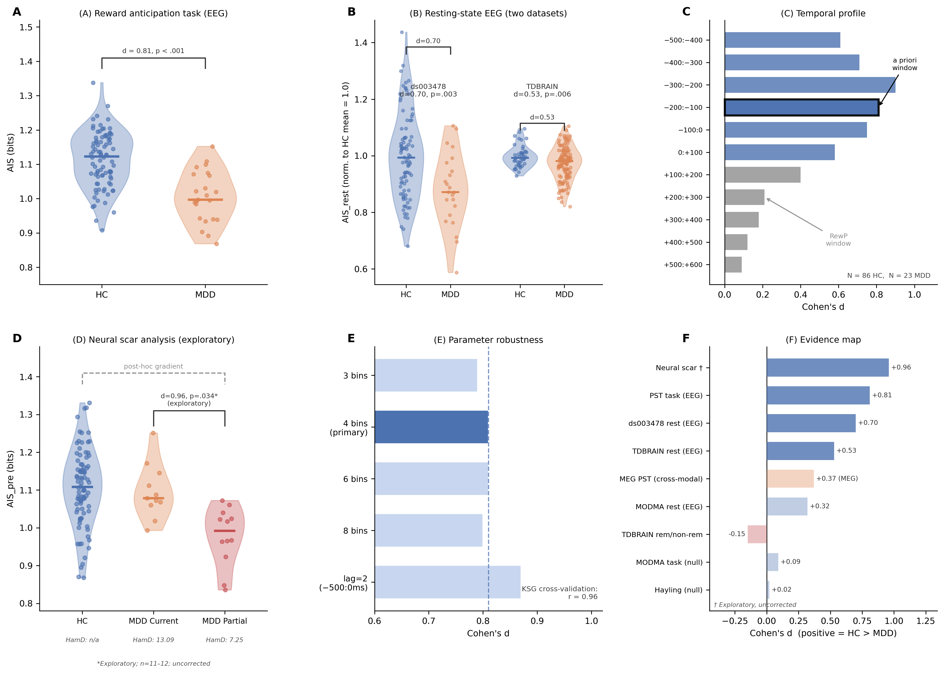

[DELETED: Fig. 1. Active Information Storage (AIS) at FCz in MDD across datasets and contexts. (A) AIS_pre (task, −200 to 0 ms pre-feedback) in HC versus MDD (Cavanagh PST; N = 109: 86 HC, 23 SCID-confirmed MDD…] Fig. 1. Active Information Storage (AIS) at FCz in MDD across datasets and contexts. (A) AIS_pre (task, −200 to 0 ms pre-feedback) in HC versus MDD (Cavanagh PST; N = 109: 86 HC, 23 SCID-confirmed MDD; nine ANX_other participants excluded). Individual data points shown; horizontal line indicates median. d = 0.81, p < .001. (B) AIS_rest (resting state, normalised to HC mean = 1.0) in two independent datasets: ds003478 (same participants as panel A; d = 0.70, p = .003) and TDBRAIN (independent clinical rTMS sample, BDI = 31; d = 0.53, p = .006). Absolute AIS_rest values are not directly comparable between datasets due to differences in clinical severity and preprocessing. (C) Cohen's d for AIS across eleven time windows (−500 to +600 ms relative to feedback onset; N = 86 HC, N = 23 MDD; ANX_other excluded). The a priori window (solid border, −200 to 0 ms, d = 0.81) is not the maximum (−300 to −200 ms: d = 0.90). The RewP window (+200 to +400 ms) shows a null effect (d = 0.21, p = .32). (D) AIS_pre by illness phase: HC, currently depressed (MDD Current; BDI = 22.45, HamD = 13.09), and partially remitted (MDD Partially Remitted; BDI = 20.92, HamD = 7.25). HamD scores annotated to illustrate dissociation between symptomatic and neural recovery. Solid bracket: pre-specified comparison (current vs. partially remitted, d = 0.96, p = .034, ANCOVA-confirmed); dashed bracket: exploratory post-hoc gradient. Analysis is explicitly exploratory (n = 11–12 per subgroup). (E) Parameter robustness: Cohen's d across five AIS parameter variants (d = 0.79–0.87). KSG (Kraskov–Stögbauer–Grassberger) cross-validation: r = 0.96. (F) Evidence map: Cohen's d for all findings including cross-modal MEG replication. Transparent bars indicate non-significant effects. MODMA resting state (d = 0.32): directionally consistent but underpowered (power = 21%); two of three resting-state EEG datasets reached conventional significance (task-based PST counted separately). The HC > MDD direction was consistent across all five datasets tested.

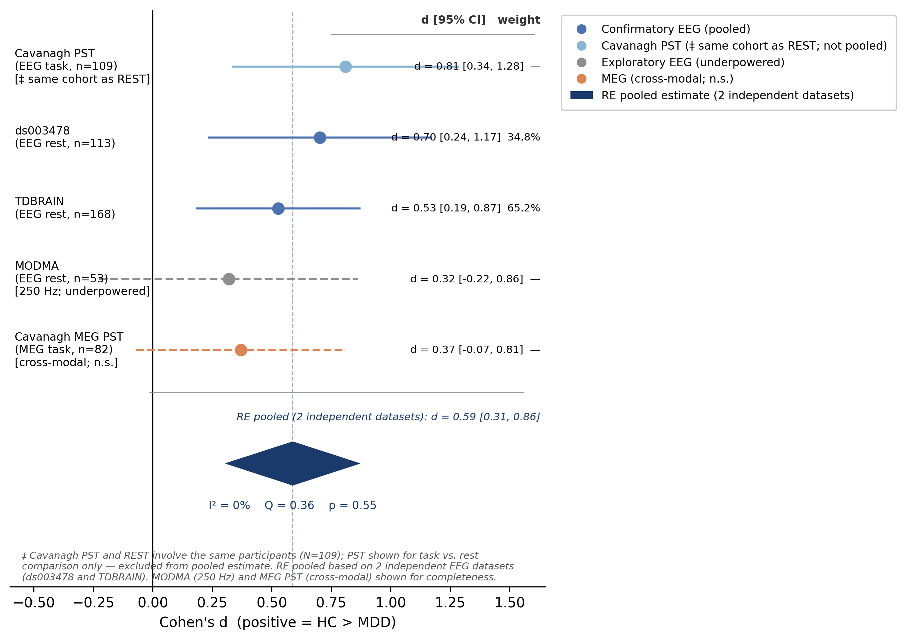

[DELETED: Fig. 2. Forest plot of Active Information Storage (AIS) effect sizes across datasets (positive d = HC > MDD). Each point represents Cohen's d with 95% confidence intervals. Blue circles: three confirm…] Fig. 2. Forest plot of Active Information Storage (AIS) effect sizes across datasets (positive d = HC > MDD). Each point represents Cohen's d with 95% confidence intervals. Blue circles: two genuinely independent EEG datasets included in the random-effects pooled estimate (ds003478 and TDBRAIN; DerSimonian-Laird method). Light blue circle: Cavanagh PST (same participants as ds003478; shown for task vs. rest comparison, excluded from pooled estimate). Grey circle: MODMA resting-state EEG (excluded from pooled estimate; 250 Hz sampling rate introduces a temporal lag mismatch relative to other datasets; underpowered, post-hoc power = 21%). Orange circle: Cavanagh MEG PST cross-modal replication (excluded from pooled estimate; p = .164, two-tailed; N=82 after exclusion of 1 subject). Navy diamond: random-effects pooled estimate based on two genuinely independent EEG datasets (ds003478 and TDBRAIN; Cavanagh PST excluded due to sample overlap with ds003478; d = 0.59 [95% CI: 0.31, 0.86]). Heterogeneity was negligible (I² = 0%, Q = 0.36, p = .55), indicating consistent effect magnitude across datasets in addition to consistent direction. The HC > MDD direction was observed across all five datasets. Percentages indicate dataset weights in the pooled estimate. Note: Cavanagh PST (ds003474) and Cavanagh REST (ds003478) involve the same participants (N=109) and are shown separately for task vs. rest comparison only; the random-effects pooled estimate is based exclusively on the two independent replication datasets (ds003478 and TDBRAIN).

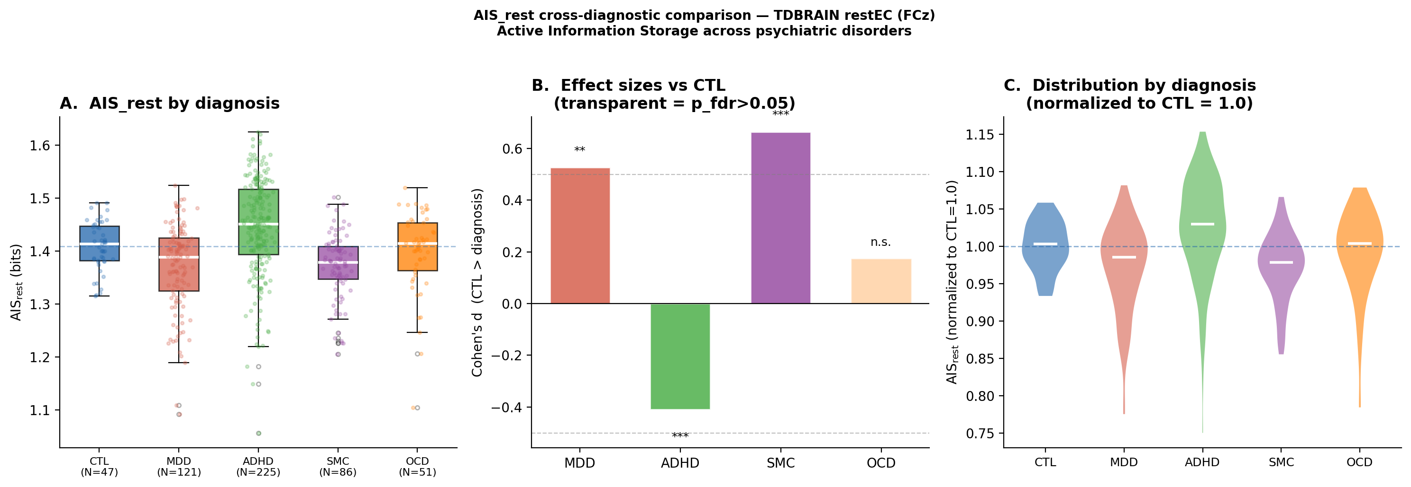

Supplementary Fig. S1. Cross-diagnostic comparison of resting-state AIS (AIS_rest) at FCz in the TDBRAIN database (eyes-closed resting state; N = 530 total; exploratory analysis). (A) Raw AIS_rest distributions by diagnostic group. Dashed line = HC mean (1.409 bits). HC (N = 47), MDD (N = 121), ADHD (N = 225), Subjective Memory Complaints (SMC, N = 86), OCD (N = 51). (B) Cohen’s d effect sizes versus HC (positive d = HC > diagnosis; negative d = diagnosis > HC). MDD: d = +0.53, p_fdr = .006. ADHD: d = −0.41, p_fdr < .001 (ADHD > HC; age-adjusted d = −0.26). SMC: d = +0.67, p_fdr < .001 but fully accounted for by age (SMC mean age 65.1 vs. HC 32.2 years; age-adjusted d = +0.01) — not a diagnostic effect. OCD: d = +0.17, n.s. Transparent bars = p_fdr > .05. (C) Violin plots of AIS_rest normalised to HC mean. All findings are exploratory. The ADHD elevation should not be interpreted as evidence for disorder-specific elevation; stimulant medication effects cannot be ruled out, and replication in medication-naïve samples with verified medication status is required before any transdiagnostic claim can be made.

Supplementary Material

Supplementary Table S1: Cross-Diagnostic AIS_rest Results (TDBRAIN; exploratory)

Diagnosis | N | AIS_rest M±SD | d vs HC (raw) | p_fdr | d (age-adj.) | Notes
HC | 47 | 1.409±0.047 | — | — | — | Reference
MDD | 121 | 1.371±0.082 | +0.53 | < .001 | +0.53 (crude); age-matching reduces to d = +0.145, p = .80 (see Limitations §4.5) | Treatment-resistant; AUC = 0.64 within-sample only; not validated externally
ADHD | 225 | 1.445±0.098 | −0.41 | < .001 | −0.26 | ADHD > HC; medication status unknown; NF subgroup (likely drug-free) d = −0.32. Do not interpret as diagnostic evidence.
SMC | 86 | 1.371±0.062 | +0.67 | < .001 | +0.01 | Age artefact: mean age 65.1 vs. HC 32.2 yrs; not a diagnostic finding
OCD | 51 | 1.398±0.071 | +0.17 | .94 | +0.01 | Null result

Note. d = Cohen’s d (positive = HC > diagnosis; negative = diagnosis > HC). Age-adjusted d = OLS residualisation of AIS_rest on age. All analyses are exploratory. Multi-class OvR AUC (five groups, AIS_rest as sole feature) = 0.75.

Supplementary Table S2: Forensic audit: seven potential sources of methodological inflation and empirical test results.

Risk | Empirical test | Verdict
1. Baseline leakage | r(AIS_baselined, AIS_raw) across trials | r = 1.00; equiquantile binning is rank-invariant to mean subtraction by construction
2. Channel selection | AIS_pre at Fz, FC1, FC2, Cz; Bonferroni threshold p = .0125 | 2/4 survived Bonferroni (Fz p = .001; FC2 p = .011); uncorrected: FC1 p = .027, Cz p = .013; frontocentral specificity confirmed
3. Binning amplification | r(signal variance, AIS_pre) across subjects | r = 0.07, p = .50; equiquantile binning removes amplitude dependence
4. Window selection bias | AIS at 8 windows, −500 to +600 ms (N = 23 SCID-confirmed MDD) | A priori window (d = 0.81) is not the maximum (Pre-2: d = 0.90); choice was conservative
5. Amplitude confound (TDBRAIN) | HC vs. MDD signal std at FCz | HC = 11.83 µV, MDD = 12.26 µV; d = −0.04, p = .76; no group difference
6. Preprocessing exclusion | Exclusion rate by group (Cavanagh PST) | HC 3.3% (3/90 excluded), MDD 0% (0/23); any bias is conservative with respect to the hypothesis
7. Estimator reliability | Split-half Spearman–Brown r + KSG cross-validation | Task r_SB = 0.98; resting r_SB = 0.996; KSG r = 0.96, p < .001

