Министерство образования и науки Кыргызской Республики

Кыргызский Государственный Технический Университет

им. И. Раззакова

Кафедра программного обеспечения компьютерных систем

БАКАЛАВРСКАЯ УЧЕБНАЯ ПРОГРАММА

НАПРАВЛЕНИЕ—710400 «ПРОГРАММНАЯ ИНЖЕНЕРИЯ»

Дисциплина «Методы оптимизации»

**Отчет по практической работе №2**

**«Разработка ПО для поиска решения одномерной задачи оптимизации**

**на основе *Pocket Search* method of optimization – *Метод поразрядного приближения*»**

по дисциплине

«МЕТОДЫ ОПТИМИЗАЦИИ»

Выполнил: Жанболот уулу Аскабек

Группа: ПИ-2-20

Проверил: Тен И.Г.

Бишкек 2022

**Практическая работа №2**

«Разработка ПО для поиска решения одномерной задачи оптимизации

на основе ***Pocket Search*** method of optimization – ***Метод поразрядного приближения***»

**Дано:**

* Задается аналитическое выражение для произвольной целевой функции f(x);
* Спецификация метода оптимизации (***Pocket Search Method***) для нахождения оптимального значения решающей переменной;
* Структура интерфейсной формы, реализующая метод — ***Pocket Search Method***.

**Что требуется:**

* Разработать проект ПО для поиска **решения задач оптимизации** для произвольной заданной допустимой погрешности;
* Написать ***код*** ПО для поиска **решения задач оптимизации** для произвольной заданной допустимой погрешности;
* Доказать, что найдено **оптимальное**решение с погрешностью решения не более заданной допустимой погрешности.

**Раздел №1**

**Наименование работы –** поиск решения одномерной задачи оптимизации методом Поразрядного приближения (PSM)

**Раздел №2**

СПЕЦИФИКАЦИЯ ПРОБЛЕМЫ №1: Поиск решения одномерной задачи оптимизации методом Поразрядного приближения.

Найти решение задачи оптимизации для произвольной заданной функции с допустимой погрешностью. Метод поразрядного приближения изменяет значение размера шага поиска h в зависимости от N итерации. Таким образом, метод поразрядного приближения генерирует нестационарные одношаговые итерационные процессы.

**Раздел №3**

**3.1: Описание метода**

To solve the one-dimensional optimization problem 𝐹𝑖𝑛𝑑 𝑒𝑥𝑡𝑟 𝑓(𝑥)𝑓𝑜𝑟 𝑥 ∈ 𝑅 1 using Pocket Search Method and given single an initial approximation x(0) of the searching variable value, and given an initial step size H(0), and given any significance value of digit position R with a required error tolerance tol.

**Initial input:** a function 𝑓(𝑥), an initial approximation x(0), step size H and an error tolerance 𝑡𝑜𝑙, value of digit position R.

**3.2: Mathematical description of the algorithm:  
Case (i):** IF f(x(k))>=f(x(k-1)) THEN /*To find a minimum*/

IF abs(H(k))< (tol/R) THEN H(k+1)=H(k); x(k+1)=x(k);

ELSE H(k+1)= –H(k)/R; x(k+1)=x(k)+H(k+1);

ELSE H(k+1)=H(k); x(k+1)=x(k)+H(k+1);

For all k=1,2,…;

Where k – is a number of iteration; x(k) – is an approximate value of the searching variable x on the k-th iteration; H(k) – is a step size value at k-th iteration; R – an adjustable parameter of the method (decreasing rate of the step size).

**Note:** It is the algorithm of the Pocket Search Method to find a minimum of a given objective function.

**Case (ii):** IF f(x(k))<=f(x(k-1)) /*To find a maximum*/

IF abs(H(k))< (tol/R) THEN H(k+1)=H(k); x(k+1)=x(k);

ELSE H(k+1)= –H(k)/R; x(k+1)=x(k)+H(k+1);

ELSE H(k+1)=H(k); x(k+1)=x(k)+H(k+1);

For all k=1,2,…;

Where k – is a number of iteration; x(k) – is an approximate value of the search variable x on the k-th iteration; H(k) – is a step size value at k-th iteration ; R – an adjustable parameter of the method (decreasing rate of the step size).

**Note:** It is the algorithm of the Pocket Search Method to find a maximum of a given objective function

**3.3a: Flow-chart of the POCKET SEARCH METHOD to find out minimum of an objective function**



**3.3b: Flow-chart of the POCKET SEARCH METHOD to find out maximum of an objective function**



**3.4: Computational description of the algorithm:**

Input {f(x); X0; Epsilon; H0; k_max; t_max; R}

YF0 = f(X0);

Timer_1 = Timer;

H1=H0;

X1 = X0 + H1;

YF1 = f(X1);

k = 0;

Cond = 0;

WHILE Cond = 0 & Abs(X1 – X0) !=0

IF k = k_max Then

Increase k_max?

Reply = Yes/No;

IF Reply = Yes Then

k_max += k_max;

ELSE

Cond=2;

END IF

END IF

IF ElapsedTime >= t_max Then

Increase t_max?

Reply = Yes/No;

IF Reply = Yes Then

t_max += t_max;

ELSE

Cond=2;

END IF

END IF

IF Cond != 2

IF YF1 <= YF0: //if find the maximum

IF |H0|<=Epsilon/R

IF k = 1:

Cond = 1;

END IF

H1 = H0;

X1 = X0;

YF1 = YF0;

ELSE:

H1 = -H0/R;

H0 = H1;

X0 = X1;

YF0 = YF1;

X1 = X0 + H1;

YF1 = f(X1);

END IF

ELSE:

H1 = H0;

X0 = X1;

YF0 = YF1;

X1 = X0 + H1;

YF1 = f(X1);

END IF

Timer_2 = Timer

ElapsedTime = Timer_2 – Timer_1

END IF

END WHILE

Output {X1; YF1; Abs(X1 – X0); k; ElapsedTime; H1}

**Note:** It is the algorithm of the Even Search Method to find a **maximum** of a given objective function.

Input {f(x); X0; Epsilon; H; k_max; t_max}

YF0 = f(X0);

Timer_1 = Timer;

X1 = X0 + H;

YF1 = f(X1);

k = 0;

Cond = 0;

WHILE Cond = 0 & Abs(X1 – X0) !=0

IF k = k_max Then

Increase k_max?

Reply = Yes/No;

IF Reply = Yes Then

k_max += k_max;

ELSE

Cond=2;

END IF

END IF

IF ElapsedTime >= t_max Then

Increase t_max?

Reply = Yes/No;

IF Reply = Yes Then

t_max += t_max;

ELSE

Cond=2;

END IF

END IF

IF Cond != 2

IF YF1 >= YF0: //if find the minimum

IF |H0|<=Epsilon/R

IF k = 1:

Cond = 1;

END IF

H1 = H0;

X1 = X0;

YF1 = YF0;

ELSE:

H1 = -H0/R;

H0 = H1;

X0 = X1;

YF0 = YF1;

X1 = X0 + H1;

YF1 = f(X1);

END IF

ELSE:

H1 = H0;

X0 = X1;

YF0 = YF1;

X1 = X0 + H1;

YF1 = f(X1);

END IF

Timer_2 = Timer

ElapsedTime = Timer_2 – Timer_1

END IF

END WHILE

Output {X1; YF1; Abs(X1 – X0); k; ElapsedTime; H1}

**Note:** It is the algorithm of the Even Search Method to find a **minimum** of a given objective function.

**Раздел № 4 Стадия проектирования системы для поиска решения одномерной задачи оптимизации методом Поразрядного приближения**

**4.1: Функциональные требования:**

1) Программа должна производить поиск экстремума произвольной нелинейной функции, с заданной погрешностью.

2) В программе должно быть предоставлено доказательство валидности найденного решения.

3) Программа должна определять траекторию к определенному excel-file “MO_LookingForOnePoint.xlsx”.

4) Программа должна открывать лист “Russian” excel файла “MO_LookingForOnePoint.xlsx”, и вставлять целевую функцию, левую и правую границы в определенные ячейки листа.

5) Программа должна вычислять значение целевой функции f(x), для любого значения аргумента x.

6) В программе должна производиться проверка валидности введеных данных.

7) В программе должна быть реализована PocketSearchMethod для поиска экстремума функции.

**Раздел №5**

**ПРОЕКТИРОВАНИЕ По**: Документирование этапов проектирования интерфейсной формы системы, реализующей метод поразрядного приближения – для поиска решения одномерной задачи оптимизации

**5.1: Документирование процесса задания свойств элементов интерфейсной формы системы, выбранной для внедрения и реализующей Even Search Method**

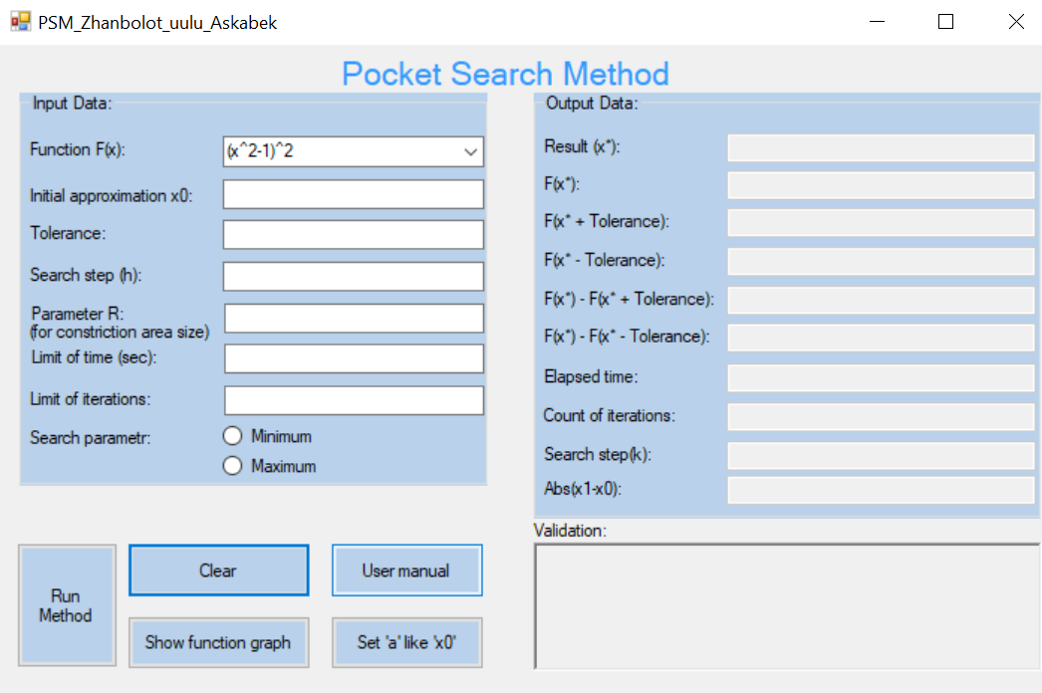

Table 1: Settings for control properties of the software system implementing Even Search method (the table is intended to document the activity of a student to settings control properties of the interface form – the table is ***mandatory***)

|  |  |  |  |
| --- | --- | --- | --- |
| **Number of control** | **Control** | **Property** | **Setting** |
| 1 | Label1 | Appearance (Text) | Pocket Search Method |
| Design (Name) | label1 |
| 2 | GroupBox1 | Appearance (Text) | Input Data |
| Design (Name) | groupBox1 |
| 3 | Label2 | Appearance (Text) | Function F(x) |
| Design (Name) | label2 |
| 4 | ComboBox1 | Appearance (Text) | (x^2-1)^2 |
| The rest (Items) | Collection |
| Items (Collection) | (x-1)*(x-2)^2  x^2-4*sin(x)  x^3-5*x^2+x+5  (x-2)^2-ln(x)  (x-2)^2-log(x) |
| Design (Name) | Function |
| 5 | Label3 | Appearance (Text) | Initial approximation x0 |
| Design (Name) | label3 |
| 6 | TextBox1 | Appearance (Text) |  |
| Design (Name) | InitialApproximation |
| 7 | Label4 | Appearance (Text) | Tolerance |
| Design (Name) | label4 |
| 8 | TextBox2 | Appearance (Text) |  |
| Design (Name) | Tolerance |
| 9 | Label5 | Appearance (Text) | Limit of time: |
| Design (Name) | label6 |
| 10 | TextBox3 | Appearance (Text) |  |
| Design (Name) | limitOfTime |
| 11 | Label6 | Appearance (Text) | Limit of iterations: |
| Design (Name) | label5 |
| 12 | TextBox4 | Appearance (Text) |  |
| Design (Name) | limitOfIterations |
| 13 | ProgressBar1 | Behavior (Visible) | true |
| Design (Name) | progressBar1 |
| 14 | GroupBox2 | Appearance (Text) | Output Data |
| Design (Name) | groupBox2 |
| 15 | Button1 | Appearance (Text) | User manual |
| Design (Name) | button5 |
| 16 | RadioButton1 | Appearance (Text) | minimum |
| Design (Name) | Minimum |
| 17 | RadioButton2 | Appearance (Text) | maximum |
| Design (Name) | Maximum |
| 18 | Button2 | Appearance (Text) | Run Method |
| Design (Name) | button1 |
| 19 | Button3 | Appearance (Text) | Show function graph |
| Design (Name) | FunctionGraph |
| 20 | Button4 | Appearance (Text) | Clear |
| Design (Name) | button3 |
| 21 | Button5 | Appearance (Text) | Set ‘a’ like ‘x0’ |
| Design (Name) | button2 |
| 22 | GroupBox3 | Appearance (Text) | Output Data |
| Design (Name) | groupBox2 |
| 23 | Label7 | Appearance (Text) | Result (x*): |
| Design (Name) | label12 |
| 24 | TextBox5/ Behavior  (ReadOnly) | ReadOnly | true |
| Design (Name) | ResultX |
| 25 | Label8 | Appearance (Text) | Elapsed time: |
| Design (Name) | label9 |
| 26 | TextBox6/ Behavior  (ReadOnly) | ReadOnly | true |
| Design (Name) | elapsedTime |
| 27 | Label9 | Appearance (Text) | Count of iterations: |
| Design (Name) | label10 |
| 28 | TextBox7/ Behavior  (ReadOnly) | ReadOnly | true |
| Design (Name) | countofiterations |
| 29 | Label10 | Appearance (Text) | F(x*): |
| Design (Name) | label13 |
| 30 | TextBox8/ Behavior  (ReadOnly) | ReadOnly | true |
| Design (Name) | fx |
| 31 | Label11 | Appearance (Text) | F(X*+Tolerance): |
| Design (Name) | label16 |
| 32 | TextBox9/ Behavior  (ReadOnly) | ReadOnly | true |
| Design (Name) | fxplustolerance |
| 33 | Labe112 | Appearance (Text) | F(X*-Tolerance): |
| Design (Name) | label15 |
| 34 | TextBox10/ Behavior  (ReadOnly) | ReadOnly | true |
| Design (Name) | fxminustolerance |
| 35 | Label13 | Appearance (Text) | Validation |
| Design (Name) | label17 |
| 36 | RichTextBox1/ Behavior  (ReadOnly) | Appearance  (Text) |  |
|  |  |  |  |
|  |  |
| 38 | Label14 | Appearance (Text) | F(X*)-F(X*+Tolerance) |
| Design (Name) | label11 |
| 39 | TextBox13/ Behavior  (ReadOnly) | ReadOnly | true |
|  |  | Design (Name) | fxminusplustolerance |
| 40 | Label15 | Appearance (Text) | F(X*)-F(X*-Tolerance) |
|  |  | Design (Name) | label8 |
| 41 | TextBox12/ Behavior  (ReadOnly) | ReadOnly | true |
|  |  | Design (Name) | fxminusminustolerance |
| 42 | TextBox13/Behavior  (ReadOnly) | ReadOnly | true |
|  |  | Design (Name) | absError |
| 43 | Label16 | Appearance (Text) | Abs(x1-x0): |
|  |  | Design (Name) | label21 |
| 44 | TextBox14/Behavior  (ReadOnly) | ReadOnly | true |
|  |  | Design (Name) | resultSearchStep |
| 45 | Label17 | Appearance (Text) | Search step(k): |
|  |  | Design (Name) | label20 |
| 46 | Label18 | Appearance (Text) | Search step (h): |
|  |  | Design (Name) | label7 |
| 47 | TextBox15 | Appearance (Text) |  |
|  |  | Design (Name) | SearchStep |
| 48 | Label19 | Appearance (Text) | Parameter (R) |
|  |  | Design (Name) | label18 |
| 49 | TextBox16 | Appearance (Text) |  |
|  |  | Design (Name) | ParameterR |

**Раздел №6**

**Стадии *конструирования* программного обеспечения для поиска решения одномерной задачи оптимизации, реализующей Pocket Search Method:**

**6.1:** Код программы на C# Windows Forms(.NET Framework), ***ассоцированный с интерфейсной формой*** “Form1.cs”, который ***реализует функции ввода и вывода данных***, ***реализует логику*** Pocket Search метода и составляет Public Class “Form1”

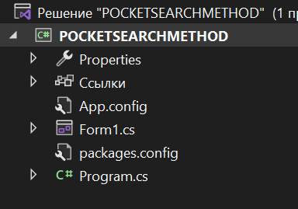

**6.2:** **Листинг программы**

using System;

using System.Text;

using Microsoft.Office.Interop.Excel;

using System.Windows.Forms;

using Application = Microsoft.Office.Interop.Excel.Application;

using TextBox = System.Windows.Forms.TextBox;

using MessageBox = System.Windows.Forms.MessageBox;

using aziretParser;

using System.Diagnostics;

using System.Drawing;

namespace POCKETSEARCHMETHOD

{

public partial class Form1 : Form

{

private const string nameOfExcel = @"\Zhanbolot_uulu_Askabek_LookingForOnePoint.xlsm";

string inputFuncFX = "";

decimal x0 = 0;

decimal x1 = 0;

decimal f0;

decimal f1;

decimal e_tol = 0;

decimal h = 0;

int k_max = 0;

decimal t_max = 0;

decimal parameterR = 0;

bool b = false;

decimal fplusTol;

decimal fminusTol;

decimal constB = 0;

Application xls;

Workbook book = null;

Worksheet sheet = null;

public Form1()

{

InitializeComponent();

xls = new Application();

}

public int getSign(decimal number)

{

if (number < 0)

{

return -1;

}

else

{

return 1;

}

}

public void OpenExcel()

{

if (!checkFunction(1)) return;

string function;

decimal startPoint;

if (book == null)

{

book = xls.Workbooks.Open(System.IO.Directory.GetCurrentDirectory() + nameOfExcel);

}

if (sheet == null)

{

sheet = book.Sheets["Russian"];

sheet.Activate();

}

xls.Visible = true;

function = Function.Text;

if (InitialApproximation.Text != "" && InitialApproximation.Text != "-" && InitialApproximation.Text != "+" && InitialApproximation.Text != ".")

{

startPoint = Decimal.Parse(InitialApproximation.Text);

}else

{

startPoint = 1;

}

sheet.Cells[4, 9] = startPoint;

sheet.Cells[2, 1] = "f(x)=" + Function.Text;

StringBuilder builder = new StringBuilder(function);

builder.Replace("exp", ":");

builder.Replace("x", "D4");

builder.Replace(":", "exp");

function = builder.ToString();

sheet.Range["E4:E10003"].Value = "=" + function;

}

private bool parseTry(TextBox t, String type)

{

try

{

if (type == "Decimal")

Decimal.Parse(t.Text, System.Globalization.NumberStyles.Float);

else if (type == "Integer")

int.Parse(t.Text);

return true;

}

catch

{

return false;

}

}

private void Clean(Control control)

{

foreach (var element in control.Controls)

{

switch (element.GetType().Name)

{

case "TextBox":

((TextBox)element).Text = String.Empty;

break;

case "RadioButton":

((RadioButton)element).Checked = false;

break;

case "RichTextBox":

((RichTextBox)element).Text = String.Empty;

break;

case "GroupBox":

Clean((Control)element);

break;

default:

break;

}

}

}

private bool IsOKForDecimalTextBox(char theCharacter, TextBox theTextBox, bool positive)

{

if (!char.IsControl(theCharacter) && !char.IsDigit(theCharacter) && (theCharacter != ',') && (theCharacter != '.')

&& (theCharacter != '-') && (theCharacter != '+') && (theCharacter != 'E') && (theCharacter != 'e'))

{

return false;

}

if(positive && theCharacter == '-' && (theTextBox.Text.IndexOf('E') == -1 && theTextBox.Text.IndexOf('e') == -1))

{

return false;

}

if (theCharacter == ',' && (theTextBox.Text.IndexOf(',') > -1 || theTextBox.Text.IndexOf('.') > -1))

{

return false;

}

if (theCharacter == '.' && (theTextBox.Text.IndexOf('.') > -1 || theTextBox.Text.IndexOf(',') > -1))

{

return false;

}

if (theCharacter == 'e' && (theTextBox.Text.IndexOf('e') > -1 || theTextBox.Text.IndexOf('E') > -1))

{

return false;

}

if (theCharacter == 'E' && (theTextBox.Text.IndexOf('E') > -1 || theTextBox.Text.IndexOf('e') > -1))

{

return false;

}

if (theCharacter == '-' && (theTextBox.Text.IndexOf('-') > -1 || theTextBox.Text.IndexOf('+') > -1))

{

return false;

}

if (theCharacter == '+' && (theTextBox.Text.IndexOf('+') > -1 || theTextBox.Text.IndexOf('-') > -1))

{

return false;

}

if (((theCharacter == '-') || (theCharacter == '+')) && (theTextBox.SelectionStart != 0 && (theTextBox.Text.IndexOf('E') == -1 && theTextBox.Text.IndexOf('e') == -1)))

{

return false;

}

if ((char.IsDigit(theCharacter) || (theCharacter == ',') || (theCharacter == '.')) && ((theTextBox.Text.IndexOf('-') > -1)

|| (theTextBox.Text.IndexOf('+') > -1)) && theTextBox.SelectionStart == 0)

{

return false;

}

return true;

}

public decimal Fx(decimal x)

{

decimal result;

result = aziretParser.Computer.Compute(inputFuncFX, x);

return result;

}

private void button4_Click(object sender, EventArgs e)

{

OpenExcel();

}

private void button3_Click(object sender, EventArgs e)

{

Clean(this);

progressBar1.Visible = false;

}

private void InitialApproximation_KeyPress(object sender, KeyPressEventArgs e)

{

e.Handled = !IsOKForDecimalTextBox(e.KeyChar, InitialApproximation, false);

if (e.KeyChar == '.')

{

e.KeyChar = ',';

}

}

private void Tolerance_KeyPress(object sender, KeyPressEventArgs e)

{

e.Handled = !IsOKForDecimalTextBox(e.KeyChar, Tolerance, true);

if (e.KeyChar == '.')

{

e.KeyChar = ',';

}

}

private void SearchStep_KeyPress(object sender, KeyPressEventArgs e)

{

e.Handled = !IsOKForDecimalTextBox(e.KeyChar, SearchStep, true);

if (e.KeyChar == '.')

{

e.KeyChar = ',';

}

}

private void ParametrR_KeyPress(object sender, KeyPressEventArgs e)

{

if ((int)e.KeyChar == (int)48 && ParametrR.Text == "")

{

e.Handled = true;

return;

}

e.Handled = !char.IsDigit(e.KeyChar) && !char.IsControl(e.KeyChar);

}

private String checkParse()

{

String errorMessage = "";

if (!parseTry(InitialApproximation, "Decimal"))

{

errorMessage += "Invalid value of the field x0 (the starting point of the approximation)! Change the input and perform the calculation!\n\n";

}

else

{

x0 = Decimal.Parse(InitialApproximation.Text, System.Globalization.NumberStyles.Float);

}

if (!parseTry(SearchStep, "Decimal"))

{

errorMessage += "Invalid value of the field search step! Change the input and perform the calculation!\n\n";

}

else

{

h = Decimal.Parse(SearchStep.Text, System.Globalization.NumberStyles.Float);

}

if (parseTry(Tolerance, "Decimal"))

{

e_tol = Decimal.Parse(Tolerance.Text, System.Globalization.NumberStyles.Float);

}

else

{

errorMessage += "Invalid value of the Tolerance(e) field (entered tolerance)! Change the input and perform the calculation!\n\n";

}

if (!parseTry(LimitOfIterations, "Integer"))

{

errorMessage += "Invalid value of the field limit of iterations! Change the input and perform the calculation!\n\n";

}

else

{

k_max = Int32.Parse(LimitOfIterations.Text);

}

if (!parseTry(ParametrR, "Integer"))

{

errorMessage += "Invalid value of the field parameter R! Change the input and perform the calculation!\n\n";

}

else

{

parameterR = Decimal.Parse(ParametrR.Text);

}

if (!parseTry(LimitOfTime, "Decimal"))

{

errorMessage += "Invalid value of the field limit of time! Change the input and perform the calculation!\n\n";

}

else

{

t_max = Decimal.Parse(LimitOfTime.Text, System.Globalization.NumberStyles.Float);

}

return errorMessage;

}

public bool fullCheck()

{

bool check = false;

if (Function.Text == "" || InitialApproximation.Text == "" ||

Tolerance.Text == "" || LimitOfIterations.Text == "" ||

LimitOfTime.Text == "" || SearchStep.Text == "" || ParametrR.Text == "")

{

MessageBox.Show("All fields must be filled in! Enter the missing information and make the calculation!", "Error", MessageBoxButtons.OK, MessageBoxIcon.Error);

}

else

{

if (checkParse() != "")

{

MessageBox.Show(checkParse(), "Error", MessageBoxButtons.OK, MessageBoxIcon.Error);

}

else

{

if (isRigth() && checkFunction(x0))

{

check = true;

}

}

}

return check;

}

public string getComparisonSign(decimal a, decimal b)

{

if (a > b)

{

return ">";

}

else if (a < b)

{

return "<";

}

else

{

return "=";

}

}

private bool isRigth()

{

bool b = true;

if (e_tol <= 0)

{

MessageBox.Show("The value of the tolerance field must be greater than 0! Change the input and perform the calculation!", "Error", MessageBoxButtons.OK, MessageBoxIcon.Error);

b = false;

}

if (h <= 0)

{

MessageBox.Show("The value of the search step field must be greater than 0! Change the input and perform the calculation!", "Error", MessageBoxButtons.OK, MessageBoxIcon.Error);

b = false;

}

if (k_max <= 0)

{

MessageBox.Show("The value of the limit of iterations field must be greater than 0! Change the input and perform the calculation!", "Error", MessageBoxButtons.OK, MessageBoxIcon.Error);

b = false;

}

if (t_max <= 0)

{

MessageBox.Show("The value of the limit of time field must be greater than 0! Change the input and perform the calculation!", "Error", MessageBoxButtons.OK, MessageBoxIcon.Error);

b = false;

}

if (parameterR <= 1)

{

MessageBox.Show("The value of the parameter R field must be greater than 1! Change the input and perform the calculation!", "Error", MessageBoxButtons.OK, MessageBoxIcon.Error);

b = false;

}

if (!(Maximum.Checked || Minimum.Checked))

{

MessageBox.Show("Please select search option maximum or minimum.", "Error", MessageBoxButtons.OK, MessageBoxIcon.Error);

b = false;

}

if (b)

{

return true;

}

return false;

}

private bool checkFunction(decimal x0)

{

inputFuncFX = Function.Text;

if (inputFuncFX == "" || inputFuncFX.IndexOf('x') == -1)

{

MessageBox.Show("The function is entered incorrectly! Change the input and perform the calculation!", "Error", MessageBoxButtons.OK, MessageBoxIcon.Error);

Clean(this);

return false;

}

try

{

if (inputFuncFX.Contains("log") && x0 <= 0 || inputFuncFX.Contains("ln") && x0 <= 0)

{

MessageBox.Show("If you entered function with 'log' or 'ln' value of X0 must greater than zero!", "Error", MessageBoxButtons.OK, MessageBoxIcon.Error);

return false;

}

else

{

decimal F1 = Fx(x0);

return true;

}

}

catch

{

MessageBox.Show("The function or initial approximation is entered incorrectly! Change the input and perform the calculation!", "Error", MessageBoxButtons.OK, MessageBoxIcon.Error);

Clean(this);

return false;

}

}

public bool MaxOrMin(decimal f0, decimal f1)

{

if (Maximum.Checked)

{

return f0 >= f1;

}

return f0 <= f1;

}

public void FillResult(string solution, string iterations, string resultTolerance, string fminustol, string fplustol, string fxvalue, string fminusplus, string fminusminus, string searchStep)

{

ResultX.Text = solution;

countofiterations.Text = iterations;

fxplustolerance.Text = fplustol;

fxminustolerance.Text = fminustol;

fxminusplustolerance.Text = fminusplus;

fxminusminustolerance.Text = fminusminus;

fx.Text = fxvalue;

resultSearchStep.Text = getError(SearchStep, Decimal.Parse(searchStep));

}

public string getError(TextBox tol, decimal error)

{

Console.WriteLine(tol);

if (tol.Text.Contains("E"))

{

return error.ToString("0E0");

}

else if (tol.Text.Contains("e"))

{

return error.ToString("0e0");

}

else

{

return error.ToString();

}

}

private void LimitOfTime_KeyPress(object sender, KeyPressEventArgs e)

{

e.Handled = !IsOKForDecimalTextBox(e.KeyChar, LimitOfTime, true);

if(e.KeyChar == '.')

{

e.KeyChar = ',';

}

}

private void LimitOfIterations_KeyPress(object sender, KeyPressEventArgs e)

{

if ((int)e.KeyChar == (int)48 && LimitOfIterations.Text == "")

{

e.Handled = true;

return;

}

e.Handled = !char.IsDigit(e.KeyChar) && !char.IsControl(e.KeyChar);

}

private void button5_Click(object sender, EventArgs e)

{

DialogResult result = MessageBox.Show("1) Choose a function or write your's on field 'Function'\n" +

"2) Click on the button 'Show function graph'\n" +

"3) In the opened file select the values for a or b,\n" +

"then save the document and return to the program\n" +

"4) If you need 'a' value to insert,\n" +

"click the button 'Set 'a' like 'X0'' or write your's\n" +

"5) Enter tolerance\n" +

"6) Enter search step\n" +

"7) Enter parameter R for constriction area size\n" +

"8) Enter limit of time in sec\n" +

"9) Enter limit of iterations \n" +

"10) Select search parameter\n" +

"Then click the button 'Run Method'.", "Information",

MessageBoxButtons.OK, MessageBoxIcon.Information);

}

private void button2_Click(object sender, EventArgs e)

{

if (book == null)

{

book = xls.Workbooks.Open(System.IO.Directory.GetCurrentDirectory() + nameOfExcel);

}

if (sheet == null)

{

sheet = book.Sheets["Russian"];

sheet.Activate();

}

book.Save();

InitialApproximation.Text = sheet.Cells[4, 9].Value.ToString();

xls.Visible = false;

book = null;

sheet = null;

}

private void button1_Click(object sender, EventArgs e)

{

if (book == null)

{

book = xls.Workbooks.Open(System.IO.Directory.GetCurrentDirectory() + nameOfExcel);

}

if(sheet == null)

{

sheet = book.Sheets["Russian"];

sheet.Activate();

}

decimal checkA = Decimal.Parse(InitialApproximation.Text, System.Globalization.NumberStyles.Float);

constB = Decimal.Parse(sheet.Cells[4, 10].Value.ToString());

if(checkA >= constB)

{

constB = checkA + 2;

}

xls.Visible = false;

book = null;

sheet = null;

h = 0;

x0 = 0;

x1 = 0;

f0 = 0;

f1 = 0;

e_tol = 0;

k_max = 0;

t_max = 0;

parameterR = 0;

inputFuncFX = "";

fminusTol = 0;

fplusTol = 0;

string extremium;

try

{

if (fullCheck())

{

if (Maximum.Checked)

{

extremium = "maximizer";

}

else

{

extremium = "minimizer";

}

progressBar1.Value = 0;

Clean(groupBox2);

validation.Text = String.Empty;

Stopwatch stopwatch = new Stopwatch();

stopwatch.Start();

f0 = Fx(x0);

x1 = x0 + h;

f1 = Fx(x1);

int k = 0;

do

{

k = k + 1;

progressBar1.Visible = true;

progressBar1.Maximum = (int)(k + 0.00000001);

progressBar1.Value = k;

if (k > k_max)

{

stopwatch.Stop();

f1 = Fx(x1);

fminusTol = Fx(x1 - h);

fplusTol = Fx(x1 + h);

DialogResult result = MessageBox.Show("Iteration limit reached. Do you want to add iterations?",

"Information", MessageBoxButtons.YesNo, MessageBoxIcon.Information);

if (result == DialogResult.Yes)

{

k_max += k_max;

LimitOfIterations.Text = k_max.ToString();

}

else

{

k--;

validation.Text += "Result X* not found because of limit of iterations = " + k_max + "." +

"\nSince the following condition is false, namely:" +

"\nSign(f(X*)-f(X*+Tolerance)) = " + getSign(f1 - fplusTol) + " and Sign(f(X*)-f(X*-Tolerance)) = " + getSign(f1 - fminusTol) + "!" +

"\nResult X* is not " + extremium + " of the function.";

validation.ForeColor = Color.Red;

FillResult(x1.ToString("F28"), k.ToString(), getError(Tolerance, Math.Abs(x1 - x0)), fminusTol.ToString("F28"), fplusTol.ToString("F28"), f1.ToString("F28"), (f1 - fplusTol).ToString("F28"), (f1 - fminusTol).ToString("F28"), getError(absError, Math.Abs(h)));

absError.Text = getError(Tolerance, Math.Abs(x1 - x0));

DialogResult answer = MessageBox.Show("Result X* not found because of maximum limit of iterations = " + k_max + "." +

"\nSince the following condition is false, namely:" +

"\nSign(f(X*)-f(X*+Tolerance)) = " + getSign(f1 - fplusTol) + " and Sign(f(X*)-f(X*-Tolerance)) = " + getSign(f1 - fminusTol) + "!" +

"\nResult X* is not " + extremium + " of the function." +

"\n\nYou probably entered the values of 'a' and 'b' range incorrectly on Ecxel!" +

"\nSince the program is looking for an extremum only in the range 'a' and 'b'." +

"\nYou need to open the graph and select the correct points [a;b]!" +

"\n\nDo you want to open file?", "Error", MessageBoxButtons.YesNo, MessageBoxIcon.Error);

if (answer == DialogResult.Yes)

{

OpenExcel();

}

break;

}

stopwatch.Start();

}

if (stopwatch.ElapsedMilliseconds >= t_max * 1000)

{

stopwatch.Stop();

f1 = Fx(x1);

fminusTol = Fx(x1 - h);

fplusTol = Fx(x1 + h);

DialogResult result = MessageBox.Show("Time limit reached. Do you want to add time?",

"Information", MessageBoxButtons.YesNo, MessageBoxIcon.Information);

if (result == DialogResult.Yes)

{

t_max += t_max;

LimitOfTime.Text = t_max.ToString();

}

else

{

validation.Text += "Result X* not found because of limit of time = " + t_max + " sec." +

"\nSince the following condition is false, namely:" +

"\nSign(f(X*)-f(X*+Tolerance)) = " + getSign(f1 - fplusTol) + " and Sign(f(X*)-f(X*-Tolerance)) = " + getSign(f1 - fminusTol) + "!" +

"\nResult X* is not " + extremium + " of the function.";

validation.ForeColor = Color.Red;

FillResult(x1.ToString("F28"), k.ToString(), getError(Tolerance, Math.Abs(x1 - x0)), fminusTol.ToString("F28"), fplusTol.ToString("F28"), f1.ToString("F28"), (f1 - fplusTol).ToString("F28"), (f1 - fminusTol).ToString("F28"), getError(absError, Math.Abs(h)));

absError.Text = getError(Tolerance, Math.Abs(x1 - x0));

DialogResult answer = MessageBox.Show("Result X* not found because of maximum time limit = " + t_max + " sec." +

"\nSince the following condition is false, namely:" +

"\nSign(f(X*)-f(X*+Tolerance)) = " + getSign(f1 - fplusTol) + " and Sign(f(X*)-f(X*-Tolerance)) = " + getSign(f1 - fminusTol) + "!" +

"\nResult X* is not " + extremium + " of the function." +

"\n\nYou probably entered the values of 'a' and 'b' range incorrectly on Ecxel!" +

"\nSince the program is looking for an extremum only in the range 'a' and 'b'." +

"\nYou need to open the graph and select the correct points [a;b]!" +

"\n\nDo you want to open file?", "Error", MessageBoxButtons.YesNo, MessageBoxIcon.Error);

if (answer == DialogResult.Yes)

{

OpenExcel();

}

break;

}

stopwatch.Start();

}

if (MaxOrMin(f0, f1))

{

if (Math.Abs(h) < e_tol / parameterR)

{

x1 = x0;

f1 = f0;

continue;

}

else

{

h = -h / parameterR;

}

}

if (x1 > constB || x1 < Decimal.Parse(InitialApproximation.Text, System.Globalization.NumberStyles.Float))

{

h = -h / parameterR;

x1 = Decimal.Parse(InitialApproximation.Text, System.Globalization.NumberStyles.Float) + Math.Abs(h);

}

x0 = x1;

f0 = f1;

x1 = x0 + h;

f1 = Fx(x1);

fminusTol = Fx(x1 - h);

fplusTol = Fx(x1 + h);

if (Math.Abs(x1 - x0) <= e_tol)

{

if (extremium == "minimizer")

{

if (f1 <= fminusTol && f1 <= fplusTol)

{

FillResult(x1.ToString("F28"), k.ToString(), getError(Tolerance, Math.Abs(x1 - x0)), fminusTol.ToString("F28"), fplusTol.ToString("F28"), f1.ToString("F28"), (f1 - fplusTol).ToString("F28"), (f1 - fminusTol).ToString("F28"), getError(absError, Math.Abs(h)));

validation.Text += "Since the following condition is true, namely:" +

"\nSign(f(X*)-f(X*+Tolerance)) = " + getSign(f1 - fplusTol) + " and Sign(f(X*)-f(X*-Tolerance)) = " + getSign(f1 - fminusTol) + "!" +

"\nResult X* is minimizer of the function. It has been found with the error = " + Math.Abs(h) + ". This is less than or equal to given Tolerance!";

absError.Text = Math.Abs(x1 - x0).ToString("F28");

validation.ForeColor = Color.Green;

absError.Text = getError(Tolerance, Math.Abs(x1 - x0));

break;

}

}

else

{

if ((f1 >= fminusTol && f1 >= fplusTol))

{

FillResult(x1.ToString("F28"), k.ToString(), getError(Tolerance, Math.Abs(x1 - x0)), fminusTol.ToString("F28"), fplusTol.ToString("F28"), f1.ToString("F28"), (f1 - fplusTol).ToString("F28"), (f1 - fminusTol).ToString("F28"), getError(absError, Math.Abs(h)));

validation.Text += "Since the following condition is true, namely:" +

"\nSign(f(X*)-f(X*+Tolerance)) = " + getSign(f1 - fplusTol) + " and Sign(f(X*)-f(X*-Tolerance)) = " + getSign(f1 - fminusTol) + "!" +

"\nResult X* is maximizer of the function. It has been found with the error = " + Math.Abs(h) + ". This is less than or equal to given Tolerance!";

validation.ForeColor = Color.Green;

absError.Text = getError(Tolerance, Math.Abs(x1 - x0));

break;

}

}

}

} while (true);

stopwatch.Stop();

elapsedtime.Text = stopwatch.ElapsedMilliseconds / 1000.0 + " sec";

timer1.Enabled = true;

timer1.Start();

}

}

catch (Exception ex)

{

MessageBox.Show(ex.Message, "Error", MessageBoxButtons.OK, MessageBoxIcon.Error);

Clean(this);

progressBar1.Value = 0;

}

}

private void timer1_Tick(object sender, EventArgs e)

{

progressBar1.Value = 0;

timer1.Enabled = false;

timer1.Stop();

}

private void Function_TextChanged(object sender, EventArgs e)

{

Clean(groupBox2);

validation.Text = String.Empty;

}

private void InitialApproximation_TextChanged(object sender, EventArgs e)

{

Clean(groupBox2);

validation.Text = String.Empty;

}

private void Tolerance_TextChanged(object sender, EventArgs e)

{

Clean(groupBox2);

validation.Text = String.Empty;

}

private void SearchStep_TextChanged(object sender, EventArgs e)

{

Clean(groupBox2);

validation.Text = String.Empty;

}

private void ParametrR_TextChanged(object sender, EventArgs e)

{

Clean(groupBox2);

validation.Text = String.Empty;

}

private void LimitOfTime_TextChanged(object sender, EventArgs e)

{

Clean(groupBox2);

validation.Text = String.Empty;

}

private void LimitOfIterations_TextChanged(object sender, EventArgs e)

{

Clean(groupBox2);

validation.Text = String.Empty;

}

private void Maximum_CheckedChanged(object sender, EventArgs e)

{

Clean(groupBox2);

validation.Text = String.Empty;

}

private void Minimum_CheckedChanged(object sender, EventArgs e)

{

Clean(groupBox2);

validation.Text = String.Empty;

}

private void Form1_FormClosed(object sender, FormClosedEventArgs e)

{

xls.Quit();

}

}

}

**6.3:** Подключение библиотечных программ «Microsoft.Office.Interop.Excel» к программному проекту для выполнения функции парсинга и открытия excel файла

Шаг №1: Правой кнопкой мыши открыть контекстное меню на выделенной синим цветом строке:

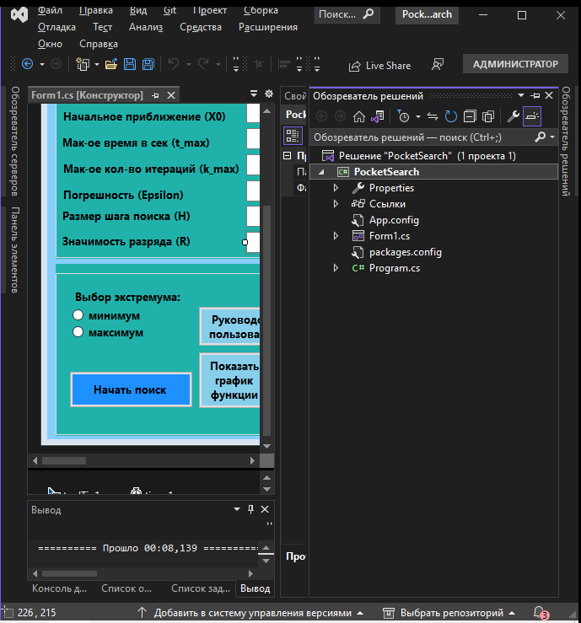

Шаг №2: Щелкнуть мышкой на строчке «Управление пакетами NuGet»:

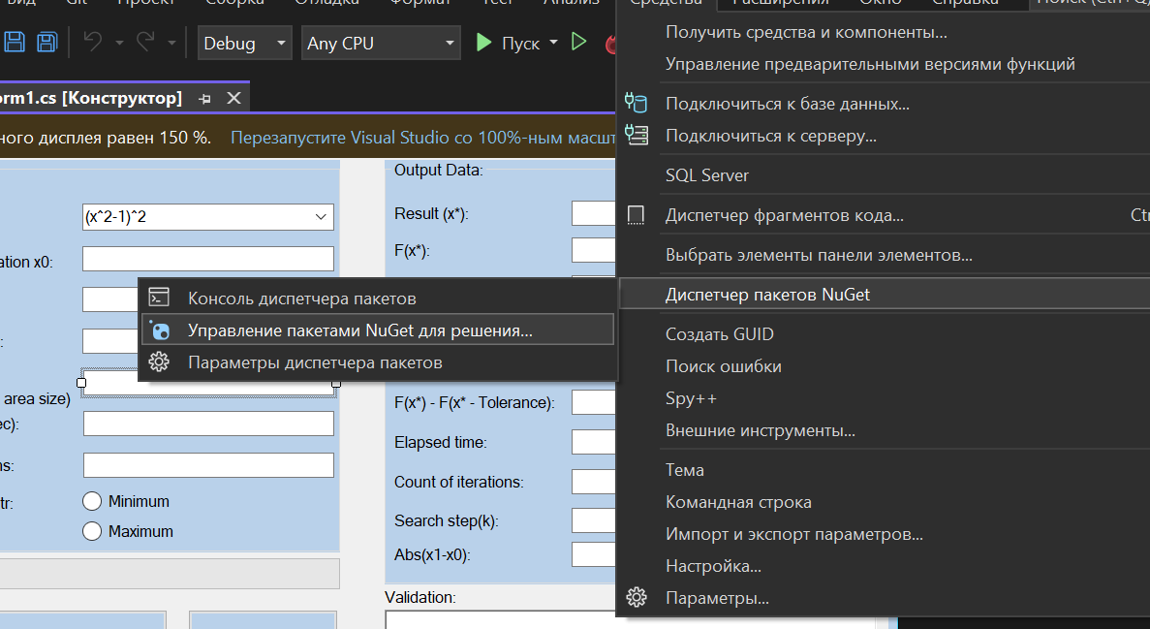

Шаг №3: В диалоговом окне в поиске ввести имя файла “ microsoft.office.interop.excel” и установить пакет:

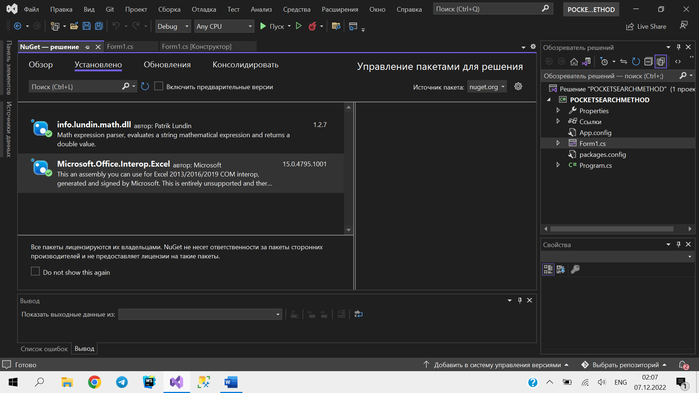

Шаг №4: В листинге программы исчезнут все пометки об ошибках в коде программы, связанных с тем, что операторы «Microsoft.Office.Interop.Excel» были неопределены, если нижеприведенные строки кода программы были уже введены до введения ссылки на эти библиотечные функции. Если же эти строки кода не были до сих пор введены, то теперь можно ввести эти коды, в которых используется функция парсинга, как это показано ниже:

*************это примеры использования парсинга “aziretParser.dll” и «aziretParser»

public decimal F(decimal x)

{

decimal result;

result = aziretParser.Computer.Compute(inputFuncFX, x);

return result;

}

**********это примеры использования “Microsoft.Office.Interop.Excel”*********************

public void OpenExcel()

{

if (!checkFunction(1)) return;

string function;

decimal startPoint;

book = xls.Workbooks.Open(System.IO.Directory.GetCurrentDirectory() + nameOfExcel);

sheet = book.Sheets["Russian"];

xls.Visible = true;

sheet.Activate();

function = Function.Text;

if (InitialApproximation.Text != "" && InitialApproximation.Text != "-" && InitialApproximation.Text != "+" && InitialApproximation.Text != ".")

{

startPoint = Decimal.Parse(InitialApproximation.Text);

}else

{

startPoint = 1;

}

sheet.Cells[4, 9] = startPoint;

sheet.Cells[4, 10] = startPoint + 2;

sheet.Cells[2, 1] = "f(x)=" + Function.Text;

StringBuilder builder = new StringBuilder(function);

builder.Replace("exp", ":");

builder.Replace("x", "D4");

builder.Replace(":", "exp");

function = builder.ToString();

sheet.Range["E4:E10003"].Value = "=" + function;

}

**Раздел 7**

**Тесты для проверки ПРОГРАММНОГО ОБЕСПЕЧЕНИЯ, РЕАЛИЗУЮЩЕГО POCKET SEARCH METHOD**

Тест №1: Цель теста проверка валидности решения задачи максимизации 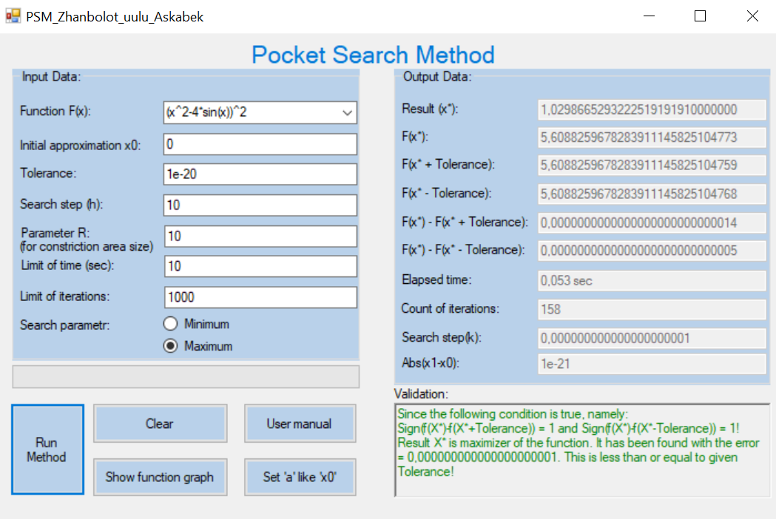

ЗАКЛЮЧЕНИЕ по результатам проведения Теста №1:

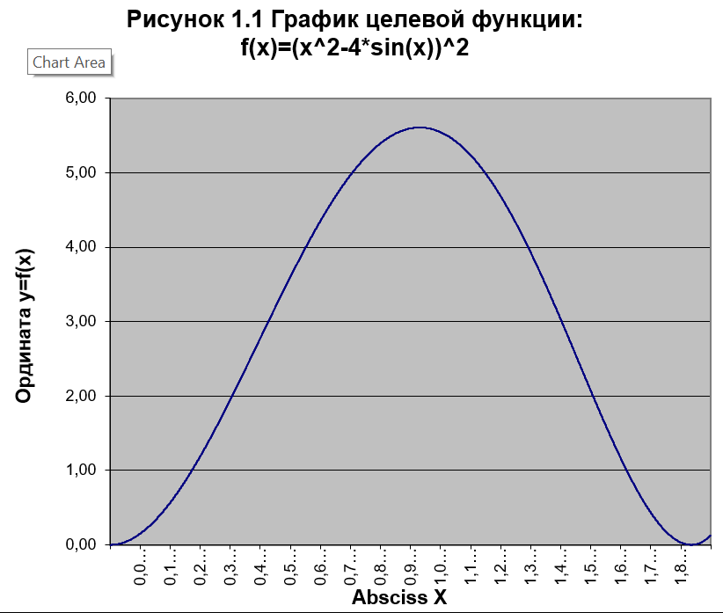

F(x*+Tolerance))))

F(x*)

F(x*-Tolerance)

***Screen-shot 7.1*** The graph of the function 𝑓(𝑥) = (𝑥^2 − 4 ∗ sin(𝑥))^2 which visualizes the validation’s sentence such as: the value of the point x* is a root of the nonlinear equation 𝑓(𝑥 ∗ ) = 1,02986652932225191919100000 𝑡ℎ𝑒 𝑜𝑛𝑒 𝑖𝑠 𝑐𝑜𝑚𝑝𝑢𝑡𝑒𝑑 𝑤𝑖𝑡ℎ 𝑡ℎ𝑒 𝒅𝒆𝒔𝒊𝒓𝒂𝒃𝒍𝒆 𝒂𝒄𝒄𝒖𝒓𝒂𝒄𝒚 since the following conditions are true, namely: 𝑠𝑖𝑔𝑛[𝑓(𝑥 ∗ + 𝑇𝑜𝑙𝑒𝑟𝑎𝑛𝑐𝑒)] = 1 𝒂𝒏𝒅 𝑠𝑖𝑔𝑛[𝑓(𝑥 ∗ − 𝑇𝑜𝑙𝑒𝑟𝑎𝑛𝑐𝑒)] = 1

Тест №2: Цель теста проверка валидности на ограничение итераций

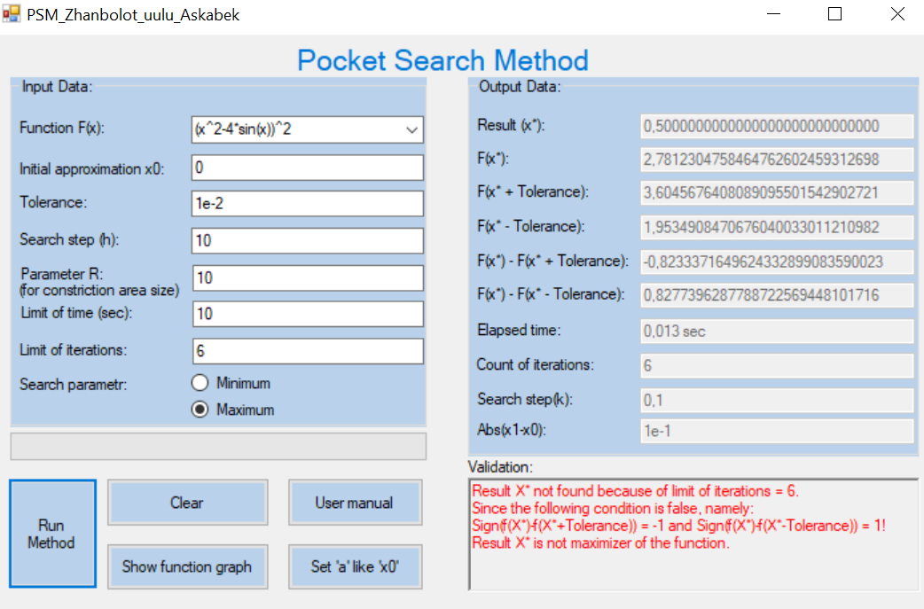

ЗАКЛЮЧЕНИЕ по результатам проведения Теста №2:

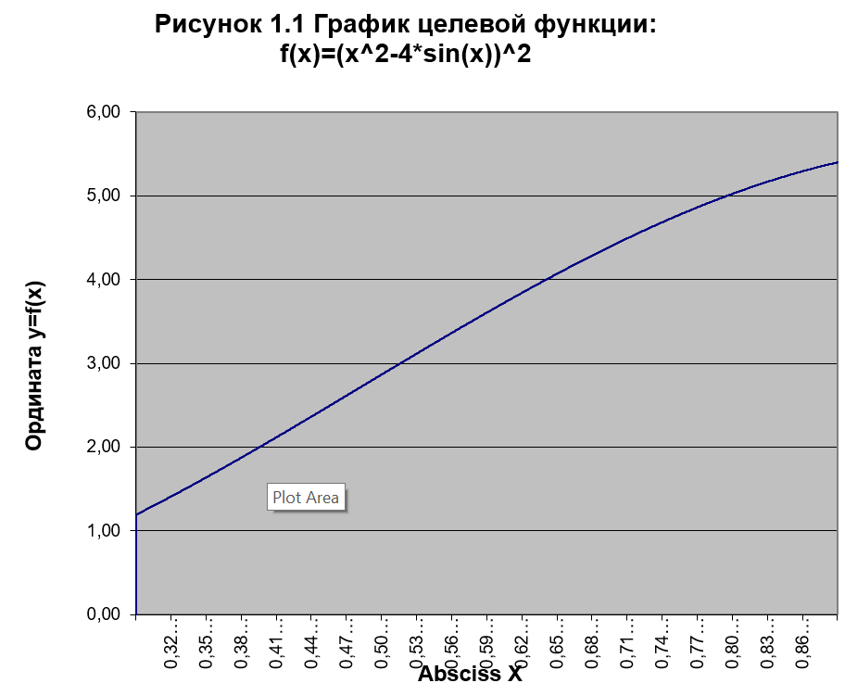

F(x*)

F(x*+Tolerance)

F(x*-Tolerance)

***Screen-shot 7.2*** The graph of the function 𝑓(𝑥) = (𝑥^2 − 4 ∗ sin(𝑥))^2 which visualizes the validation’s sentence such as: the value of the point x* is not a root of the nonlinear equation 𝑓(𝑥∗) = 0,500000000000000000000 since the following conditions are false, namely: 𝑠𝑖𝑔𝑛[𝑓(𝑥 ∗ + 𝑇𝑜𝑙𝑒𝑟𝑎𝑛𝑐𝑒)] = -1 𝒂𝒏𝒅 𝑠𝑖𝑔𝑛[𝑓(𝑥 ∗ − 𝑇𝑜𝑙𝑒𝑟𝑎𝑛𝑐𝑒)] = 1

Тест №3: Цель теста проверка валидности решения задачи минимизации

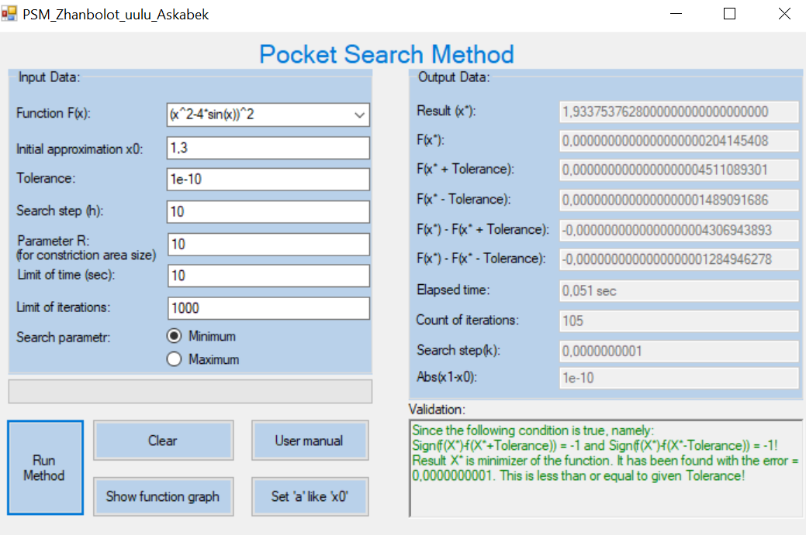

ЗАКЛЮЧЕНИЕ по результатам проведения Теста №3:

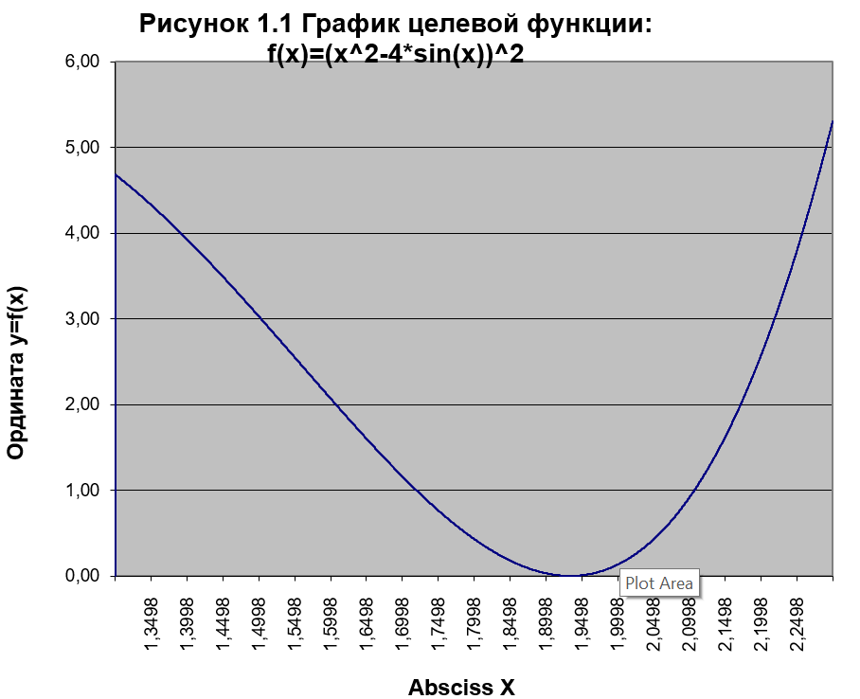

F(x*)

F(x*-Tolerance)

F(x*+Tolerance)

***Screen-shot 7.3*** The graph of the function 𝑓(𝑥) = (𝑥^2 − 4 ∗ sin(𝑥))^2 which visualizes the validation’s sentence such as: the value of the point x* is a root of the nonlinear equation 𝑓(𝑥 ∗ ) = 1,9337537628000000000000 𝑡ℎ𝑒 𝑜𝑛𝑒 𝑖𝑠 𝑐𝑜𝑚𝑝𝑢𝑡𝑒𝑑 𝑤𝑖𝑡ℎ 𝑡ℎ𝑒 𝒅𝒆𝒔𝒊𝒓𝒂𝒃𝒍𝒆 𝒂𝒄𝒄𝒖𝒓𝒂𝒄𝒚 since the following conditions are true, namely: 𝑠𝑖𝑔𝑛[𝑓(𝑥 ∗ + 𝑇𝑜𝑙𝑒𝑟𝑎𝑛𝑐𝑒)] = -1 𝒂𝒏𝒅 𝑠𝑖𝑔𝑛[𝑓(𝑥 ∗ − 𝑇𝑜𝑙𝑒𝑟𝑎𝑛𝑐𝑒)] = -1

Тест №4: Цель теста проверка открытия excel-file и вставки целевой функции с левой и правой границей в определенные ячейки листа “Russian”

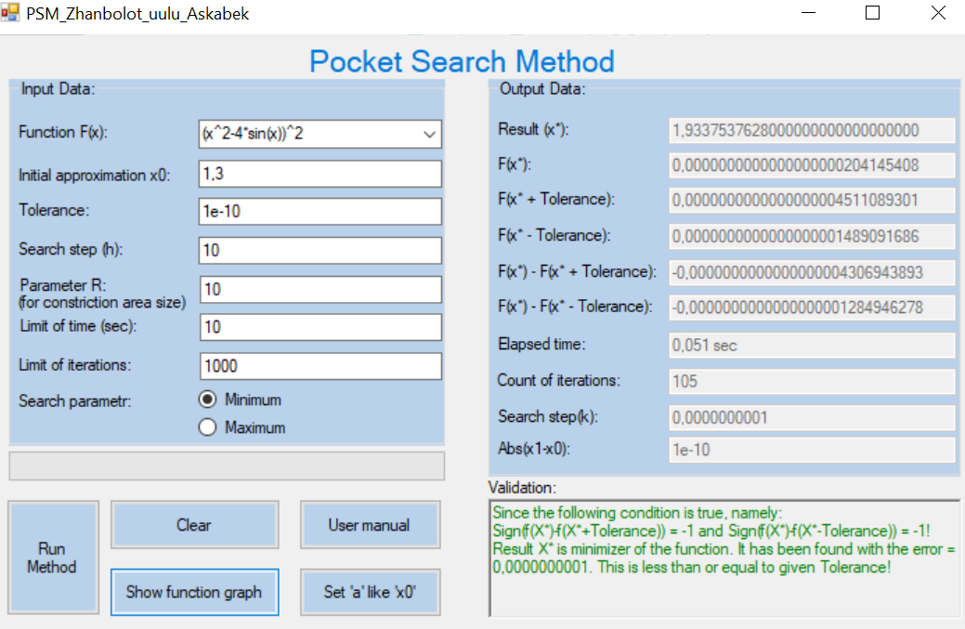

ЗАКЛЮЧЕНИЕ по результатам проведения Теста №4:

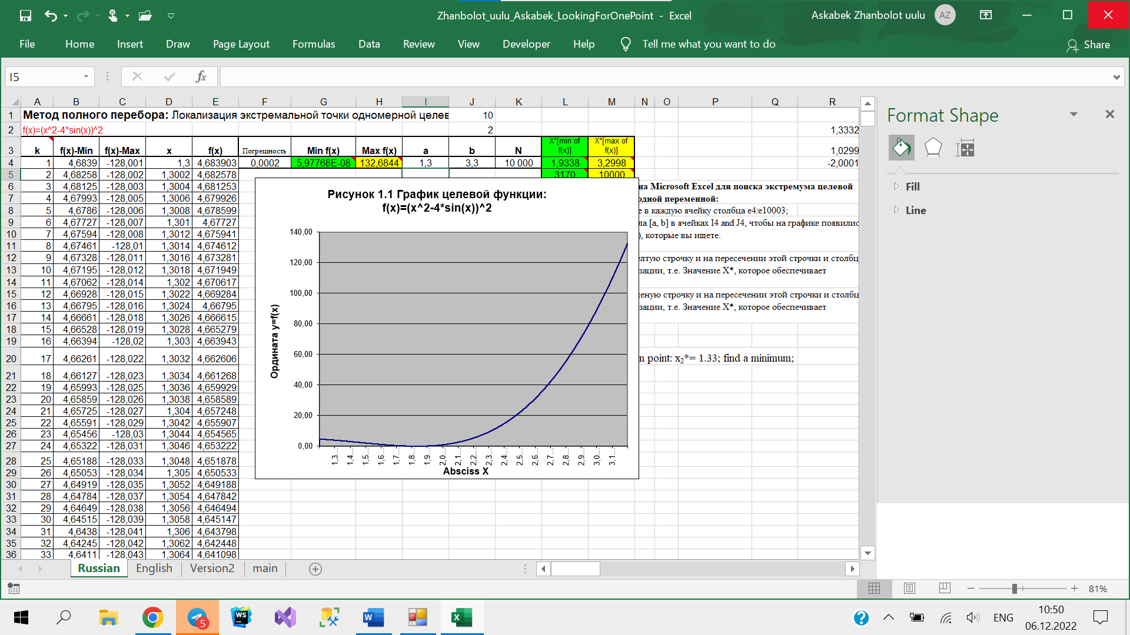

***Screen-shot 7.4*** Из excel-file видим, что в ячейке A2 установлена целевая функция, которую ввели в программе PocketSearchMethod; в ячейках I4 и J4 установлены левая и правая границы целевой функции, где левая граница имеет значение X0= 1,3 из программы PocketSearchMethod.

Тест №5: Цель теста проверка валидности на ограничение времени

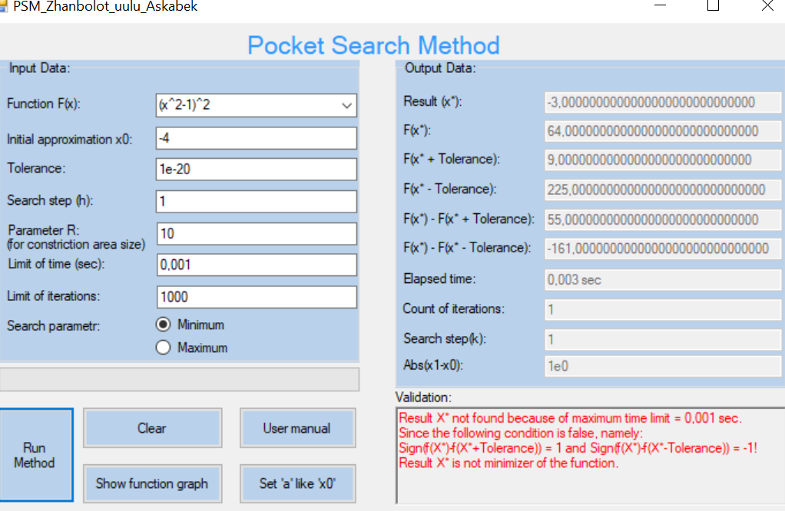

ЗАКЛЮЧЕНИЕ по результатам проведения Теста №5:

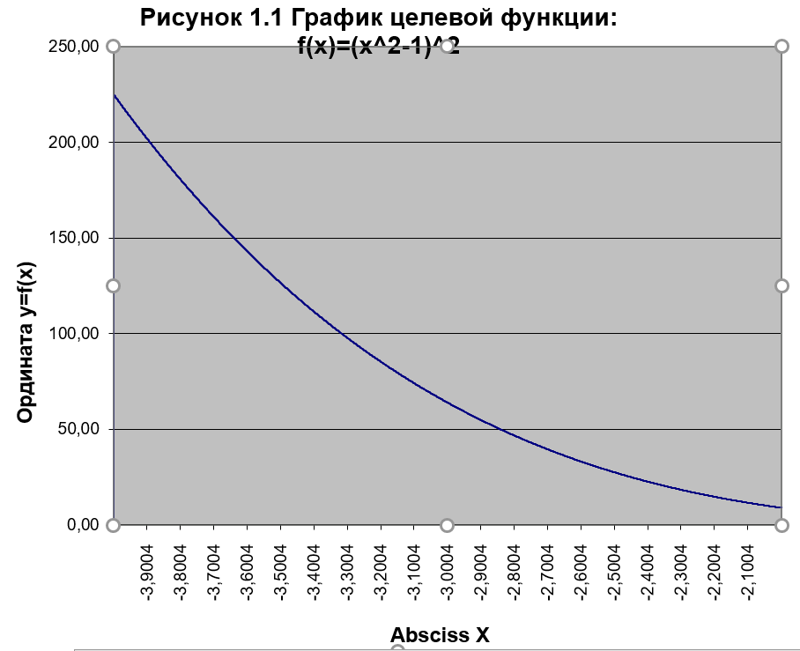

F(x*-Tolerance)

F(x*+Tolerance)

F(x*)

***Screen-shot 7.5*** The graph of the function 𝑓(𝑥) = (𝑥^2 – 1)^2 which visualizes the validation’s sentence such as: the value of the point x* is not a root of the nonlinear equation 𝑓(𝑥∗) = 3,0000000000000000000000 since the following conditions are false, namely: 𝑠𝑖𝑔𝑛[𝑓(𝑥 ∗ + 𝑇𝑜𝑙𝑒𝑟𝑎𝑛𝑐𝑒)] = -1 𝒂𝒏𝒅 𝑠𝑖𝑔𝑛[𝑓(𝑥 ∗ − 𝑇𝑜𝑙𝑒𝑟𝑎𝑛𝑐𝑒)] = 1

Тест №6: Цель теста проверка импорта данных из Excel-файла

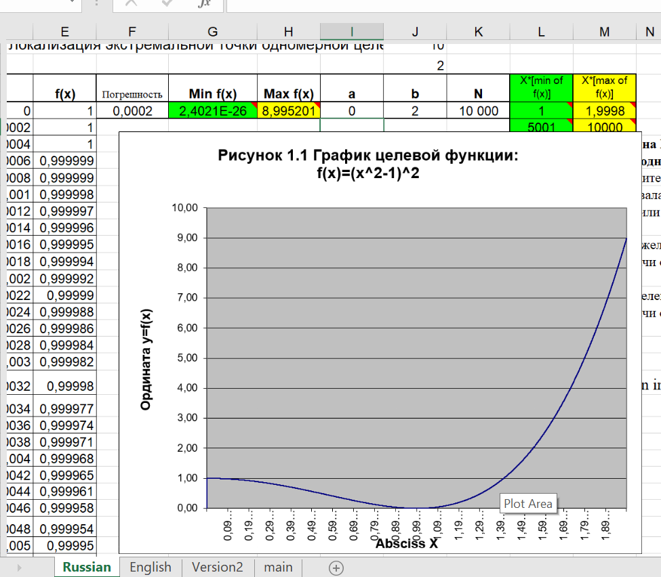

ЗАКЛЮЧЕНИЕ по результатам проведения Теста №6:

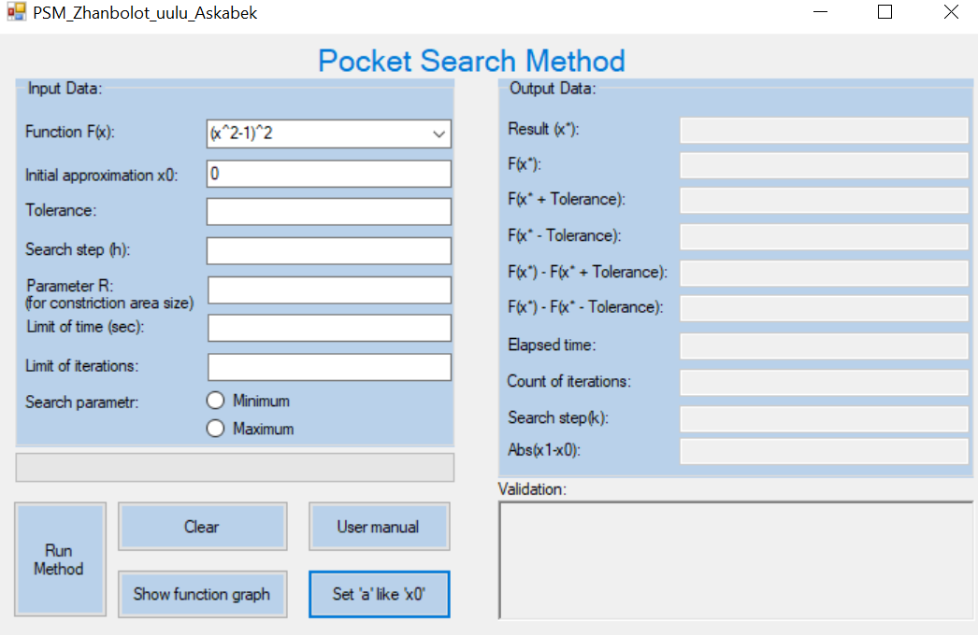

***Screen-shot 7.6*** После изменения значения ячейки I4, где хранится значение левой границы целевой функции, “вставляем ‘a’ как ‘x0’” в программе EvenSearchMethod. Значение ячейки I4 равен 0. После “вставки ‘a’ как ‘x0’” “Начальное приближение (X0)” равен 0.

Тест №7: Цель теста проверка валидности введенных данных

X0:

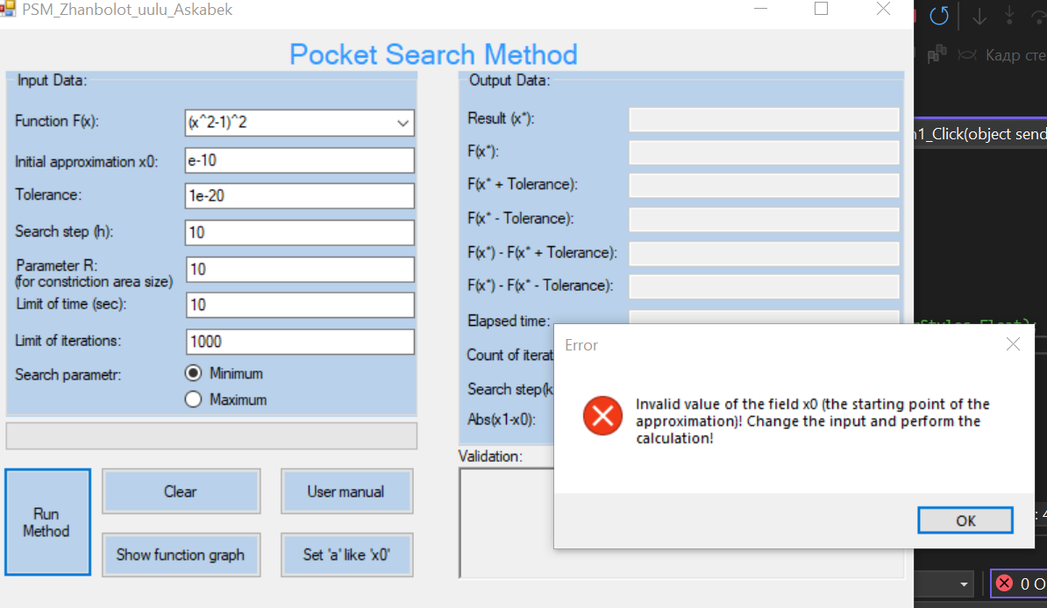

t_max:

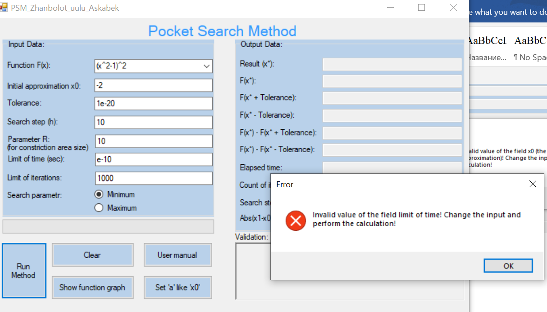

Tolerance:

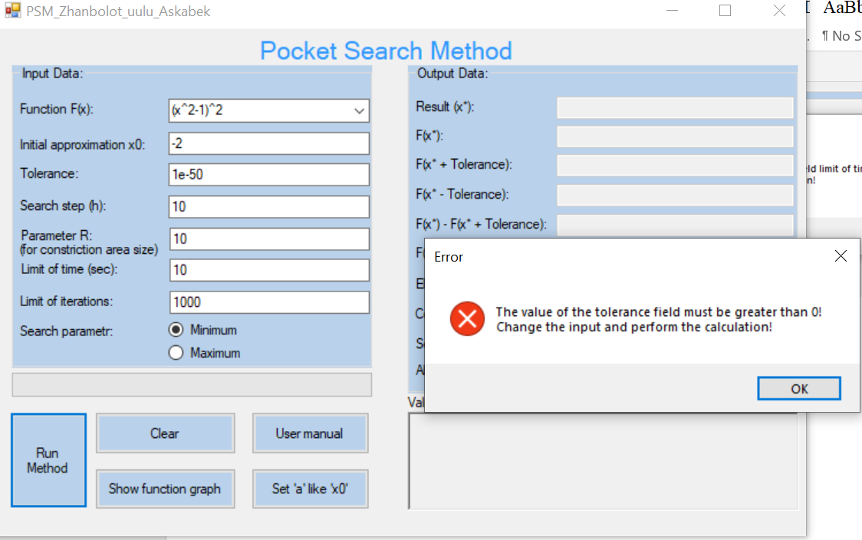

H:

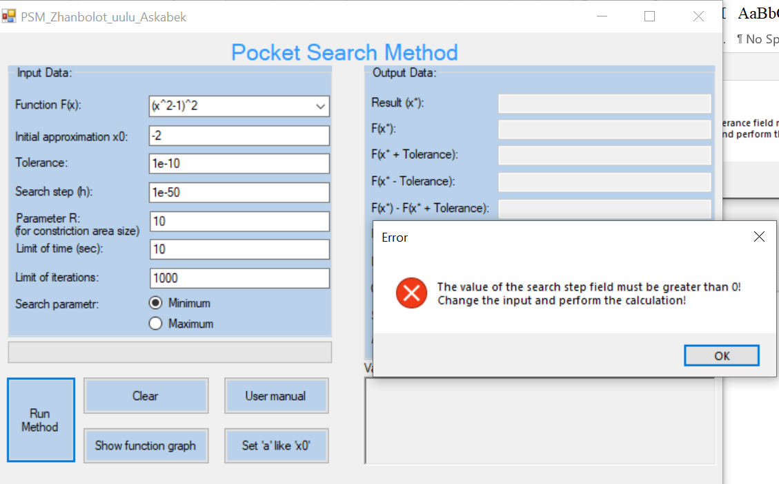

R:

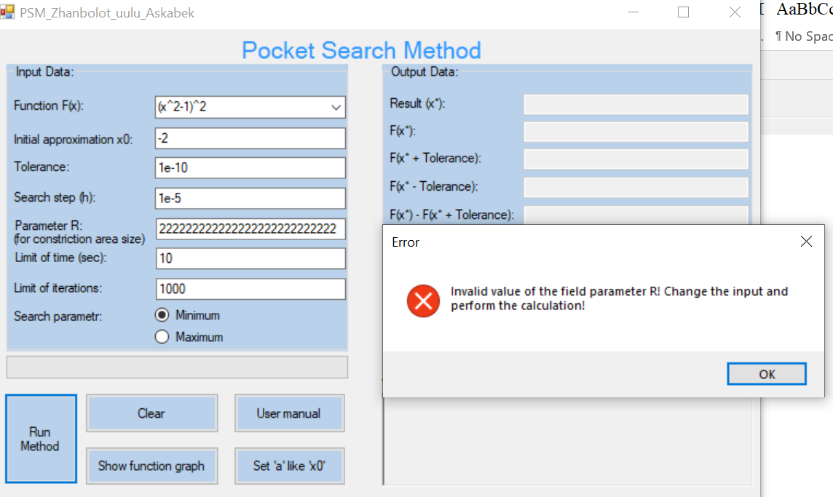

Тест №8: Цель теста проверка валидности решения задачи минимизации c выбранным диапазоном [a;b] на excel.

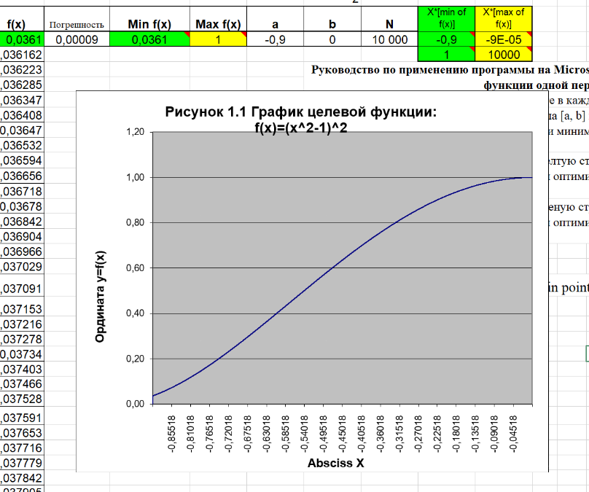

ЗАКЛЮЧЕНИЕ по результатам проведения Теста №8:

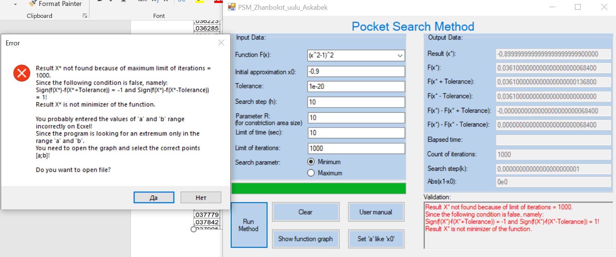

***Screen-shot 7.7*** The graph of the function 𝑓(𝑥) = (𝑥^2 − )^2 which visualizes the validation’s sentence such as: the value of the point x* is not a root of the nonlinear equation 𝑓(𝑥∗) = -0,8999999999999999900000 since the following conditions are false, namely: 𝑠𝑖𝑔𝑛[𝑓(𝑥 ∗ + 𝑇𝑜𝑙𝑒𝑟𝑎𝑛𝑐𝑒)] = -1 𝒂𝒏𝒅 𝑠𝑖𝑔𝑛[𝑓(𝑥 ∗ − 𝑇𝑜𝑙𝑒𝑟𝑎𝑛𝑐𝑒)] = 1

Программа не нашла решение так как отрезок a(-0,9) и b(0) не имел экстремум.