Exchange Digits

Problem Description

Compute nearest larger number by interchanging digits updated.

Given 2 numbers a and b find the smallest number greater than b by interchanging the digits of a and if not possible print -1.

Constraints

1 <= a,b <= 10000000

Input Format

2 numbers, a and b, separated by space.

Output

A single number, greater than than b.

If not possible, print -1.

Test Case

Explanation

Example 1

Input

459 500

Output

549

Example 2

Input

645757 457765

Output

465577

Example 3

Input

5964 9984

Output

-1

## Min Combinations

### Problem Description

Alexander The great, while roaming the stretch of Turkey, came across a wise man.

He asked the wise man, "Who is the greatest conqueror of all?". The wise man replied, "A person with great strength and intelligence. Whosoever can solve my puzzle will go on to become the greatest!". The puzzle is as follows; Given two integers 'n1' and 'n2', select two integers 'a' and 'b', such as to solve the equation (n1 * a + n2 * b = x). But there is a catch, 'x' is the smallest positive integer which satisfies the equation. Can you help Alexander become the greatest?

### Constraints

1 <= T <= 1000

-10^7 <= a, b <= 10^7

0 <= n1, n2 <= 10^7

### Input Format

The first line contains the number of Test cases T.

Next T lines contains two space-separated integers, n1 and n2.

### Output

Print the value of x.

### Test Case

### Explanation

Example 1

Input

1

34818 45632

Output

2

Explanation

Given n1 = 34818 and n2 = 45632, if we choose a = 3553 and b = -2711, we get

=> n1 * a + n2 * b = x

=> 34818 * 3553 + 45632 * (-2711)

=> 2

Note: No other value of a and b, within the range, will give smaller value than 2.

## Coins Required

### Problem Description

Find minimum number of coins required to form any value between 1 to N, both inclusive. Cumulative value of coins should not exceed N. Coin denominations are 1 Rupee, 2 Rupee and 5 Rupee.

Lets understand the problem using the following example.

Consider value of N is 13, then the minimum number of coins required to formulate any value between 1 and 13, is 6. One 5 Rupee, three 2 Rupee and two 1 Rupee coins are required to realize any value between 1 and 13. Hence this is the answer.

However, if one takes two 5 Rupee coins, one 2 rupee coin and two 1 rupee coin, then too all values between 1 and 13 are achieved. But since the cumulative value of all coins equals 14, i.e., exceeds 13, this is not the answer.

### Constraints

0 < n < 100000

### Input Format

A single integer value.

### Output

Four space separated integer values.

1st – Total number of coins.

2nd - number of 5 Rupee coins.

3rd – number of 2 Rupee coins.

4th – number of 1 Rupee coins.

### Test Case

### Explanation

Example 1

Input

13

Output

6 1 3 2

Explanation

The minimum number of coins required is 6 with in it:

minimum number of 5 Rupee coins = 1

minimum number of 2 Rupee coins = 3

minimum number of 1 Rupee coins = 2

Using these coins, we can form any value with in the given value and itself, like below:

Here the given value is 13

For 1 = one 1 Rupee coin

For 2 = one 2 Rupee coin

For 3 = one 1 Rupee coin and one 2 Rupee coins

For 4 = two 2 Rupee coins

For 5 = one 5 Rupee coin

For 6 = one 5 Rupee and one 1 Rupee coins

For 7 = one 5 Rupee and one 2 Rupee coins

For 8 = one 5 Rupee, one 2 Rupee and one 1 Rupee coins

For 9 = one 5 Rupee and two 2 Rupee coins

For 10 = one 5 Rupee, two 2 Rupee and one 1 Rupee coins

For 11 = one 5 Rupee, two 2 Rupee and two 1 Rupee coins

For 12 = one 5 Rupee, three 2 Rupee and one 1 Rupee coins

For 13 = one 5 Rupee, three 2 Rupee and two 1 Rupee coins

## Number Mystery

### Problem Description

There exists **K** integers and a hidden integer **H**, all of which can be generated by using different values of the variable of a single variable function, say**f(x)**of degree**L**

The task is to find **H i**f it is possible. The K integers given correspond to f(1),f(2)...f(K)

### Constraints

0<=L<=10 -10^8<=H<=10^8 0<=K<=10000 abs(value of the K integers<=10^9)

x is a whole number

### Input Format

The first line of Input contains two integers K, and L separated by space Next, K lines contain the K integers

### Output

Print the value of Integer H, if possible otherwise print "Impossible" without the quotes

### Test Case

### Explanation

Example 1

Input

3 2 6 15 28

Output

1

Example 2

Input

6 8 12 19 25 44 66 99

Output

Impossible

## Angels vs Devils

### Problem Description

In a board game (12x12) of Angels vs Devils, various devils try to kill an angel whose aim is to get across the board. Person playing for devil can place 3 devils at any cell on the board, each devil has different powers.

Starting point of Angel can only be on border but not corners of the board and will be provided as input. He will walk in a straight line (horizontal or vertical only) across the board, one cell every second. For example, if he is placed on the left border he will move right towards the right border. Starting points and types of devils will be provided as input, their powers are as follows (please also refer the image in Example 1).

**OGRE (O)**: He cannot move but he can kill with his breath. His powers change with time.

· In 1st second Ogre can kill angel if the angel reaches Ogre’s location

· In 2nd second Ogre can kill angel surrounding upto 8 neighbouring cells (see diagram)

· In 3rd second Ogre can kill angel if the angel reaches Ogre’s location

· In 4th second Ogre is powerless i.e. even if angel reaches Ogre’s location, Ogre cannot harm him

**XiXi (X):** He has the power to kill an angel only if both the following conditions are true

· He is active

· Angel is on same colored cell as XiXi

XiXi is active only for 1 particular second in this game. According to Figure 1, XiXi is on cell D8. What this means is – XiXi will be active only in 8th second and if and only if angel is on blue colored square at 8th second, XiXi can kill the angel.

**ZeeSNAKE (Z):** He leaves a poison trail and moves in 'Z' shape. His first move is 'down' and then 'right' and keeps on making a trail in that order until he reaches the border. If he reaches the 'Bottom Border' he starts moving 'up' instead of 'down' and vice-versa. If he reaches the 'Right Border' he starts moving 'left' instead of 'right' and vice-versa. Angel coming on the poison box will die immediately. Trail created by him till 12th second is shown in Figure 1

You need to provide the box number on which the Angel gets killed, or output 'SS' if Angel successfully crosses the board

### Constraints

Angel starts from the border but not from the corners (i.e. cells A1, A12, L1 and L12)

Starting points of angel and all the devils will be different

Powers of devils do not conflict. Thus if an angel reaches a cell which is under influence of more than one devil’s power, the angel will still get killed

Angel cannot stop, he has to move every second

### Input Format

First Line contains the starting point of Angel at t = 1.

Second Line contains the types of devils in order delimited by comma (,).

Third Line contains starting points of devils (at t = 1) in order delimited by comma (,).

### Output

Cell number where the angel gets killed, if angel does not get killed then print "SS"

### Test Case

### Explanation

Example 1

Input

K12

O,X,Z

I3,D8,C4

Output

K5

Explanation

Angel will be killed by the Devil XiXi as at the 8th second, he can kill angel on blue boxes

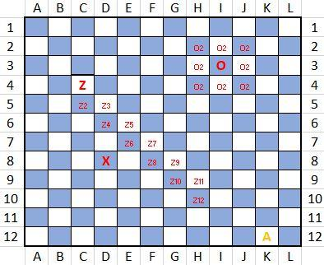

Figure. 1.

Example 2

Input

I12

Z,O,X

K2,B10,G3

Output

SS

Explanation

Angel is successfully saved because no devil’s power is able to harm him.

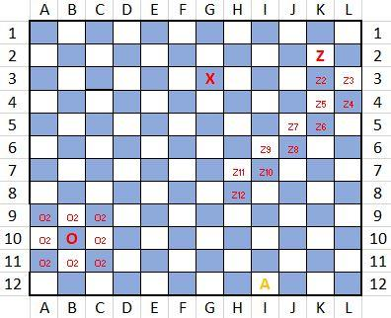

Figure. 2.

## Hermoine Number

### Problem Description

Voldemort is finally dead. Hermoine is bored and has now developed some interest in mathematics, so she keeps challenging her friends. Harry is now one of the victims to those hard problems and needs your help to solve this puzzle.

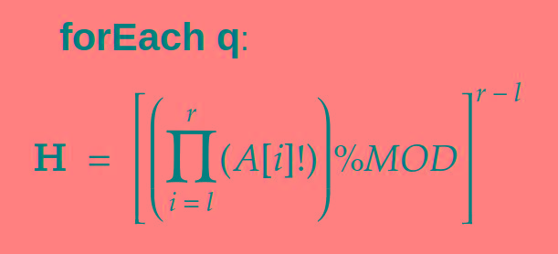

She calls the result to be Hermoine Number H.

Since H can be large, you need to print the result modulo MOD =**1000000007**

### Constraints

N <= 10^5

A[i] <= 10^5

### Input Format

First line provides an integer N denoting number of elements in Array A

Second line provides N space separated values for the array A,

Third Line provides an integer denoting Query (q) corresponding the problem statement

Next q lines contain two numbers l, r denoting the values mentioned above in the statement

### Output

q lines containing the value of H mod **1000000007**

### Test Case

### Explanation

Example 1

Input

5

1 2 3 4 5

2

2 2

2 4

Output

1

82944

Example 2

Input

10

77883 48760 68269 31574 57351 20528 45398 54148 37399 31382

10

5 9

2 8

2 9

6 6

1 3

1 9

7 8

6 10

2 7

1 2

Output

667891964

31641898

769678014

1

29992112

654285930

776096678

444042335

886182048

728170986