**GAMEDEVREJECTS:**

**INTRO & GETTING STARTED**

**Orlando Unity3d Development Group**

**Date: 19-Apr-22**

**All Copyright GAMEDEVREJECTS©2022**

**Contents**

**1.1.0** **Intro & Getting Started** 3

**1.1.1** **Introduction** 3

**1.1.2** **Why Unity ?** 3

**1.1.3** **What is Unity?** 3

**1.1.4** **Workflow Overview** 4

**1.1.5** **Unity Download & Install** 4

**1.1.6** **Create a Unity Account/ID** 4

**1.1.7** **Getting Started** 4

**1.1.8** **Download Unity Hub** 6

**1.1.9** **Adding a Unity Version** 7

**1.1.10** **Create a New Project** 8

**1.1.11** **Select a Template** 9

**1.1.12** **Name Your Project** 9

**1.1.13** **The Project Folders** 10

**1.1.14** **The Default Layout** 10

**Glossary** 12

**Resources** 13

# **Intro & Getting Started**

Introduction and Getting Started.

# **Introduction**

Hello, and WELCOME! My name is XXXX. I am going to be your instructor for the next hour or so. I appreciate you all taking the time out from your busy schedules to study this.

**Whether you’re** at the start of your game development journeyor **"struggling"** to apply the knowledge you’ve learned from a previous tutorial…then this is the course for you?

Please note, before we begin. I do expect you to have downloaded & installed (on your laptops or PCs) **1)Visual studio 2015/2017 or VSCODE or XCODE if you have a Mac…, and 2)Unity version 5 or higher.**

We will be doing application walkthroughs. In other words, ... “as-I-type-you-type” …so you can follow in the exact same steps & processes as me. Feel free to comment or interrupt at any time if you have questions or need further clarification. Also, If I am going to fast let me know. And I will sloooowwww down !

# **Why Unity ?**

Let’s get started. So, why Unity ? Well, there are several reasons:

* **Accessibility : ITS FREE!!!**
* **The Unity Personal Edition, is free to download, is fully featured**
* There is a lot of backwards compatibility & documentation support, large online unity3d community
* The unity graphical features require very low-end hardware,
* The **Unity Asset Store** offers an extensive database of free and paid assets, (e.g. 3d models, Game Object, Images etc.) for use in your application so you don’t have to start from scratch.
* Unity provides better integrated services for: Game Analytics, Source Control & Advertising,
* Reduced Platform Risk > Supports Android & iOS > W.O.R.A. (Write Once Run Anytime)

# **What is Unity?**

Right, so what is unity exactly? Unity is a game development engine. A “glorified” code editor to build small & medium sized video games, simulations, 2D/3D Environments for **pcs/laptops, mobile phones, tablets & consoles (XBOX, PSP etc.)**

* Unity is a Game Engine
* Unity is a software application where all the assets (e.g. like code scripts, 3d models, graphics, audio files and Plugins) needed to make a video game are imported then attached and aggregated to make interactive applications – efficiently so you don’t have to create your game or application completely from scratch.
* Unity was created on 8 June 2005 by Unity Technologies Inc in Seattle. The Current CEO is John Riccitiello,
* Unity has on average 600,000 active developers per day.
* 34% of top 1,000 free mobile games are made with Unity.
* Unity is a cross platform game engine. Meaning that any files or assets created in unity on a windows machine will work when imported into the unity platform on a MAC OS machine, and vice-versa.

# **Workflow Overview**

So the standard Unity workflow is you create your assets in some 3rd Party application like Blender, Photoshop, AutoCAD, then you import them into Unity, attach a script, then create an interactive experience like a game, or live environment.

# **Unity Download & Install**

To download Unity you need to navigate to unity.com.

# **Create a Unity Account/ID**

Firstly, before you get started it’s recommended to create a Unity user account (if you haven’t done so already). To do this, if you’ re older than 18 years of age. You just need to click on the human icon, then click on Create a Unity ID in the drop-down, follow the steps; use your preferred email and a password.

Creating a Unity Account is important, because whenever you need to download assets will enable you to sync access to the Unity Asset Store and access the latest Unity Updates.

# **Getting Started**

Once you have created a Unity Account, navigate back to (the website) unity.com; click on “Get Started”

Then, you choose your pricing plan.

…the most common plan developer’s pick is the free plan surprise, surprise. Typically individual developer’s sign-up for the free persona licence, provided they have not accrued revenues or funding less than **US$ 100K in the previous 12 months**; and for commercial businesses generally they go for the Unity Pro which is an all-in-one solution.

# **Download Unity Hub**

Now, when you’ve clicked, and selected your pricing plan,…you need to download the unity hub, which looks like as follows:

It will download to your downloads folder, or whatever location you’ve specified. Now once you’ve installed Unity hub, this is

what it will look like. Unity hub is a licensed software management menu system. Your licenses are managed via the Installs menu. When you first install Unity hub your installs collection is going to be empty. Unity tends to install new versions, updates very frequently, so therefore Unity Hub is important so you can self-manage your licenses. So when you action to add a new Unity Licence you click on the Add button top right. If you had a Unity version installed and you can’t see it in your Unity Hub Overview, click on the locate button, next to the add button; then Unity will find/display it under Installs.

# **Adding a Unity Version**

Adding Unity is generally completed in two steps 1)pick the licence 2)Select the platform/s. Unity allows you to build your application for the most common ones like Android, iOS, PC, MacOS, WebGL, Console etc. Now one thing to consider is your starting a long-term project and not just creating an ad-hoc one-off project. We recommend you install an LTS or Long-Term Support version, what that means is that it’s Unity promise’s that they will continue to develop and improve that specific licence, for at least no shorter than 3 years; which in turn will make your project better.

After you’ve selected the version you want to use, you have the option to add a code editor and some modules for the specific platforms, you want to build your application for as follows:

Please be advised you can acquire the modules independently e.g. Android Studio, and install them separately, but usually Unity is quite pro-active in keeping the files it supports. So we would recommend you just tick/check the recommended modules. Then when you’re ready, you just click Next to kickstart the download and installation process. Once complete you will see it displayed in the Unity Hub GUI, under installs with the others.

Please note, I believe any Unity Version from 2017 or later support VR.

# **Create a New Project**

Now once the unity download & installation process is completed. You need to sign into the Unity Hub, top right. Then click the blue NEW button top right to create a new project…you only click on the ADD button to the left if you want to Add a new project from one of your folders, that you do not see displayed under Projects in Unity Hub. There are other ways to launch a

new project but opening the project from Unity Hub is the quickest and easiest process.

# **Select a Template**

After you click, NEW, unity will load whatever licence you have installed, but if you want to pick a specific licence to load, you click on the little arrowhead to the right of the NEW button, then a new window pops up. Every time you create a new project you required to select one of the templates as follows:

The templates are just designed to expedite your development. For example, if your planning to make a VR application, then you can choose the VR template, which will pre-download some plugins and extra tools, that you might have to do manually if you use a different template. For demonstration purposes I recommend you use the 3d template, which is the standard render for most applications.

# **Name Your Project**

Inside Unity Hub Create, then you name your project; then choose a Filepath/location on your computer to store your project, as follows::

**(NavigateTo).UNITY HUB -- (IN).Unity Hub – Projects – New – 3D – Settings => / Project Name – Rename <TEST001 > /**

**(NavigateTo).UNITY HUB -- (IN).Unity Hub – Projects – New – 3D – Settings => / Location -- (Select).Filepath /**

**(NavigateTo).UNITY HUB -- (IN).Unity Hub – Projects – New – 3D – Settings => / (Select.Click).Create /**



# **The Project Folders**

Once the project is created, unity creates the following template folders:

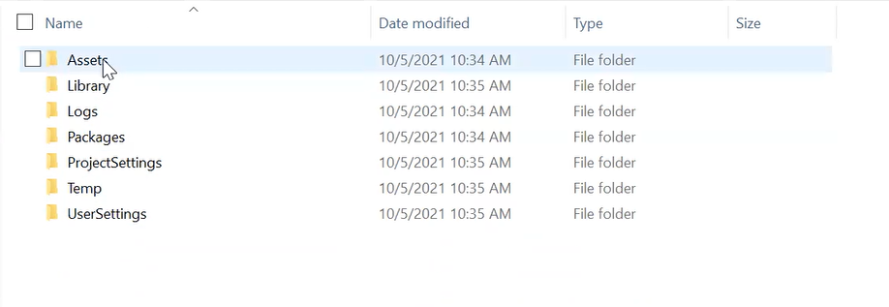

In the Unity interface, you will always have access to the **Assets** folder, which will become your repository for all the assets you want to import and add to your project; external to the Unity Interface. Alternatively you can also drag and drop them into the Unity GUI Interface, which in Unreal I know from experience is not as straightforward to do.

# **The Default Layout**

Once Unity opens, loads etc. you should see the following default layout, with 1 x Main Camera, 1 x Directional light in the Hierarchy.

/END

# **Glossary**

LTS Long-Term Support

HDRP The **High-Definition Render Pipeline (HDRP)** is used for applications that require significant resources. For Eg. an application that runs of the video card that require a lot of rendering power. E.g. Open World experiences.

URP The **Universal Render Pipeline** is used for mobile (Android, iOS, tablet) applications

WORA Write Once Run Anytime

Assets A Unity asset is a file you use to build your game or Project. E.g. 3D model, an audio file, an image etc.

Visual Studio Microsoft Visual Studio is an integrated code editor used to create program scripts for Unity applications.

# **Resources**

Scripting API: MonoBehaviour.StartCoroutine - Unity – Manual

<https://docs.unity3d.com/ScriptReference/MonoBehaviour.StartCoroutine.html>

/End