How to use it?

1. Run python Code located at <https://github.com/djaramillo11/VoiceUserRecognition> as shown in Fig. 1
2. Run postman with the address and parameters given in Fig. 2.
3. If the user is new, the app will register the user and will give feedback about the emotion the user has.
4. 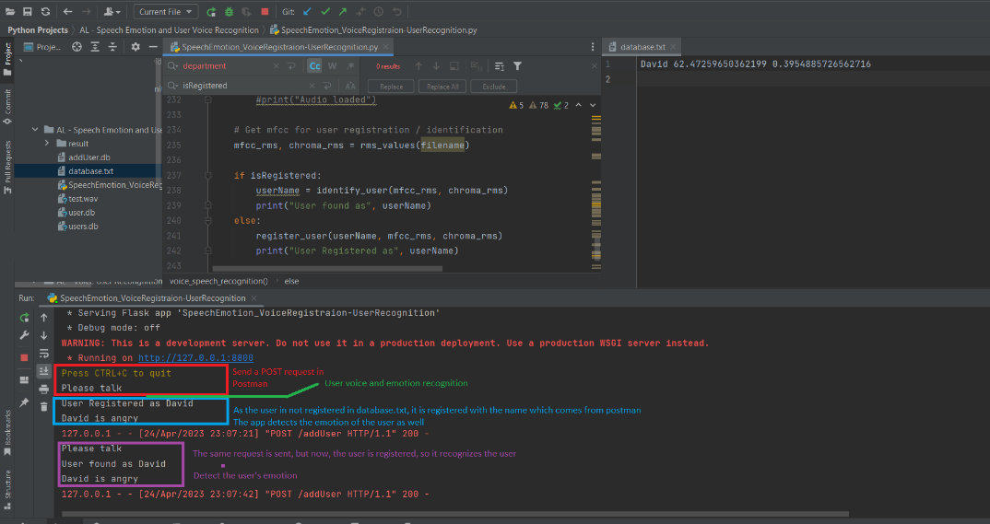If the user is already registered, the application will return the user’s name and emotion.

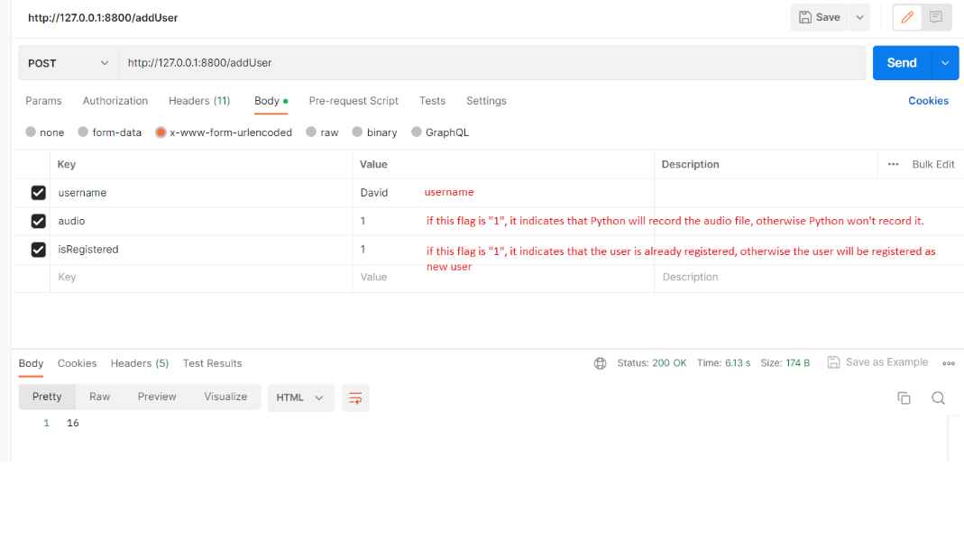

Fig. 2 API testing with postman

Fig. 1 API Creation and result