eventus: Object-Oriented Longitudinal Cohort Analysis with Events, Occurrences, and Observation Periods
Daniel J. Arenas, Riccardo Fincato
Target journal: Journal of Statistical Software

Abstract
Longitudinal cohort analysis — characterizing how entities behave within defined observation periods through interval events and point-in-time occurrences — is a recurring challenge in multiple fields. Despite the ubiquity of this structure, no existing Python or R package provides a unified framework in which observation periods, interval events, and point-in-time occurrences are simultaneously treated as first-class typed objects with validated relationships between them. Analysts typically must write bespoke scripts that couple data cleaning, analytical computation, and visualization in ways that are difficult to maintain, audit, or reproduce across datasets. We present eventus, a domain-agnostic Python package that structures this class of analysis through object-oriented abstractions: semantics, data objects, cleaners, analyzers, intermediates, and visualizers. Each class has a single responsibility and trusts the objects it receives from other classes. Cleaning decisions are versioned in YAML configuration files and produce per-row audit trails. Analytical results are typed intermediate objects that can easily carry additional information such as validated denominators and explicit eligibility thresholds. Visualization decisions live in versioned configuration files independent of analysis code. We demonstrate the package through eight vignettes on simulated data covering insurance coverage periods, nursing facility stays, emergency department visits, and inpatient hospitalizations. Equivalent script-based implementations required approximately 5–10 times more code and could not provide guaranteed denominators, per-row audit trails, or reproducible visualization regardless of code quality. eventus is available at https://github.com/djarenas/eventus (currently private prior to publication).

Keywords: longitudinal data analysis, cohort analysis, health services research, reproducibility, object-oriented programming, Python, events, occurrences, observation periods.

1. Introduction

1.1 The ubiquity and unreliability of longitudinal data cleaning
A recurring challenge in applied data science — particularly in health services research, insurance analytics, and longitudinal program evaluation — is the need to characterize how entities behave within defined periods of time. A cohort may contain patients observed over several years, with intermittent insurance coverage, who make discrete visits to the emergency department and experience inpatient hospitalizations. Before any scientific question can be asked, a seemingly mundane one must be answered: "Do I know what I have?"
Data cleaning in longitudinal studies is ubiquitous, consequential, and easy to under-document. Hospitalization records may have missing discharge dates or ones that precede admission dates. Emergency department claims may contain null patient identifiers. Coverage files contain exact duplicate rows, overlapping intervals that represent transfers rather than re-admissions, and records that extend beyond the study window. Records may also require merging: ED visits on the same day may represent one visit billed twice, or may represent two genuine visits to different hospitals — a distinction that depends on a declared analytical rule, not a default assumption.
The analyst who does not handle these issues systematically introduces silent errors that propagate through every downstream calculation. The analyst who handles them in a script carries the risk of handling them invisibly — the decisions made on line 12 of a cleaning function are inaccessible to any collaborator who reads only the output, unreproducible without reading the exact code, and undocumented by default. Most published analyses in health services research provide limited documentation of data cleaning decisions — how duplicates were handled, how causality violations were resolved, or how many records were excluded and why. Broader analyses of computational reproducibility suggest this is not unique to health services research: journal reproducibility policies have been shown to be largely ineffective at ensuring that published analyses can be reconstructed from reported methods (Stodden et al. 2018). In our experience reviewing and conducting longitudinal analyses in health services research, cleaning decisions are rarely reported in sufficient detail to reproduce the pipeline from the methods section alone. Scripts do not produce audit trails and collaborators and reviewers cannot be expected to carefully sift through massive scripts implementing various cleaning choices and their consequences. This is not negligence — it is a structural limitation of the script-based paradigm. In contrast, a configuration-driven software with declarative construction, such as eventus, can produce easily auditable cleaning choices and consequences.
A second and underappreciated consequence of the config-driven design is that it makes systematic sensitivity analysis straightforward. Any longitudinal analysis involves analytical decisions that reasonable researchers would make differently — what gap length constitutes a coverage lapse, whether causality violations should be rejected or repaired, how many days before a hospitalization an emergency department visit counts as clinically related. These are not errors. They are legitimate choices with no single correct answer, and the conclusions of an analysis may be more or less sensitive to them. The literature has developed several frameworks for examining this sensitivity systematically: multiverse analysis (Steegen et al. 2016), vibration of effects (Patel et al. 2015), sensitivity analysis (widely used in clinical trials and epidemiology), and specification curve analysis (Simonsohn et al. 2020). All share the same core idea: run the analysis across a range of reasonable analytical choices and report how the conclusions vary. In a script-based pipeline, this requires maintaining multiple versions of the same code and manually tracking which version produced which output — a practical barrier that most analysts do not overcome. In the eventus design, it requires writing multiple YAML config files and running the same pipeline once per file. An analyst studying coverage gaps who wants to know whether their findings are robust to a lapse definition of 7, 14, or 30 days runs three config files. The results are directly comparable because the script does not have to be changed at multiple points. Three YAML files are also easier to document, share with collaborators, and attach to a journal submission than three versions of the same script.
Although motivated by health services research, the structure that eventus addresses — entities, observation periods, interval events, and point-in-time occurrences — recurs across domains wherever entities are observed over time: insurance analytics, educational longitudinal studies, ecological monitoring, clinical trial follow-up, and workforce analysis. The framework is domain-agnostic by design. All classes accept user-defined column names through semantics objects. This paper uses simulated data on insurance coverage periods, nursing facility stays, emergency department visits, and inpatient hospitalizations as its running example, but the design principles apply wherever the three-object structure appears. We hope this work is useful not only to analysts in health services research but also to researchers in other domains and to software developers designing similar frameworks.

1.2 The script-based paradigm and its structural limitations
The dominant paradigm for longitudinal cohort analysis is the analysis script: a sequence of DataFrame transformations, hardcoded column references, and inline plotting code. This approach is fast to write and straightforward to understand for a single analysis. It becomes a liability when the analysis must be reproduced, shared, extended, or audited. A script that cleans hospitalization records on line 12, filters to an observation period on line 47, and computes coverage statistics on line 83 embeds three distinct scientific decisions — what counts as a duplicate, what counts as in-window, what counts as covered — in ways that are invisible to any collaborator who reads only the output.
The script-based paradigm offers no mechanism for carrying guarantees across analytical steps. A function that receives a DataFrame cannot know whether that DataFrame is clean, whether its columns mean what they appear to mean, or whether the decisions that produced it were deliberate or accidental. Rename a column in the data warehouse and the script may break silently in multiple places. Change an aggregation rule and the change is not recorded anywhere. The denominator of a percentage statistic is tracked manually — one misplaced filter produces wrong statistics silently, with no error and no warning. A script writer who wants data safety must write defensive validation functions manually — and must remember to call them, pass the right DataFrames to them, and update them when the schema changes. Every guarantee is opt-in and fragile. Object-oriented programming offers a structural alternative: data objects that enforce their own validity at construction, so that a valid object is a guarantee rather than a hope.
Pandas is powerful precisely because it is agnostic. It does not know that discharge_date should follow admit_date, that patient_id should never be null, or that two records with the same entity, date, and hospital represent a duplicate while two records at different hospitals do not. This agnosticism is appropriate for a general-purpose library — but it means that every application built on pandas must either enforce these rules itself, or silently accept violations. No existing Python or R package fills this gap for longitudinal cohort analysis specifically. The R ecosystem offers powerful tools for specific problems — survival analysis (survival; Therneau 2023), date arithmetic (lubridate; Grolemund and Wickham 2011), and longitudinal data manipulation (dplyr; Wickham et al. 2023) — but these operate on raw DataFrames and provide no mechanism for guaranteeing structural soundness across steps. Now, eventus extends pandas by wrapping DataFrames in typed objects that carry domain semantics — what the columns mean, what constraints must hold, and what decisions produced the data. The DataFrame becomes an attribute of the object rather than the object itself.

1.3 eventus: object-oriented longitudinal cohort analysis
eventus addresses this gap by treating longitudinal cohort analysis as a software engineering problem. It does not replace pandas — it elevates it. The raw DataFrame becomes an attribute of a first-class object that carries the meaning of its columns, the rules that validated it, and the decisions that produced it. An Events object in eventus is not a DataFrame with hospitalization data — it is a guarantee that every row has a valid entity identifier, a start date, an end date, and that causality is ensured (start precedes or equals end). Every column name has been declared and verified against a semantics object. Every cleaning decision has been recorded in a versioned configuration file.
The framework rests on four architectural commitments. First, if a data object exists, it is complete — constructors raise on invalid inputs, so every function or class that utilizes the data object can trust what it receives. Second, analytical and visualization behavior is fully specified through config objects that can be built from versioned YAML files — every analytical and visual decision is declared explicitly, not embedded in code. Third, semantics decouple logic from schema — column names are declared once in a semantics object and never referenced again, so renaming a column in the data warehouse requires changing one line and nothing else. Fourth, cleaners act as the required bridge between raw DataFrames and validated data objects — they cannot be bypassed, and they produce structured reports of every row rejected or modified, with explicit reasons.
Beyond reproducibility, these commitments produce a shared vocabulary. When a team uses eventus, the concepts ObsPeriodPerEntity, Events, and Occurrences acquire precise, shared meanings. Collaborators can discuss “the observation period for this cohort” and mean something unambiguous — not “the date range I filtered to on line 47.” Typed objects are not just engineering artifacts. They are conceptual tools that clarify scientific communication.

1.4 Design principles as structural invariants
The architectural commitments of eventus are not stylistic preferences — they are structural invariants enforced by the design. Each class has a single responsibility and trusts the object types it receives. This means a visualizer that receives a configuration object should not check whether the configuration has all the parameters it needs or whether any values are nonsensical — that is the configuration object’s job, done at construction time. By the time the visualizer runs, the config is already guaranteed to be valid. A histogram plotter receiving a violin config, or a plotter receiving a config with an impossible axis range, raises immediately at config construction — not halfway through drawing a figure.
This trust flows in both directions. Because each class trusts its inputs, it can be trusted by its callers. An analyzer that receives a validated Events object does not need to check for null entity identifiers, causality violations, or duplicate rows — those guarantees were earned upstream by the cleaner and are carried by the object itself. The cost of establishing a guarantee is paid once, at the boundary where the guarantee is earned. Everything downstream inherits it for free.
A practical consequence of this design is that new capabilities can be added with minimal surface area — touching exactly the classes that own the new capability and no others. This follows the open/closed principle: the system is open for extension and closed for modification of existing components. Adding OccurrenceEventAnalyzer in Chapter 8 of the vignettes did not require changing CohortTimeline, Events, Occurrences, or any existing analyzer — it required writing one new class that consumed existing validated objects. Adding descriptor column carriage to the CohortTimeline — enabling condition-based stratification across all downstream analyses — required changes to four components and zero changes to any analyzer. Adding a new visualization for events within an observation period should not require changing the object that holds the data; in eventus, it does not. These are not claims about good intentions. They are properties demonstrated in the vignette series and verifiable in the repository’s development history.

1.5 eventus and large language model-assisted analysis
A practical consideration for any scientific software framework in the current era is its compatibility with large language model (LLM) assisted analysis. Increasingly, analysts write code with the assistance of LLMs. A framework built on clearly defined typed objects, versioned configuration files, and comprehensive documentation provides the structural scaffolding that is likely to make LLM-assisted analysis more reliable. The module README becomes a specification that an LLM can learn. The type system becomes a contract that an LLM can respect. The eventus design is such that if an LLM is asked to extend an eventus pipeline, it can produce consistent, architecturally correct code — rather than writing bespoke pandas scripts from scratch, which tend to produce variable and often subtly incorrect results. Object-oriented frameworks with clear semantics are not in tension with LLM-assisted development. They are likely to make it better and more efficient.
The general principle that clearer specifications and structured interfaces improve LLM code generation is well-documented (Chen et al. 2021; Austin et al. 2021). Whether OOP frameworks specifically outperform script-based approaches for LLM-assisted scientific analysis is an open empirical question — a systematic study is beyond the scope of this paper. We raise the point as a reasonable inference and a direction worth investigating.

1.6 Paper organization and documentation
The remainder of this paper is organized as follows. Section 2 describes the software architecture and its core abstractions with emphasis on design decisions. Section 3 presents eight vignettes demonstrating the full pipeline on simulated insurance and clinical data. Section 4 compares eventus with equivalent script-based implementations. Section 5 describes additional analytical capabilities not covered in the vignettes. Section 6 discusses implications for reproducibility, generalizability, and future directions.
The package is organized into subfolders corresponding to each abstraction — semantics, data objects, cleaners, analyzers, intermediates, and visualizers — each with a dedicated README providing full API reference, design notes, and usage examples. Computational workhorse code is separated into _utils.py modules, keeping the primary classes readable and meant to be focused on their single responsibility. The module READMEs are intended to serve as both human-readable documentation and machine-readable specifications for LLM-assisted development, as discussed in Section 1.5.

2. Software Architecture
eventus is organized into six abstractions that can be composed into analysis pipelines:

Semantics — Data Objects — Cleaners — Analyzers — Intermediates — Visualizers

Each class within each abstraction has a single responsibility. Each object in a pipeline trusts the objects it receives. An analyzer that accepts a validated Events object does not need to verify that it has a start column, an end column, or that causality holds — those guarantees were established at construction and are carried by the object. Plotters plot — they are not responsible for computing statistics, validating inputs beyond confirming the right type was passed, or making analytical decisions. Those responsibilities belong to the classes upstream.
This design does not preclude future orchestration. Automated pipelines, dashboardsm agents, and workflow managers that compose eventus components can rely on each component behaving predictably and raising explicitly when its contract is violated. The bricks must be clear before the building can be automated.

2.1 Semantics
The semantics abstraction maps column names to concepts. In any real dataset, column names are idiosyncratic — one dataset calls the entity identifier patient_id, another calls it member_id. Without a semantics object, every downstream class would need to accept column names as constructor arguments. eventus solves this once. The analyst defines a semantics object at the top of the analysis, passes it into the constructor of a cleaner, and everything downstream uses it.
Two fields deserve particular attention. also_defined_by answers: beyond entity and date, what else defines whether two records represent the same event? A patient may have overlapping hospitalizations at different hospitals — a transfer. These are different events. Setting also_defined_by = ["hospital_id"] tells the cleaner it may only merge intervals where hospital_id also matches. This is not a default assumption — it is a declared scientific decision, versioned in the semantics file.
descriptor_cols declares columns that describe the event but do not define its identity. The DescriptorColConfig declares both the column type (category or numeric) and a timeline rule controlling how multiple values are aggregated when carried into the CohortTimeline (sequence, unique, average, or none). Semantics objects are built from YAML files and defined once.

2.2 Data Objects
Data objects are validated, self-describing input containers. A pandas DataFrame does not know what its columns mean or whether its data is clean. An eventus data object knows both. If it exists, it is complete — constructors raise on invalid inputs, producing no partial objects and no silent failures.
Events — every row has a valid entity identifier, a start date, an end date, and causality is ensured (start precedes or equals end). Occurrences — every row has a valid entity identifier and a date. ObsPeriodPerEntity — one row per entity with a construction_path attribute recording how the object was built (construct_from_calendar, construct_from_age_window, or construct_from_events). The construction path is a first-class attribute downstream code can inspect. The same downstream pipeline accepts an ObsPeriodPerEntity regardless of how it was constructed.

2.3 Cleaners and Filters
Cleaners are the required bridge between raw DataFrames and validated data objects. They cannot be bypassed. EventsCleaner applies a configurable pipeline: date parsing, normalization, null rejection, date floor/ceiling enforcement, causality checking, duplicate removal, and interval merging. Every rejected row is recorded with an explicit reason. Every repaired row is recorded with a description of what changed. The causality_check parameter accepts either "reject" (discard) or "swap" (repair and record). These are scientific decisions that belong in a versioned config file, not on line 34 of a script.
OccurrencesCleaner applies the same philosophy to occurrence data, with an additional consolidate option for same-date same-identity records with different descriptor values — for example, collecting all diagnoses from two claims for the same ED visit, or taking the median of repeated blood pressure readings.
Filters subset validated data objects by entity or date. They are chainable and non-mutating. to_obs_period() restricts data to each entity's individual observation window, clipping events that partially overlap the boundary. For occurrences, there is no clipping — an occurrence either falls within the window or it does not.

2.4 Analyzers
Analyzers compute quantities from validated data objects and produce typed intermediates. They do not clean. By the time an analyzer receives its input, structural soundness is already guaranteed by the objects themselves.
Analyzers produce outputs in two patterns. compute_* methods return typed result intermediates ready for visualization. enrich_with_* methods return a new CohortTimeline with computed columns attached for further use. The primary analyzers are CohortTimelineEventAnalyzer (event coverage statistics with tiered validated denominators), CohortTimelineOccurrenceAnalyzer (volume, timing, shape including burstiness and memory, and Kaplan-Meier survival), OccurrenceEventAnalyzer (nearest-neighbor gap statistics between one occurrence and one event identity, with explicit NaN semantics), and EventDurationAnalyzer (durations from an Events object directly, because duration is a property of individual events, not observation periods).

2.5 Intermediates
Intermediates are validated result objects produced by analyzers and consumed by visualizers. An intermediate either exists and is complete, or it does not exist at all.
The central intermediate is CohortTimeline — a per-entity table assembling observation periods, events, and occurrences. One row per entity. Multi-value columns are pipe-delimited strings. The CohortTimeline is both a result object and an enrichment hub, progressively enriched by calling methods that each return a new instance. Descriptor columns from semantics are carried forward, enabling condition-based stratification without additional joins.
The per-entity constraint is not arbitrary — it is what allows any analyzer or visualizer to consume a CohortTimeline without knowing what other components produced it. This is the open/closed principle in practice: the CohortTimeline is stable and extensible because its structural invariant is fixed. When a new analytical result requires a different structure, a new intermediate class is introduced rather than relaxing this constraint.
The OccurrenceResult family carries per-entity statistics: OccurrenceResultVolume (counts), OccurrenceResultTiming (nth-occurrence timing), and OccurrenceResultShape (behavioral fingerprint). All carry explicit eligibility thresholds — NaN values are scientifically meaningful absences of signal, not missing data. SurvivalResult carries a Kaplan-Meier survival curve with validated structural invariants (Kaplan and Meier 1958).

2.6 Visualizers
Visualizers consume one intermediate and one configuration object and produce one plot. They do not compute. The intermediate already guarantees structural soundness. The configuration already owns every visual choice.
Configuration objects are frozen dataclasses that validate all parameters at construction — if a configuration object exists, it is valid. Invalid configurations raise immediately with specific messages before any drawing begins. For example, passing x_axis: calendar to StackedTimelinePlotter when entities have different observation period lengths raises with the exact count of differing entities and the two valid alternatives. Passing a bin configuration with min > max raises at config construction, not halfway through rendering a figure. The primary plotters are StackedTimelinePlotter (per-entity timelines with event and occurrence overlays), OccurrenceResultVolumePlotter, OccurrenceResultTimingPlotter (faceted histograms with shared x-axis), OccurrenceResultShapePlotter (gap distributions and fingerprint scatter), ActivityOverTimePlotter, and ArraysViolinPlotter (stratified violins). All follow the same pattern: one intermediate, one config, one output.

2.7 The abstractions as a whole
At no point in an analysis pipeline is a raw DataFrame passed between components. At no point does a component check whether its input is clean. At no point does a visual decision live in code rather than in a versioned file. This is what it means for guarantees to be carried forward.

Raw DataFrame
↓ [Semantics declares column meaning]
EventsCleaner / OccurrencesCleaner
↓ [Every decision recorded, every row accounted for]
Events / Occurrences / ObsPeriodPerEntity
↓ [Structurally sound, semantics attached]
EventsFilter / OccurrencesFilter → to_obs_period()
↓ [Subsetted to observation window, non-mutating]
CohortTimeline.build_from_components()
↓ [One row per entity, all streams assembled]
CohortTimelineOccurrenceAnalyzer / OccurrenceEventAnalyzer / ...
↓ [Computed, validated, typed result]
OccurrenceResultVolume / EventCoverageSummary / OccurrenceEventResult / ...
↓ [Config declares every visual decision]
OccurrenceResultVolumePlotter / StackedTimelinePlotter / ...
↓
plot.png

3. Vignettes
The vignette series demonstrates the full eventus pipeline on simulated data covering insurance coverage periods, nursing facility stays, emergency department visits, and inpatient hospitalizations. Eight chapters progress from basic event cleaning through co-occurrence analysis, each building on validated objects produced in previous chapters. All data are synthetic, generated with a fixed random seed using generate_vignette_data.py. All code, configuration files, synthetic data, and without-eventus comparison scripts are available in the repository.

3.1 Chapter 1 — Cleaning Hospitalization Records
Scientific question: What is a clean hospitalization record, and how many of the 11,500 raw records survive cleaning?
A hospitalization file may not be one row per hospitalization. A single stay may generate multiple billing rows — one per billing day, one per diagnosis code, one per provider. Transfers produce overlapping intervals at different hospitals that are clinically distinct events, not duplicates. However, same-hospital overlaps within a short gap may represent one continuous stay. Missing identifiers, implausible dates, and causality violations — discharge before admission — add further complexity. These are not edge cases. They are the normal state of administrative claims data.
Two YAML files define the analysis — one declaring the semantics (what the columns mean and what defines a unique hospitalization), one declaring the cleaning rules (how to handle each problem). An EventSemantics object and an EventsCleanerConfig are built from these files. The EventsCleaner accepts the raw DataFrame along with both objects and applies a fixed pipeline: null entity ID rejection, date parsing, floor/ceiling enforcement, causality checking, duplicate removal, and interval merging. The result is two outputs: an Events object — a guarantee that every row is structurally sound — and a cleaning report.

Cleaning report
────────────────────────────────────────────────
Total input rows: 11,500
────────────────────────────────────────────────
Rejected:
duplicate_row: 9,434 (82.0%)
null_start_date: 341 (3.0%)
null_entity_id: 115 (1.0%)
end_before_start_rejected: 57 (0.5%)
before_date_floor: 1 (0.0%)
after_date_ceiling: 1 (0.0%)
────────────────────────────────────────────────
Total rejected: 9,949 (86.5%)
Clean rows: 1,486 (12.9%)

Every rejected row is accounted for with an explicit reason. The modified DataFrame records every repaired row — available for sharing with collaborators and/or IRB review, automatic by design. A Bonus vignette applies the same pattern to ED visit data using OccurrencesCleaner (2,086 clean records from 5,442 raw rows).
Architectural point: The cleaner as required gate to a validated object. The config as the methods section. The audit trail as automatic output.

3.2 Chapter 2 — Descriptor Aggregation in Nursing Facility Data
Scientific question: When monthly nursing facility assessments are collapsed into episodes of care, how should clinical measurements be aggregated?
A nursing facility assessment file may also not be one row per stay as the data may be saved in one-month intervals. Furthermore, each resident has monthly measurements — blood pressure, BMI, mobility status — one row per assessment. Collapsing the data into episodes requires aggregation and may require different rule per column: BMI might need median, systolic BP might need mean, and mobility status is categorical — averaging it makes no sense. Nothing in a standard pandas groupby prevents accidentally applying mean to a categorical column. And a sequence of independent | assisted | dependent tells a clinical story of decline that a unique set assisted | dependent | independent destroys entirely. These are scientific decisions that belong in a versioned file, not buried in lambdas on line 89 of a script.
Two YAML files again define the analysis. The semantics file declares also_defined_by = ["facility_id"] — stays at different facilities are different episodes — and descriptor_cols declaring the type of each column (numeric or category). The cleaner config declares the aggregation rule per column. The EventsCleaner validates that mean is not applied to a category column at construction — before any data is touched.

Cleaning report
────────────────────────────────────────────────────────
Total input rows: 1,016
────────────────────────────────────────────────────────
Rejected:
duplicate_row: 48 (4.7%)
────────────────────────────────────────────────────────
Total rejected: 48 (4.7%)
Clean rows: 227 (22.3%)

The resulting Events object carries the aggregated descriptor columns. A resident with multiple assessments in one stay produces one row:

resident_id facility_id systolic_bp bmi mobility_status
NF0043 Facility_A 103.92 24.9 dependent | assisted | dependent

Changing systolic_bp from mean to median is one word, easy to find in the semantics file. Running both as a sensitivity analysis — or a multiverse analysis across multiple reasonable aggregation choices — requires two config files and zero code changes.
Architectural point: Aggregation rules declared and versioned in YAML configuration files. Type declarations in semantics prevent silent errors at construction. The also_defined_by / descriptor_cols distinction — what defines an event versus what describes it.

3.3 Chapter 3 — Event Duration Analysis
Scientific question: How long were nursing facility stays, and does stay length differ across facilities?
You have 227 clean nursing facility stays. Your clinical collaborator asks: “How long were the stays?” You reach for matplotlib. Before you write a single line of plotting code, you need to answer a question that sounds trivial: “What exactly am I plotting, and will I be able to reproduce it?”
Bin width is a scientific choice. A 7-day bin aligns with clinical discharge patterns. A 30-day bin hides variation. A 1-day bin shows noise. That choice belongs in a methods section, not buried in bins=range(0, 200, 7) on line 34 of a script. Which percentile lines — 25th, 50th, 75th, 90th? Do you label them? The KDE bandwidth is a choice too — Scott’s rule and Silverman’s rule produce different curves. And when your collaborator asks for duration by facility, you need consistent bins, consistent colors, and consistent percentile lines across both facilities. A script hardcoded for the unstratified case has to be rewritten.
In eventus design, EventDurationAnalyzer accepts the Events object directly and produces an EventDurationResult — one row per event, one duration_days column.

EventDurationResult:
n_events : 227
n_entities : 200
mean_duration : 112.0 days
median_duration : 113.0 days

Every visual decision lives in a versioned YAML config file — bin width, percentile lines, KDE bandwidth, colors per facility. build_arrays(stratify_by="facility_id") prepares stratified arrays for ArraysViolinPlotter. Adding facility stratification requires one argument change. The config file is the complete, reproducible record of what was plotted and how. Figure 1 shows the KDE. Figure 2 shows the stratified violin.

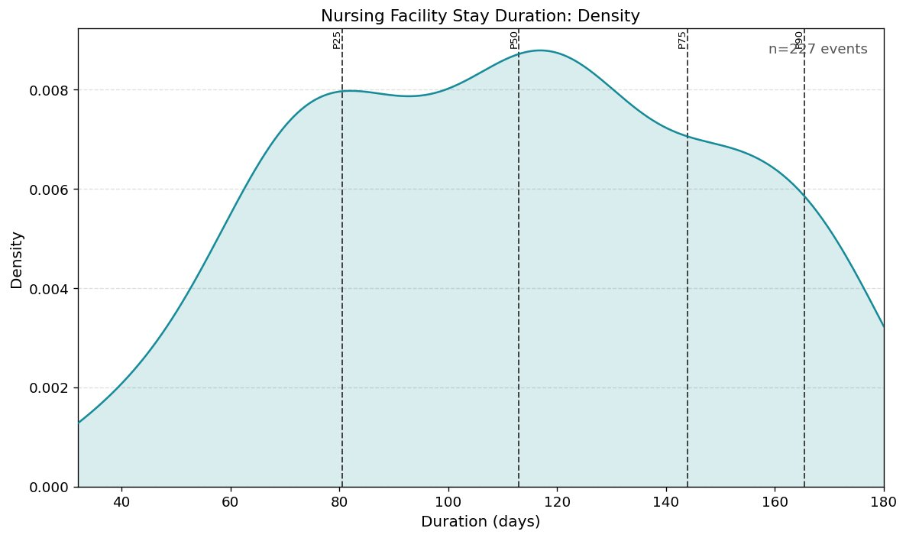
Figure 1. KDE of nursing facility stay duration (n=227 episodes). Bimodal distribution with peaks near 80 and 115 days. Dashed lines: P25, P50, P75, P90.

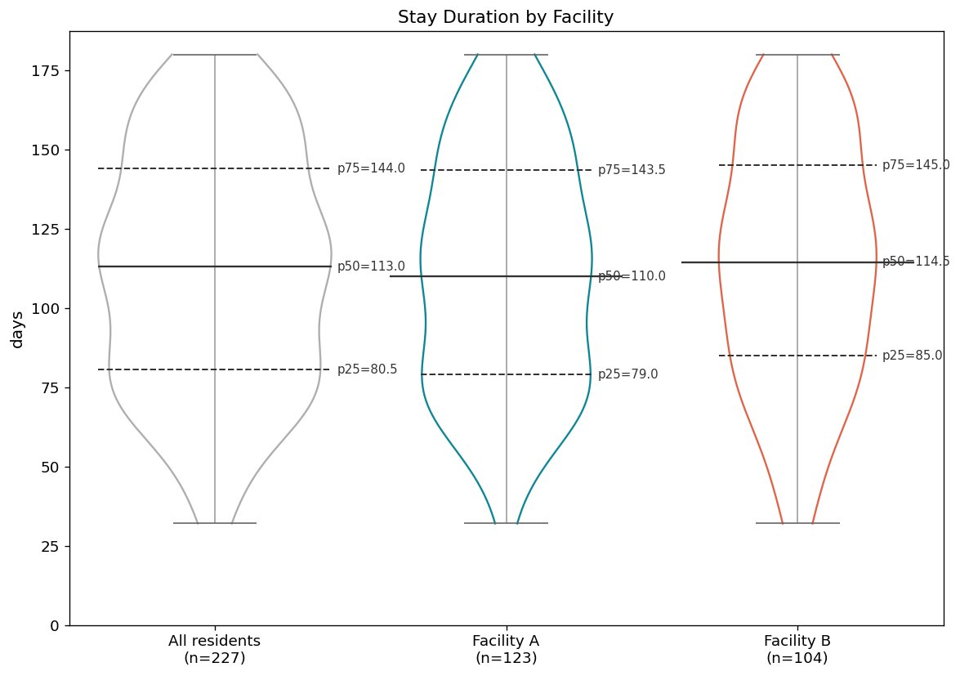
Figure 2. Stay duration stratified by facility. All residents (n=227, p50=113 days), Facility A (n=123, p50=110 days), Facility B (n=104, p50=114.5 days).

Architectural point: Visual and stratification decisions are scientific decisions — they belong in a versioned config file, not in plotting code. Adding stratification requires one argument change in one config file.

3.4 Chapter 4 — Observation Period Construction
Scientific question: How many days of Medicaid coverage did members have during calendar year 2022, and how does this change when the observation window is defined by age rather than calendar year?
You have coverage records for 500 Medicaid members. Before you can ask any scientific question — who was covered, for how long, were there gaps — you need to answer a structural one: “What is each member’s observation window, and what happened inside it?” This question has two versions. The first is simple: everyone shares the same calendar year. The second is harder and more realistic: each member has a different window based on their age.
Events data rarely aligns neatly with the period you are studying. This goes beyond simply filtering to a date range. The time before the first event, between events, and after the last event is scientifically meaningful — a member with no insurance coverage in the first quarter of their observation window is a different scientific situation from one who was covered from day one. The right value for any member's coverage in 2022 is the intersection of their coverage records with the observation window — not the raw record. And denominators depend on this intersection: "19.4% of members had gaps" means 19.4% of members with any coverage — a different denominator than "19.4% of all members." Mixing them silently produces wrong statistics.
Per-entity windows make this harder still. When the observation window is each member's 18th to 25th birthday, every member has a different start and end date. Members who turned 25 before the study data begins have zero-length windows — they must not be silently dropped. A script applies a date filter somewhere in the middle of the pipeline. It has no object. It has no name. It cannot be inspected or reused.
ObsPeriodPerEntity is a first-class object with a construction_path attribute recording exactly how it was built. Two paths are demonstrated — construct_from_calendar() gives every member the same 2022 window; construct_from_age_window() gives each member a personal 18–25 window from their date of birth. The rest of the pipeline is identical for both.
EventsFilter(events).to_obs_period(obs, clip=True) clips coverage periods to each member’s window. CohortTimeline.build_from_components() assembles the filtered events and observation period into one per-entity table — the first CohortTimeline in the vignette series:

CohortTimeline(
entities : 495
entity_col : 'patient_id'
has_obs_period : True
event_identities : ['medicaid_coverage']
event_descriptor_cols : {}
computed_event_identities : []
occurrence_identities : []
occurrence_descriptor_cols : {}
computed_occurrence_identities: []
)

CohortTimelineEventAnalyzer.enrich_with_event_coverage() enriches the timeline with seven evt_comp_* columns per member. These columns travel with the object and are available for every downstream step without recomputing. A sample of the enriched data:

patient_id obs_start obs_end evt_medicaid_coverage_starts evt_comp_..._active_days
P0001 2022-01-01 2022-12-31 2022-01-01 | 2022-06-15 311
P0002 2022-01-01 2022-12-31 2022-03-10 296
P0003 2022-01-01 2022-12-31 NaN 0

P0001 had two coverage periods (pipe-delimited); P0002 had one; P0003 had none. get_summary() produces an EventCoverageSummary with three tiers and validated denominators. Switching to the age window changes one constructor call. The age-window summary tells a different story: 13.6% of members had no coverage during ages 18–25, only 3.5% were continuously covered for the full seven years, and nearly a third had gaps.
Architectural point: The observation period is a first-class object — not a date filter buried in a script. Multiple construction paths, same downstream pipeline. CohortTimeline.build_from_components() is a dumb assembler — it performs no analysis, makes no decisions, and imposes no constraints beyond what the objects already guarantee. Any valid ObsPeriodPerEntity and Events object snap together cleanly, because they have already earned their structural guarantees upstream.

3.5 Chapter 5 — Stacked Timeline Visualization
Scientific question: What do individual Medicaid coverage patterns look like across the 18–25 age window?
You know from Chapter 4 that 13.6% of members had no coverage, only 3.5% were continuously covered, and 31.9% had gaps. A table of statistics tells you what happened. It cannot show you the pattern. Which members had gaps early in their window? Which had gaps late? A stacked timeline answers all of these at once — one bar per member, colored by coverage status.
No new cleaning. No new semantics. The CohortTimeline from Chapter 4 is the input. ct.sample_subset(n=50, random_seed=42) draws a reproducible 50-member sample — a display decision, not an analytical decision, explicitly separated from the analysis that used all 500 members. Every visual choice lives in a versioned YAML. Using mode: calendar instead of mode: auto raised immediately with the exact count of differing entities and the two valid alternatives. Figure 3 shows the result — continuous members as solid blue bars, gapped members as blue broken by orange, partially covered members as short bars, and uncovered members as near-white.

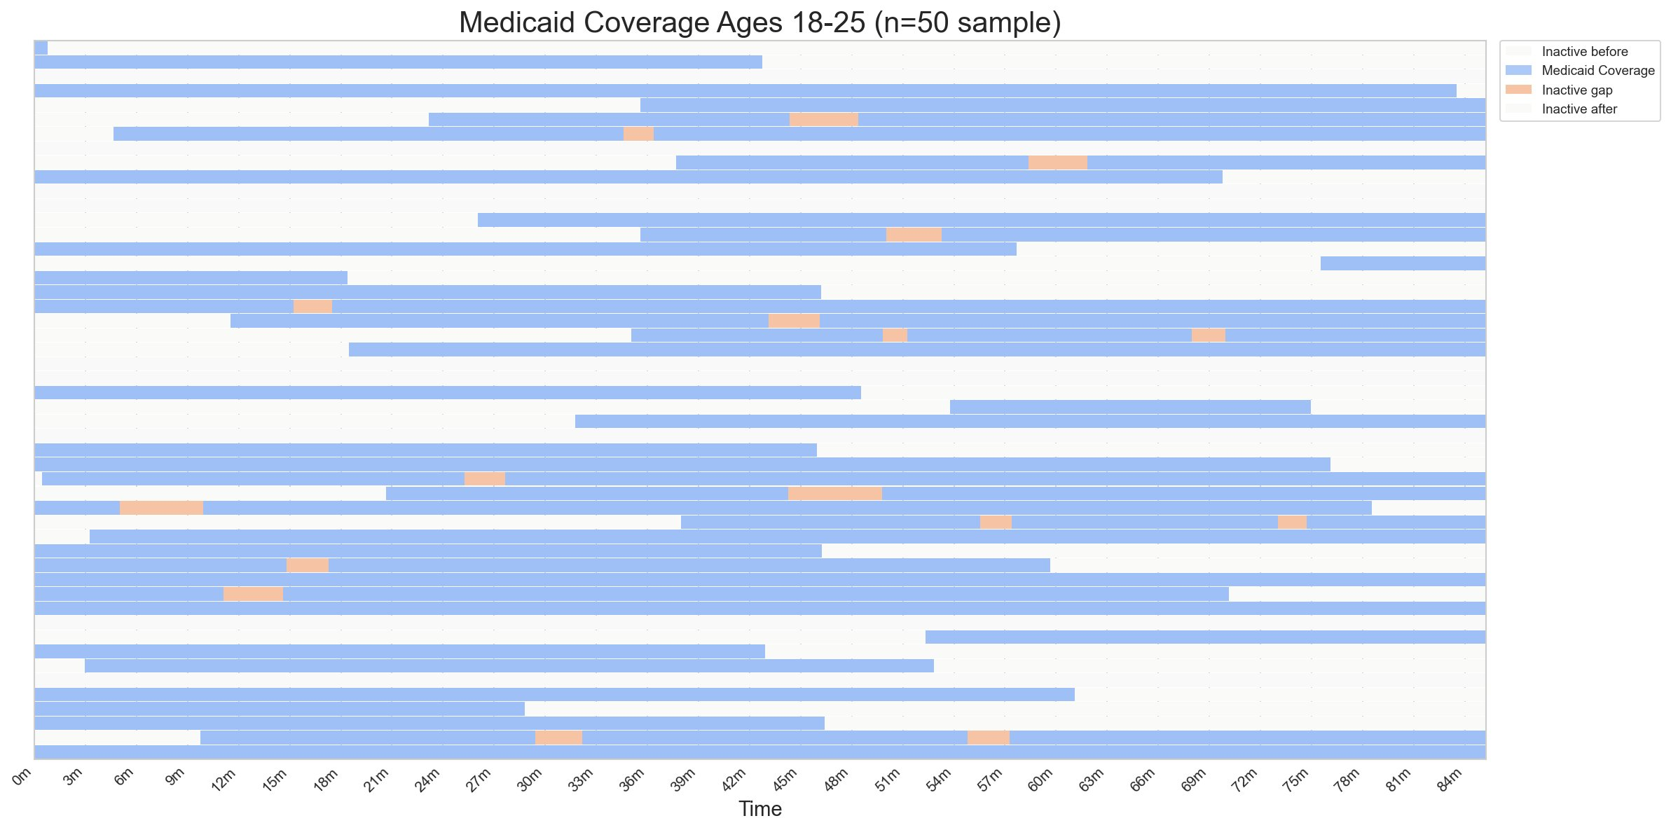
Figure 3. Stacked timeline of Medicaid coverage for 50 members, ages 18–25. Each row is one member; bar length reflects their personal 18–25 window. Blue: active coverage. Orange: coverage gaps. White: outside window.

Architectural point: The CohortTimeline is the contract between analysis and visualization. The plotter does not know how the observation periods were constructed, how the events were cleaned, or which entities were filtered — it receives a validated object and trusts it. The same plotter that draws calendar-year coverage draws age-window coverage with one config change and zero code changes. All visual decisions live in a versioned config file.

3.6 Chapter 6 — Occurrence Volume Analysis
Scientific question: How many ED visits did members have during their coverage period, and how does that change when restricted to the ages 18–21 transition window?
This is the first chapter where two data types appear in the same pipeline — events (coverage periods) and occurrences (ED visits). Before that assembly can happen, the occurrences need the same cleaning guarantees as events: null identifiers, unparseable dates, and duplicates handled explicitly. But occurrences have one additional problem: same-date same-hospital records with different diagnoses or blood pressure readings are not duplicates — they are the same visit recorded twice. The consolidation rule belongs in a config file, not a groupby lambda.
OccurrenceSemantics declares also_defined_by = ["hospital_id"] — two visits on the same date at different hospitals are different occurrences. The cleaner config declares consolidation rules: icd10_condition: unique (collect all diagnoses) and systolic_bp: median (take the median reading).

Cleaning report — occurrences
────────────────────────────────────────────────────────
Total input rows: 5,442
────────────────────────────────────────────────────────
Rejected:
duplicate_row: 3,195 (58.7%)
null_date: 107 (2.0%)
null_entity_id: 54 (1.0%)
────────────────────────────────────────────────────────
Total rejected: 3,356 (61.7%)
Clean rows: 2,060 (37.9%)

CohortTimeline.build_from_components() now accepts both data types. event_identities and occurrence_identities are tracked separately — the timeline knows what it holds. CohortTimelineOccurrenceAnalyzer.compute_volume() produces a validated result: 339 members (68.5%) with any ED visit, 199 (40.2%) with multiple. Switching to the 18–21 age window changes one constructor call: 337 (67.4%) with any visit, 243 (48.6%) with multiple — nearly half had repeat ED visits during the transition to young adulthood. The pipeline is identical. The denominators are validated at construction.
Architectural point: OccurrencesCleaner provides the same guarantees as EventsCleaner — same design, different data type. CohortTimeline holds both data types, tracking them separately. OccurrenceResultVolume validates its denominators — n_with_any and n_with_multiple cannot be accidentally computed against the wrong cohort.

3.7 Chapter 7 — Occurrence Timing and Gap Analysis
Scientific question: When did members have their first, second, and third ED visit between ages 18 and 21, and does the gap between visits differ by diagnosis?
You know 67.4% of members had at least one ED visit and nearly half had multiple. Now the question is when — and whether the pattern differs by condition. Two problems make this harder than it looks. Each nth timing has a different denominator: time to first visit is defined for 337 members, time to second for 243, time to third for 147. A script must track three denominators manually and apply them correctly to three histograms on a shared axis. And stratifying gap distributions by condition requires that diagnosis labels survive from raw claims through cleaning, consolidation, and timeline assembly — without any additional joins.
Chapter 7 reuses the full pipeline from Chapter 6. compute_timing(max_n=3) produces per-member timing with shrinking validated denominators: 337 (67.4%) with a first visit, 243 (48.6%) with a second, 147 (29.4%) with a third. Figure 4 shows faceted histograms on the same x-axis — each subplot shows its eligible denominator automatically. The first-visit distribution is left-skewed; the third-visit distribution is flatter and shifts right.

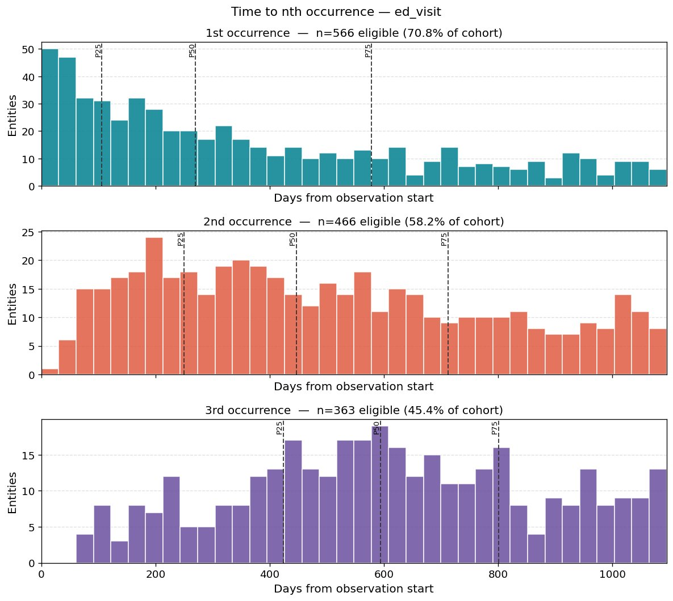
Figure 4. Time to nth ED visit from age 18, signal simulation (n=800). Top: 1st visit (n=566, 70.8%). Middle: 2nd (n=466, 58.2%). Bottom: 3rd (n=363, 45.4%). Shared x-axis. Dashed lines: P25, P50, P75.

compute_shape() produces per-entity behavioral fingerprints. plot_mean_gap_violin_stratified() reads occ_ed_visit_icd10_condition directly from the CohortTimeline — declared in OccurrenceSemantics.descriptor_cols with timeline: unique, no join required. Figure 5 shows the signal: single-condition members (conditionA median 219 days, conditionB 207 days, conditionC 152 days) have longer gaps than comorbid members (132–150 days) — consistent with the higher visit rates assigned to conditionB and conditionC.

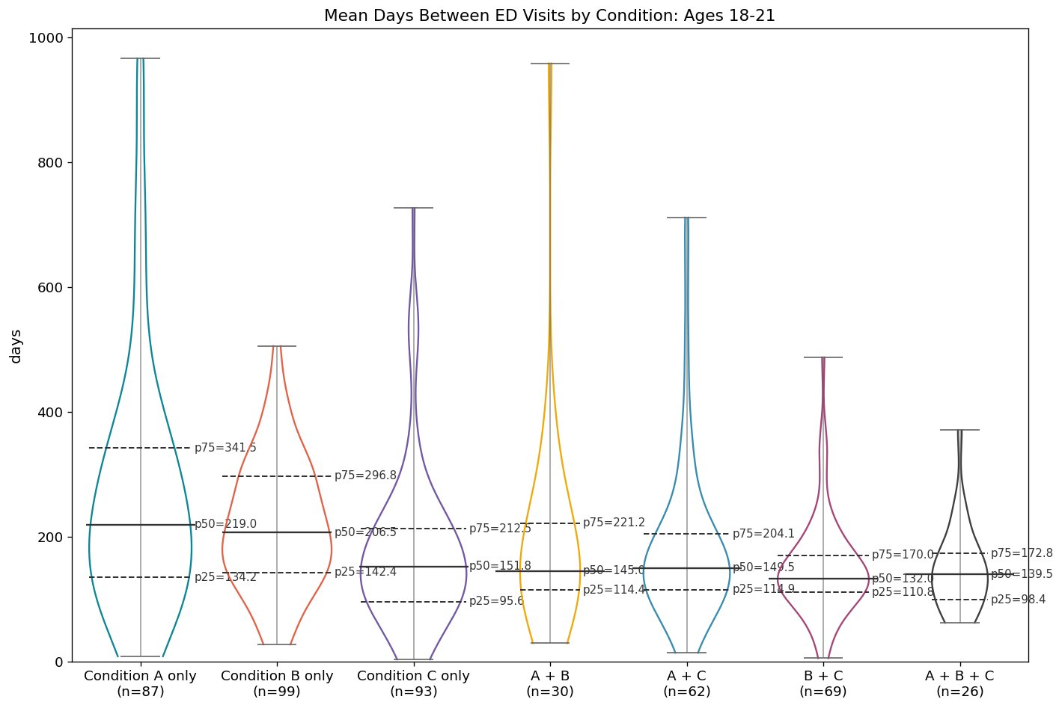
Figure 5. Mean days between ED visits by condition group, ages 18–21 (signal simulation). Single-condition members show longer gaps than comorbid members. Dashed lines: P25, P50, P75.

Architectural point: New intermediate classes — OccurrenceResultTiming, OccurrenceResultShape — extend the framework without modifying existing components. Each carries its own validated denominators as properties, so the right denominator appears in each subplot title automatically rather than being tracked manually. Descriptor columns declared with timeline: unique survive the full pipeline into the CohortTimeline and are available for stratification without additional joins. Adding this capability changed four components; every analyzer, cleaner, and other intermediate required zero changes.

3.8 Chapter 8 — Occurrence-Event Co-occurrence Analysis
Scientific question: Do ED visits precede hospitalizations? Do members return to the ED after discharge? How many ED visits happen during a hospitalization stay itself?
You have two event streams for the same cohort: ED visits (point-in-time occurrences) and hospitalizations (interval events). The scientific question is not whether members had both — it is how they relate in time. Both streams need separate cleaning pipelines before assembly. The visual pattern should be shown before any statistics are computed. And nearest-neighbor gap computation across two pipe-delimited date streams is not a standard pandas groupby.
A new patient pool (C0001–C0800) was generated with clinically realistic structure: ED visits at λ=3.0/year, 20% triggering a hospitalization the same or next day, 5% billing artifacts (ED on the exact admission date), 75% independent. Elective hospitalizations (λ=0.3/year) add admissions without preceding ED visits. Both streams are cleaned independently — separate semantics, separate cleaner configs, separate reports — then assembled.
Chapter 4 showed the assembler accepting an observation period and events. Chapter 8 shows it accepting all three — observation period, events, and occurrences — each cleaned independently, each carrying its own structural guarantees, none knowing about the others. The assembler did not change. The StackedTimelinePlotter did not change either — it received a CohortTimeline with two identities instead of one and rendered both, because the config declared two layers and the plotter reads whatever the timeline holds.

CohortTimeline(
entities : 775
has_obs_period : True
event_identities : ['inpatient_hospitalization']
occurrence_identities : ['ed_visit']
)

Figure 6 shows the stacked timeline for 50 members — red hospitalization bars and teal ED visit dots on a shared calendar axis. Members with ED visits clustered around hospitalization bars are immediately visible before any statistics are computed. OccurrenceEventAnalyzer has no config — no thresholds, no windows. The computation is nearest-neighbor gaps within the observation period. The 392 ED visits during or on the day of a hospitalization (16.5%) reflect billing artifacts and ED-triggered admissions. NaN values are scientifically meaningful absences of signal — entities with no hospitalizations have NaN for all event-related statistics, not missing data.

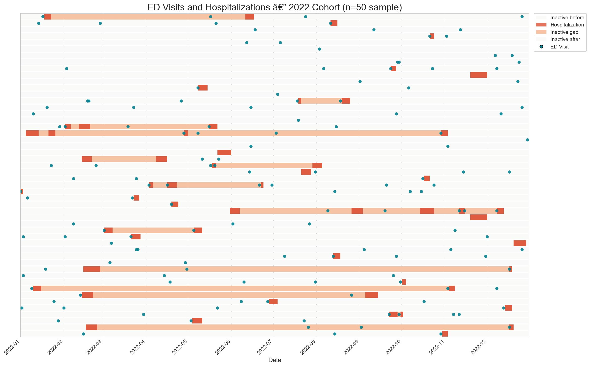
Figure 6. Stacked timeline of ED visits (teal dots) and hospitalizations (red bars), 2022 cohort (n=50 sample). ED visits clustering around hospitalization bars reflect the 20% ED-to-admission rate.

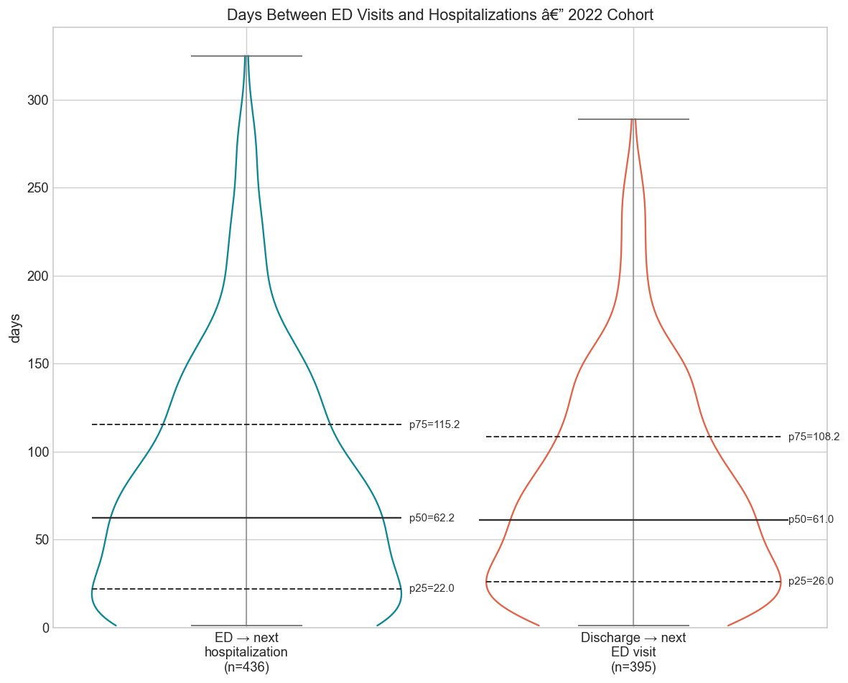
Figure 7. Nearest-neighbor gap distributions. Left: ED visit to next hospitalization (n=436, p50=62.2 days). Right: discharge to next ED visit (n=395, p50=61.0 days). Dashed lines: P25, P50, P75.

Architectural point: Chapter 4 showed the assembler accepting an observation period and events. Chapter 8 shows it accepting all three — observation period, events, and occurrences — each cleaned independently, none knowing about the others. The assembler did not change. The plotter did not change. The only new component is OccurrenceEventAnalyzer. This is the open/closed principle demonstrated end-to-end: the system was extended without modifying anything that already worked.

4. Comparison with Script-Based Implementations
To evaluate the practical cost of the script-based paradigm, we implemented equivalent pipelines for six vignettes using standard pandas, numpy, and matplotlib. Scripts were generated by a large language model given identical specifications and refactored to use global constants. Table 1 summarizes the results.

Table 1. Comparison of eventus and script-based implementations.

Vignette | Script lines | eventus lines | Script issues
Ch 1 — Event cleaning | ~150 | ~10 | Runs correctly
Ch 1B — Occurrence cleaning | ~70 | ~10 | Runs correctly
Ch 2 — Descriptor aggregation | ~150 | ~10 | Aggregation rules hardcoded
Ch 4 — Observation periods | ~275 | ~20 | Runs with pandas UserWarning
Ch 5 — Stacked timeline | ~165 | ~3 | Normalized x-axis only
Ch 6 — Occurrence volume | ~99 | ~15 | Age window not implemented

Line counts alone understate the difference. Four structural limitations appear consistently across all script implementations regardless of code quality. First, no versioned config: cleaning and aggregation parameters live as hardcoded values invisible to collaborators reading the output. Second, no per-row audit trail: scripts produce aggregate counts; eventus produces a rejected DataFrame and a modified DataFrame, both accessible programmatically. Third, silent errors instead of specific exceptions: the Chapter 4 script produced a pandas UserWarning and continued execution; the Chapter 5 script silently produced a normalized x-axis when calendar mode was requested for variable-length observation periods. Fourth, adaptation requires rewriting: switching from calendar to age window analysis required ~40 additional lines in the script and one constructor call change in eventus.
Chapters 3 and 7 were not implemented as script comparisons. Chapter 3 was estimated at ~140 lines. Chapter 7 was estimated at ~240 lines before accounting for the per-entity age window (~75 additional lines) and condition stratification join (~30 lines). The escalating complexity — from ~150 lines in Chapter 1 to ~275 lines in Chapter 4 to not implemented in Chapters 3 and 7 — is itself the argument.

5. Additional Capabilities
The eight vignettes do not cover all analytical capabilities in the current release.
Kaplan-Meier survival analysis. CohortTimelineOccurrenceAnalyzer.compute_survival() computes time-to-first-occurrence survival curves. Entities with no occurrence are right-censored at their obs_duration_days. The SurvivalResult carries validated structural invariants: survival values in [0, 1], CI bounds bracketing the estimate at every timepoint, and monotonically non-increasing n_at_risk.
Event activity over time. CohortTimelineEventAnalyzer.compute_activity_over_time() produces a per-timepoint activity timeseries in normalized (relative to each entity's obs_start) or calendar mode. The result feeds ActivityOverTimePlotter with a two-panel output: coverage curve and entry/exit flow.
Event coverage summary. get_summary() produces an EventCoverageSummary with three tiers and validated denominators, preventing the silent denominator errors that script-based summaries are prone to.
Occurrence behavioral fingerprint. compute_shape() produces burstiness, memory, density, and center of mass per entity. plot_fingerprint() renders a burstiness vs. memory scatter with four behavioral quadrants.
Planned extensions. Occurrence-occurrence and event-event co-occurrence analyzers, descriptor-based filtering (selection operation σ in relational algebra; Codd 1970), and interactive visualization are planned for future releases.

6. Discussion

6.1 Implications for reproducibility in health services research
The reproducibility crisis in computational science has been extensively documented (Stodden et al. 2018; Sandve et al. 2013; Wilson et al. 2017). Health services research is particularly vulnerable: analyses involve complex multi-step pipelines, large administrative datasets with known quality issues, and analytical decisions that are rarely reported in published methods sections. eventus addresses this structurally. It does not ask analysts to document their decisions more carefully. It makes the decisions impossible to make without documenting them. The config file is not optional documentation — it is the required input to the cleaner. The audit trail is not an optional report — it is an automatic output of every cleaning run.

6.2 Domain agnosticism and generalizability
The three-object structure — entities, observation periods, interval events, point-in-time occurrences — recurs across domains wherever entities are observed over time: insurance analytics, educational longitudinal research, ecological monitoring, clinical trial follow-up, and workforce analysis. eventus is designed to be applicable to any of these domains without modification. We hope this work is useful to researchers in other domains who face the same structural challenge and to software developers designing similar frameworks.

6.3 Object-oriented design in applied data science
The object-oriented design patterns used in eventus — typed objects with validated invariants, layered architecture with explicit boundaries, configuration objects as first-class citizens — are standard in software engineering but underutilized in applied data science. eventus demonstrates that these patterns are not only applicable to data analysis but produce measurable benefits: shorter calling code, automatic audit trails, reproducible visualization, and feature additions that propagate with minimal surface area. When descriptor columns were added to the CohortTimeline, the change required modifications to exactly four components; every other component in the pipeline required zero changes.

6.4 Compatibility with large language model-assisted development
Object-oriented frameworks with clear semantics and comprehensive documentation are better suited to LLM-assisted development than unstructured scripts. An LLM asked to extend an eventus pipeline produces consistent, architecturally correct code because the layer boundaries and type system constrain the space of valid implementations. The README becomes a specification. The type system becomes a contract. We expect this practical consideration will become increasingly important for scientific software design.

6.5 Limitations and future directions
The pipe-delimited storage format in CohortTimeline is compact and human-readable but requires parsing at every analytical step; for very large cohorts this may introduce performance costs that a sparse matrix representation would avoid. Python's interpreted execution adds further overhead relative to compiled alternatives for computationally intensive operations. However, the layered architecture makes targeted optimization tractable. Because each layer has a single responsibility (Single Responsibility Principle; Martin 2000) and depends on typed object interfaces rather than concrete implementations (Dependency Inversion Principle), any individual layer can be reimplemented in C, C++, or Rust without modifying any other layer. A C extension that produces a valid CohortTimeline object is, by the Liskov Substitution Principle (Liskov and Wing 1994), interchangeable with the pure Python implementation from the perspective of every downstream component. The typed object boundaries that enforce architectural discipline also make performance optimization safe — the contract between layers is the interface, not the implementation.
The co-occurrence analysis layer currently supports only one occurrence-event analyzer; occurrence-occurrence and event-event analyzers are planned. Sequential dependency analysis — characterizing whether occurrence type B tends to follow type A (first-order Markov chain analysis) — is a natural extension planned for a future release. The visualization layer currently produces static plots; interactive visualization is a direction for future development.

6.6 Conclusion
eventus provides a unified, object-oriented framework for longitudinal cohort analysis in which observation periods, interval events, and point-in-time occurrences are first-class typed objects. The six-layer architecture carries guarantees forward from raw data to publication-ready visualization, making reproducibility a structural property of the pipeline. The eight vignettes demonstrate that the framework produces correct, auditable, reproducible analyses with substantially less code than equivalent script-based implementations, and that script-based implementations cannot provide the same structural guarantees regardless of code quality. The framework is domain-agnostic, LLM-compatible, and designed to be extended.

References
Core dependencies
McKinney W (2010). “Data Structures for Statistical Computing in Python.” In Proceedings of the 9th Python in Science Conference, pp. 56–61.
Harris CR, et al. (2020). “Array programming with NumPy.” Nature, 585, 357–362.
Hunter JD (2007). “Matplotlib: A 2D graphics environment.” Computing in Science & Engineering, 9(3), 90–95.

R packages
Therneau TM (2023). A Package for Survival Analysis in R. https://CRAN.R-project.org/package=survival
Grolemund G, Wickham H (2011). “Dates and Times Made Easy with lubridate.” Journal of Statistical Software, 40(3), 1–25.
Wickham H, et al. (2023). dplyr: A Grammar of Data Manipulation. https://CRAN.R-project.org/package=dplyr

Theoretical and methodological
Codd EF (1970). “A Relational Model of Data for Large Shared Data Banks.” Communications of the ACM, 13(6), 377–387.
Kaplan EL, Meier P (1958). “Nonparametric estimation from incomplete observations.” Journal of the American Statistical Association, 53(282), 457–481.

Reproducibility
Sandve GK, et al. (2013). “Ten simple rules for reproducible computational research.” PLOS Computational Biology, 9(10), e1003285.
Simonsohn U, Simmons JP, Nelson LD (2020). “Specification curve analysis.” Nature Human Behaviour, 4, 1208–1214.
Steegen S, Tuerlinckx F, Gelman A, Vanpaemel W (2016). “Increasing Transparency Through a Multiverse Analysis.” Perspectives on Psychological Science, 11(5), 702–712.
Patel CJ, Burford B, Ioannidis JPA (2015). “Assessment of vibration of effects due to model specification can demonstrate the instability of observational associations.” Journal of Clinical Epidemiology, 68(9), 1046–1058.
Wilson G, et al. (2017). “Good enough practices in scientific computing.” PLOS Computational Biology, 13(6), e1005510.
Stodden V, et al. (2018). “An empirical analysis of journal policy effectiveness for computational reproducibility.” PNAS, 115(11), 2584–2589.

Software engineering and design patterns
Gamma E, Helm R, Johnson R, Vlissides J (1994). Design Patterns: Elements of Reusable Object-Oriented Software. Addison-Wesley.
Liskov B (1987). “Data abstraction and hierarchy.” SIGPLAN Notices, 23(5), 17–34.
Liskov B, Wing J (1994). “A behavioral notion of subtyping.” ACM Transactions on Programming Languages and Systems, 16(6), 1811–1841.
Martin RC (2000). “Design Principles and Design Patterns.” Object Mentor.

LLMs and code generation
Austin J, Odena A, Nye M, et al. (2021). “Program Synthesis with Large Language Models.” arXiv:2108.07732.
Chen M, et al. (2021). “Evaluating large language models trained on code.” arXiv:2107.03374.

