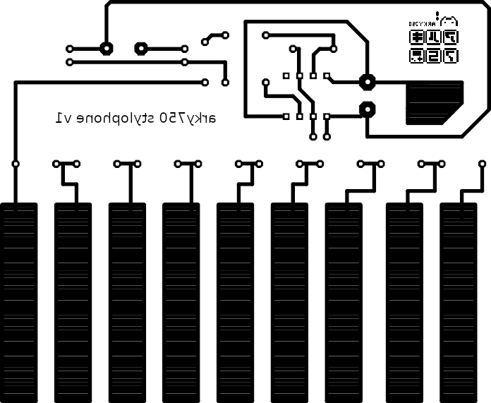

15/5/2025 09:49 mirrored C:\Users\pp-zx\OneDrive\Documentos\EAGLE\projects\piano555.brd