Midpoint.m

function [ t,Vout,iL ] = midpoint( R,L,tf,iL0,h,vin )

N=round(tf/h);

iLa=zeros(1,N); ta=zeros(1,N);Vout = zeros(1,N);

ta(1)=0; iLa(1)=iL0;Vout(1)=feval(vin,0);

for j=1:N-1

tt=ta(j);iLt=iLa(j);

func=@(t,iL) 1./L*feval(vin,tt) -R./L*iLt;

k1=feval(func, tt,iLt);

k2 = feval(func,tt+0.5*h, iLt+0.5*h*k1);

iLa(j+1)=iLt + h*k2;

ta(j+1)=tt+h;

Vout(j+1)= feval(vin,tt+h)-R*iLa(j+1);

end

t=ta;

iL = iLa;

Midpoint_script.m

1. step signal

R =0.5;

L=0.0015;

tf=0.04;

iL0 =0;

h=0.0005;

vin=@(t) 3.5*heaviside(t);

[t,Vout,iL]=midpoint( R,L,tf,iL0,h,vin );

Vout against t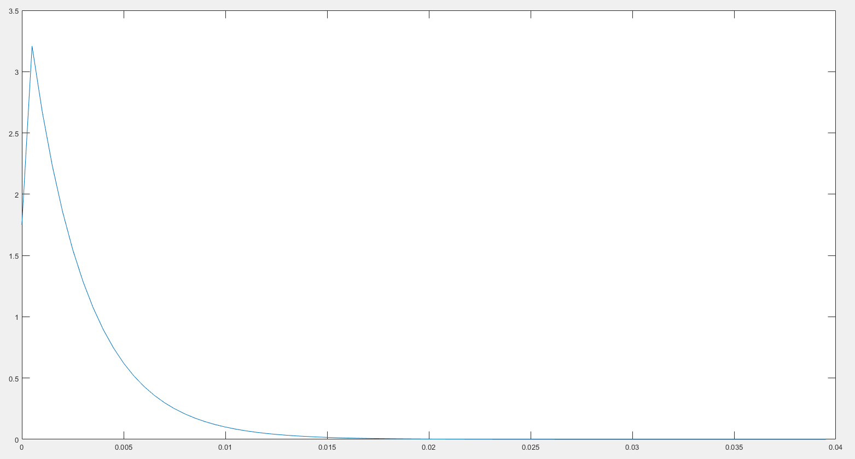

iL(t) against t

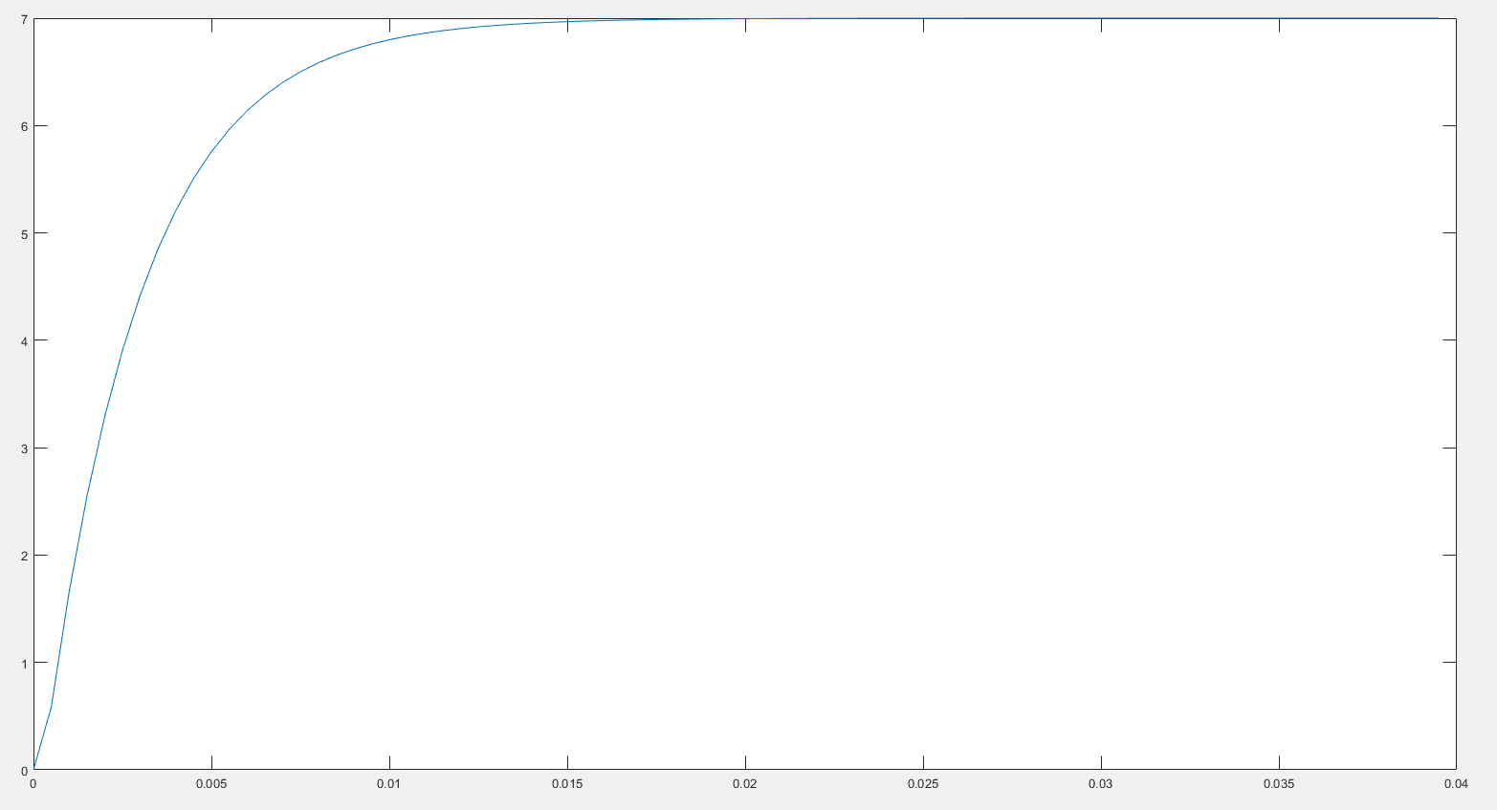

Comment:

For the step response

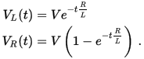

The voltage across the inductor tends towards 0 as time passes, while the voltage across the resistor tends towards *V.* This is in keeping with the intuitive point that the inductor will only have a voltage across as long as the current in the circuit is changing — as the circuit reaches its steady-state, there is no further current change and ultimately no inductor voltage.

1. impulse signal and decay

[1]

R =0.5;

L=0.0015;

tf=0.01;

iL0 =0;

h=0.000005;

lifetime = 0.000110;

vin=@(t) 4.5 *exp(- t.^2./lifetime);

[t,Vout,iL]=midpoint( R,L,tf,iL0,h,vin );

Vout against t

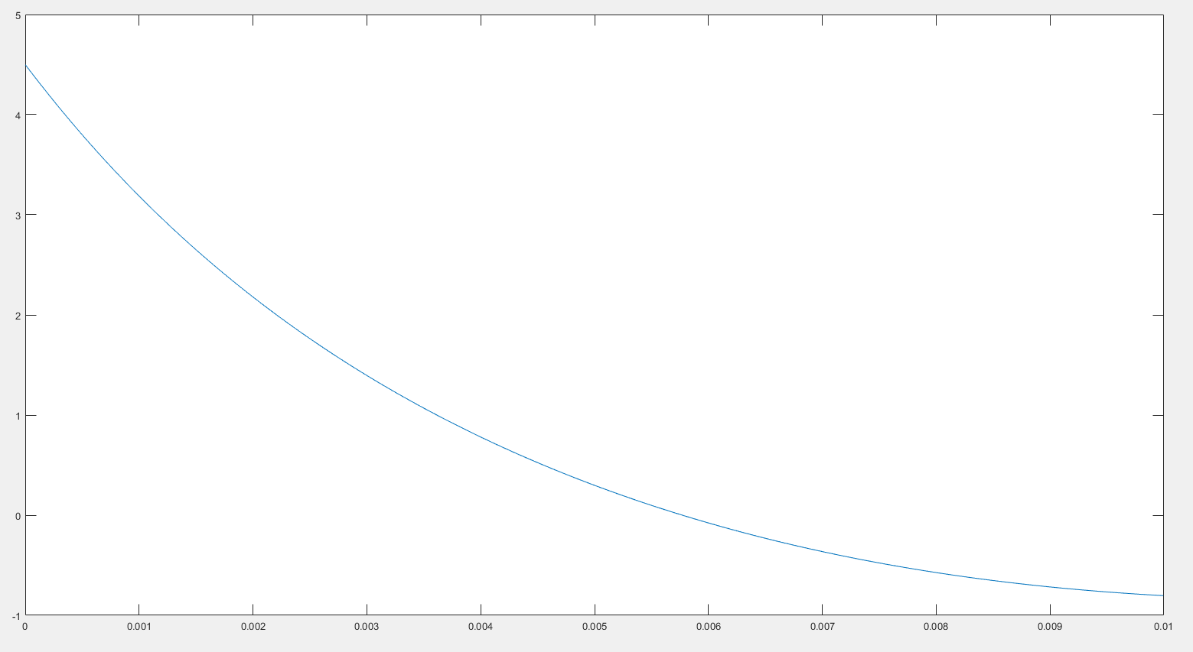

[2]

R =0.5;

L=0.0015;

tf=0.001;

iL0 =0;

h=0.000005;

lifetime = 0.000110;

vin=@(t) 4.5 *exp(- t./lifetime);

[t,Vout,iL]=midpoint( R,L,tf,iL0,h,vin );

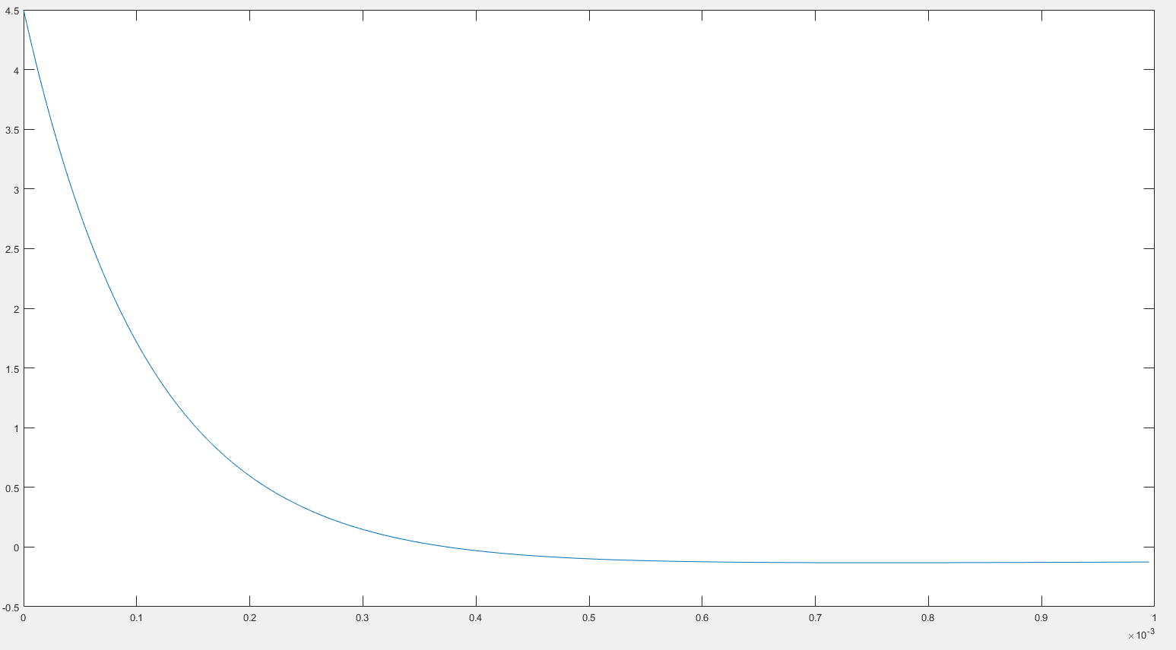

Comment:

1. sine, square and sawtooth waves

R =0.5;

L=0.0015;

tf=0.002;

iL0 =0;

h=0.000005;

T = 0.000035;

f = 1./T;

vin=@(t) 4*sin(2*pi*f*t);

[t,Vout,iL]=midpoint( R,L,tf,iL0,h,vin );

[1] sine wave T =110us

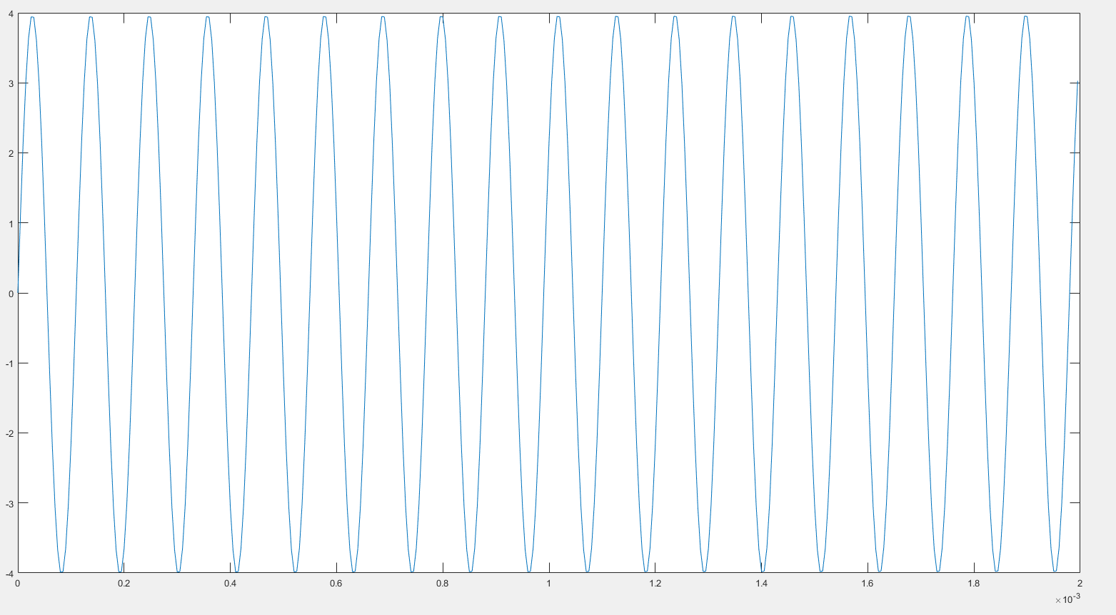

[2] sine wave T=35us

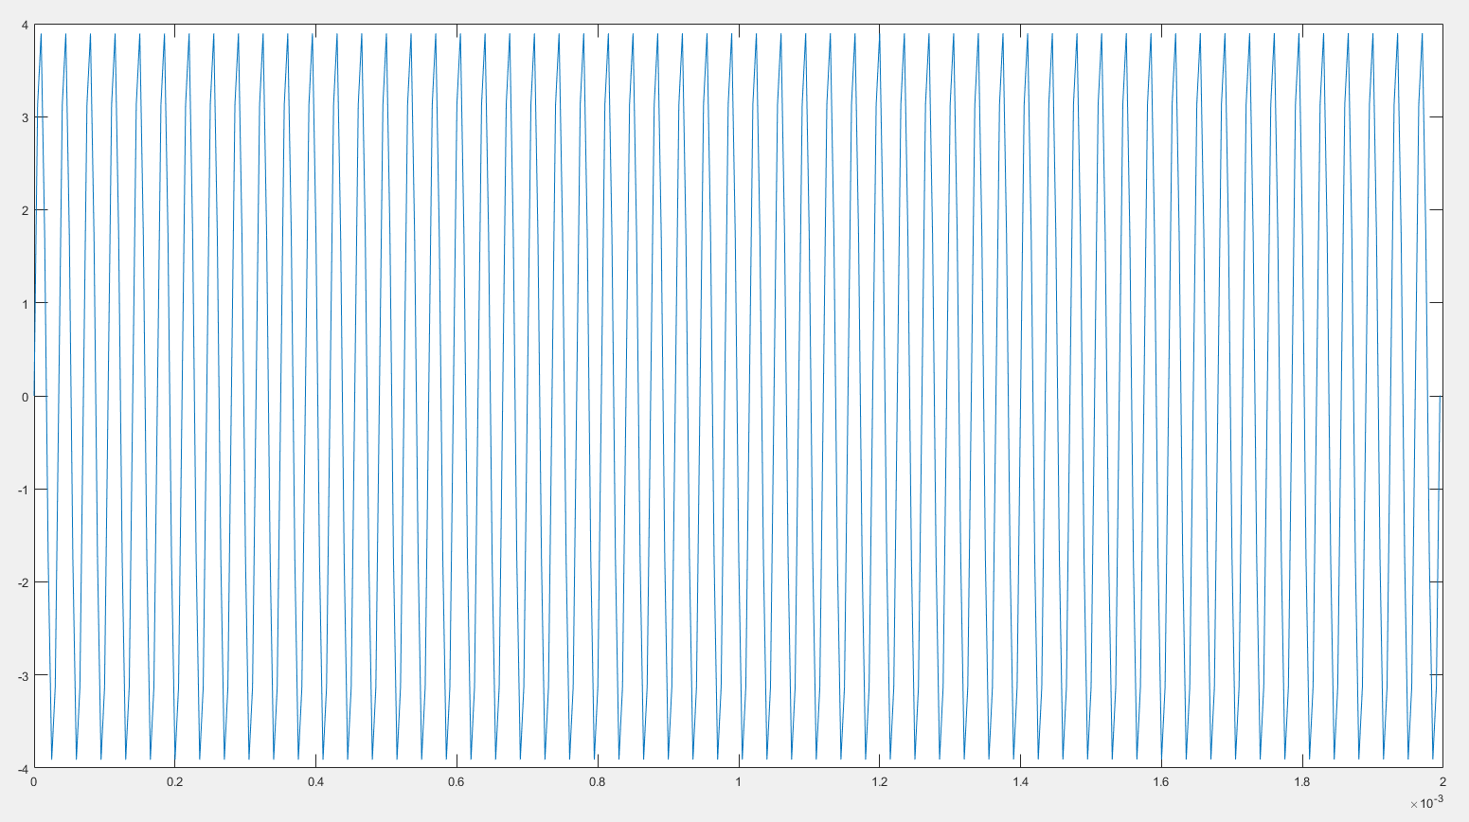

[3] sine wave T =750us

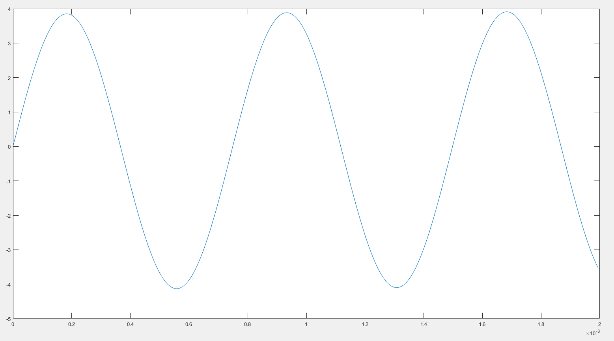

[4] sine wave T=1000us

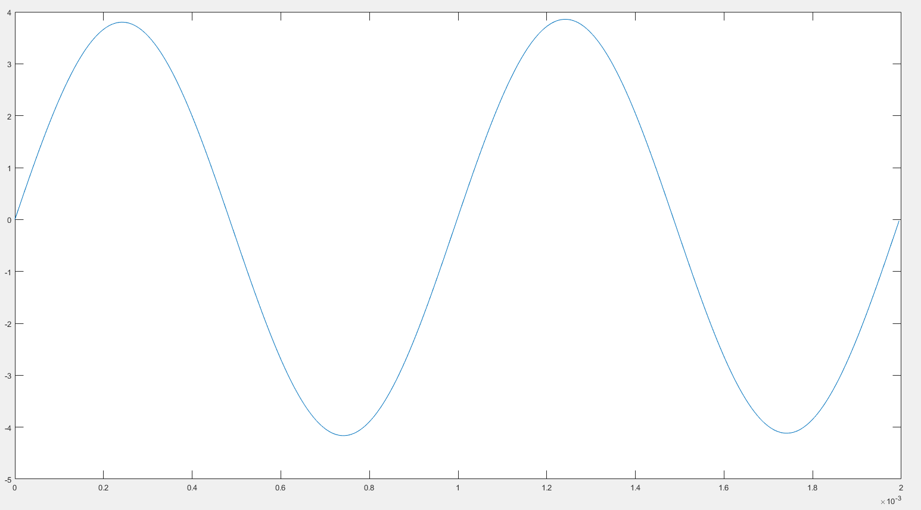

*[5] sine wave T =350us

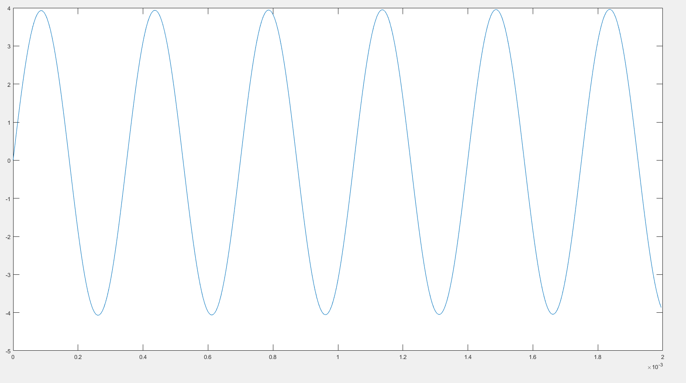

[6] square wave T =110us

R =0.5;

L=0.0015;

tf=0.002;

iL0 =0;

h=0.000005;

T = 0.000110;

f = 1./T;

vin=@(t) 4*square(2*pi*f*t);

[t,Vout,iL]=midpoint( R,L,tf,iL0,h,vin );

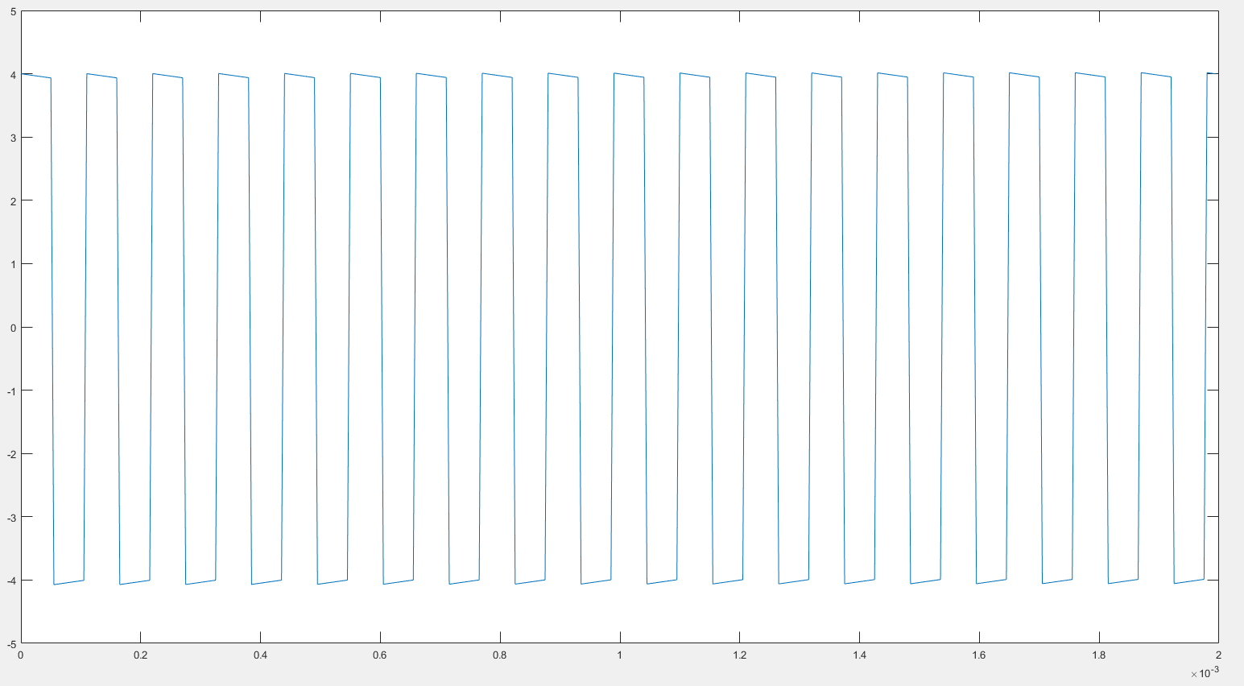

[7] square wave T = 35 us

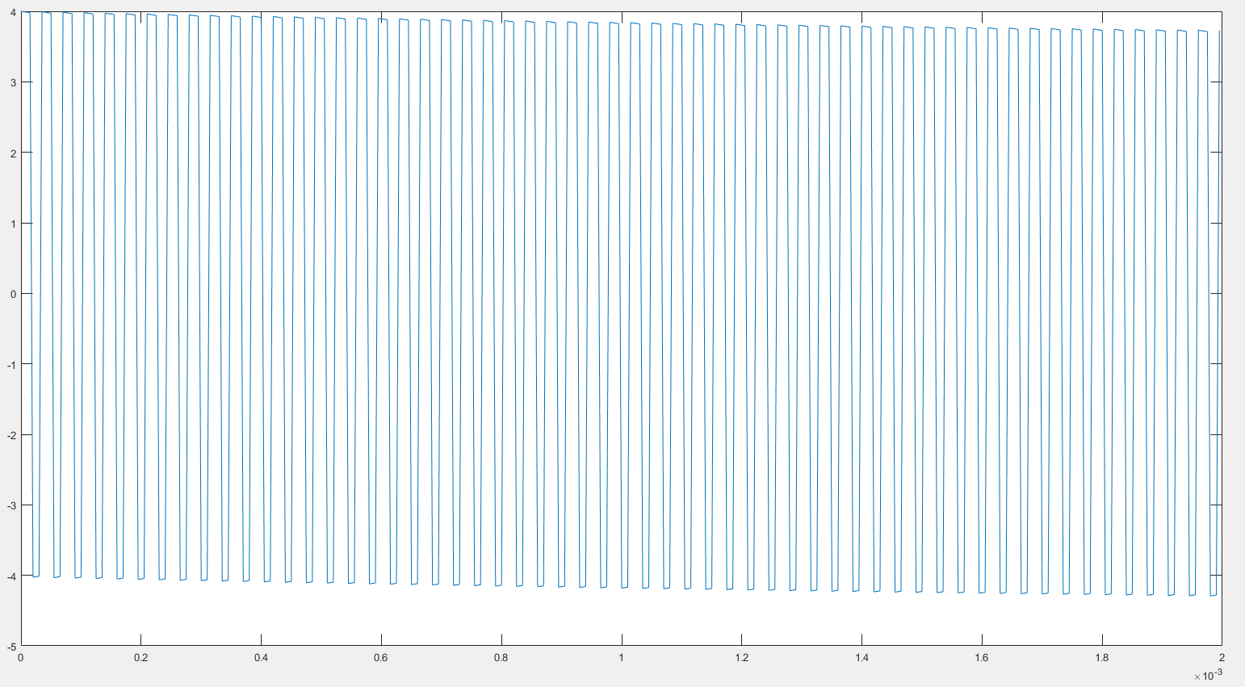

[8] square wave T =750us

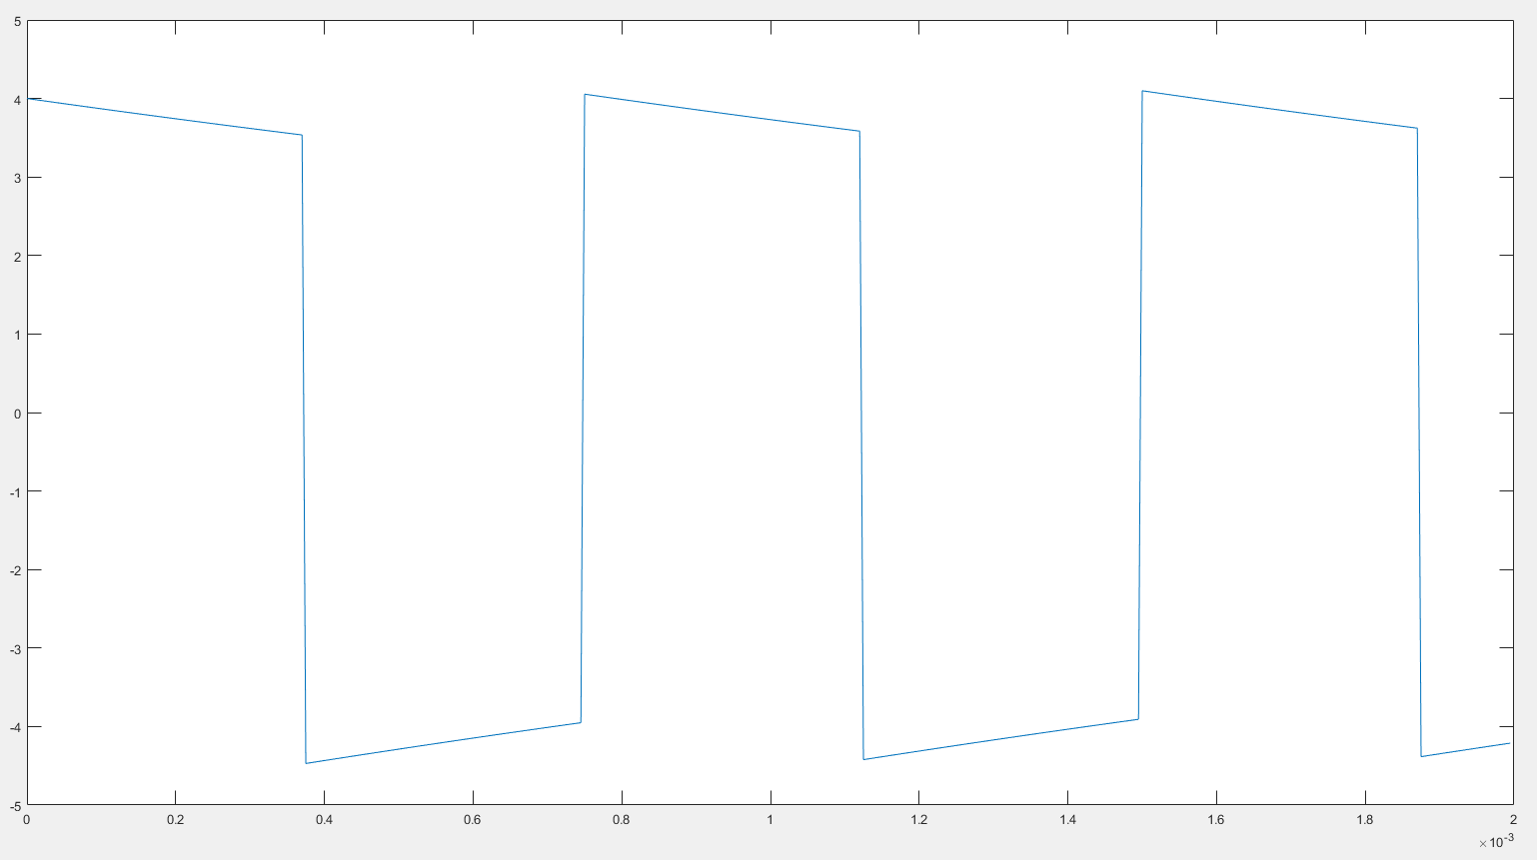

[9] square wave T =1000us

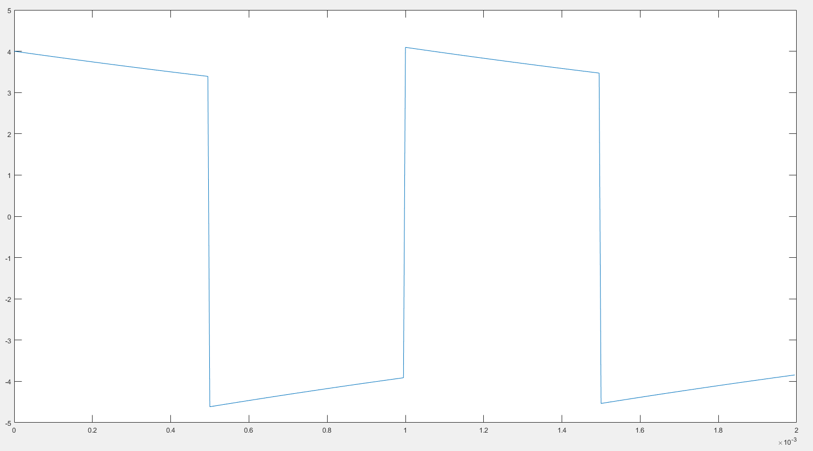

*[10] square wave T = 350us

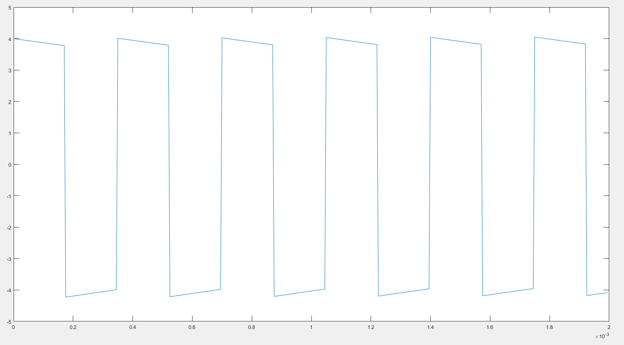

[11] sawtooth T =110us

R =0.5;

L=0.0015;

tf=0.002;

iL0 =0;

h=0.000005;

T = 0.000110;

f = 1./T;

vin=@(t) 4*sawtooth(2*pi*f*t);

[t,Vout,iL]=midpoint( R,L,tf,iL0,h,vin );

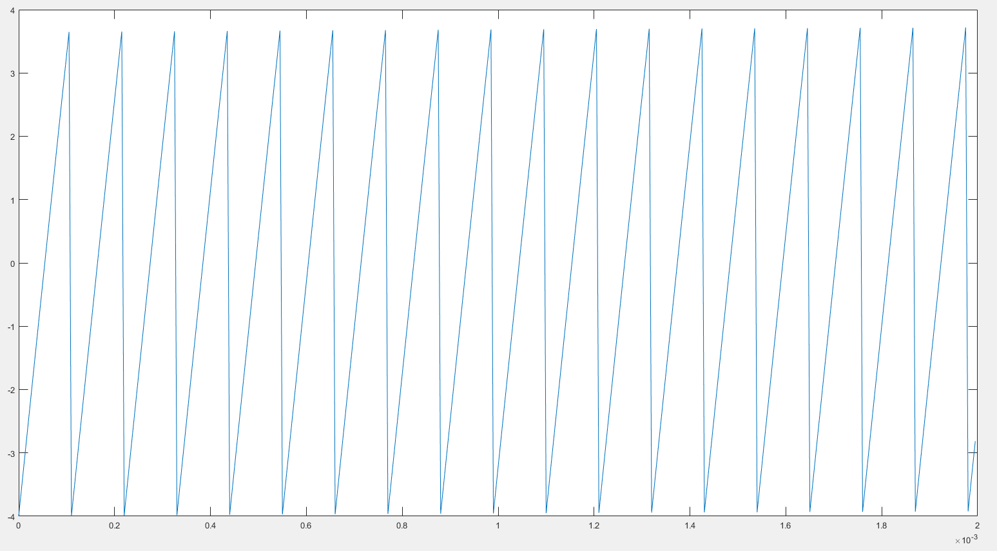

[12] sawtooth T=35us

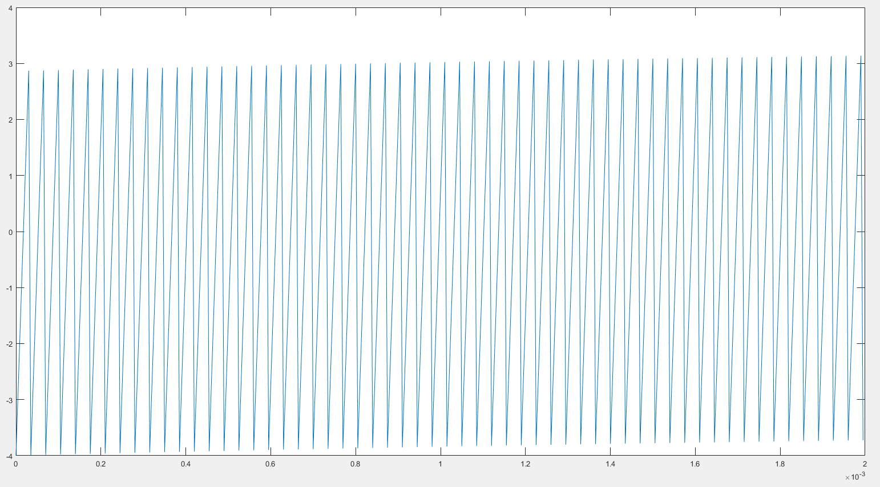

[13] sawtooth T =750us

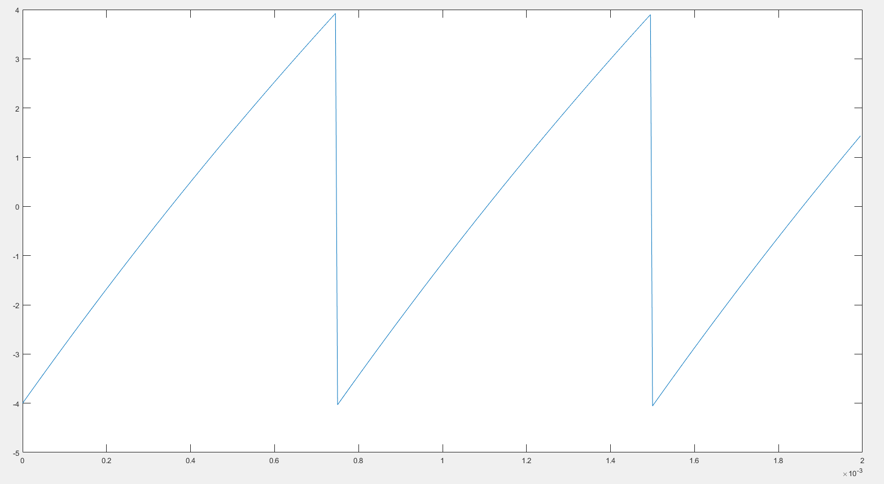

[14] sawtooth T =1000us

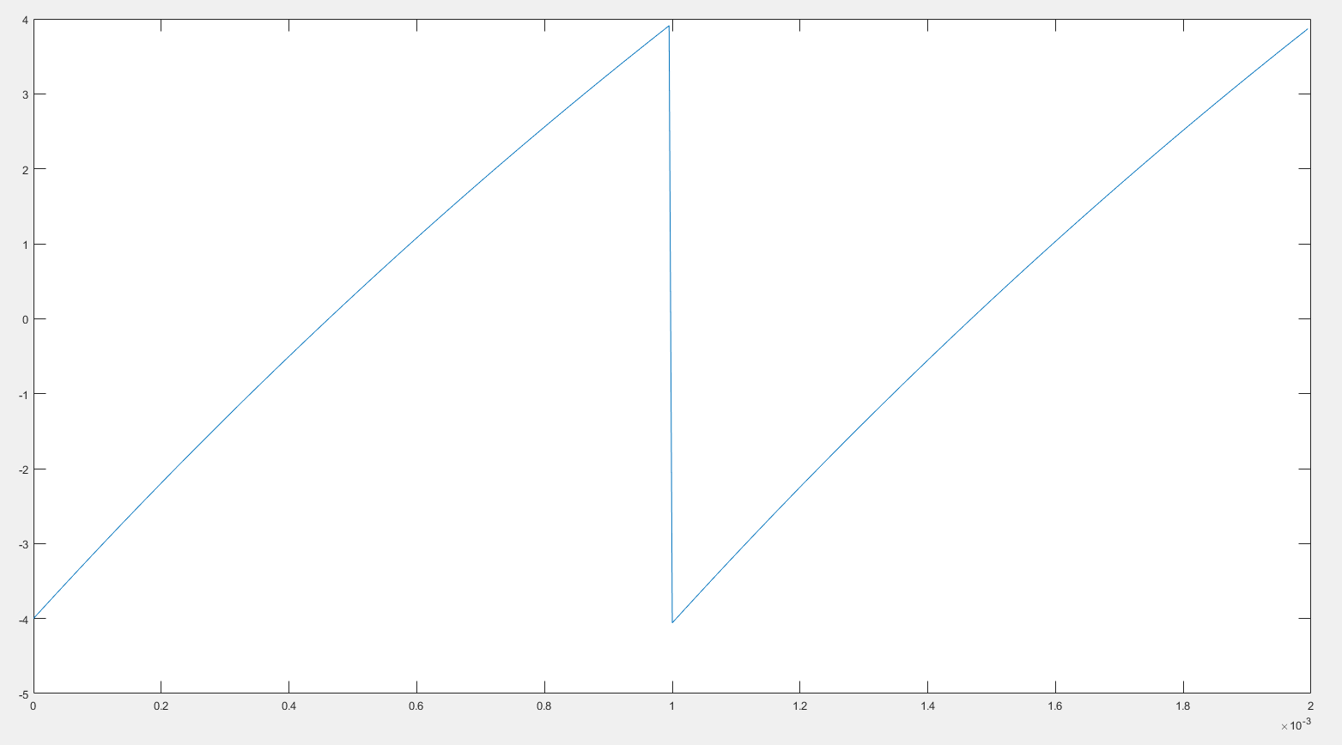

*[15] sawtooth T =350 us

