Food Composition Analysis

Team 8: Dipak Bange([djbange@iu.edu](mailto:djbange@iu.edu))

ADT(D-532) Project: Milestone -I

1. **Create Conceptual Diagram/Schema for database.**

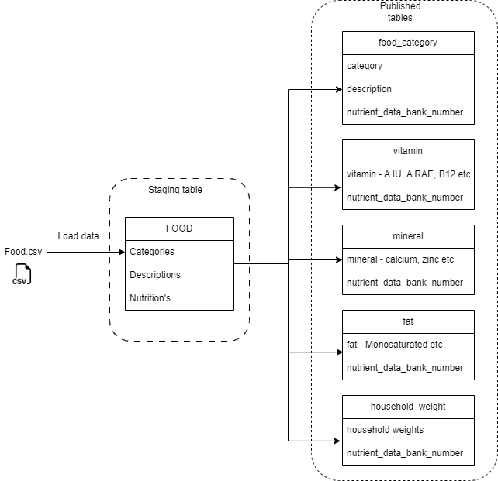

* 1. **Food.csv has the raw data.**
  2. **Data will be loaded into the food table from CSV file (This is one time action).**
  3. **After the food table is created, there won’t be any constraints on the table as it is just raw data.**
  4. **As of now, five new tables will be created from the food table (see diagram).**
  5. **In the new tables, columns will be renamed. New constraints like Primary key, foreign key, unique etc. will be added.**
  6. **For each table sequence is created for primary table.**
  7. **In the future, new aggregated tables will be created.**
  8. **The food category will be the main table. And it will have one to many relations with other four tables.**

1. **Database**
   1. **Tables as follow:**
      1. **Food category: This table will have food categories and data bank number. The data category has values of Food (Butter, Jam etc.)**
      2. **Vitamin: This contains values of different vitamins for food bank number.**
      3. **Mineral: Mineral table contains values of different minerals for a particular food bank number from food category table.**
      4. **Fat: This contains Monosaturated_Fat, Polysaturated_Fat, Saturated_Fat, Total_Lipid columns.**
      5. **Household weight: This is a table to get values of particular item in common household.**
   2. **The Food category is the main source table for the other 4 tables.**
   3. **Each table us primary key and a unique integer sequence is create for them.**
   4. **TODO: New aggregated tables in milestone 2.**
   5. **I plan to create views on existing table once I finalize the visualizations of the data.**
2. **Write code to create a database and build queries. Your task is to create a reproducible code.**
   1. **Code in the code separate sql file.**
3. **Assessment Table: Add your individual assessment/evaluation for your work**

|  |  |  |
| --- | --- | --- |
| Task NO | Task | Owner |
| 1. | Check raw CSV file for any corruption in data | Dipak |
| 2. | Create database schema - concept | Dipak |
| 3. | Create Postgres database on digitalOcean(cloud host) | Dipak |
| 4. | Create SQL script for tables | Dipak |
| 5. | Add data to tables | Dipak |
| 6. | Verify data | Dipak |

Assessment:

I am satisfied with my work for Milestone -I. I can further update and create more granular database further.

Task completion satisfaction: 9/10