**Food Composition Analysis**

**Team 8**: Dipak Bange([djbange@iu.edu](mailto:djbange@iu.edu))

# Section 1

Architecture Diagram:

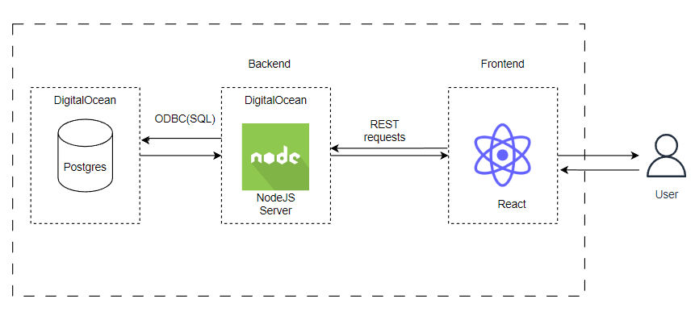

1. Database: Postgres
2. Back-end: NodeJS/JavaScript
3. Database Connector: ODBC-sequalize library in npm
4. Front-end: React/JavaScript
5. Deployment: DigitalOcean
   1. Backup plan: if any issues faced during deployment – app will be locally hosted and can be accessed using Nginx anywhere.
6. Users will be able to use app in the browser and interact with app.

# Section 2

Login Page:

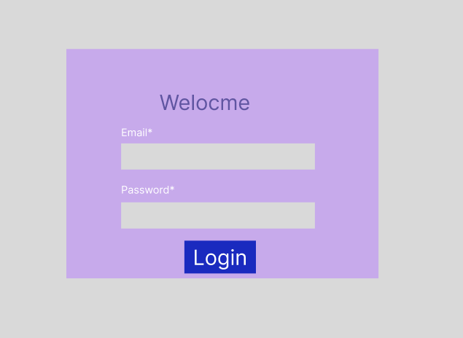

Dashboard view:

Table view:

Table edit view:

# Section 3

* Work satisfaction: **8/10**
* As I am not familiar with react, I could have accelerated development with learning react quickly.
* Create a better plan for web app.
* I could have used my time better and distinguished between different tasks better.