**Week 9 Coding Practice**

**Student:** Dipak Bange

Practice on Movie Dataset(sandbox)

1. Retrieve all Person nodes

MATCH (p:Person)

RETURN p

1. Retrieve Person nodes that have a born property value of 1970

MATCH (p:Person {born : 1970})

RETURN p

1. Retrieve a movie releases in 2003 and tagline "Free your mind"

MATCH (m:Movie {released : 2003, tagline : ‘Free your mind’})

RETURN m

1. Return property values as a table for a person born in 1965 with two columns

name and year

MATCH (p: Person {born : 1965})

RETURN p.name, p.born

1. Add aliases column headings NAME and YEAR for the query #4

MATCH (p:Person {born : 1965})

RETURN p.name as NAME, p.born AS YEAR

1. Add aliases column headings NAME OF PERSON and YEAR BORN for the

query #4

MATCH (p: Person {born: 1965})

RETURN p.name AS ‘NAME OF PERSON’, p.born AS ‘YEAR BORN’

1. Examine relationship schema in Movie database + make a screenshot

CALL db.schema.visualization()

1. Find a person who acted in the movie "the Matrix" and

return person, relation, and movie

MATCH (p:Person)-[rel:ACTED_IN] -> (m:Movie {title : ‘The Matrix’})

RETURN p, rel, m

1. Retrieve all movies that are connected to Tom Hanks. Note two alternative ways

of writing the same query.

MATCH (m: Movie) <-- (p:Person {name : ‘Tom Hanks’})

RETURN m.title

//or

MATCH (p : Person {name : ‘Tom Hanks’}) --> (m : Movie)

RETURN m.title

1. Return all relationships for the title "The Matrix"

MATCH (p : Person) – [rel] -> (m : Movie {title : ‘The Matrix’})

RETURN p.name, type(rel)

1. Use anonymous relationship for the title "The Matrix"

MATCH (p : Person) – (m : Movie {‘The Matrix’})

RETURN p, m

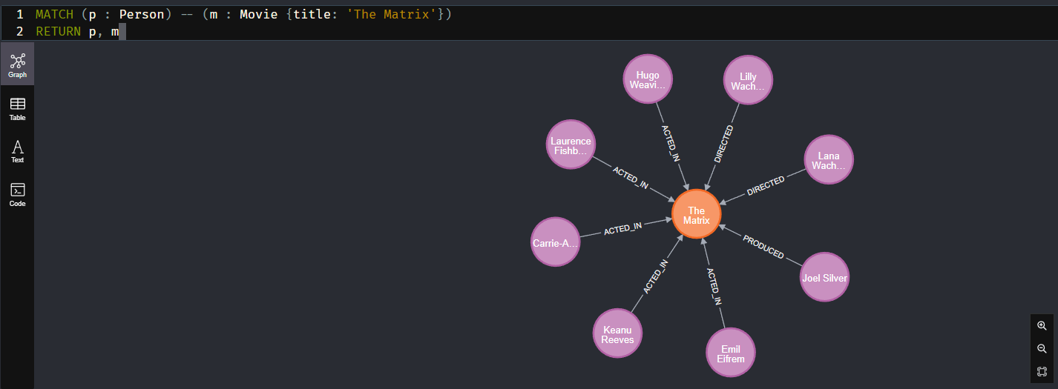

1. Find who reviewed "Cloud Atlas" and return name and rating

MATCH (p : Person)- [r : REVIEWED] -> (m : Movie {title : ‘Cloud Atlas’})

1. Find all nodes (Person) who follow Angela Scope. Note: you can leave empty

variable (:Person) if you do not need to return it

MATCH (p : Person) – [: FOLLOWS] -> (: Person {name : ‘Angela Scope’})

RETURN p

1. Find a person whom Angela Scope follows. Note the change of direction.

MATCH (p : Person) <- [:FOLLOWS] – (: Person {name : ‘Angela Scope’})

RETURN p

