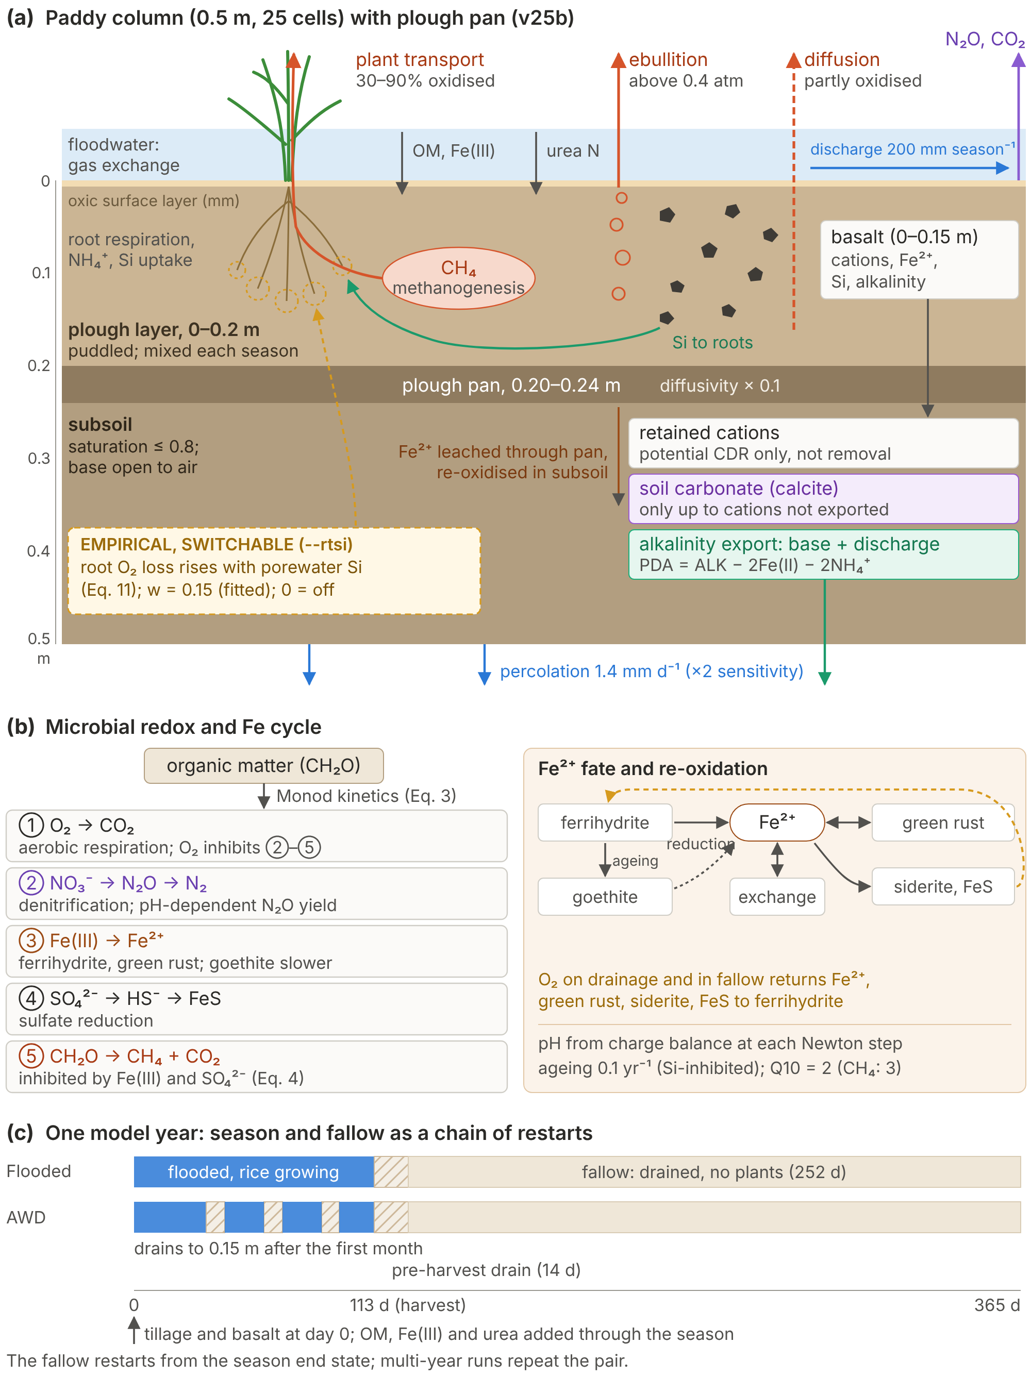
Fig. 1. Model structure and processes.
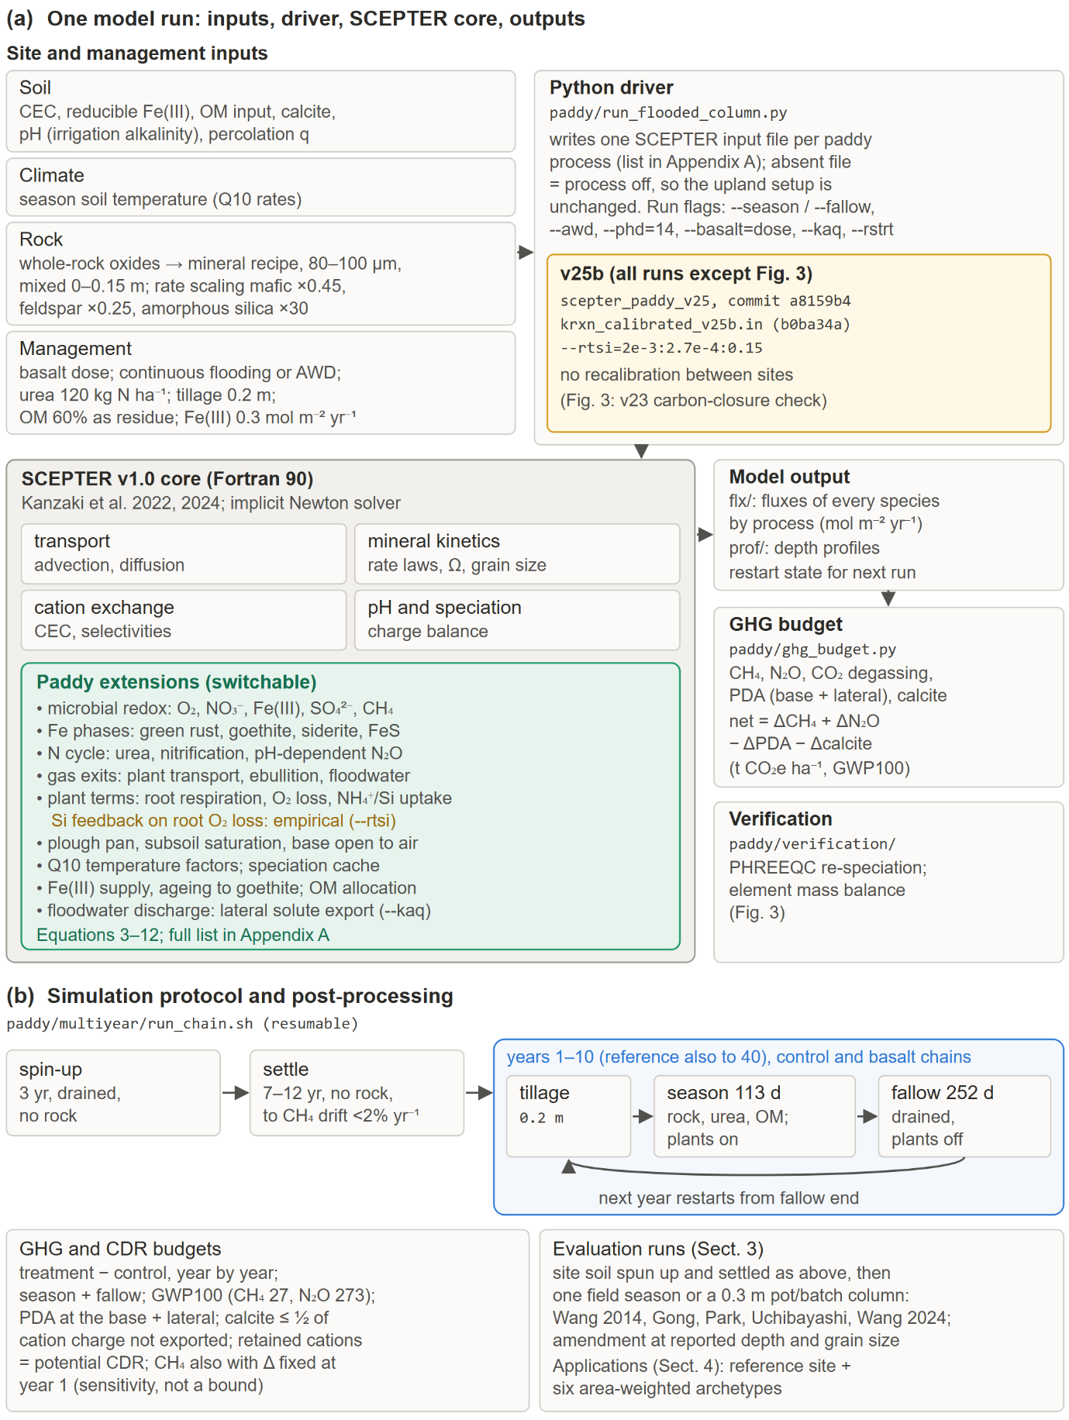
Fig. 2. Implementation and simulation protocol.
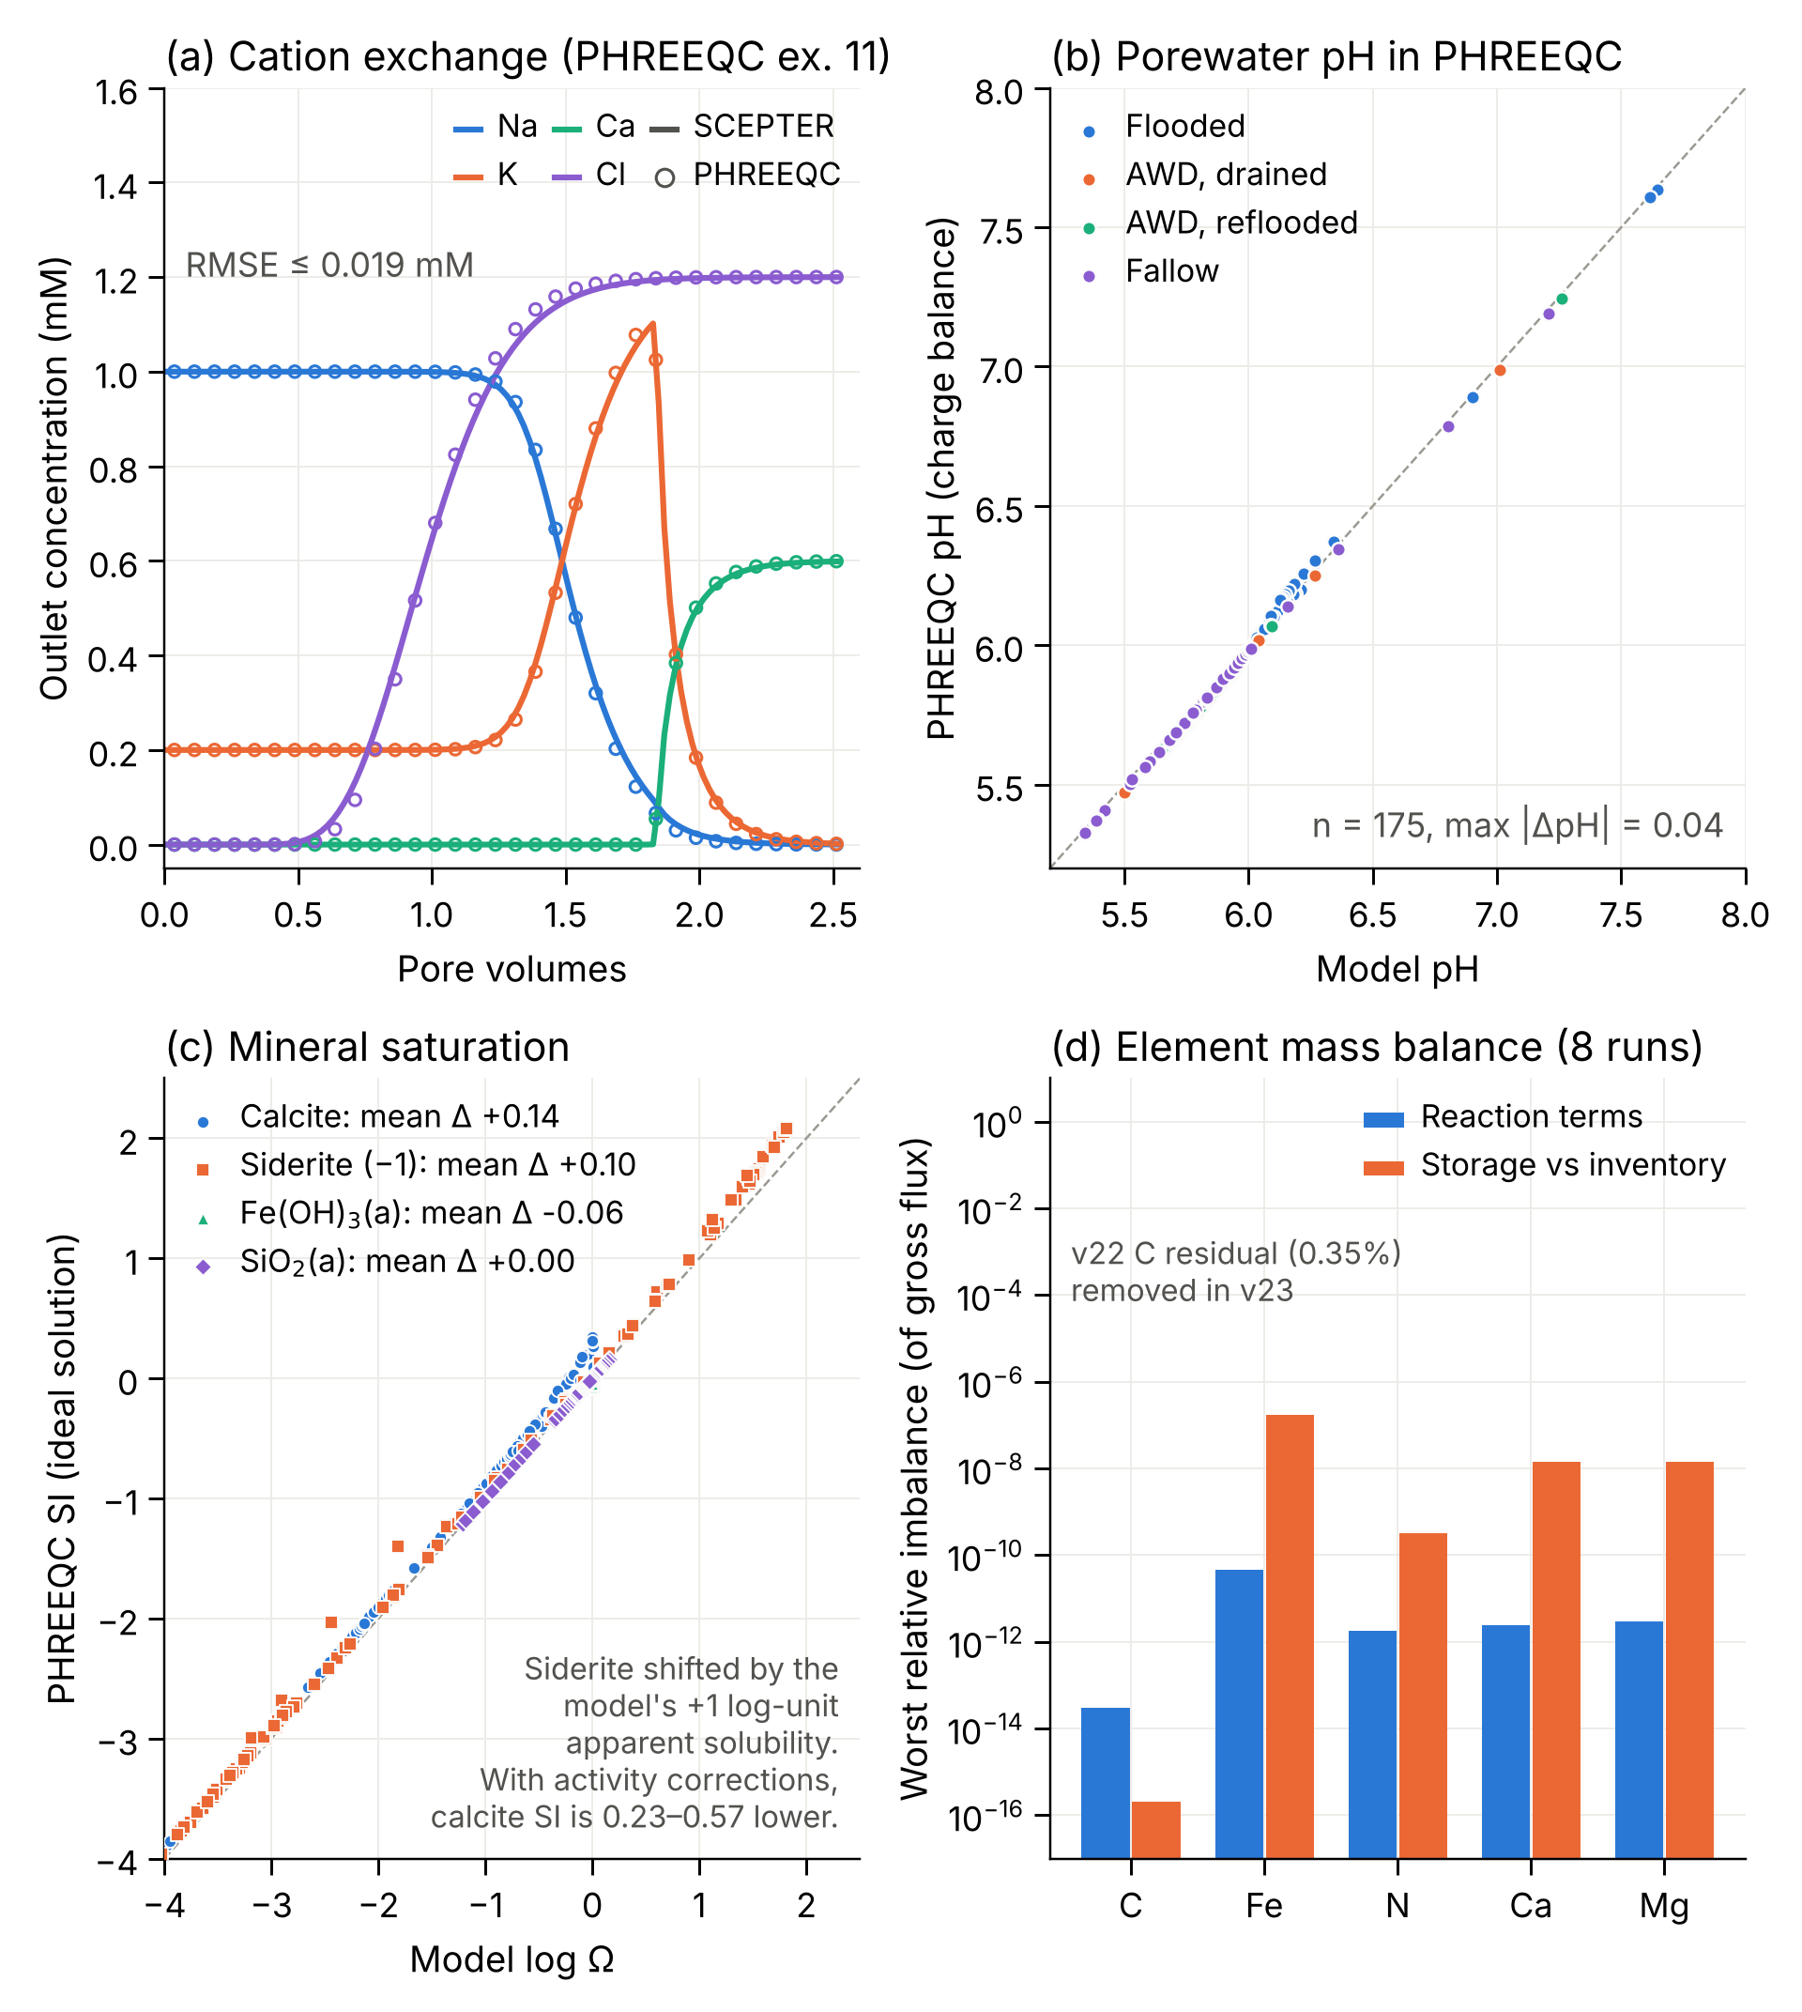
Fig. 3. Numerical verification of Riceland Scepter.
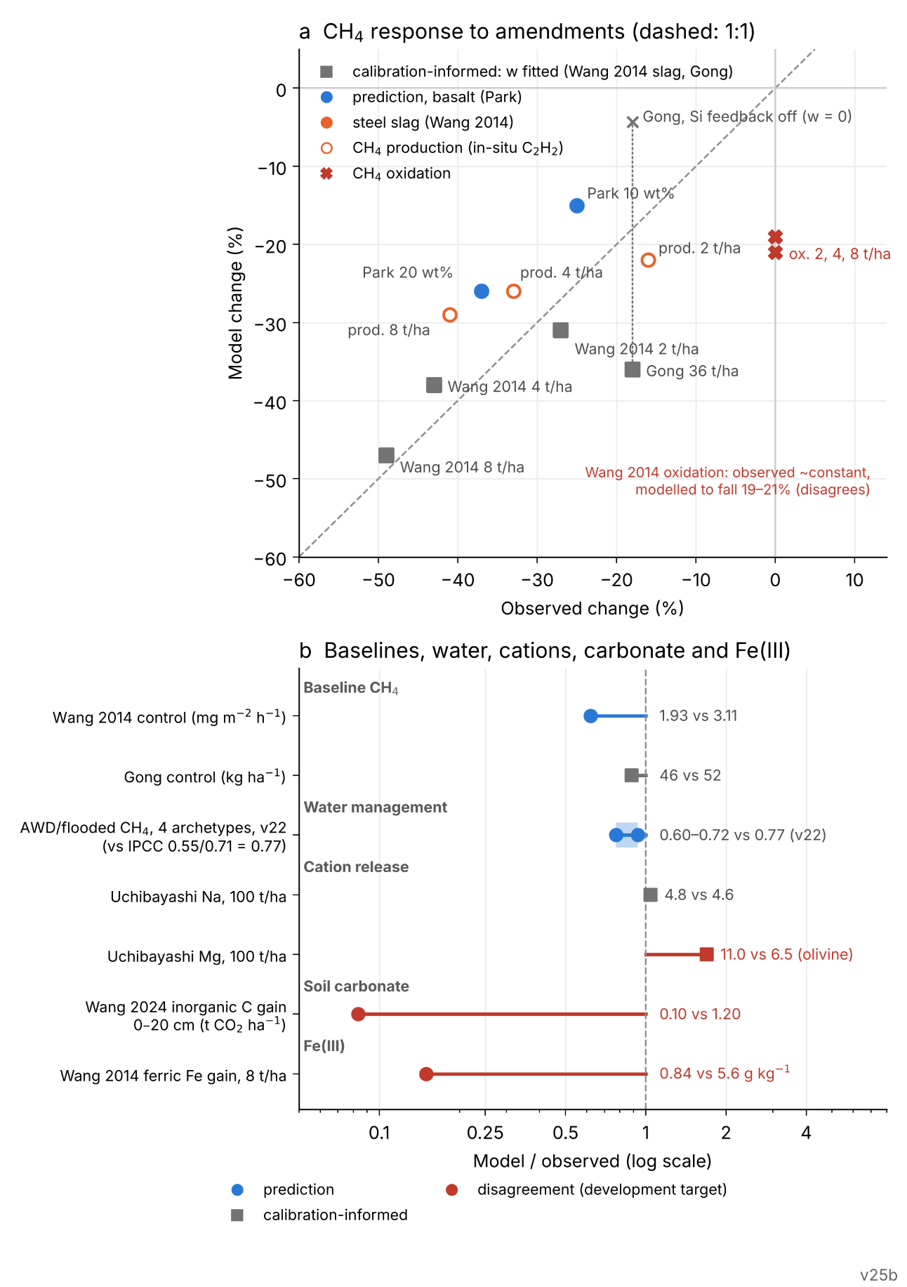
Fig. 4. Evaluation against observations.
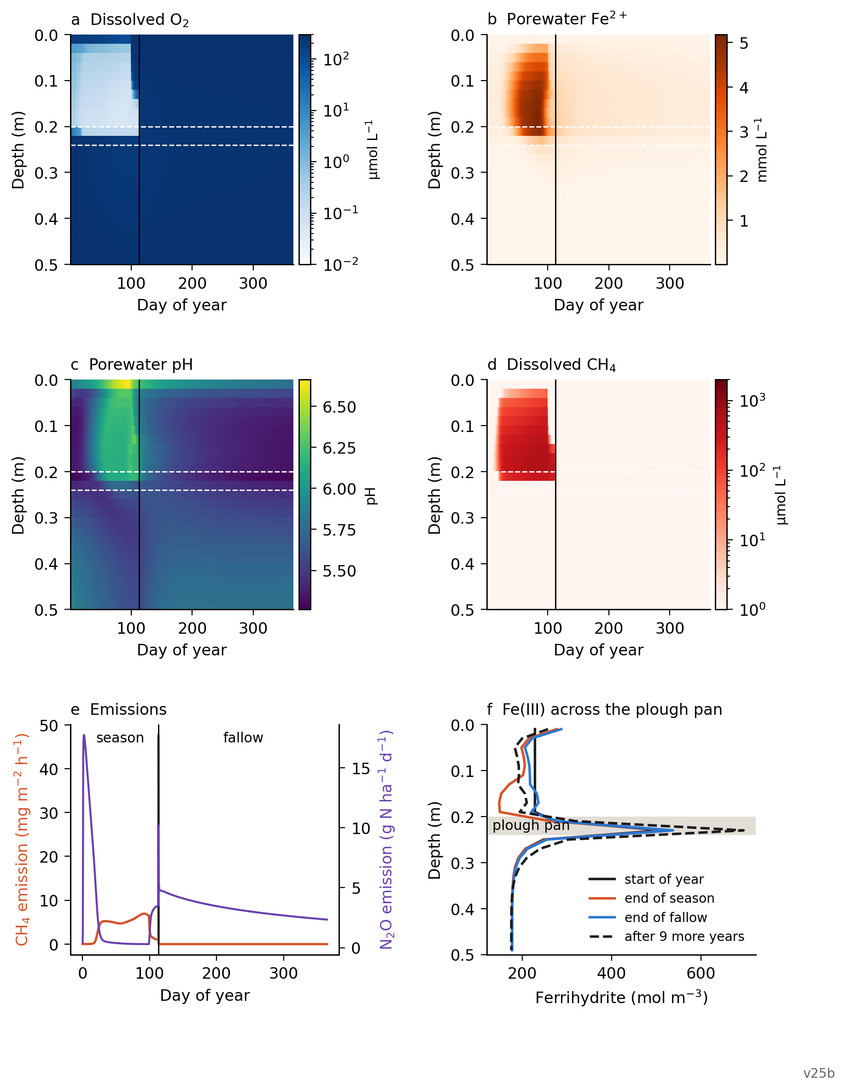
Fig. 5. Simulated paddy rice biogeochemical dynamics in the reference control column (no rock), one year (season and fallow) after the 9-yr settle.
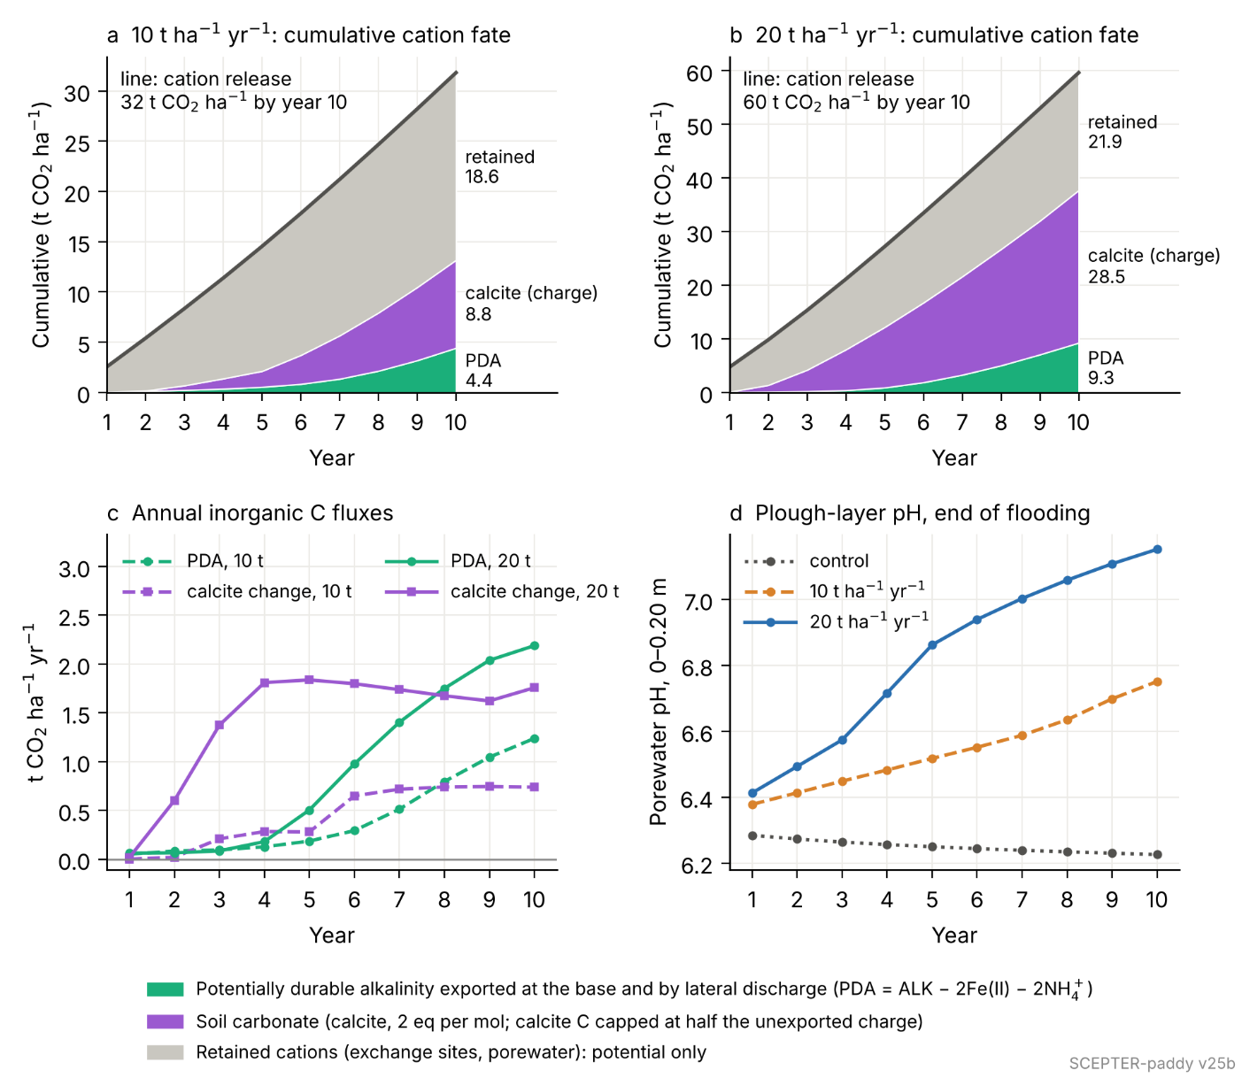
Fig. 6. Weathering and carbon fate over ten years at the reference site, 10 and 20 t ha⁻¹
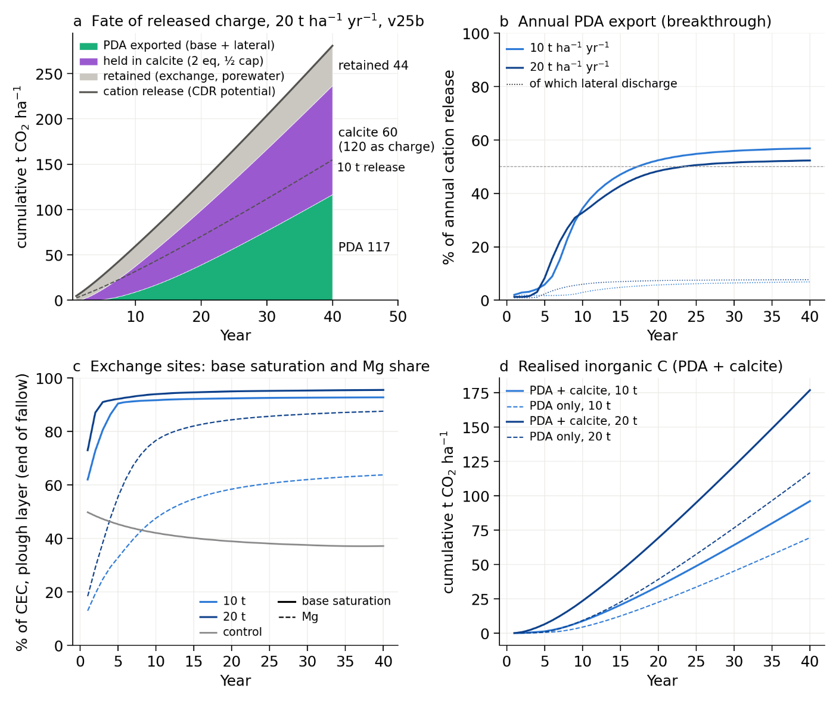
Fig. 7. Forty years of annual basalt application at the reference site, 10 and 20 t ha⁻¹ yr⁻¹
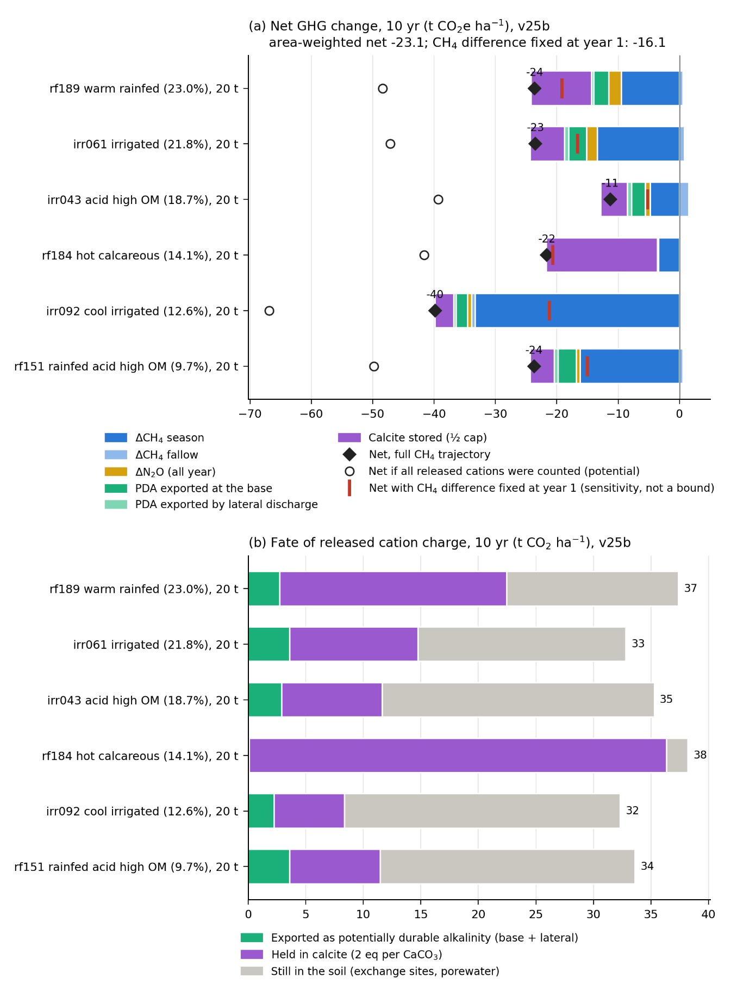
Fig. 8. Contrasting rice-soil archetypes: v25b, six area-weighted archetypes at 20 t ha⁻¹ yr⁻¹ for 10 years (season and fallow, against year-matched controls).
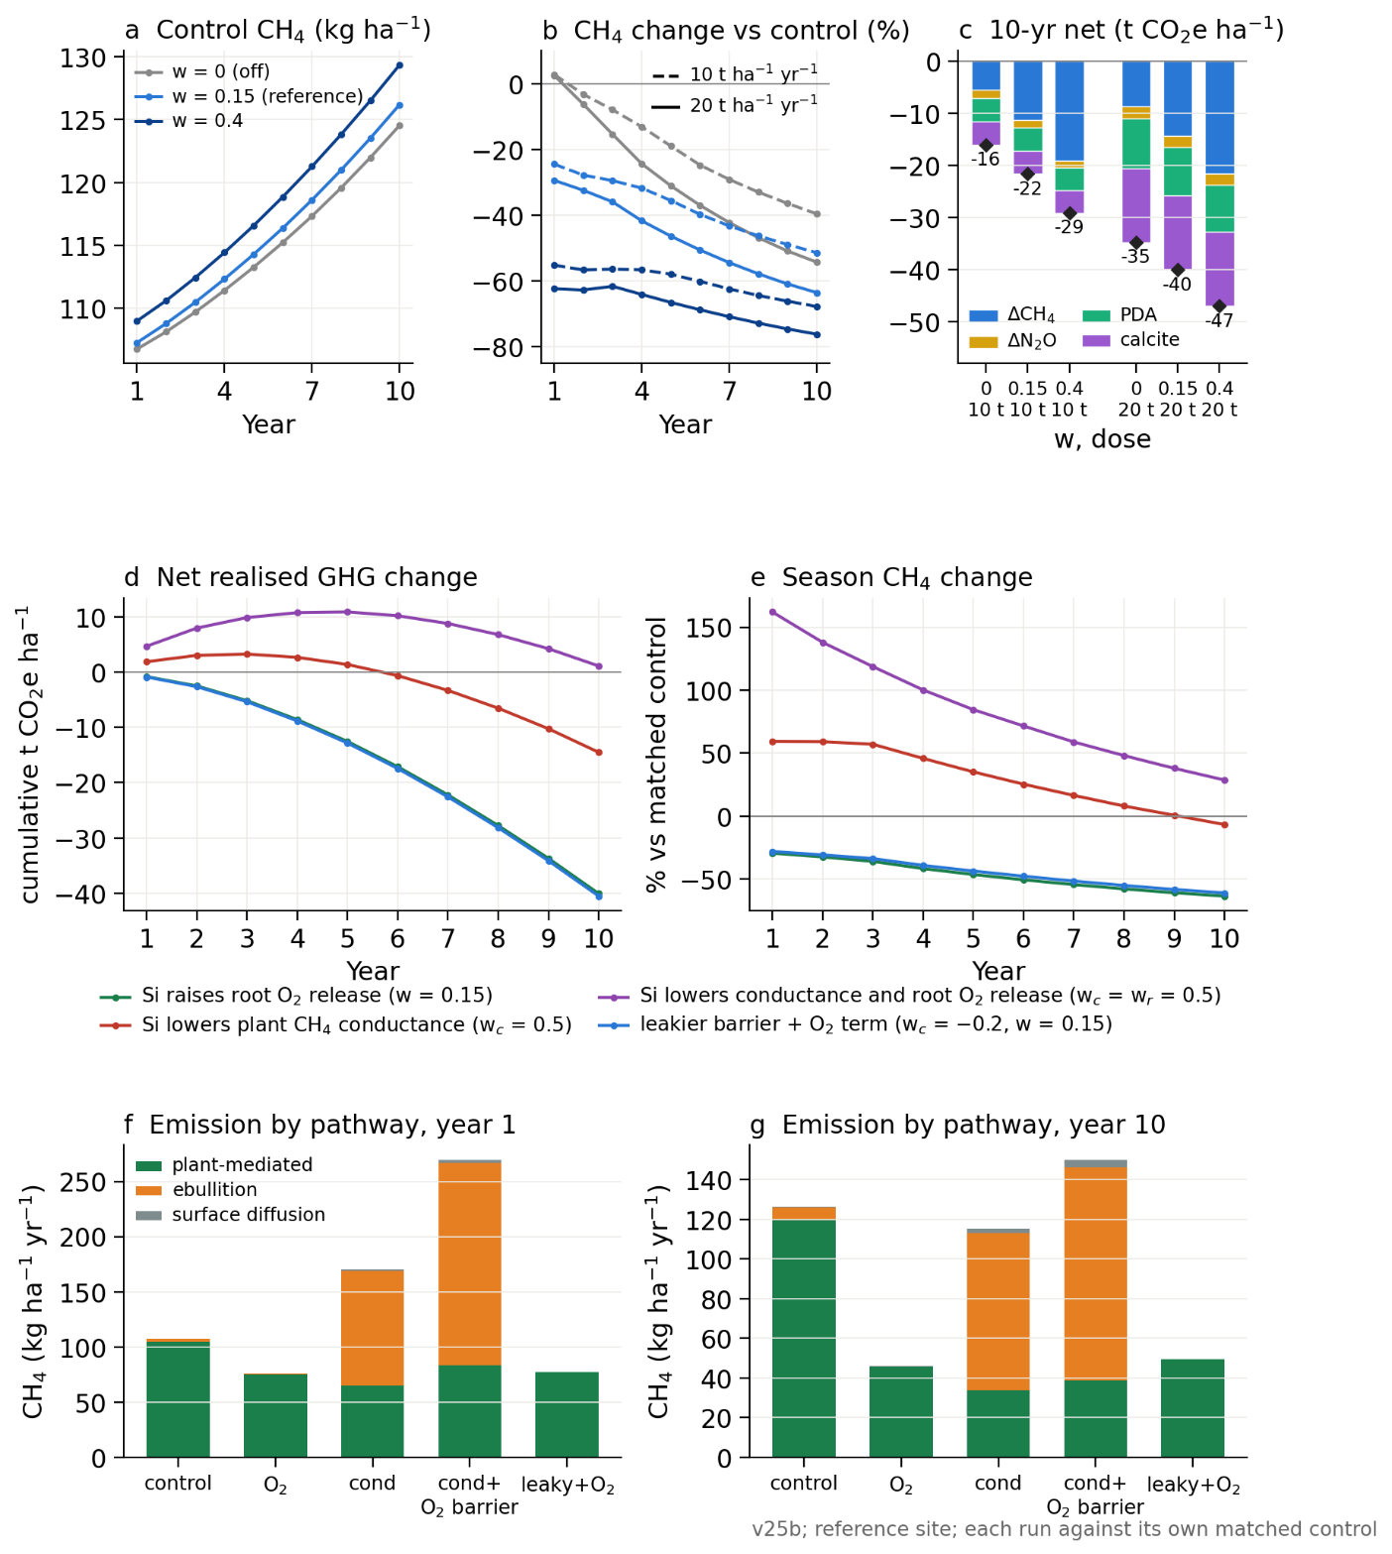
Fig. 9. Uncertainty in the Si–root response at the reference site
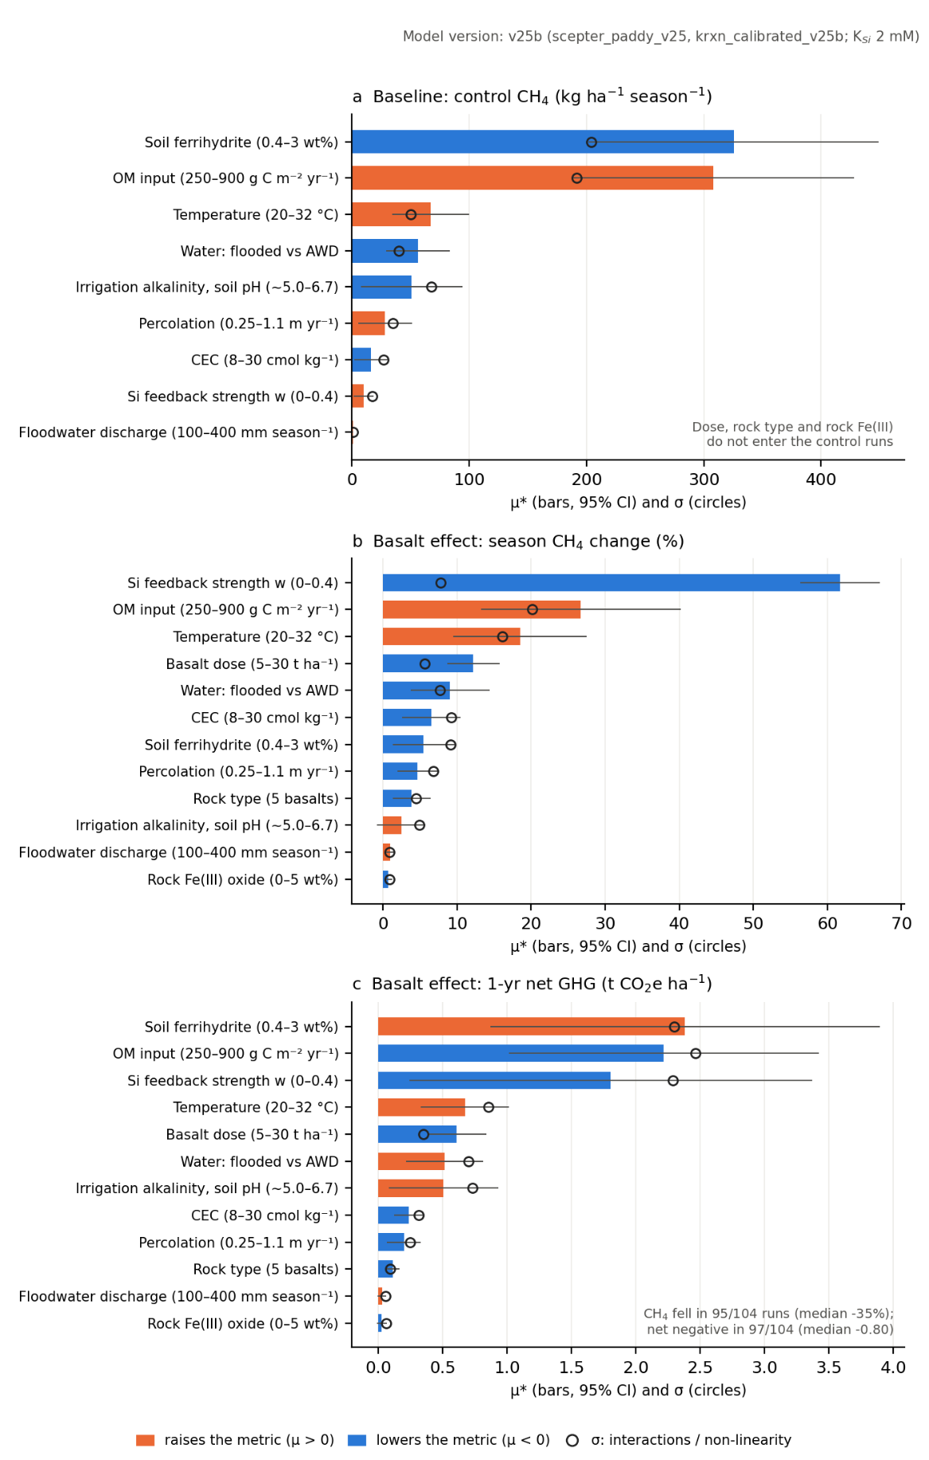
Fig. 10. Morris elementary-effects screen (12 factors, r = 8, 104 points).

