Draft figures, frozen model v22 (31 Oct 2026)
Fig. 3 uses executable scepter_paddy_v23 (commit 267a856: v22 plus the carbon-closure fix); all other panels use scepter_paddy_v22 (commit 162913a). v23 changes year-1 CH₄, N₂O and exported alkalinity by less than 0.3% and CO₂ degassing by up to 1% (eight irr061 season and fallow runs), so Figs 4–8 keep their v22 runs, k_cal.in (methanogenesis vmax 1860 yr⁻¹) and the Si feedback K_Si = 2 mmol L⁻¹, w = 0.2, with no site recalibration, except where a panel says otherwise. Fig. 6a varies w and other inputs as stated.
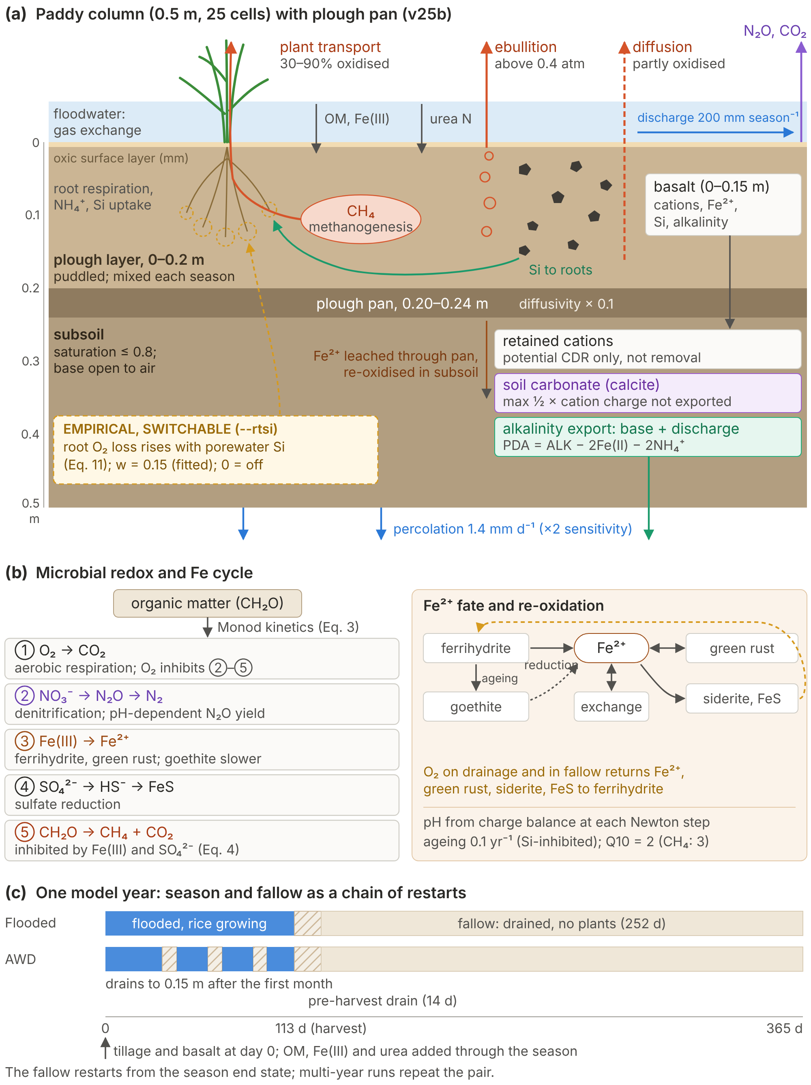
Fig. 1. Model structure and processes.
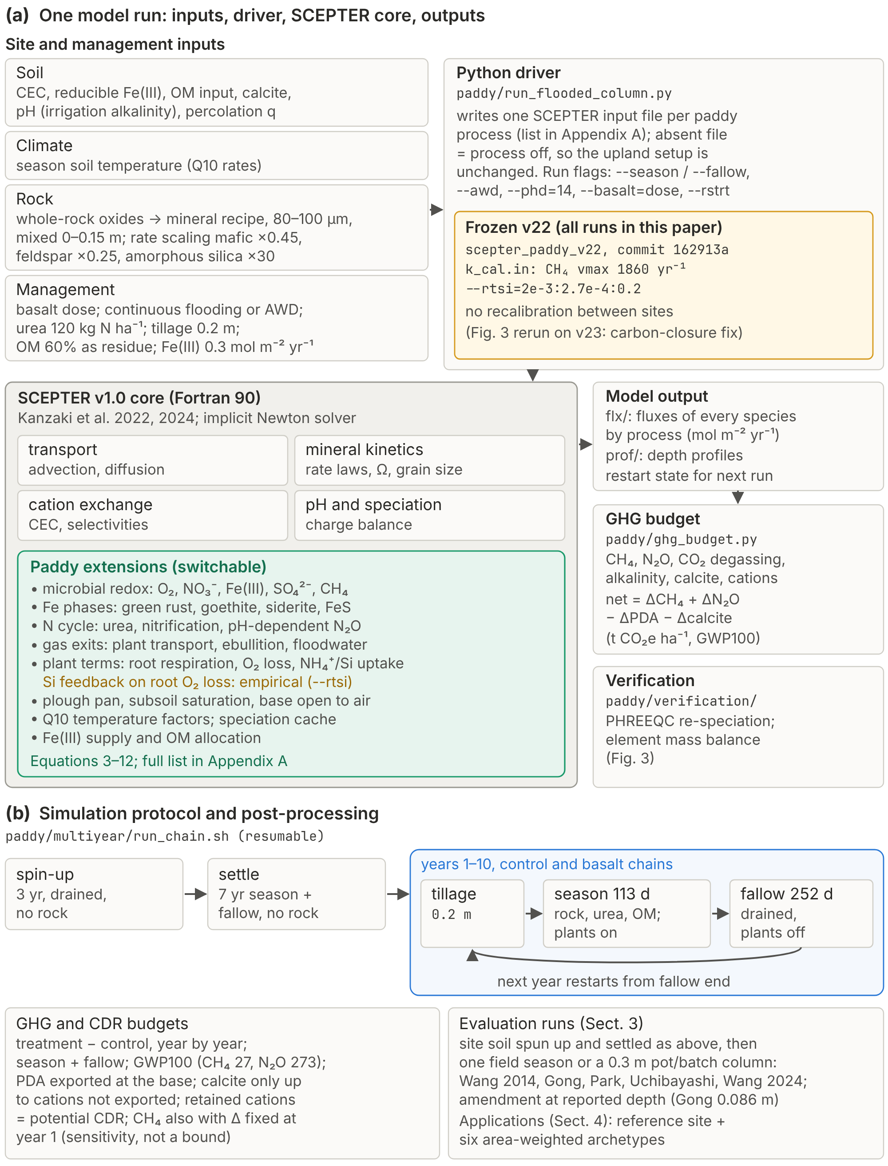
Fig. 2. Implementation and simulation protocol.
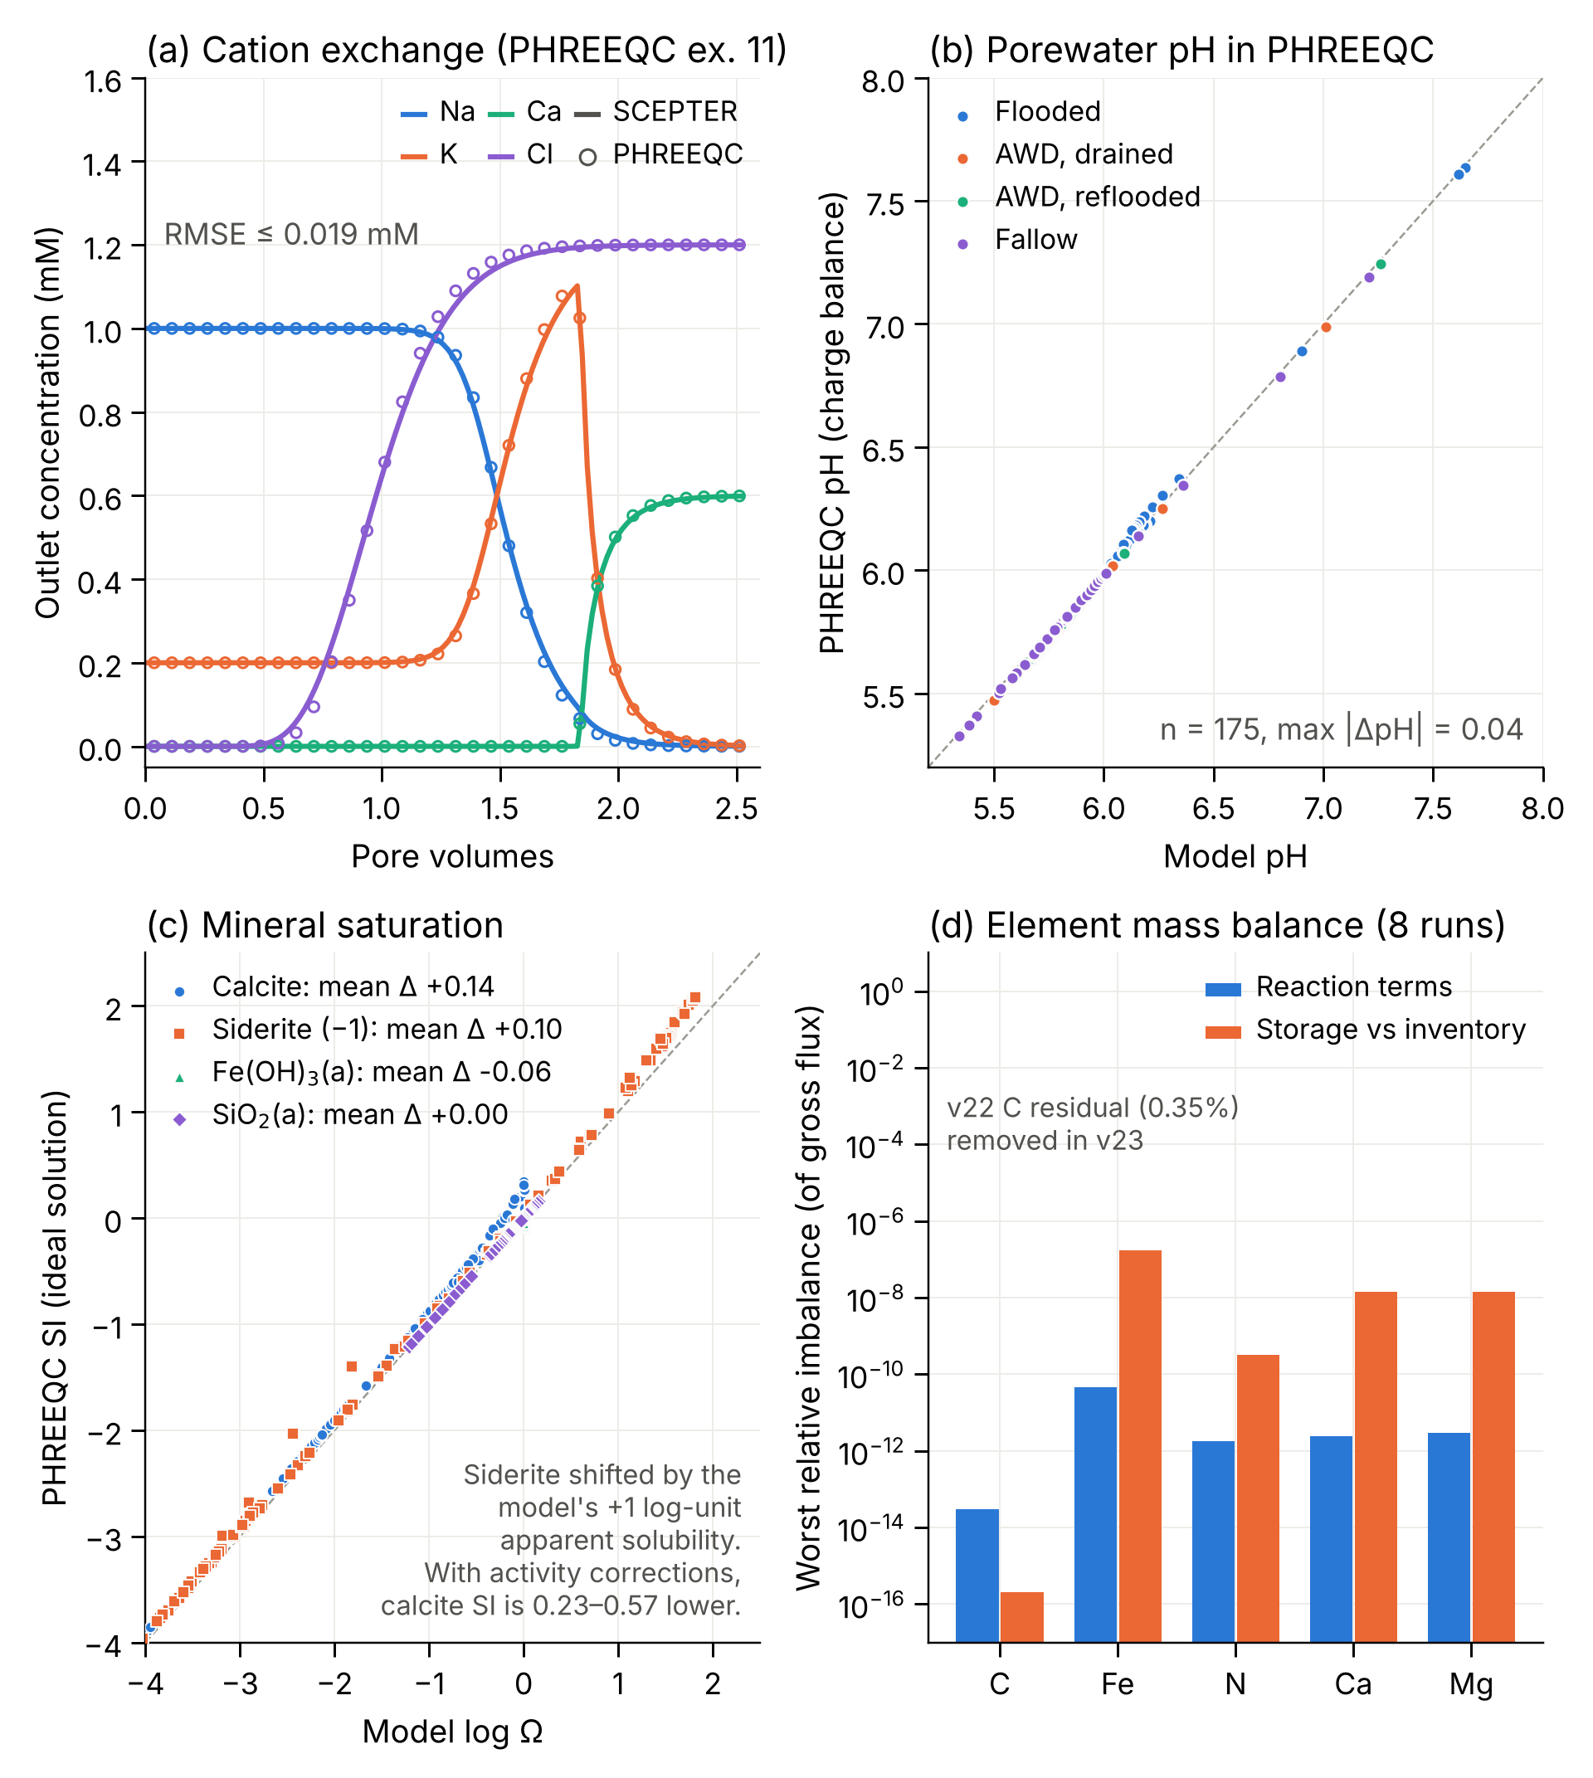
Fig. 3. Numerical verification of Riceland Scepter (v23).
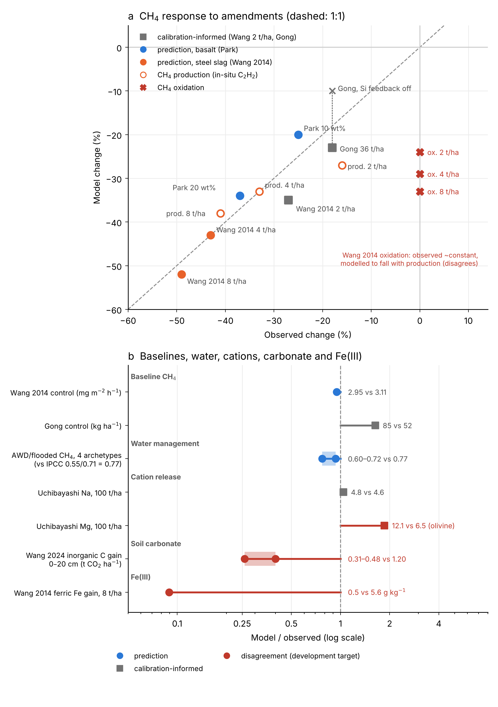
Fig. 4. Evaluation against observations (frozen v22, no site recalibration).
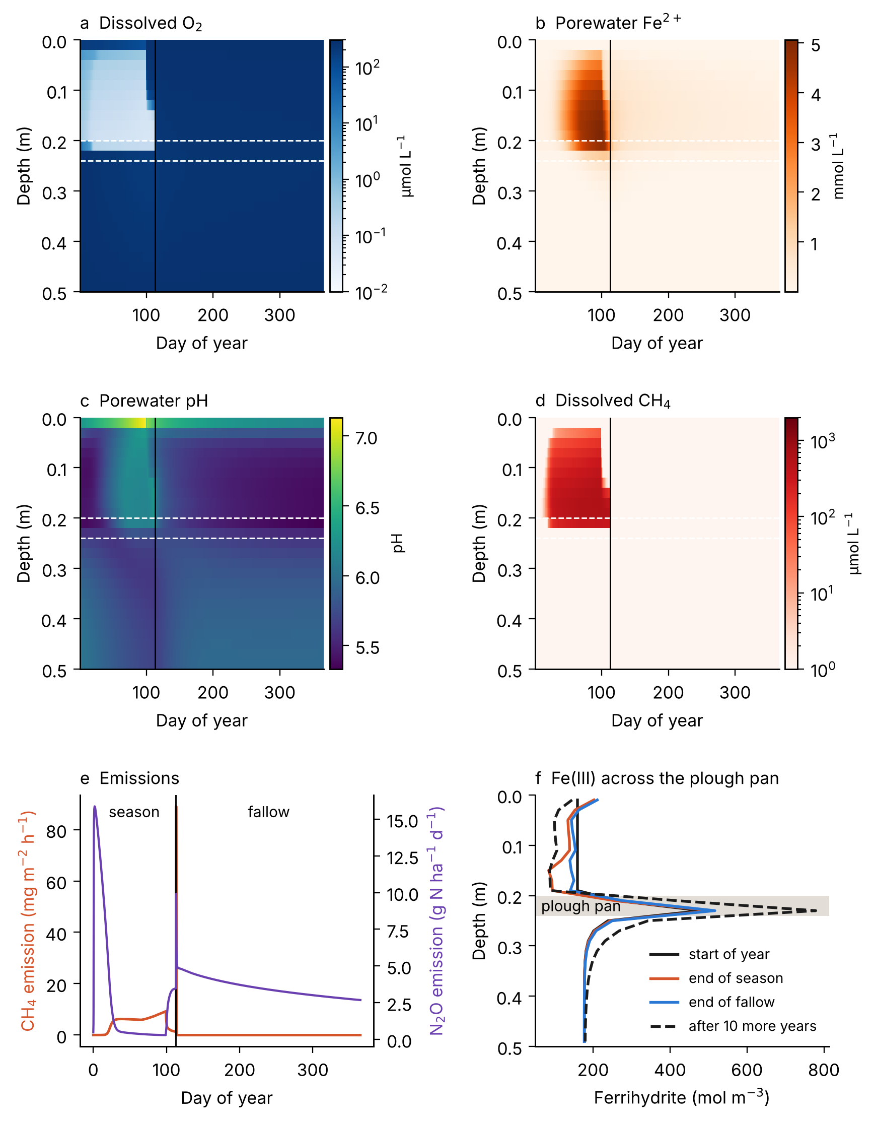
Fig. 5. Simulated paddy rice biogeochemical dynamics in the reference control column (no rock), one year (season and fallow) after the 7-yr settle.
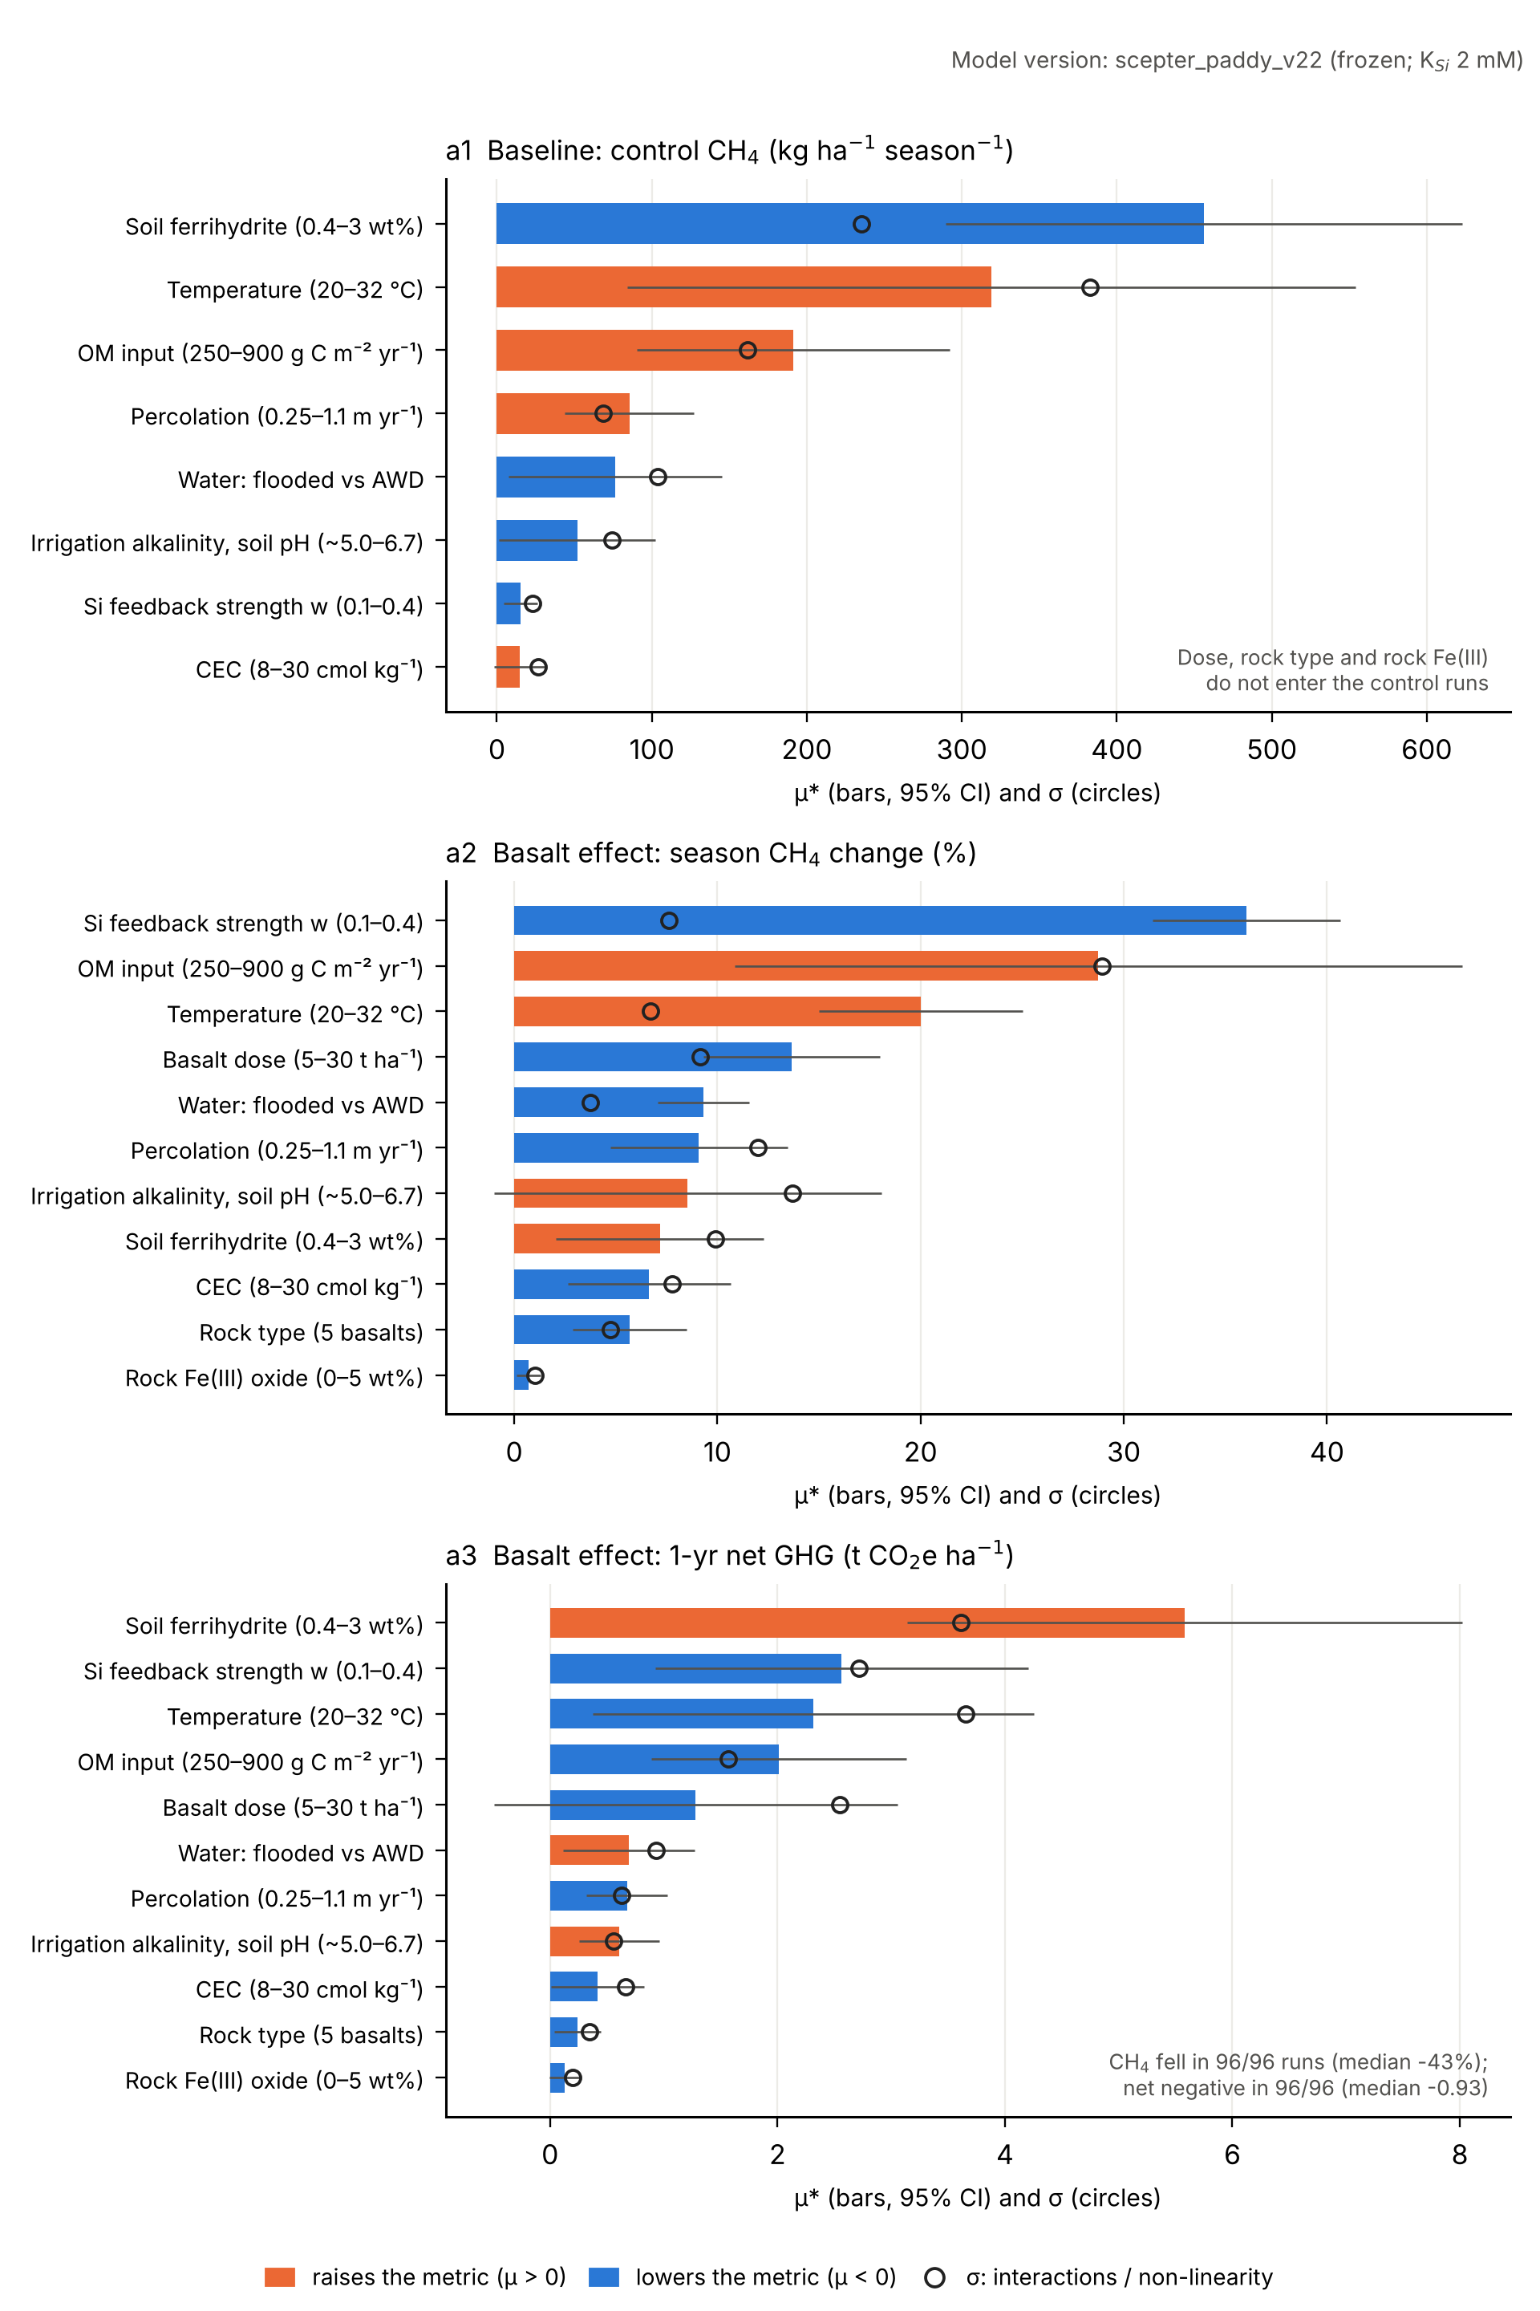
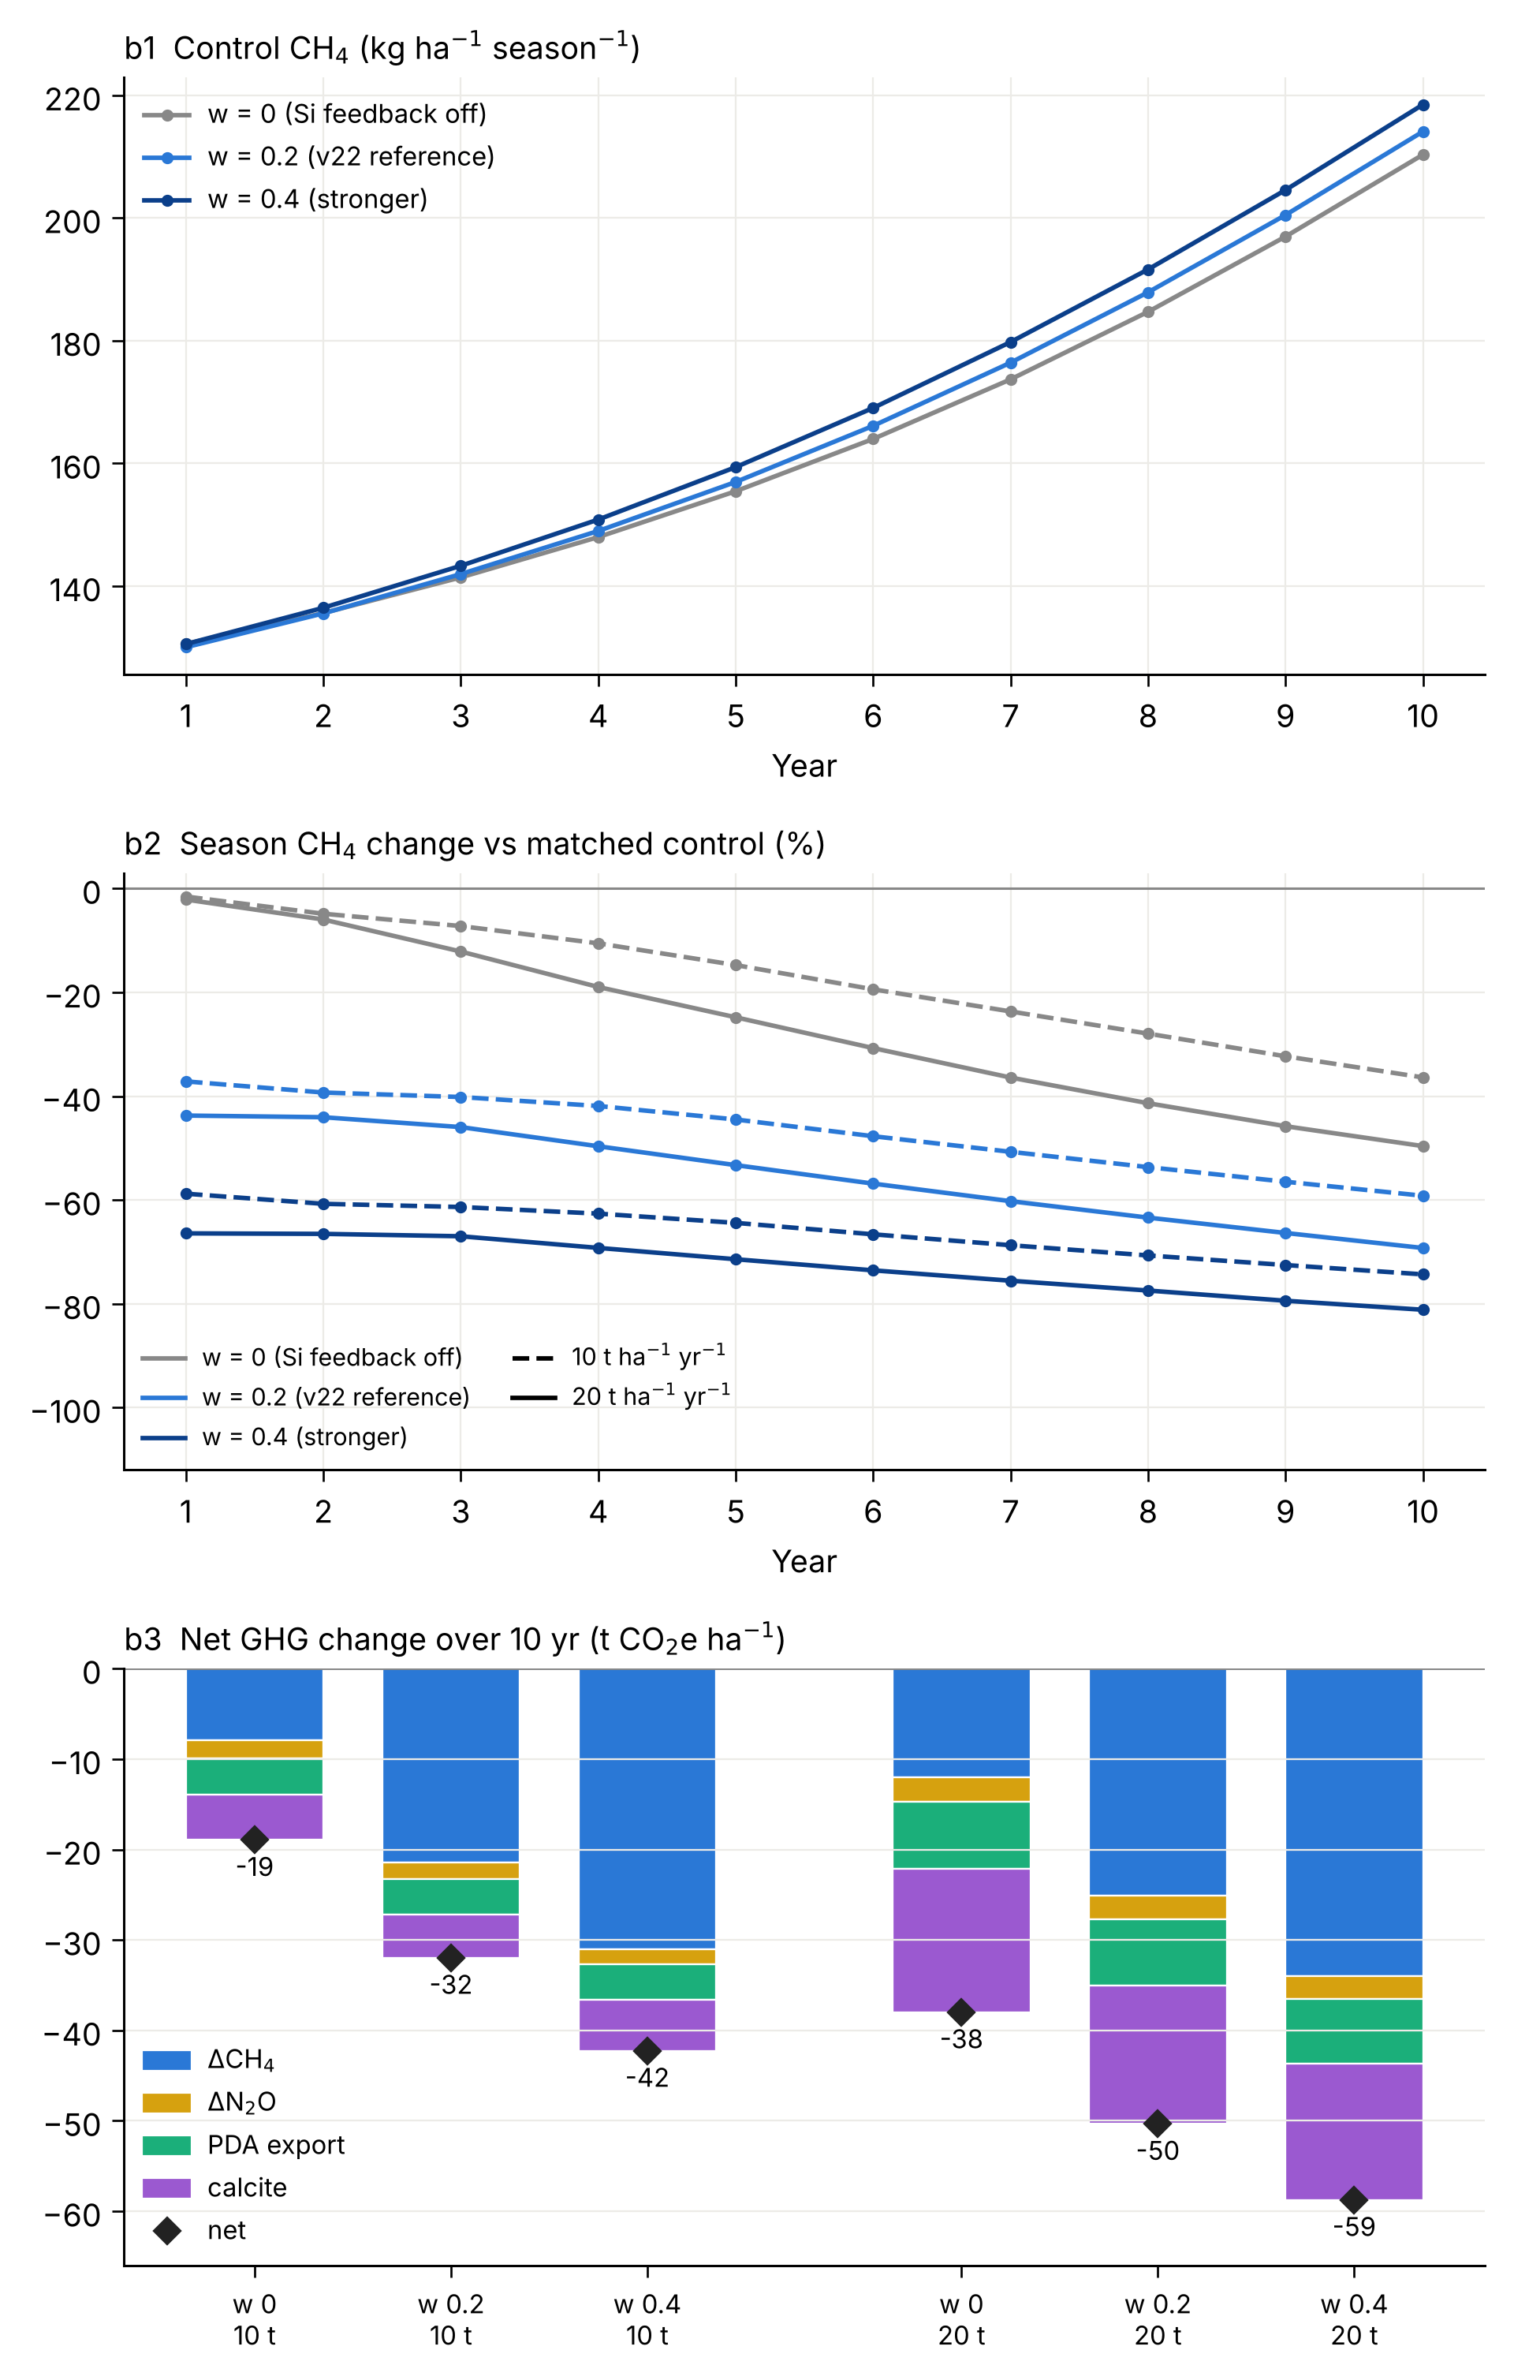
Fig. 6. Parameter sensitivity and structural uncertainty in simulated CH₄ emissions.
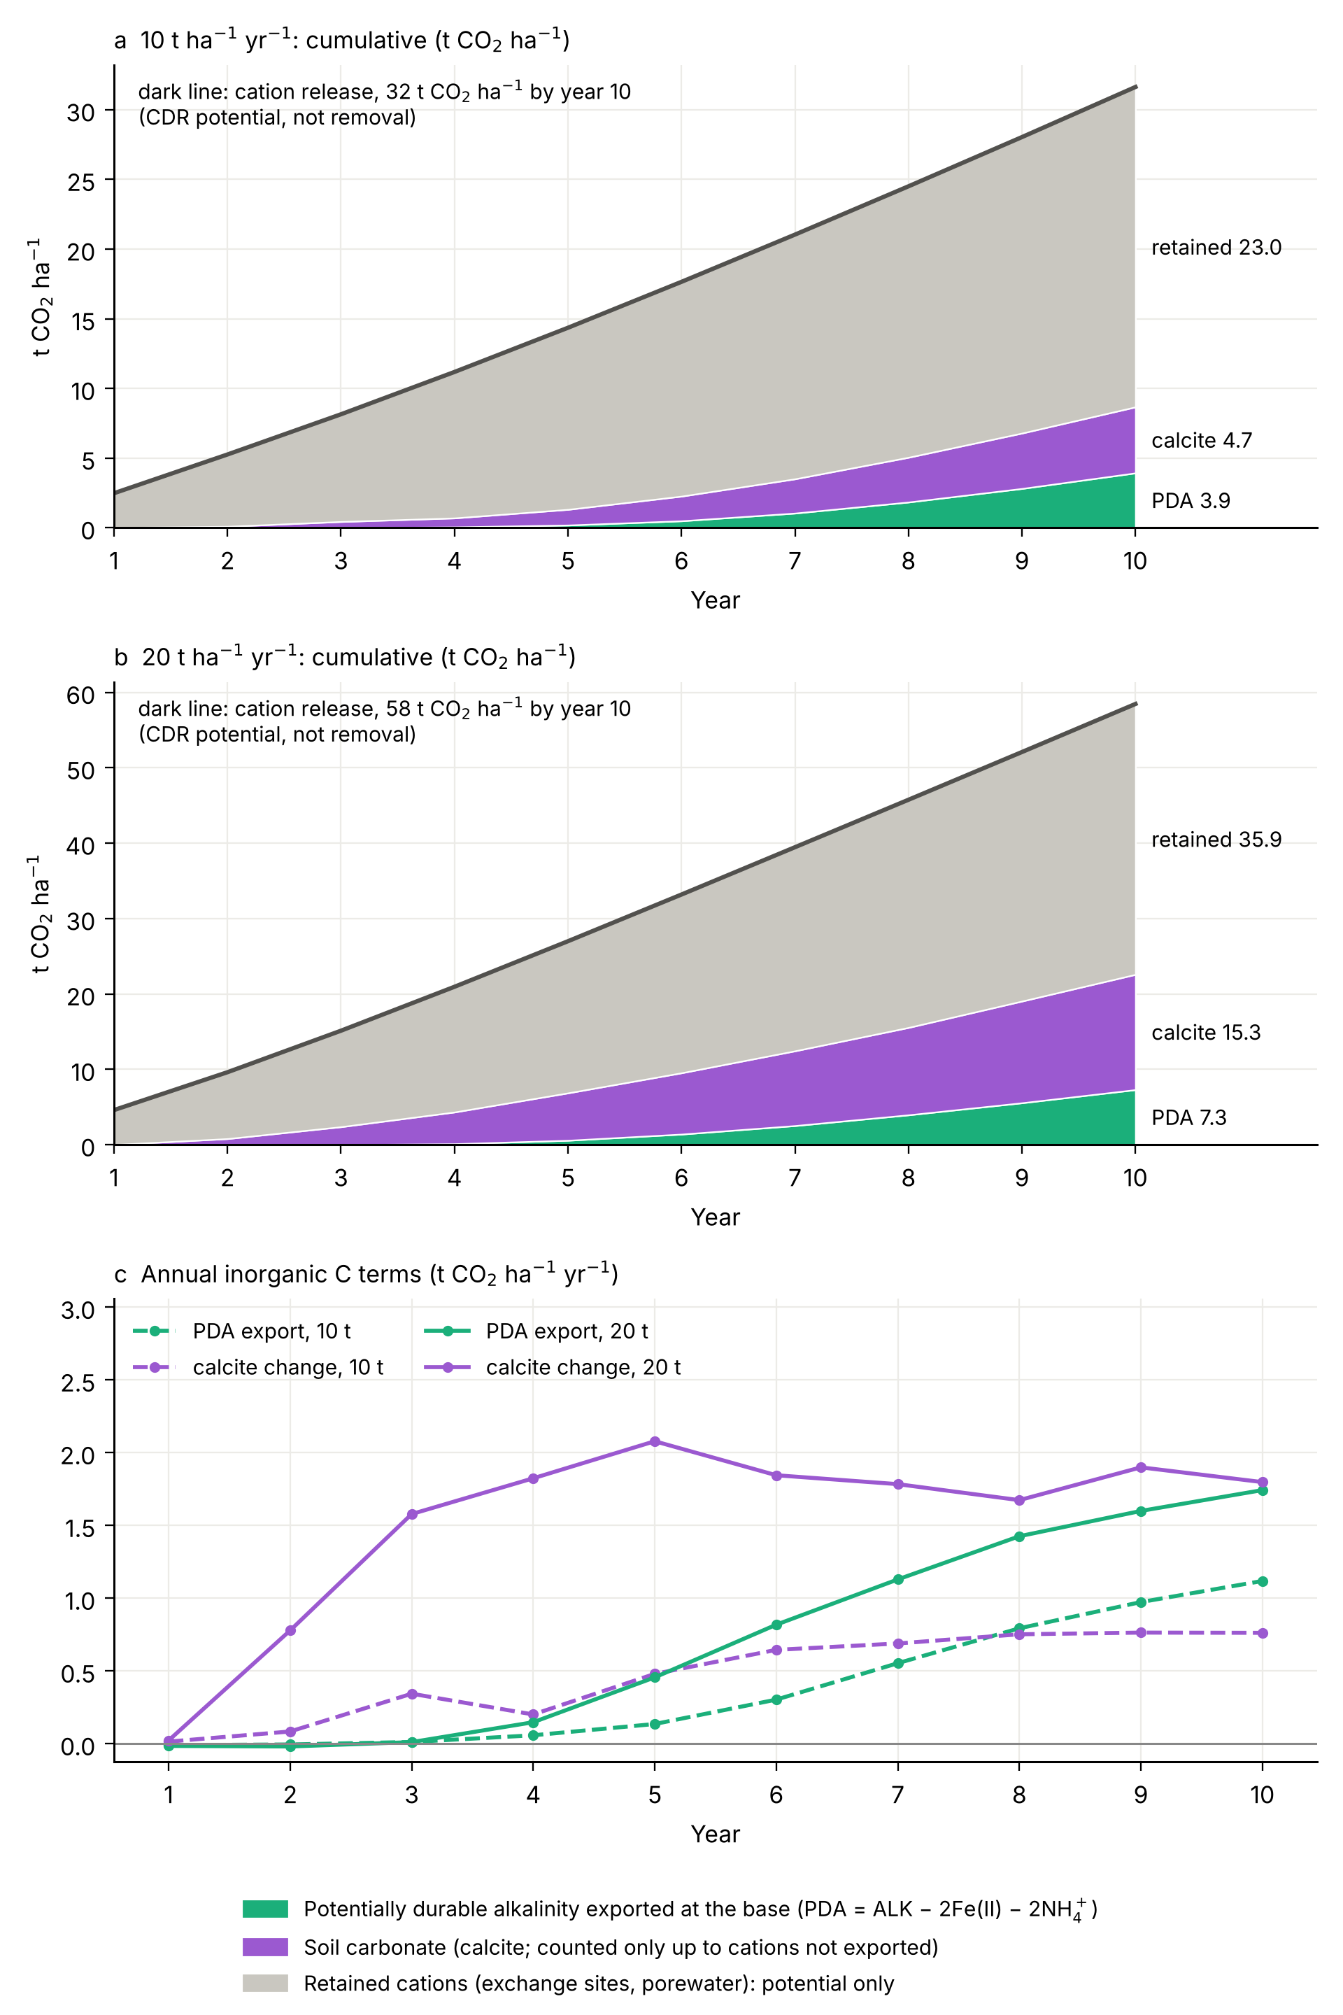
Fig. 7. Weathering and carbon fate over ten years at the reference site, 10 and 20 t ha⁻¹ yr⁻¹ (treatment minus year-matched control; season and fallow).
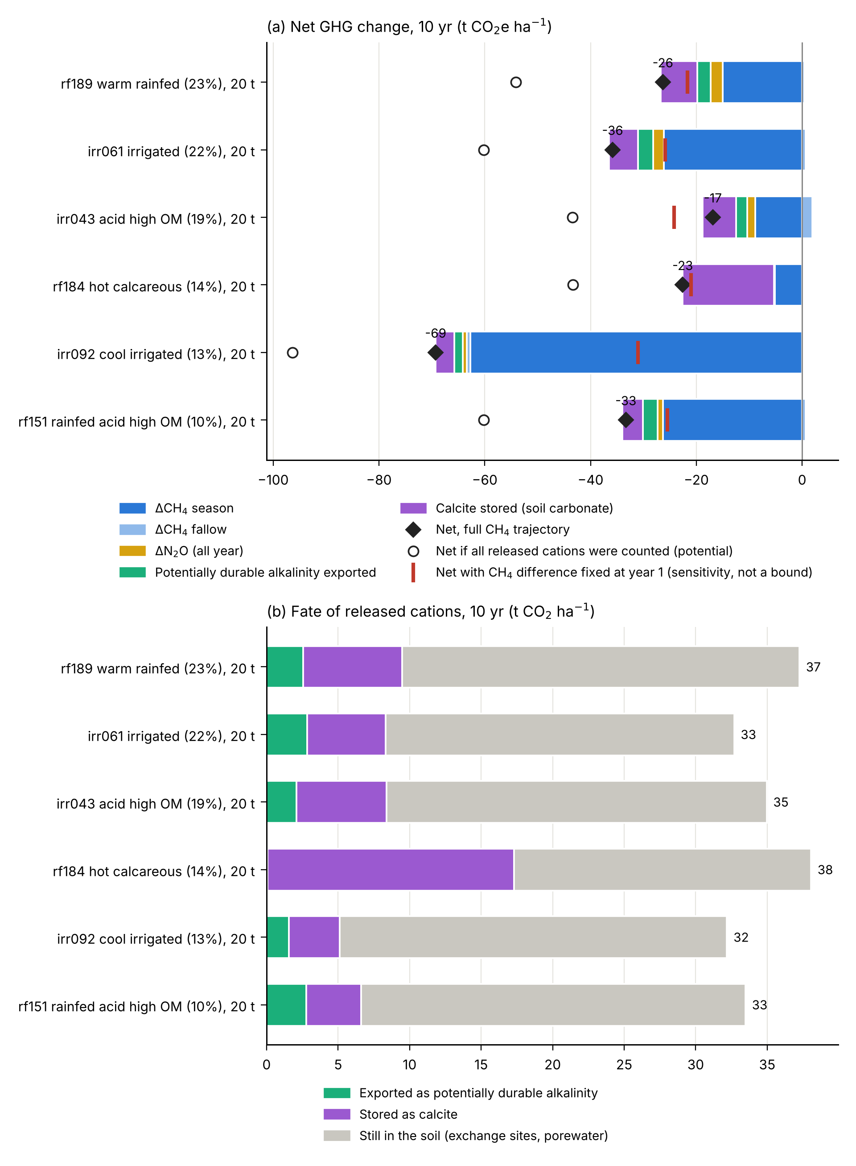
Fig. 8. Contrasting rice-soil archetypes: frozen v22, six area-weighted archetypes at 20 t ha⁻¹ yr⁻¹ for 10 years (season and fallow, against year-matched controls).

