Riceland SCEPTER v1: GMD manuscript figures (draft)
28 October 2026

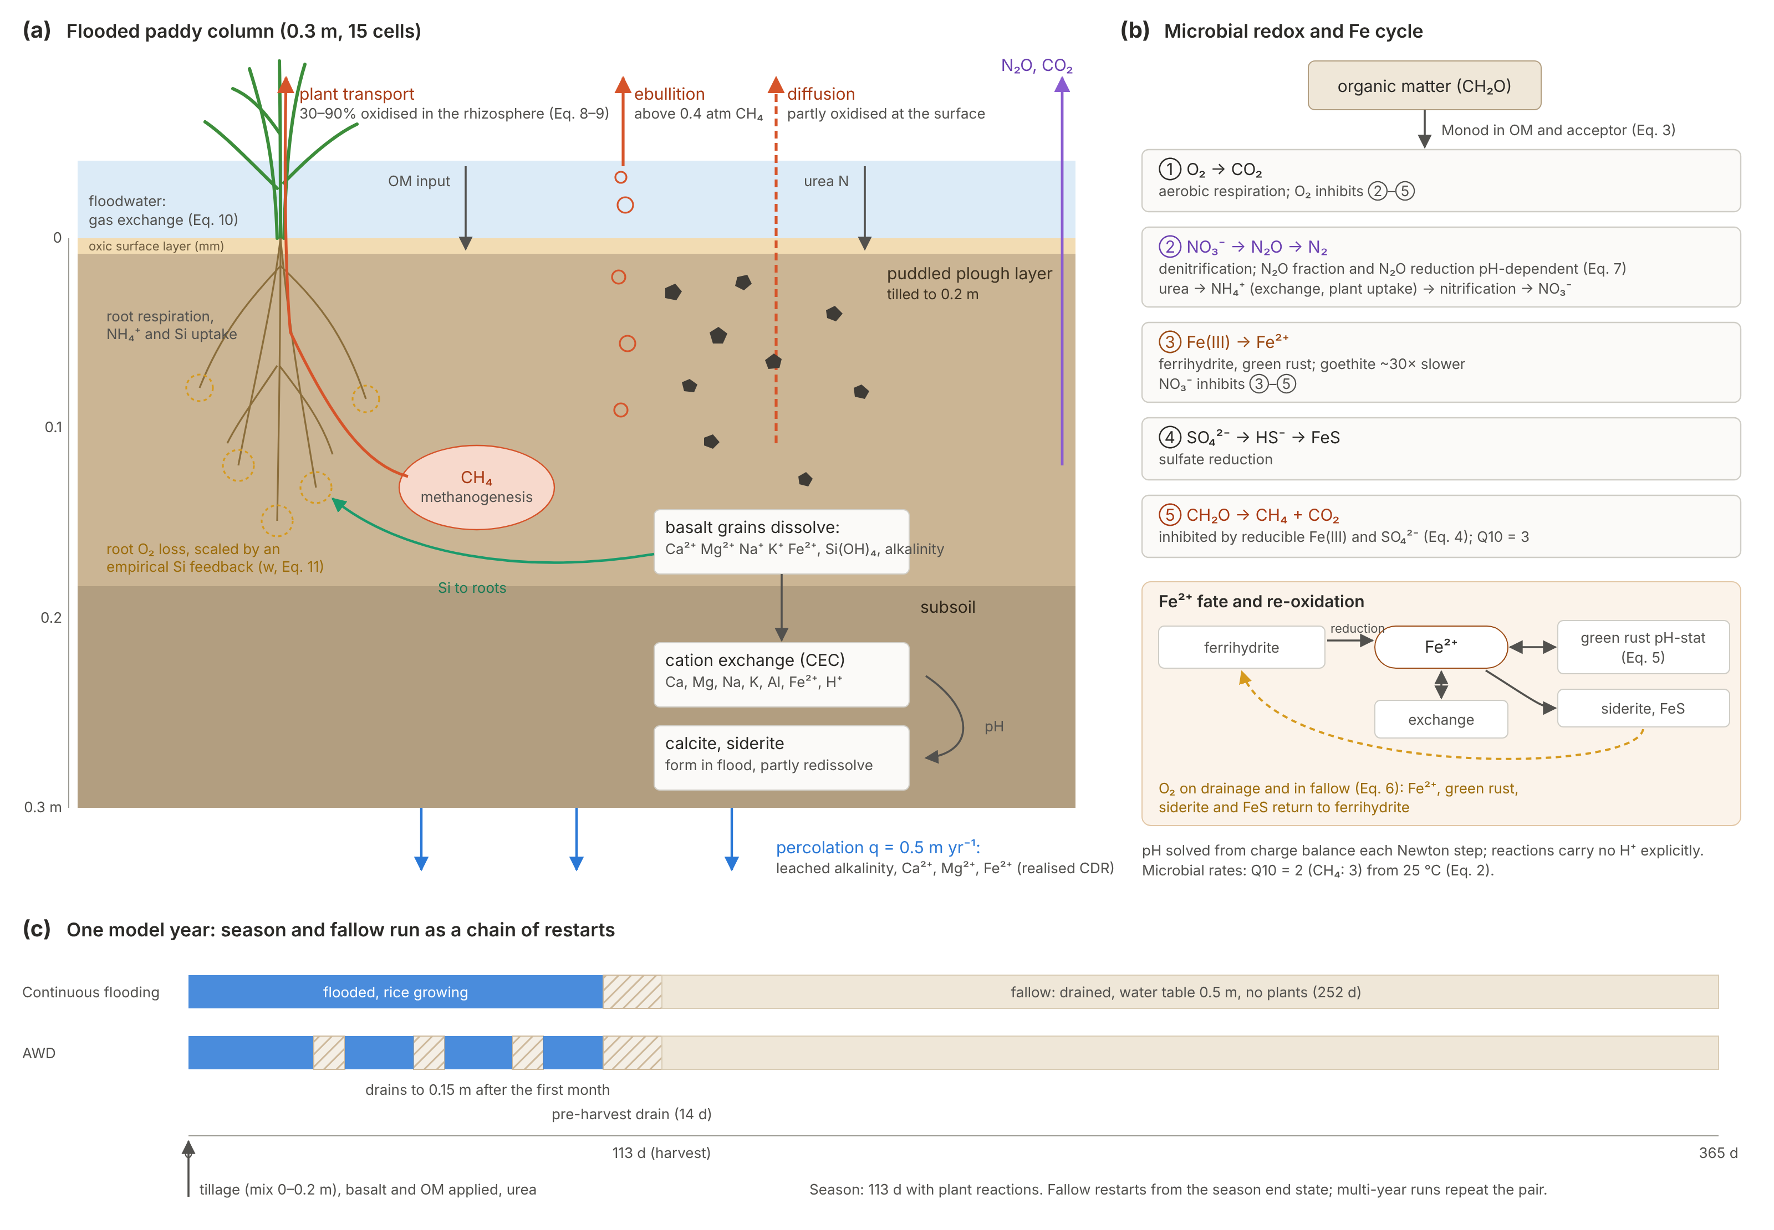
Fig. 1. Processes in Riceland SCEPTER. (a) The 0.3 m paddy column: floodwater, oxic surface layer, puddled plough layer and subsoil, with CH₄ leaving by plant transport, ebullition and diffusion; basalt dissolution supplies cations, Si and alkalinity to the exchange complex, carbonates and percolating water; an empirical Si–plant feedback acts through root O₂ loss (Eq. 11). (b) Microbial redox sequence on organic matter and the Fe²⁺ cycle (green rust pH-stat, siderite, FeS, exchange) with re-oxidation by O₂ on drainage. (c) One model year: a 113-day season (continuous flooding or AWD, both with a 14-day pre-harvest drain) and a 252-day drained fallow, run as a chain of restarts.

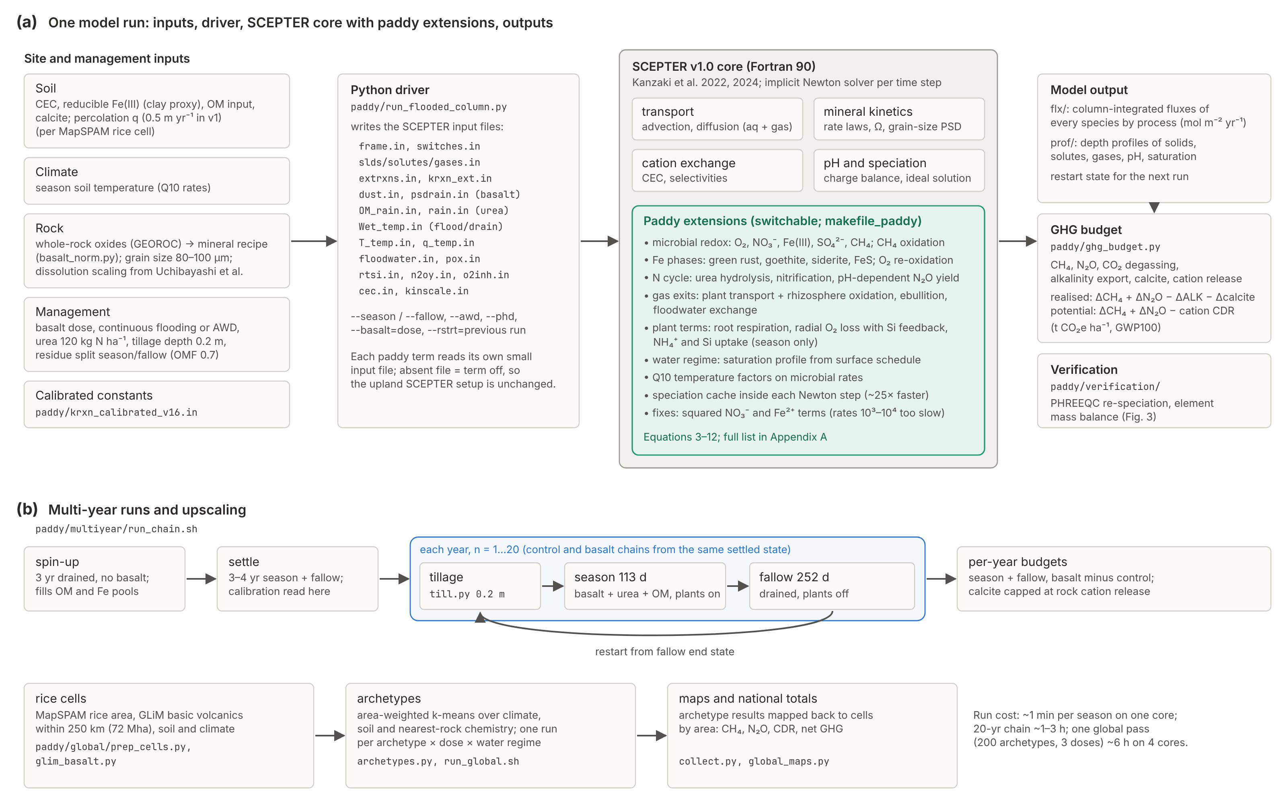
Fig. 2. Coupling of the paddy extensions to SCEPTER v1.0. (a) Site and management inputs are written by the Python driver into SCEPTER input files; the paddy terms sit inside the Fortran core and each is switched on by its own input file; flux and profile output feed the GHG budget and the verification scripts. (b) Multi-year runs (spin-up, settling, then yearly tillage, season and fallow restarts) and upscaling through area-weighted archetypes of rice cells near basalt.

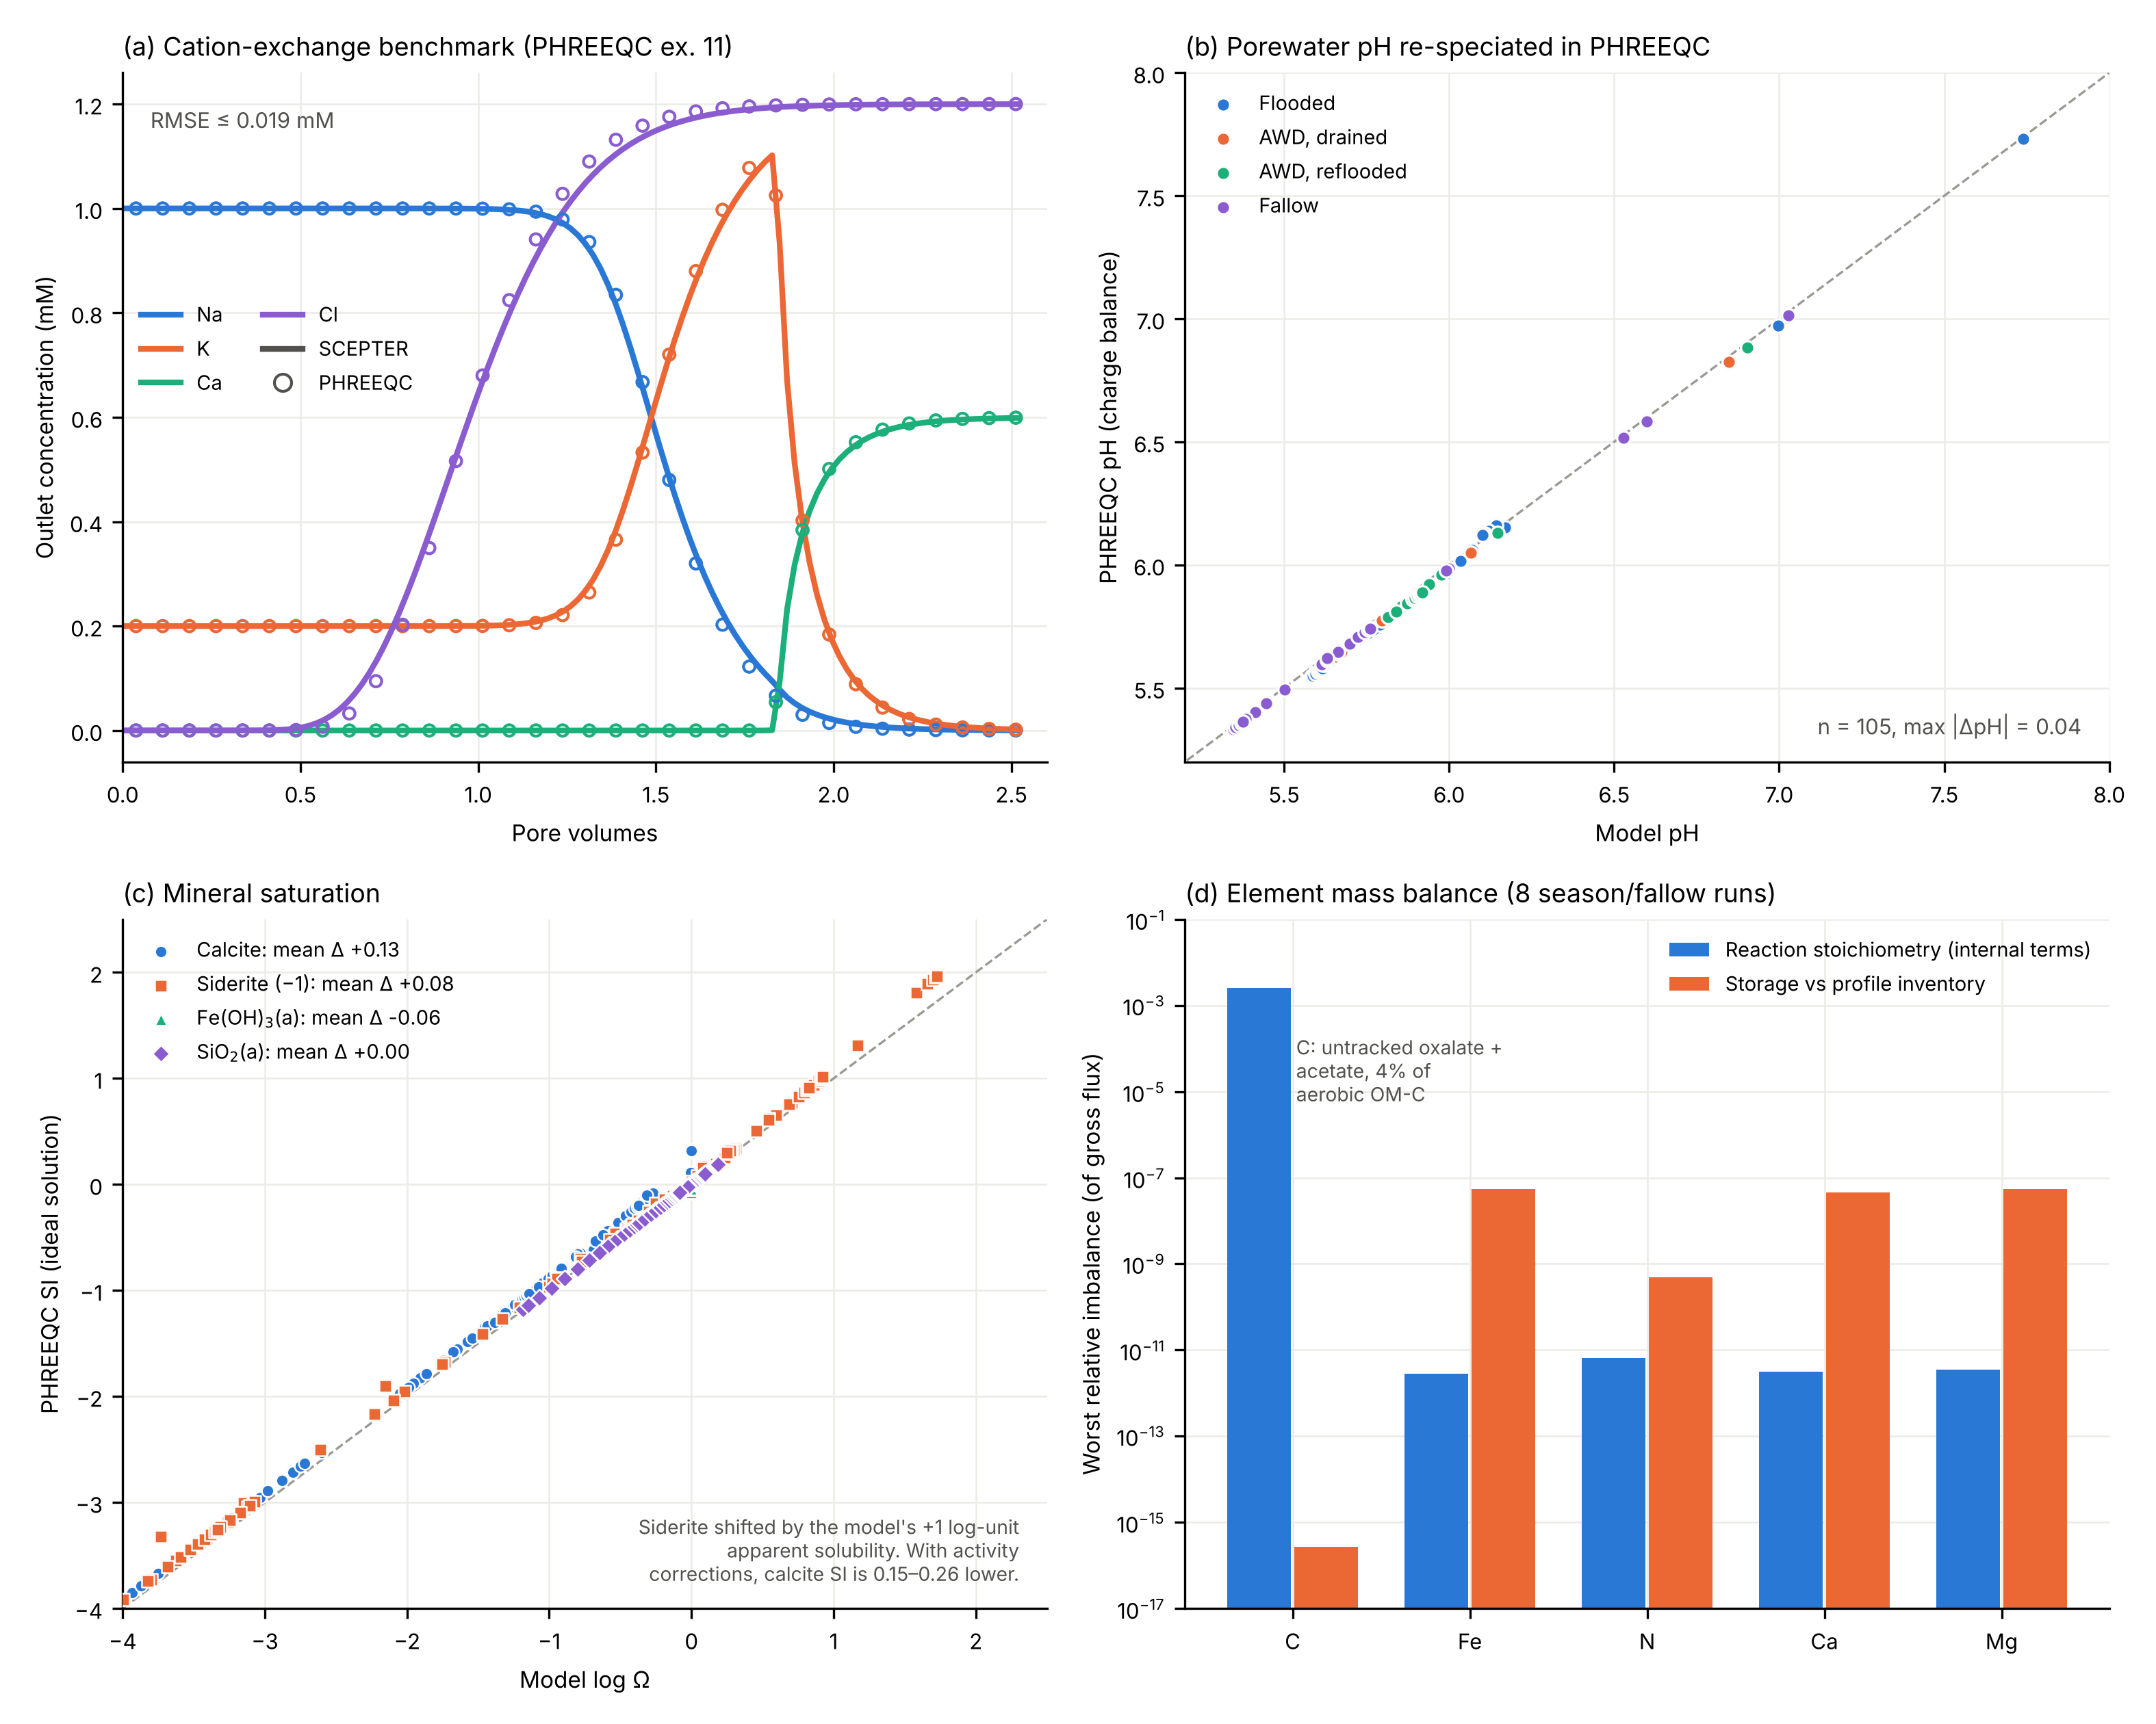
Fig. 3. Verification. (a) PHREEQC example 11 cation-exchange benchmark, outlet concentrations (lines: SCEPTER; circles: PHREEQC). (b) pH of 105 model porewaters (site irr061; flooded, AWD drained and reflooded, fallow; 0 and 20 t ha⁻¹ basalt) recomputed by charge balance in PHREEQC. (c) Model log Ω against PHREEQC SI with activity coefficients removed; siderite shifted by the model’s +1 log-unit apparent solubility. (d) Worst relative imbalance in element budgets over eight season and fallow runs: internal reaction terms (blue) and storage against profile inventories (orange).

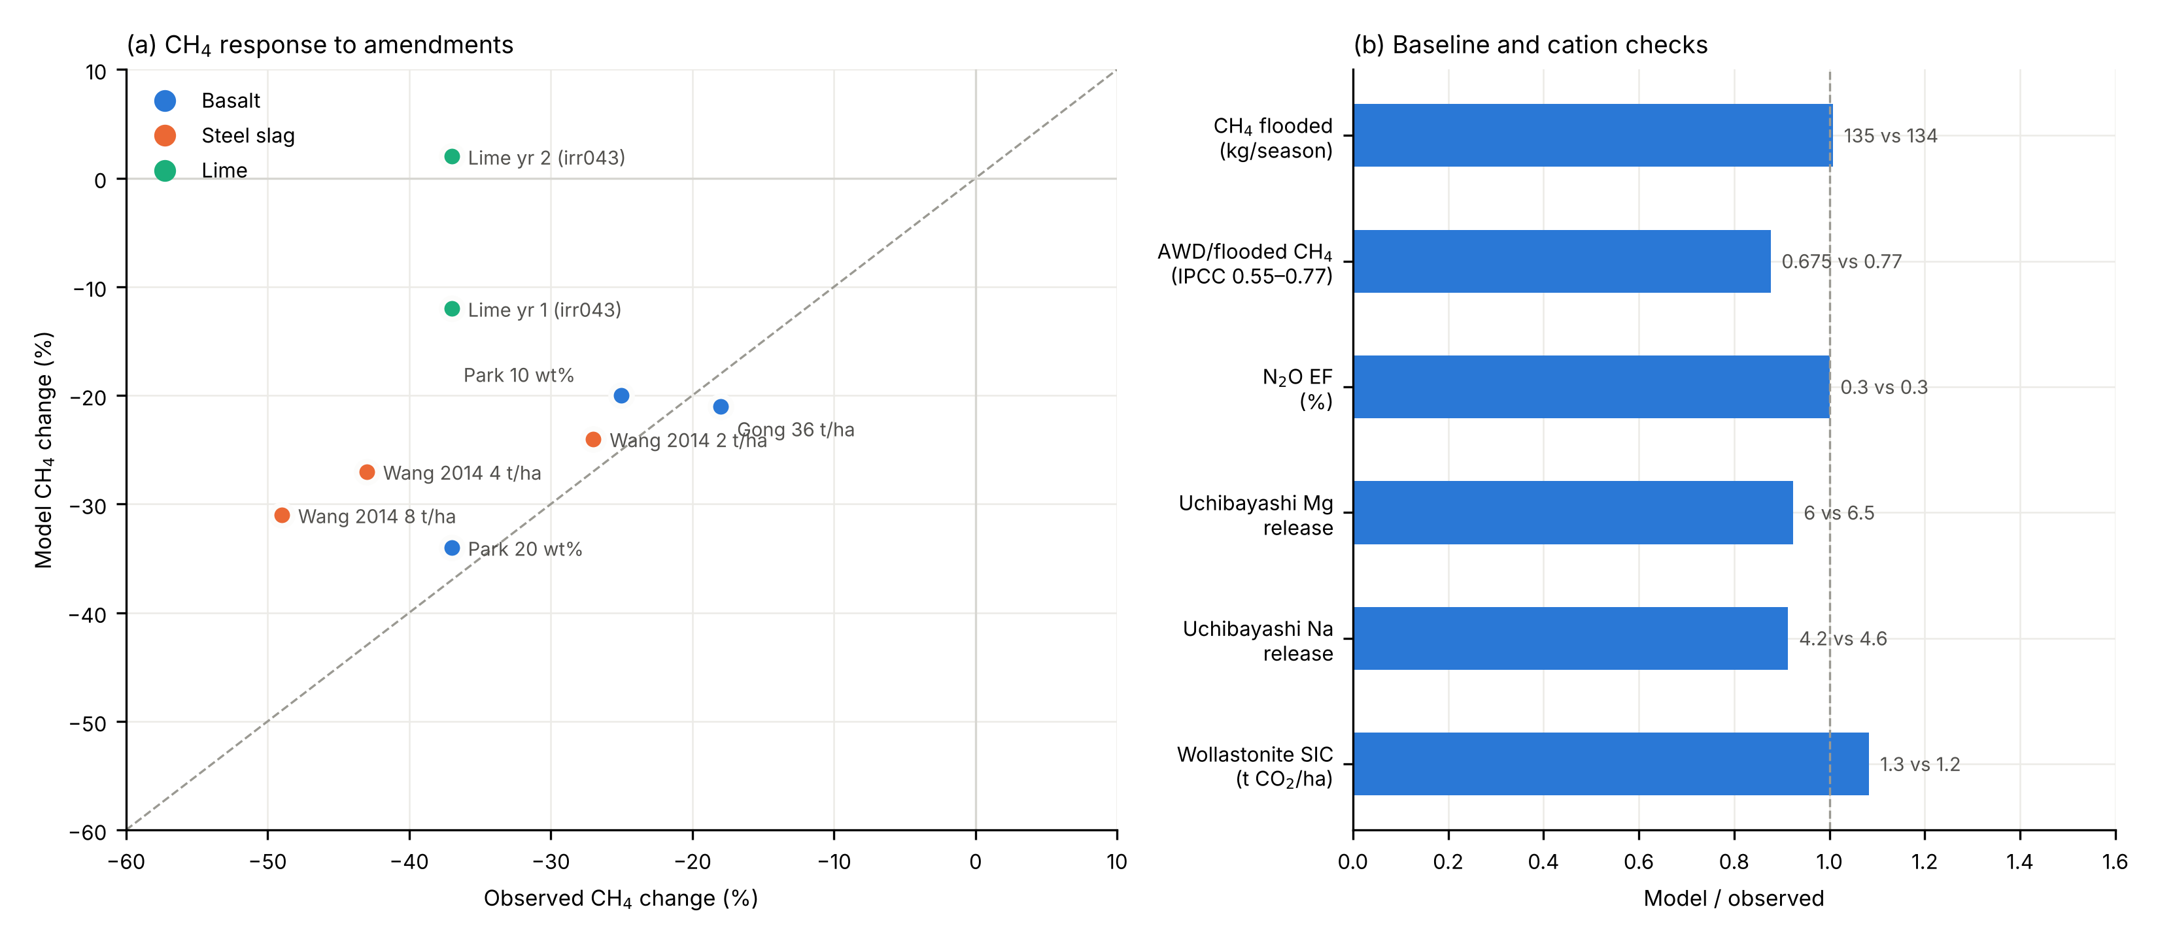
Fig. 4. Validation against basalt, steel slag and lime trials (a: CH₄ change, model against observed; dashed line 1:1) and baseline checks (b: model/observed).

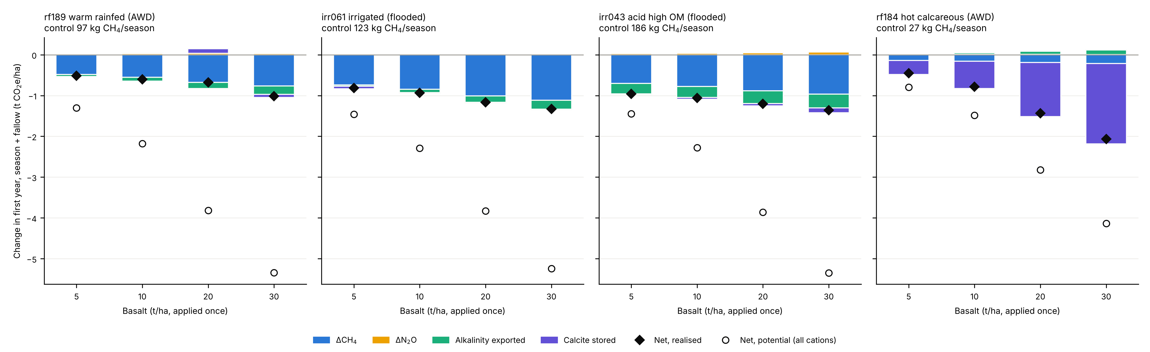
Fig. 5. First-year GHG budget response to basalt dose (0–30 t ha⁻¹) at four representative archetypes.

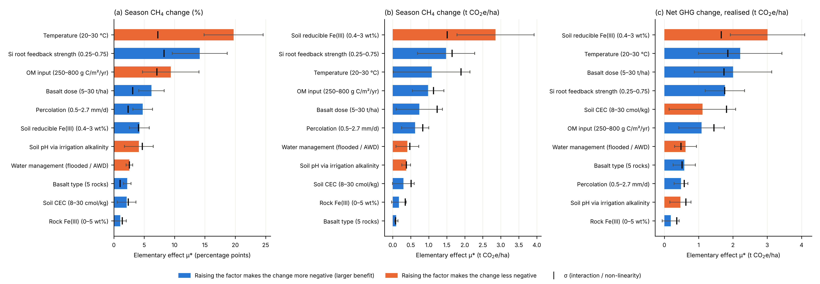
Fig. 6. Morris screen of 11 factors: controls on the CH₄ and net GHG response to basalt.

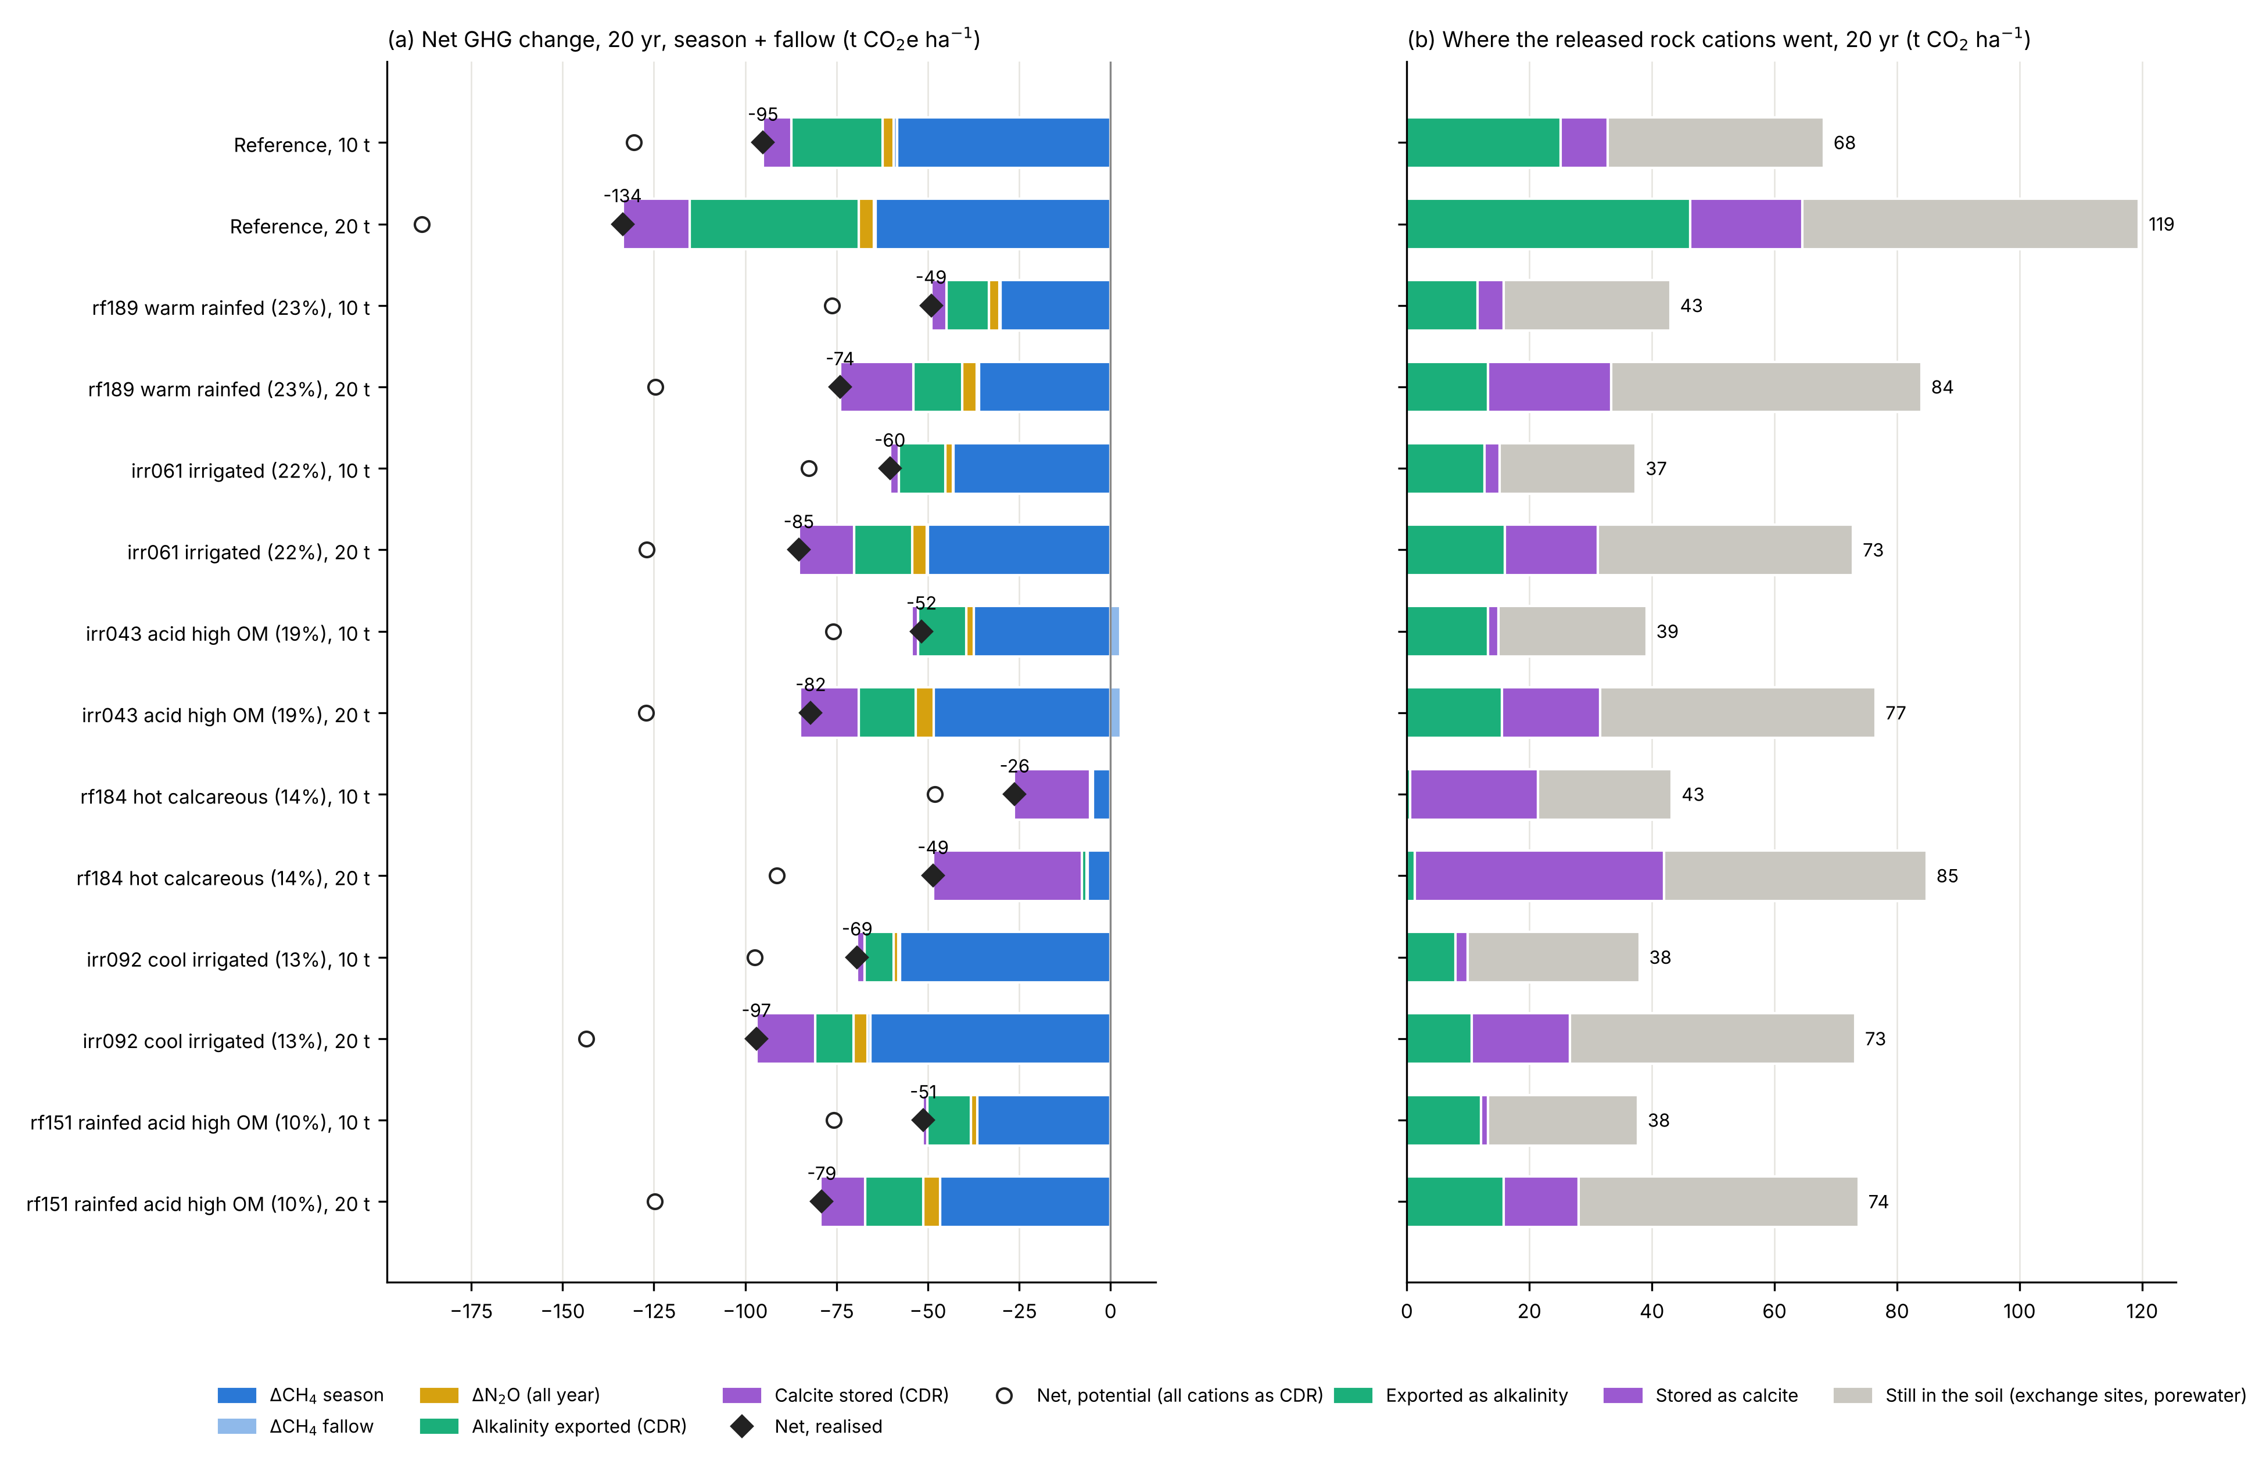
Fig. 7. Twenty years of annual basalt (10 and 20 t ha⁻¹ yr⁻¹): net GHG change and fate of rock-derived cations at the reference site and six archetypes.

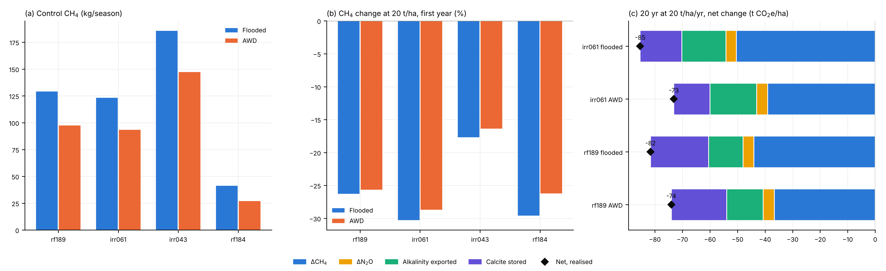
Fig. 8. Alternate wetting and drying and basalt: CH₄ and net GHG under the two water regimes.

