Draft figures, frozen model v22 (31 Oct 2026)
Fig. 3 uses executable scepter_paddy_v23 (commit 267a856: v22 plus the carbon-closure fix); all other panels use scepter_paddy_v22 (commit 162913a). v23 changes year-1 CH₄, N₂O and exported alkalinity by less than 0.3% and CO₂ degassing by up to 1% (eight irr061 season and fallow runs), so Figs 4–8 keep their v22 runs, k_cal.in (methanogenesis vmax 1860 yr⁻¹) and the Si feedback K_Si = 2 mmol L⁻¹, w = 0.2, with no site recalibration, except where a panel says otherwise. Fig. 6a varies w and other inputs as stated.
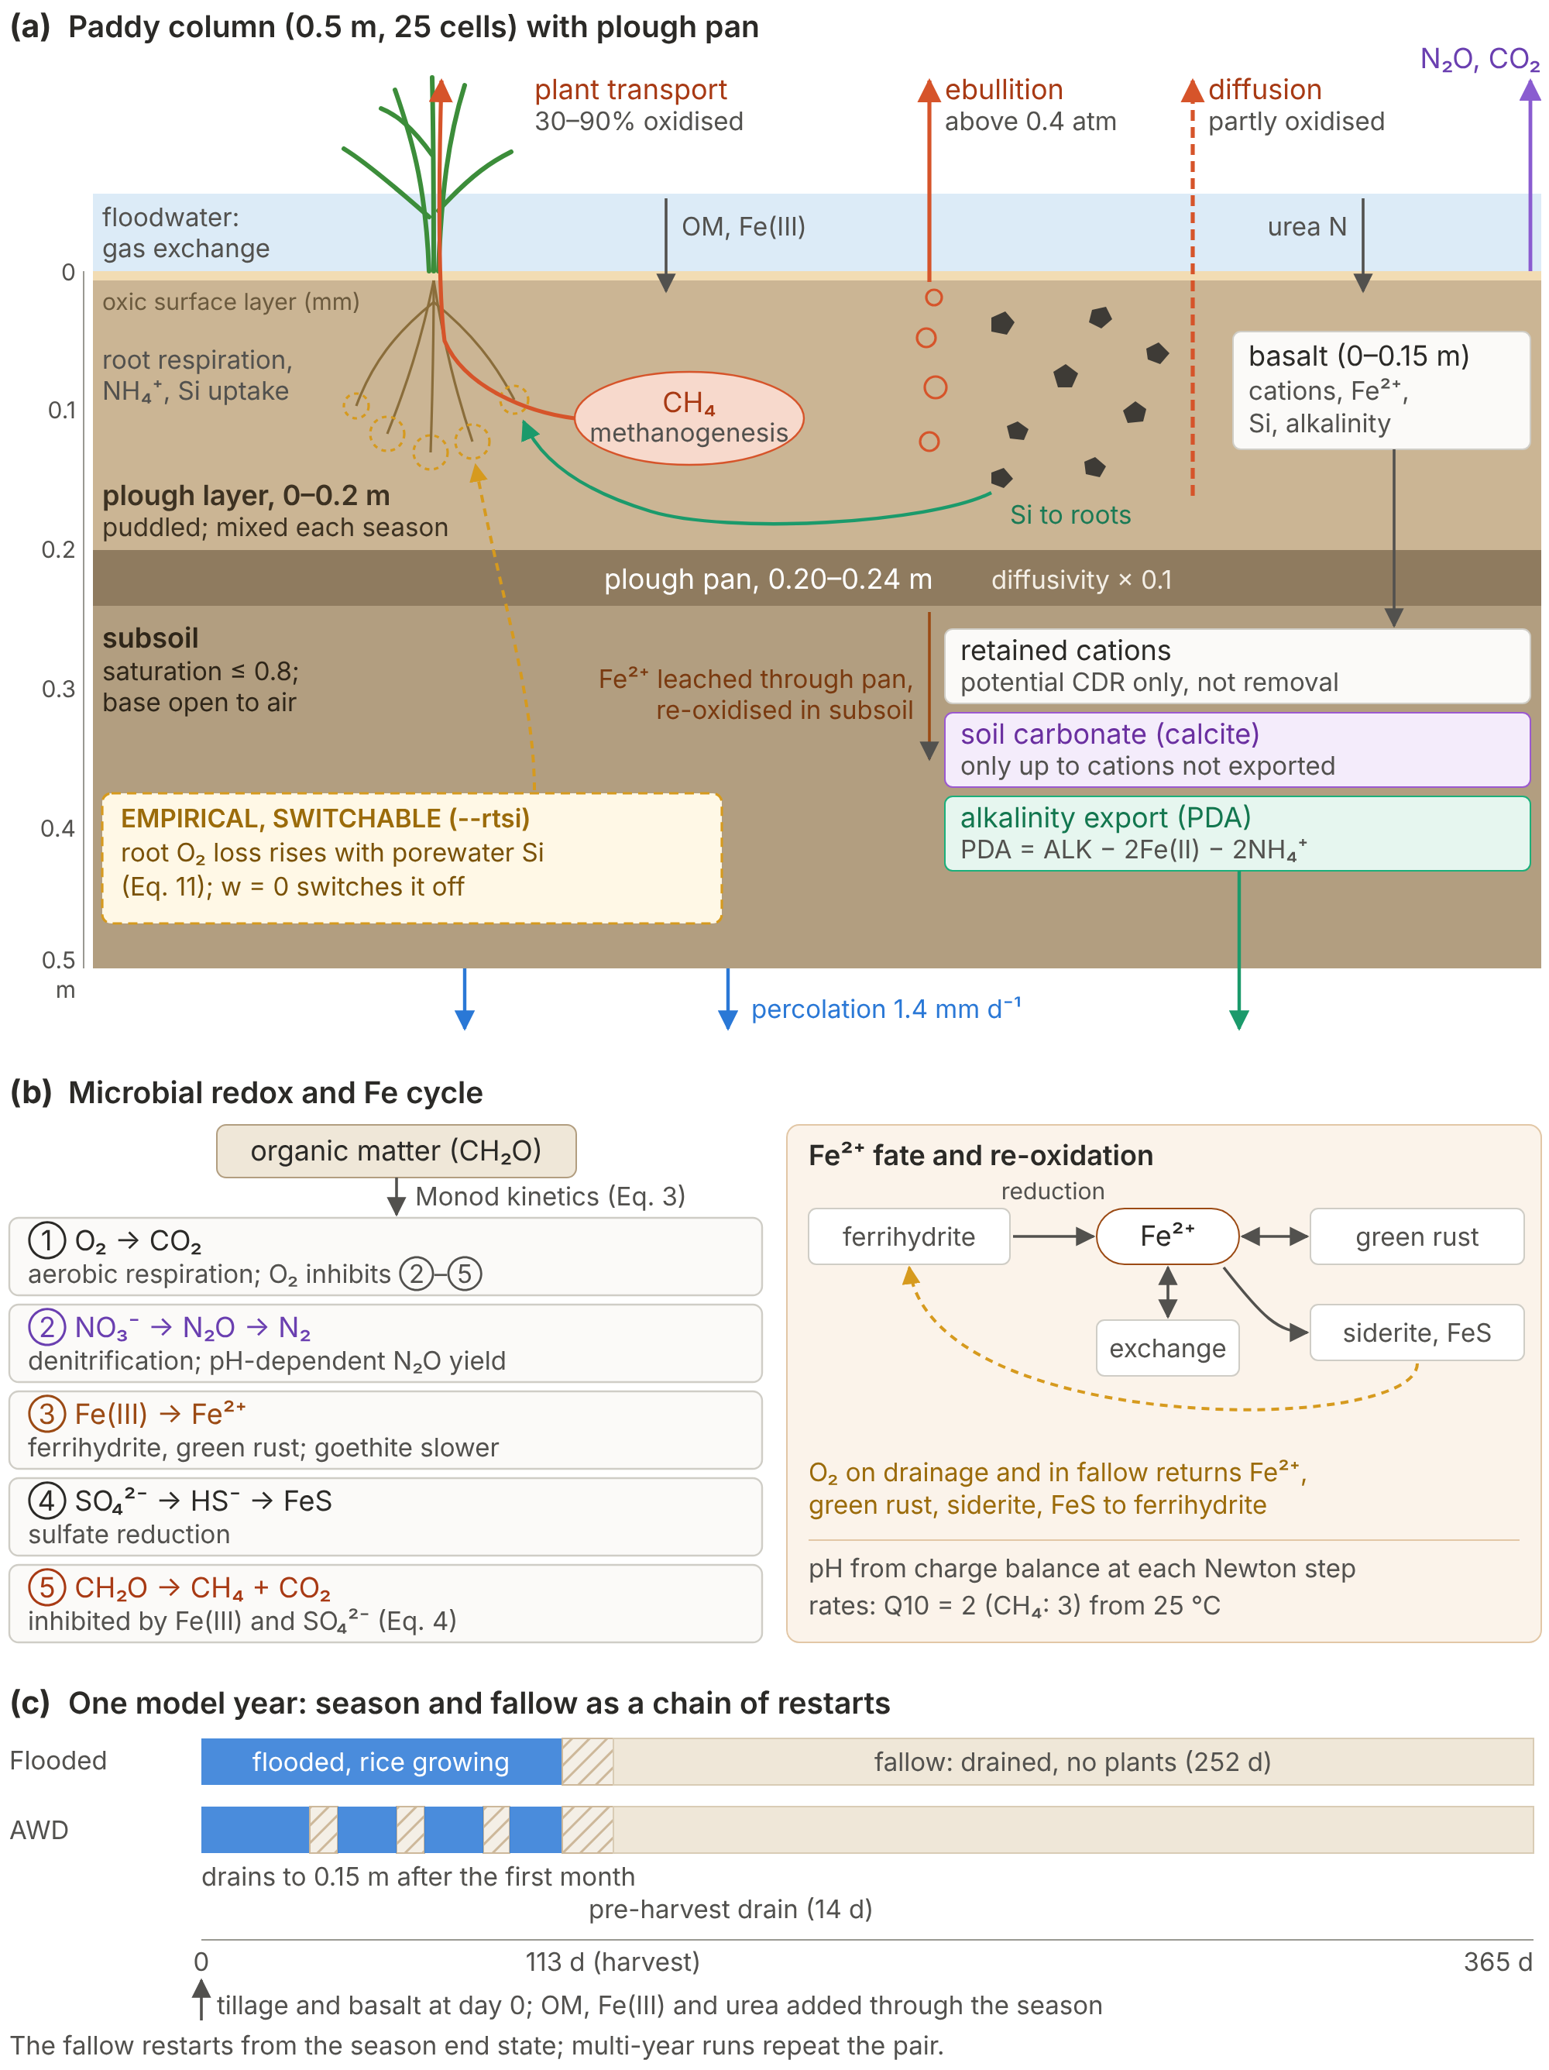
Fig. 1. Model structure and processes. (a) The 0.5 m paddy column (25 cells): puddled plough layer (0–0.2 m, mixed before each season), plough pan (0.20–0.24 m; aqueous and gas diffusivities × 0.1) and a partly saturated subsoil open to air at its base. CH₄ leaves by plant transport (30–90% oxidised in the rhizosphere; Eqs. 8–9), ebullition (above 0.4 atm CH₄) and diffusion through the floodwater (Eq. 10). Percolation is 0.5 m yr⁻¹ (1.4 mm d⁻¹); Fe²⁺ leached through the pan is re-oxidised in the subsoil. Basalt, mixed into 0–0.15 m, releases cations, Fe²⁺, Si and alkalinity, and the model tracks three fates separately: cations retained on exchange sites and in porewater (CDR potential only), soil carbonate, and potentially durable alkalinity exported through the base (PDA = ALK − 2Fe(II) − 2NH₄⁺). The Si-dependent root-O₂ term (dashed box) is empirical and switchable (v22: K_Si = 2 mmol L⁻¹, w = 0.2; w = 0 switches it off). (b) Microbial electron-acceptor sequence (Monod kinetics in OM and acceptor, Eq. 3) and the Fe²⁺ cycle (green rust pH-stat, Eq. 5; siderite, FeS, exchange; re-oxidation by O₂ on drainage and in the fallow, Eq. 6). Urea hydrolyses to NH₄⁺, which is held on exchange sites, taken up by rice or nitrified to NO₃⁻; the N₂O yield of denitrification depends on pH (Eq. 7). NO₃⁻ inhibits pathways ③–⑤; goethite is reduced ~30× more slowly than ferrihydrite; CH₄ production is inhibited by reducible Fe(III) and SO₄²⁻ (Eq. 4). Microbial rates scale with Q10 = 2 (methanogenesis 3) from 25 °C (Eq. 2). pH is solved from charge balance at each Newton step, so reactions carry no explicit H⁺. (c) Seasonal saturation and drainage: a 113-day season (continuous flooding or AWD, both ending with a 14-day pre-harvest drain) and a 252-day drained fallow (water table 0.5 m), run as a chain of restarts. Tillage and basalt are applied on day 0; OM, Fe(III) and urea (120 kg N ha⁻¹) are added at a constant rate through the season.
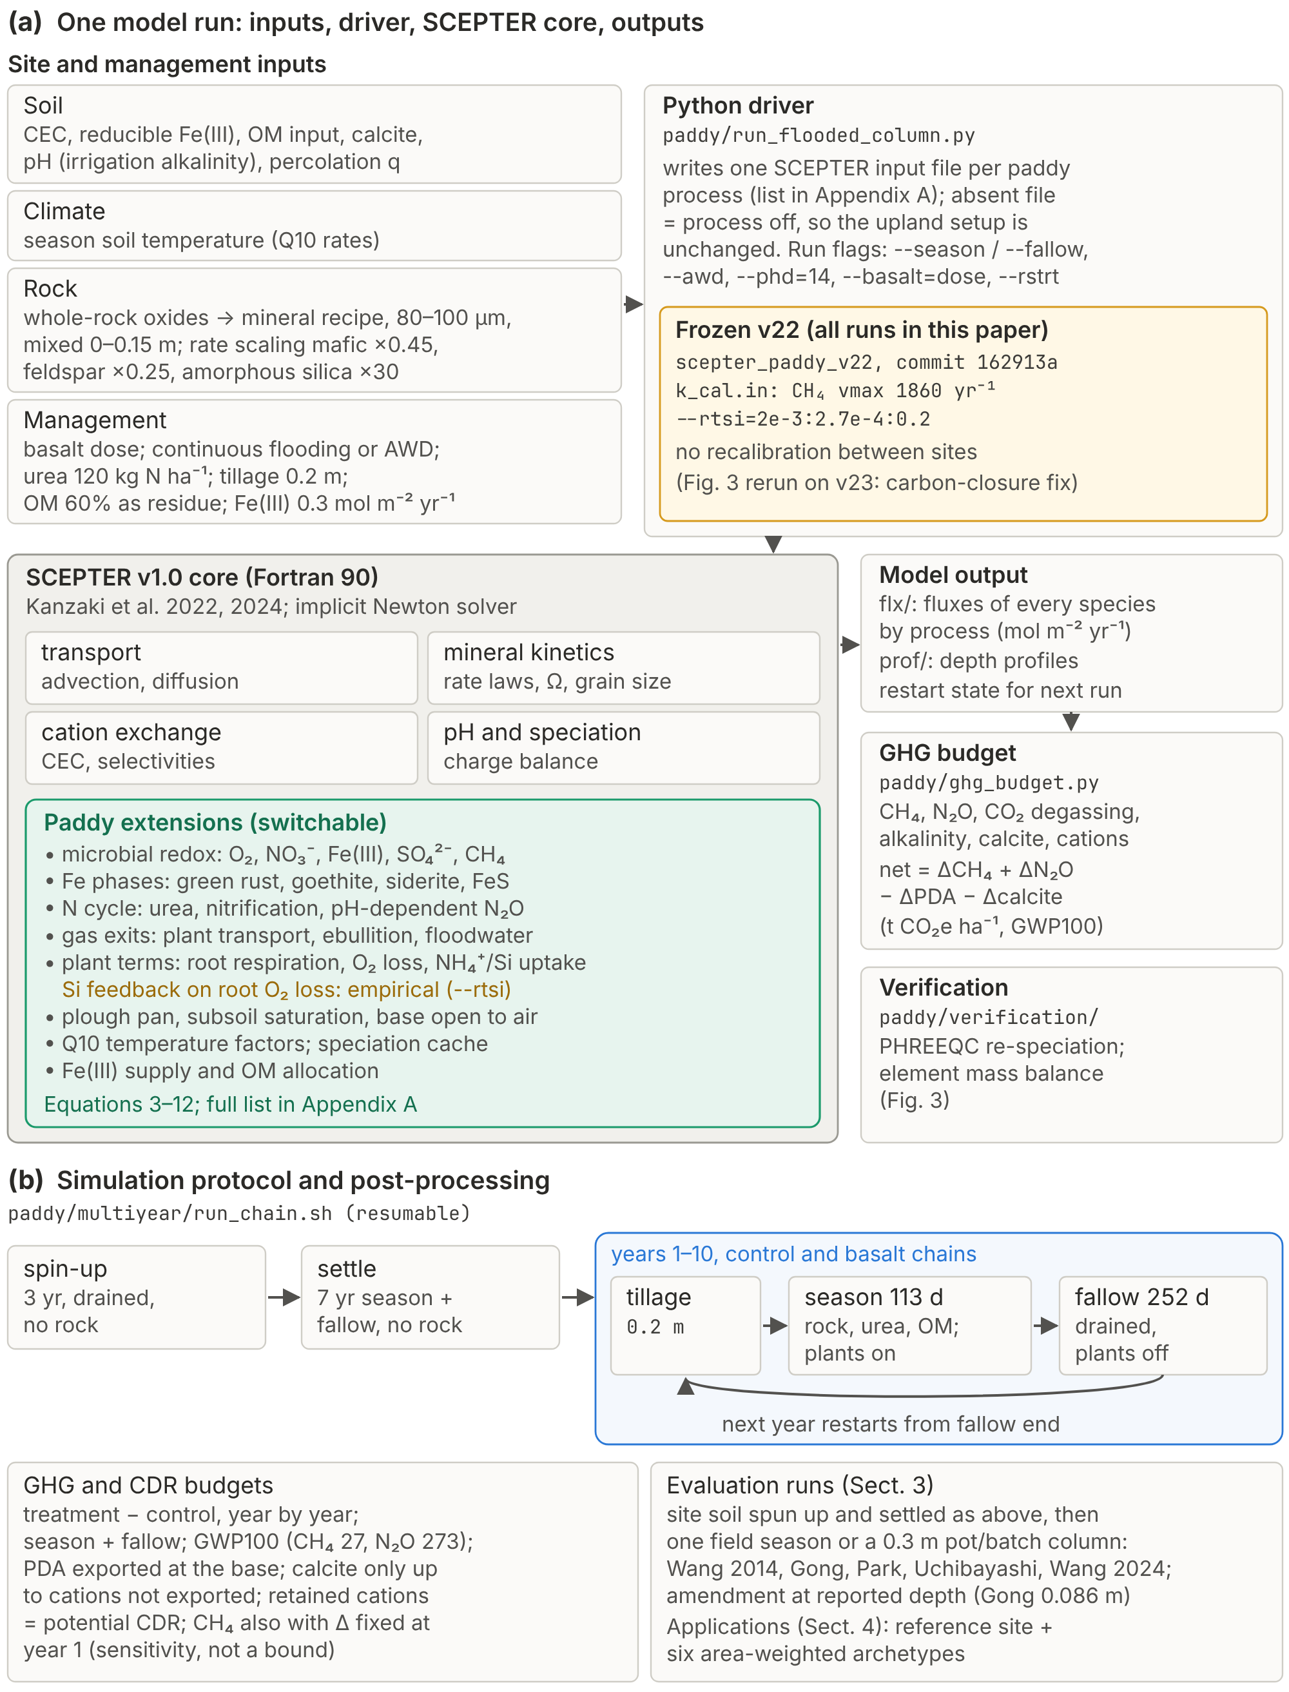
Fig. 2. Implementation and simulation protocol. (a) Inputs, the Python driver, the original SCEPTER v1.0 core (grey) and the added paddy modules (green), and outputs. Each paddy term reads its own input file and is off when the file is absent. Frozen v22 provenance: executable, commit, calibrated constants and Si-feedback setting. (b) Prescribed hydrology and the run protocol: 3-yr drained spin-up, 7-yr settle without rock, then year-matched control and treatment chains from the same settled state (tillage, season, fallow), with GHG and CDR post-processing. The input files written by the driver and the model switches (driver flag → input file) are listed in Appendix A. Fig. 3 was rerun on v23 (v22 plus the carbon-closure fix).
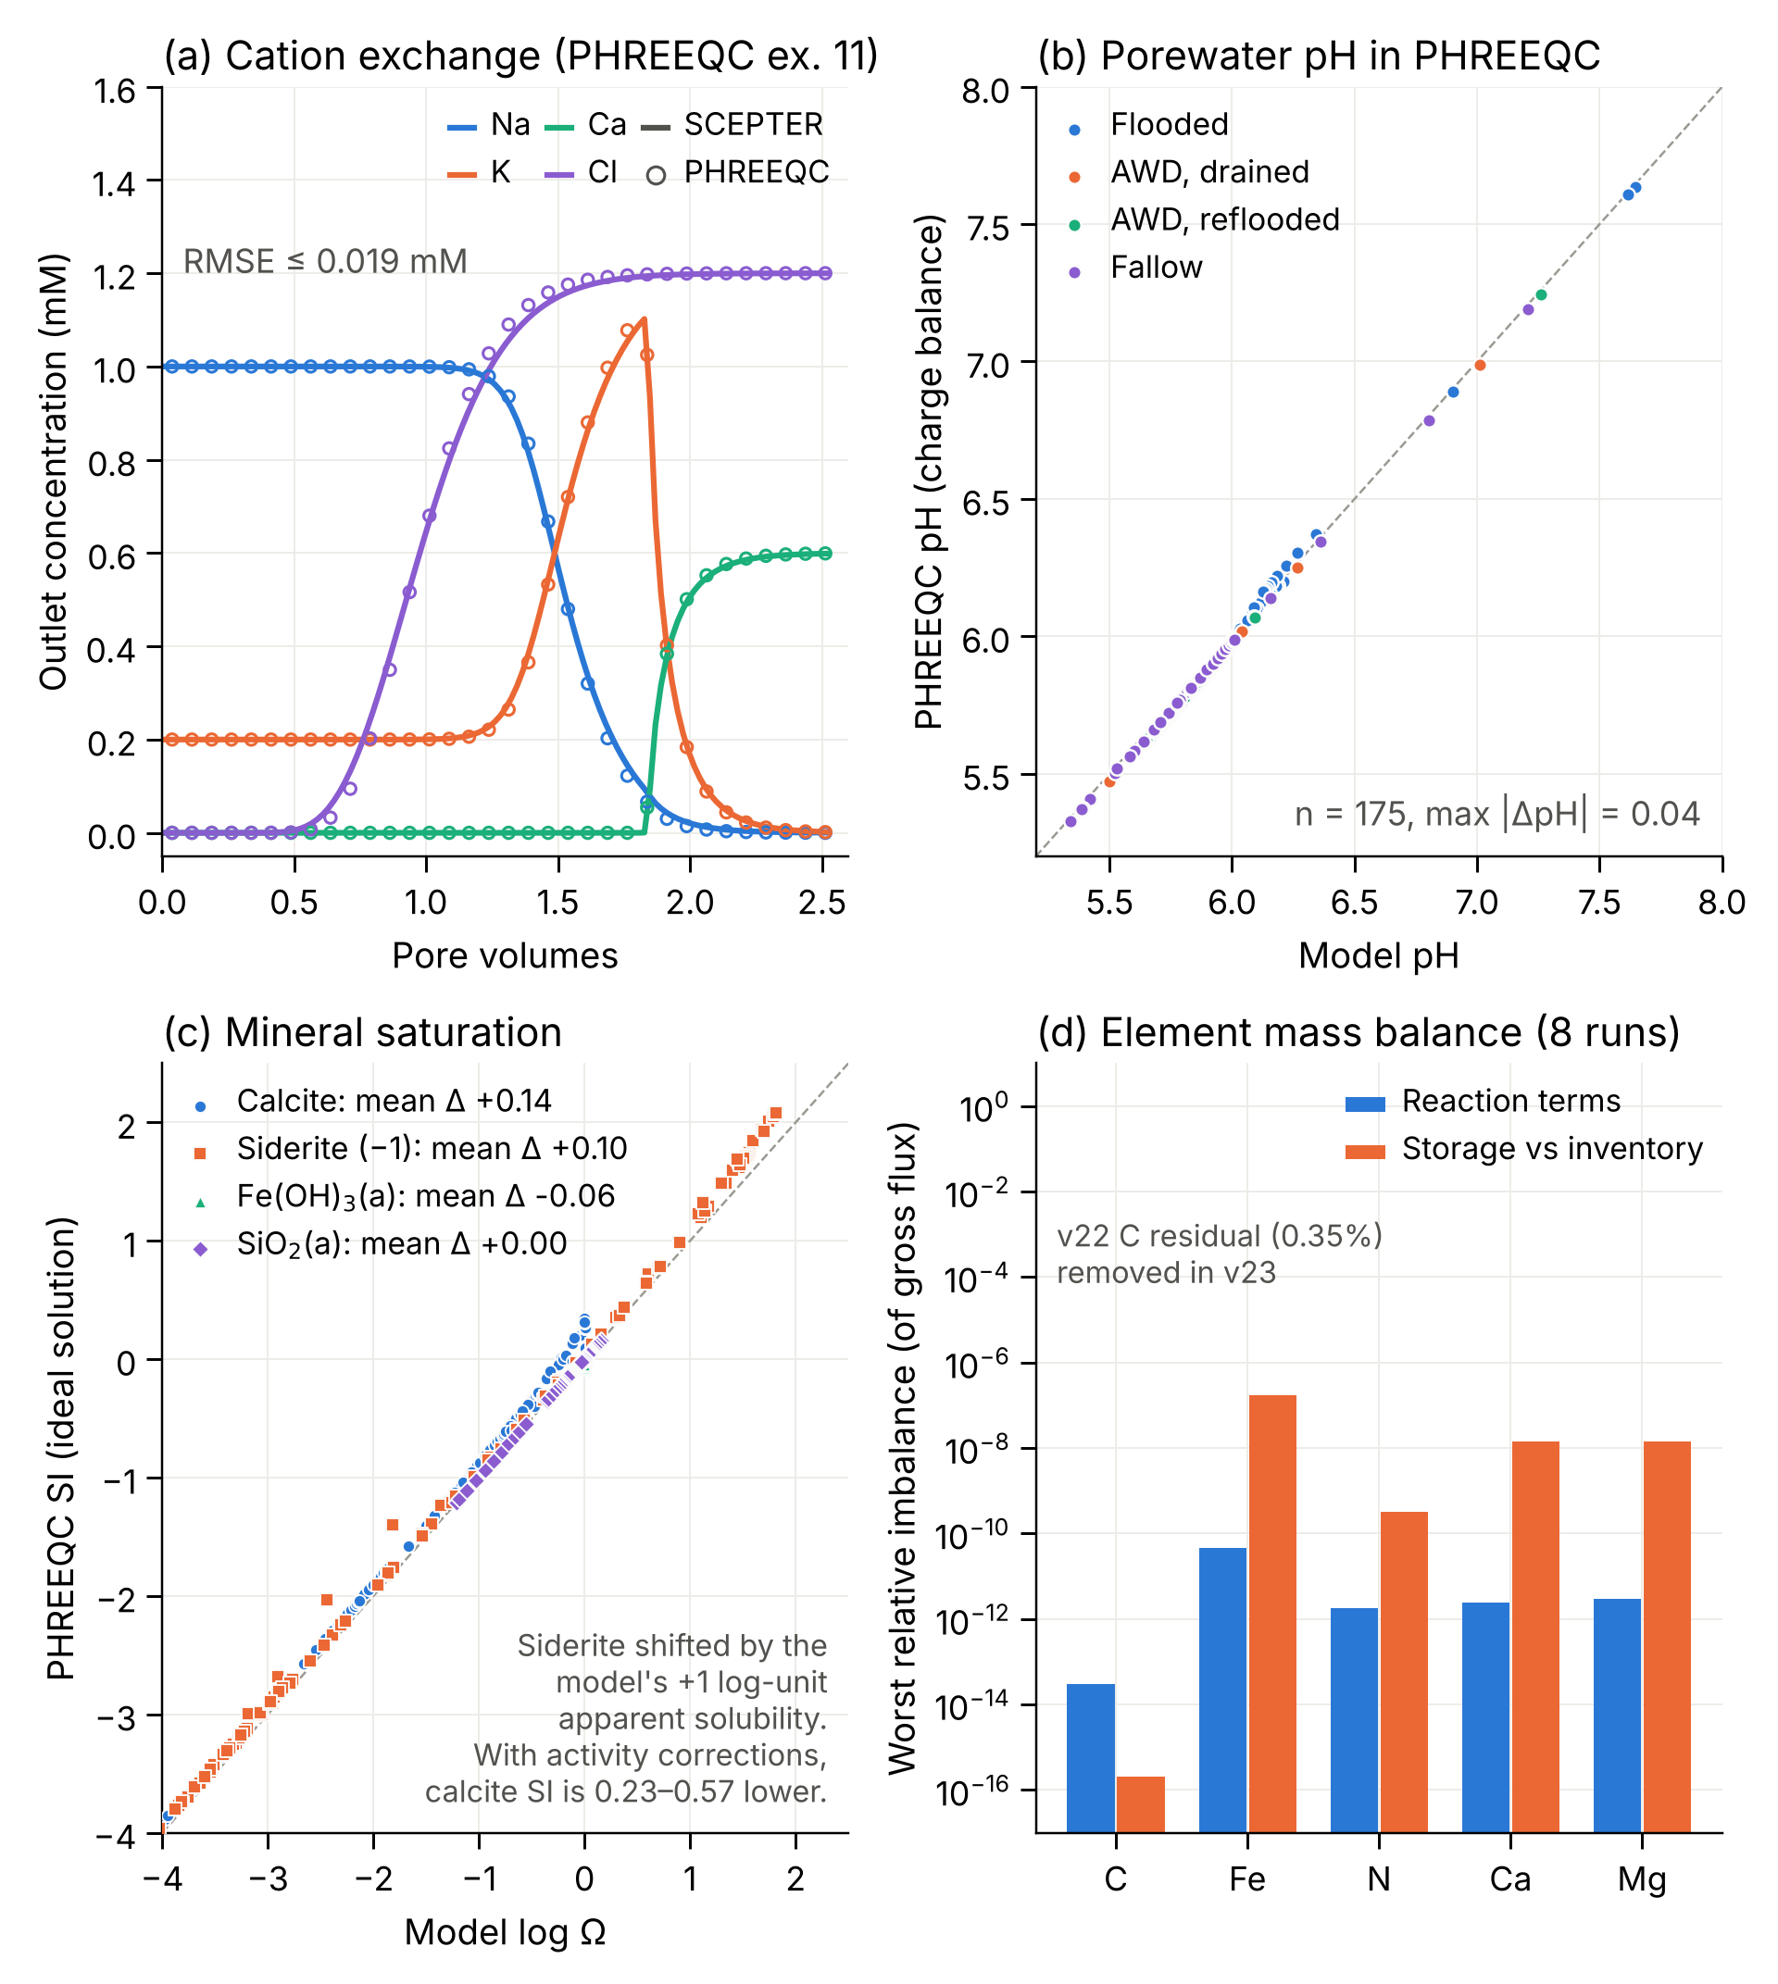
Fig. 3. Numerical verification (v23). (a) PHREEQC example 11 cation-exchange benchmark, outlet concentrations (lines: SCEPTER; circles: PHREEQC). (b) pH of 175 model porewaters (archetype irr061: flooded, AWD drained and reflooded, and fallow, at 0 and 20 t ha⁻¹) recomputed by charge balance in PHREEQC (phreeqc.dat). (c) Model log Ω against PHREEQC SI with activity coefficients removed (the model runs as an ideal solution); siderite is shifted by the model’s +1 log-unit apparent solubility. (d) Worst relative imbalance in element budgets over eight season and fallow runs: internal reaction terms (blue) and storage against profile inventories (orange). C, Fe, N, Ca and Mg close to within 5 × 10⁻¹¹ (reaction terms) and 2 × 10⁻⁷ (storage) of the gross flux. In v22, carbon had a residual of 0.35% of the gross C flux because the upstream SCEPTER organic-matter decay sent 4% of its carbon to oxalate and acetate, which are not tracked in the paddy configuration; v23 returns that carbon to CO₂, closing the carbon budget to machine precision. The change alters year-1 CH₄, N₂O and exported alkalinity by less than 0.3% at irr061.
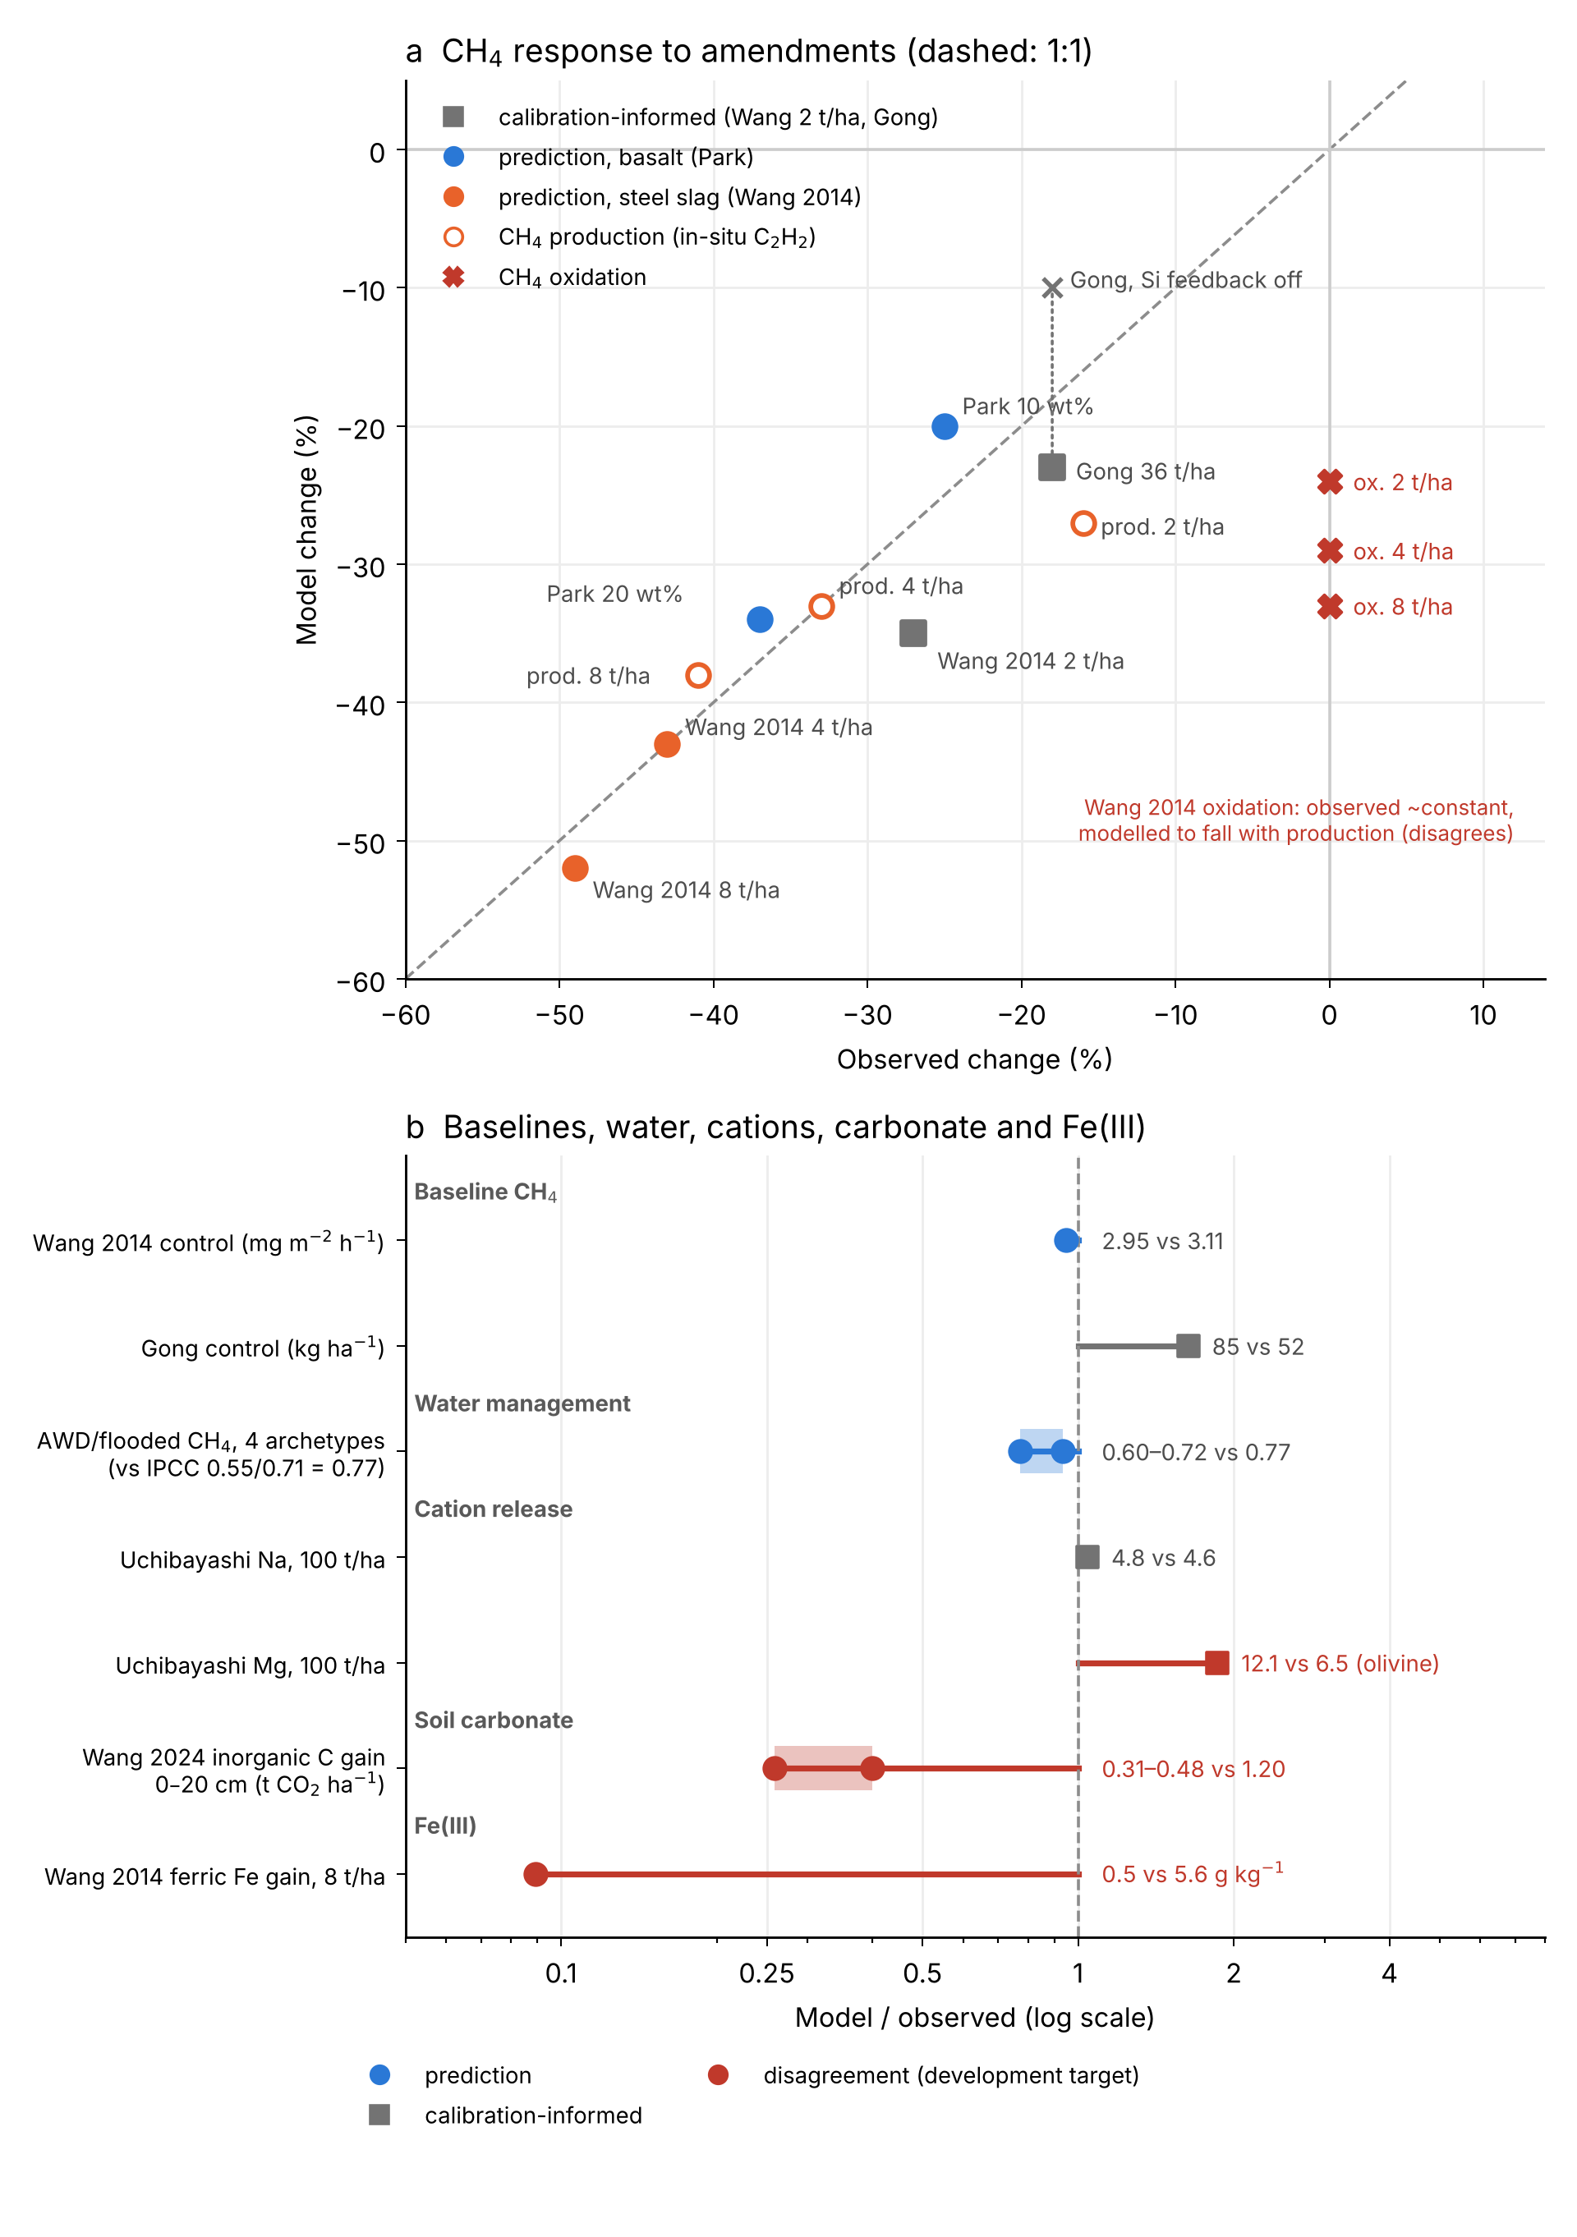
Fig. 4. Evaluation against observations (frozen v22, no site recalibration). (a) CH₄ response to basalt and steel slag, model against observed (dashed line 1:1). Squares are calibration-informed comparisons (Wang et al. 2014 at 2 t ha⁻¹ and Gong et al. 2026, used to set the Si feedback); circles are predictions. Open circles are CH₄ production (in-situ C₂H₂ inhibition); red crosses are CH₄ oxidation, which was observed to stay nearly constant but falls with production in the model. (b) Model/observed ratios for baseline CH₄, the water-management response (first-year AWD/flooded control CH₄ at four archetypes against the IPCC (2019) multiple-to-single-drainage scaling, 0.55/0.71), cation release (Uchibayashi et al. 2025; mineral rate scaling was informed by this study), soil carbonate (Wang et al. 2024) and Fe(III) (Wang et al. 2014). Red marks disagreements kept as development targets: Mg release about 2× too fast (olivine), carbonate gain underpredicted 2.5–4×, and the ferric-Fe gain not reproduced.
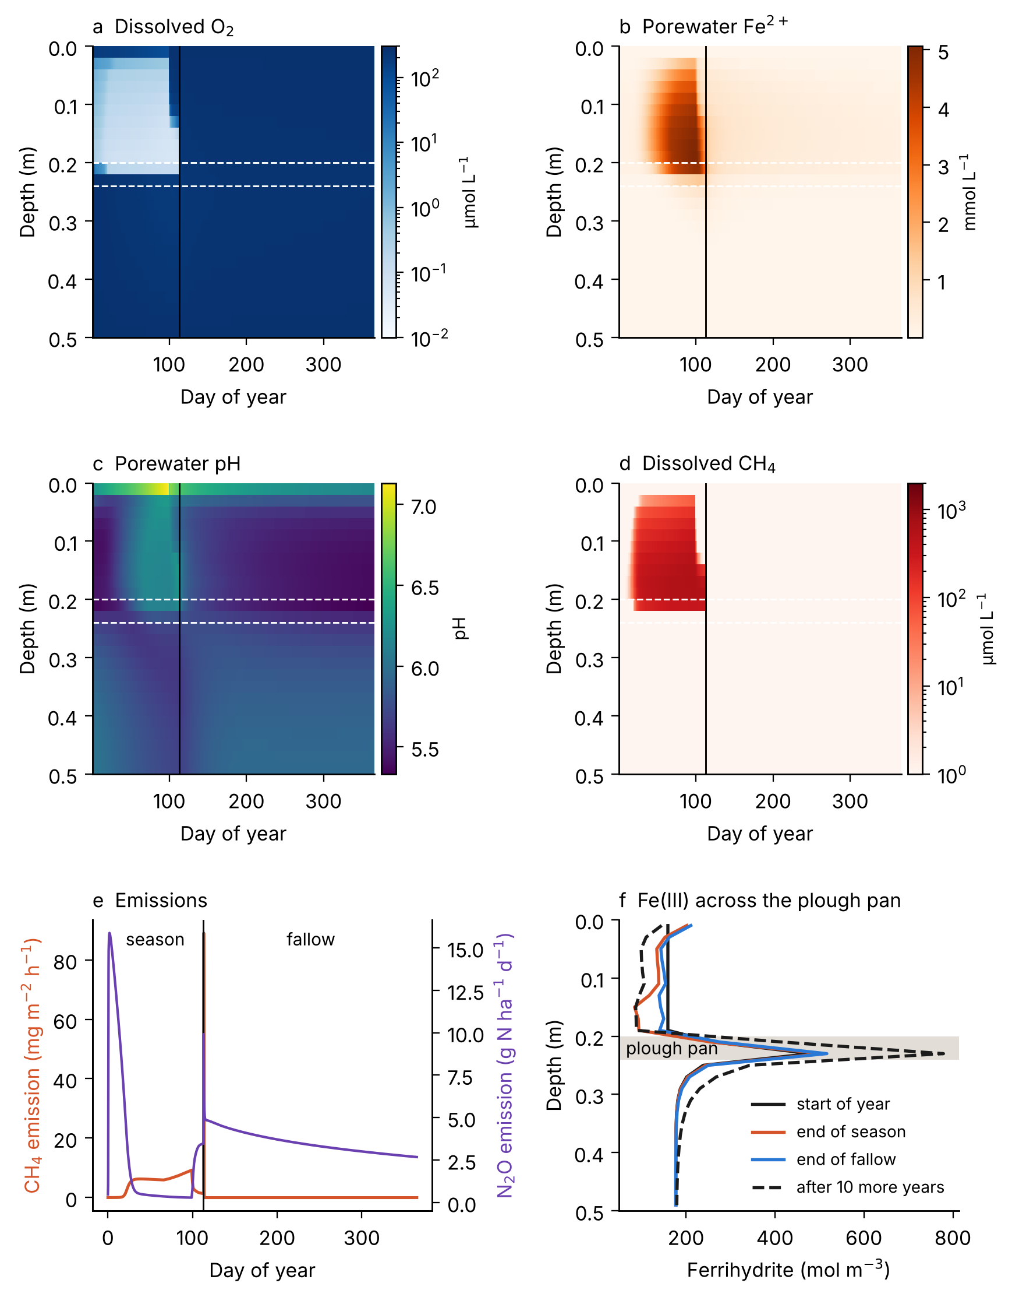
Fig. 5. Paddy biogeochemical dynamics in the reference control column (no rock), one year (season and fallow) after the 7-yr settle. (a–d) Depth–time sections of dissolved O₂, porewater Fe²⁺, pH and dissolved CH₄; dashed white lines mark the plough pan and the vertical line the end of the season. (e) CH₄ and N₂O emission to the atmosphere. (f) Ferrihydrite profiles at the start of the year, the end of the flooded season, the end of the fallow, and in the control after a further 10 years (run r10_ref_0, identical physics). Reducible Fe(III) is depleted from the plough layer and accumulates in the plough pan, consistent with re-oxidation there of Fe²⁺ leached from the plough layer during flooding. None of these panels depends on basalt or the Si feedback.
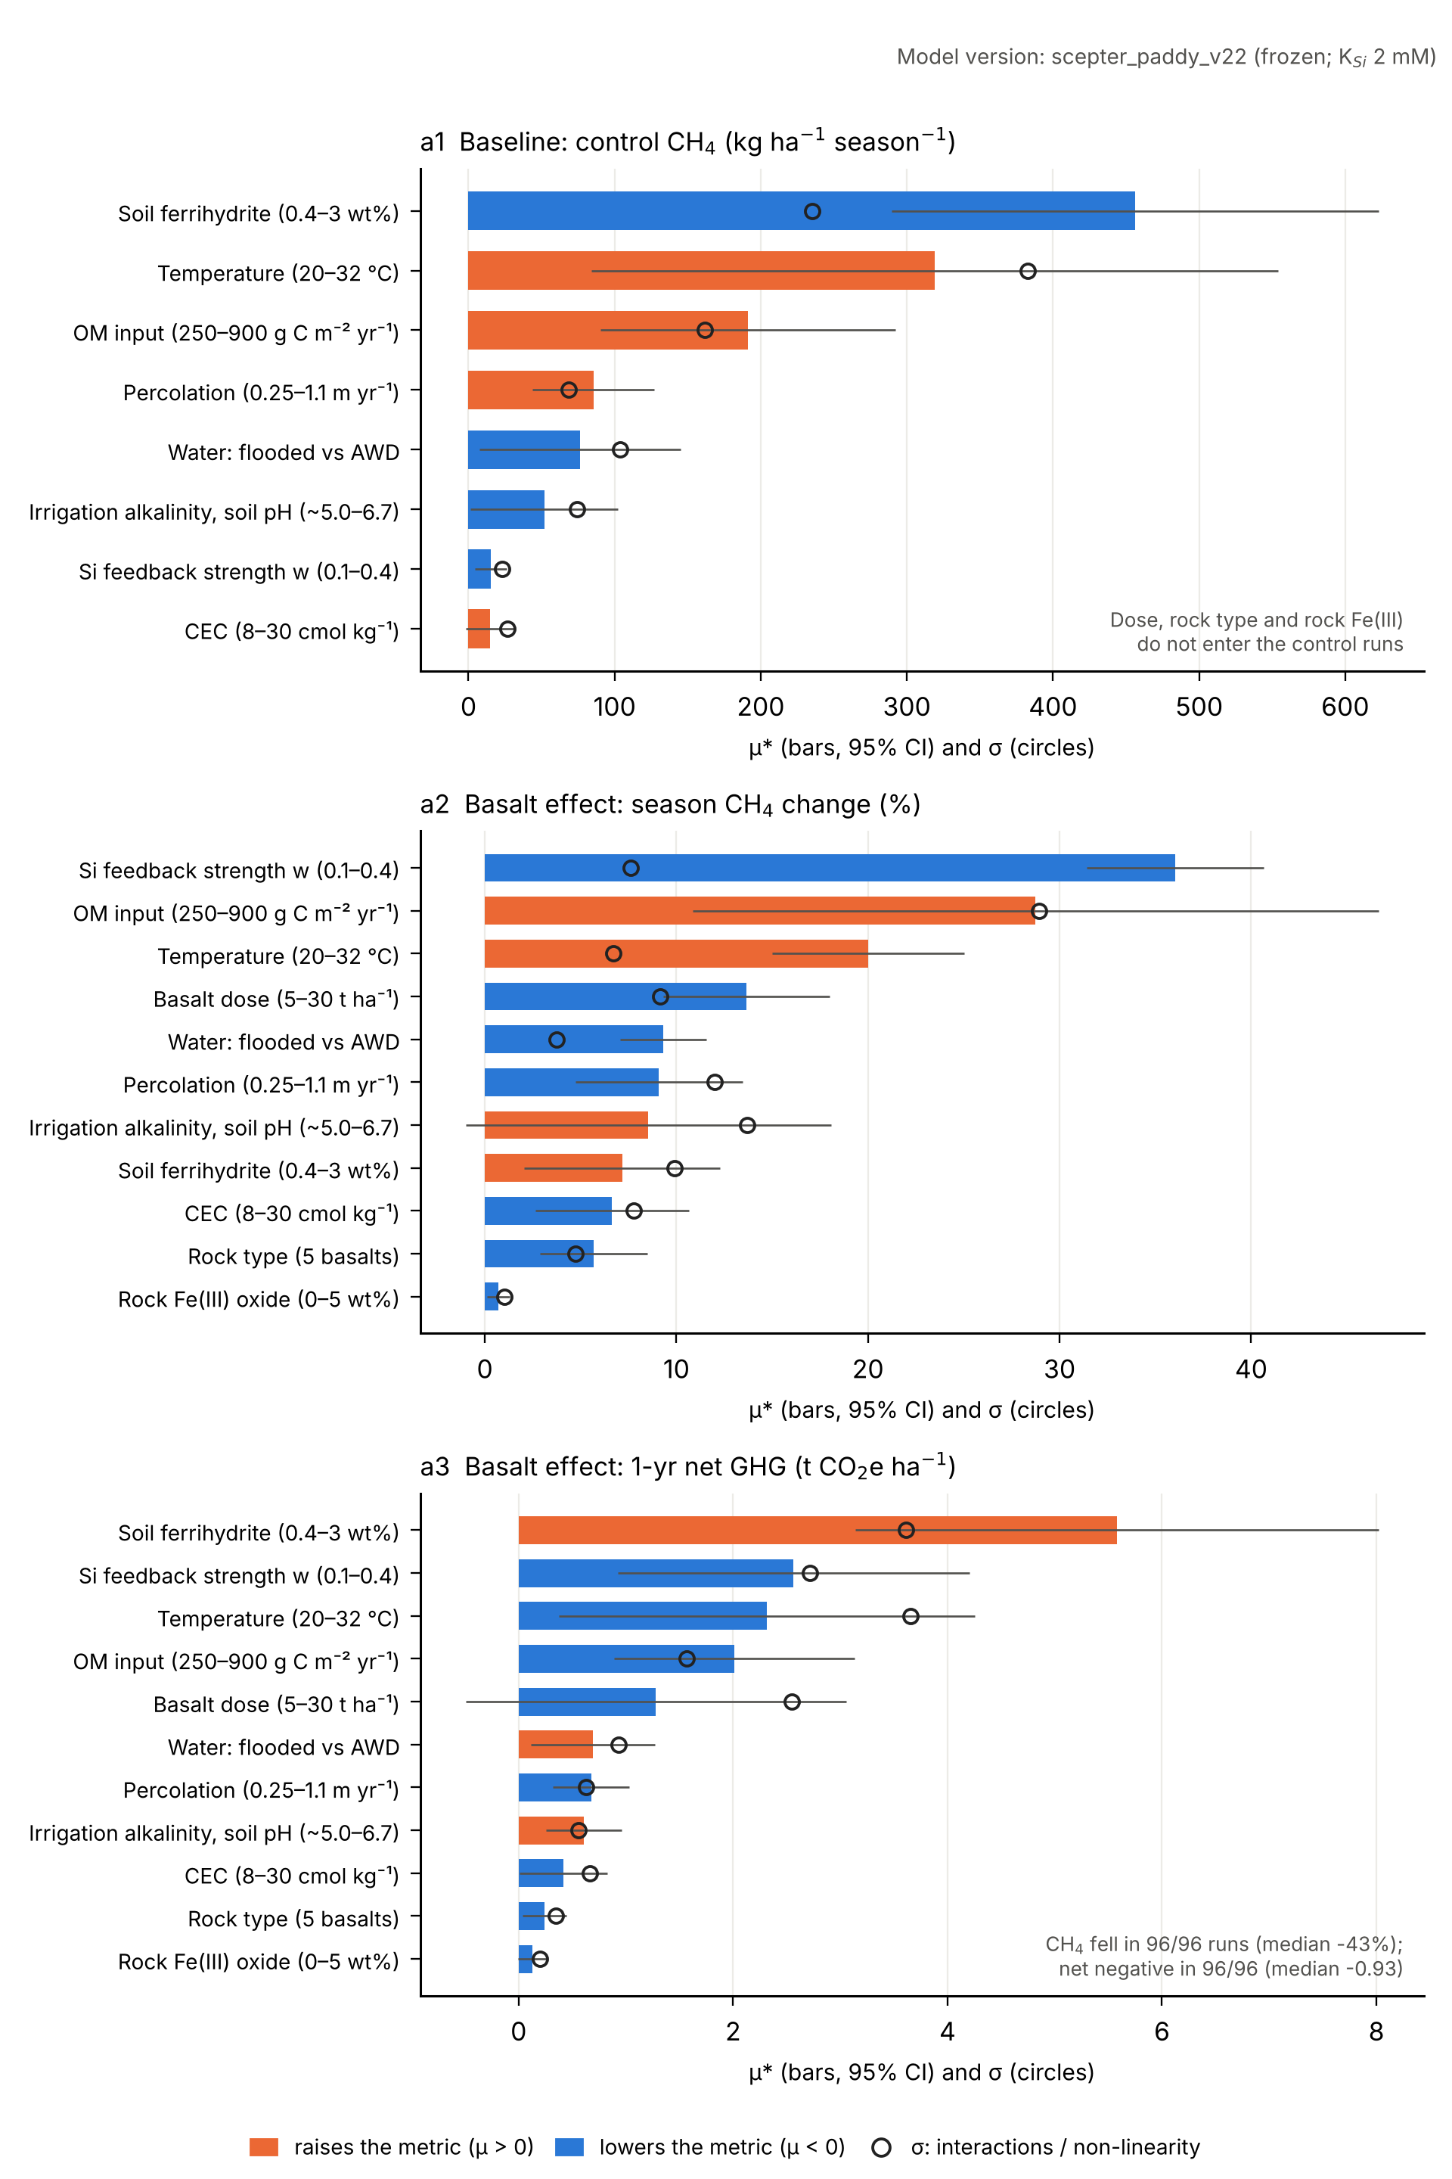
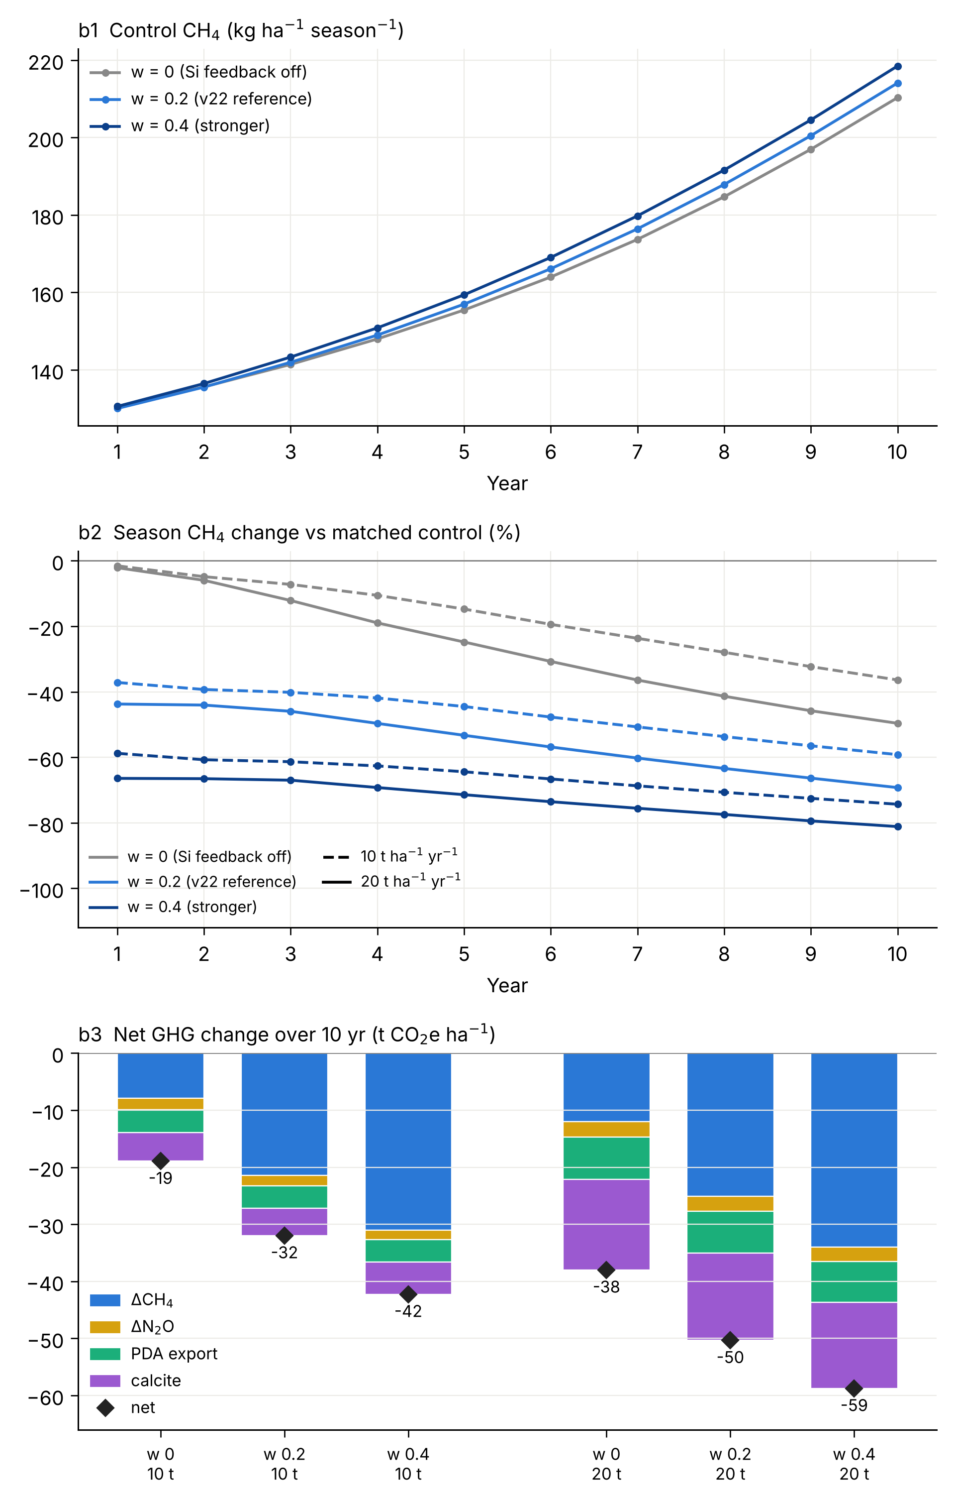
Fig. 6. Parameter sensitivity and structural uncertainty in simulated CH₄ emissions. (a) Morris elementary-effects screen, v22 (11 factors, r = 8, 96 points; each point is a 3-yr drained spin-up and 7-yr settle, then one year with basalt applied once, against a year-matched control). Bars give μ* with 95% confidence intervals, circles σ; colour gives the sign of μ. (a1) Baseline: control season CH₄, which depends only on soil, climate, water management and w (dose and rock do not enter the controls); it spans 6–1390 kg ha⁻¹ across the points and is controlled mainly by soil ferrihydrite (lowers CH₄), temperature and OM input (raise it). (a2, a3) Basalt effect: season CH₄ change (%) and one-year net GHG change (t CO₂e ha⁻¹, GWP100). The relative CH₄ change is ranked first by the Si-feedback strength w, then OM input, temperature and dose. The absolute net change is ranked first by soil ferrihydrite, because Fe-rich soils have low baseline CH₄ and so less to lose, then by w, temperature and OM input. σ is comparable to μ* for most factors, so interactions matter. CH₄ fell in all 96 runs (median −43%) and the one-year net change was negative in all (median −0.93 t CO₂e ha⁻¹), but w was sampled only between 0.1 and 0.4: Morris explores sensitivity within the assumed model structure and cannot show that the Si–root-O₂ mechanism is correct. (b) Structural test of the empirical Si feedback at the reference site over 10 years (v22; each treatment against a control run with the same w): Si feedback off (w = 0), v22 reference (w = 0.2) and stronger (w = 0.4). (b1) Control CH₄ hardly depends on w (130–131 kg ha⁻¹ in year 1), so the baseline is set by other processes. (b2) The first-year CH₄ response to basalt depends almost entirely on w: −2% with w = 0 against −37 to −44% (w = 0.2) and −59 to −66% (w = 0.4). Without the feedback, CH₄ still falls over the years (to −36% at 10 t and −50% at 20 t ha⁻¹ yr⁻¹ by year 10), partly because the control’s CH₄ rises as its plough-layer Fe(III) declines. (b3) Net GHG change over 10 years remains negative in all three cases: −19, −32 and −42 t CO₂e ha⁻¹ at 10 t ha⁻¹ yr⁻¹, and −38, −50 and −59 at 20 t ha⁻¹ yr⁻¹, for w = 0, 0.2 and 0.4.
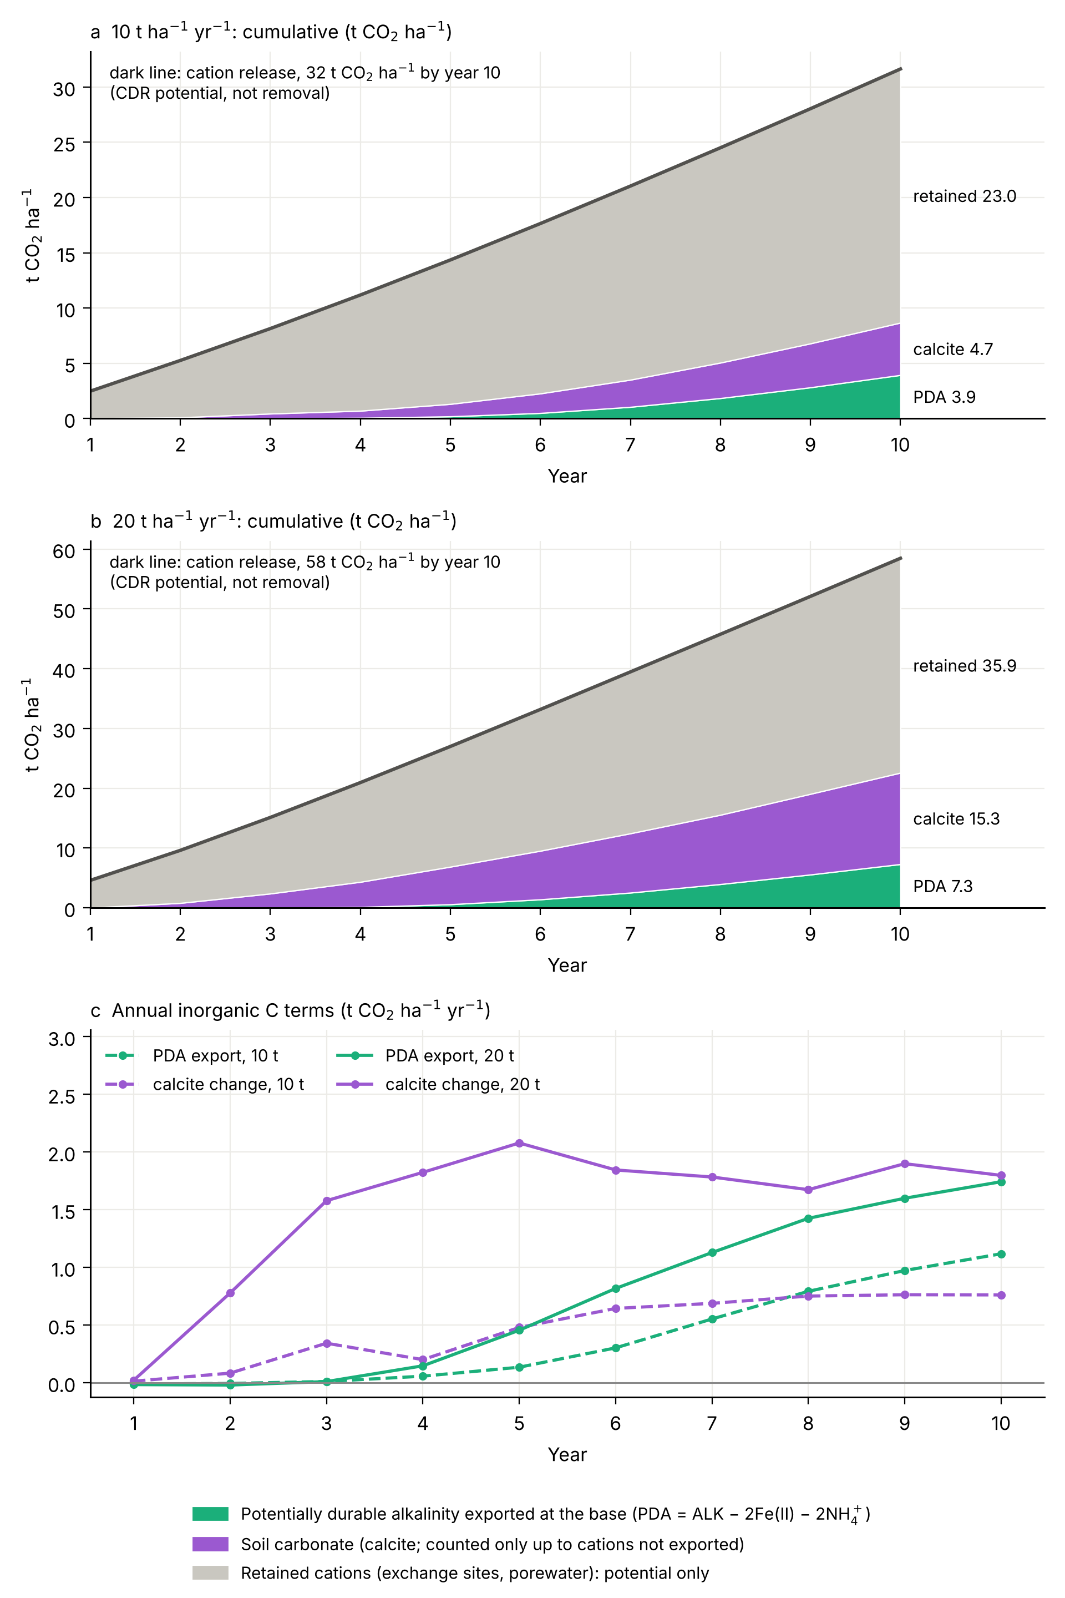
Fig. 7. Weathering and carbon fate over ten years at the reference site, 10 and 20 t ha⁻¹ yr⁻¹ (treatment minus year-matched control; season and fallow). (a, b) Cumulative cation release (top line, the CDR potential, not removal), split into potentially durable alkalinity exported at the column base (PDA = ALK − 2Fe(II) − 2NH₄⁺), soil carbonate (calcite, counted only up to the cations not exported) and cations retained on exchange sites and in porewater. (c) Annual PDA export and calcite change. None of these terms is verified durable CDR; after 10 years, 61–73% of the released cations are still retained in the soil.
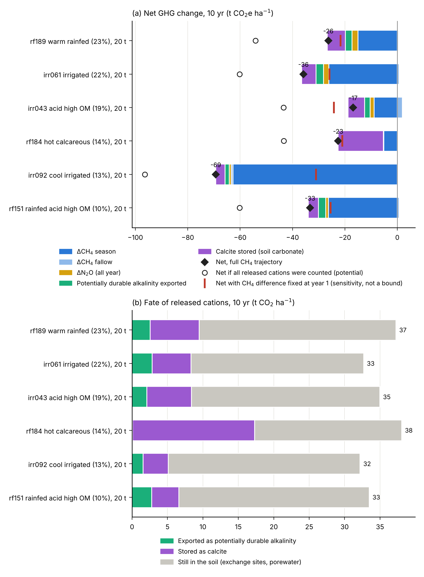
Fig. 8. Contrasting rice-soil archetypes: frozen v22, six area-weighted archetypes at 20 t ha⁻¹ yr⁻¹ for 10 years (season and fallow, against year-matched controls). (a) Net GHG change decomposed into CH₄ (season and fallow), N₂O and inorganic-C terms (PDA export and calcite). Diamonds give the net change with the full CH₄ trajectory. Red bars give the net change with the CH₄ difference held at its year-1 value; this is a diagnostic sensitivity to the persistence of the CH₄ response and Fe ageing, not a confidence bound, and it does not isolate the Si mechanism. Open circles count all released cations (potential). (b) Fate of the released cations after 10 years.

