Draft figures, frozen model v22 (30 Oct 2026)
All panels use executable scepter_paddy_v22 (commit 162913a), k_cal.in (methanogenesis vmax 1860 yr⁻¹) and the Si feedback K_Si = 2 mmol L⁻¹, w = 0.2, with no site recalibration, except where a panel says otherwise. Fig. 6 is a placeholder until the v22 Morris screen and the Si-feedback runs finish.
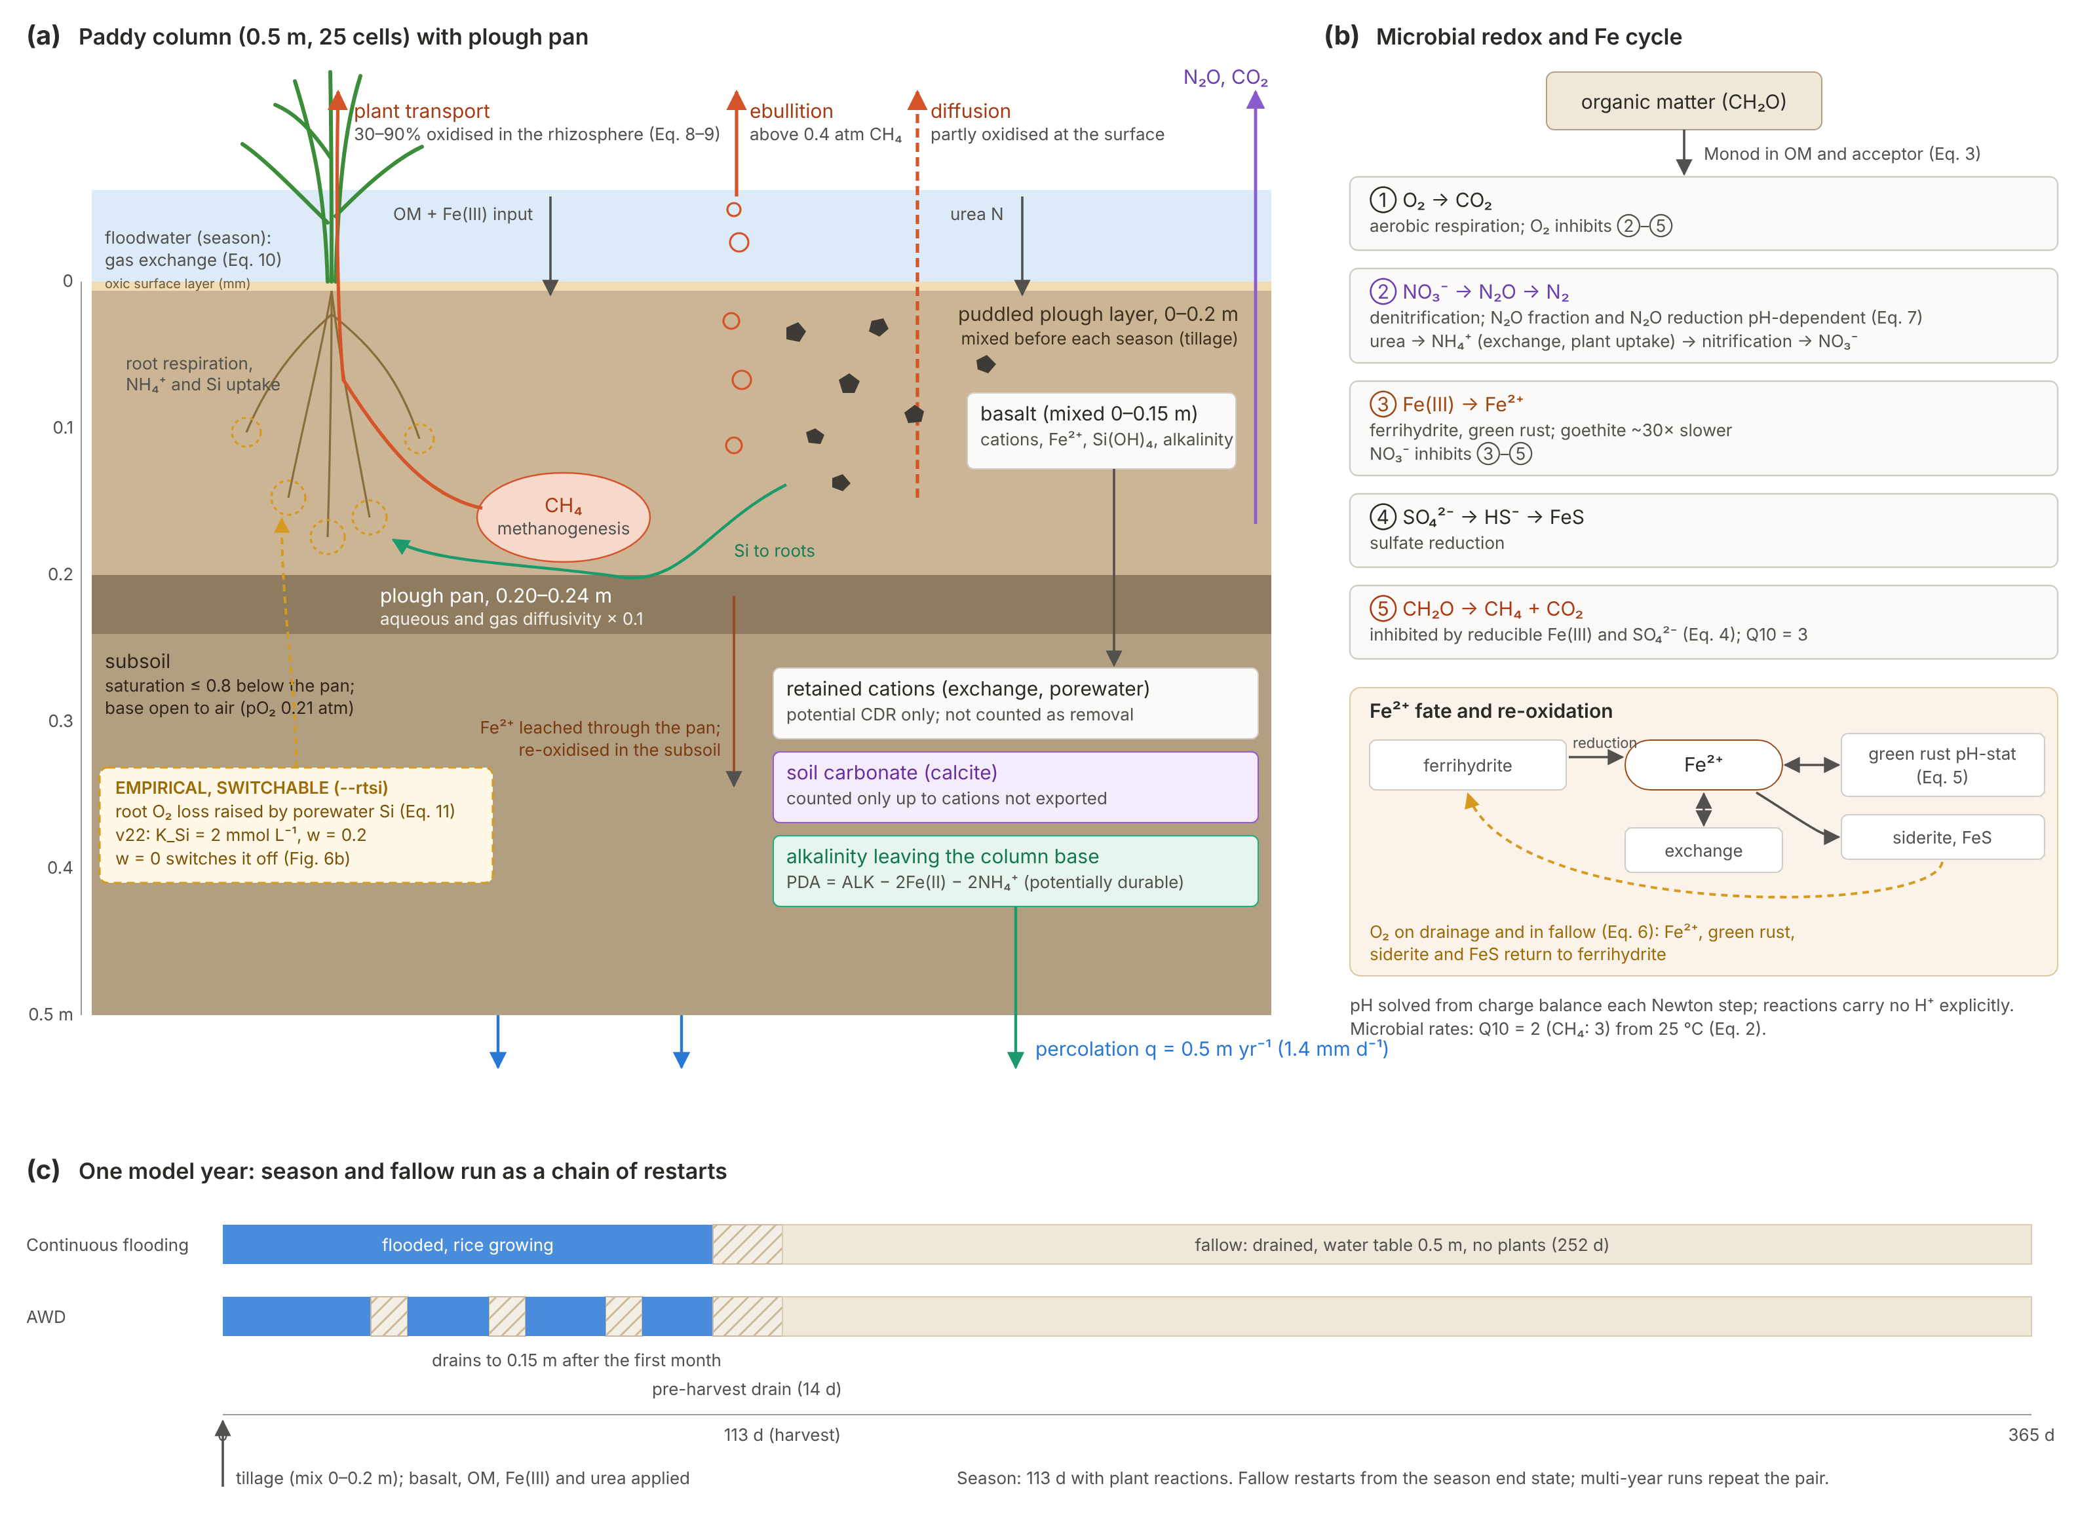
Fig. 1. Model structure and processes. (a) The 0.5 m paddy column (25 cells): puddled plough layer (0–0.2 m, mixed before each season), plough pan (0.20–0.24 m; aqueous and gas diffusivities × 0.1) and a partly saturated subsoil open to air at its base. CH₄ leaves by plant transport, ebullition and diffusion. Basalt, mixed into 0–0.15 m, releases cations, Fe²⁺, Si and alkalinity, and the model tracks three fates separately: cations retained on exchange sites and in porewater (CDR potential only), soil carbonate, and potentially durable alkalinity exported through the base (PDA = ALK − 2Fe(II) − 2NH₄⁺). The Si-dependent root-O₂ term (dashed box) is empirical and switchable (v22: K_Si = 2 mmol L⁻¹, w = 0.2; w = 0 switches it off). (b) Microbial electron-acceptor sequence and the Fe²⁺ cycle (green rust pH-stat, siderite, FeS, exchange, re-oxidation by O₂ on drainage). (c) Seasonal saturation and drainage: a 113-day season (continuous flooding or AWD, both ending with a 14-day pre-harvest drain) and a 252-day drained fallow, run as a chain of restarts.
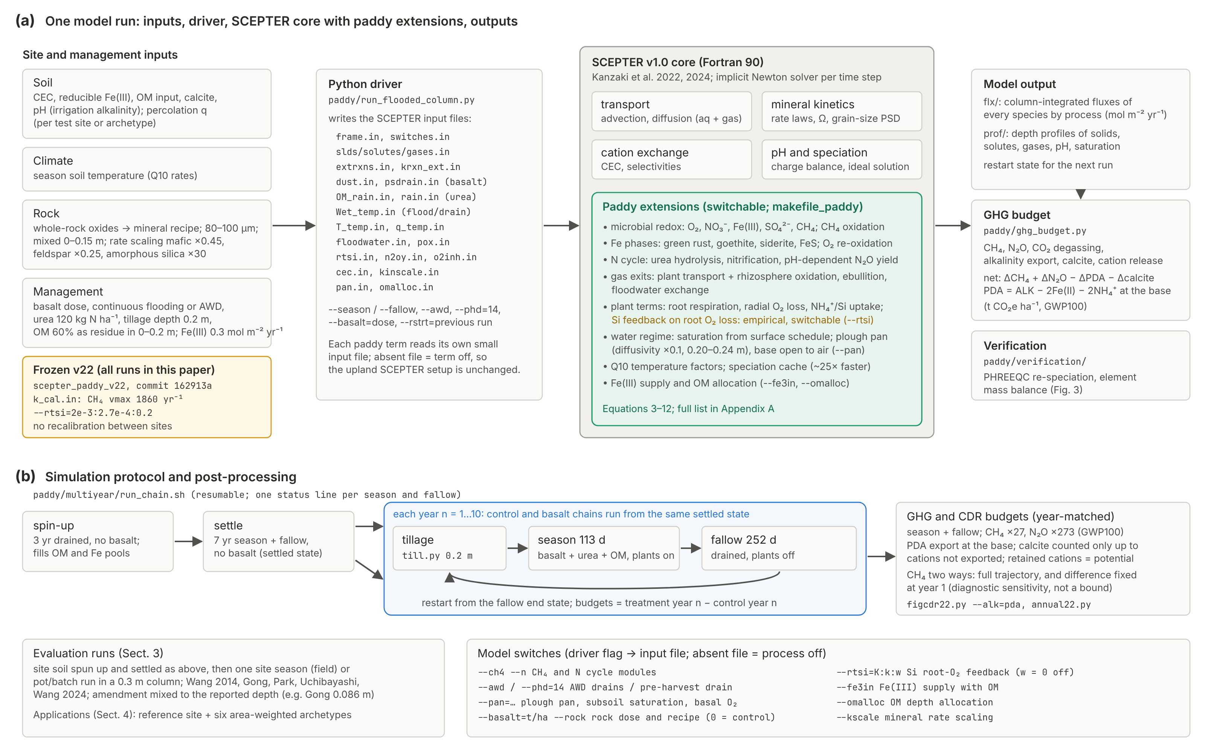
Fig. 2. Implementation and simulation protocol. (a) Inputs, the Python driver, the original SCEPTER v1.0 core (grey) and the added paddy modules (green), and outputs. Each paddy term reads its own input file and is off when the file is absent. Frozen v22 provenance: executable, commit, calibrated constants and Si-feedback setting. (b) Prescribed hydrology and the run protocol: 3-yr drained spin-up, 7-yr settle without rock, then year-matched control and treatment chains from the same settled state (tillage, season, fallow), with GHG and CDR post-processing. Model switches are listed with their driver flags.
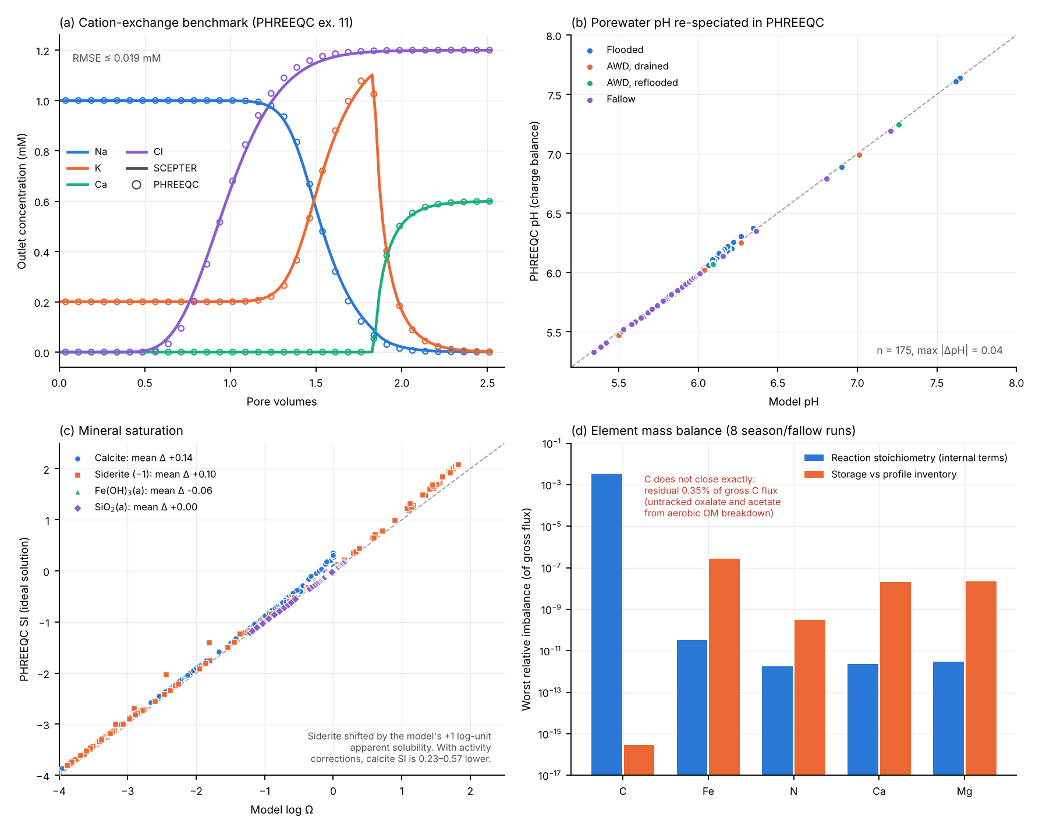
Fig. 3. Numerical verification (v22). (a) PHREEQC example 11 cation-exchange benchmark, outlet concentrations (lines: SCEPTER; circles: PHREEQC). (b) pH of 175 model porewaters (archetype irr061: flooded, AWD drained and reflooded, and fallow, at 0 and 20 t ha⁻¹) recomputed by charge balance in PHREEQC (phreeqc.dat). (c) Model log Ω against PHREEQC SI with activity coefficients removed (the model runs as an ideal solution); siderite is shifted by the model’s +1 log-unit apparent solubility. (d) Worst relative imbalance in element budgets over eight season and fallow runs: internal reaction terms (blue) and storage against profile inventories (orange). Fe, N, Ca and Mg close to within 3 × 10⁻⁷ of the gross flux. Carbon does not close exactly: a bookkeeping residual of 0.35% of the gross C flux remains in the internal reaction terms, attributed to oxalate and acetate from aerobic OM breakdown that are not tracked as carbon.
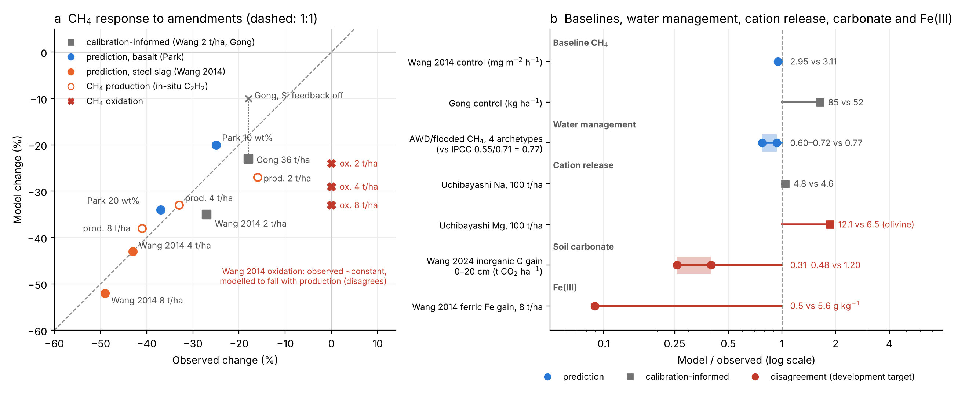
Fig. 4. Evaluation against observations (frozen v22, no site recalibration). (a) CH₄ response to basalt and steel slag, model against observed (dashed line 1:1). Squares are calibration-informed comparisons (Wang et al. 2014 at 2 t ha⁻¹ and Gong et al. 2026, used to set the Si feedback); circles are predictions. Open circles are CH₄ production (in-situ C₂H₂ inhibition); red crosses are CH₄ oxidation, which was observed to stay nearly constant but falls with production in the model. (b) Model/observed ratios for baseline CH₄, the water-management response (first-year AWD/flooded control CH₄ at four archetypes against the IPCC (2019) multiple-to-single-drainage scaling, 0.55/0.71), cation release (Uchibayashi et al. 2025; mineral rate scaling was informed by this study), soil carbonate (Wang et al. 2024) and Fe(III) (Wang et al. 2014). Red marks disagreements kept as development targets: Mg release about 2× too fast (olivine), carbonate gain underpredicted 2.5–4×, and the ferric-Fe gain not reproduced.
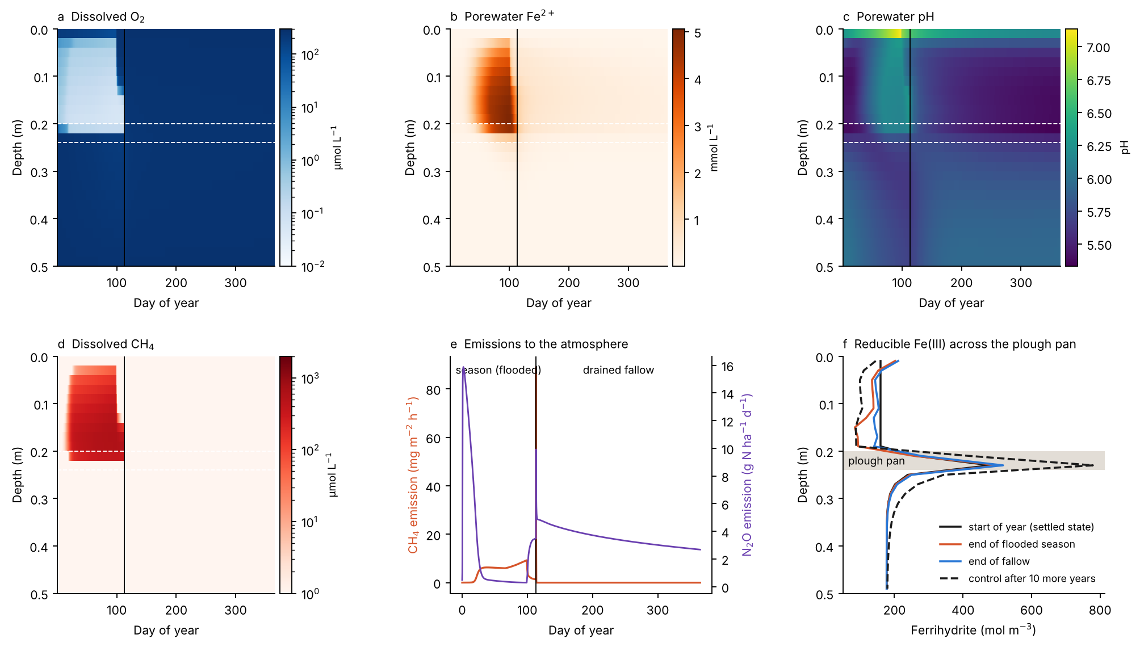
Fig. 5. Paddy biogeochemical dynamics in the reference control column (no rock), one year (season and fallow) after the 7-yr settle. (a–d) Depth–time sections of dissolved O₂, porewater Fe²⁺, pH and dissolved CH₄; dashed white lines mark the plough pan and the vertical line the end of the season. (e) CH₄ and N₂O emission to the atmosphere. (f) Ferrihydrite profiles at the start of the year, the end of the flooded season, the end of the fallow, and in the control after a further 10 years (run r10_ref_0, identical physics). Reducible Fe(III) is depleted from the plough layer and accumulates in the plough pan, consistent with re-oxidation there of Fe²⁺ leached from the plough layer during flooding. None of these panels depends on basalt or the Si feedback.
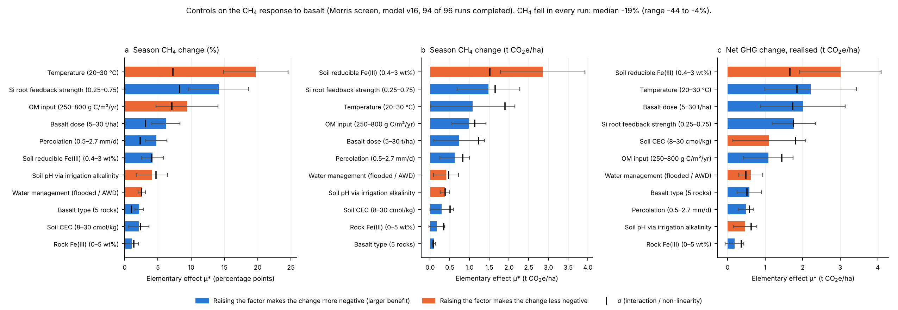
Fig. 6 (PLACEHOLDER: model v16, superseded; not a v22 result). Parameter sensitivity and structural uncertainty in simulated CH₄ emissions. The final figure will have two panels. (a) Morris elementary effects on v22 (11 factors, 96 points, 7-yr settle, year-matched controls), shown separately for baseline CH₄ (control) and for the basalt-induced change; this screen is running now. (b) Si feedback off (w = 0), reference (w = 0.2) and stronger (w = 0.4) at the reference site over 10 years at 0, 10 and 20 t ha⁻¹ yr⁻¹; these runs are also in progress. Morris explores sensitivity within the assumed structure; it cannot show that the Si–root-O₂ mechanism is correct.
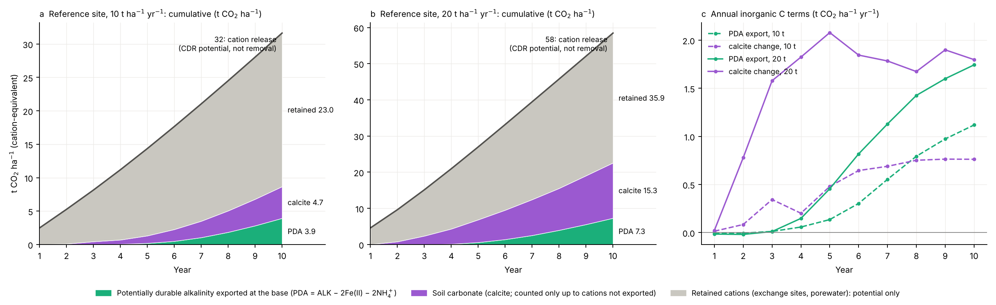
Fig. 7. Weathering and carbon fate over ten years at the reference site, 10 and 20 t ha⁻¹ yr⁻¹ (treatment minus year-matched control; season and fallow). (a, b) Cumulative cation release (top line, the CDR potential, not removal), split into potentially durable alkalinity exported at the column base (PDA = ALK − 2Fe(II) − 2NH₄⁺), soil carbonate (calcite, counted only up to the cations not exported) and cations retained on exchange sites and in porewater. (c) Annual PDA export and calcite change. None of these terms is verified durable CDR; after 10 years, 61–73% of the released cations are still retained in the soil.
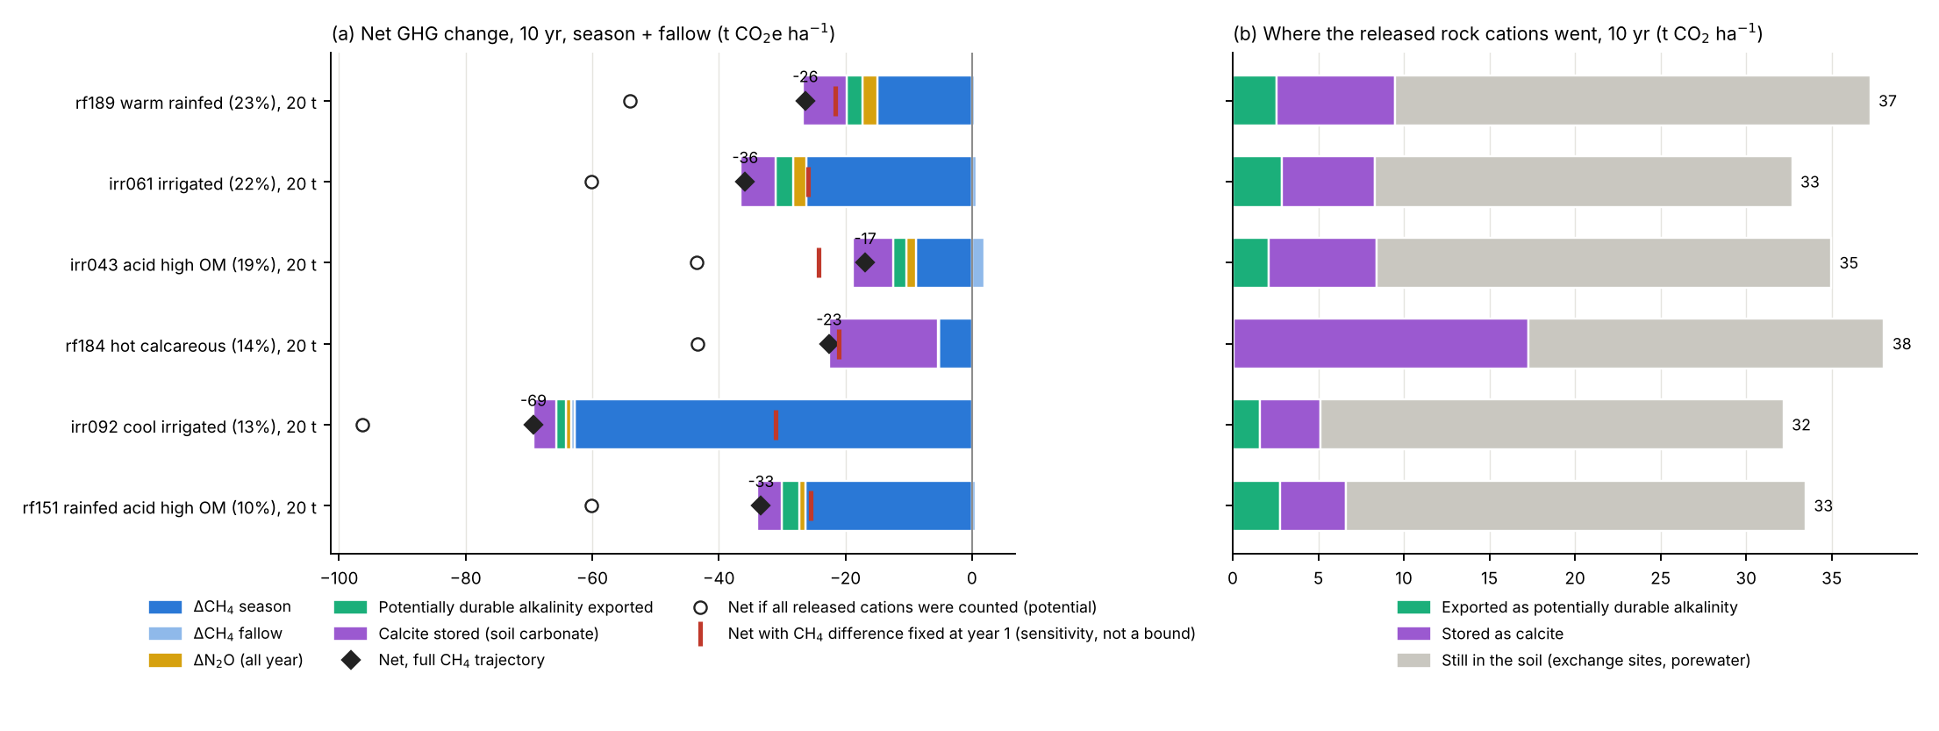
Fig. 8. Contrasting rice-soil archetypes: frozen v22, six area-weighted archetypes at 20 t ha⁻¹ yr⁻¹ for 10 years (season and fallow, against year-matched controls). (a) Net GHG change decomposed into CH₄ (season and fallow), N₂O and inorganic-C terms (PDA export and calcite). Diamonds give the net change with the full CH₄ trajectory. Red bars give the net change with the CH₄ difference held at its year-1 value; this is a diagnostic sensitivity to the persistence of the CH₄ response and Fe ageing, not a confidence bound, and it does not isolate the Si mechanism. Open circles count all released cations (potential). (b) Fate of the released cations after 10 years.

