Assignment #2 – Unit Testing

By

Dhara Bosmiya (8866250)

Date – 08/06/2023

Commit for equilateral triangle test case

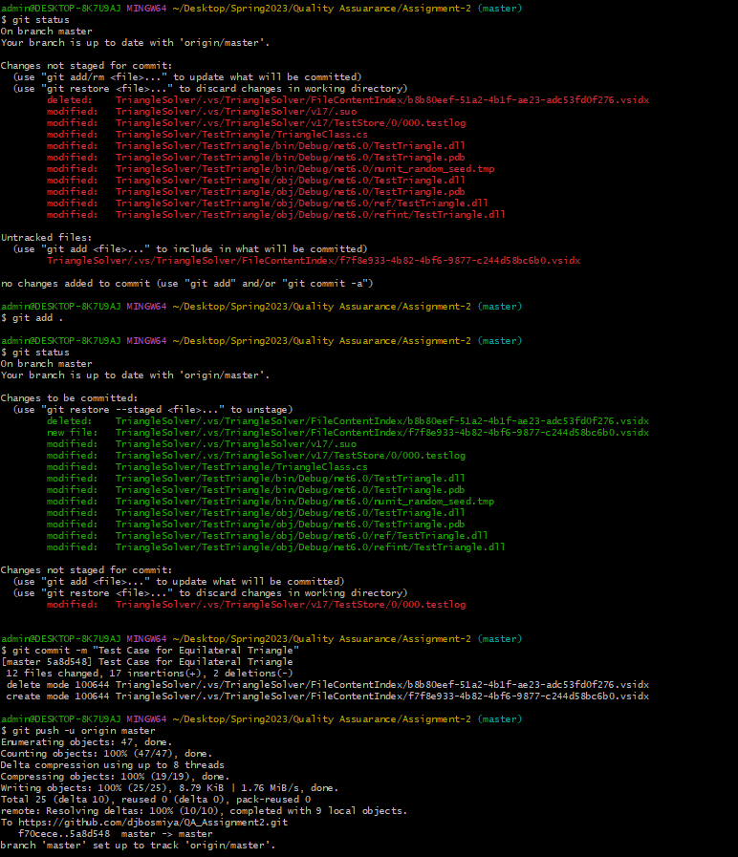

Commit for Isosceles triangle test case

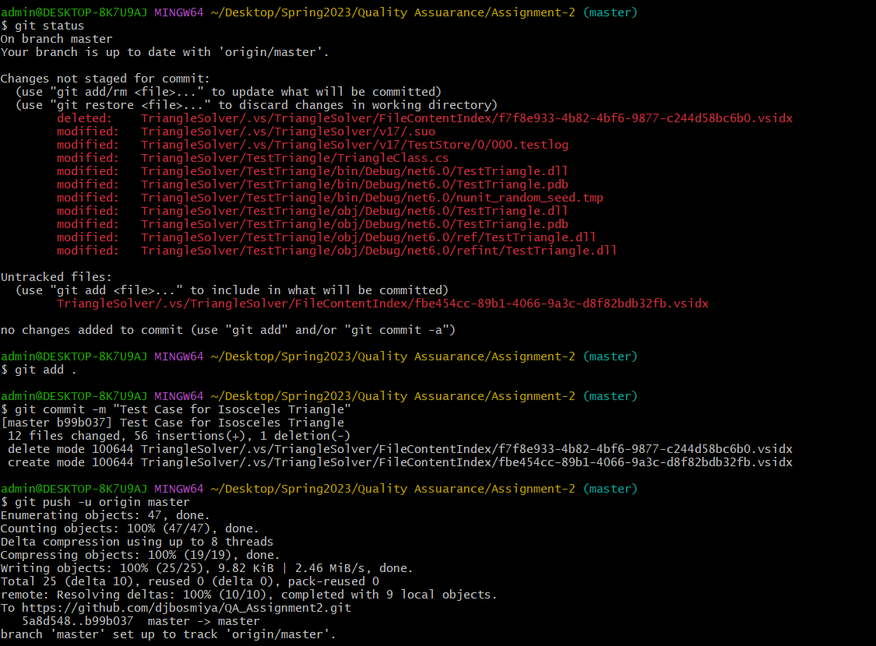

Commit for scalene triangle test case

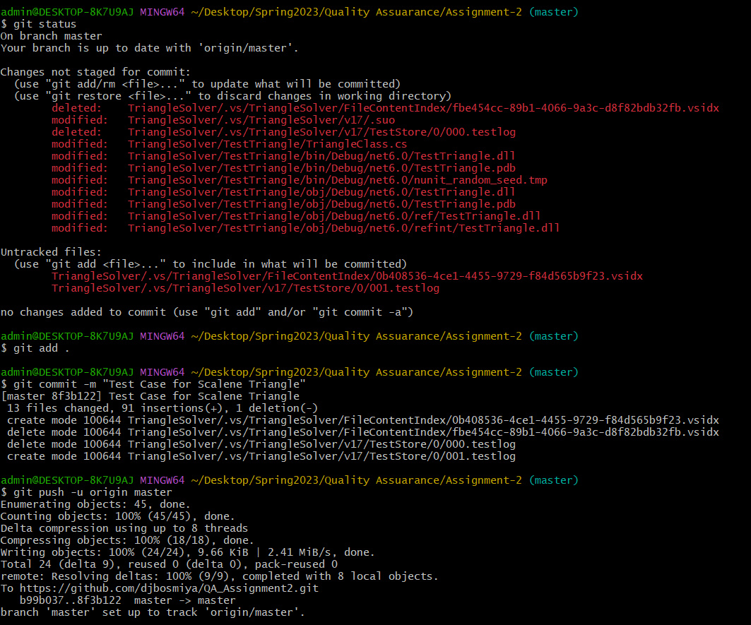

Commit for verifying a zero length for one or more sides

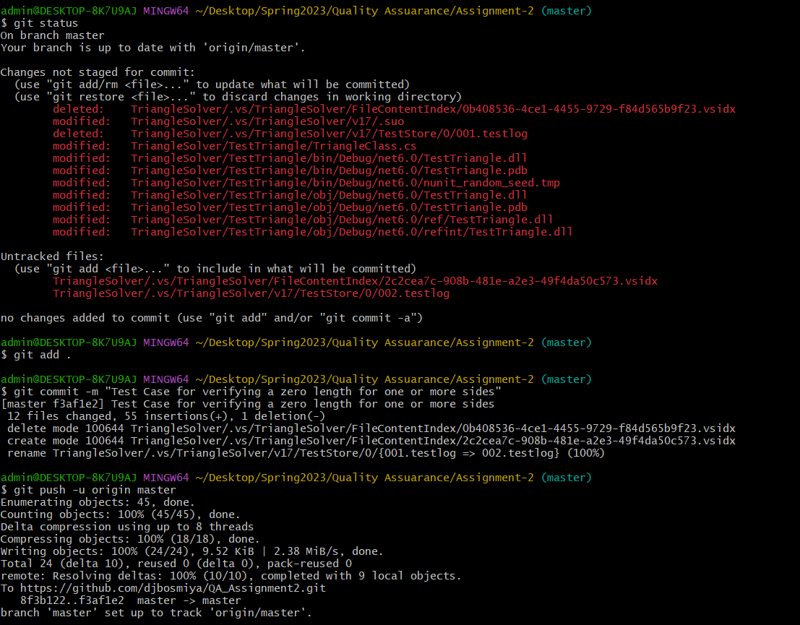

Commit for Invalid response