Important Features

Metadata:

* Date
* Publication
* Publication type (weekly, daily, periodical)
* Publication audience
* Author (if possible)
  + Personography
* Publication address?
* Source/Citation

Body:

* Paragraph organization
* Place references
* People references
  + Direct references to personography
  + Indirect references to unidentified people
* Political/class references
  + This is a little bit difficult to parse?
  + What is a class reference? Reference to a person’s economic standing, so servant/master?
* Ghost references
* Framing devices

Deciding what goes into the collection:

* “non-fiction”: news reports in a paper of record, or another newspaper that mostly publishes news stories and editorials
  + Report of hoax
  + Early report of haunting that turns out to be a hoax later
  + Report of reaction to hoax
* “ambiguous non-fiction”: possibly fiction, possibly non-fiction, but framed as non-fiction. Usually repeating a story told to the author, who expresses doubt as to the authenticity of the haunting
  + Alternatively, a true account which USES some ghost story as a tool to further some other idea, likely political
* “fictional reporting of ambiguity”: a most likely fictional account of a hoax or possible hoax, still framed as non-fiction reported to the author, the author expresses some doubt about the reliability of the ghost story

Examples:

Non-fiction

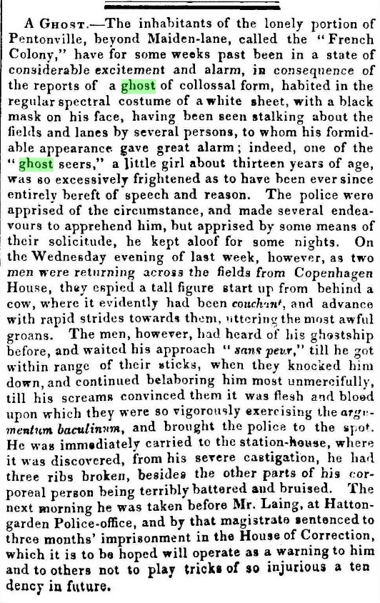

Ambiguous non-fiction

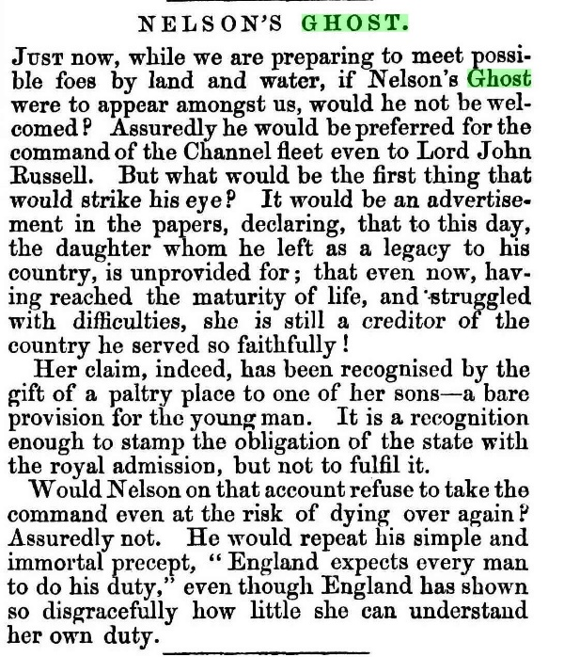

Fictional reporting of ambiguity

C:\Users\gabikeane\Desktop\vict_hoax\clippings\ghostcutghost_chambers_1889.pdf

Something I don’t want (but will probably collect and then exclude anyway)

C:\Users\gabikeane\Desktop\vict_hoax\clippings\ghostofastory_bentleys_1847.pdf